Supporting Information

A Novel Hydrophobic-Zincophilic Bifunctional Layer for Stable Zn Metal Anodes
Xuan Zhou^{a,1}, Renpeng Chen^{a,1}, Enhui Cuiª, Qin Liuª, Hong Zhangª, Jiahui Dengª, Nannan Zhangª, Can Xieª, Lin Xu^{a,b,c,}*, Liqiang Mai^{a,b,c}

Experimental Section
Synthesis of HZBL: 0.5 g polyvinylidene fluoride (Mw = 1 000 000, Canrd) was first dissolved in 20 ml 2 M KOH/absolute ethanol solution at 60 °C under magnetic stirring for 2 h. Then, the mixed precursor was centrifuged and washed 3 times with deionized water. The alkalized sample was obtained after dried in an oven at 70 °C for 24 h. Second, 0.4 g alkalized sample was added to 30 ml N-Methylpyrrolidone (NMP) (Sinopharm Chemical), stirring for 1 h at 50 °C. After that, 0.033 g azobisisobutyronitrile (AIBN) and 2.06 ml acrylic acid was added into the above solution to perform free radical polymerization at 80 °C under magnetic stirring for 2 h. Finally, HZBL was collected by centrifugation, washing (deionized water 3 times, absolute ethanol 3 times), and drying under vacuum at 70 °C for 24 h.
Preparation of HZBL-Zn electrodes: 0.2 g HZBL was added into 15 ml NMP under magnetic stirring for 1 week at room temperature. Then, a bottle of evenly dispersed brown solution was obtained. To prepare HZBL-Zn, the as-prepared solution was coated on the surface of Zn plate by spin-coating under 1000 rpm for 10 s. After that, the plate was placed on a heating table at 70 °C for 2 min. The above two steps were repeated three times, but for the third time, the Zn foils are placed in a 60 °C vacuum oven and stored for 24 h. Finally, the HZBL-Zn was obtained.
Synthesis of MnO₂/CNT: MnO₂/CNT nanocomposites were synthesized by a hydrothermal method reported in the previous literature [1]. Firstly, 1.13 g Mn(CH₃COO)₂·4H₂O (AR, Aladdin) was added to 50 mL of deionized water, then 0.16 g CNT was added into the solution under continuously stirring. Second, the above mixed solution was added slowly into 25 mL aqueous solution, which dissolved 1.45 g KMnO₄ (AR, Aladdin). Third, after stirring for 2 h, the mixed solution was transferred to a Teflon-lined autoclave and maintained at 80℃ for 6 h. Finally, the dark brown precipitate was washed with deionized water and dried to finally give the MnO₂/CNT.
Material Characterization: Scanning electron microscope (SEM) images are observed by a JEOL JSM-7100F scanning electron microscope. X-ray diffractometer (XRD) with Cu Kα radiation (λ = 1.054056 Å) with 2θ in the range of 5~80° are used to collect XRD results. Thermogravimetric (DTA/TG, STA 449, Netzsch) were conducted at a heating rate of 10 ℃ min⁻¹ under argon atmosphere. Fourier transform infrared Spectroscopy (FTIR) measurements were collected by using Nicolet 6700 (Thermo Fisher Scientifc Co., USA) IR spectrometer with wavenumber range from 400 to 4000 cm⁻¹. The X-ray photoelectron spectroscopy (XPS) analysis was tested by ESCALAB 250 Xi spectrometer. The in-situ observation of dendrites uses optical microscope (MXFMS-BD), and in-situ pool of Beijing Scistar Technology Co., Ltd. The dynamic contact angles of the bare Zn and HZBL-Zn were measured on Dataphysics OCA35 optical contact angle system for each test at the temperature of 25 °C. Differential scanning calorimetry were done using a DSC8500 machine (PerkinElmer, USA).
Electrochemical Measurements: The cathode slurry was prepared by mixing the MnO₂/CNT powder, acetylene black carbon, and PVDF in NMP solution at a weight ratio of 7:2:1. And then the slurry was coated onto a carbon paper. After drying, the carbon paper was cut into circular sheets. The areal mass loading of the cathode electrodes in Fig. 6a, Fig. S27 and Fig. S28 was about 1.3 mg cm⁻², 7.6 mg cm⁻² and 5 mg cm⁻², respectively. The thickness of Zn foils in this work was 200 µm, except for 10 µm in Fig. S27. All the electrochemical performances were tested with CR2016 coin cells assembled by a glass fiber separator. The Zn plating/stripping performance was measured in Zn||Zn (or PVDF-Zn|| PVDF-Zn, HZBL-Zn||HZBL-Zn) symmetrical cells in 2 M ZnSO₄ solution. The CE of Zn anodes was measured with Zn||bare Cu (or Zn||HZBL-Cu) cells at a current density of 2 mA cm⁻² for 0.5 h. The electrochemical performance of full cells (Zn||MnO₂ or HZBL-Zn||MnO₂) was tested at current density of 3 C in a voltage range of 0.9 - 1.8 V, using 2 M ZnSO₄ and 0.2 M MnSO₄ solution as electrolyte. All the tests above were performed on a Neware Battery Tester. The electrochemical impedance spectroscopy (EIS) of the symmetrical cells in the frequency range of 0.01-100 kHz and cyclic voltammogram (CV) curves of the full cells at a scan rate of 0.1 mV s⁻¹ were tested by a BioLogic electrochemistry workstation.
Density functional theory calculations: The DFT calculation was carried out using DMol3 package. A double-numeric polarized basis set and all electron for the core-treatment were selected. For the numerical integration, the system was set as the open-shell (spin unrestricted) structure. The general gradient approximation with the Perdew-Burke-Ernzerh function (GGA-PBE) was applied for the electronic structure. The conductor-like screening model (COSMO) was used to simulate a H₂O solvent environment. The convergence tolerances of energy, maximum force and maximum displacement for structural optimization were 1.0 × 10⁻⁵ Ha, 0.002 Ha/Å and 0.005 Å, respectively. The self-consistent field (SCF) density convergence tolerance was 1 × 10⁻⁶.
The adsorption energy (E_{ads}) of the Zn²⁺ and G was defined as：
$$E_{ads}=E\left({Zn}^{2+}/G\right)-E\left({Zn}^{2+}\right)-E\left(G\right)$$
where G represent the functional groups: -F, -COOH. E(Zn²⁺/G), E(Zn²⁺) and E(G) were the energy of Zn²⁺ adsorbed on G, the energy of Zn²⁺, and the energy of G, respectively.
The desolvation energy (E_{des.}) value can be obtained by equation:
$$E_{des}=E\left(i-xH_{2}O\right)-E\left(i\right)-xE\left(H_{2}O\right)$$
Where E(i-xH₂O) is the energy of compound (Zn-6H₂O or Zn-chain-nH₂O) aquo-complex, E(i) is the energy of compound (Zn²⁺ or Zn-chain), E(H₂O) is the energy of H₂O.

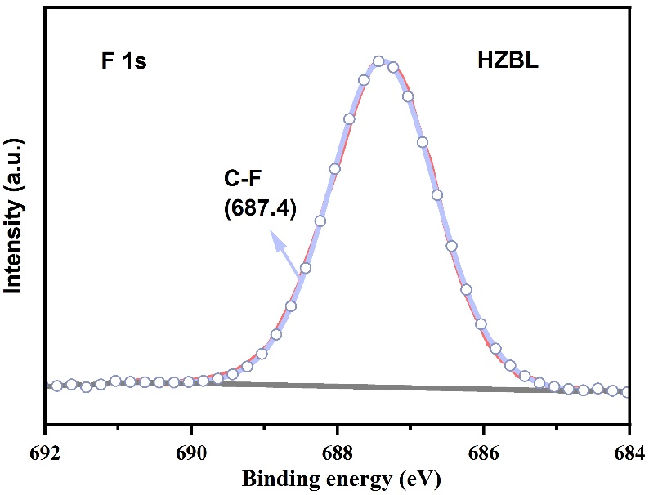
Fig. S1. XPS F 1s spectrum of HZBL.

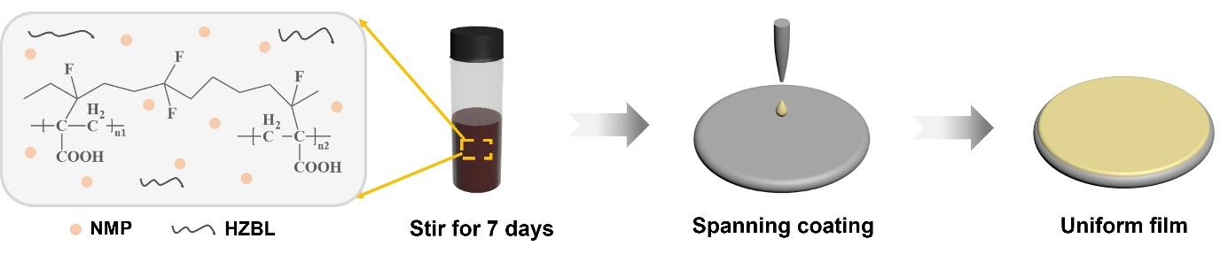
Fig. S2. The flow chart for the synthesis of HZBL-Zn by spin coating.

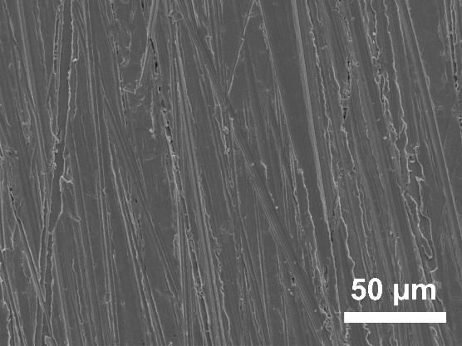
Fig. S3. SEM images of initial bare Zn.

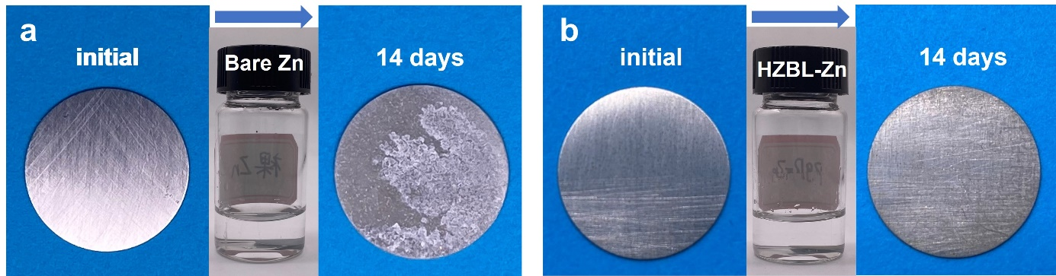
Fig. S4. The stability of bare Zn and HZBL-Zn in 2 M ZnSO₄ electrolyte. Optical photos of (a) bare Zn and (b) HZBL-Zn before and after being soaked in 2 M ZnSO₄ for 14 days.

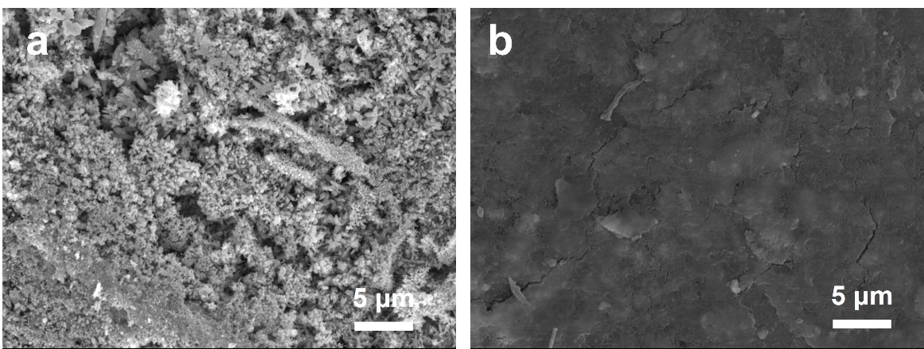
Fig. S5. Corresponding SEM images of (a) bare Zn and (b) HZBL-Zn after being soaked.

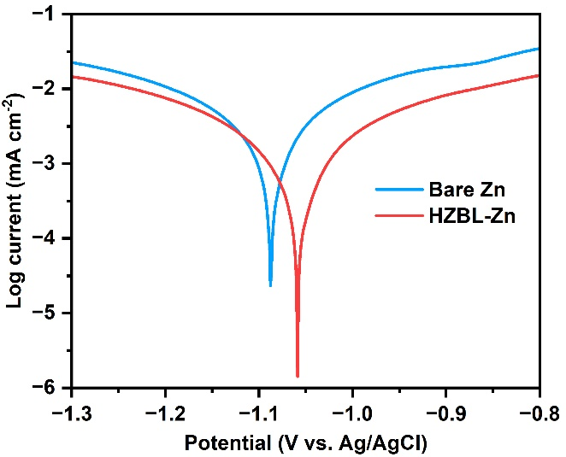
Fig. S6. Taffel curves showing the corrosion on bare Zn and HZBL-Zn.

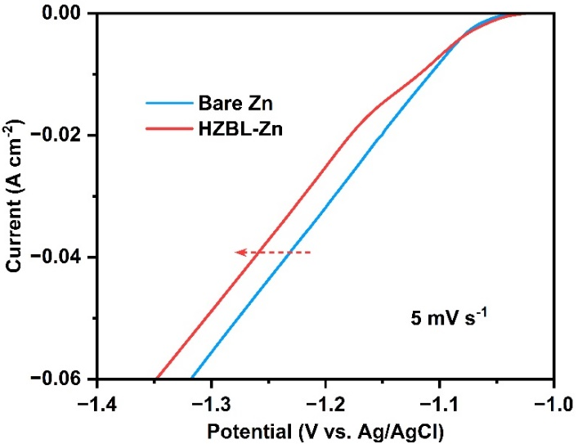
Fig. S7. Linear polarization curves of the bare Zn and HZBL-Zn.

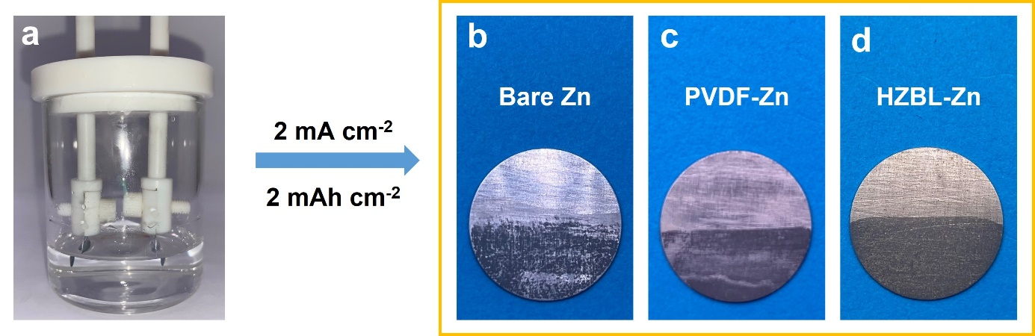
Fig. S8. (a) Optical photo of symmetrical Zn cell in a transparent tank. Digital photos of (b) bare Zn, (c) PVDF-Zn and (d) HZBL-Zn after Zn plating at the current density of 2 mA cm⁻² for 1 h in the transparent tank, respectively. (Only half of each anode was immersed in the solution.)

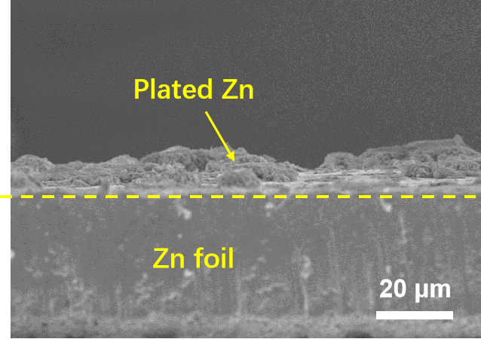
Fig. S9. Cross-sectional SEM images of PVDF-Zn after continuous Zn plating/stripping at a current density of 2 mA cm⁻² in transparent symmetrical cells for 1 h.

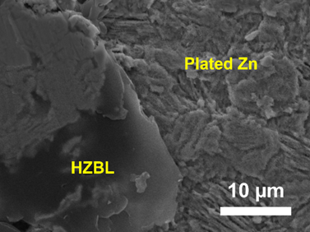
Fig. S10. SEM image of cycled HZBL-Zn with half HZBL removed.

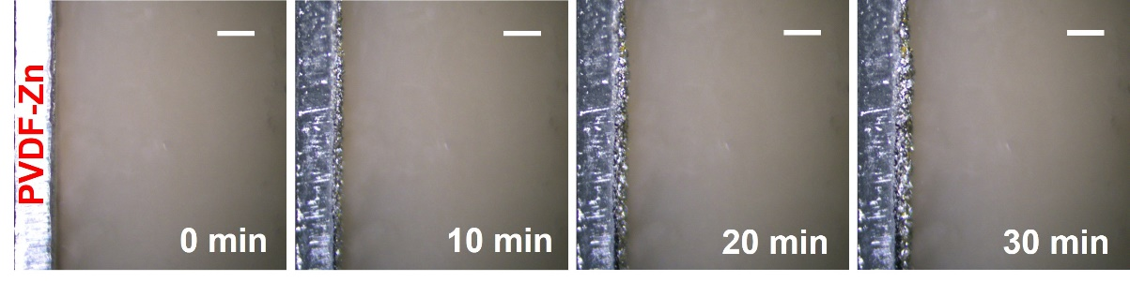
Fig. S11. In situ optical microscope results of PVDF-Zn at the current density of 10 mA cm⁻². Scale bar: 200 µm.

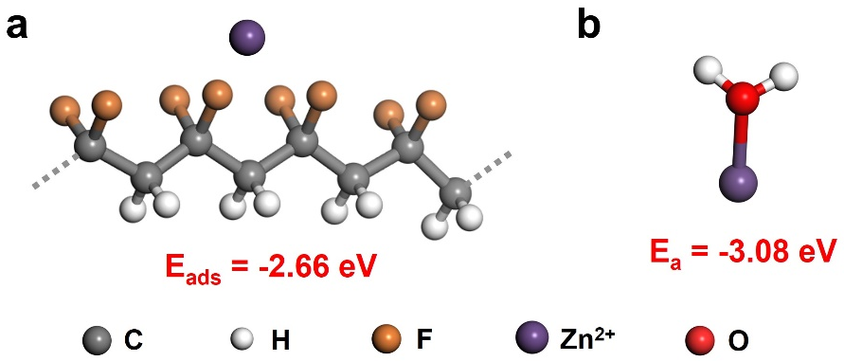
Fig. S12. DFT calculation results for adsorption energy of zinc ion with (a) ‒F groups on PVDF and (b) water molecule.

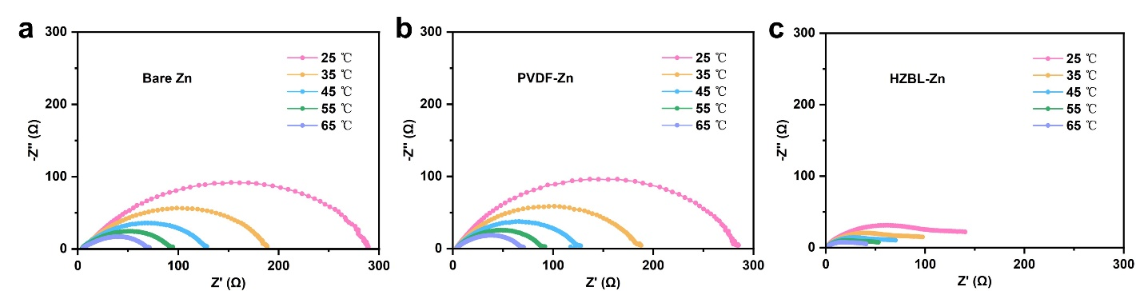
Fig. S13. Nyquist patterns at different temperatures of (a) bare Zn, (b) PVDF-Zn and (c) HZBL-Zn anodes in symmetric cells.

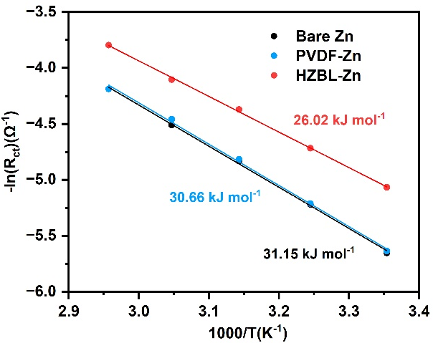
Fig. S14. Arrhenius curves of bare Zn, PVDF-Zn and HZBL-Zn anodes.
The activation energy was calculated by Arrhenius equation:
$$\frac{1}{R_{ct}}=Aexp\left(-\frac{E_{a}}{RT}\right)$$
Where R_{ct} is charge transfer resistance, R is molar gas constant, E_{a} is activation energy, A is pre-exponential factor.

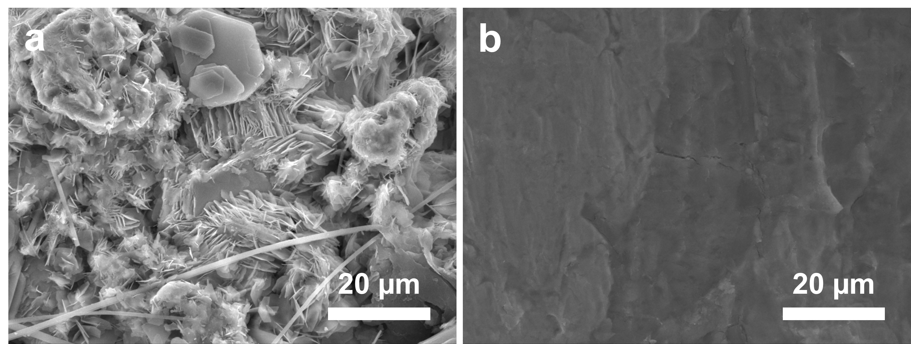
Fig. S15. SEM images of a) bare Zn and e) HZBL-Zn after 50 cycles at 12 mA cm⁻², 6 mAh cm⁻².

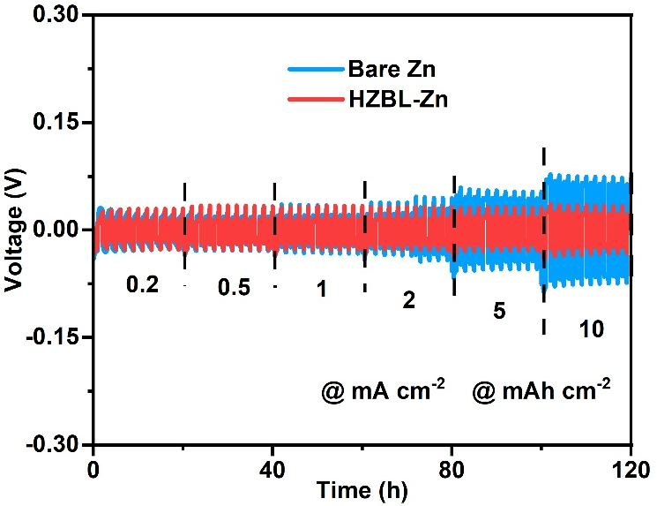
Fig. S16. Rate stability of Zn symmetric cells with bare Zn and HZBL-Zn.

We prepared PVDF and HZBL coated stainless steel (SS) by the same process as HZBL-Zn (denoted as PVDF-Zn and HZBL-SS). EIS tests were conducted on bare SS, PVDF-SS and HZBL-SS symmetric cells to get their bulk resistances.
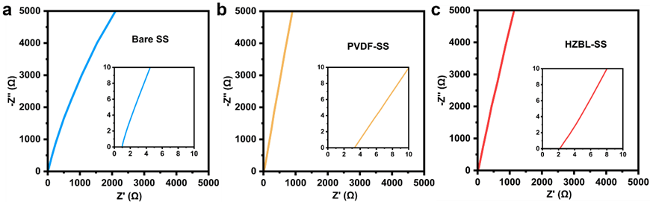
Fig. S17. Nyquist diagrams of unsealed symmetric cells with a) bare SS, b) PVDF-SS and c) HZBL-SS, with the insets showing the enlargement of the indicated curves.
The ionic conductivity was calculated according to the following equation (Adv. Mater. 2022, 34, 2105133):
$$σ=\frac{l}{AR}$$
where 𝜎 represents the ionic conductivity, l is the thickness of the coating, A is for the area of the prepared electrode, and R refers to the bulk resistance.

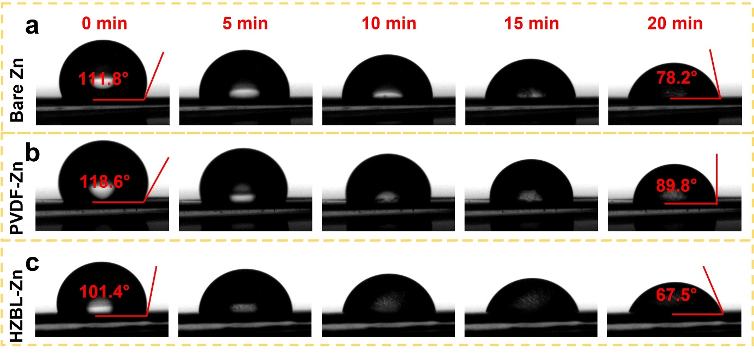
Fig. S18. In situ contact angle test of 2 M ZnSO₄ on (a) bare Zn (b) PVDF-Zn and (c) HZBL-Zn.

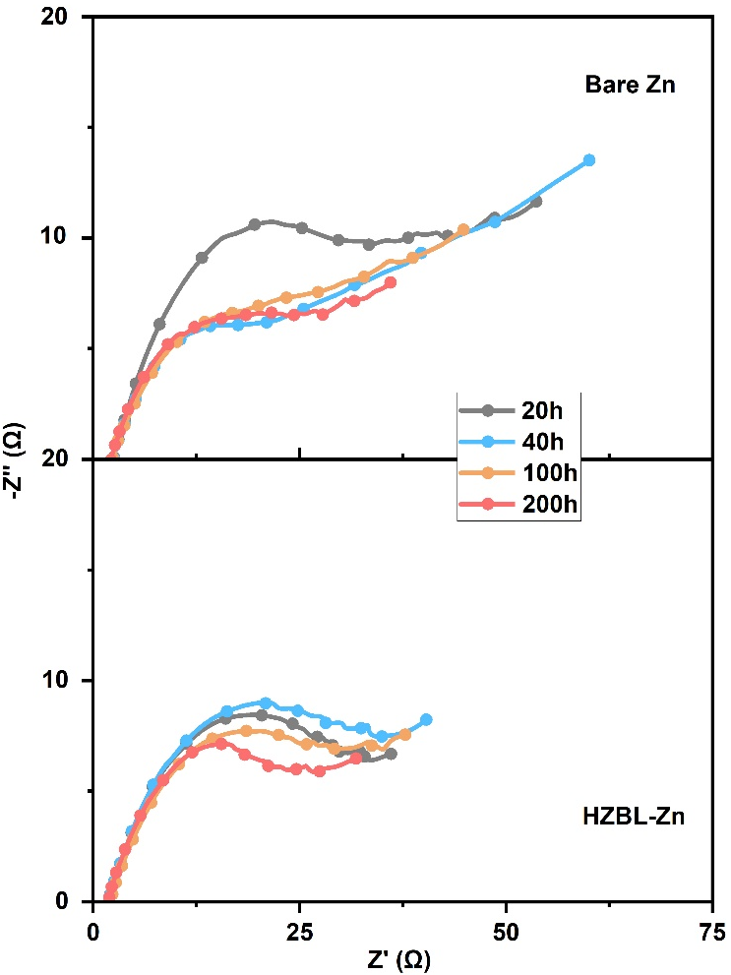
Fig. S19. EIS results of the symmetrical bare Zn||bare Zn and HZBL-Zn||HZBL-Zn cells after different cycles.

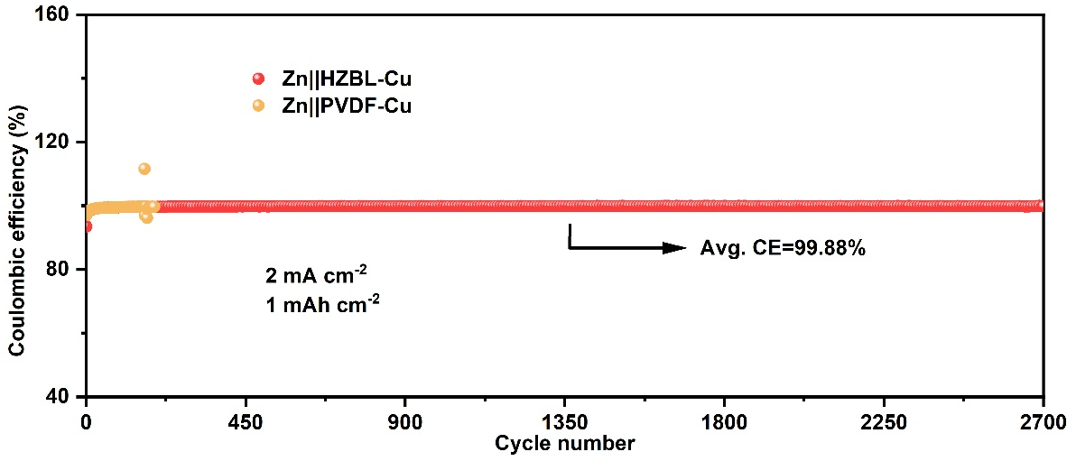
Fig. S20. The CE tests of Zn||PVDF-Cu and Zn||HZBL-Cu at a current density of 2 mA cm⁻².

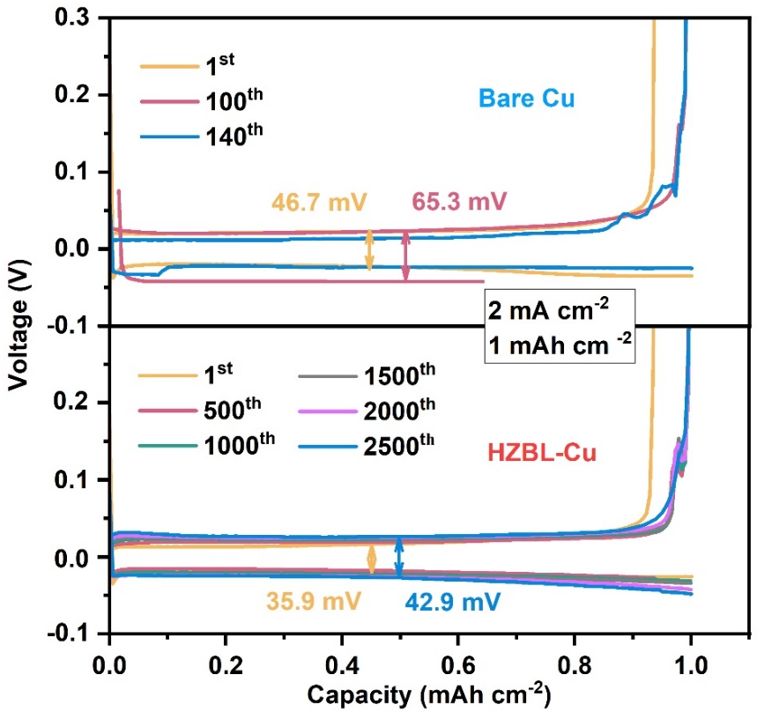
Fig. S21. Voltage-Capacity profiles of (c) Zn||bare Cu and (d) Zn||HZBL-Cu at different cycles.

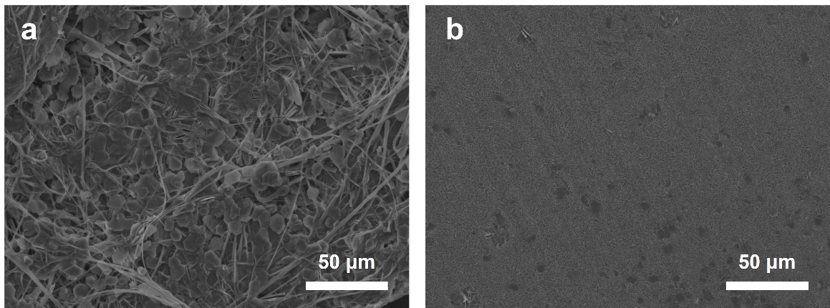
Fig. S22. Corresponding SEM images of (a) bare Cu and (b) HZBL-Cu after 150 cycles at 2 mA cm⁻² and 1 mAh cm⁻².

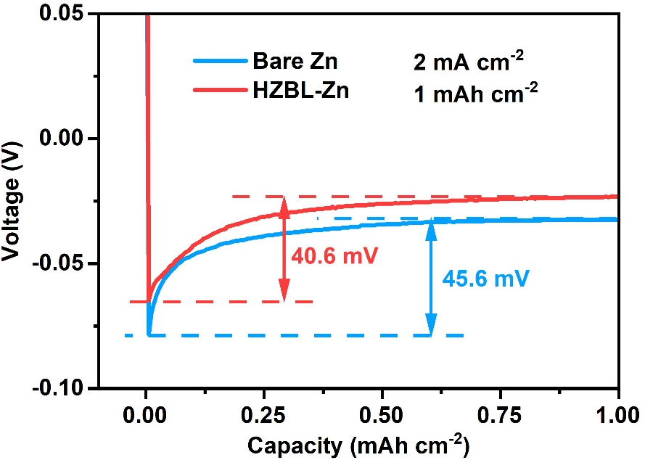
Fig. S23. Nucleation overpotentials of Zn deposition on the bare Cu and HZBL-Cu.

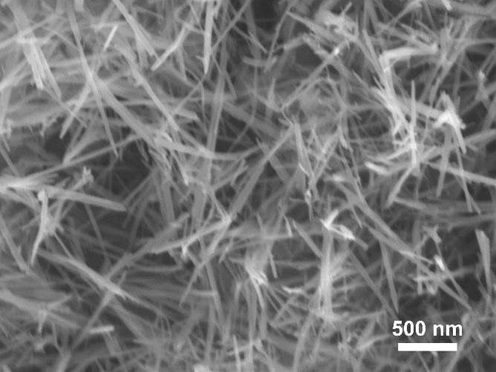
Fig. S24. SEM image of the α-MnO₂/CNT composites.

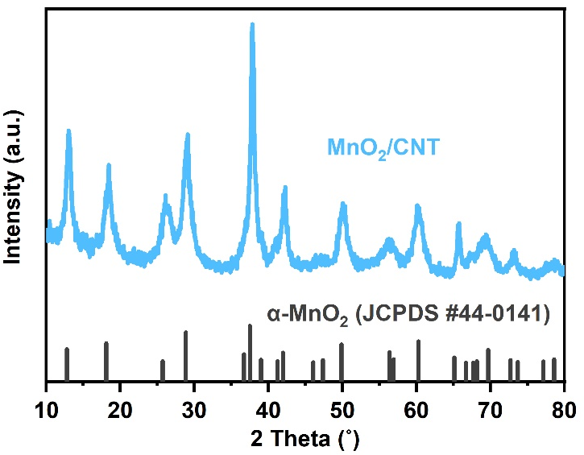
Fig. S25. XRD pattern of the α-MnO₂/CNT composites.

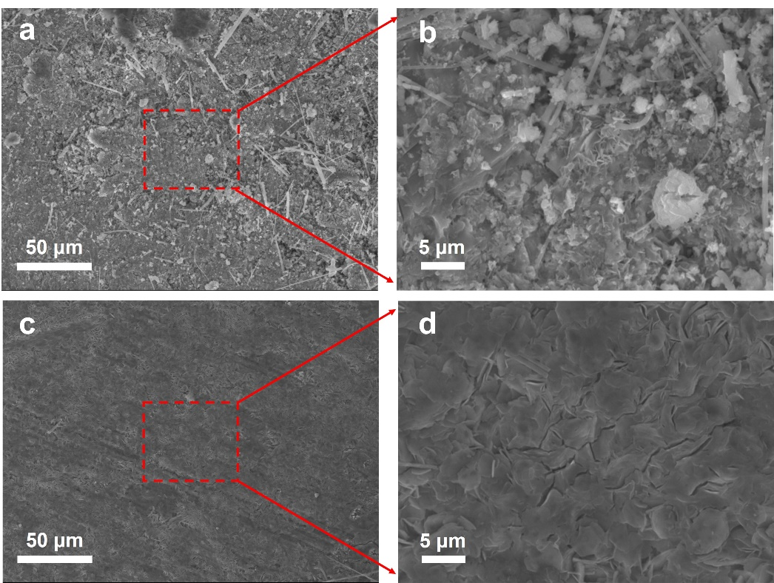
Fig. S26. SEM images of bare Zn (a and (b) and HZBL-Zn (c and (d) after 500 cycles in full cells with MnO₂/CNT.

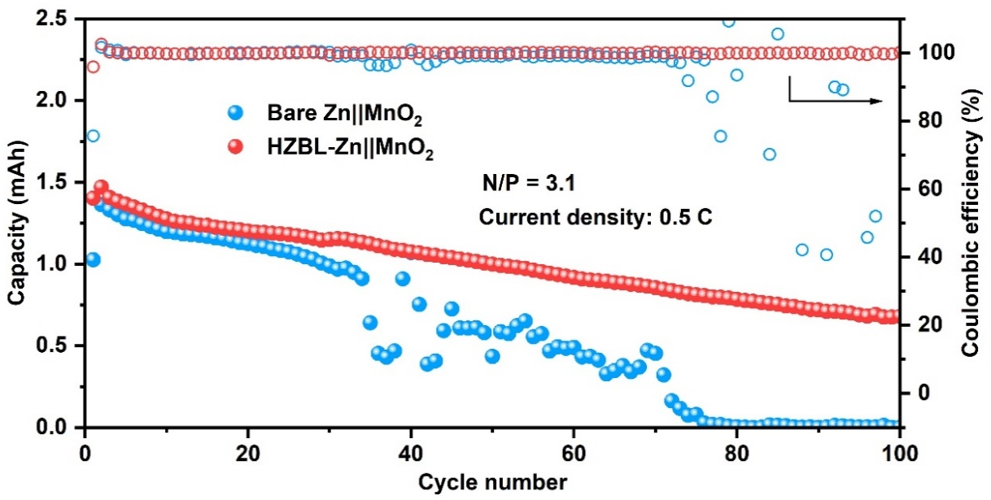
Fig. S27. CE and specific discharge capacity of full cells with N/P (Negative/Positive Electrode Capacity) of 3.1 at 0.5 C.

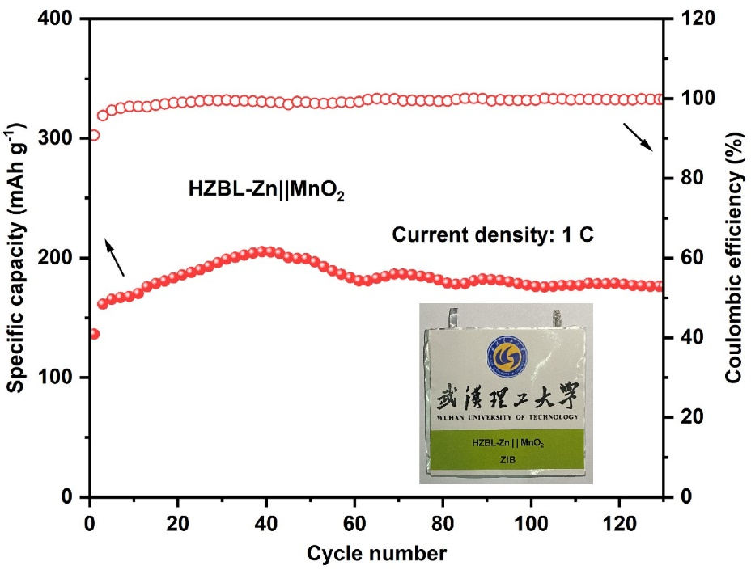
Fig. S28. Cycling performance of HZBL-Zn||MnO₂ pouch cell (5 cm × 5 cm) at 1 C with the inset showing the photo of the pouch cell.

Table S1. Different Zn anodes modification methods and the corresponding electrochemistry performance
Zn anodes | Current density (mA cm⁻²) | Areal density (mAh cm⁻²) | Worked time (h) | Reference (listed alphabetically)
ZrO₂@Zn | 0.25 | 0.125 | 3700 | [2]
Kaolin@Zn | 4.4 | 1.1 | 800 | [3]
PVB@Zn | 0.5 | 0.5 | 2200 | [4]
ZnO HPA@Zn | 0.2 | 0.2 | 1000 | [5]
ZnF₂@Zn | 0.5 | 0.5 | 700 | [6]
Sn@3D carbon | 40 | 20 | 290 | [7]
HsGDY@Zn | 0.5 | 0.1 | 2400 | [8]
ZnS@Zn | 2 | 2 | 1100 | [9]
ZIF-7@Zn | 0.5 | 0.25 | 3000 | [10]
Nafion-Zn-X | 1 | 0.5 | 1000 | [11]
ZnO@Zn | 5 | 1.25 | 500 | [12]
Cu@Zn | 1 | 0.5 | 1500 | [13]
Zn₈₈Al₁₂ (at%) alloys | 0.5 | 0.5 | 2000 | [14]
Faceted TiO₂@Zn | 1 | 1 | 460 | [15]
HZBL-Zn | 1 | 1 | 2500 | This work
References
[1] F. Mo, G. Liang, Q. Meng, Z. Liu, H. Li, J. Fan, C. Zhi, A flexible rechargeable aqueous zinc manganese-dioxide battery working at −20 °C, Energy Environ. Sci. 12 (2019) 706-715.
[2] P. Liang, J. Yi, X. Liu, K. Wu, Z. Wang, J. Cui, Y. Liu, Y. Wang, Y. Xia, J. Zhang, Highly Reversible Zn Anode Enabled by Controllable Formation of Nucleation Sites for Zn‐Based Batteries, Adv. Funct. Mater. 30 (2020) 1908528.
[3] C. Deng, X. Xie, J. Han, Y. Tang, J. Gao, C. Liu, X. Shi, J. Zhou, S. Liang, A Sieve‐Functional and Uniform‐Porous Kaolin Layer toward Stable Zinc Metal Anode, Adv. Funct. Mater. 30 (2020) 2001867.
[4] J. Hao, X. Li, S. Zhang, F. Yang, X. Zeng, S. Zhang, G. Bo, C. Wang, Z. Guo, Designing Dendrite‐Free Zinc Anodes for Advanced Aqueous Zinc Batteries., Adv. Funct. Mater. 30 (2020) 2001263.
[5] J.Y. Kim, G. Liu, G.Y. Shim, H. Kim, J.K. Lee, Functionalized Zn@ZnO Hexagonal Pyramid Array for Dendrite‐Free and Ultrastable Zinc Metal Anodes, Adv. Funct. Mater. 30 (2020) 2004210.
[6] J. Han, H. Euchner, M. Kuenzel, S.M. Hosseini, A. Groß, A. Varzi, S. Passerini, A Thin and Uniform Fluoride-Based Artificial Interphase for the Zinc Metal Anode Enabling Reversible Zn/MnO₂ Batteries, ACS Energy Lett. 6 (2021) 3063-3071.
[7] Y. Yin, S. Wang, Q. Zhang, Y. Song, N. Chang, Y. Pan, H. Zhang, X. Li, Dendrite-Free Zinc Deposition Induced by Tin-Modified Multifunctional 3D Host for Stable Zinc-Based Flow Battery, Adv. Mater. 32 (2020) 1906803.
[8] Q. Yang, Y. Guo, B. Yan, C. Wang, Z. Liu, Z. Huang, Y. Wang, Y. Li, H. Li, L. Song, J. Fan, C. Zhi, Hydrogen-Substituted Graphdiyne Ion Tunnels Directing Concentration Redistribution for Commercial-Grade Dendrite-Free Zinc Anodes, Adv. Mater. 32 (2020) 2001755.
[9] J. Hao, B. Li, X. Li, X. Zeng, S. Zhang, F. Yang, S. Liu, D. Li, C. Wu, Z. Guo, An In-Depth Study of Zn Metal Surface Chemistry for Advanced Aqueous Zn-Ion Batteries, Adv. Mater. 32 (2020) 2003021.
[10] H. Yang, Z. Chang, Y. Qiao, H. Deng, X. Mu, P. He, H. Zhou, Constructing a Super-Saturated Electrolyte Front Surface for Stable Rechargeable Aqueous Zinc Batteries, Angew. Chem., Int. Ed. 59 (2020) 9377-9381.
[11] Y. Cui, Q. Zhao, X. Wu, X. Chen, J. Yang, Y. Wang, R. Qin, S. Ding, Y. Song, J. Wu, K. Yang, Z. Wang, Z. Mei, Z. Song, H. Wu, Z. Jiang, G. Qian, L. Yang, F. Pan, An Interface-Bridged Organic-Inorganic Layer that Suppresses Dendrite Formation and Side Reactions for Ultra-Long-Life Aqueous Zinc Metal Anodes, Angew. Chem., Int. Ed. 59 (2020) 16594-16601.
[12] X. Xie, S. Liang, J. Gao, S. Guo, J. Guo, C. Wang, G. Xu, X. Wu, G. Chen, J. Zhou, Manipulating the ion-transfer kinetics and interface stability for high-performance zinc metal anodes, Energy Environ. Sci. 13 (2020) 503-510.
[13] Z. Cai, Y. Ou, J. Wang, R. Xiao, L. Fu, Z. Yuan, R. Zhan, Y. Sun, Chemically resistant Cu–Zn/Zn composite anode for long cycling aqueous batteries, Energy Storage Mater. 27 (2020) 205-211.
[14] S.B. Wang, Q. Ran, R.Q. Yao, H. Shi, Z. Wen, M. Zhao, X.Y. Lang, Q. Jiang, Lamella-nanostructured eutectic zinc-aluminum alloys as reversible and dendrite-free anodes for aqueous rechargeable batteries, Nat. Commun. 11 (2020) 1634.
[15] Q. Zhang, J. Luan, X. Huang, Q. Wang, D. Sun, Y. Tang, X. Ji, H. Wang, Revealing the role of crystal orientation of protective layers for stable zinc anode, Nat. Commun. 11 (2020) 3961.

