Supplemental files

Dual sulfur-doped sites boost potassium storage in carbon nanosheets derived from low-cost sulfonate

Zijian Li^{a,§}, Xinfei Wu^{b,§}, Wen Luo ^{a,c}*, Chenxu Wang^{c}, Wencong Fengª, Xufeng Hong^{d}, Liqiang Mai^{a,}*

ª State Key Laboratory of Advanced Technology for Materials Synthesis and Processing, School of Materials Science and Engineering, Wuhan University of Technology, Wuhan 430070, P. R. China.
^{b} State Key Laboratory of Advanced Technology for Materials Synthesis and Processing, International School of Materials Science and Engineering, Wuhan University of Technology, Wuhan 430070, P. R. China.
^{c} Department of Physics, School of Science, Wuhan University of Technology, Wuhan 430070, P. R. China.
^{d} School of Materials Science and Engineering, Peking University, Beijing 100871, P. R. China.
§ Zijian Li and Xinfei Wu contributed equally to this work.

* E-mail: luowen_1991@whut.edu.cn; mlq518@whut.edu.cn
Experimental Section
CH₃C₆H₄SO₃Na and CH₃C₆H₄SO₃H were purchased from Sinopharm Chemical Reagent Co., Ltd. respectively and used without further purification.

1.1 Preparation of DS-CN
2 g CH₃C₆H₄SO₃Na was calcined at 700 °C for 2 hours under flowing N₂ atmosphere with a heating rate of 5 °C min ⁻¹. After cooling down to room temperature, the product was manually ground to powder by the agate mortar. Then, it was added into the solution of 40 mL HCl and 10 mL deionized water. After further stirring for 1h at room temperature (25 °C) to remove impurities, the abovementioned solution was separated by centrifugation and washed with deionized water and isopropanol for three times respectively, afterward dried under 70°C for 12 hours at air atmosphere.

1.2 Preparation of S-CB
The S-CB was also synthesized in the same process by replacing CH₃C₆H₄SO₃Na with CH₃C₆H₄SO₃H.

1.3 Materials characterizations
X-ray diffraction (XRD) was measured by a Burker D8 Discover X-ray diffractometer with Cu-Kα radiation. Scanning electron microscopy (SEM) and transmission electron microscopy (TEM) images were collected via Phenom Pro microscope and JEM-2100F microscope, respectively. High-resolution transmission electron microscopy (HRTEM) selected area electron diffraction (SAED) and energy dispersive spectrometer (EDS) images were collected utilizing Talos F200S. The VG Multi Lab 2000 instrument was used to collect X-ray photoelectron spectroscopic (XPS) spectra. FT-IR spectra were recorded on KBr pellets using a Perkin–Elmer spectrum IR Affinity-1 spectrometer. Atomic force microscopy (AFM) image was collected by AIST-NT. Raman characterizations were carried out using green laser (532 nm) by HORIBA HR EVO Raman system. The Tristar II 3020 instrument was used to measure Brunner-Emmett-Teller (BET) specific surface area by nitrogen adsorption at 77 K. The water contact angle was gained by a drop shape analyzer (Kruss DSA100).

1.4 Electrochemical characterizations
The electrochemical properties were investigated with CR2016 coin cells in a glove box filled with argon (＜1ppm of water and oxygen). The working electrode was made of the mixture of 80 wt% active materials, 10 wt% acetylene black and 10 wt% Carboxymethylcellulose sodium (CMC) in deionized water. And the slurry was pasted on copper foil and dried for at least 10 h at 70 °C. In potassium half cells, potassium foil was used as the counter electrode. 0.8 M Potassium hexafluorophosphate (KPF₆) in ethylene carbon (EC)/diethyl carbonate (DEC) (1:1 vol/vol) was used as electrolyte. The Whatman glass fiber membrane (GF/D) was used as the separator. The area loading of active materials were approximately about 0.9 ~ 1.2 mg cm⁻². Galvanostatic charge–discharge measurement was performed between 0.01 and 3.0 V (vs K⁺/K) using a NEWARE battery testing system. An electrochemical workstation (Autolab PGSTAT302 N) was tested cyclic voltammetry (CV) between 0.01 and 3.0 V (vs K⁺/K). And the Electrochemical impedance spectroscopy (EIS) was tested from 0.1 Hz to 1 MHz via Autolab PGSTAT302 N.

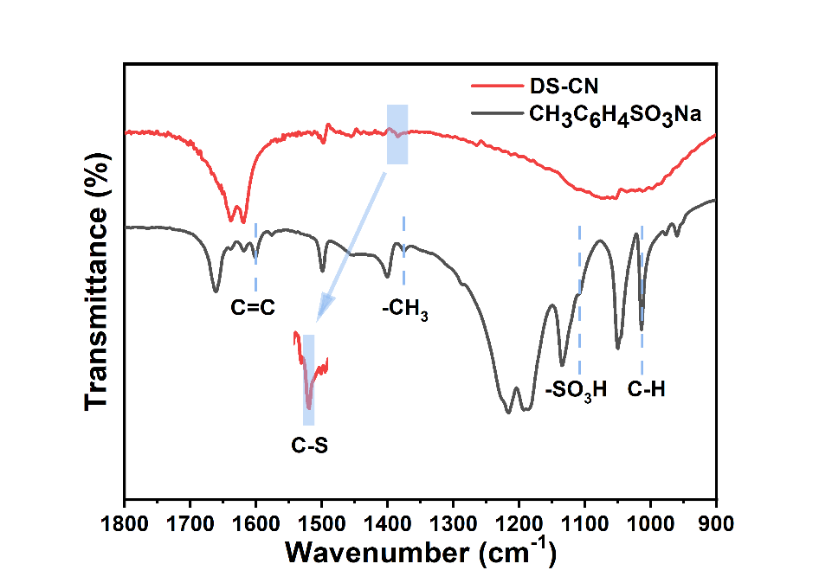
Fig. S1 FT-IR spectra of DS-CN and CH₃C₆H₄SO₃Na.

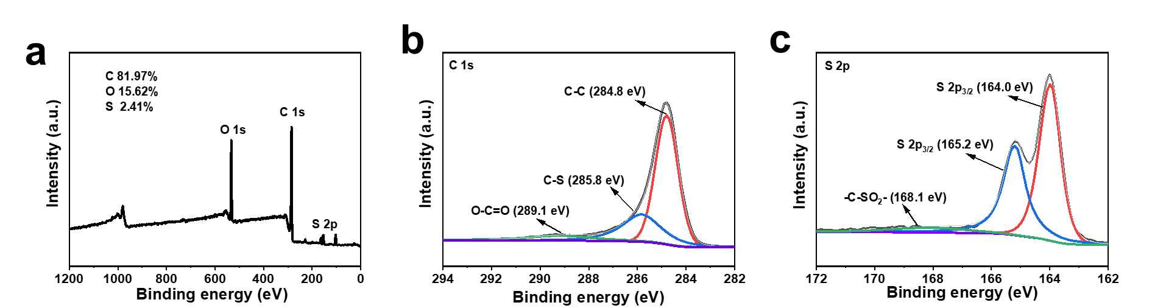
Fig. S2 (a) Full-spectrum XPS survey, (b) C 1s, (c) S 2p of S-CB.

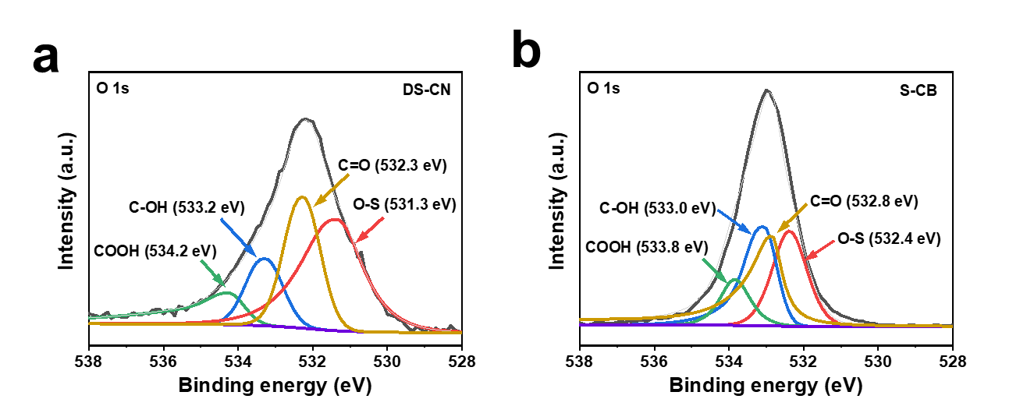
Fig. S3 (a) O 1s of DS-CN, (b) O 1s of S-CB.

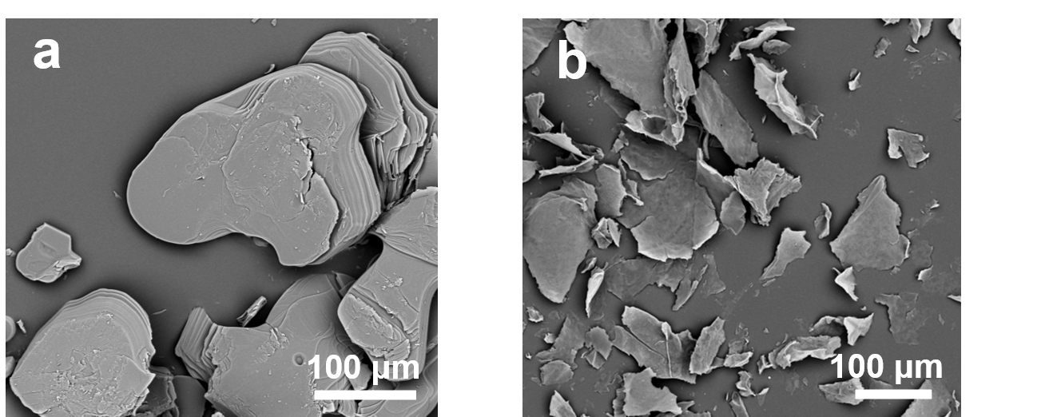
Fig. S4 SEM images of (a) CH₃C₆H₄SO₃Na and (b) DS-CN.

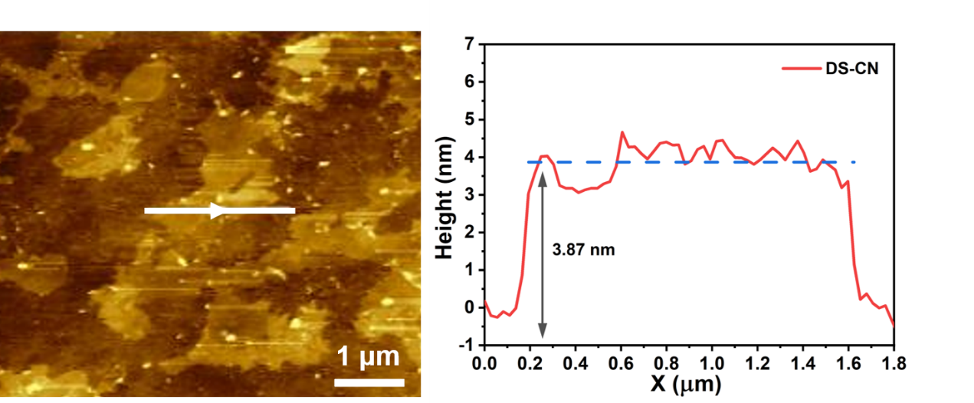
Fig. S5 AFM image of DS-CN and height profile along the white line.

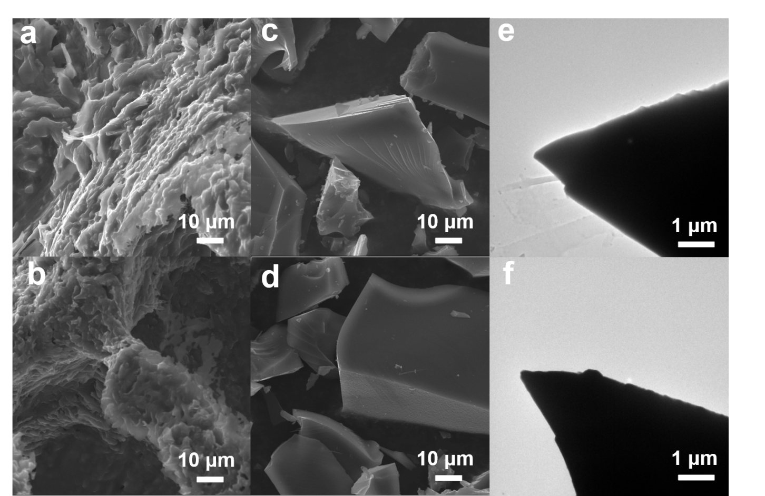
Fig. S6 Morphological characterization: SEM images of (a-b) CH₃C₆H₄SO₃H and (c-d) S-CB; (e-f) TEM images of S-CB

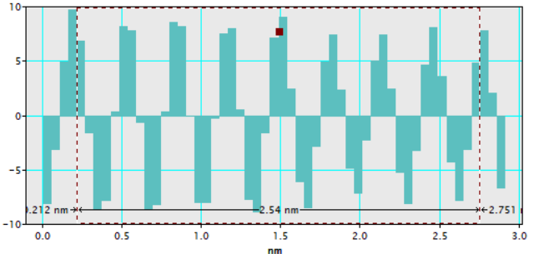
Fig S7 The lattice spacing (2.54 nm) of eight lattice fringes for DS-CN.
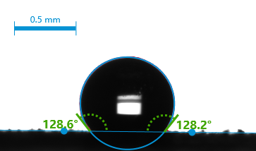
Fig. S8 The water contact angle test of DS-CN.

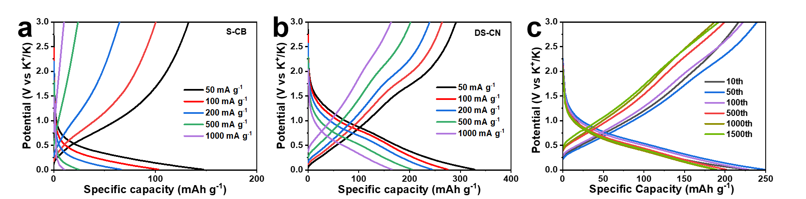
Fig S9 The corresponding charge-discharge profiles in rate of S-CB (a) and DS-CN (b); (c) Galvanostatic charge-discharge profiles of long cycling performance of DS-CN at a current density of 1000 mA g⁻¹.

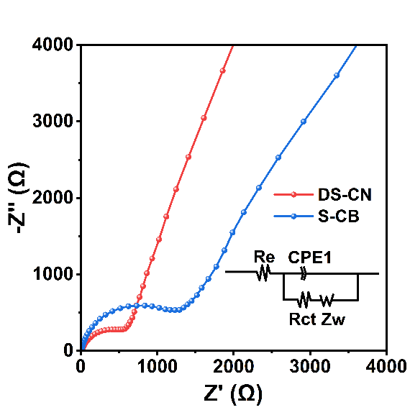
Fig S10 EIS curves and the corresponding equivalent circuit of DS-CN and S-CB.

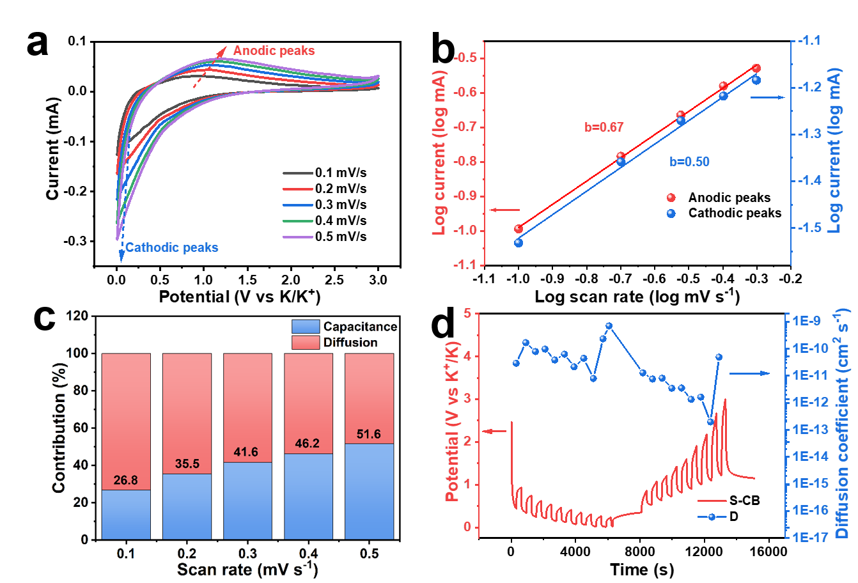
Fig S11 Quantitative analysis to confirm the kinetics of S-CB: (a) CV curves at different sweep rates; (b) Calculated b-value for the anodic peaks and cathodic peaks; (c) Normalized contribution ratio of capacitance and diffusion at different scan rates; (d) The GITT curve and the calculated K⁺ chemical diffusion coefficients.

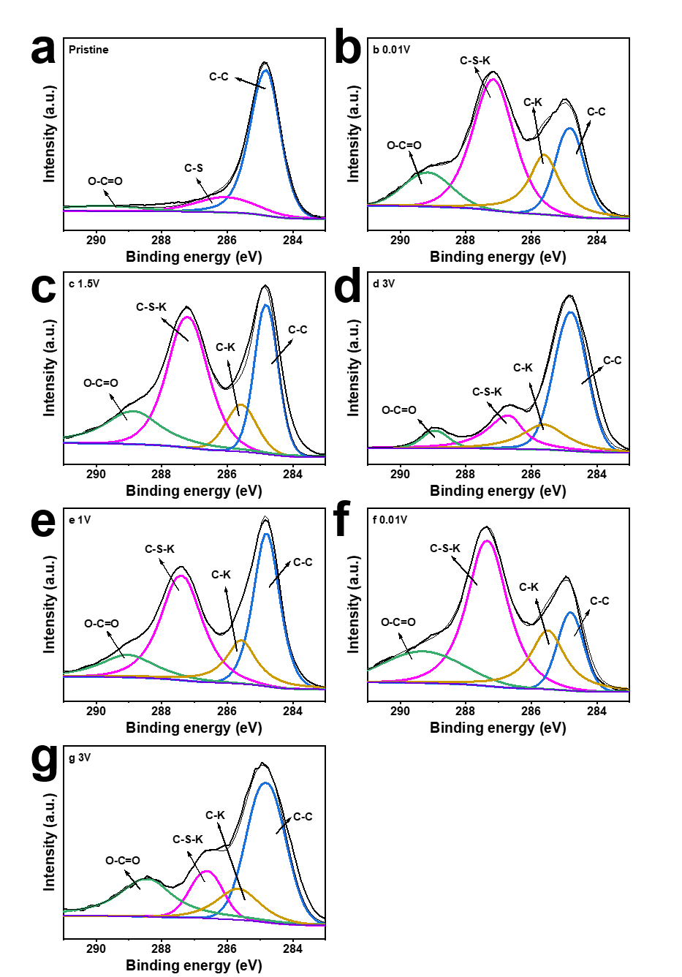
Fig S12 (a-g) Ex-situ XPS C 1s spectra of DS-CN in different intercalation/deintercalation states corresponding potential to the state of Figure 6a.

