Dual redox groups enable organic cathode material with a high capacity for aqueous zinc-organic batteries

Yongkang Anª, Yu Liuª, Shuangshuang Tanª, Fangyu Xiongª, Xiaobin Liao^{b}, and Qinyou An^{ac}*
ª State Key Laboratory of Advanced Technology for Materials Synthesis and Processing, Wuhan University of Technology, Wuhan 430070, Hubei, P. R. China
^{b} State Key Laboratory of Silicate Materials for Architectures, International School of Materials Science and Engineering, Wuhan University of Technology, Wuhan 430070, China
^{c} Foshan Xianhu Laboratory of the Advanced Energy Science and Technology Guangdong Laboratory Xianhu Hydrogen Valley, Foshan 528200, Guangdong, P. R. China
*Corresponding Author
E-mail address: anqinyou86@whut.edu.cn (Q. An)

Experimental Section
Synthesis and Characterizations of TBQPH:
TBQPH was synthesized by a simple dehydration condensation reaction with hexaketocyclohexane octahydrate (Aladdin, ≥99%) and 2,3-diaminonaphthalene-1,4-dione (Yanshen Technology Co., Ltd., ≥98%). Typically, hexaketocyclohexane octahydrate (52.2 mg) and 2,3-diaminonaphthalene-1,4-dione (94.1 mg) are dissolved in 15 ml ethanol/glacial acetic acid (volume ratio = 1:1) mixed solvent, stirred and heated to 65ºC for 12 hours. The product is collected after centrifugal cleaning with acetone, ethanol and water. Finally, TBQPH was achieved by vacuum dried at 80ºC (94 mg, 90% yield). ¹H NMR (500 MHz, CF₃COOD, δ ppm): 8.72-8.69 (m, 6H), 8.19-8.16 (m, 6H). ¹³C NMR (500 MHz, CF₃COOD, δ ppm): 181.70, 146.75, 145.69, 137.33, 133.55, 129.23. The products are hardly soluble in solvents such as ethanol, H₂O, dichloromethane (CH₂Cl₂), tetrahydrofuran (THF), and acetone. In addition, no self-aggregation of DND was observed under the same conditions.
Fourier transform infrared (FTIR) spectra measured on Thermo Fishe Nicolet FTIR spectrometer were used to characterize the structures of TBQPH at various states. X-ray photoelectron spectrometer (XPS, Kratos AXIS SUPRA) was adopted to examined surface element of the TBQPH powder. The microstructure of the synthesized TBQPH were characterized by the field-emission scanning electron microscopy (SEM, MIRA3 LMH). The elemental distributions were obtained from energy dispersive spectroscopy (EDS) mapping analysis. XRD data of the samples were collected with a D8 Advance Xray diffractometer with an area detector using Cu Kα radiation (λ = 1.5418 Å). EIS was recorded with a frequency range from 0.01 to 100 kHz.
Electrochemical measurements: The TBQPH electrode slurry were prepared by homogeneous mixing 60 wt% of TBQPH powder, 30 wt% of Ketjen black, and 10wt% polytetrafluorethylene (PTFE) binder in ethanol. Then, it was prepared into a sheet with a load of 2-3 mg cm⁻² by a roller machine. The batteries were assembled into 2025 type coin cells in Air. The coin cells are composed of TBQPH as the cathode, glass fibers D as the separators, 2M ZnSO₄ as the electrolyte, Zn foil as the anode.
Computational details: The DFT calculations were carried out using Gaussian 16 software package. The geometry of TBQPH, TBQPH-2H, TBQPH-4H, TBQPH-6H, TBQPH-8H, TBQPH-10H, and TBQPH-12H were fully optimized at B3LYP level of theory, with 6-31+G (d, p) basis set for C, H, O, and N elements.[1-3] For all of the calculations, solvent effects were incorporated employing integral equation formalism polarizable continuum model (IEFPCM) with SMD solvation model using water as solvent.[4, 5]
To further explore the energy preference of TBQPH binding to protons in water solvents, the vibrational frequencies were calculated to verify the minima of the corresponding structures. We checked the binding free energy (∆G) in the solution using the following formula (1):
$∆G=G_{TBQPHnH}-G_{TBQPH(n-2)H}-G_{2H}$ (1)
where the G is the Gibbs free energies of the most stable water-solvated species, and n denotes the number of H atoms (n = 2, 4, 6, 8, 10, 12).
GITT: The calculation of ionic diffusion coefficient by GITT is employed the following formula (2), which based on Fick’s second law:
$D_{GITT}=\frac{4}{πτ}{\left(\frac{m_{B}V_{M}}{M_{B}S}\right)}^{2}{\left(\frac{{∆E}_{S}}{{∆E}_{τ}}\right)}^{2}$ (2)
where τ is the duration of the current impulse; m_{B} is the mass load of the electrode material; S represents the geometric area of the electrode; ∆E_{S} is the quasi-thermodynamic equilibrium potential difference between before and after the current pulse; ∆E_{τ} represents the potential difference during the current pulse; V_{M} is the molar volume of the material; and M_{B} is the molar mass of material.

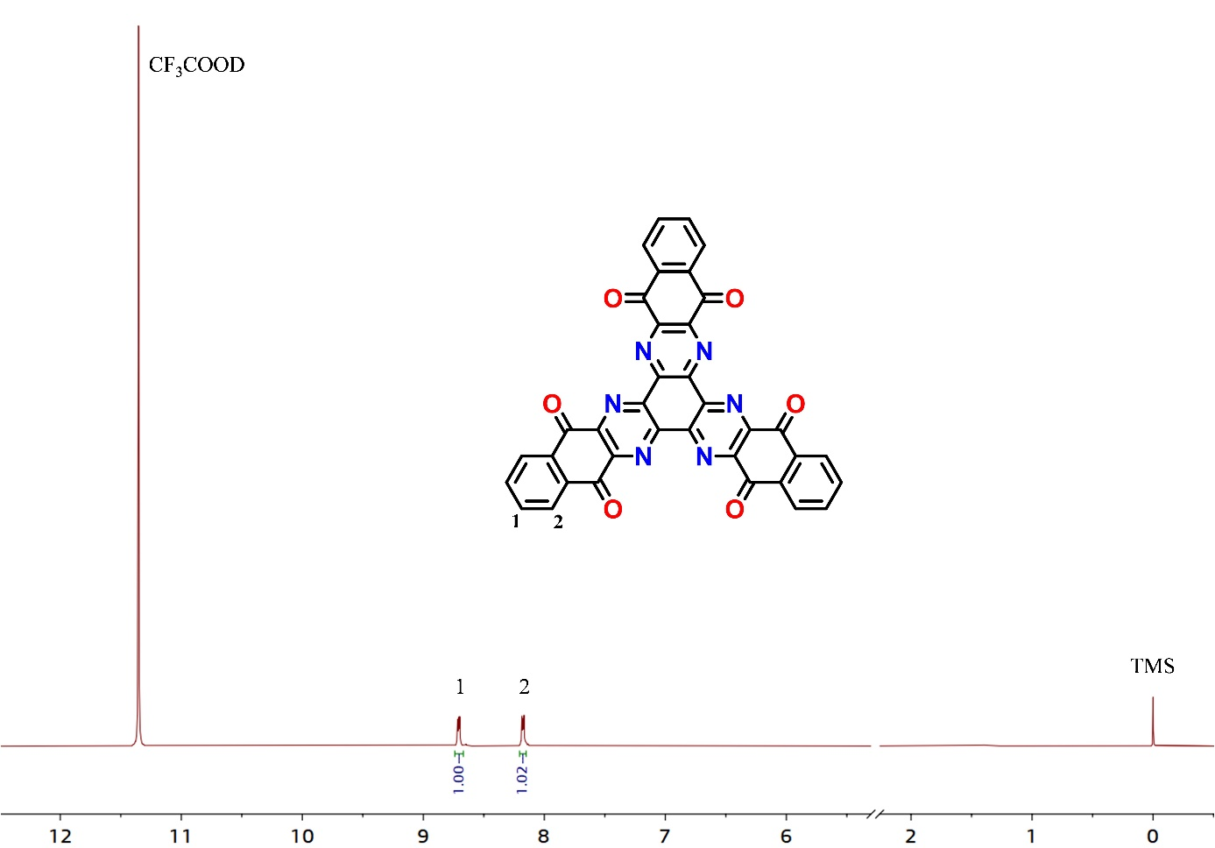
Figure S1. ¹H-NMR spectrum of TBQPH in CF₃COOD solvent.

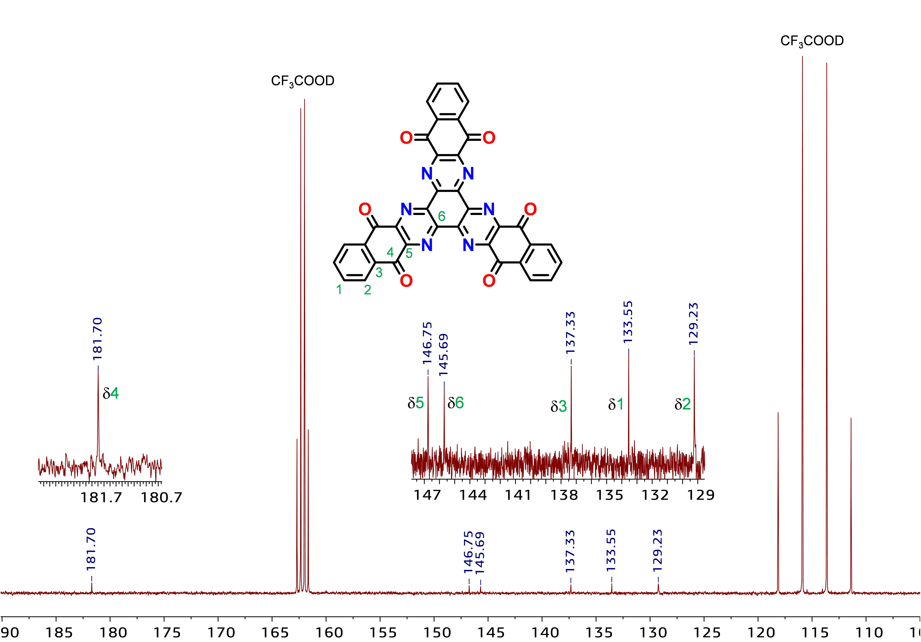
Figure S2. ¹³C-NMR spectrum of TBQPH in CF₃COOD solvent.

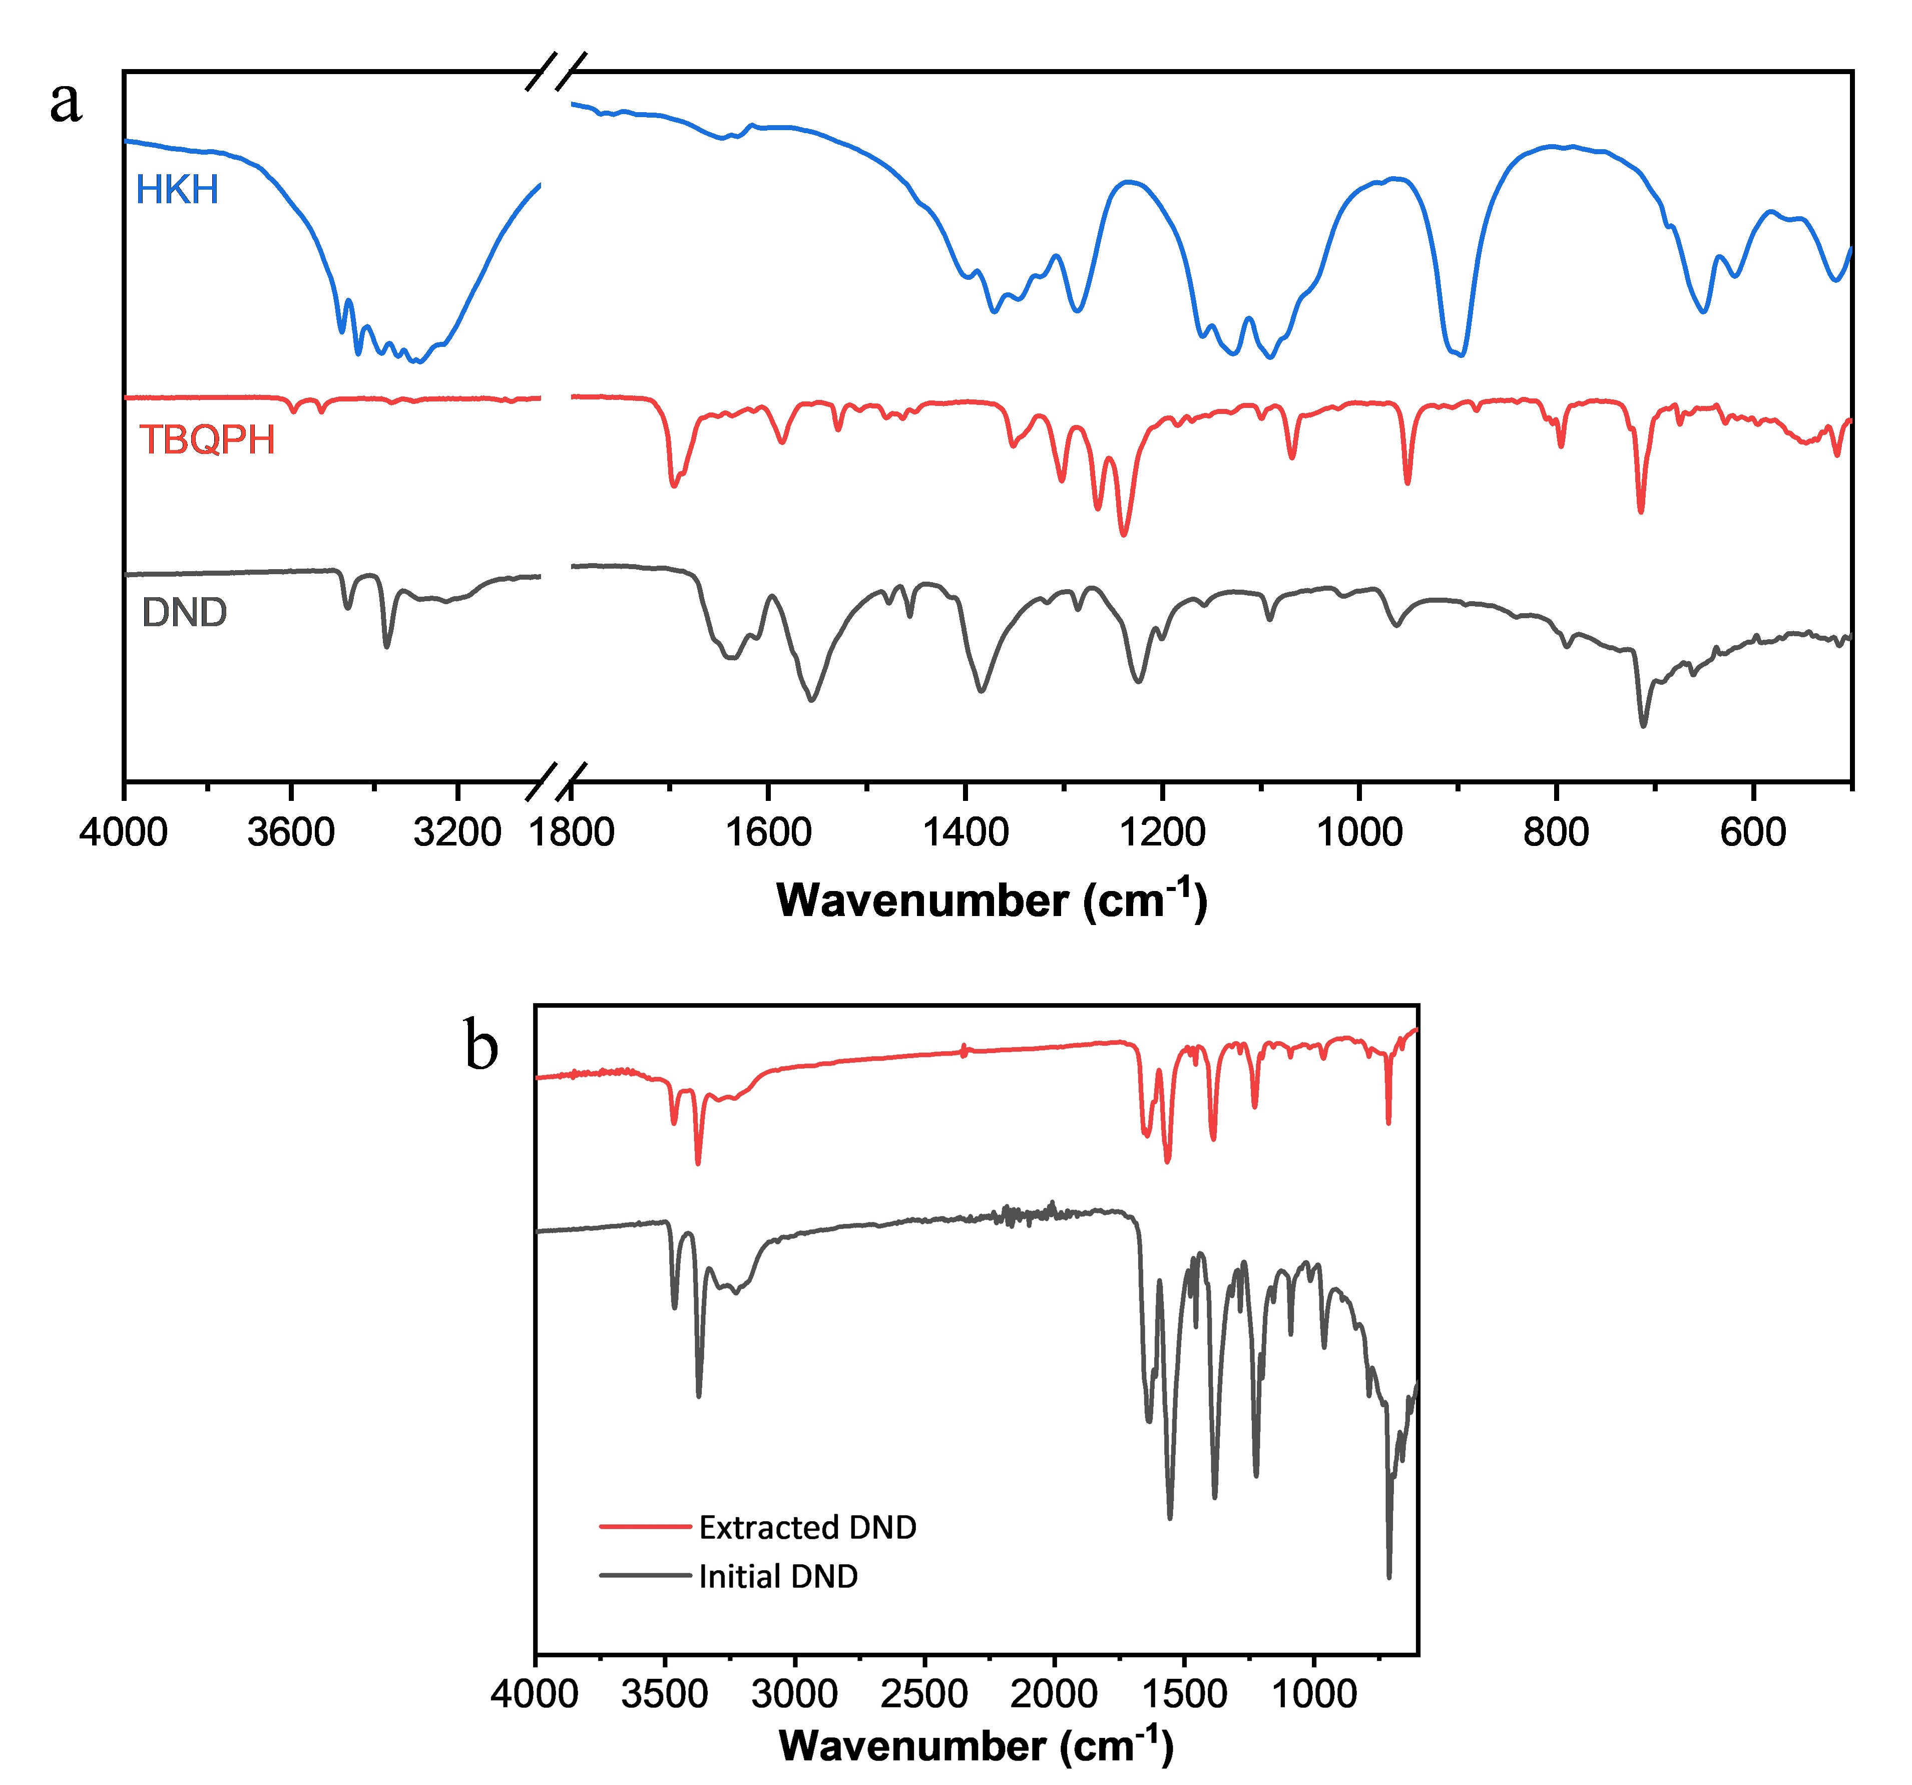
Figure S3. (a) FT-IR spectra of HKH (blue), TBQPH (red), and DND (black). (b) FT-IR spectra of the initial and extracted DND in the DND self-polymerization experiment.

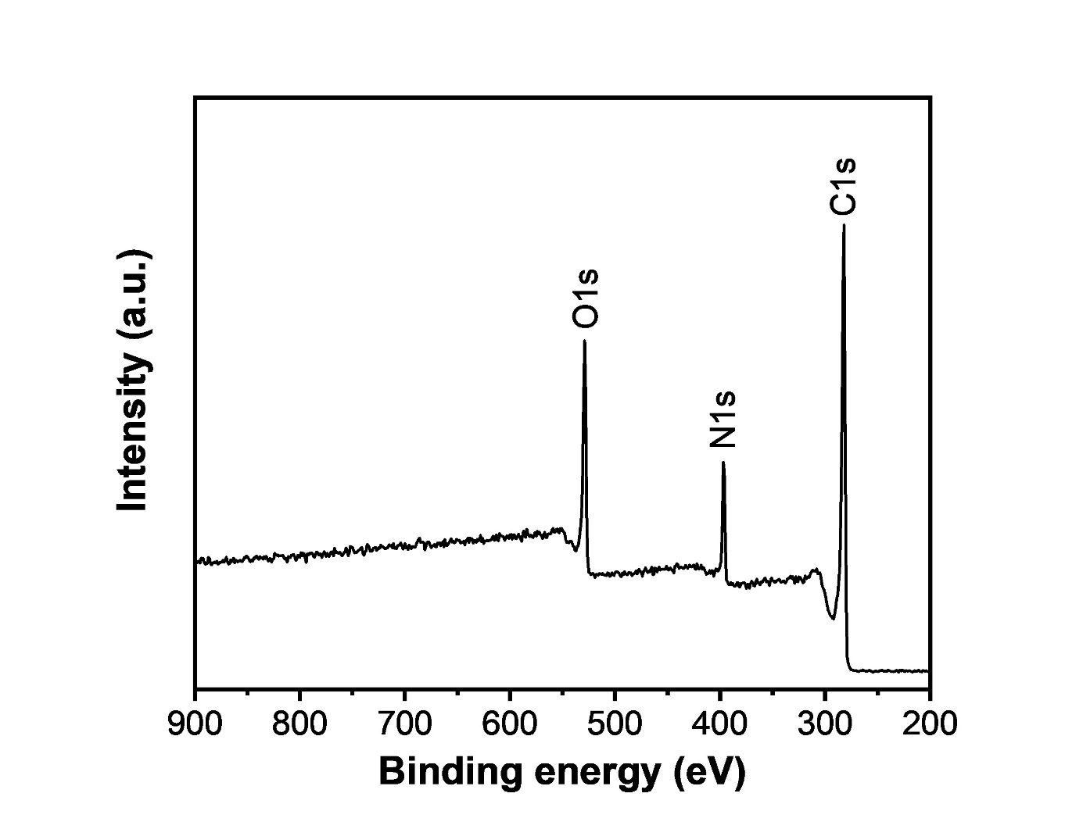
Figure S4. Full survey XPS spectrum of TBQPH.

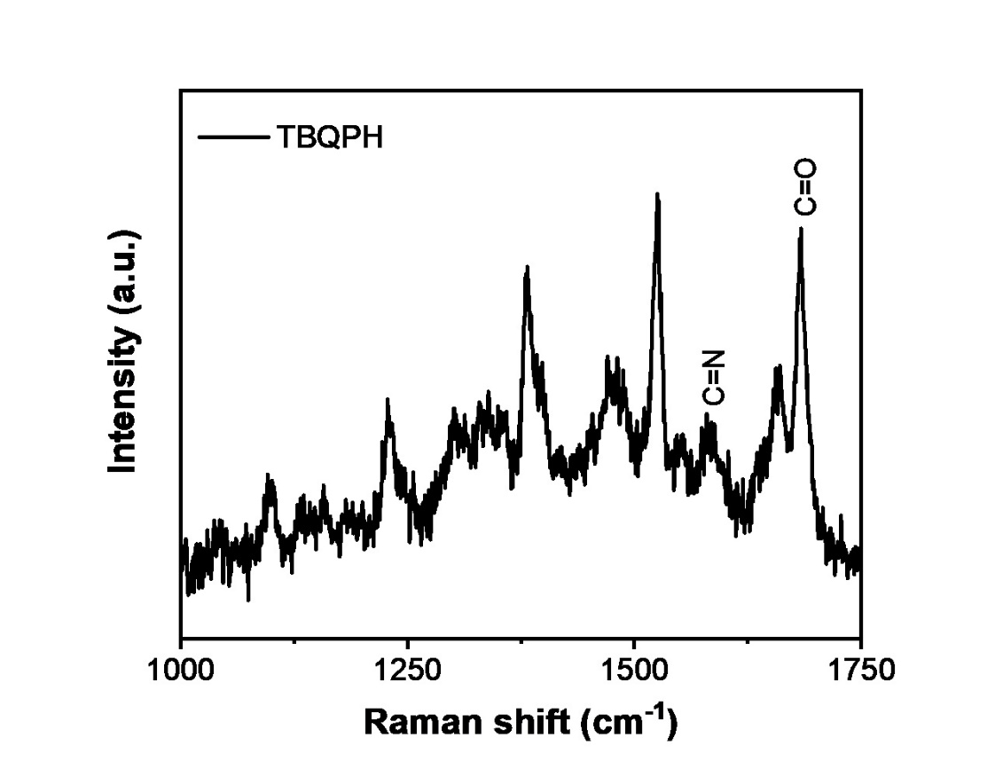
Figure S5. Raman spectrum of TBQPH.

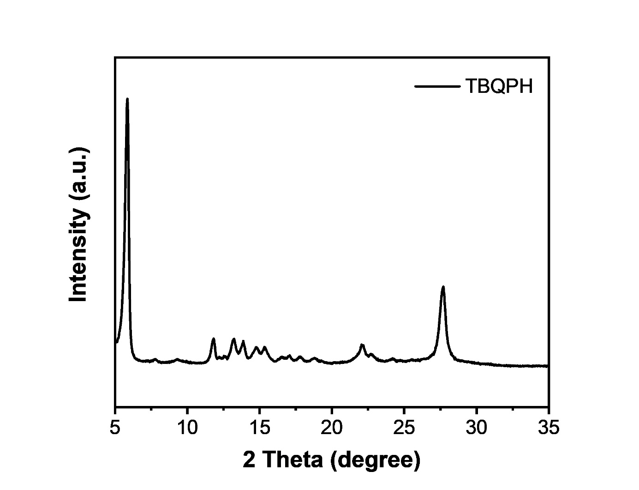
Figure S6. Powder XRD pattern of TBQPH.

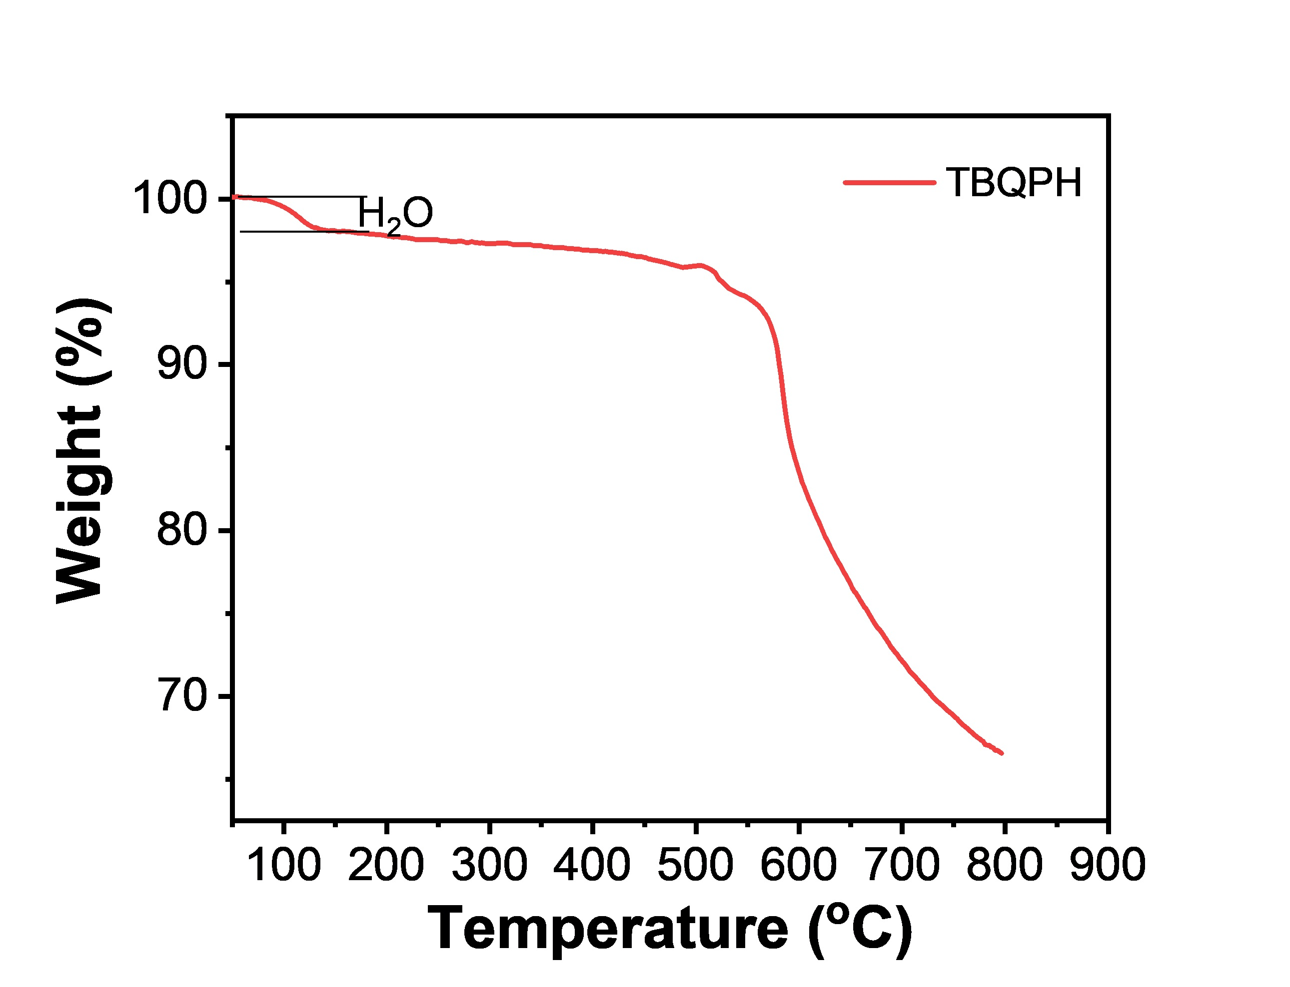
Figure S7. TG of TBQPH measured under argon at a heating rate of 10ºC min⁻¹.

Figure S8. The Contact angle test of TBQPH electrode sheet.

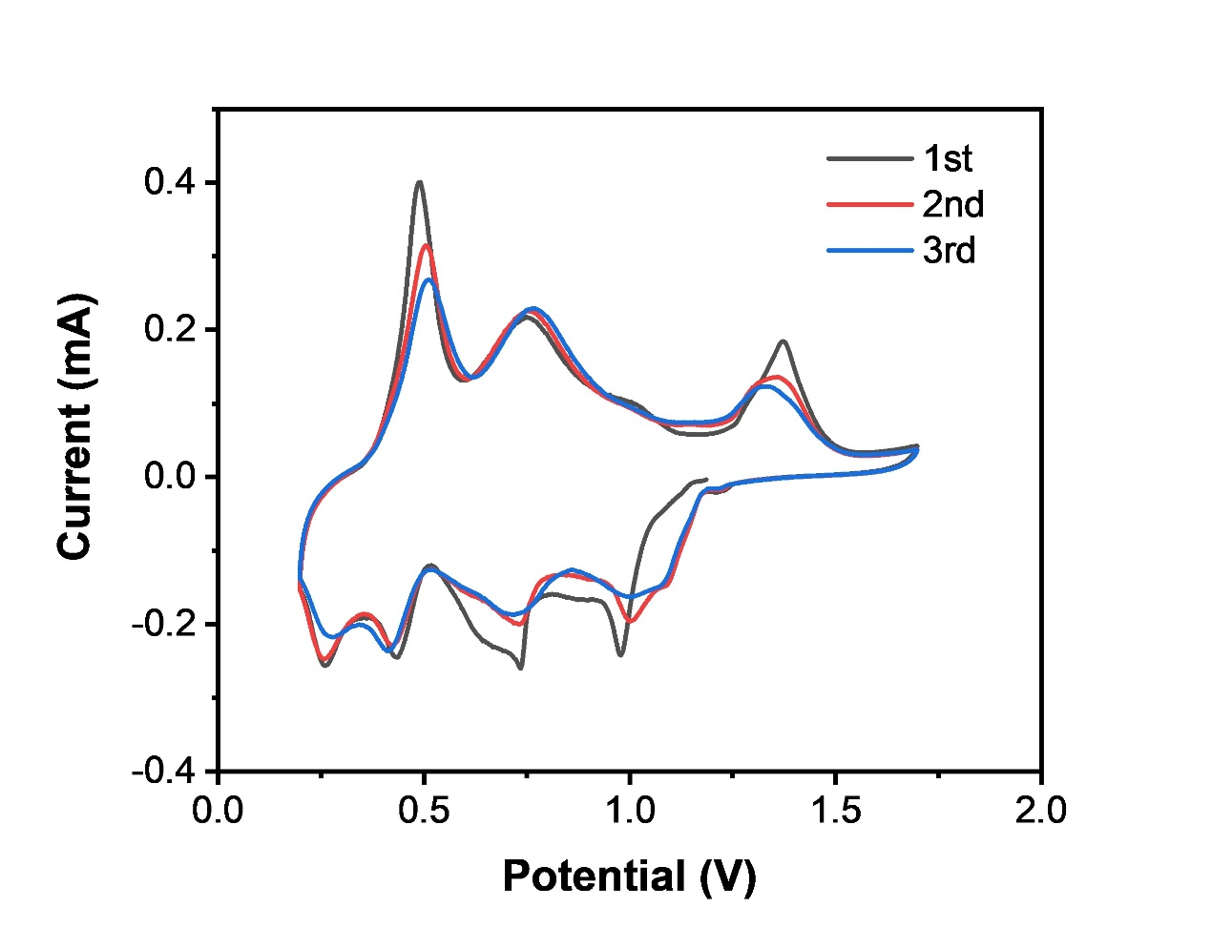
Figure S9. The CV curves of the first three circles of TBQPH//Zn batteries at the scan rate of 0.2 mV s⁻¹.

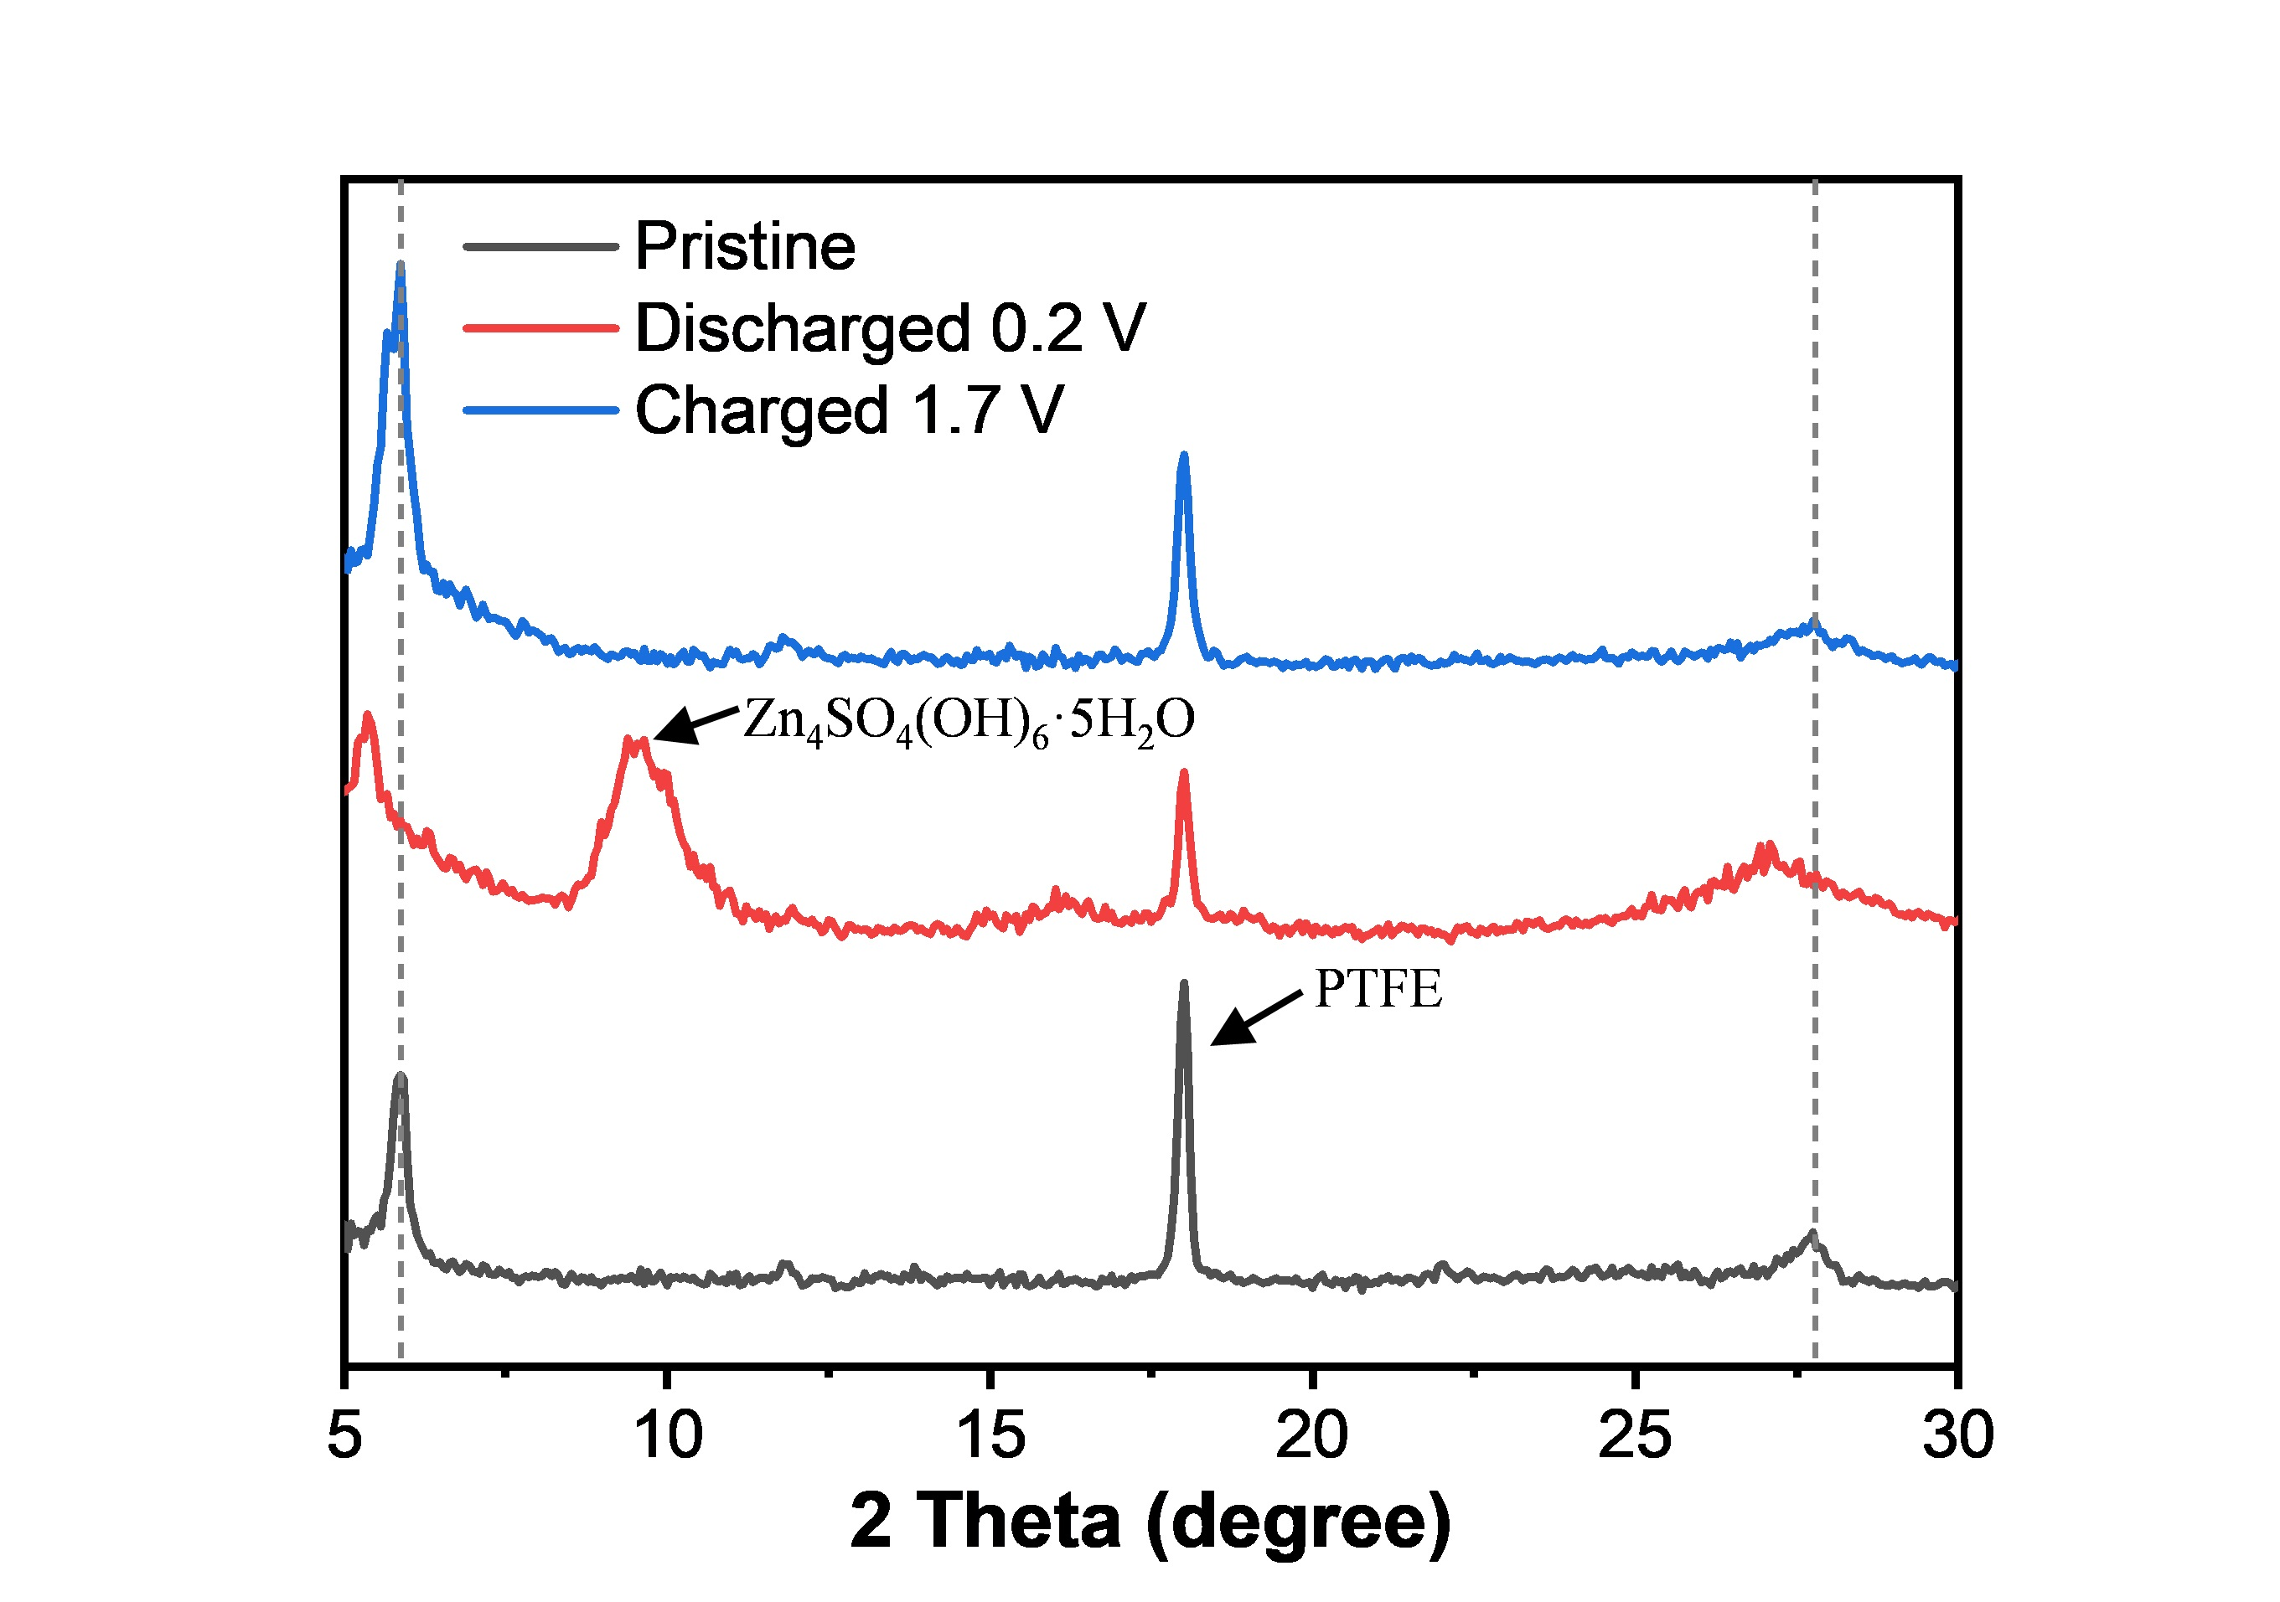
Figure S10. Ex-situ XRD profile of TBQPH electrode.

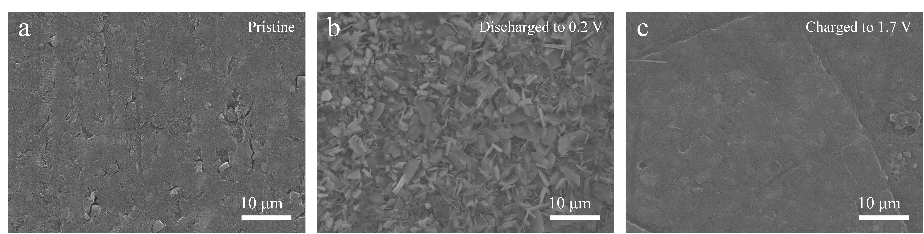
Figure S11. The SEM images of TBQPH cathodes at different states: (a) pristine, (b) discharged to 0.2 V, and (c) charged to 1.7 V.

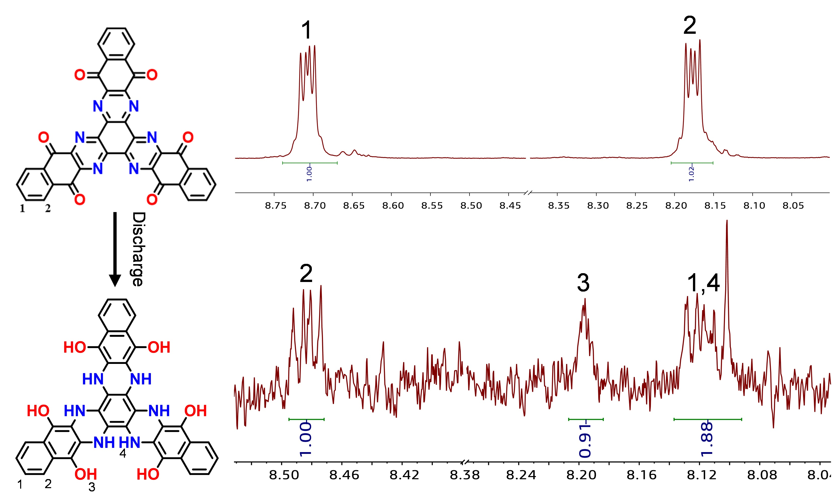
Figure S12. The ¹H-NMR spectrum of initial state (above)was obtained in CF₃COOD solvent. The ¹H-NMR spectrum of discharge state (below) was obtained by dissolving a TBQPH electrode discharged to 0.2 V in DMSO-d₆ solution by ultrasonic treatment.

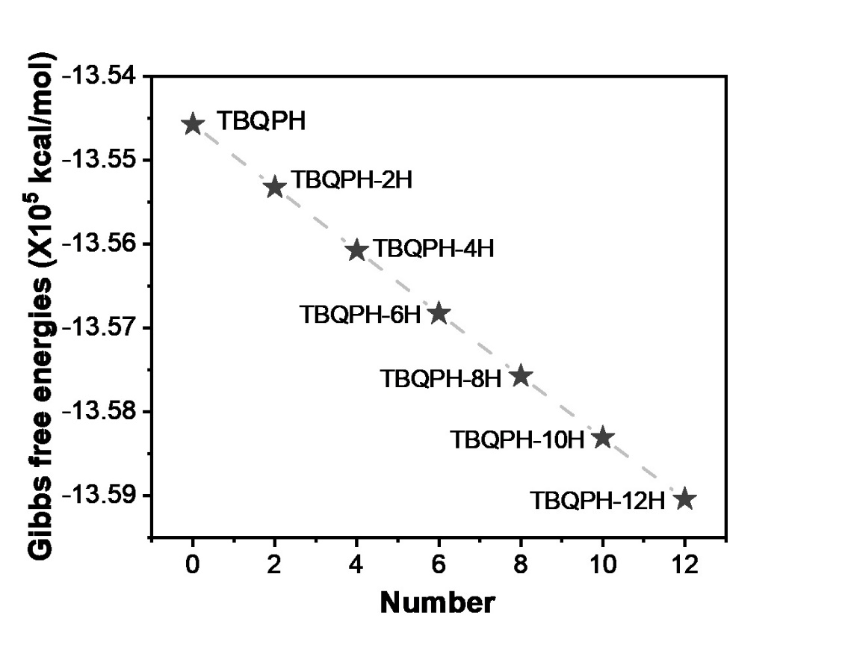
Figure S13. The most stable Gibbs free energies of TBQPHs in water solvent state.

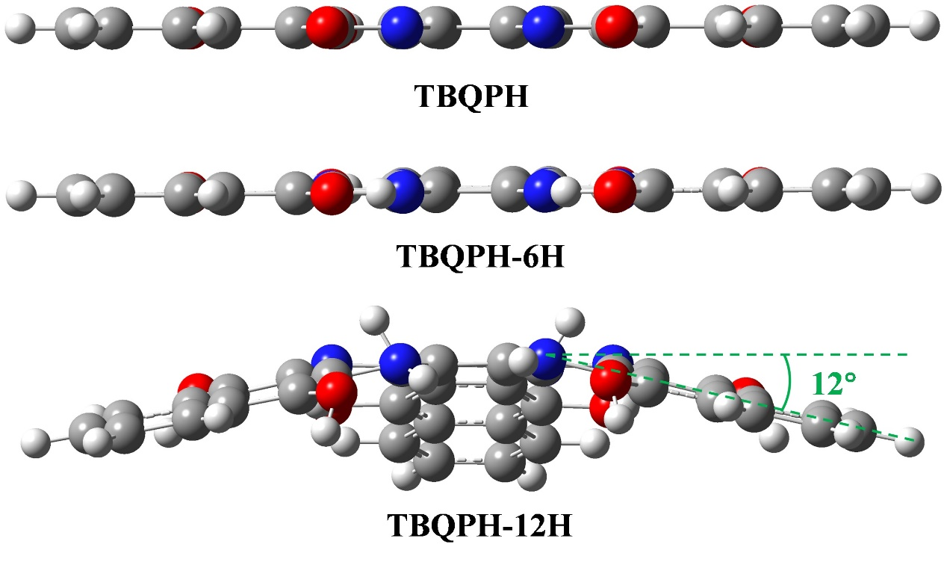
Figure S14. The structural transformation processes of TBQPHs.

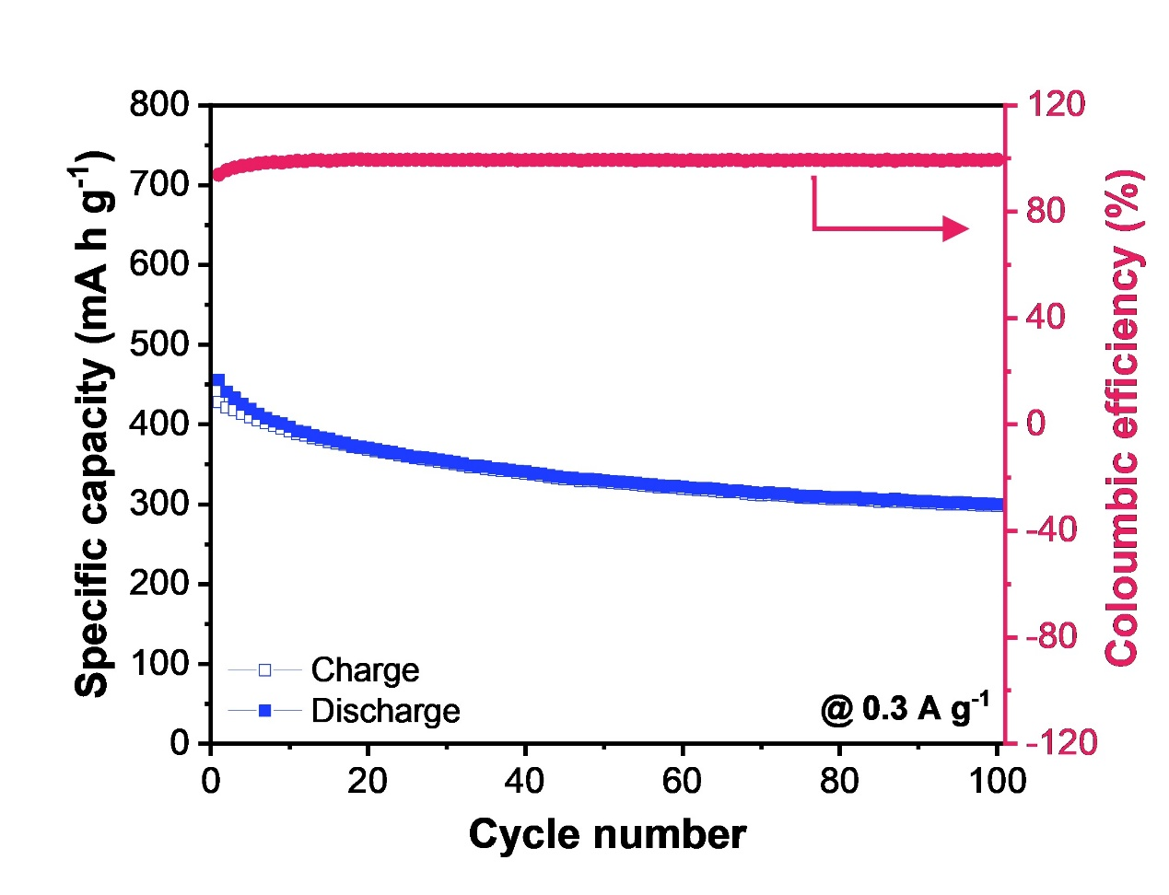
Figure S15. Cycling performance of TBQPH electrode at 0.3 A g⁻¹ in 0.2-1.7 V.

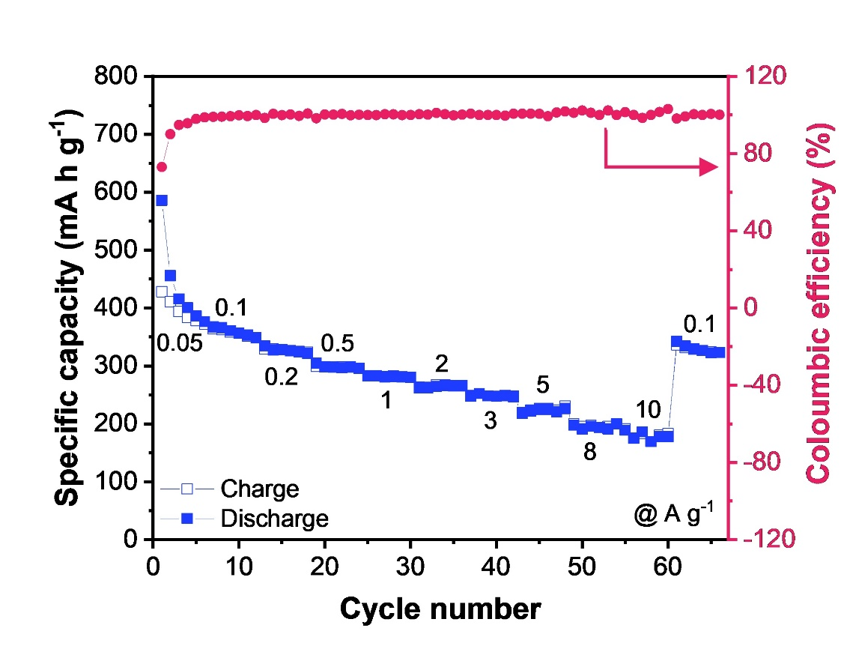
Figure S16. Rate performance of TBQPH electrode in 0.2-1.7 V.

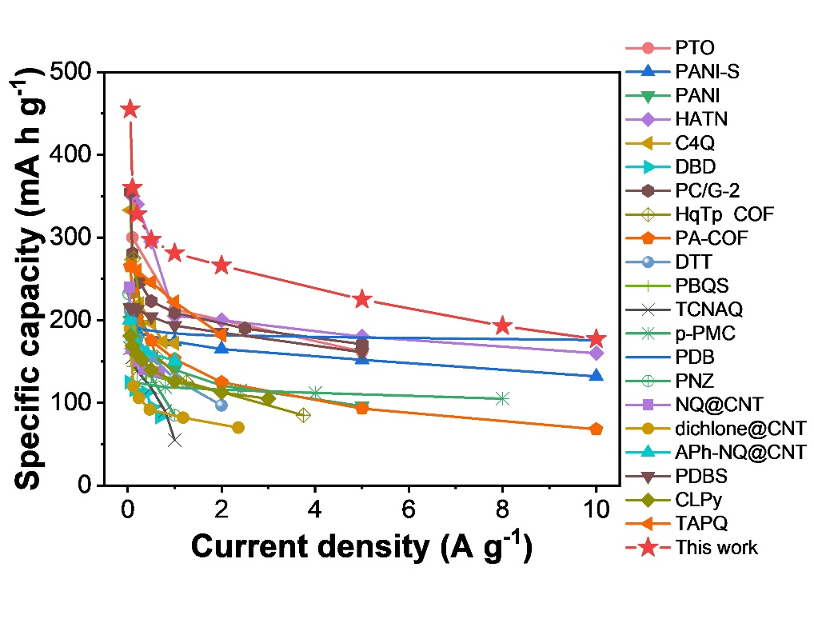
Figure S17. Rate capability comparison of TBQPH versus previously reported Zn-organic batteries.

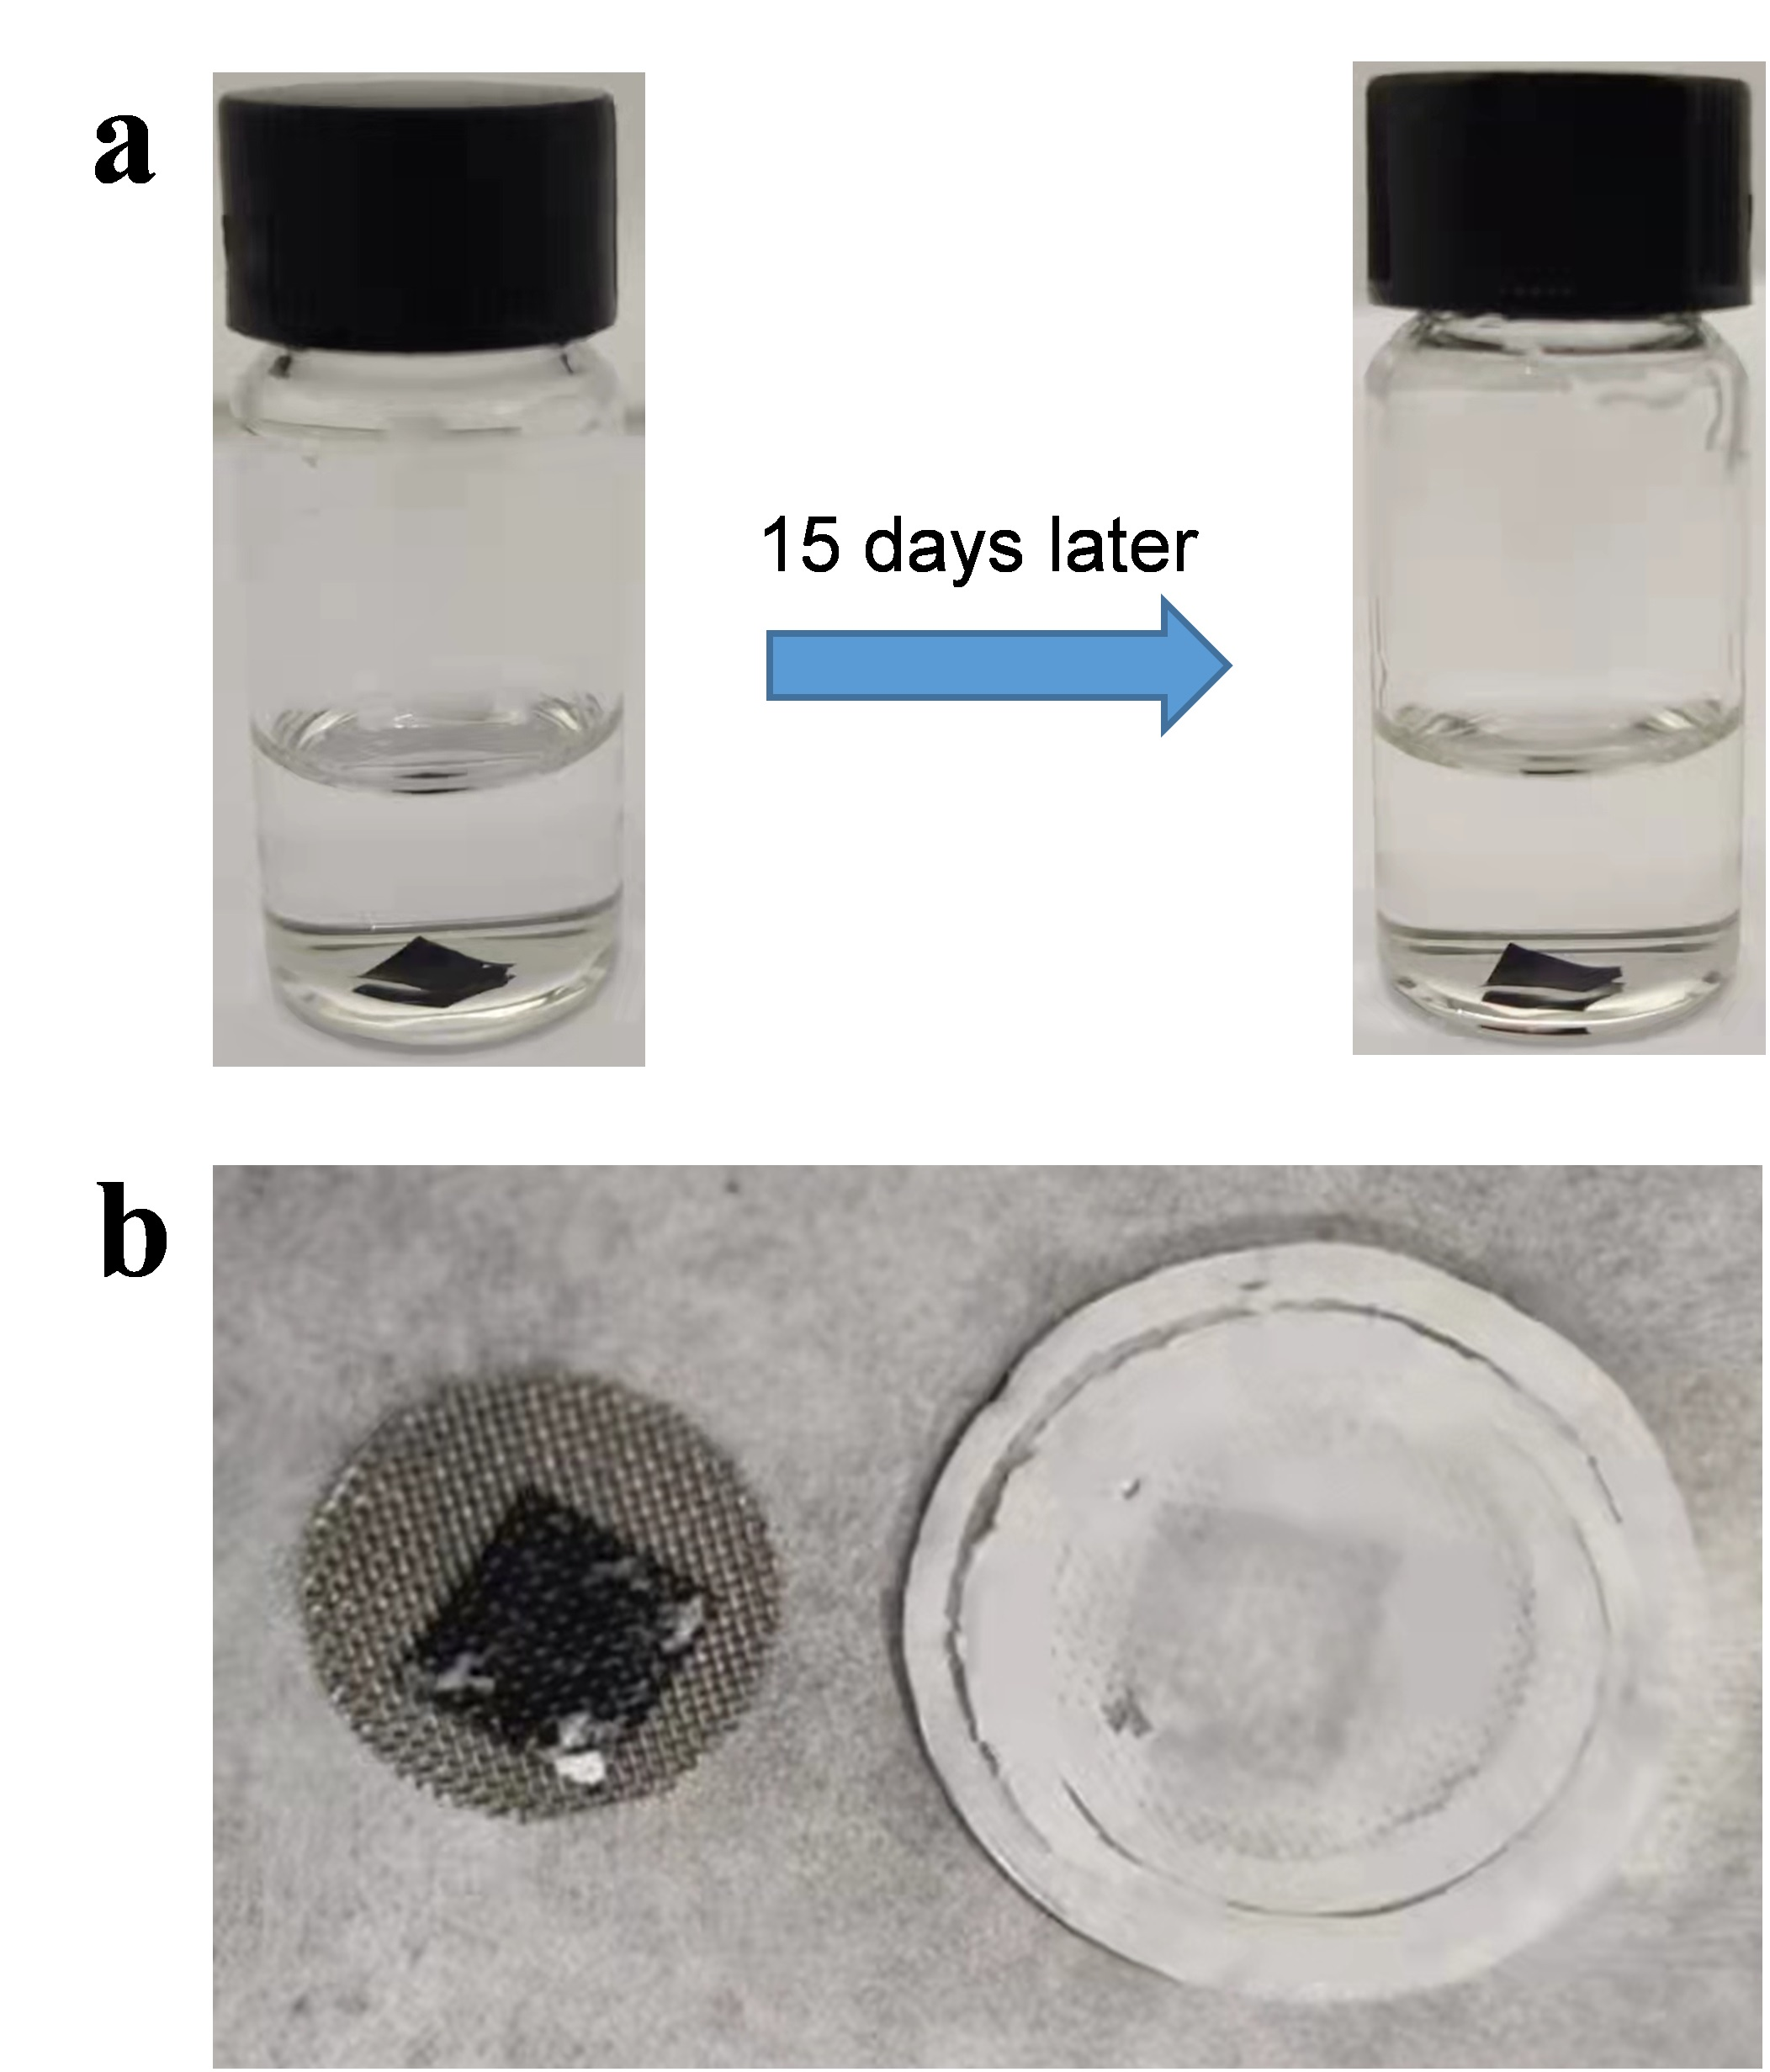
Figure S18. The Solubility test of TBQPH electrode. (a) The initial TBQPH electrode sheet soaked in 2M ZnSO₄ aqueous solution for 15 days. (b) The state of the electrode sheet and separator when discharged to 0.2V.

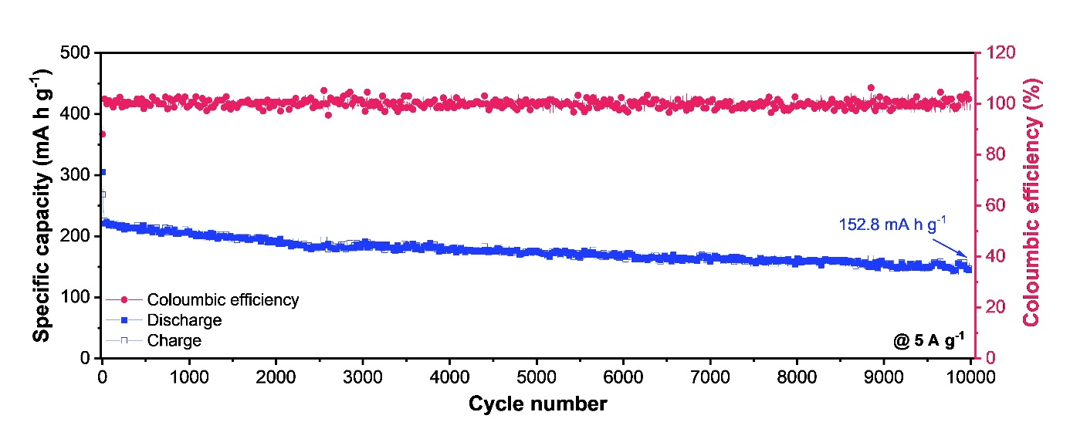
Figure S19. Cycling performance of TBQPH electrode at 5 A g⁻¹.

Table S1.
Compounds | Current density (A g⁻¹) | Initial reversible capacity (mAh g⁻¹) | Electrolyte (aqueous) | Refs
PTO | 0.04 | 336 | 2 M ZnSO₄ | [6]
PANI-S | 0.2 | 184 | 1 M ZnSO₄ | [7]
PANI | 0.05 | 191 | 1 M Zn(CF₃SO₃)₂ | [8]
HATN | 0.1 | 370 | 2 M ZnSO₄ | [9]
C4Q | 0.05 | 337 | 3 M Zn(CF₃SO₃)₂ | [10]
BDB | 0.026 | 125 | 19 M LiN(SO₃CF₃)₂ + 1 M Zn(CF₃SO₃)₂ | [11]
PC/G-2 | 0.05 | 355 | 3 M ZnSO₄ | [12]
HqTp COF | 0.125 | 275 | 3 M ZnSO₄ | [13]
DQP | 0.1 | 392 | 1 M ZnSO₄ | [14]
PA-COF | 0.05 | 265 | 1 M ZnSO₄ | [15]
DTT | 0.05 | 210.9 | 2 M ZnSO₄ | [16]
PBQS | 0.02 | 203 | 3 M Zn(CF₃SO₃)₂ | [17]
TCNAQ | 0.02 | 169 | 2 M ZnSO₄ | [18]
p-PMC | 0.2 | 122.9 | 2 M ZnCl₂ | [19]
PDB | 0.02 | 234 | 4 M ZnSO₄ | [20]
PNZ | 0.02 | 232 | 2 M ZnSO₄ | [21]
NQ@CNT | 0.339 | 333.5 | 2 M Zn(CF₃SO₃)₂ | [22]
dichlone@CNT | 0.118 | 210.3 | 2 M Zn(CF₃SO₃)₂
APh-NQ@CNT | 0.101 | 200.5 | 2 M Zn(CF₃SO₃)₂
PDBS | 0.05 | 225 | 2 M ZnSO₄ | [23]
CLPy | 0.05 | 181 | 30 M ZnCl₂ | [24]
HATN-3CN | 0.05 | 313 | 2 M ZnSO₄ | [25]
TAPQ | 0.05 | 325 | 1 M ZnSO₄ | [26]
TBQPB | 0.3 | 455.8 | 2 M ZnSO₄ | This work

References
[1] J. Tirado-Rives, W.L. Jorgensen, Performance of B3LYP density functional methods for a large set of organic molecules, J. Chem. Theory Comput. 4(2) (2008) 297-306. https://doi.org/10.1021/ct700248k.
[2] A.V. Marenich, C.J. Cramer, D.G. Truhlar, Universal Solvation Model Based on Solute Electron Density and on a Continuum Model of the Solvent Defined by the Bulk Dielectric Constant and Atomic Surface Tensions, J. Phys. Chem. B 113(18) (2009) 6378-6396. https://doi.org/10.1021/jp810292n.
[3] Y. Hu, Y. Gao, L. Fan, Y. Zhang, B. Wang, Z. Qin, J. Zhou, B. Lu, Electrochemical Study of Poly(2,6‐Anthraquinonyl Sulfide) as Cathode for Alkali‐Metal‐Ion Batteries, Adv. Energy Mater. 10(48) (2020) 2002780. https://doi.org/10.1002/aenm.202002780.
[4] J. Tomasi, B. Mennucci, R. Cammi, Quantum mechanical continuum solvation models, Chem. Rev. 105(8) (2005) 2999-3093. https://doi.org/10.1021/cr9904009.
[5] C. Peng, G.-H. Ning, J. Su, G. Zhong, W. Tang, B. Tian, C. Su, D. Yu, L. Zu, J. Yang, M.-F. Ng, Y.-S. Hu, M. Armand, K. Loh, Reversible multi-electron redox chemistry of π-conjugated N-containing heteroaromatic molecule-based organic cathodes, Nat. Energy 2 (2017) 17074. https://doi.org/10.1038/nenergy.2017.74.
[6] Z. Guo, Y. Ma, X. Dong, J. Huang, Y. Wang, Y. Xia, An Environmentally Friendly and Flexible Aqueous Zinc Battery Using an Organic Cathode, Angew. Chem. Int. Ed. 57(36) (2018) 11737-11741. https://doi.org/10.1002/anie.201807121.
[7] H.Y. Shi, Y.J. Ye, K. Liu, Y. Song, X. Sun, A Long-Cycle-Life Self-Doped Polyaniline Cathode for Rechargeable Aqueous Zinc Batteries, Angew. Chem. Int. Ed. 57(50) (2018) 16359-16363. https://doi.org/10.1002/anie.201808886.
[8] F. Wan, L. Zhang, X. Wang, S. Bi, Z. Niu, J. Chen, An Aqueous Rechargeable Zinc-Organic Battery with Hybrid Mechanism, Adv. Funct. Mater. 28(45) (2018) 1804975. https://doi.org/10.1002/adfm.201804975.
[9] Z. Tie, L. Liu, S. Deng, D. Zhao, Z. Niu, Proton Insertion Chemistry of a Zinc-Organic Battery, Angew. Chem. Int. Ed. 59(12) (2020) 4920-4924. https://doi.org/10.1002/anie.201916529.
[10] Q. Zhao, W. Huang, Z. Luo, L. Liu, Y. Lu, Y. Li, L. Li, J. Hu, H. Ma, J. Chen, High-capacity aqueous zinc batteries using sustainable quinone electrodes, Sci. Adv. 4(3) (2018) eaao1761. https://doi.org/10.1126/sciadv.aao1761.
[11] H. Glatz, E. Lizundia, F. Pacifico, D. Kundu, An Organic Cathode Based Dual-Ion Aqueous Zinc Battery Enabled by a Cellulose Membrane, ACS Appl. Energy Mater. 2(2) (2019) 1288-1294. https://doi.org/10.1021/acsaem.8b01851.
[12] S. Zhang, W. Zhao, H. Li, Q. Xu, Cross-Conjugated Polycatechol Organic Cathode for Aqueous Zinc-Ion Storage, ChemSusChem 13(1) (2020) 188-195. https://doi.org/10.1002/cssc.201902697.
[13] M.A. Khayum, M. Ghosh, V. Vijayakumar, A. Halder, M. Nurhuda, S. Kumar, M. Addicoat, S. Kurungot, R. Banerjee, Zinc ion interactions in a two-dimensional covalent organic framework based aqueous zinc ion battery, Chemcial Science 10(38) (2019) 8889-8894. https://doi.org/10.1039/c9sc03052b.
[14] H. Zhang, S. Xie, Z. Cao, D. Xu, L. Wang, H. Fang, J. Shen, M. Ye, Extended π-Conjugated System in Organic Cathode with Active C═N Bonds for Driving Aqueous Zinc-Ion Batteries, ACS Applied Energy Materials 4(1) (2021) 655-661. https://doi.org/10.1021/acsaem.0c02526.
[15] W. Wang, V.S. Kale, Z. Cao, S. Kandambeth, W. Zhang, J. Ming, P.T. Parvatkar, E. Abou-Hamad, O. Shekhah, L. Cavallo, M. Eddaoudi, H.N. Alshareef, Phenanthroline Covalent Organic Framework Electrodes for High-Performance Zinc-Ion Supercapattery, ACS Energy Lett. 5(7) (2020) 2256-2264. https://doi.org/10.1021/acsenergylett.0c00903.
[16] Y. Wang, C. Wang, Z. Ni, Y. Gu, B. Wang, Z. Guo, Z. Wang, D. Bin, J. Ma, Y. Wang, Binding Zinc Ions by Carboxyl Groups from Adjacent Molecules toward Long-Life Aqueous Zinc-Organic Batteries, Adv. Mater. 32(16) (2020) 2000338. https://doi.org/10.1002/adma.202000338.
[17] G. Dawut, Y. Lu, L. Miao, J. Chen, High-performance rechargeable aqueous Zn-ion batteries with a poly(benzoquinonyl sulfide) cathode, Inorg. Chem. Front. 5(6) (2018) 1391-1396. https://doi.org/10.1039/c8qi00197a.
[18] Q. Wang, X. Xu, G. Yang, Y. Liu, X. Yao, An organic cathode with tailored working potential for aqueous Zn-ion batteries, Chem. Commun. 56(79) (2020) 11859-11862. https://doi.org/10.1039/d0cc05344a.
[19] H. Zhang, Y. Fang, F. Yang, X. Liu, X. Lu, Aromatic organic molecular crystal with enhanced π–π stacking interaction for ultrafast Zn-ion storage, Energy Environ. Sci. 13(8) (2020) 2515-2523. https://doi.org/10.1039/d0ee01723j.
[20] J. Xie, F. Yu, J. Zhao, W. Guo, H.-L. Zhang, G. Cui, Q. Zhang, An irreversible electrolyte anion-doping strategy toward a superior aqueous Zn-organic battery, Energy Storage Materials 33 (2020) 283-289. https://doi.org/10.1016/j.ensm.2020.08.027.
[21] Q. Wang, Y. Liu, P. Chen, Phenazine-based organic cathode for aqueous zinc secondary batteries, J. Power Sources 468 (2020) 228401. https://doi.org/10.1016/j.jpowsour.2020.228401.
[22] J. Kumankuma-Sarpong, S. Tang, W. Guo, Y. Fu, Naphthoquinone-Based Composite Cathodes for Aqueous Rechargeable Zinc-Ion Batteries, ACS Appl. Mater. Interfaces 13(3) (2021) 4084-4092. https://doi.org/10.1021/acsami.0c21339.
[23] T. Sun, Z.J. Li, Y.F. Zhi, Y.J. Huang, H.J. Fan, Q. Zhang, Poly(2,5‐Dihydroxy‐1,4‐Benzoquinonyl Sulfide) As an Efficient Cathode for High‐Performance Aqueous Zinc–Organic Batteries, Adv. Funct. Mater. 31(16) (2021) 2010049. https://doi.org/10.1002/adfm.202010049.
[24] C. Zhang, W. Ma, C. Han, L.-W. Luo, A. Daniyar, S. Xiang, X. Wu, X. Ji, J.-X. Jiang, Tailoring the linking patterns of polypyrene cathodes for high-performance aqueous Zn dual-ion batteries, Energy Environ. Sci. 14(1) (2021) 462-472. https://doi.org/10.1039/d0ee03356a.
[25] Z. Ye, S. Xie, Z. Cao, L. Wang, D. Xu, H. Zhang, J. Matz, P. Dong, H. Fang, J. Shen, M. Ye, High-rate aqueous zinc-organic battery achieved by lowering HOMO/LUMO of organic cathode, Energy Storage Mater. 37 (2021) 378-386. https://doi.org/10.1016/j.ensm.2021.02.022.
[26] Y. Gao, G. Li, F. Wang, J. Chu, P. Yu, B. Wang, H. Zhan, Z. Song, A high-performance aqueous rechargeable zinc battery based on organic cathode integrating quinone and pyrazine, Energy Storage Mater. 40 (2021) 31-40. https://doi.org/10.1016/j.ensm.2021.05.002.

