In-situ Surface Self-Reconstruction in Ternary Transition Metal Dichalcogenide Nanorod Arrays Enables Efficient Electrocatalytic Oxygen Evolution

Qiang Chen^{a,b}, Yulu Fu^{a,b}, Jialun Jinª, Wenjie Zang^{b}, Xiong Liuª, Xiangyong Zhang^{b}, Wenzhong Huangª, Zongkui Kou^{b,}*, John Wang^{b}, Liang Zhou^{a,c}*, Liqiang Mai^{a,c}*

ªState Key Laboratory of Advanced Technology for Materials Synthesis and Processing, Wuhan University of Technology, Wuhan 430070, China
^{b}Department of Materials Science and Engineering, National University of Singapore, Singapore 117574, Singapore
^{c}Foshan Xianhu Laboratory, Foshan 528216, Guangdong, China
*Corresponding authors.
E-mail address: mlq518@whut.edu.cn (L. Mai);
liangzhou@whut.edu.cn (L. Zhou);
msekz@nus.edu.sg (Z. Kou)

Experimental Section
Catalyst synthesis
The FCND on NF was synthesized by a one-step hydrothermal method. The clean Ni foam (2.0 cm × 3.0 cm) was put into a solution (40 mL) including 1 mmol FeSO₄·7H₂O, 1 mmol Co(NO₃)₂·6H₂O, 3.5 g Na₂S, 0.1 g urea and 0.04 g Na₃C₆H₅O₇∙2H₂O, and then transferred into a Teflon-lined stainless steel autoclave. After heating 12 h at 160 ºC, the sample was taken out and cleaned with deionized water and dried. The ND, FND, and CND electrode materials were also prepared by the same method, but with different amounts of FeSO₄·7H₂O, Co(NO₃)₂·6H₂O. The preparation of ND electrode materials does not require the addition of FeSO₄·7H₂O and Co(NO₃)₂·6H₂O. The preparation of FND electrode materials only needs to add 1 mmol of FeSO₄·7H₂O. The preparation of CND electrode materials only requires the addition of 1 mmol of Co(NO₃)₂·6H₂O.

Material characterizations
The catalysts structure and compositions were measured with X-ray diffraction (XRD, Bruker D8). The field emission scanning electron microscopy (FE-SEM, JEOL-7100F) and transmission electron microscopy (TEM, JEM-2100F) were recorded on surface morphologies of catalysts. The valence states of elements of the samples were measured by an X-ray photoelectron spectroscopy (XPS, VG MultiLAB 2000). The Raman measurements were recorded using a HORIBA HR EVO Raman system (633 nm laser) and an electrochemical workstation (CHI 760D). The potential-dependent in-situ Raman spectra were recorded with interval potential of 25 mV and meanwhile the LSV measurements were carried out at 1.1-1.6 V and 0.25 mV s⁻¹ in 1.0 M KOH.

Electrochemical measurements
Electrochemical measurements were made at an electrochemical workstation (CHI 760D). The electrocatalytic performance of FCND was studied in a three-electrode system in 1.0 M KOH. A Hg/HgCl (saturated KCl) electrode and a carbon rod were used as the reference electrode and counter electrode, respectively. The calibration of the reversible hydrogen electrode (RHE) potential is as follows: E _{vs. RHE} = measured value (vs. Hg/HgCl) + 0.2412 + 0.0591 pH. For comparison, the electrocatalytic activities of NF, ND, FND, CND, and IrO₂/C electrode were also tested under the same conditions.

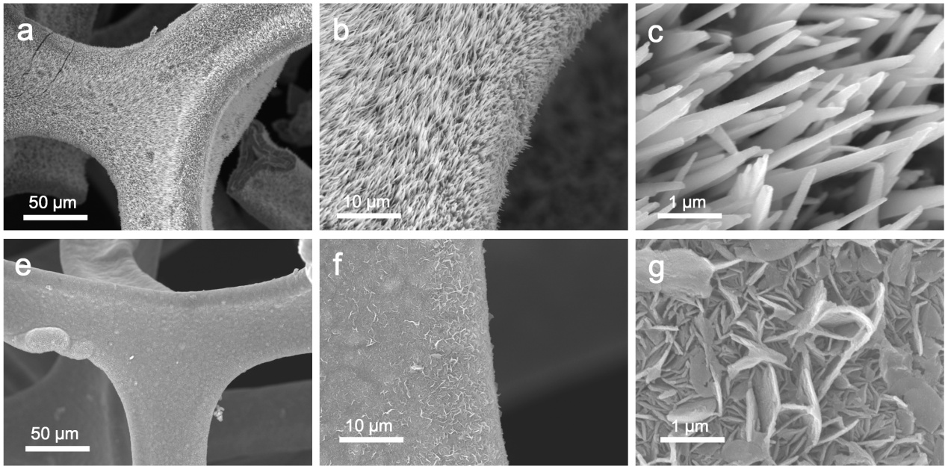
Fig. S1. SEM images of CND nanorods (a-c) and FND nanosheets (e-g) at different magnification.

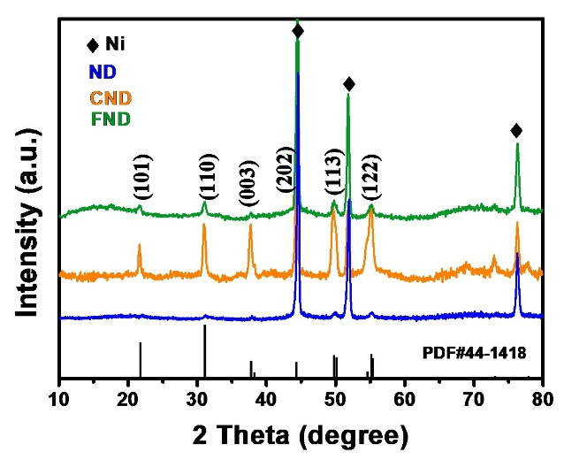
Fig. S2. XRD patterns of ND, CND, and FND.

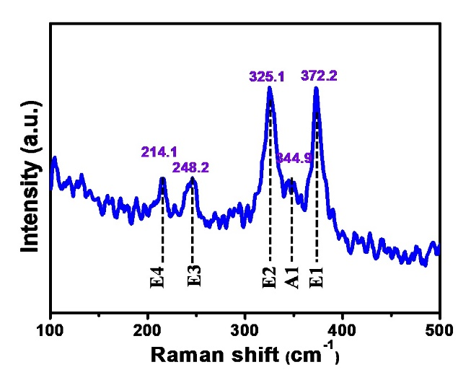
Fig. S3. Raman spectra of ND.

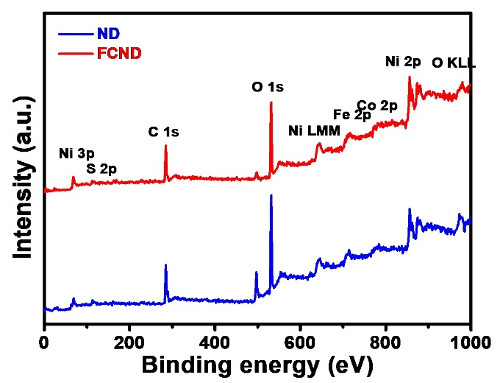
Fig. S4. XPS survey peaks of ND and FCND.

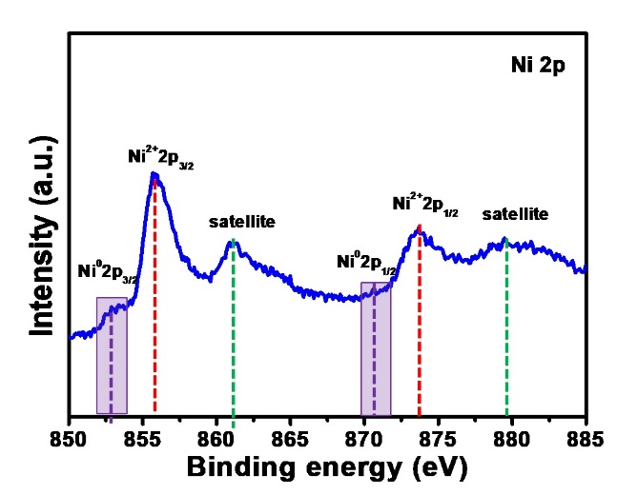
Fig. S5. Ni 2p XPS spectra of ND.
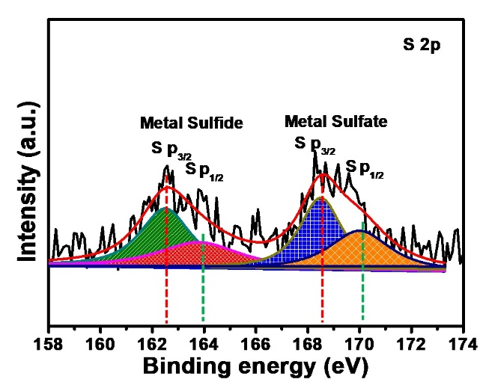
Fig. S6. S 2p XPS spectra of ND.

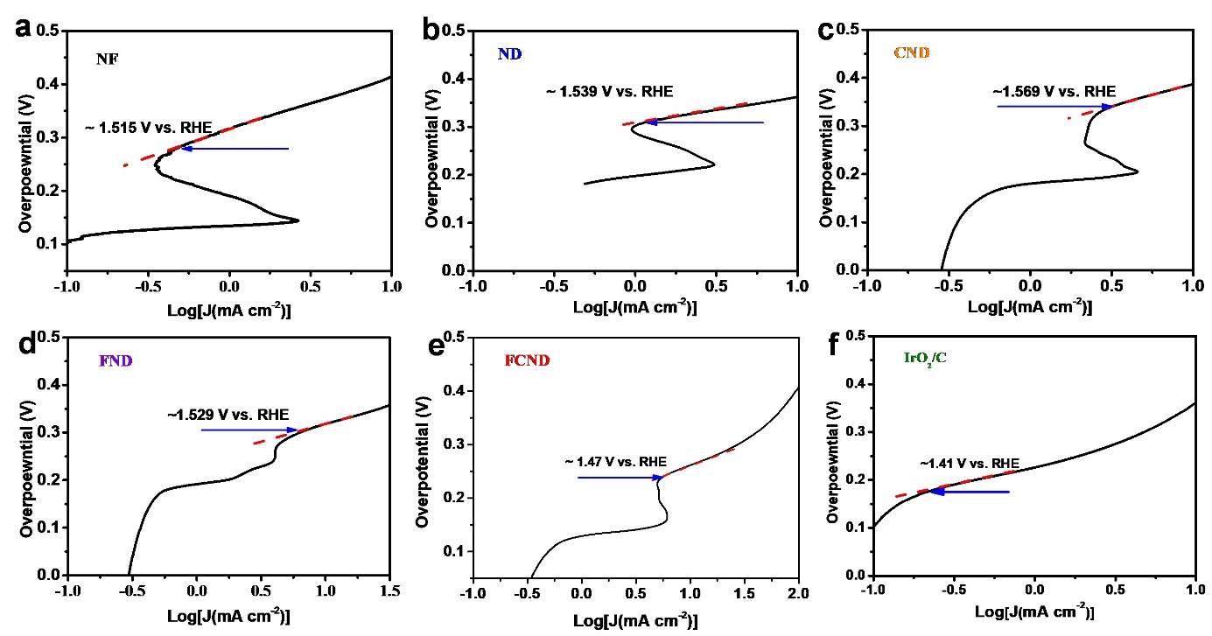
Fig. S7. Onset potential of (a) NF, (b) ND, (c) CND, (d) FND, (e) FCND, and (f) IrO2/C electrodes in 1.0 M KOH solution.

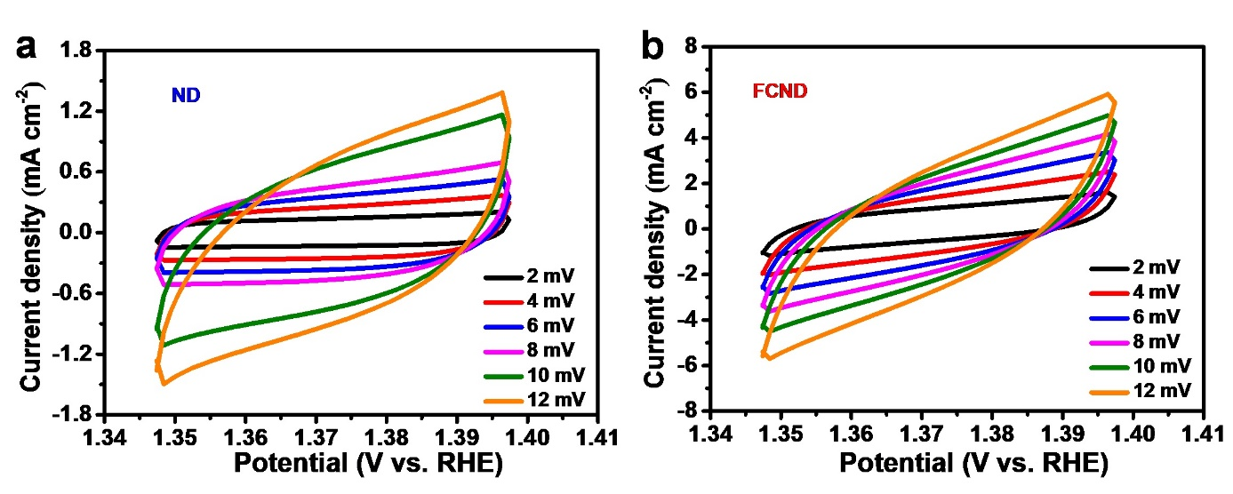
Fig. S8. Cyclic voltammograms curves in the double layer region at scan rate of 2, 4, 6, 8 10, 12 mV s⁻¹ (along the arrow direction) of (a) ND and (b) FCND.

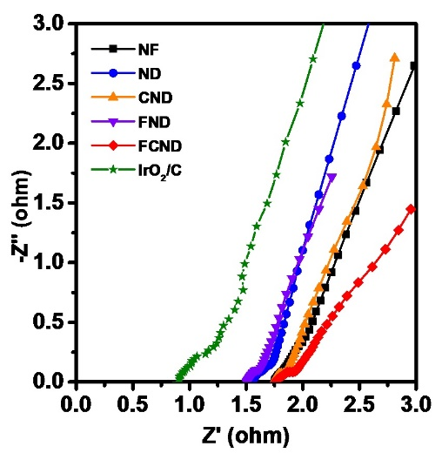
Fig. S9. Nyquist plots of NF, ND, and CND, FND, FCND, and IrO₂/C electrodes.

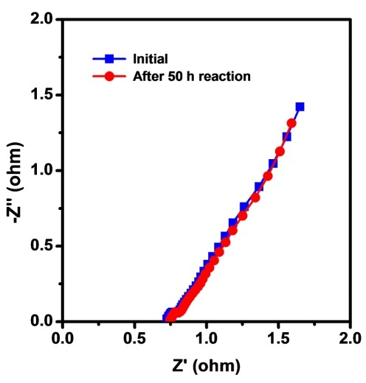
Fig. S10. Nyquist plots of FCND electrodes before and after 50 h reaction.

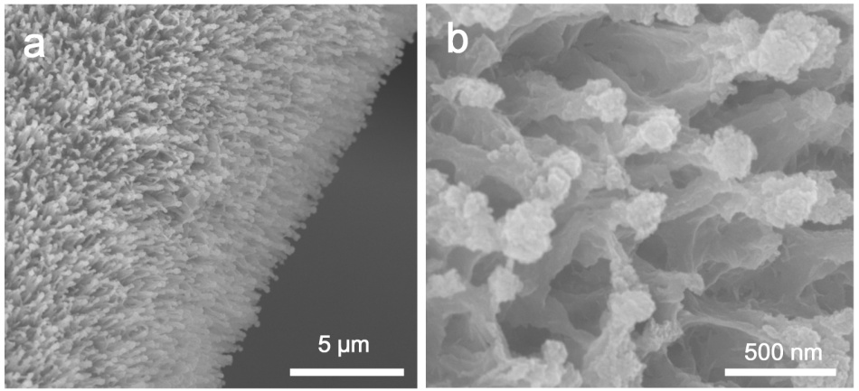
Fig. S11. SEM image of FCND nanorods at different magnification after 50 h reaction.

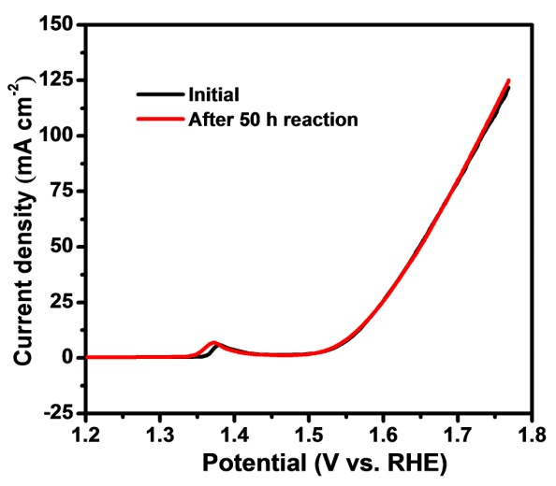
Fig. S12. The LSV curves of ND before and after 50 h reaction.

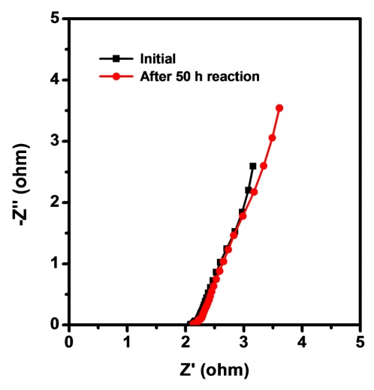
Fig. S13. Nyquist plots of ND electrodes before and after 50 h reaction.

