Supplemental files

MOF Derived TiO₂ with Reversible Magnesium Pseudocapacitance for Ultralong-life Mg Metal Batteries

Xinyin Caiª, Yanan Xu^{b,}*, Qinyou Anª, Yalong Jiangª, Ziang Liuª, Fangyu Xiongª, Wenyuan Zouª, Gang Zhangª, Yuhang Daiª, Ruohan Yuª, Liqiang Mai^{a,}*

ª State Key Laboratory of Advanced Technology for Materials Synthesis and Processing, International School of Materials Science and Engineering, Wuhan University of Technology, Wuhan 430070, P. R. China.
^{b} Key Laboratory of Applied Superconductivity, Institute of Electrical Engineering, Chinese Academy of Sciences, Beijing 100190, P.R. China.
* E-mail: mlq518@whut.edu.cn; xuyanan@mail.iee.ac.cn
Methods
The measurement of Arrhenius activation energy
The relationship between ionic conductivity and temperature follows the classical Arrhenius relationship:
σ(T) = A exp (-E_{a}/RT)
where T is the absolute temperature, E_{a} the activation energy, and A is a pre-exponential factor [1,2].
Specifically speaking, firstly, based on the EIS results, the charge transfer impedance (R_{ct}) was obtained by fitting the circuit. Secondly, according to the Arrhenius relationship σ(T) = A exp (-E_{a}/RT), the relationship can be transformed as lnR_{ct}⁻¹ = lnA - (E_{a}/R) × (1/T). This equation illustrates that the lnR_{ct}⁻¹ is the linear function of T⁻¹and the slope of the linear function can be expressed as -E_{a}/R. Then, after fitting the lnR_{ct}⁻¹ and T⁻¹, the value of -E_{a}/R can be obtained. Furthermore, R is the gas constant (8.314 J/(mol·K)) and the activation energies of the two materials can be calculated by multiplying the slope value and gas constant.

DFT calculations
The present calculations were carried out by using the projector augmented wave (PAW) [3] method within DFT, as implemented in the Vienna ab initio simulation package (VASP) [4,5] The generalized gradient approximation (GGA) in the form of the Perdew-Burke-Ernzerhof (PBE) [6] was used to treat the exchange-correlation energy. A kinetic energy cutoff of 500 eV was used for wave functions expanded in the plane wave basis. All atoms were allowed to relax until the forces were less than 0.05 eV Å⁻¹. For the Brillouin-zone sampling, 6×6×6 k-points were adopted to ensure convergence of the total energy. Ultrasoft pseudopotentials were used to describe the interactions of the ionic core and valence electrons. The valence states considered in this study were Ti 3d²4s² and O 2s²2p⁴. A unit cell of TiO₂ crystal with a periodic structure was used in the DFT calculations. The TiO₂ crystal had a rhombohedral structure and belonged to the space group I41/amd.

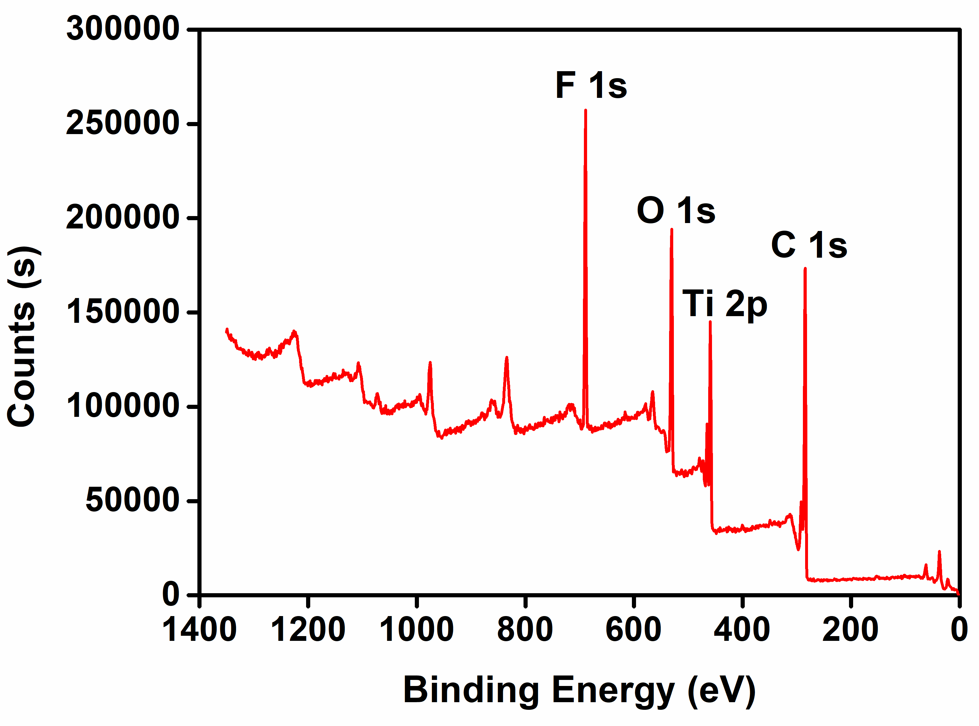
Fig S1 Full XPS spectrum of pristine TiO₂ cathode.

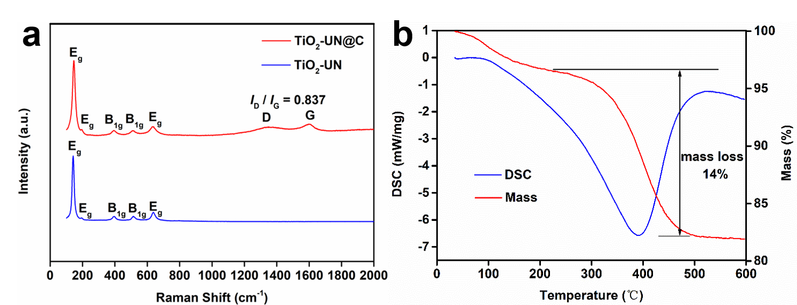
Fig S2 a) Raman spectra of the two prepared samples (TiO₂-UN@C, TiO₂-UN). b) DSC-TG analysis measured from room temperature to 600 °C with a heating rate of 5 °C min⁻¹ under air atmosphere of TiO₂-UN@C.

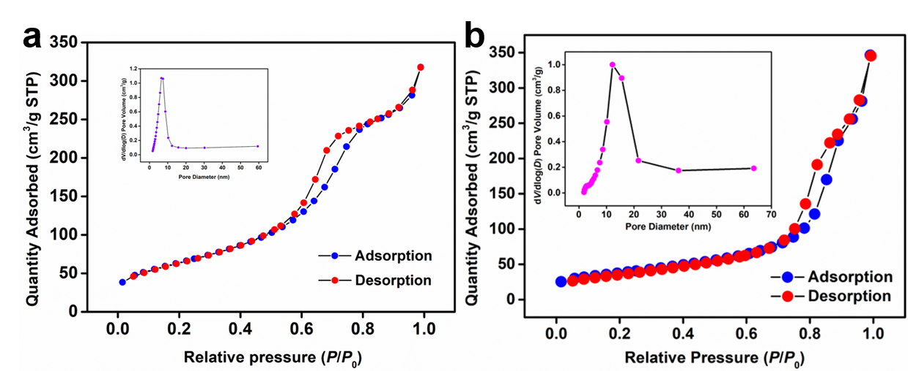
Fig S3 Nitrogen adsorption–desorption isotherms of a) as-prepared TiO₂-UN@C and b) TiO₂-UN. The insets are the pore size distribution obtained from the adsorption–desorption isotherms.

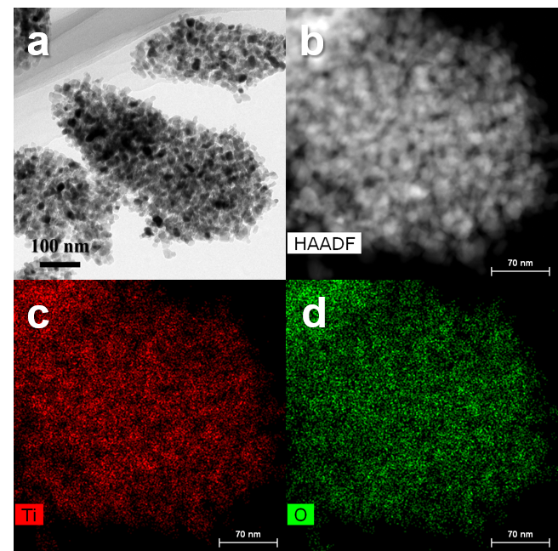
Fig S4 a) HAADF-STEM image; b-d) elemental mapping images (Ti and O elements) of the as-prepared TiO₂-UN.

Fig S5 Cyclic voltammetry test of the prepared APC electrolyte.

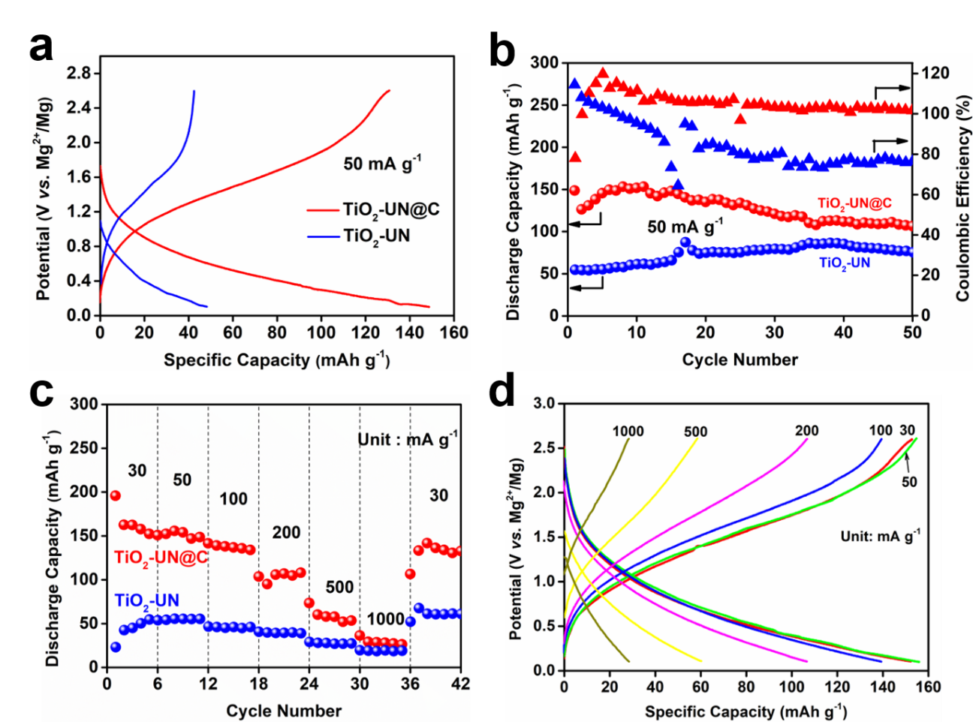
Fig S6 (a) Charge and discharge curves at first cycle, b) cycling performance at 50 mA g⁻¹ and c) rate capability of the two samples. (d) Charge and discharge curves at various current densities.

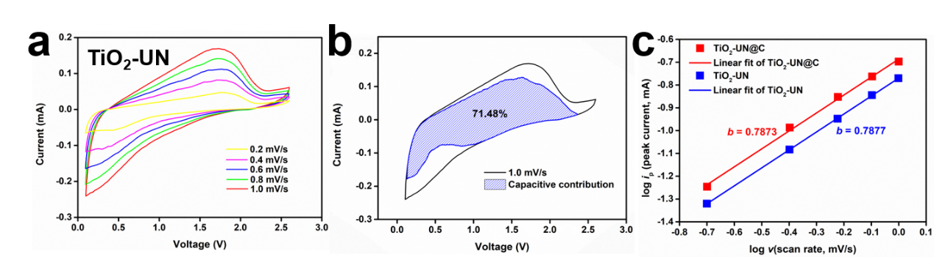
Fig S7 (a) CV curves of TiO₂-UN at scan rates ranging from 0.2 to 1.0 mV/s. (b) Capacitive contributions (shaded area) to charge storage of TiO₂-UN at 1.0 mV/s. (c) Analysis of b-value of TiO₂-UN and TiO₂-UN@C by using the relationship between peak currents and scan rates.

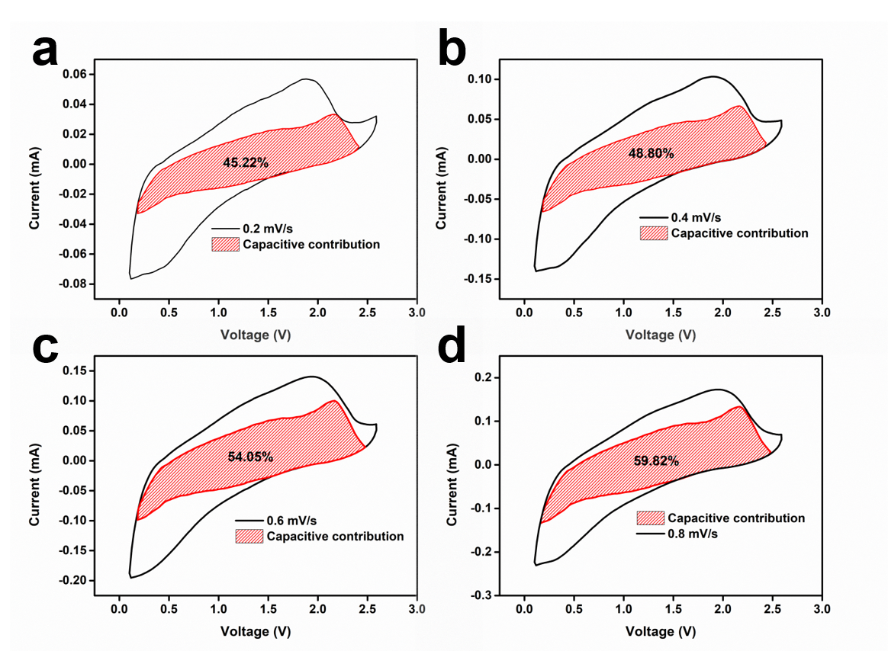
Fig S8 Capacitive contributions (shaded area) to charge storage of TiO₂-UN@C at (a) 0.2 mV/s, (b) 0.4 mV/s, (c) 0.6 mV/s and (d) 0.8 mV/s.

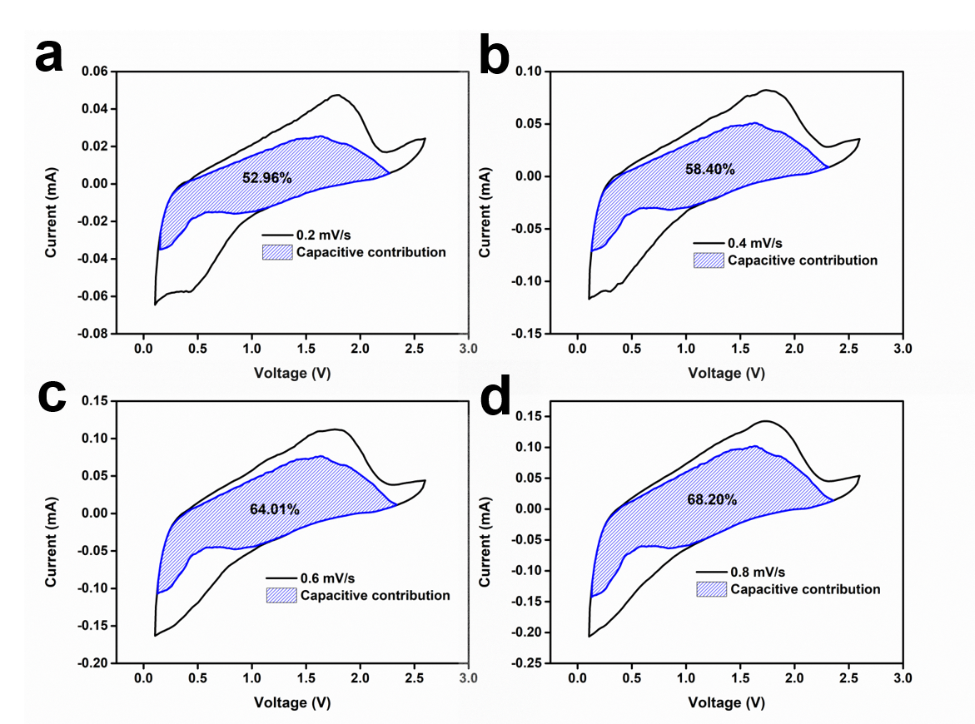
Fig S9 Capacitive contributions (shaded area) to charge storage of TiO₂-UN at (a) 0.2 mV/s, (b) 0.4 mV/s, (c) 0.6 mV/s and (d) 0.8 mV/s.

Fig S10 Nyquist plots of a) Mg(s)||APC|| TiO₂-UN@C and b) Mg(s)||APC|| TiO₂-UN at different temperatures.

Fig. S11 Ex-situ XRD characterizations of anatase TiO₂ cathodes at pristine/discharged/charged states.

Fig. S12 a) GITT curves of TiO₂-UN@C at a small current density of 20 μA, b) diffusion coefficient of magnesium ions in TiO₂-UN@C at different discharge state. c) GITT curves of TiO₂-UN at a small current density of 20 μA, d) diffusion coefficient of magnesium ions in TiO₂-UN at different discharge state.

Fig. S13 Selected electron diffraction images of anatase TiO₂ cathodes at a) pristine, b) discharged and c) charged states.

Fig. S14 a) Discharge and charge curves and b) cycling performance test of carbon at the current density of 50 mA g⁻¹.

Fig. S15 FTIR spectra of TiO₂-UN@C and TiO₂-UN.

Table S1 DFT calculation results of the cell parameters.
Parameters | TiO₂ | TiO₂-Mg²⁺ | TiO₂-MgCl⁺ | TiO₂-Mg²⁺MgCl⁺
a/Å | 3.78450 | 4.01325 | 4.00828 | 4.09581
b/Å | 3.78450 | 4.01325 | 3.73862 | 3.86803
c/Å | 9.51430 | 8.79961 | 12.80894 | 11.97901
α/degree | 90.0000 | 90.0000 | 90.0000 | 90.0000
β/degree | 90.0000 | 90.0000 | 87.7504 | 89.7049
γ/degree | 90.0000 | 90.0000 | 90.0000 | 90.0000
Unit cell volume/Å³ | 136.2680 | 141.7281 | 191.1424 | 189.7775

Table S2 Cycling performance comparation of several typical cathode materials in Mg metal batteries.
Cathodes | Capacity retention | Cycles | Capacity decrease  per cycle | References
Cu₂Se | 60% | 35 | 1.1% | [7]
CuS | 40% | 20 | 3.0% | [8]
PTCDA | 79.3% | 200 | 0.10% | [9]
Ti₂S₄ | 88% | 40 | 0.30% | [10]
TiS₂ | 88.4% | 40 | 0.29% | [11]
TiSe₂ | 82.5% | 50 | 0.35% | [12]
VS₂ | 70% | 600 | 0.050% | [13]
This work | 75% | 1000 | 0.025% | ——

References:
- G.B. Appetecchi, J. Hassoun, B. Scrosati, F. Croce, F. Cassel, M. Salomon, J. Power Sources 124 (2003) 246-253.
- C. Kuo, C. Huang, B.n Chen, W. Li, P. Chen, T. Ho, C. Tseng, T. Wu, Int. J. Electrochem. Sci. 8 (2013) 3834-3850.
- A. Jiang, N. Awasthi, A. N. Kolmogorov, W. Setyawan, A. Boerjesson, K. Bolton, A. R. Harutyunyan, S. Curtarolo, Phys. Rev. B 75 (2007) p.205426.1-205426.12.
- Kresse G，Furthmüller J, Phys. Rev. B 54 (1996) 11169-11186.
- Z. Zhou, B. Wu, S. Dou, C. Zhao, Y. Xiong, Y. Wu, S. Yang, Z. Wei, Comp. Mater. Sci. 6 (1996) 15-50.
- J. Perdew, K. Burke, M. Ernzerhof, Phys. Rev. Lett. 77 (1996) 3865.
- Y. Tashiro, K. Taniguchi, H. Miyasak, Electrochim. Acta 210 (2016) 655-661.
- F. Xiong, Y. Fan, S. Tan, L. Zhou, Y. Xu, C. Pei, Q. An, L. Mai, Nano Energy 47 (2018) 210-216.
- L. Cui, L. Zhou, K. Zhang, F. Xiong, S. Tan, M. Li, Q. An, Y. Kang, L. Mai, Nano Energy 65 (2019) 103902.
- X. Sun, P. Bonnick, V. Duffort, M. Liu, Z. Rong, K. A. Persson, G. Ceder, L. F. Nazar, Energy Environ. Sci. 9 (2016) 2273
- X. Sun, P. Bonnick, L. F. Nazar, ACS Energy Lett. 1 (2016) 297-301.
- Y. Gu, Y. Katsura, T. Yoshino, H. Takagi, K. Taniguchi, Sci. Rep. 5 (2015) 12486.
- X. Xue, R. Chen, C. Yan, P. Zhao, Y. Hu, W. Kong, H. Lin, L. Wang, Z. Jin, Adv. Energy Mater. 9 (2019) 1900145.

