Introducing Na₂SO₄ in aqueous ZnSO₄ electrolyte realizes superior electrochemical performance in zinc-ion hybrid capacitor
K. A. Owusu, X. Pan, R. Yu, L. Qu, Z. Liu, Z. Wang, M. Tahir, W. A. Haider, L. Zhou, L. Mai

- Supplementary figures

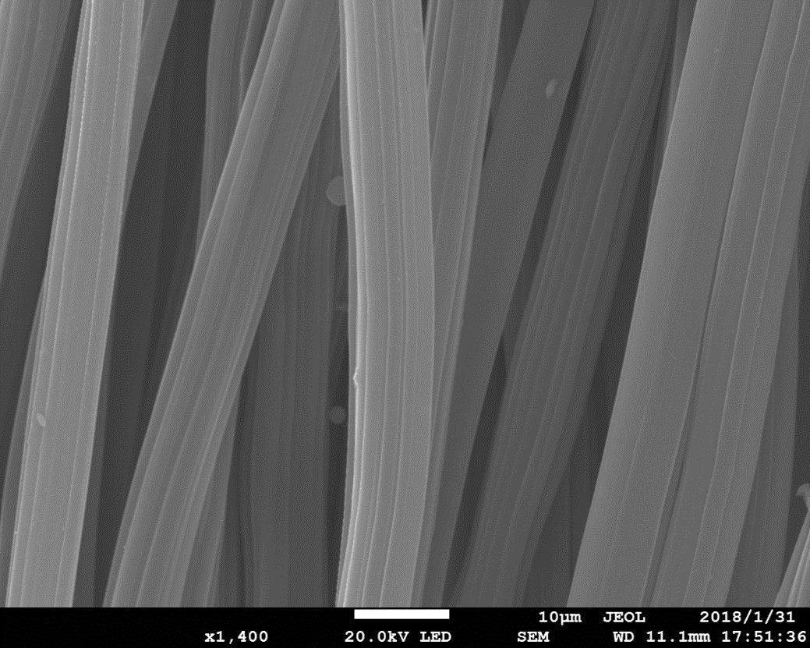
Figure S1. SEM image of the pristine CC.

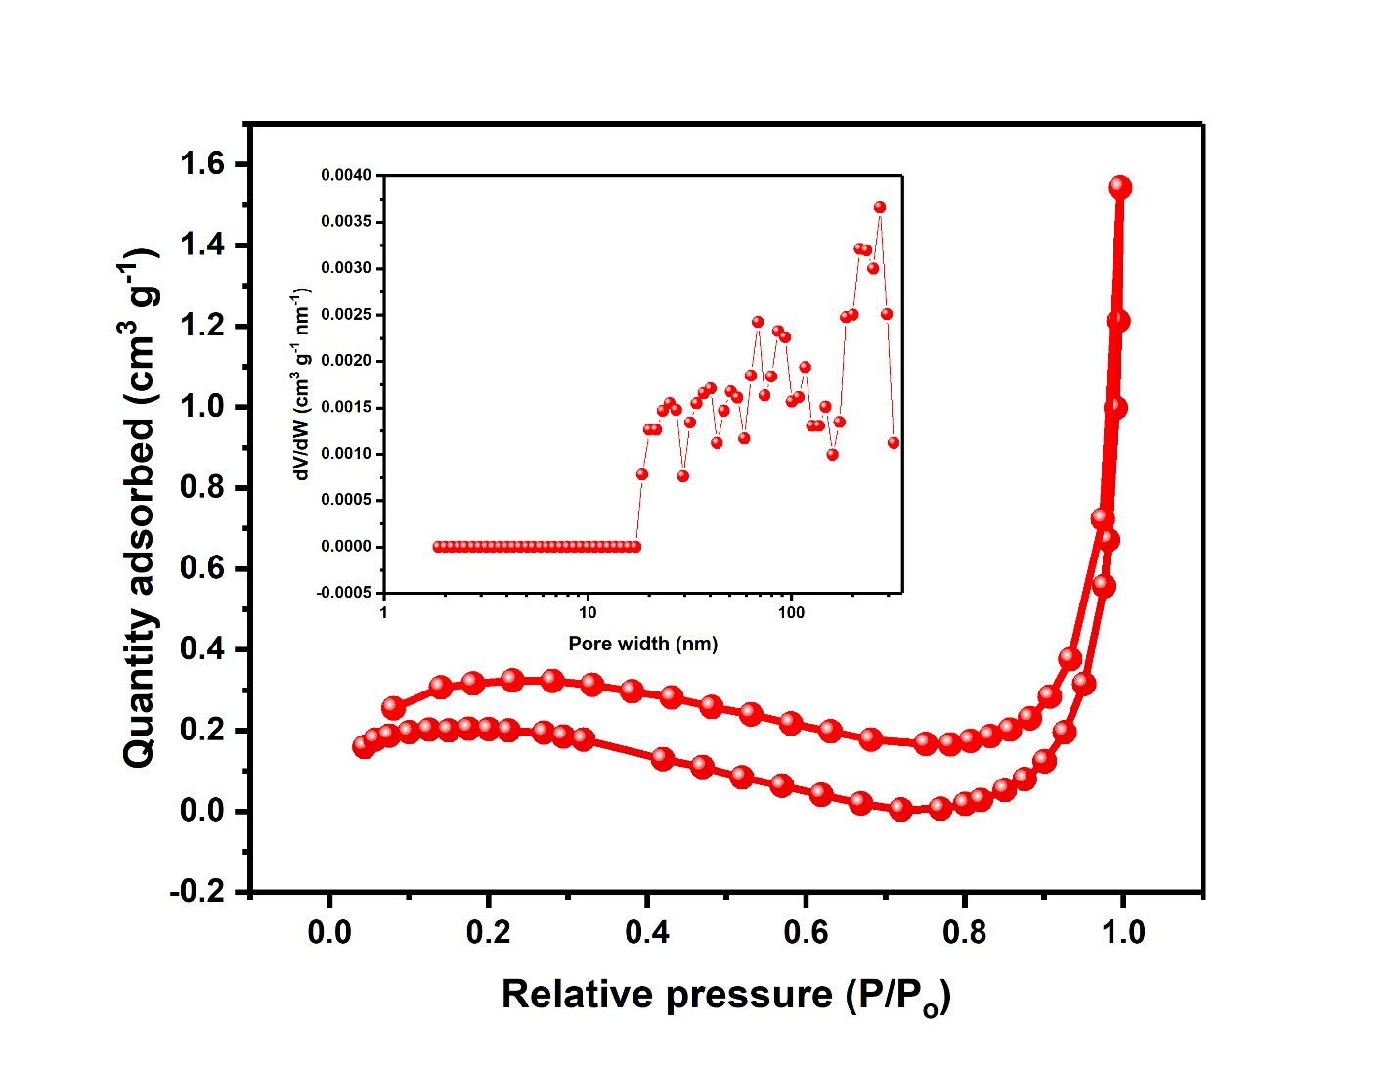
Figure S2. N₂ adsorption-desorption curve of the pristine CC (Inset: pore-size distribution of the untreated CC).
Figure S3. XPS survey spectrum of the ACC
Figure S4. (a) Cyclic voltammetry (CV) curves of the ACC//Zn ZIHC using different combinations of the Na₂SO₄ and ZnSO₄ electrolytes. (b) Rate capability of the ACC//Zn ZIHC using different combinations of the Na₂SO₄ and ZnSO₄ electrolytes. (c) EIS Nyquist plots of the ACC//Zn ZIHC device using different combinations of Na₂SO₄ and ZnSO₄ electrolytes.

Figure S5. Cyclic voltammetry curves of the ZIHC using (a) 1 M ZnSO₄ and (b) 1 M ZnSO₄/1 M Na₂SO₄ electrolyte.
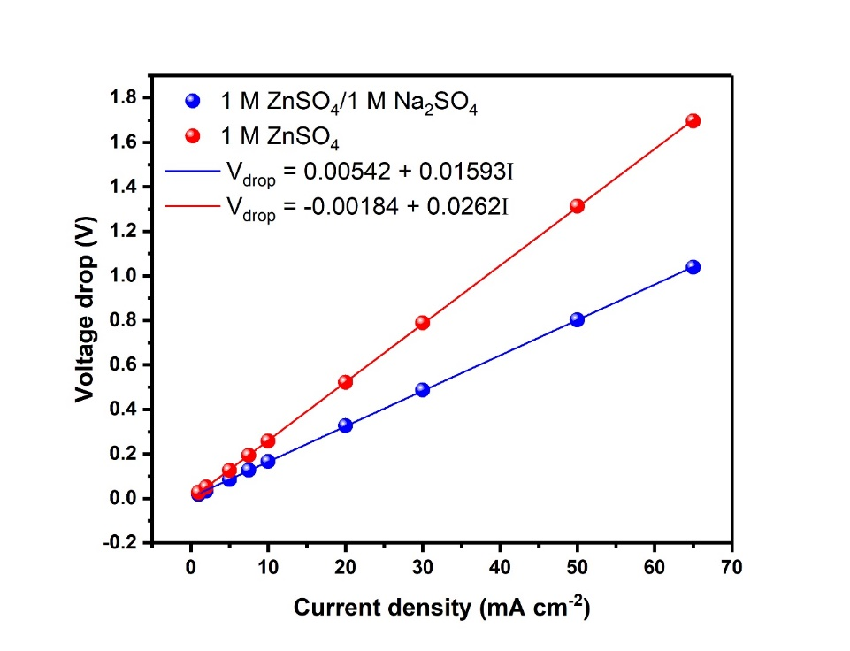
Figure S6. Comparison of the voltage drops at different current densities of the ZIHCs in 1 M ZnSO₄ and 1 M ZnSO₄/1 M Na₂SO₄ electrolyte.
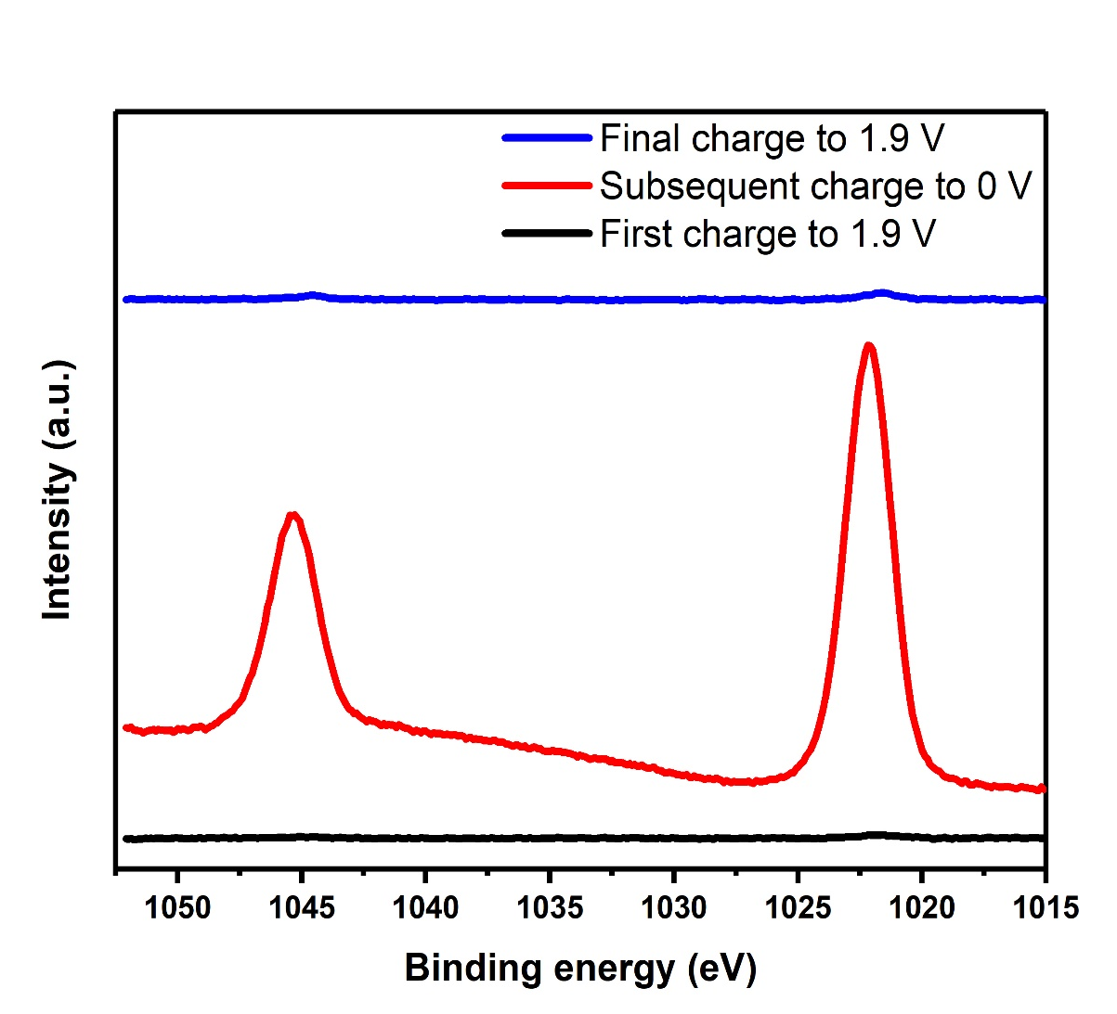
Figure S7. Zn 2p XPS signal at first charge (charge to 1.9 V), discharge to 0 V and final charge to 1. 9 V.
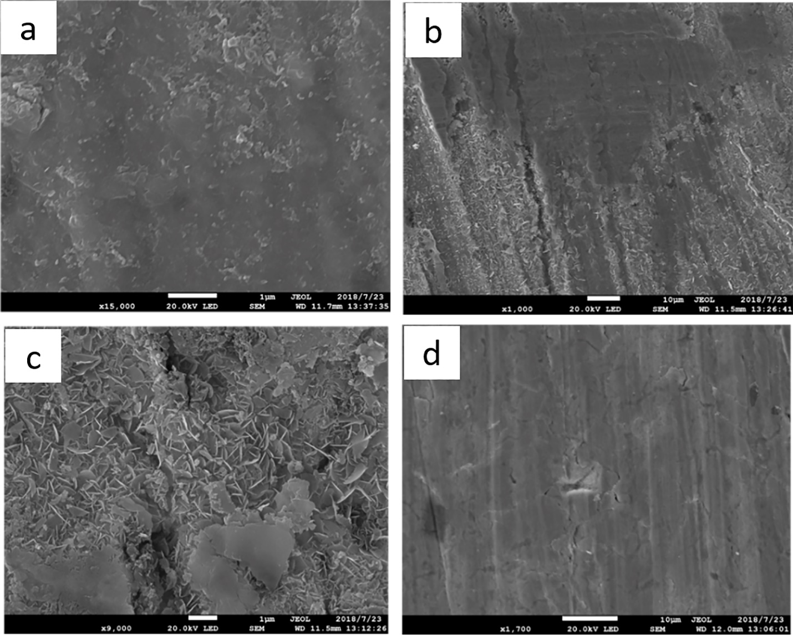
Figure S8. SEM images at (a) charge to 1.9 V (b) discharge from 1.9 V to 1.0 V (c) discharge to 0 V and (d) final charge to 1.9 V.

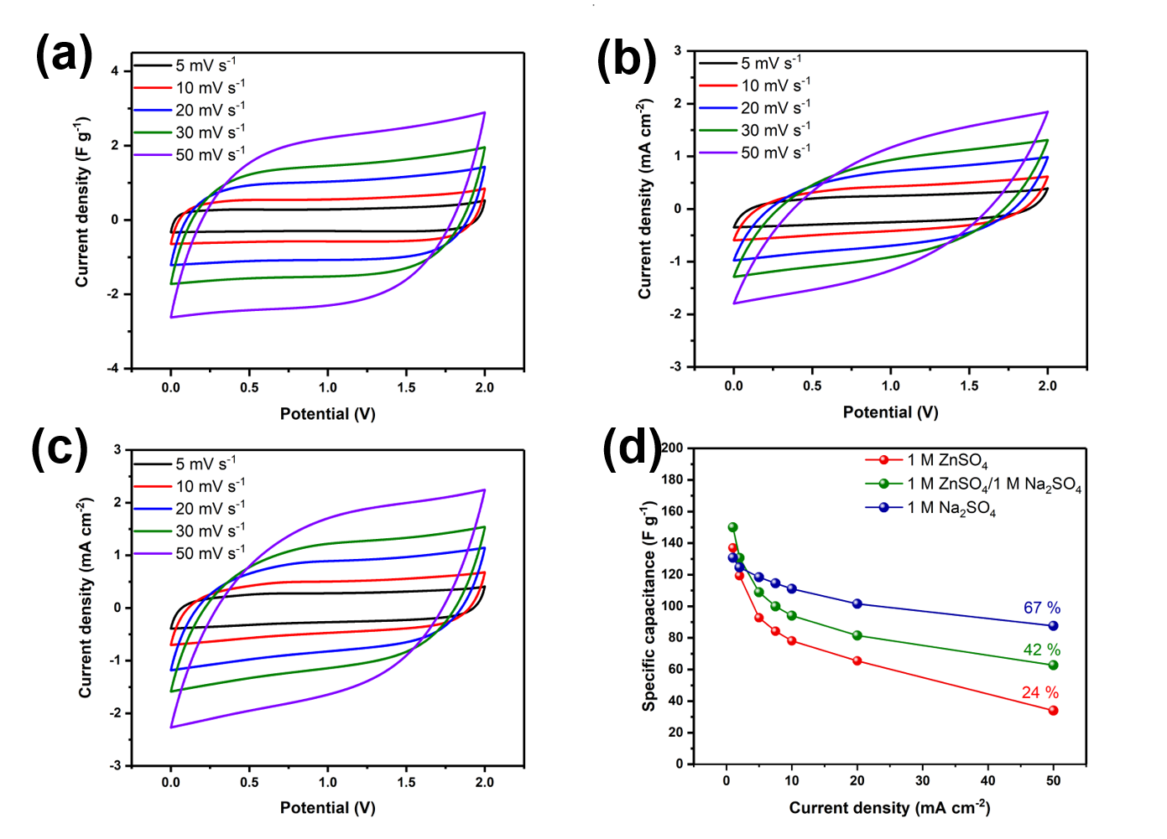
Figure S9. (a) Cyclic voltammetry curves of the ACC symmetric supercapacitor fabricated with 1 M Na₂SO₄. (b) Cyclic voltammetry curves of the ACC symmetric supercapacitor fabricated with 1 M ZnSO₄ electrolyte. (c) Cyclic voltammetry curves of the ACC symmetric supercapacitor fabricated with 1 M ZnSO₄/1 M Na₂SO₄ electrolyte. (c) Rate capability of the ACC electrodes in the different electrolytes.

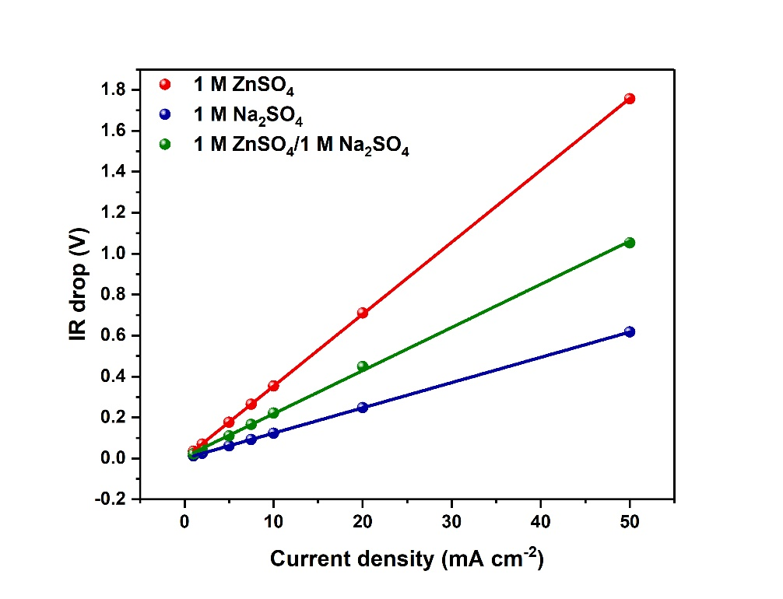
Figure S10. Comparison of the voltage drops at different current densities of the carbon symmetric supercapacitor device in 1 M ZnSO₄, 1 M Na₂SO₄ and 1 M ZnSO₄/1 M Na₂SO₄ electrolyte.
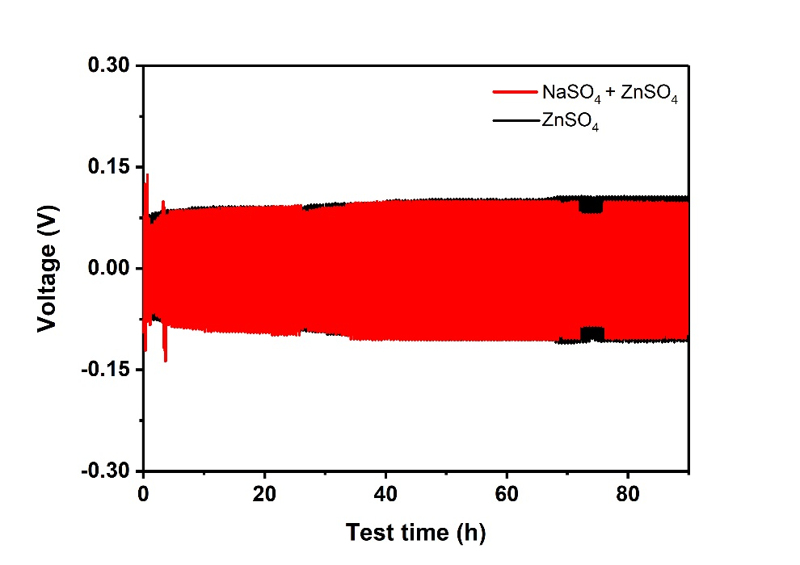
Figure S11. Typical GCD curves of symmetric cells with 1 M ZnSO₄ electrolyte (black) and 1 M ZnSO₄/1 M Na₂SO₄ at a current density of 0.5 mA cm⁻².

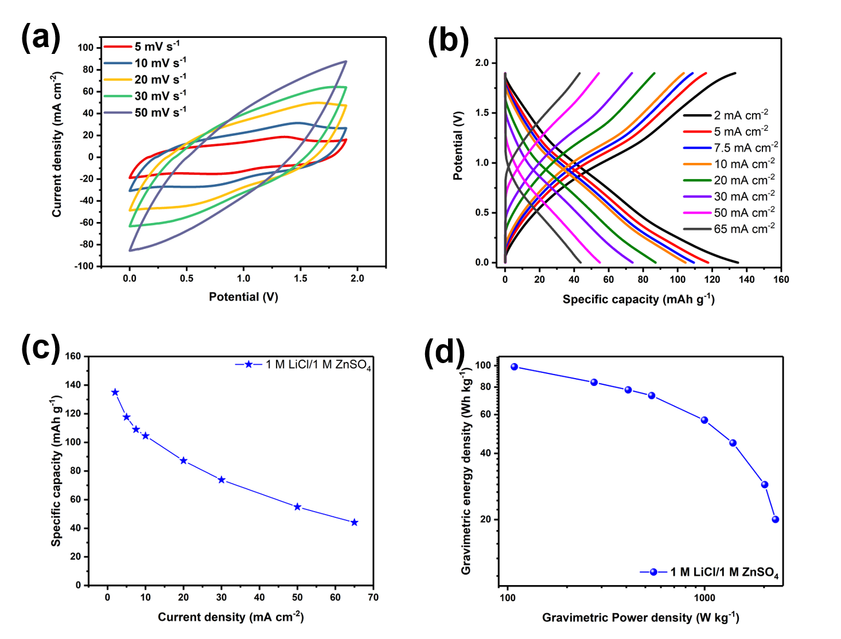
Figure S12. (a) Cyclic voltammetry curves of the Zn-ion HSC using 1 M LiCl/1 M ZnSO₄ electrolyte. (b) Charge discharge curves of the Zn-ion HSC using 1 M LiCl/ 1 M ZnSO₄ electrolyte. (c) Specific capacity of the ZIHC using 1 M LiCl/1 M ZnSO₄ electrolyte. (d) Gravimetric energy and power density of the ZIHC using 1 M LiCl/1 M ZnSO₄ electrolyte.

Table S1. Comparison of the ionic conductivities of the different zinc and sodium sulphate electrolyte combinations.
Electrolyte | Ionic Conductivity (S cm⁻¹)
1 M ZnSO₄ electrolyte  1 M Na₂SO₄ electrolyte  1 M ZnSO₄/1 M Na₂SO₄ electrolyte  0.25 ZnSO₄/0.75 M Na₂SO₄ electrolyte  0.5 M ZnSO₄/0.5 M Na₂SO₄ electrolyte  0.75 M ZnSO₄/0.25 M Na₂SO₄ electrolyte | 0.11  0.607  0.483  0.419  0.376  0.348

Table S2. Comparison of the performance of this work with some reported ZIHC devices
Zinc-Ion Hybrid Capacitor (ZIHC) | Specific capacity  (mAh g⁻¹) | Cell Voltage  (V) | Energy Density (Wh kg⁻¹) | Cycling Performance
MnO₂/ZnSO₄/Zn^{[1]} | 54.1 | 2 V | 34.8 | 65.3 % after 3000 cycles
AC/Zn(CF₃SO₃)₂/Zn^{[2]} | 170 F g⁻¹ | 1.8 V | 52.7 | 91 % after 20000 cycles
HCS/ZnSO₄/Zn^{[3]} | 86.8 | 1.8 V | 59.7 | 98 % after 15000 cycles
ACC/ZnSO₄/Zn^{[4]} | 318 F g⁻¹ | 1.6 V | 94 | 99.2 % after 10000 cycles
HNPC/ZnSO₄/Zn^{[5]} | 177.8 | 1.8 V | 107.3 | 99.7 % after 20000 cycles
HPC/ZnSO₄/Zn^{[6]} | 305 | 1.8 V | 118 | 94.9 % after 20000 cycles
ACC/ZnSO₄/Na₂SO₄/Zn ^{[this work]} | 154 | 1.9 | 100 | Stable cycling up to 20000 cycles

References
- X.P. Ma, J.Y. Cheng, L.B. Dong, W.B. Liu, J. Mou, L. Zhao, J.J. Wang, D.Y. Ren, J.L. Wu, C.J. Xu, F.Y. Kang, Energy Storage Mater. 20 (2019) 335-342.
- H. Wang, M. Wang, Y.B. Tang, Energy Storage Mater. 13 (2018) 1-7.
- S.M. Chen, L.T. Ma, K. Zhang, M. Kamruzzaman, J.A. Zapien, J. Mater. Chem. A. 7 (2019) 7784-7790.
- L. He, Y. Liu, C.Y. Li, D. Yang, W.G. Wang, W.Q. Yan, W.B. Zhou, Z.X. Wu, L.L. Wang, Q.H. Huang, Y.S. Zhu, Y.H. Chen, L.J. Fu, X.H. Hou, Y.P. Wu, ACS Appl. Energy Mater. 2 (2019) 5835-5842.
- H.Z. Zhang, Q.Y. Liu, Y.B. Fang, C.L. Teng, X.Q. Liu, P.P. Fang, Y.X. Tong, X.H. Lu, Adv. Energy Mater. 31 (2019) 1904948.
- P.F. Yu, Y. Zeng, Y.X. Zeng, H.W. Dong, H. Hu, Y.L. Liu, M.T. Zheng, Y. Xiao, X.H. Lu, Y. Liang, Electrochim. Acta 327 (2019) 134999.

