Supporting Information
Ni/Fe Based Bimetallic Coordination Complexes with Rich Active Sites for Efficient Oxygen Evolution Reaction
Wenzhong Huang^{‡,a}, Chuanxi Chen^{‡,a}, Zhaohong Ling^{‡,a}, Jiantao Li^{*,a}, Longbing Qu^{c} , Jiexin Zhuª, Wei Yangª, Manman Wang^{d}, Kwadwo Asare Owusuª, Ling Qinª, Liang Zhou^{*,a} , and Liqiang Mai^{*,a,b}

Figures and Tables:

Figure S1. The Fe/(Ni+Fe) molar ratio of Ni-MI, Ni9Fe1-MI/OH, Ni8Fe2-MI/OH, Ni7Fe3-MI/OH, and Fe-MI/OH measured from ICP.
Figure S2. SEM images of Ni-MI, Ni9Fe1-MI/OH, Ni8Fe2-MI/OH, Ni7Fe3-MI/OH, and Fe-MI/OH grown on Ni foam or the corresponding powders.
Figure S3. Digital photos of the solution (Ni(NO₃)₂∙6H₂O + methanol) and nickel foam before and after solvothermal reaction.
Figure S4. Raman spectra of Ni-MI, Ni9Fe1-MI/OH, Ni8Fe2-MI/OH, Ni7Fe3-MI/OH, Fe-MI/OH, and 2-MI.
Figure S5. XPS survey spectra of Ni-MI, Ni9Fe1-MI/OH, Ni8Fe2-MI/OH, Ni7Fe3-MI/OH, and Fe-MI/OH and C 1s XPS spectrum of Ni8Fe2-MI/OH.
Figure S6. EDX elemental spectrum of Ni8Fe2-MI/OH.
Figure S7. CVs of Ni-MI, Ni9Fe1-MI/OH, Ni8Fe2-MI/OH, Ni7Fe3-MI/OH, Fe-MI/OH, and IrO₂ measured at the non-Faradaic region (-0.04 ~ 0.06 V vs. SCE) with the scan rates ranging from 20 to 100 mV s⁻¹.
Figure S8. The corresponding C_{dl} derived from the CV data (tested on the NF). Electrochemical performances of Ni-MI, Ni9Fe1-MI/OH, Ni8Fe2-MI/OH, Ni7Fe3-MI/OH, Fe-MI/OH, and IrO₂ powders.
Figure S9. The TOF values calculated from the current at an overpotential of 330 mV for Ni9Fe1-MI/OH, Ni8Fe2-MI/OH, and Ni7Fe3-MI/OH powders.
Figure S10. LSV curves of Ni-MI, Ni9Fe1-MI/OH, Ni8Fe2-MI/OH, Ni7Fe3-MI/OH, Fe-MI/OH, and IrO₂ normalized by ECSA (j_{ECSA-normalized}) and Tafel plots of different catalysts normalized by ECSA (j_{ECSA-normalized}).
Figure S11. Ni 2p_{3/2} XPS spectra of the Ni8Fe2-MI/OH and Ni-MI (a); Fe 2p_{3/2} XPS spectra of the Ni8Fe2-MI/OH and Fe-MI/OH (c). (b) and (d) are the local amplified curves of (a) and (c), respectively.
Figure S12. XPS spectra of the Ni8Fe2-MI/OH before and after durability test at 10 mA cm⁻² for 2 h in 1 M KOH.
Figure S13. TEM, HRTEM images, and the corresponding SAED pattern of Ni8Fe2-MI/OH after OER process at 10 mA cm⁻² for 2 h in 1 M KOH. The corresponding HAADF-STEM image of and EDX elemental maps of Ni, Fe, N, C and O.

Table S1. The comparison of OER performance between Ni8Fe2-MI/OH, IrO₂, and other recently reported catalysts tested in 1 M KOH.

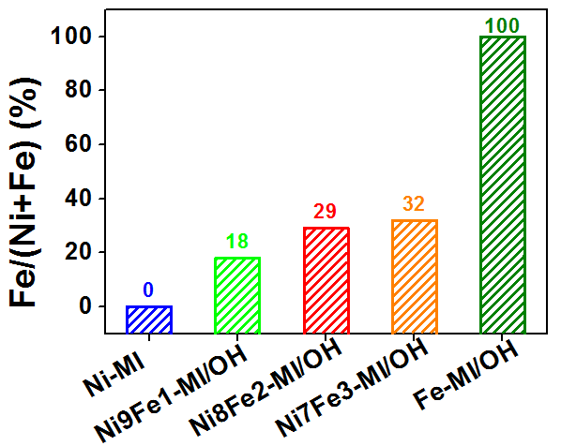
Figure S1. The Fe/(Ni+Fe) molar ratio of Ni-MI, Ni9Fe1-MI/OH, Ni8Fe2-MI/OH, Ni7Fe3-MI/OH, and Fe-MI/OH measured from ICP.

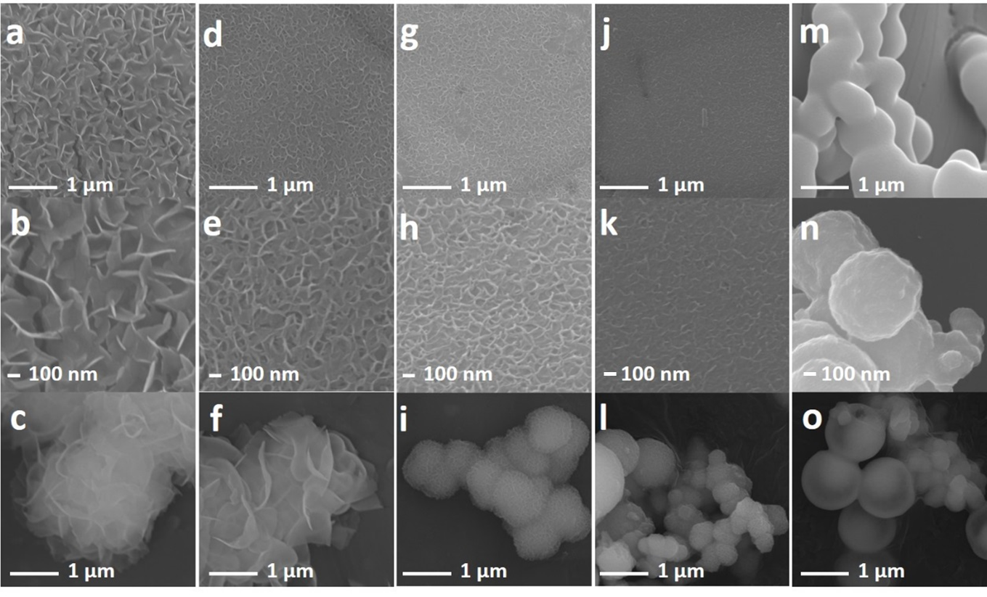
Figure S2. SEM images of (a-c) Ni-MI, (d-f) Ni9Fe1-MI/OH, (g-i) Ni8Fe2-MI/OH, (j-l) Ni7Fe3-MI/OH, and (m-o) Fe-MI/OH. Images of (c), (f), (i), (l) and (o) are the corresponding powders, and other images belong to samples grown on Ni foam.

Figure S3. Digital photos of the solution (Ni(NO₃)₂·6H₂O + methanol) and nickel foam (a, c) before and (b, d) after solvothermal reaction. All the other reaction conditions were kept the same with that of Ni/Fe-MI/OH, except that no 2-MI was added. After solvothermal reaction, no powder was found at the bottom of autoclave and the surface of NF was kept unchanged, indicating that 2-MI does act as the ligands and have coordinated with metal ions to form the final product.

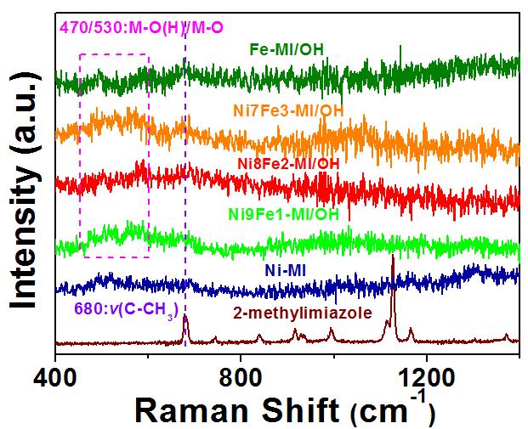
Figure S4. Raman spectra of Ni-MI, Ni9Fe1-MI/OH, Ni8Fe2-MI/OH, Ni7Fe3-MI/OH, Fe-MI/OH, and 2-MI.

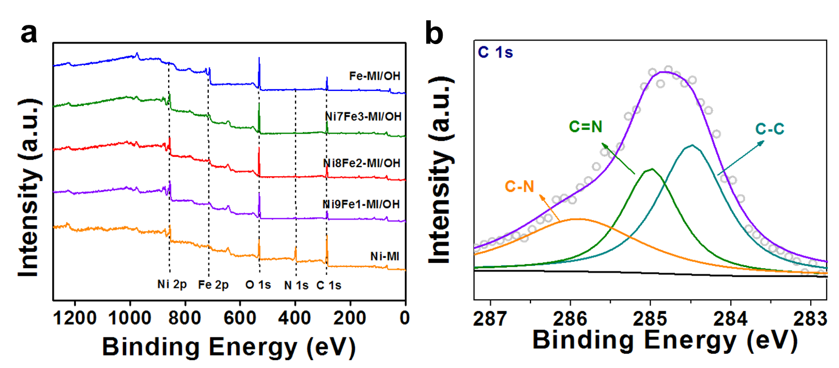
Figure S5. (a) XPS survey spectra of Ni-MI, Ni9Fe1-MI/OH, Ni8Fe2-MI/OH, Ni7Fe3-MI/OH, and Fe-MI/OH and (b) C 1s XPS spectrum of Ni8Fe2-MI/OH.

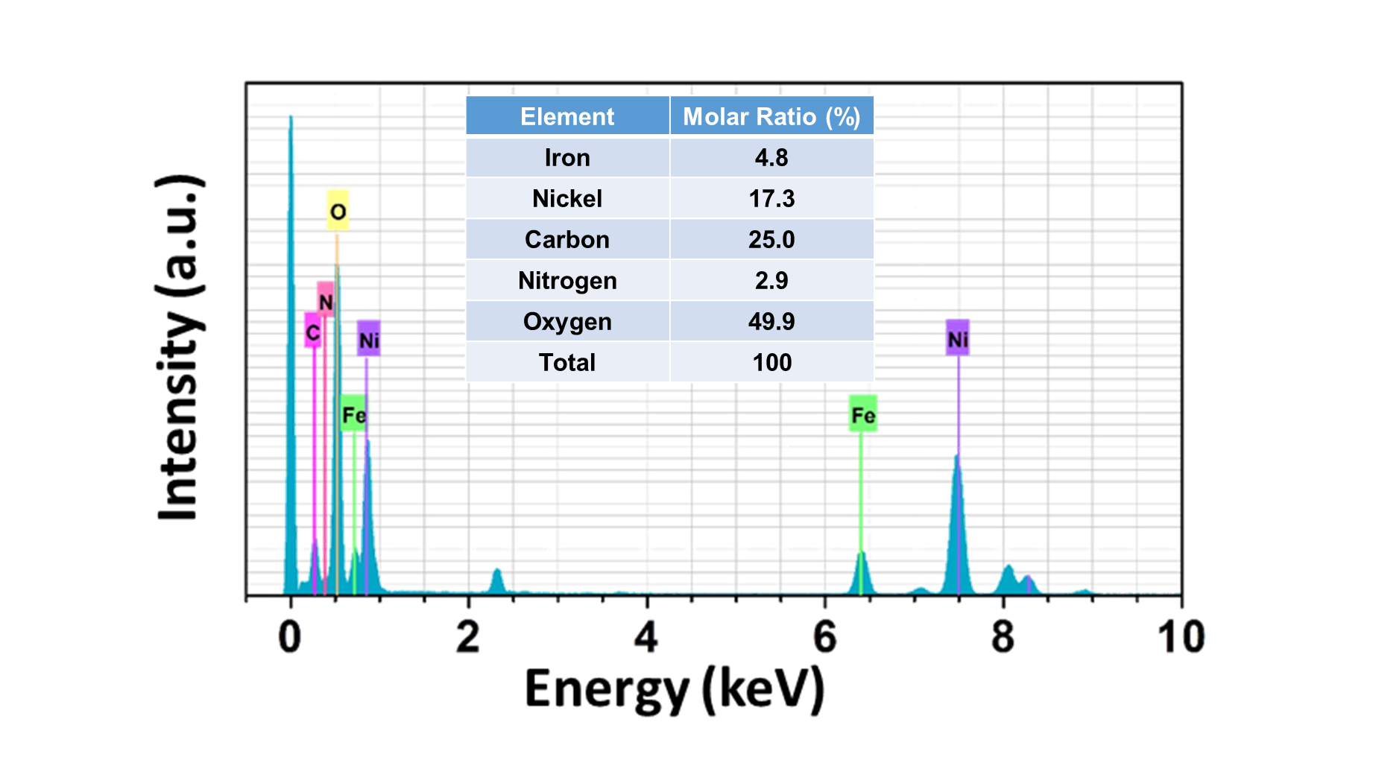
Figure S6. EDX elemental spectrum of Ni8Fe2-MI/OH.
The chemical formula of Ni8Fe2-MI/OH is derived by the following method: Based on the XPS results and basic knowledge, it is easy to know that the Ni/Fe and MI/OH groups are +2 and -1 in valence, respectively. The MI is the dissociated 2-MI without one H⁺. In addition, all N atoms are derived from 2-MI and the N/MI molar ratio is 2/1. Based on the above results and law of conservation of charge, the chemical formula of Ni8Fe2-MI/OH can be regarded as Ni_{17.3}Fe_{4.8}-(MI)_{1.5}/(OH)_{42.7}.

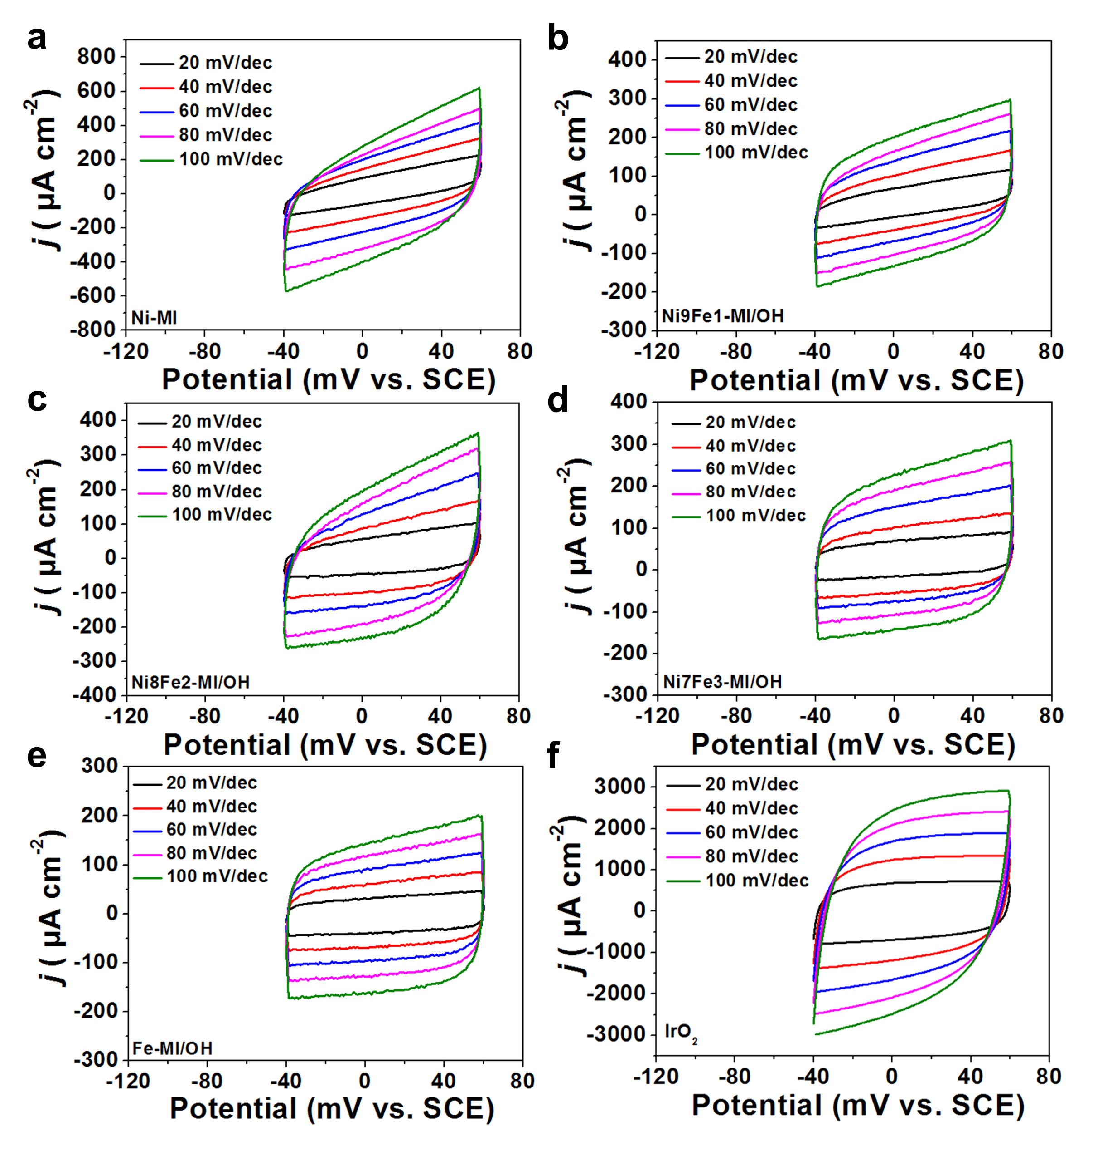 Figure S7. CVs of (a) Ni-MI, (b) Ni9Fe1-MI/OH, (c) Ni8Fe2-MI/OH, (d) Ni7Fe3-MI/OH, (e) Fe-MI/OH, and (f) IrO₂ measured at the non-Faradaic region (-0.04 ~ 0.06 V vs. SCE) with the scan rates ranging from 20 to 100 mV s⁻¹.

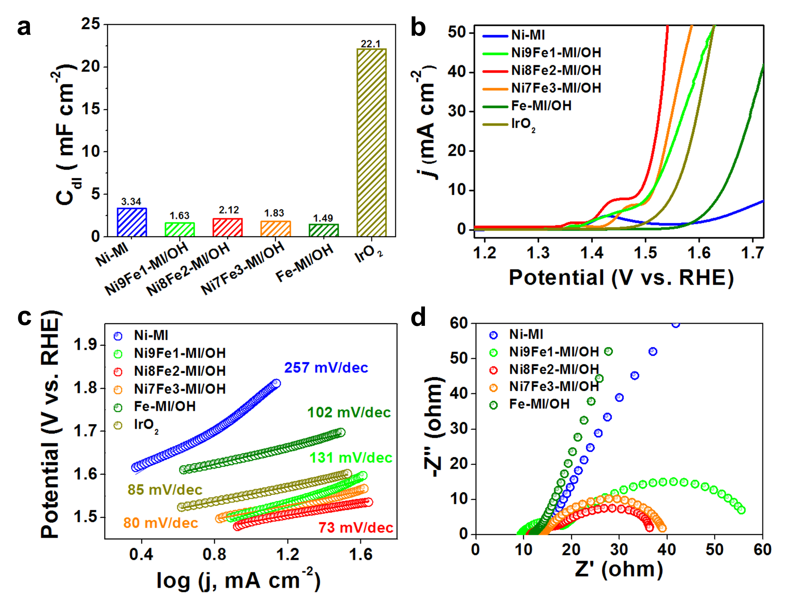
Figure S8. (a) The corresponding C_{dl} derived from the CV data (tested on the NF). Electrochemical performances of Ni-MI, Ni9Fe1-MI/OH, Ni8Fe2-MI/OH, Ni7Fe3-MI/OH, Fe-MI/OH, and IrO₂ powders: (b) LSV curves in 1 M KOH at a scan rate of 20 mV s⁻¹; (c) corresponding Tafel plots; (d) EIS Nyquist plots.
As shown in Figure S8b-d, Ni8Fe2-MI/OH powder possess the lowest overpotential of 260 mV at the current density of 10 mA cm⁻², the lowest Tafel slope of 73 mV dec⁻¹ and the smallest R_{ct}. TOF of NiFe-MI/OH powders are also calculated at 330 mV overpotential (Figure S9): the TOF of Ni8Fe2-MI/OH is 0.125 s⁻¹, much larger than those of Ni9Fe1-MI/OH (0.046 s⁻¹) and Ni7Fe3-MI/OH (0.035 s⁻¹), illustrating that the reaction kinetics on average single active site of Ni8Fe2-MI/OH is the fastest.
The Nyquist plots shown in Figure 4a and S8d are both semicircle and the reason are discussed as follow. EIS is a very important method in electrochemical measurement technology to study the dynamics of electrode process and surface phenomena. Its test results are closely related to the electrochemical reactions that occur on the electrode surface (Electrochimica Acta 252 (2017); ChemTexts 6 (2020)). (1) When the reaction on the electrode surface is dominated by diffusion, the Nyquist plots appears as a straight line with a phase transition of 45 degrees. (2) When the reaction on the electrode surface is dominated by the charge transfer process, the Nyquist plots is a semicircle. (3) When the electrode surface is controlled by both the charge transfer and the diffusion process, the corresponding Nyquist plots is composed of a straight line in the low frequency region and a semicircle in the high frequency region. For the OER reaction, it is obviously a process dominated by charge transfer, therefore, its Nyquist plots is a semicircle, which is also consistent with previous reports such as: Adv. Mater. 31 (2019) 1900430; J. Am. Chem. Soc. 141 (2019) 8136–8145.

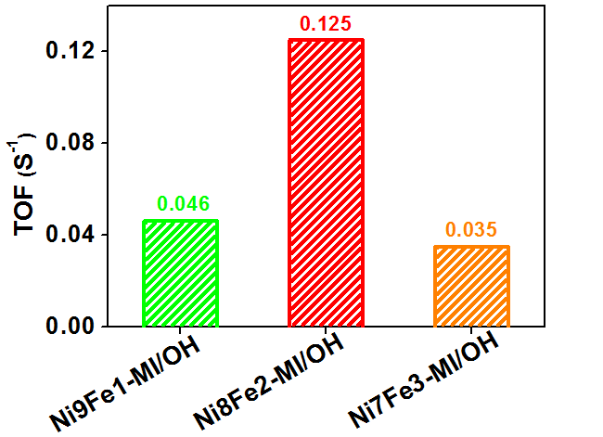
Figure S9. The TOF values calculated from the current at an overpotential of 330 mV for Ni9Fe1-MI/OH, Ni8Fe2-MI/OH, and Ni7Fe3-MI/OH powders.

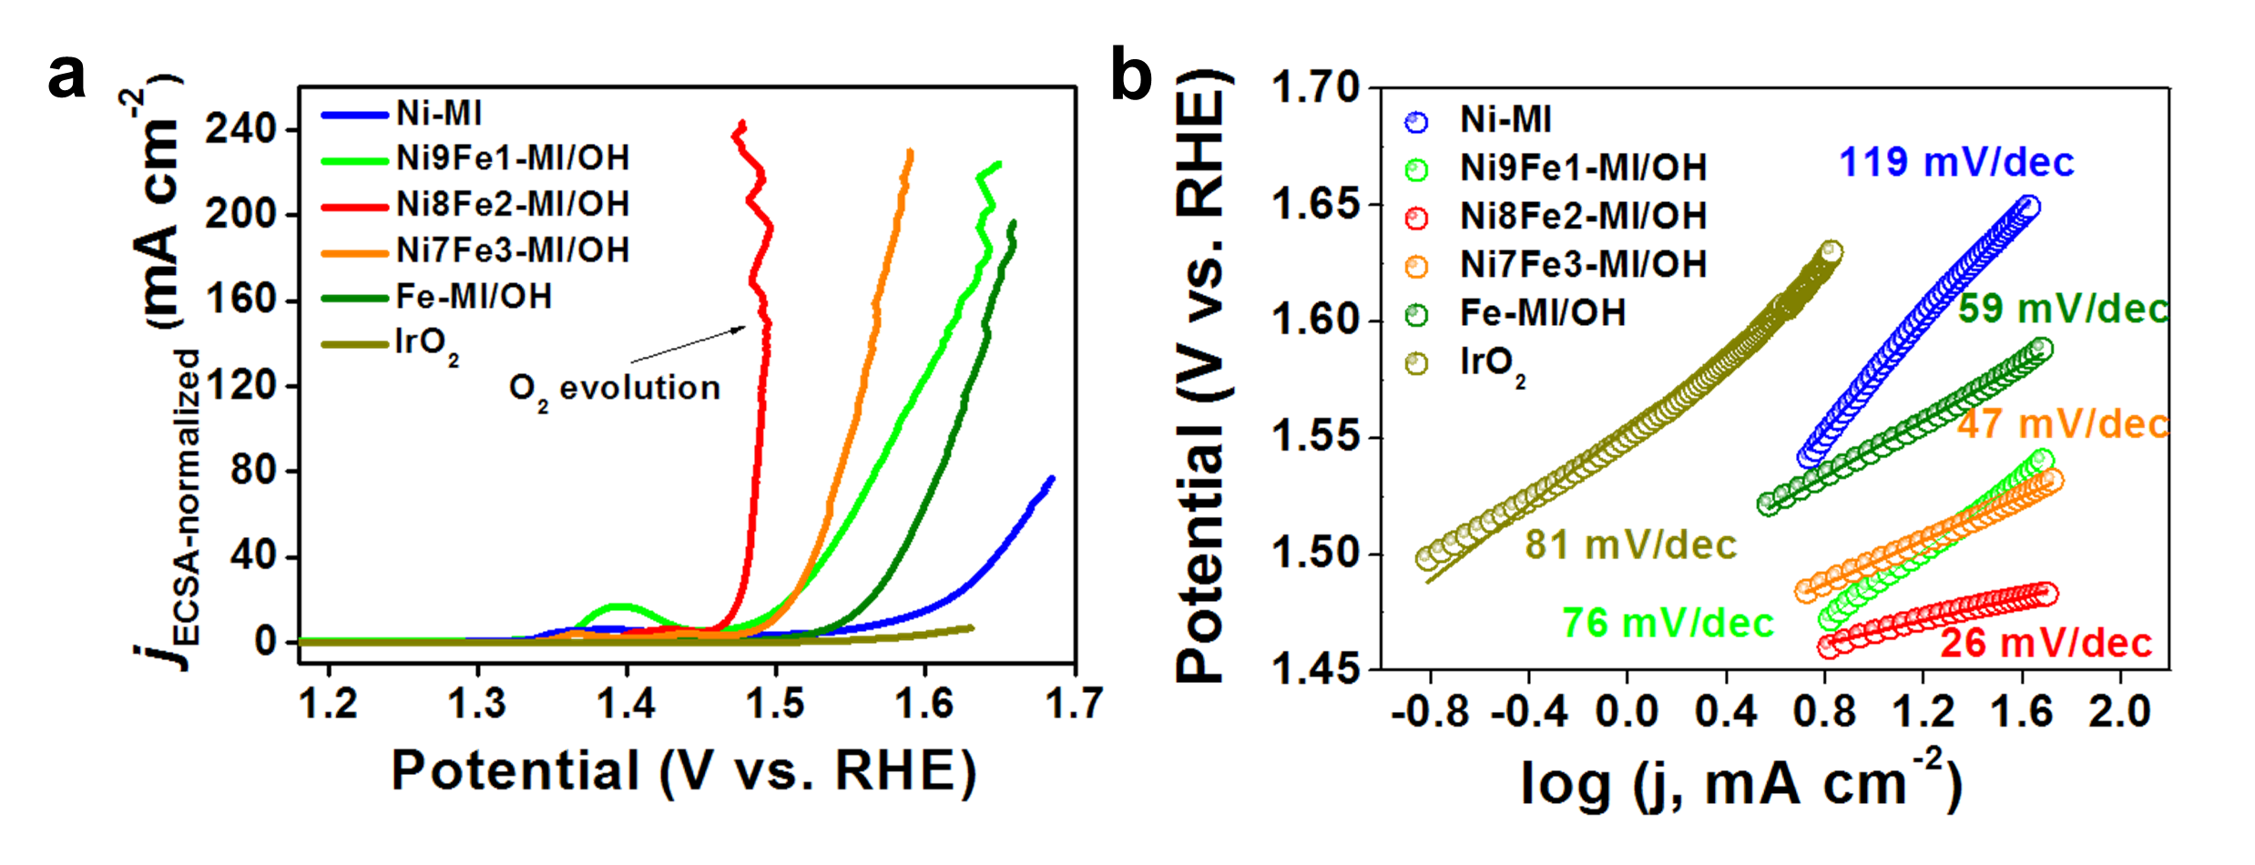
Figure S10. (a) LSV curves of Ni-MI, Ni9Fe1-MI/OH, Ni8Fe2-MI/OH, Ni7Fe3-MI/OH, Fe-MI/OH, and IrO₂ normalized by ECSA (j_{ECSA-normalized}) and (b) Tafel plots of different catalysts normalized by ECSA (j_{ECSA-normalized}).
In Figure S10a, due to the generation and accumulation of oxygen bubble on the surface, the LSV curves show obvious fluctuations. In fact, this phenomenon has also been observed in previous reports, such as Nat. Commun. 10 (2019) 5599; Nano Lett. 20 (2020) 136–144, etc.

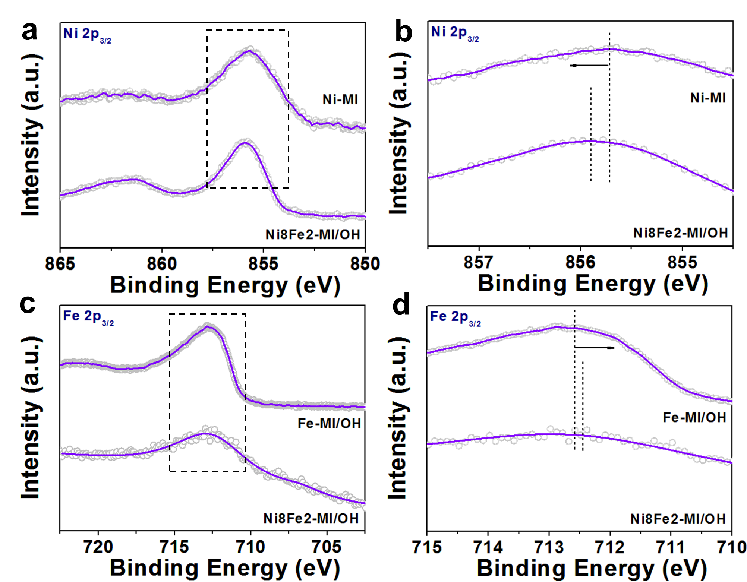

Figure S11. Ni 2p_{3/2} XPS spectra of the Ni8Fe2-MI/OH and Ni-MI (a); Fe 2p_{3/2} XPS spectra of the Ni8Fe2-MI/OH and Fe-MI/OH (c). (b) and (d) are the local amplified curves of (a) and (c), respectively.

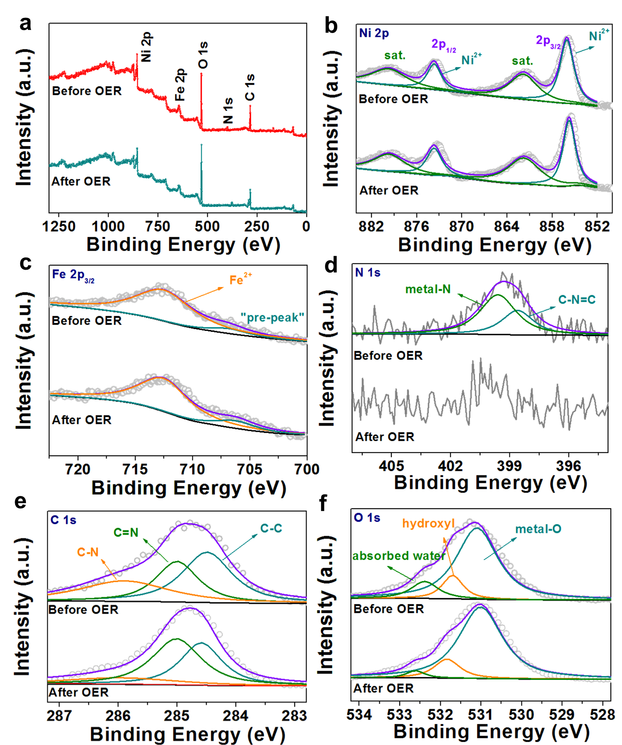
Figure S12. XPS spectra of the Ni8Fe2-MI/OH before and after durability test at 10 mA cm⁻² for 2 h in 1 M KOH: (a) XPS survey spectra, (b) high-resolution Ni 2p XPS spectra, (c) Fe 2p XPS spectra, (d) N 1s XPS spectra, (e) C 1s XPS spectra and (f) O 1s XPS spectra.

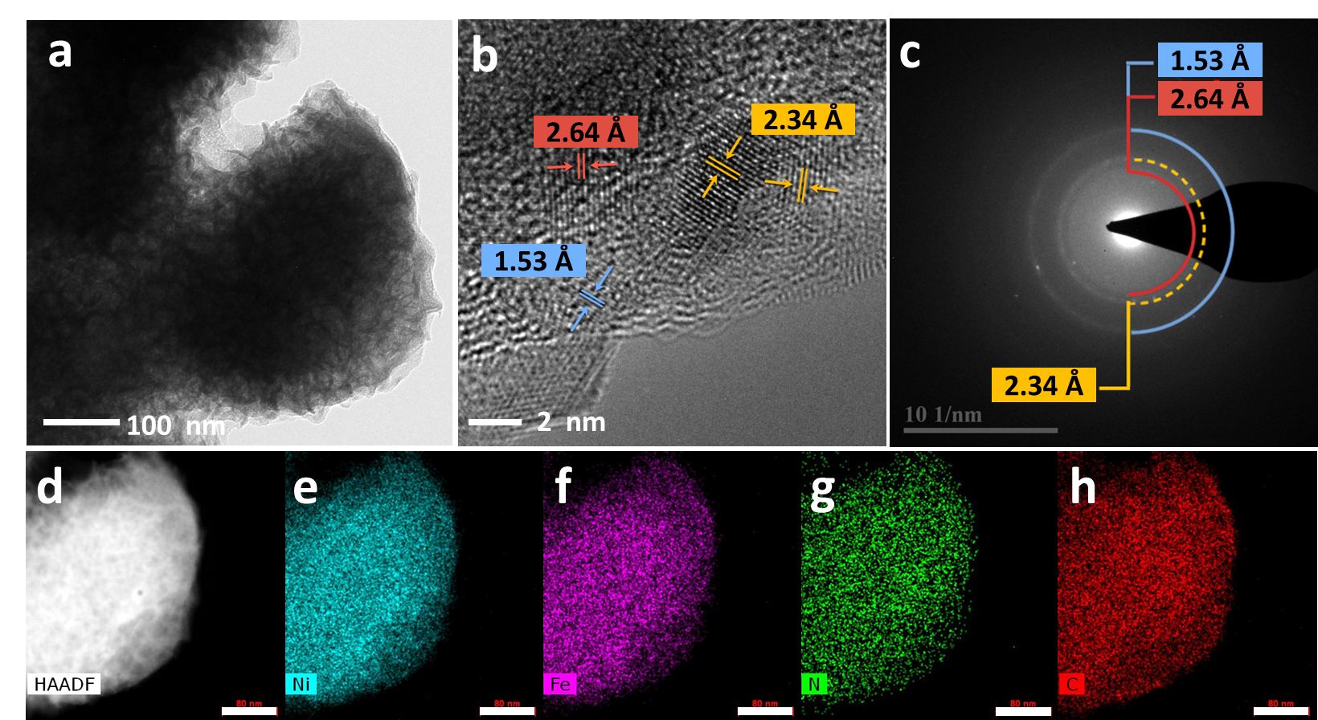
Figure S13. (a) TEM, (b) HRTEM images, and (c) the corresponding SAED pattern of Ni8Fe2-MI/OH after OER process at 10 mA cm⁻² for 2 h in 1 M KOH. (d) The corresponding HAADF-STEM image of and EDX elemental maps of (e) Ni, (f) Fe, (g) N, (h) C and (i) O (scale bars for d-i: 80 nm).

Table S1. The comparison of OER performance between Ni8Fe2-MI/OH, IrO₂, and other recently reported catalysts tested in 1 M KOH.
Catalysts | Overpotential  (mV) | Tafel slope  (mV dec⁻¹) | Substrate | Ref.
Ni8Fe2-MI/OH | 229 | 30 | Ni foam | This work
IrO₂ | 305 | 66 | Ni foam | This work
NiFeRu-LDH | 225 | 32.4 | Ni foam | Adv. Mater. 2018, 1706279
Cu₃N | 286 | 118 | Ni foam | ACS Energy Lett. 2019, 4, 3, 747-754
DR-Ni3FeN/N-G NHs | 250 | 38 | Ni foam | Adv. Funct. Mater. 2018, 1706018
NiFe-MOF | 240 | 34 | Ni foam | Nat.Comm.2017,8,15341
Bulk NiFe-LDH | 251 | 46 | Ni foam | ACS Catal. 2019, 9, 7, 6027-6032
FeOOH/NPC | 230 | 33.8 | Ni foam | Adv. Energy Mater. 2018, 1702598
FeSe₂ | 245 | / | Ni foam | Angew. Chem. Int. Ed.2017, 56, 10506 – 10510
CoFeZr oxides | 248 | 54.2 | Ni foam | Adv. Mater. 2019, 31, 1901439
NiFe-LDH | 280 | 49.4 | GCE | Angew. Chem. Int. Ed. 2017, 129, 1 – 6
hollow Co₃O₄ microtubes | 290 | 84 | GCE | Angew. Chem. Int. Ed. 2016, 56, 1324
CoO_{x}-ZIF/C | 318 | 70 | GCE | Adv. Funct. Mater. 2017, 27, 1702546
Fe-BDC | 419 | 76 | GCE | ACS Energy Lett. 2019, 4, 285-292
Fe1Ni2-BDC | 260 | 35 | GCE | ACS Energy Lett. 2019, 4, 285-292
Ni₂Fe₁-O | 244 | 39 | GCE | Adv. Energy Mater. 2018, 8,  1–9
CoV-LDH | 250 | 44 | GCE | Energy Environ. Sci. 2018, 11, 1736.
CoMoN_{x} | 370 | 69 | GCE | Adv. Mater. 2020, 1907214
CuN_{x} | 310 | 68 | Au wires | Adv. Mater. 2020, 1907214

