Supplementary materials
Interface enhanced well-dispersed Co₉S₈ nanocrystals as an efficient polysulfide host in lithium-sulfur batteries

Xue Liu^{a,c,1}, Qiu He^{b,1}, Hong Yuan^{c}, Chong Yan^{d}, Yan Zhao^{b}, Xu Xuª, Jia-Qi Huang^{d}, Yu-Lun Chueh^{e}, Qiang Zhang^{c,*}, Liqiang Mai^{a,* *}

ª State Key Laboratory of Advanced Technology for Materials Synthesis and Processing,
Wuhan University of Technology,
Wuhan, 430070, Hubei, China

^{b} State Key Laboratory of Silicate Materials for Architectures,
Wuhan University of Technology,
Wuhan, 430070, Hubei, China

^{c} Beijing Key Laboratory of Green Chemical Reaction Engineering and Technology, Department of Chemical Engineering,
Tsinghua University,
Beijing, 100084, China

^{d} Advanced Research Institute of Multidisciplinary Science,
Beijing Institute of Technology,
Beijing, 100081, China

^{e} Department of Materials Science and Engineering,
Taiwan Tsinghua University,
Hsinchu, 30013, Taiwan, China.

¹ These authors contributed equally to this work
*Corresponding author.
**Corresponding author.

E-mail addresses: zhang-qiang@mails.tsinghua.edu.cn (Q. Zhang),
mlq518@whut.edu.cn (L. Mai)

Keywords: Metal sulfides; Composite sulfur cathode; Cobalt sulfides; Lithium-sulfur batteries; Electrocatalysis.

Experimental Section
Preparation of the Co₉S₈ and Co₉S₈-GO composites. The Co₉S₈ nanocrystals grown on graphene nanosheets were prepared by a solvothermal method. All of the reagents were used as obtained without further purification. Graphene oxide (GO) dispersion was synthesized through a modified Hummers’ method. In a typical synthesis of the composites, 4 mmol Co (NO₃)₂·6H₂O (Alfa Aesar) and 8 mmol thiourea (Alfa Aesar) were dissolved in the homogenous mixture of a ml GO (aq, 6 mg/ml), b ml Dimethyl Formamide (DMF) and c ml deionized water (a+b+c=480.0). The weight ratios of GO to Co(NO₃)₂·6H₂O were 0.0, 1.0 wt%, 4.1 wt%, 10 wt%, and the obtained samples were named as GCS0 (a=0.000, b=480.0, c=0.000), GCS1 (a=1.950, b=472.0, c=6.050), GCS4 (a=8.000, b=472.0, c=0.000), and GCS10 (a=19.40, b=460.6, c=0.000), respectively. Next the mixed solution was stirred vigorously at 70 °C for 1 hour until the dispersion became clear and then sonicated for 10 minutes (100W, 90% amplitude). The homogenous dispersion was divided into 8 portions, transferred into eight 100 ml Teflon-lined autoclave respectively and held at 180 °C for 12h. After that, the precipitates from the mixture were allowed to cool to room temperature and collected by vacuum filtration, and then washed by ethanol and deionized water separately for several times. The final product was dried in an oven at 80 °C for 24h.
Preparation of the GCSx (x=0, 1, 4)-S composites. The S/GCSx composites were prepared by using a simple melt-diffusion method. 25 wt% GCSx composites with different GO contents and 75 wt% sulfur were mixed homogeneously and milled in a mortar for 10 min. Then the homogeneous powder was heated at 155 °C for 4h under vaccuum in a flask.
Preparation of the GCSx (x=0, 1, 4)-Li₂S₈ mixtures. Li₂S and S in the desired ratio were dissolved and stirred vigorously in a 1,2-dimethoxyethane (DME) and 1,3-dioxolane (DOL) solvent mixture (v:v=1:1) to synthesize Li₂S₈ electrolyte at 60 ℃ for 24h. To prepare the GCSx-Li₂S₈ samples for XPS studies, GCSx was added into a Li₂S₈ solution (0.05M), stirred for 6 h and then centrifuged. The obtained solid mixture was dried at 60 °C. All procedures were carried out in the Ar-filled glovebox.
Visualization experiment. When preparing the XPS samples, a visualization test was conducted. 100 mg GCSx (x=0, 1, 4) were added into a 1ml Li₂S₈ solution (0.05M) in different test tubes, respectively. And then, after 24h, photographs of the four tubes were taken to see the color change of the supernatant.
Electrochemical measurement. Sulfur cathode slurry was prepared by mixing 70 wt% GCSx (x=0, 1, 4)-S composites, 20 wt% Super P and 10 wt% poly(vinylinene fluoride) (PVDF) in N-methyl pyrrolidone (NMP) solvent dispersion and then doctor bladed on 20μm thick aluminum current collector. The slurry coated foil was dried at 60 °C for 24 h and punched into 13 mm disks, which were used as cathode later. The cyclic performance was carried out using LAND or Neware multifunctional cycler in galvanostatic mode, employing the electrode with an average sulfur loading at ~1.5 mg cm⁻² in 2025 coin cell with 1.0 mm thick lithium foil as the anode and Celgard 2400 as the separator. For symmetric cells, electrode slurry was prepared by mixing 70 wt% GCSx and 20 wt% Super P and 10 wt% PVDF in NMP. Following procedures were the same as the sulfur cathode fabrication. The electrolyte was 0.05M Li₂S₈ dissolved in the DOL/DME (v:v=1:1) solvent. 20 μl electrolyte was added into every single symmetric cell. All procedures were carried out in the Ar-filled glovebox. Cells were tested in the voltage window of 1.7-2.8 V with 20 μl electrolyte comprising 1M LiTFSI and 0.2M LiNO₃ dissolved in DOL/DME (v:v=1:1). Specific capacity values were calculated based on the mass of sulfur. Cyclic Voltammograms (CVs) were tested on the Biologic VMP3 potentiostatic or CHI600E electrochemical workstation. CV measurements of Li-S batteries were performed at a scan rate of 0.1 mV s⁻¹. CV measurements of symmetric cells were scanned at 50 mV s⁻¹. Electrochemical Impedence Spectropy (EIS) was tested on the AutoLab potentiostatic. EIS measurements were conducted in the frequency range of 10 mHz - 1 MHz.
Characterization. Powder X-ray diffraction (XRD) patterns were obtained on a Bruker D8-Advance powder diffractometer using Cu-K_{α} radiation (λ=1.5405 Å) in the range from 5° to 80° (2θ) at a scan rate of 5° min⁻¹ to determine the crystal phase of the obtained samples. The average crystallite sizes were calculated using the Scherrer formula (d = 0.9λ/Bcosθ, where d, λ, B and θ are crystallite size, Cu K_{α} wavelength, full width at the half-maxium intensity (FWHM) in radians, and Bragg’s diffraction angle, respectively). A JSM 7401F scanning electron microscopy (SEM, JEOL Ltd., Tokyo, Japan) and a transmission electron microscopy (TEM, JEOL Ltd., Tokyo, Japan) were employed to detect the morphology of raw materials and composite electrodes. The sulfur content of GCSx-S composites was determined by thermal gravimetric analysis (TGA) using TGA/DSC STAR^{e} system in N₂ atmosphere at a temperature ramp rate of 10 °C min⁻¹. The N₂ adsorption-desorption isotherms were collected by using a N₂ adsorption analyzer (Tristar II 3020 instrument) at 77 K. The surface area was determined by the Brunauere Emmette Teller (BET) method, and the pore size distribution plot was calculated by the BJH method. X-ray photoelectron spectroscopy (XPS) measurements were performed using the Thermo Scientific Escalab 250Xi. For S 2p spectrum, two constraints were used for the fitting for 2p_{3/2} and 2p_{1/2} doublets: 1) the peak area ratio is 2:1 for 2p_{3/2}: 2p_{1/2} and 2) equal full width half maximum (FWHM). Raman spectrum test was conducted on the Renishaw INVIA. Elemental analysis was conducted on the Vario EL cube CHNS/O elemental analyzer.
Computational method
The adsorption energies between Li₂S₄, Li₂S₈ and Co₉S₈ were calculated based on density functional theory (DFT) and achieved by Vienna Initio Simulation Package (VASP). The lattice planes (440) of Co₉S₈ was simulated as the adsorption surface. The surface was simulated by periodical 4 layer of atoms (the number of S and Co are 32 and 36, respectively). For structural relaxations, the exchange-correlation energies were evaluated by Perdew-Burke-Ernzeh (PBE) generalized gradient approximation (GGA) functional. The Brillouin zone was sampled with 1×1×1 Monkhorst-Pack k-points and the plane-wave cut-off energy of 550 eV. The self-consistent field (SCF) energy convergence was set be 1×10⁻⁵ eV and the convergence threshold of maximum stress was 0.02 eV/Å. The adsorption energies were calculated by either of the following two equations:
E(a)=E(Co₉S₈)+E(Li₂S_{x})-E(Co₉S₈+Li₂S_{x}) (x=4, 8)

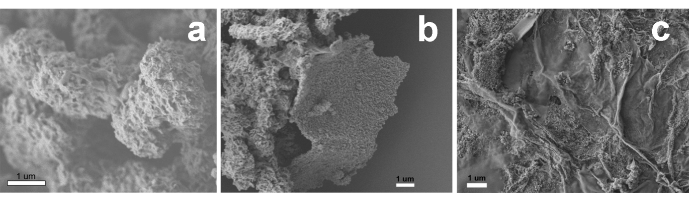
Fig. S1. SEM image of the a) GCS0, b) GCS1 and c) GCS4.

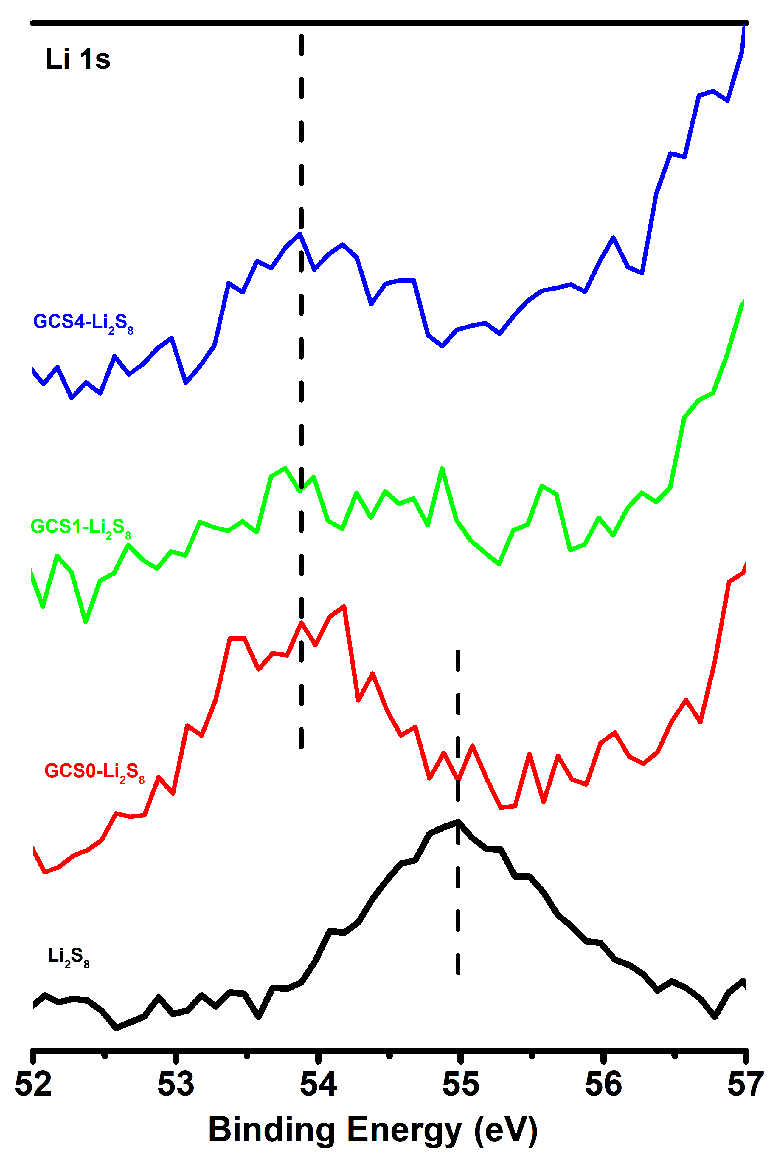
Fig. S2. Li 1s spectrum of Li₂S₈, GCS0-Li₂S₈, GCS1-Li₂S₈, and GCS4-Li₂S₈.

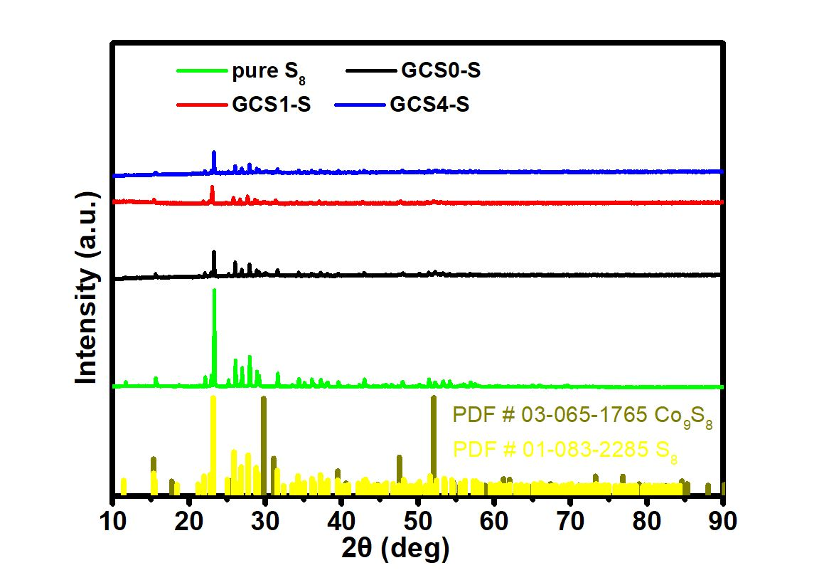
Fig. S3. PXRD patterns of pure sulfur and GCSx (x=0, 1, 4)-sulfur composites.
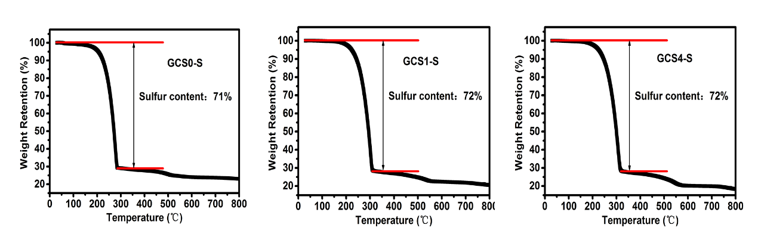
Fig. S4. TGA analysis of GCSx (x=0, 1, 4)-S composites.
Table S1. Effects of graphene content on crystallite size and surface area of different Co₉S₈-GO samples.
Samples | Graphene oxide content | Crystallite size  (311) (nm) | Surface area (BET)  (m² g⁻¹)
GCS0 | 0.0 wt% |  | 8.5
GCS1 | 1.0 wt% | 38 | 8.5
GCS4 | 4.1 wt% | 33 | 16.5

Table S2. Elemental analysis of different Co₉S₈-GO samples.
Samples | Carbon (wt%) | Nitrogen (wt%) | C/N ratio
GCS1 | 2.8 | 1.32 | 2.1
GCS4 | 7.9 | 1.40 | 5.6

Table S3. Lithium ion diffusion coefficients calculated from the current peaks from CV curves.ª
D_{Li+} coefficient (cm² s⁻¹) | I_{c1} | I_{c2} | I_{a}
GCS0 | 5.5320E-10 | 3.1213E-09 | 1.0360E-08
GCS1 | 3.0376E-09 | 2.5058E-08 | 2.6980E-08
GCS4 | 1.4242E-09 | 1.1926E-08 | 1.1705E-08

a. D_{Li+} coefficients were calculated by the Randles−Sevcik equation,
I_{p}= (2.69 × 10⁵) n^{1.5} S D_{Li+}^{0.5} C_{Li+} ν^{0.5}, where I_{P} is the peak current, n is the charge transfer number, S is the geometric area of the active electrode, D_{Li+} is the lithium ion diffusion coefficient, C_{Li+} is the concentration of lithium ions in the cathode, and ν is the potential scan rate. Here, n=2, S=1.32665E-4 m², C_{Li+}=1.2 mol L⁻¹, ν=0.1 mV s⁻¹.

