Supporting Information

Niobium oxyphosphate nanosheet assembled two-dimensional anode material for enhanced lithium storage
Bo Wen^{a,1}, Ruiting Guo^{a,1}, Xiong Liuª, Wen Luoª, Qiu He^{b}, Chaojiang Niuª, Jiashen Mengª, Qi Li^{a,*}, Yan Zhao^{b}, Liqiang Mai^{a,c}
ª State Key Laboratory of Advanced Technology for Materials Synthesis and Processing, Wuhan University of Technology, Wuhan 430070, Hubei, China
^{b} State Key Laboratory of Silicate Materials for Architectures, Wuhan University of Technology, Wuhan 430070, Hubei, China
^{c} Foshan Xianhu Laboratory of the Advanced Energy Science and Technology Guangdong Laboratory, Foshan 528216, Guangdong, China
*Corresponding author.
¹These authors contributed equally to this work.
E-mail address: qi.li@whut.edu.cn (Q. Li).

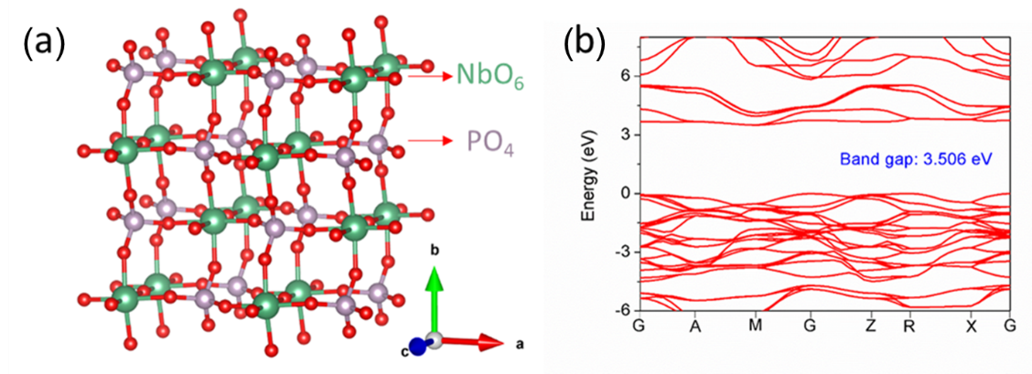
Fig. S1 (a) Crystal structure of the NbOPO₄. The green, purple and red balls represent Nb, P and O atoms, respectively. (b) Density functional theory (DFT)-calculated band structure of NbOPO₄.
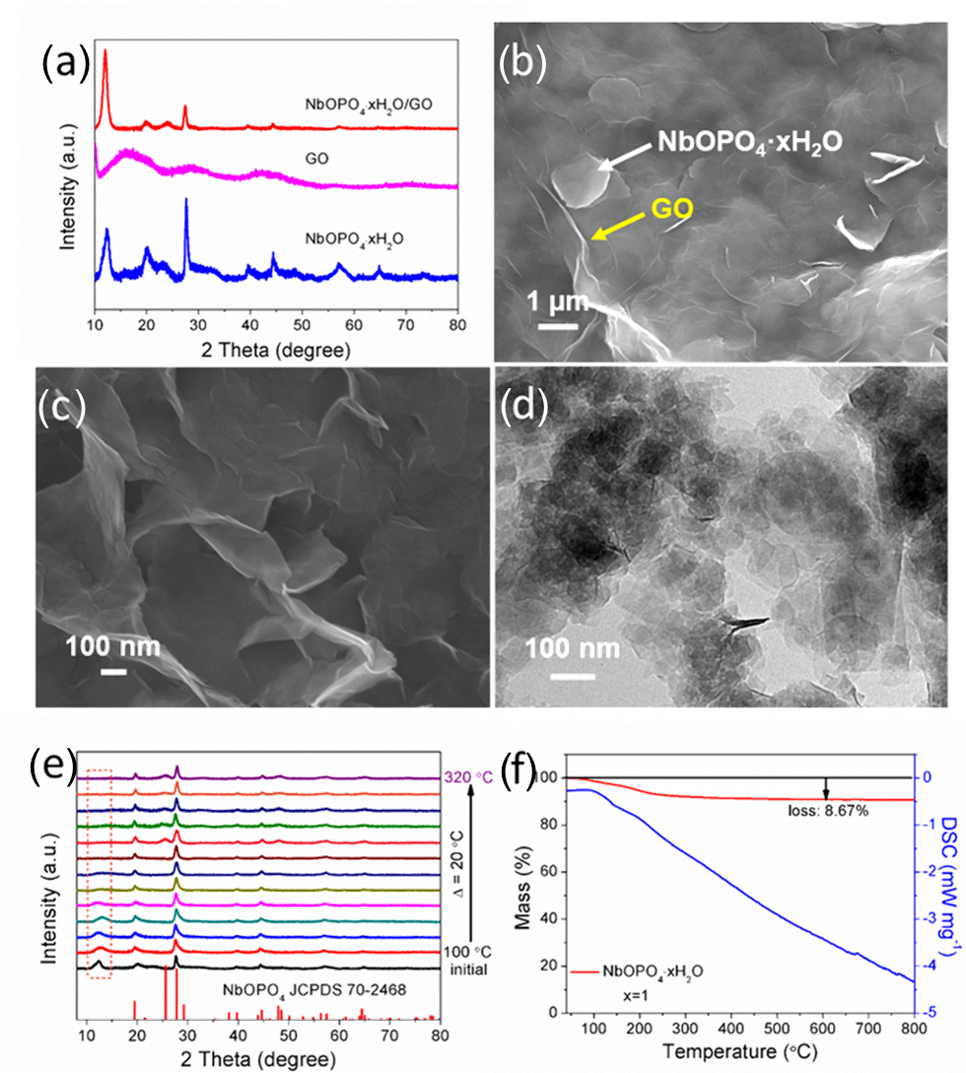
Fig. S2 (a) XRD patterns of NbOPO₄·xH₂O, GO and NbOPO₄·xH₂O/GO. (b,c) SEM images of NbOPO₄·xH₂O/GO composite and NbOPO₄·xH₂O nanosheets, respectively. (d) TEM image of NbOPO₄·xH₂O nanosheets. (e) XRD patterns of NbOPO₄·xH₂O powder calcined at different temperatures in air. (f) TG-DSC curves of NbOPO₄·xH₂O powders calcined in air.

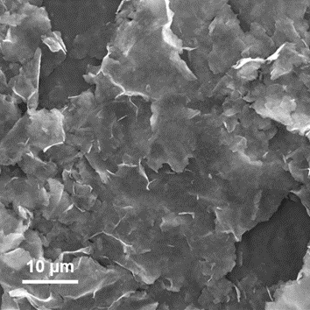
Fig. S3 SEM image of NbOPO₄/rGO.
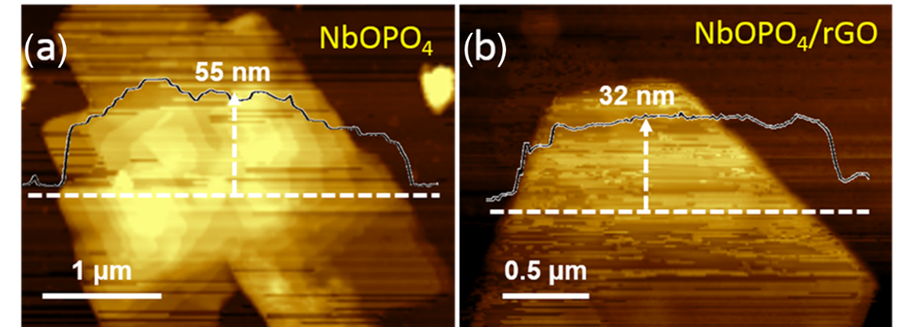
Fig. S4 AFM images of rGO-free NbOPO₄ nanosheets (a) and rGO-supported NbOPO₄ nanosheets (b), respectively.
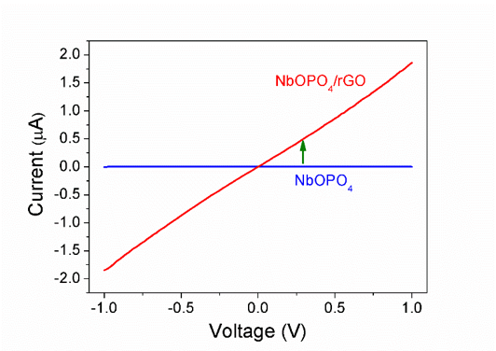
Fig. S5 I-V curves of NbOPO₄ and NbOPO₄/rGO.

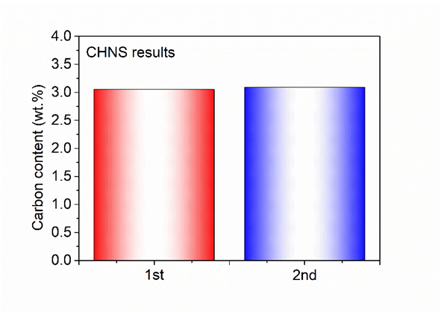
Fig. S6 Carbon content deduced from CHNS results of NbOPO₄/rGO.
Fig. S7 Thermogravimetric analysis of NbOPO₄/rGO tested in the air.

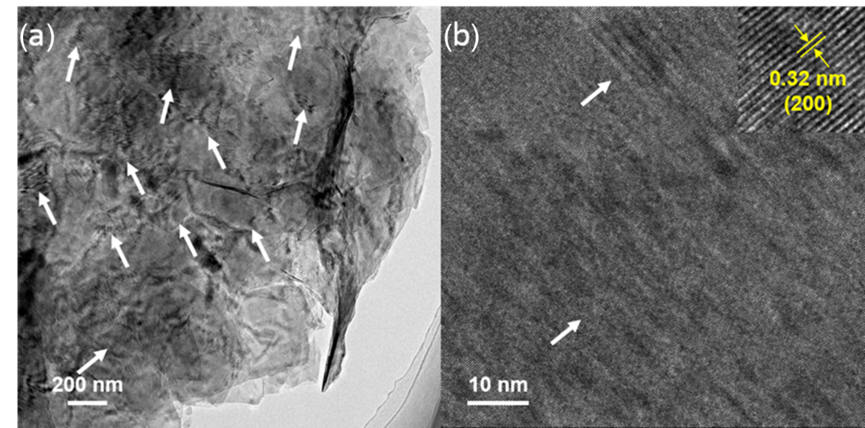
Fig. S8 (a,b) TEM images of NbOPO₄/rGO.
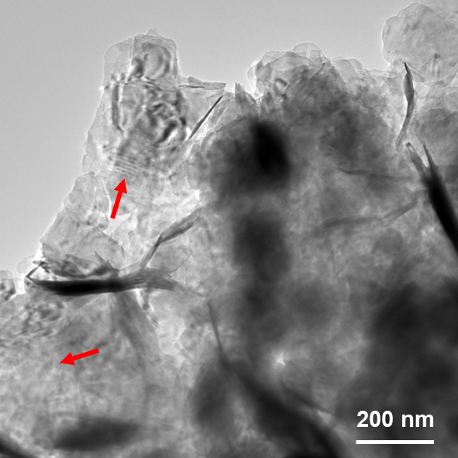
Fig. S9 TEM images of NbOPO₄.

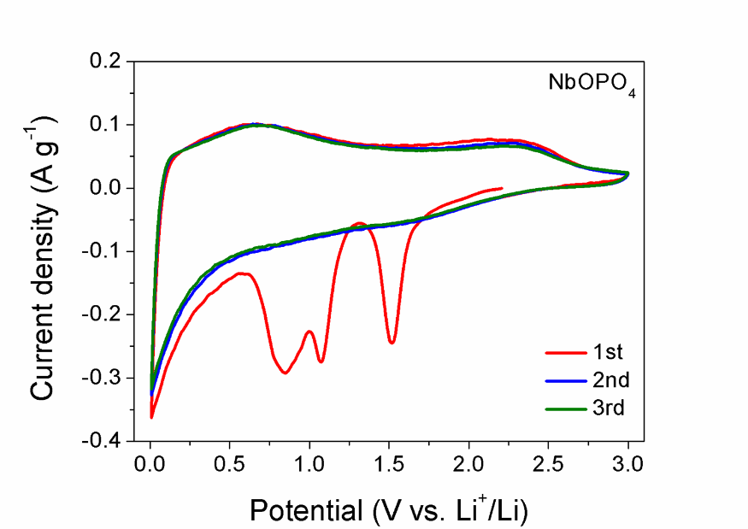
Fig. S10 CV curves of NbOPO₄ at a scan rate of 0.1 mV s⁻¹.
Fig. S11 The discharge/charge profiles of NbOPO₄/rGO at 500 mA g⁻¹ in the first three cycles.

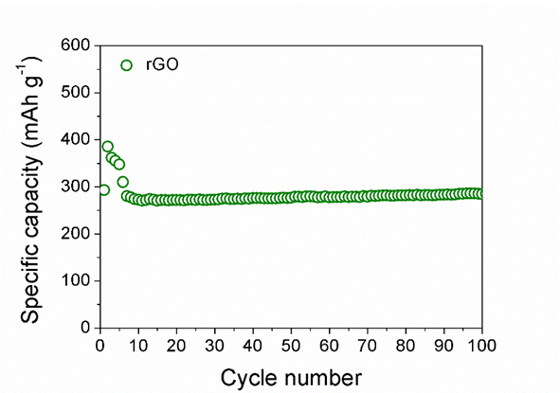
Fig. S12 Cycling performance of rGO measured at 500 mA g⁻¹.
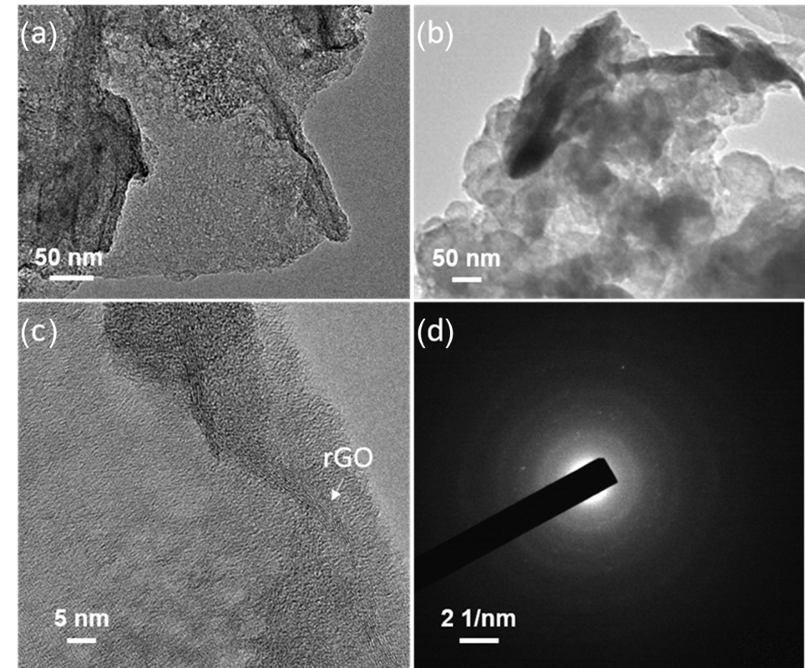
Fig. S13 TEM images of NbOPO₄/rGO (a) and NbOPO₄ (b) after long-term cycling at 500 mA g⁻¹. HRTEM image (c) and SAED pattern (d) of NbOPO₄/rGO after long-term cycling.

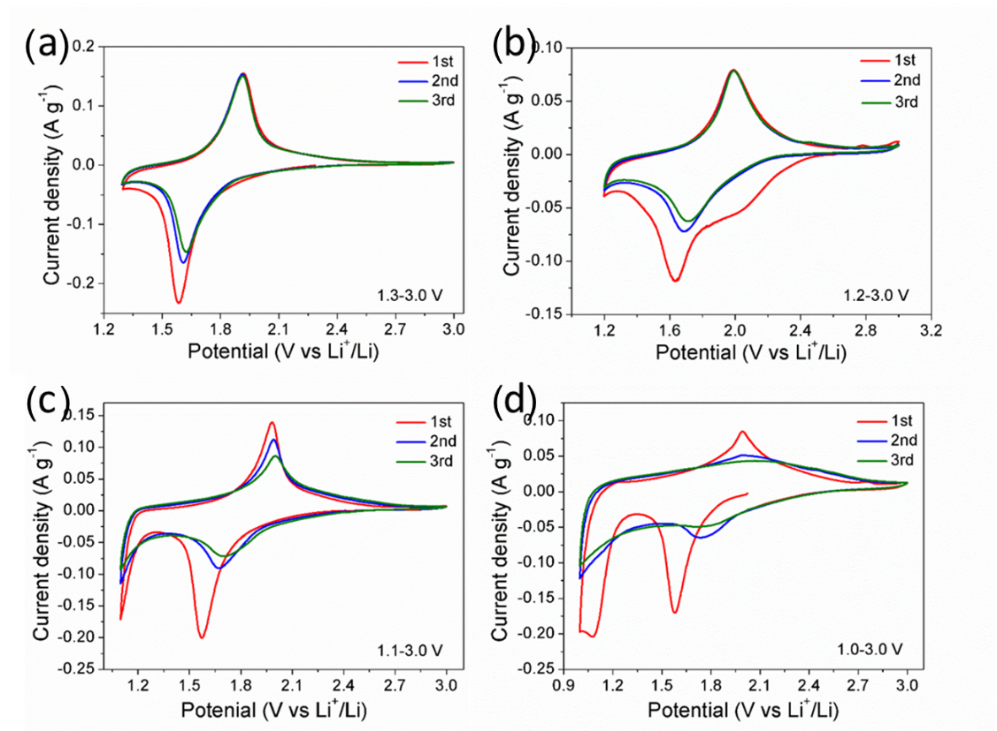
Fig. S14 (a-f) CV curves of the NbOPO₄/rGO anode at a scan rate of 0.1 mV s⁻¹ in the different voltage ranges: 1.3-3.0 V (a), 1.2-3.0 V (b), 1.1-3.0 V (c), 1.0-3.0 V (d).
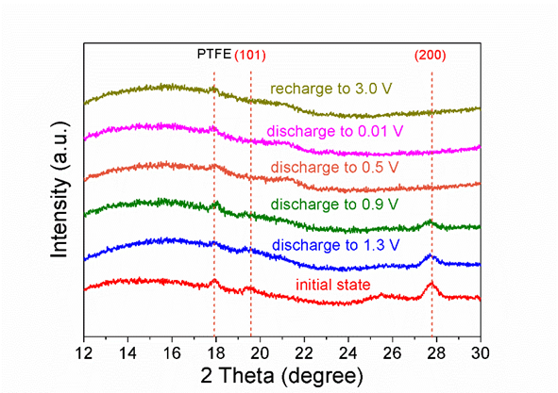
Fig. S15 Ex-situ XRD spectra of NbOPO₄/rGO at different states.

Table S1. Comparison of of our work and previous reports in different single/mixed metal oxides for LIB anodes.
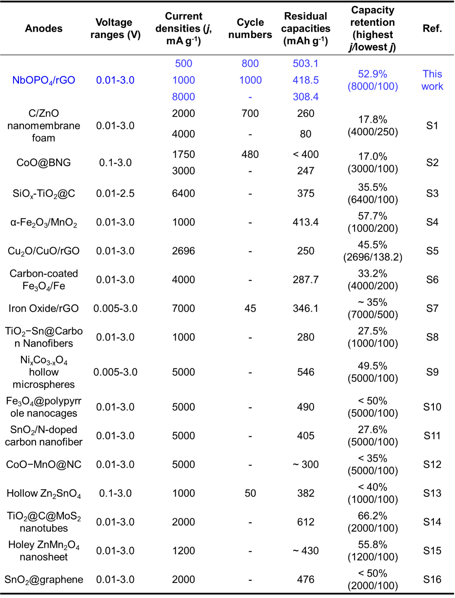

Table S2. Comparison of of our work and previous reports in different phosphate materials for LIB anodes.
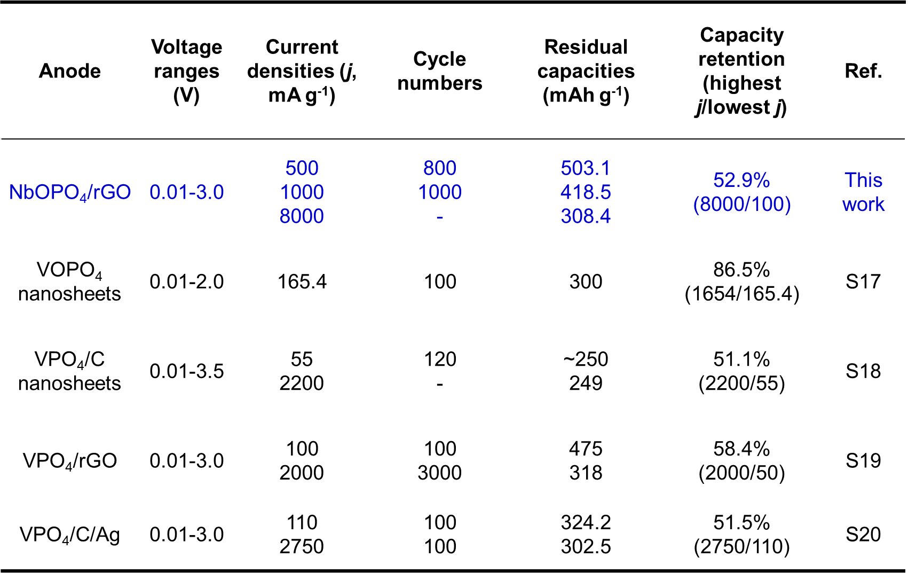

References
[1] Y. Zhao, G. Huang, Y. Li, R. Edy, P. Gao, H. Tang, Z. Bao, Y. Mei, J. Mater. Chem. A 6 (2018) 7227-7235.
[2] H. Tabassum, R. Zou, A. Mahmood, Z. Liang, Q. Wang, H. Zhang, S. Gao, C. Qu, W. Guo, S. Guo, Adv. Mater. 30 (2018) 1705441.
[3] Z. Li, H. Zhao, P. Lv, Z. Zhang, Y. Zhang, Z. Du, Y. Teng, L. Zhao, Z. Zhu, Adv. Funct. Mater. 28 (2018) 1605711.
[4] D. Wang, Y. Wang, Q. Li, W. Guo, F. Zhang, S. Niu, J. Power Sources 393 (2018) 186-192.
[5] S. Wu, G. Fu, W. Lv, J. Wei, W. Chen, H. Yi, M. Gu, X. Bai, L. Zhu, C. Tan, Y. Liang, G. Zhu, J. He, X. Wang, K. Zhang, J. Xiong, W. He, Small 14 (2018) 1702667.
[6] M. Li, H. Du, L. Kuai, K. Huang, Y. Xia, B. Geng, Angew. Chem. Int. Ed. 56 (2017) 12649-12653.
[7] A. AbdelHamid, Y. Yu, J. Yang, J. Ying, Adv. Mater. 29 (2017) 1701427.
[8] M. Mao, F. Yan, C. Cui, J. Ma, M. Zhang, T. Wang, C. Wang, Nano Lett. 17 (2017) 3830-3836.
[9] L. Wu, Z. Wang, Y. Long, J. Li, Y. Liu, Q. Wang, X. Wang, S. Song, X. Liu, H. Zhang, Small 13 (2017) 1604270.
[10] J. Liu, X. Xu, R. Hu, L. Yang, M. Zhu, Adv. Energy Mater. 6 (2016) 1600256.
[11] L. Xia, S. Wang, G. Liu, L. Ding, D. Li, H. Wang, S. Qiao, Small 12 (2016) 853-859.
[12] J. Meng, X. Liu, J. Li, Q. Li, C. Zhao, L. Xu, X. Wang, F. Liu, W. Yang, X. Xu, Z. Liu, C. Niu, L. Mai, Nano Lett. 17 (2017) 7773-7781.
[13] X. Liu, C. Niu, J. Meng, X. Xu, X. Wang, B. Wen, R. Guo, L. Mai, J. Mater. Chem. A 4 (2016) 14095-14100.
[14] S. Wang, B. Guan, L. Yu, X. Lou, Adv. Mater. 29 (2017) 1702724.
[15] L. Peng, P. Xiong, L. Ma, Y. Yuan, Y. Zhu, D. Chen, X. Luo, J. Lu, K. Amine, G. Yu, Nat. Commun. 8 (2017) 1-10.
[16] J. Han, D. Kong, W. Lv, D. Tang, D. Han, C. Zhang, D. Liu, Z. Xiao, X. Zhang, J. Xiao, X. He, F. Hsia, C. Zhang, Y. Tao, D. Golberg, F. Kang, L. Zhi, Q. Yang, Nat. Commun. 9 (2018) 1-9.
[17] B. Zhang, Y. Han, J. Zheng, J. Zhang, C. Shen, L. Ming, X. Yuan, H. Li, Chem. Commun. 50 (2014) 11132-11134.
[18] J. Zheng, Y. Han, B. Zhang, C. Shen, L. Ming, X. Ou, J. Zhang, ACS Appl. Mater. Inter. 6 (2014) 6223-6226.
[19] W. Lu, L. Cong, Y. Liu, J. Liu, A. Mauger, C. Julien, L. Sun, H. Xie, J. Alloy. Comp. 812 (2020) 152135.
[20] L. Hu, S. Zheng, S. Cheng, Z. Chen, B. Huang, Q. Liu, Q. Chen, Mater. Lett. 246 (2019) 40-44.

