Supporting Information

Boosting the Electrochemical Performance and Reliability of Conducting Polymer Microelectrode via Intermediate Graphene for On-chip Asymmetric Micro-supercapacitor
Muhammad Tahir, Liang He, Wei Yang, Xufeng Hong, Waqas Ali Haider, Hui Tang, Zhe Zhu, Kwadwo Asare Owusu, Liqiang Mai
State Key Laboratory of Advanced Technology for Materials Synthesis and Processing, Wuhan University of Technology, Wuhan 430070, P. R. China

Figure S1. Schematic illustration of the synthesis procedure of PPy@rGO anode and PEDOT@rGO cathode on rGO@Au.

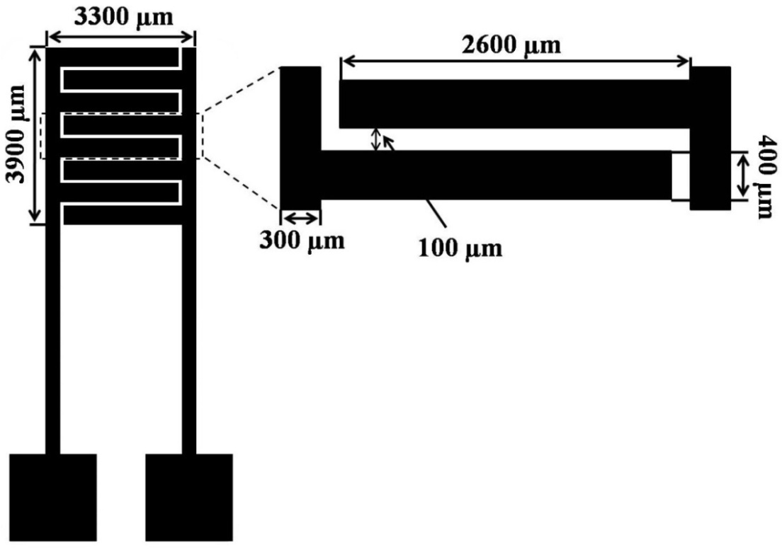
Figure S2. The design and dimensions of the AMSC.

Figure S3. Surface morphologies of PEDOT and PPy (scale bar = 1 µm). SEM images of PEDOT@Au (a) and PEDOT electrochemically deposited on rGO@Au (b). SEM images of PPy@Au (c) and PPy deposited on rGO@Au (d). SEM image of peeled PPy film (e) and cross-sectional SEM image of PPy@Au (f).

Figure S4. AFM height profile images and corresponding thicknesses of single-step deposited layer (a) and multi-step deposited layer (b, c) of electrochemically deposited rGO on Au current collectors.

Figure S5. AFM and height profile images of PPy@rGO (a) and PEDOT@rGO (b) on Au current collectors.

Figure S6. (a) Deconvolution of the C 1s spectra of PPy@rGO and PPy@Au. (b) Deconvolution of the O 1s spectra of PPy@rGO and PPy@Au.

Figure S7. (a) GCD curves of PPy@Au and PPy@rGO microelectrodes at a current density of 0.5 mA cm⁻². (b) CV curves of PPy@Au microelectrode at different scan rates from 5 to 20 mV s⁻¹ in 2 M KCl electrolyte.
Figure S8. Electrochemical performance of rGO-MSC. (a) CV curves of rGO-MSC at different scan rates from 10 to 400 mV s⁻¹. (b) GCD curves of rGO-MSC at different current densities from 10 to 1000 µA cm⁻². (c) EIS plot of rGO-MSC (the inset shows the zoom view of high-frequency region). (d) Areal capacitance evolution of rGO-MSC at different current densities under a potential window of 0-0.8 V.

Figure S9. SEM images of PPy@Au (a) and PPy@rGO (b) after cycling in 2 M KCl electrolyte.

Figure S10. Discharge curves of (a) PEDOT@rGO and (b) PPy@rGO microelectrodes at a constant current density of 0.25 mA cm⁻² in 2 M KCl electrolyte with three-electrode system.

For AMSC, the charge balance between anode and cathode is calculated by following equations (1-3).^{[1]}
$Q_{-}=Q_{+}$ (1)
$Q_{+}=C_{+}×ΔV_{+}×A$ (2)
$Q_{-}=C_{-}×ΔV_{-}×A$ (3)

Where A is the area of electrode, Q₋ and Q₊ represent the stored charge, C₋ and C₊ are the capacitances. ΔV₋ and ΔV₊ are the voltages window of anode and cathode during charge/discharge process respectively.
The specific capacitances of microelectrodes and MSCs are calculated from galvanostatic discharge curves at different current densities using equation (4) below.
$Cs=\frac{I×Δt}{A×ΔV}$ (4)
Where Cs is the specific capacitance, I is the discharge current, A is the area of electrode/device and ΔV is the voltage window of the electrode/device.

Figure S11. Electrochemical characterization results of PEDOT@rGO cathode. (a) CV curves of PEDOT@Au and PEDOT@rGO microelectrodes at a scan rate of 50 mV s⁻¹. (b) GCD curves of PEDOT@Au and PEDOT@rGO microelectrodes at a current density of 0.5 mA cm⁻². (c) EIS plots of PEDOT@rGOand PEDOT@Au cathodes (the inset shows the zoom view of high frequency region). (d) CV curves at different scan rates from 2 to 50 mV s⁻¹. (e) GCD curves at different current densities from 0.25 to 2 mA cm⁻². (e) Charge/discharge cycling performance at a current density of 5 mA cm⁻².

Figure S12. Areal capacitance vs. current density of PEDOT@rGO//PPy@rGO-AMSC.
Figure S13. Volumetric energy density of PEDOT@rGO//PPy@rGO AMSC compared with (a) aqueous batteries, supercapacitor and (b) recently reported conducting polymers based planar MSCs. Data are collected from refs. [2-13].

Figure S14. Photograph of a digital stopwatch powered by two PEDOT@rGO//PPy@rGO AMSCs connected in series.

Table S1. Comparison of performances of this work and previously reported MSCs.
Sample | Electrolyte | C_{A}  (mF cm⁻²) | C_{V}  (mF cm⁻³) | Energy density (mWh cm⁻³) | Cycling performance | Reference
PEDOT@rGO//  PPy@rGO-AMSC | 2 M KCl | 15.9 | 99.31 | 27.02 | 79%/5000 cycles | This work
rGO-QDs/MnO₂ | EMIM-NTF2-FS | 2.98 | ----- | ----- | ----- | [14]
COF-MSC | LiCl/PVA | 15.2 | ----- | 7.3 | 93.1%/5000 cycles | [15]
Thiophene Nst/graphene MSC | H₂SO₄/PVA | 3.9 | ----- | 13 | 86%/10000 cycle | [16]
Co₃O₄/Pt MSC | 1 M KOH | 0.49 | 31.7 | 3.17 | 91%/5000 cycles | [17]
Fe₂O₃/MnO₂ AMSC | 1 M KOH | 2.5 | 60 | 12 | 80%/2500 cycle | [18]
C-MoS₂@rGO CNT  MSC | PVA/H₂SO₄ | 13.7 | 40 | 5.6 | 96%/10000 cycles | [19]
MXene/graphene MSC | H₃PO₄/PVA | 3.26 | ----- | 3.4 | 82%/2500 cycles | [20]
MHCF/graphene  MSC | LiCl/PVA | 19.8 | ----- | 44.6 | 96.8%/5000 cycles | [21]
Phosphorene/graphene MSC | Ionic liquid | 9.8 | ----- | 11.6 | 89.5%/2000 cycles | [22]
PEDOT MSC | PVA/H₂SO₄ | 9 | 50 | 7.7 | 80%/1000 cycles | [23]
EG//MnO₂-PH1000 MSC | LiCl/PVA | 9.6 | 19.2 | 8.6 | 92%/5000 cycles | [24]

Supplementary references
- L. Qin, Q. Tao, X. Liu, M. Fahlmn, J. Rosena, F. Zhang, J. Halima, Nano Energy 2019, 60, 734-742.
- M. Liu, L. Chen, J. Zhang, J. Jiang, J. Yan, Y. Huang, J. Lin, H. J. Fan, Z. X. Shen, Nano Lett. 2014, 14, 7180-7187.
- Y. Ren, W. Zhang, X. Bai, Z. Chen, X. Zhang, W. Fang, Y. Weng, H. Wang, Angew. Chem. 2014, 126, 7998-8003.
- Z. Lu, X. Wu, X. Lei, Y. Li, X. Sun, Inorg. Chem. Front. 2015, 2, 184-190
- Z. Li, G. Ma, R. Ge, F. Qin, X. Dong, W. Meng, T. Liu, J. Tong, F. Jiang, Y. Zhou, Angew. Chem. 2016, 128, 991-997
- R. Li, Y. Wang, C. Zhou, C. Wang, X. Ba, Y. Li, X. Huang, J. Liu, Adv. Funct. Mater. 2015, 25, 5384.
- L. Li, Z. Lou, W. Han, D. Chen, K. Jiang, G. Shen, Adv. Mater. 2017, 2, 1600282.
- M. Zhu, Y. Huang, H. Li, C. Zhi, Adv. Mater. 2017, 29, 1605137.
- D. Aradilla, D. Gaboriau, G. Bidan, P. Gentile, M. Boniface, D. Dubal, P. Gómez-Romero, J. Wimberg, T. J.S, S. Sadki, J. Mater. Chem. A. 2015, 3, 13978-13985.
- M. Tahir, L. He, W. A. Haider, W. Yang, X. Hong, Y. Guo, X. Pan, H. Tang, Y. Li, L. Mai, Nanoscale 2019, 11, 7761-7770.
- W. Liu, X. Yan, J. Chen, Y. Feng, Q. Xue, Nanoscale 2013, 5, 6053-6059.
- Kurra. N, M. Hota, K, Alshareef, Nano Energy 2016, 13, 500-508.
- H. Hu, K. Zhang, S. Li, S. Ji, C. Ye, J. Mater. Chem. A. 2014, 2, 20916-20922.
- B. Shen,J. Lang, J. Guo, R. Zhang, X. Yan, ACS Appl. Mater. Interfaces 2015, 7, 25378-25385.
- J. Xu, Y. He, S. Bi, M. Wang, P. Yang, D. Wu, J. Wang, F. Zhang, Angew. Chem. Int. Ed. 2019, 58, 12065-12069.
- Z. Wu, Y. Zheng,S. Zheng,S. Wang,C. Sun,K. Parvez,T. Ikeda,X. Bao, X. K. Feng, Adv. Mater. 2016, 29, 1602960.
- X. Ma, S. Feng, L. He, M. Yan, X. Tian, Y. Li, C. Tang, X. Hong, L. Mai, Nanoscale, 2017, 9, 11765-11772.
- Z. Liu, X. Tian, X. Xu, L. He, M. Yan, C. Han, Y. Li, W. Yang, L. Mai, Nano Res. 2017, 10, 2471-2481.
- W. Yang, L. He, X. Tian, M. Yan, H. Yuan, X. Liao, J. Meng, Z. Hao, L. Mai, Small, 2017, 13, 1700639.
- H. Li, H. Yang, F. Wang, M. R. Lohe, X. Zhuang, N. Li, X. Feng, Adv. Energy Mater. 2016, 9, 2847-2854.
- Y. He, P. Zhang,M. Wang, F. Wang, X. Feng, Mater. Horiz. 2019, 6, 1041-1049.
- H. Xiao, Z. Wu, L. Chen, F. Zhou, S. Zheng, W. Ren, W. Cheng, H. M. Bao, ACS Nano 2017, 11, 7284-7292.
- N. Kurra, M. K. Hota, H. N. Alshareef, Nano Energy, 2015, 13, 500-508.
- S. Zheng, W. Lei, J. Qin, Z. S. Wu, F. Zhou, S. Wang, X. Shi, C. Sun, Y. Chen, X. Bao, Energy Storage Mater. 2018, 10, 24-29.

