Supporting Information for
Built-in Oriented Electric Field Facilitating Durable Zn-MnO₂ Battery
Sitian Lian^{1#}, Congli Sun^{1#}, Weina Xu^{2,3,4#}, Wangchen Huo⁴, Yanzhu Luo⁵, Kangning Zhao^{1,2∗}, Guang Yao³, Wangwang Xu⁶, Yuxin Zhang⁴, Zhi Li¹, Kesong Yu¹, Hongbin Zhao², Hongwei Cheng^{2,3}, Jiujun Zhang², Liqiang Mai^{1∗}
1. States State Key Laboratory of Advanced Technology for Materials Synthesis and Processing, Wuhan University of Technology, Wuhan 430070, P. R. China
E-mail: vicyel@126.com(K.Z.); mlq518@whut.edu.cn (L.M.)
2. College of Sciences & Institute for Sustainable Energy, Shanghai University, Shanghai 200444, China
3. Department of Material Science and Engineering, University of Wisconsin-Madison, Madison, Wisconsin 53706, USA
4. College of Materials Science and Engineering, Chongqing University, Chongqing 400044, China
5. College of Science, Huazhong Agricultural University, Wuhan 430070, China
6. Department of Mechanical and Industrial Engineering, Louisiana State University, Baton Rouge, LA, USA
# These author contributed equally.
KEYWORDS: oxygen vacancy; Ti doping; Localized electric field; Zn ion battery
Experimental Details
Synthesis of Ti-MnO₂ NWs: The MnO₂ NW was prepared via a hydrothermal method following a previous report^{[53]}. Amorphous TiO₂ coating was synthesized in a home-made atomic layer deposition system following reported procedures^{[54]}. Briefly, TiCl₄ and H₂O vapors were pulsed into a 120 °C reaction chamber separately with a pulsing time of 0.5 s, separated by 60 s N₂ purging. One deposition cycle involves 0.5 s of H₂O pulse + 60 s of N₂ purging + 0.5 s of TiCl₄ pulse + 60 s of N₂ purging. A 5-nm-thick TiO₂ coating was deposited by 100 ALD cycles. The Ti-MnO₂ NWs were obtained by annealing the core-shell MnO₂@TiO₂ NWs at 450 °C in air for 4 h.
Structural Characterization: XRD were performed in a Bruker D8 Advance X-ray diffractometer with an area detector, using Cu Kα radiation (λ = 1.5418 Å). SEM and TEM images were recorded from a JEOL-7100F field-emission SEM (FESEM), and a FEI TF30 TEM. STEM and EELS characterizations were performed in a FEI Titan microscope with a CEOS probe aberration-corrector operated at 200 keV. The probe semi-angle is 24.5 mrad and the probe current was ~25 pA. HAADF STEM imaging was collected by a Fischione Model 3000 detector spanning 84 to 160 mrad in scattering angles. In these conditions the estimated probe size was less than 1 Å. EEL spectrum image were recorded with a GIF 865 spectrometer, with an energy dispersion of 0.5 eV / pixel, which allowed for the simultaneous visualization of the O K, Ti L, and Mn L EELS edges. The energy resolution was 0.9 eV measured from the full width at half maximum of zero-loss peak. Quantifications were calculated using the Digital Micrograph implementation of the standard quantification method.
Electrochemical Characterization. The battery electrodes were fabricated by grounding 70% active material, 20% acetylene black and 10% poly(tetrauoroethylene) (PTFE) together and then compressed into pellets. The mass loading of the electrode is ~3 mg cm⁻². The testing batteries were assembled into 2016 coin cells, using zinc plate as the anode. A mixture of 3 M Zn(CF₃SO₃)₂ and 0.1M Mn(CF₃SO₃)₂ solution was used as the electrolyte. The presence of Mn(CF₃SO₃)₂ in the electrolyte could compensate the dissolution equilibrium of Mn²⁺ from the MnO₂ electrode and stabilize the electrode. The presence of Mn(CF₃SO₃)₂ in the electrolyte could compensate the dissolution equilibrium of Mn²⁺ from the MnO₂ electrode and stabilize the electrode. Galvanostatic discharge was studied in a potential range of 0.8-1.8 V vs. Zn/Zn²⁺ with a multichannel battery testing system (LAND CT 2001A). The gravimetric specific capacity was calculated based on the mass of active materials. EIS was tested using an Autolab Potentiostat Galvanostat (PGSTAT302N) within the frequency range from 0.1 to 10000 Hz at 0.01 V.
Calculation Details. All density functional theory (DFT)^{[1,2]} calculations were operated at the Vienna ab-initio simulation package (VASP5.4)^{[3]}, using the projector augmented wave (PAW) method, and the generalized gradient approximation (GGA) with the Perdew-Burke-Ernzerhof (PBE)^{[4]} functional was applied for the exchange-correlation functional. The studied models with defects (Ti doped and oxygen vacancies) consist of a 1 × 1 × 3 unit cell. A plane-wave basis set with a cutoff energy of 500 eV was employed ^{[5]}, the 4 × 4 × 4 Monkhorst Pack grid samples was adopted. The applied effective U value given to Mn ions was 4.0 eV, and to Ti ions was 3.4 eV. The energy cutoff for the plane-wave basis set was 520 eV and the force convergence criterion for the relaxation was 0.01 eV Å⁻¹. The Monkhorst-Pack scheme k-point sampling was used, and k-mesh was denser than 0.03 Å⁻¹. The simulations of the bulk structure were performed on the 1 × 1 × 3 unit cell. To simulate Ti doping bulk structure, one of Mn ions was substituted with Ti ion.

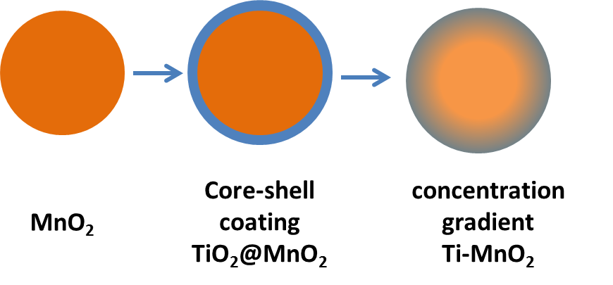
Fig. S1. Schematic illustration of the experimental process.
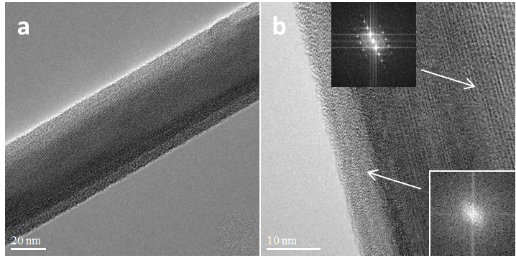
Fig. S2. TEM images of as-prepared TiO₂@MnO₂ core-shell NWs. Insets of a, and b are the FFT pattern of the core and the shell, respectively. c, HRTEM image of the termination of TiO₂@MnO₂ core-shell NW.
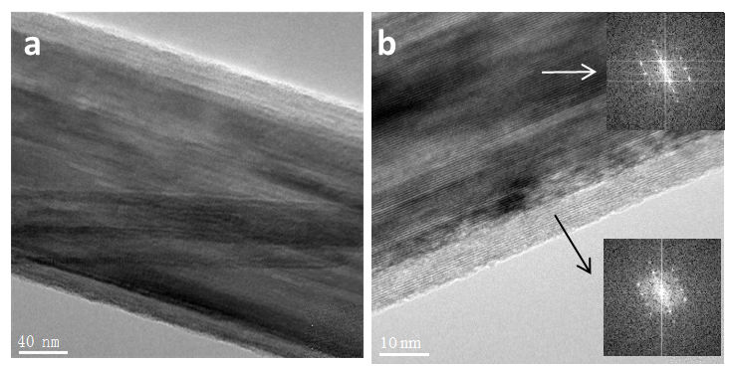
Fig. S3. TEM images of as-prepared Ti-MnO₂ NWs. Insets of a, and b are the FFT pattern of the core and the shell, respectively.

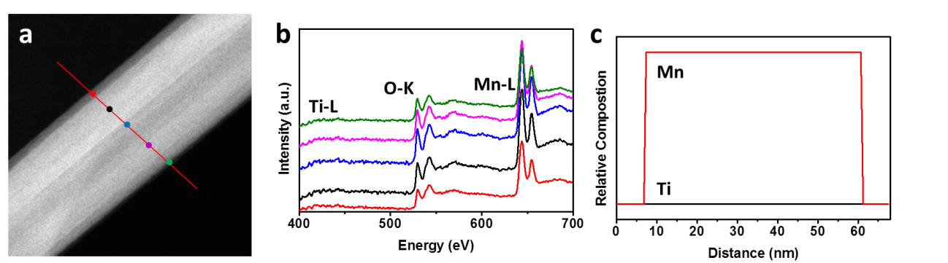
Fig. S4. Characterization of MnO₂ NWs. a, STEM image of MnO₂ NWs. b and c, EELS spectrum profiles from the surface to the interior as marked by the horizontal dashed lines with the same color as in b, Relative atomic composition of O (red), Mn (blue), and Ti (black) as a function of position calculated based on the integrated EELS peak intensity in c.

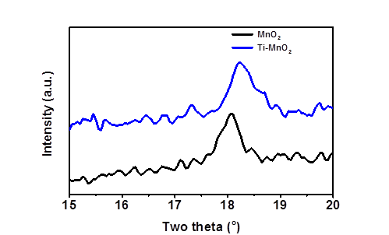
Fig. S5. Characteristic peak of (002) plane of Ti-MnO₂ in XRD pattern.
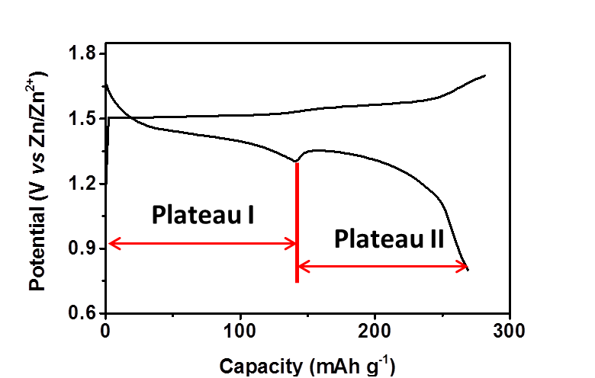
Fig. S6. Typical charge-discharge curves of Ti-MnO₂.
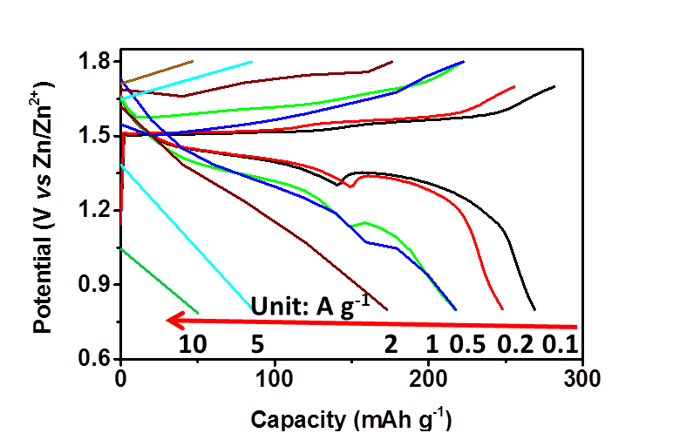
Fig. S7. Charge-discharge curves of Ti-MnO₂ at different current rates.
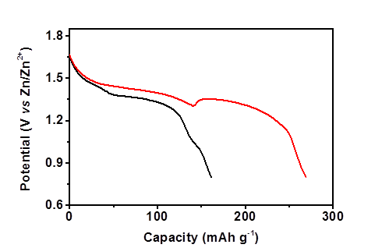
Fig. S8. Discharge curves of Ti-MnO₂ cathode in in 0.1M Mn(CF₃SO₃)₂ solution with or without Zn(CF₃SO₃)₂.
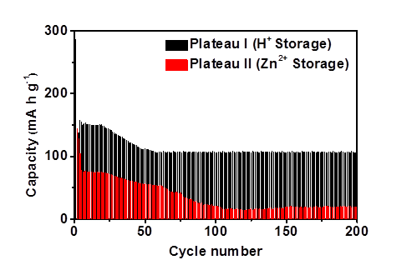
Fig. S9. Separation of H⁺ and Zn²⁺ storage capacity of MnO₂ at 100 mA g⁻¹.
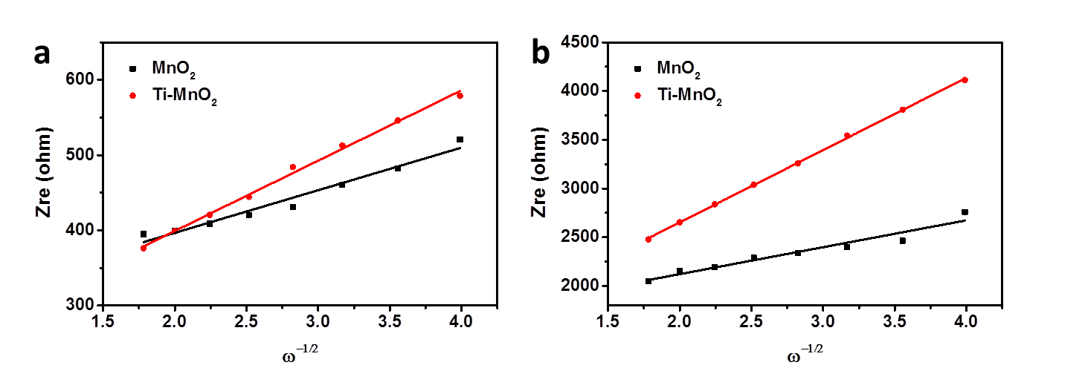
Fig. S10. Variations and fittings between Zr and the reciprocal square root of the angular frequency in the low frequency region of MnO₂ NWs and Ti-MnO₂ NWs, respectively.
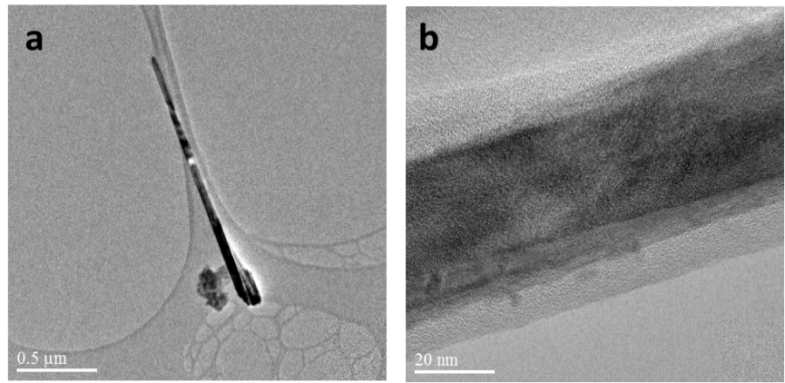
Fig. S11. TEM images of Ti-MnO₂ after long-term cycling.
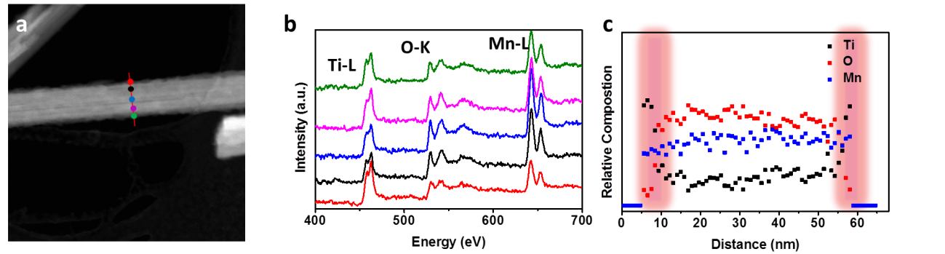
Fig. S12. Ex-situ characterization of Ti-MnO₂ after long-term cycling. a, b, EELS spectrum profiles from the surface to the interior as marked by the horizontal dashed lines with the same color as in a. c, Relative atomic composition of O (red), Mn (blue), and Ti (black) as a function of position calculated based on the integrated EELS peak intensity in b.
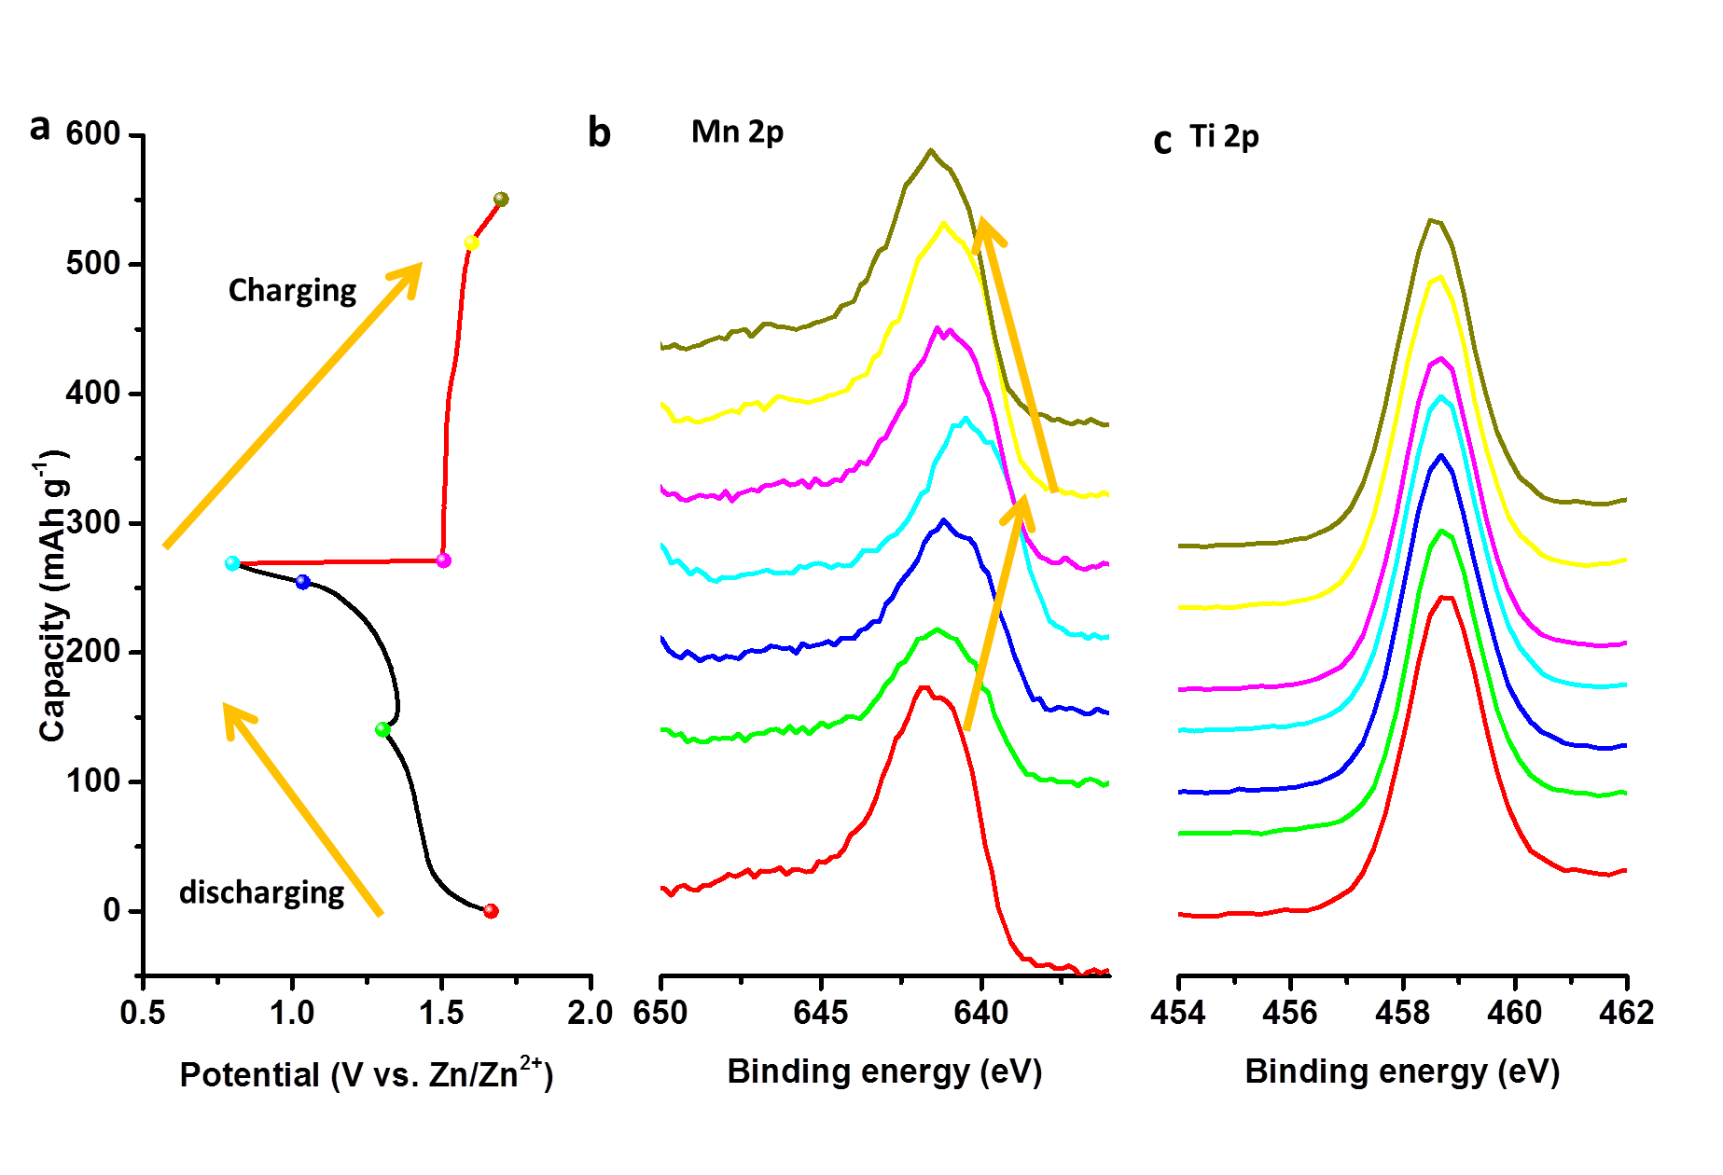
Fig. S13. Ex-situ XPS characterization of Ti-MnO₂ at different potential during charging/discharging.
Table S1. Summary of the fitting results of the EIS spectrum
Sample | R_{s} | R_{ct}
Ti-MnO₂@1.5 V | 1.9 | 175
MnO₂@1.5 V | 1.2 | 332
Ti-MnO₂@0.9 V | 1.6 | 836
MnO₂@0.9 V | 1.2 | 1642

Reference
[1] G. Kresse, J. Furthmiiller, Computational Materials Science 1996, 6, 15.
[2] S. Grimme, Journal of Computational Chemistry 2006, 27, 1787.
[3] G. Kresse, physical Review B 1996, 54, 16.
[4] J. P. Perdew, K. Burke, M. Ernzerhof, physical Review letters 1996, 77, 18.
[5] P. E. Blöchl, Physical Review B 1994, 50, 17953.

