Supplementary Information
Fast, green microwave-assisted synthesis of single crystalline Sb₂Se₃ nanowires towards promising lithium storage

Wen Luo^{a,b}, Jean-Jacques Gaumet^{*b}, Pierre Magri^{b}, Sébastien Diliberto^{c}, Feng Liª, Pascal Franchetti^{b}, Jaafar Ghanbaja^{c} and Liqiang Mai^{*a}

ª State Key Laboratory of Advanced Technology for Materials Synthesis and Processing, Wuhan University of Technology, Wuhan 430070, P. R. China
^{b} Laboratoire de Chimie et Physique: Approche Multi-échelles des Milieux Complexes, Institut Jean Barriol, Université de Lorraine, Metz 57070, France
^{c} Institut Jean Lamour, (UMR CNRS 7198) Université de Lorraine, Parc de Saurupt, CS 50840, Nancy 54011, France

*Corresponding author:
Jean-Jacques Gaumet: jean-jacques.gaumet@univ-lorraine.fr
Liqiang Mai: mlq518@whut.edu.cn

Table S1. Comparison of method, reducing agent, incubation time with previously published reports on Sb₂Se₃ via wet chemical approaches. Our method features high-quality (uniform ultralong nanowires with high yield), greener reducing agent and much shorter reaction time.
Sample | Method | Reducing  agent | Incubation time
Sb₂Se₃ nanowires  (This work) | Microwave synthesis | NaBH₄ | 0.5 h
Sb₂Se₃ submicron spheres^{[1]} | Microwave synthesis | ethylene glycol | 0.5 h
Sb₂Se₃ nanorods^{[2]} | Microwave synthesis | glycerol | 0.5 h
Sb₂Se₃ nanowires^{[3]} | Microwave synthesis | oleylamine | 1 h
Sb₂Se₃ nanowires^{[4]} | Solvothermal synthesis | benzyl alcohol | 24 h
Sb₂Se₃ nanoribbons^{[5]} | Hydrothermal reaction | NaBH₄ | 72 h
Sb₂Se₃ micro sheaf-like^{[6]} | Hydrothermal reaction | NaBH₄ | 12 h
Sb₂Se₃ hierarchical sphere^{[7]} | Solvothermal synthesis | ethanediamine | 18 h
Sb₂Se₃ nanoplates^{[8]} | Solvothermal synthesis | N₂H₄·H₂O +tetrahydrofuran | 9 h
Sb₂Se₃ nanosheets^{[9]} | Solvothermal synthesis | N₂H₄·H₂O  +tetrahydrofuran | 9 h
Sb₂Se₃ nanowires^{[10]} | Solvothermal synthesis | oleylamine | 32 h
Sb₂Se₃ nanorods/nanowires^{[11]} | Hydrothermal reaction | N₂H₄·H₂O | 24 h
Sb₂Se₃ nanowires^{[12]} | Hydrothermal reaction | NaBH₄ | 72 h
Sb₂Se₃ nanobelts^{[13]} | Hydrothermal reaction | N₂H₄·H₂O | 18 h
Sb₂Se₃ nanowires^{[14]} | Hydrothermal reaction | N₂H₄·H₂O | 36 h

Table S2. pH value of mixture solutions at interval state: 1) SbCl₃, Na₂SeO₃ dissolved in different volume ratio of EG and H₂O and 2) after adding NaBH₄ and stirring until totally dissolve.
 | pH  (E0) | pH  (E5) | pH  (E10) | pH  (E15) | pH  (E20)
1) After dissolving SbCl₃ and Na₂SeO₃ in mixture EG/H₂O solvent | 2.5 | 2.4 | 2.3 | 2.5 | 2.1
2) After adding NaBH₄ | 10.2 | 9.3 | 8.4 | 5.7 | 4.8

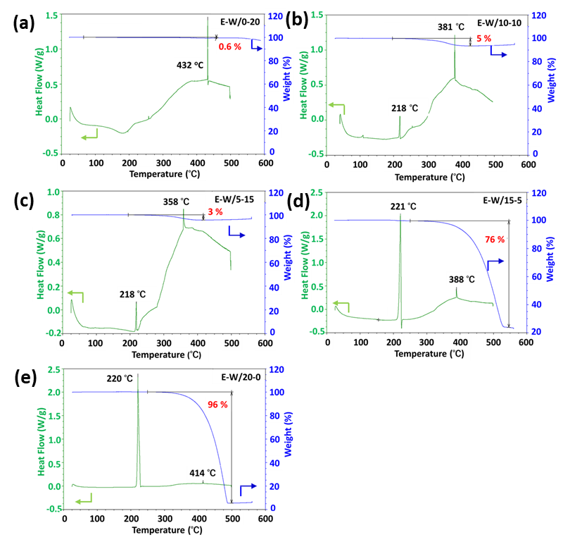
Fig. S1 TGA profiles and corresponding DSC curves of (a) sample E0, (b) sample E5, (c) sample E10, (d) sample E15 and (e) sample E20.
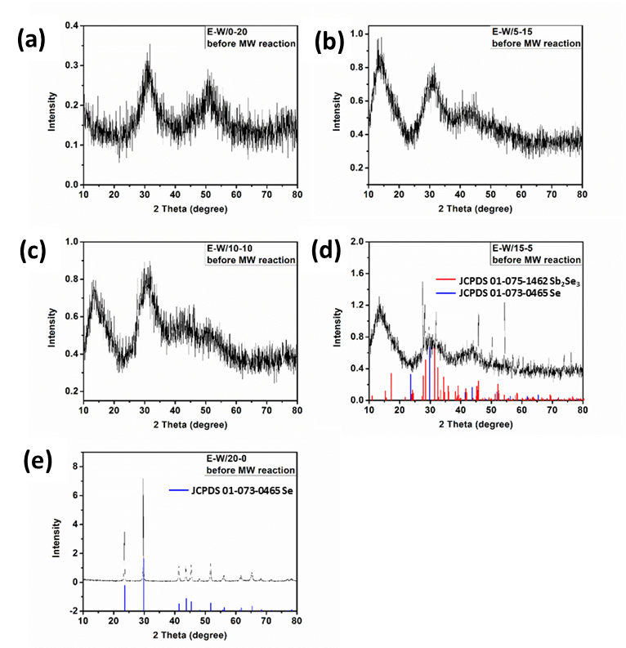
Fig. S2 XRD patterns of the intermediate products obtained with 3 h constant stirring reaction at room temperature before microwave heating (SbCl₃, Na₂SeO₃ and NaBH₄ dissolved in mixture solution of different volume ratio of EG and H₂O): (a) EG 0 mL + H₂O 20 mL; (b) EG 5 mL + H₂O 15 mL; (c) EG 10 mL + H₂O 10 mL; (d) EG 15 mL + H₂O 5 mL; (e) EG 20 mL + H₂O 0 mL).
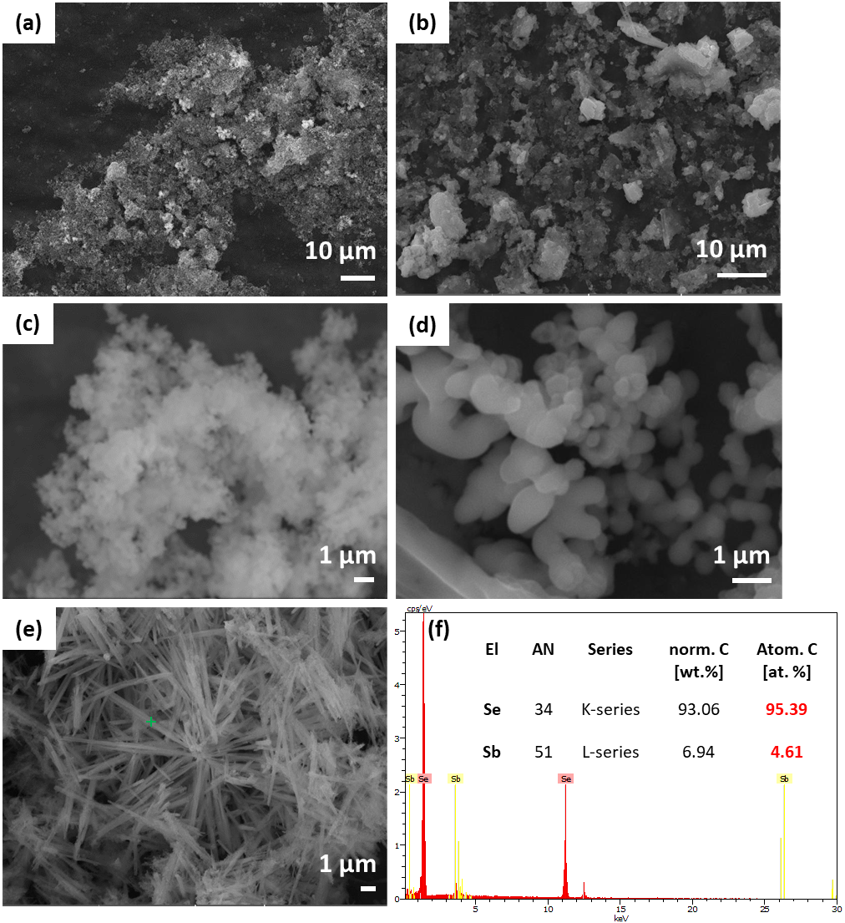

Fig. S3 SEM images of the intermediate products obtained with 3 h constant stirring reaction at room temperature before microwave heating (SbCl₃, Na₂SeO₃ and NaBH₄ dissolved in mixture solution of different volume ratio of EG and H₂O): (a) EG 0 mL + H₂O 20 mL; (b) EG 5 mL + H₂O 15 mL; (c) EG 10 mL + H₂O 10 mL; (d) EG 15 mL + H₂O 5 mL; (e) EG 20 mL + H₂O 0 mL). (f) EDX spectrum corresponds to green point area in Fig. S3(e).
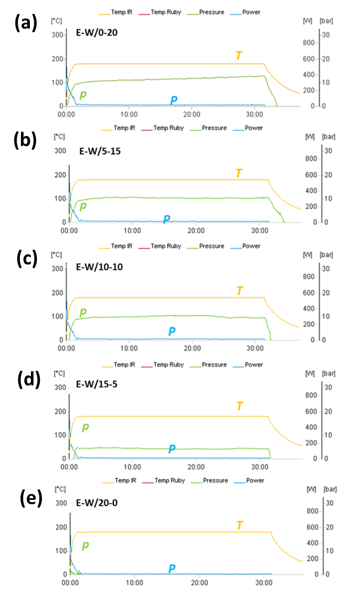
Fig. S4 The detailed parameters of power, temperature and pressure during whole microwave irradiation: (a) sample E0, (b) sample E5, (c) sample E10, (d) sample E15 and (e) sample E20

References in Supporting Information
[1] L. Guo, G. Ji, X. Chang, M. Zheng, Y. Shi and Y. Zheng, Nanotechnology, 2009, 21, 035606.
[2] C. Zhao, X.-B. Cao and X.-M. Lian, Mater. Lett. 2007, 61, 5083-5086.
[3] Y.-Q. Liu, M. Zhang, F.-X. Wang and G.-B. Pan, J. Mater. Chem. C, 2014, 2, 240-244.
[4] Z. Chen, F. Chen and N.-D. Tan, J. Mater. Sci.: Mater. El., 2015, 26, 970-977.
[5] Y. Yu, R. Wang, Q. Chen and L.-M. Peng, J. Phys. Chem. B, 2006, 110, 13415-13419.
[6] G.-Y. Chen, B. Dneg, G.-B. Cai, T.-K. Zhang, W.-F. Dong, W.-X. Zhang and A.-W. Xu, J. Phys. Chem. C, 2008, 112, 672-679.
[7] R. Jin, G. Chen, Q. Wang, J. Sun and Y. Wang, J. Mater. Chem., 2011, 21, 6628-6635.
[8] R. Jin, G. Chen, H. Xu and D. Chen, Int. J. Hydrogen Energy, 2013, 38, 10971-10977.
[9] R. Jin, Z. Liu, L. Yang, J. Liu, Y. Xu and G. Li, J. Alloys Compd., 2013, 579, 209-217.
[10] G. Chen, J. Zhou, J. Zuo and Q. Yang, ACS Appl. Mater. Interfaces, 2016, 8, 2819-2825.
[11] J. Ma, Y. Wang, Y. Wang, Q. Chen, J. Lian and W. Zheng, J. Phys. Chem. C, 2009, 113, 13588-13592.
[12] T. Zhai, M. Ye, L. Li, X. Fang, M. Liao, Y. Li, Y. Koide, Y. Bando and D. Golberg, Adv. Mater., 2010, 22, 4530-4533.
[13] R. Jin, G. Chen, J. Pei, J. Sun and Y. Wang, Nanoscale, 2011, 3, 3893-3899.
[14] W. Luo, A. Calas, C. Tang, F. Li, L. Zhou and L. Mai, ACS Appl. Mater. Interfaces, 2016, 8, 35219-35226.

