Supporting Information

Novel NaTi₂(PO₄)₃ Nanowire Clusters as High Performance Cathodes for Mg-Na Hybrid-ion Batteries

Yanan Xuª, Weijie Caoª, Yameng Yinª, Jinzhi Shengª, Qinyou An^{a,}*, Qiulong Weiª, Wei Yangª, Liqiang Mai^{a,}*

ª State Key Laboratory of Advanced Technology for Materials Synthesis and Processing, International School of Materials Science and Engineering, Wuhan University of Technology, Hubei, Wuhan 430070, P. R. China
* Corresponding authors.

E-mail: mlq518@whut.edu.cn (L. Mai); anqinyou86@whut.edu.cn (Q. An)

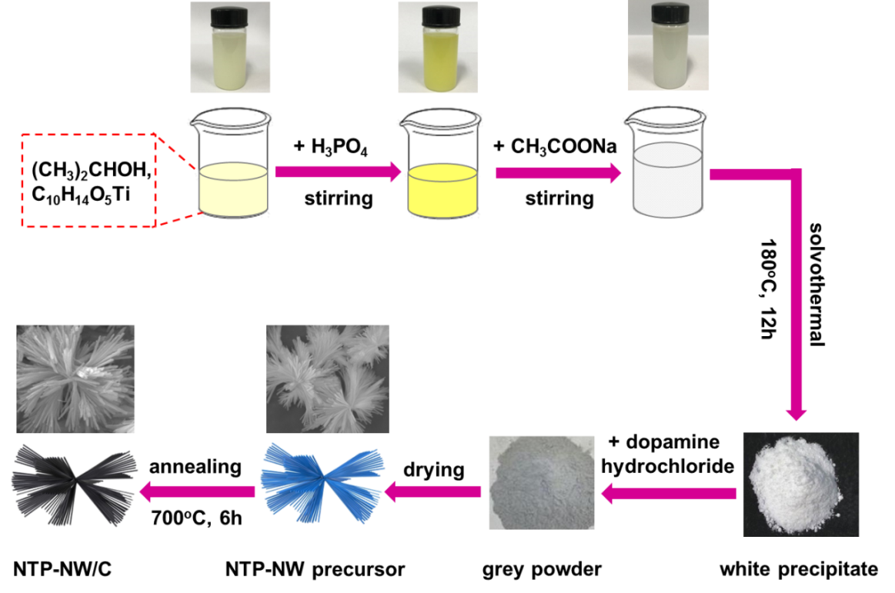
Figure S1. Schematic illustration of the fabrication process for the NTP-NW/C nanowire clusters.
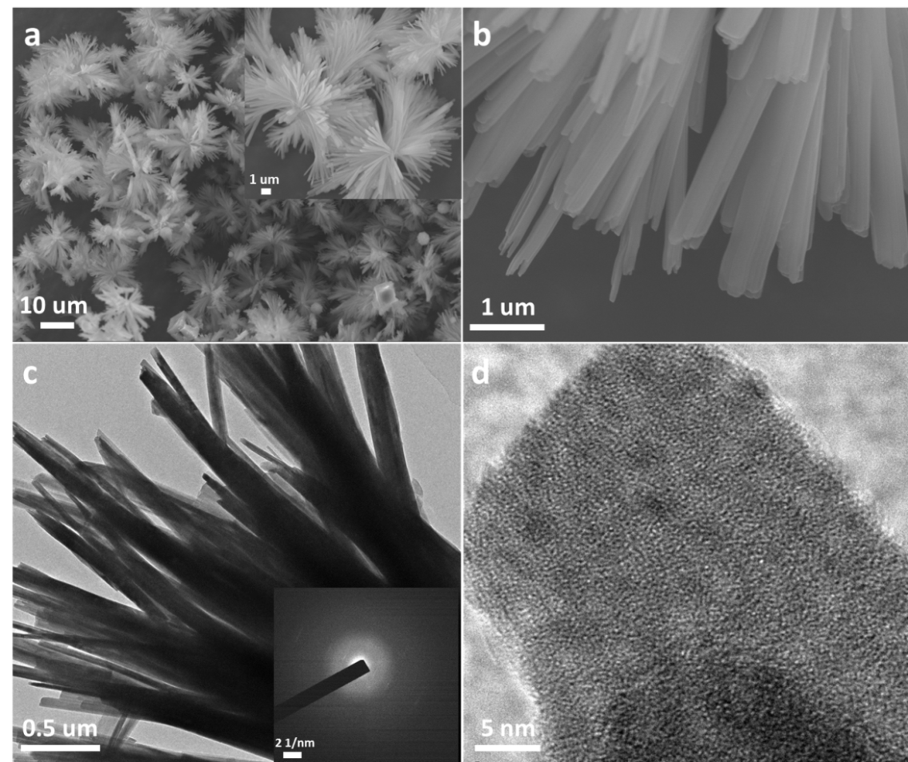
Figure S2. (a, b) FESEM images, (c) TEM image with selected area electron diffraction pattern and (d) HRTEM image of NTP nanowire cluster precursors.

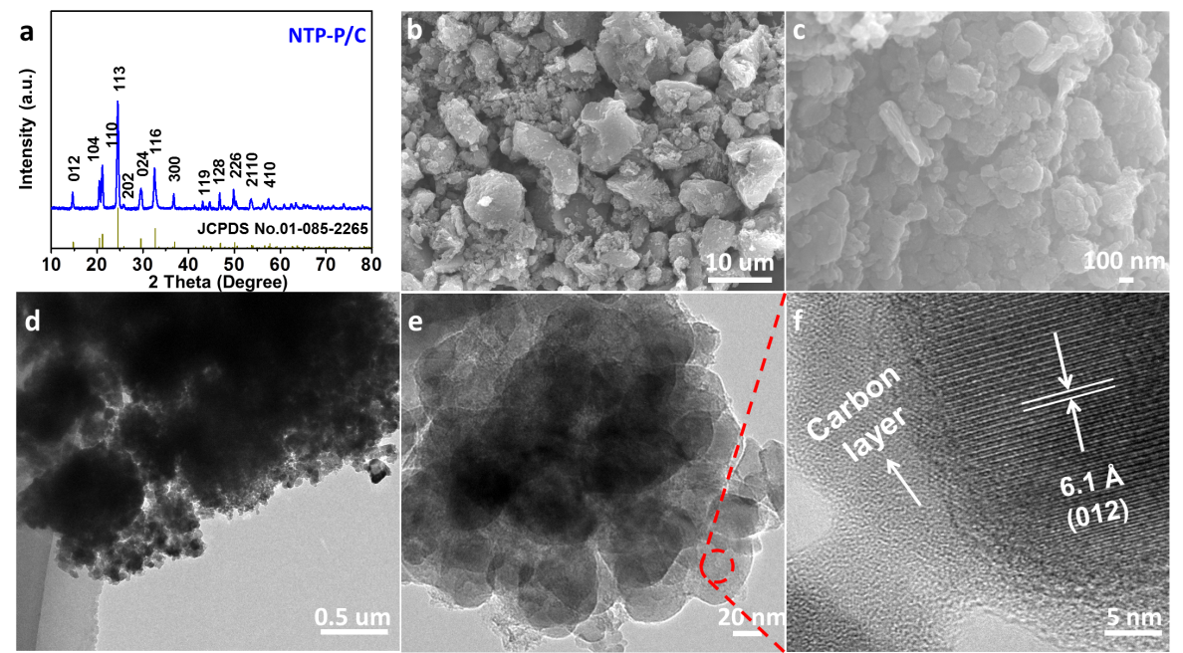
Figure S3. (a) The XRD diffraction pattern, (b,c) FESEM images, (d,e) TEM images, and (f) HRTEM image of NTP-P/C.

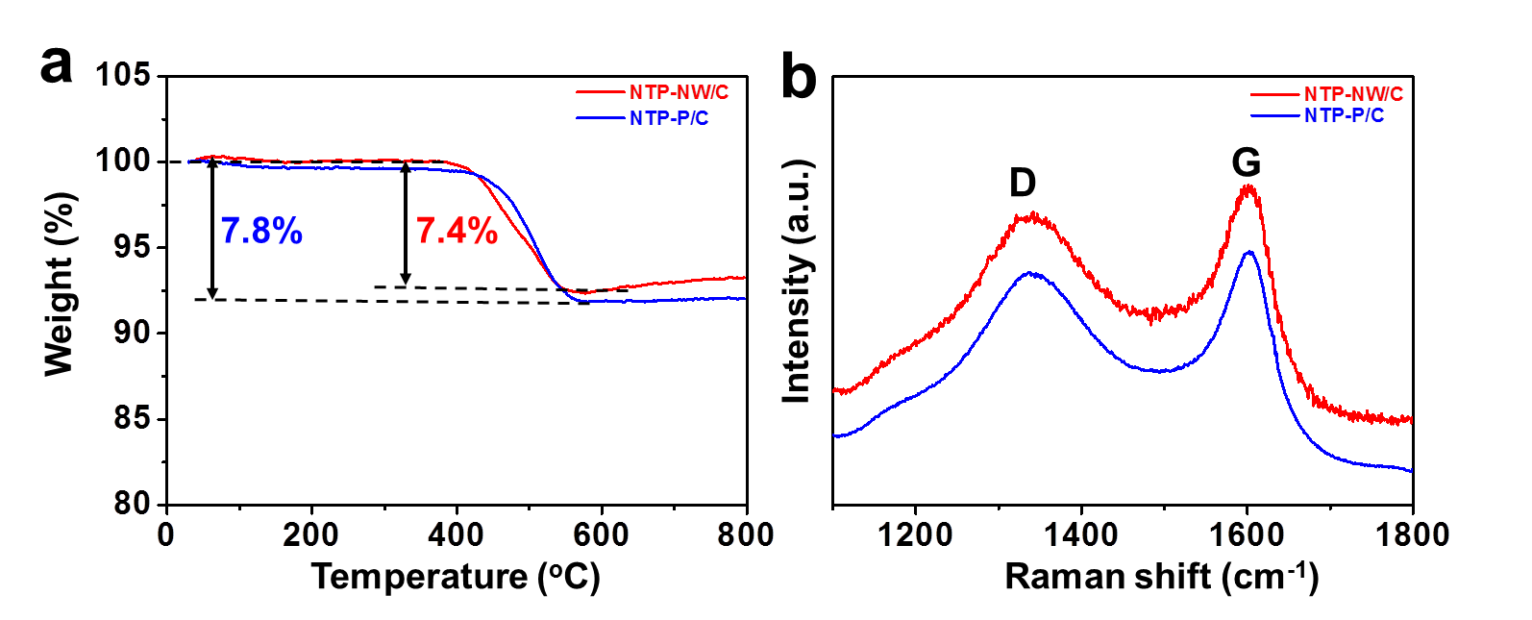
Figure S4. (a) TGA curves and (b) Raman spectra of NTP-NW/C and NTP-P/C.

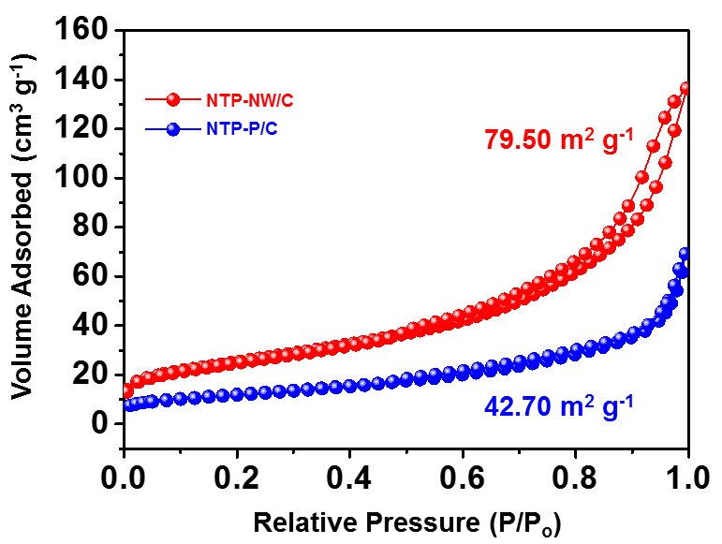
Figure S5. Nitrogen adsorption-desorption isotherms of NTP-NW/C and NTP-P/C.
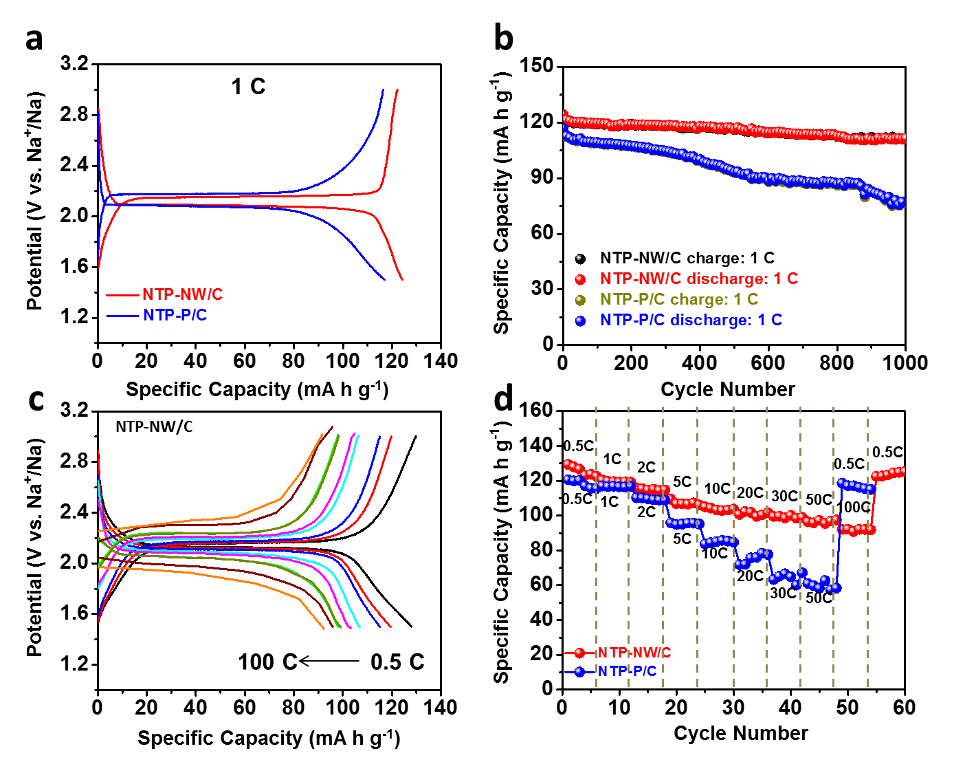
Figure S6. Sodium storage properties of the two samples by assembling Na-ion half cells. (a) The discharge-charge curves and (b) cycling performances of NTP-NW/C and NTP-P/C at 1 C. (c) Discharge-charge curves of the NTP-NW/C at different rates. (d) The rate performances of NTP-NW/C and NTP-P/C.

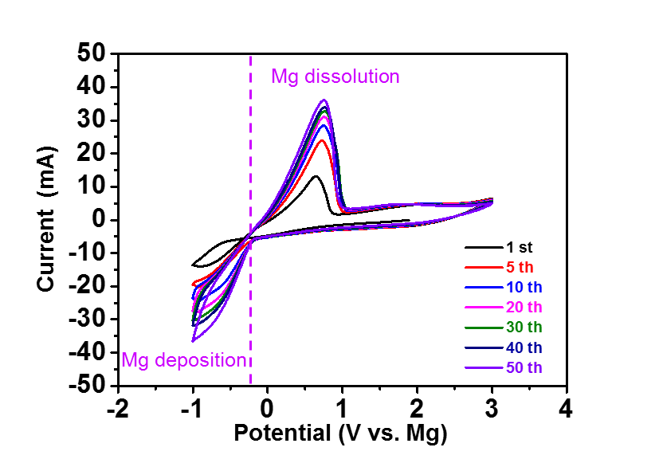
Figure S7. Cyclic voltammograms of hybrid Mg-Na electrolyte at a scan rate of 50 mV s⁻¹ in a three-electrode cell.
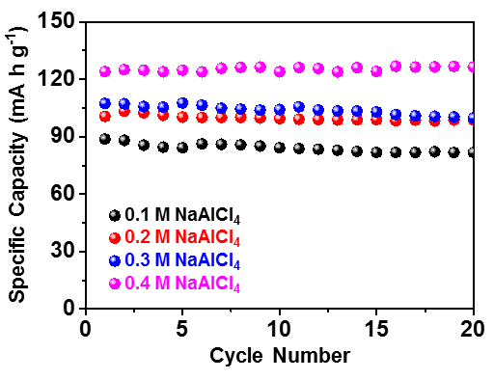
Figure S8. The cycling performances of NTP-NW/C at 0.5 C under different concentrations of NaAlCl₄.

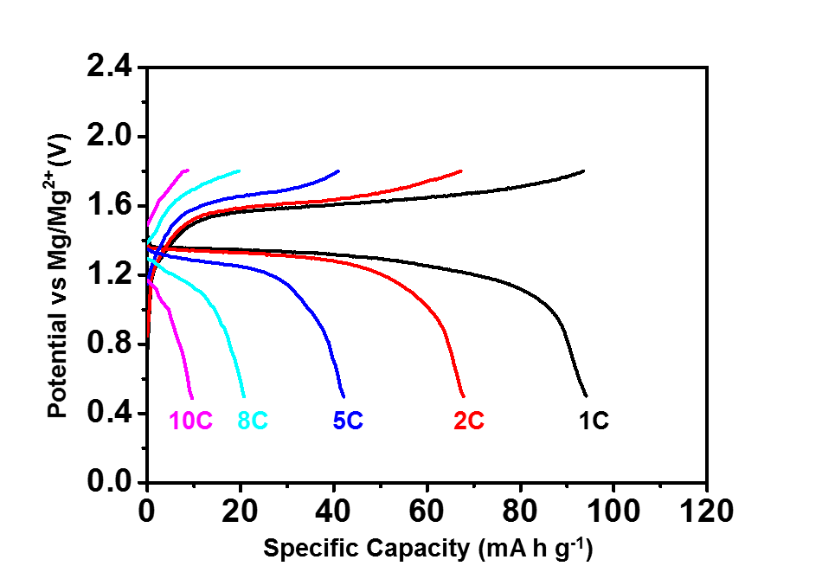
Figure S9. Discharge-charge curves of the NTP-P/C at different rates.

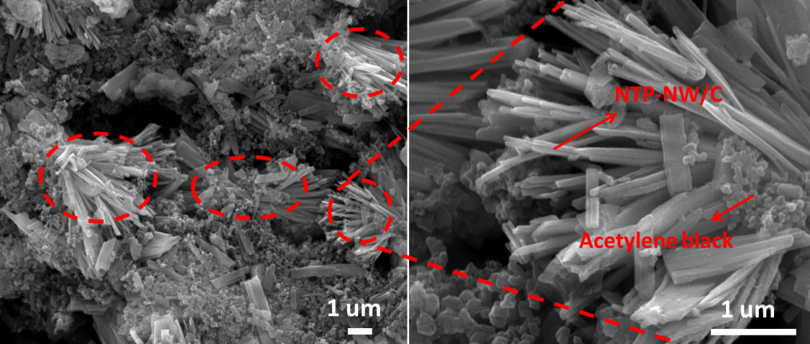
Figure S10. SEM images of NTP-NW/C electrode after 100 cycles at 5 C.
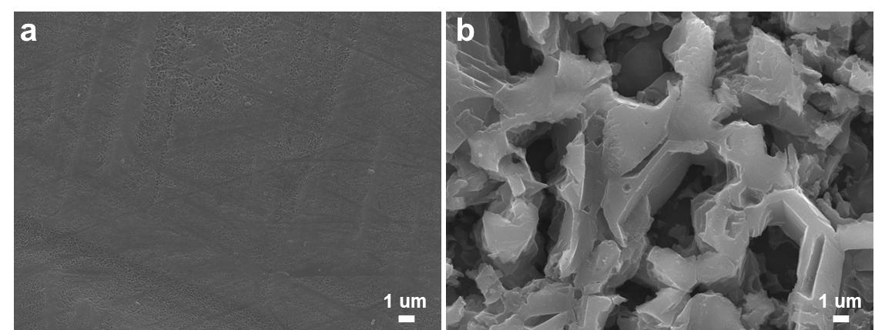
Figure S11. SEM images of the Mg anode (a) before cycling and (b) after 100 cycles at 5 C.
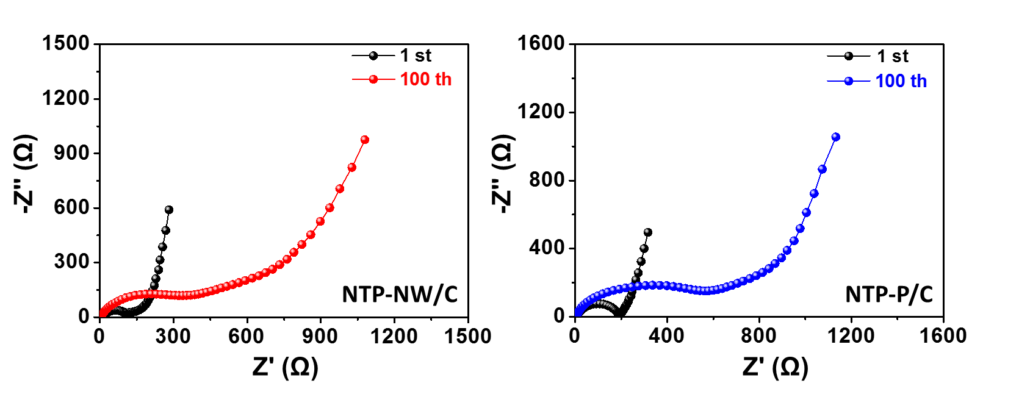
Figure S12. The Nyquist plots of the NTP-NW/C (a) and NTP-P/C (b) in different states.

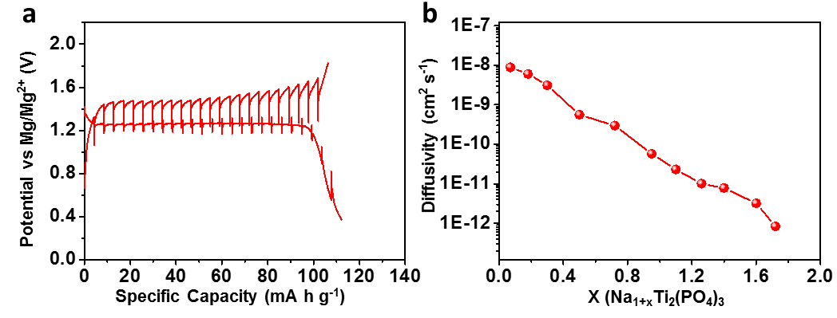
Figure S13. (a) GITT curve of NTP-P/C at 0.5-1.8 V. (b) Diffusivity versus state of discharge.

Table S1. The calculated diffusion coefficients versus state of discharge of NTP-NW/C.
X (Na_{1+x}Ti₂(PO₄)₃ | 0.07 | 0.20 | 0.36 | 0.58 | 0.8 | 1.02 | 1.22 | 1.38 | 1.54 | 1.65 | 1.77 | 1.86
D (cm² s⁻¹) | 1.2E-8 | 5.8E-9 | 3.7E-9 | 9.7E-10 | 5.8E-10 | 3.6E-10 | 1.5E-10 | 8.2E-11 | 5.9E-11 | 2.9E-11 | 2.3E-11 | 1.4E-11

Table S2. The calculated diffusion coefficients versus state of discharge of NTP-P/C.
X (Na_{1+x}Ti₂(PO₄)₃ | 0.06 |  | 0.18 | 0.30 | 0.50 | 0.72 | 0.95 | 1.10 | 1.26 | 1.40 | 1.61 | 1.68
D (cm² s⁻¹) |  | 8.9E-9 | 6.0E-9 | 3.1E-9 | 5.6E-10 | 2.9E-10 | 5.7E-10 | 2.3E-10 | 1.0E-11 | 7.8E-11 | 3.2E-12 | 8.3E-13

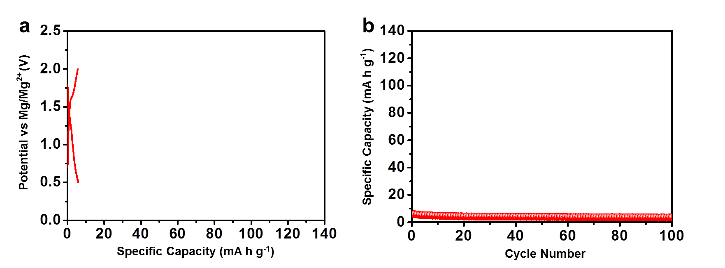
Figure S14. (a) The initial discharge-charge curves and corresponding (b) Cycling performance of NTP-NW/C at 1 C performed in the pure Mg electrolyte without NaAlCl₄.

