Supporting Information

α-MoO_{3-x} by Plasma Etching with Improved Capacity and Stabilized Structure for Lithium Storage
Guobin Zhang,^{a,#} Tengfei Xiong,^{a,#} Mengyu Yan,^{b} Liang He,^{a,c} Xiaobin Liao,ª Chunqing He,^{d} Chongshan Yin,^{d} Haining Zhang,^{e} and Liqiang Mai*ª

ª State Key Laboratory of Advanced Technology for Materials Synthesis and Processing & International School of Materials Science and Engineering, Wuhan University of Technology, Wuhan 430070, China. E-mail: mlq518@whut.edu.cn
^{b} Department of Materials Science and Engineering, University of Washington, Seattle, WA 98195, USA
^{c} Department of Materials Science and NanoEngineering, Rice University, Houston, TX 77005, USA
^{d} Key Laboratory of Nuclear Solid State Physics Hubei Province, School of Physics and Technology, Wuhan University, Wuhan 430072, China
^{e} State Key Laboratory of Advanced Technology for Materials Synthesis and Processing & School of Materials Science and Engineering, Wuhan University of Technology, Wuhan 430070, China
# Guobin Zhang and Tengfei Xiong contributed equally to this work.

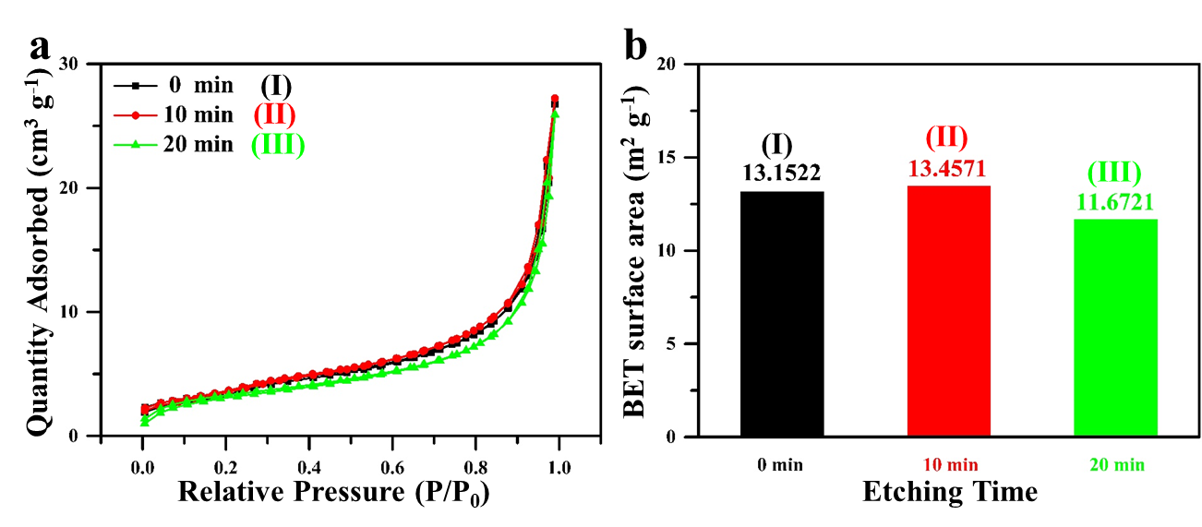
Figure S1 (a) Nitrogen adsorption-desorption isotherms and (b) BET specific surface areas.
Table S1 Assignment of vibrational modes of the Raman spectra (unit: cm⁻¹).
This work |  |  | Others  [30-33] | Assignment
(I) | (II) | (III)
83.5 | 85.0 | 84.2 | 89 | A_{g}, translational rigid MoO₄ chain mode, T_{a}
98.4 | 99.2 | 100.0 | 100 | B_{2g}, translational rigid MoO₄ chain mode, T_{a}
117.1 | 118.1 | 117.3 | 116 | B_{2g}, translational rigid MoO₄ chain mode, T_{c}
128.6 | 129.9 | 129.1 | 129 | B_{3g}, translational rigid MoO₄ chain mode, T_{c}
159.7 | 158.9 | 158.9 | 159 | A_{g}/B_{1g}, translational rigid MoO₄ chain mode, T_{b}
197.0 | 198.7 | 198.7 | 197 | B_{2g}, τ O=Mo=O twist
218.8 | 219.7 | 219.7 | 216 | A_{g}, rotational rigid MoO₄ chain mode, R_{c}
245.4 | 245.3 | 246.8 | 247 | B_{3g}, τ O=Mo=O twist
291.8 | 292.3 | 291.5 | 293 | B_{3g}, δ O=M=O wagging
338.5 | 339.8 | 339.8 | 334 | A_{g}, B_{1g}, δ O–M–O bend
379.6 | 380.1 | 379.4 | 380 | B_{1g}, δ O–M–O scissor
430.6 | 431.6 | 430.8 | 441 | Mo–O–Mo deformation
665.4 | 666.8 | 666.8 | 667 | B_{2g}, B_{3g}, ν_{as} O–M–O stretch
707.1 | 709.0 | 709.8 | 698 | Unknown
819.5 | 821.4 | 820.7 | 823 | A_{g}, ν_{s} M=O stretch
995.7 | 997.1 | 997.1 | 996 | A_{g}, ν_{as} M=O stretch
 | 1007.6 | 1008.3 | 1008 | B_{g}, ν_{as} M=O stretch
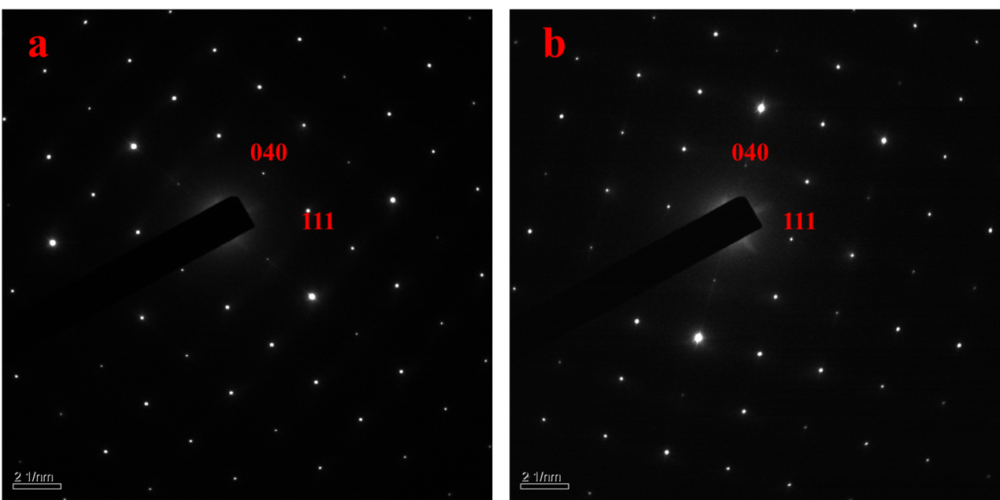
Figure S2 Selected area electron diffraction of the pristine (a) and the MoO₃ (II) (b).
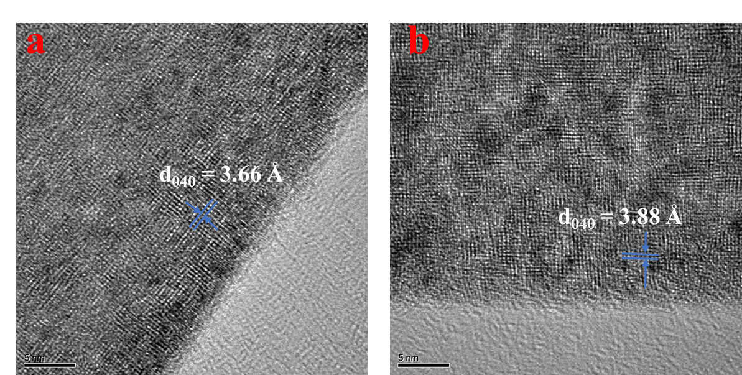
Figure S3 High resolution transmission electron microscopy of the pristine (a) and the MoO₃ (II) (b).
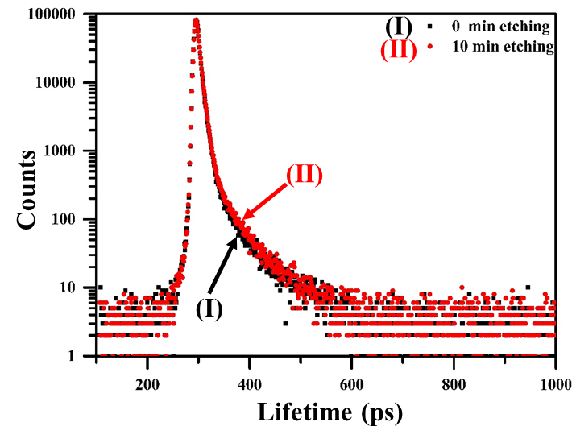
Figure S4 Positron annihilation lifetime spectra of MoO₃ (I) and MoO₃ (II).
Table S2 Positron annihilation lifetime results of MoO₃ (I) and MoO₃ (II).
 | τ₁ (ns) | I₁ (%) | τ₂ (ns) | I₂ (%) | τ (ns)
MoO₃ (I) | 0.209 | 49.11 | 0.381 | 50.89 | 0.2965
MoO₃ (II) | 0.226 | 51.76 | 0.399 | 48.24 | 0.3095
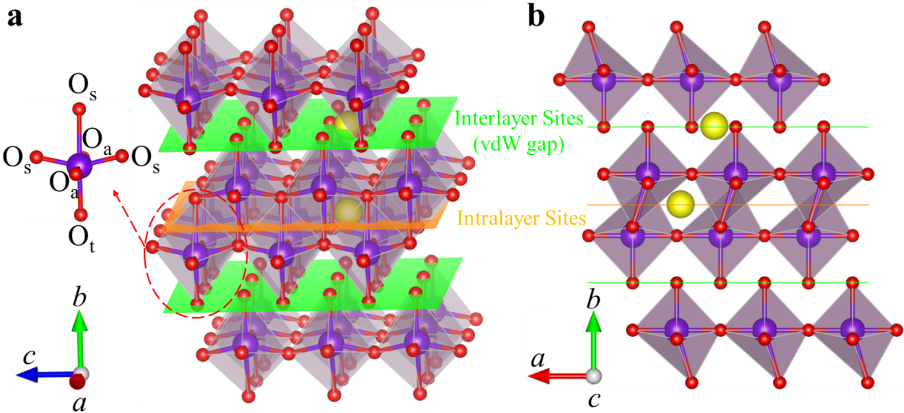
Figure S5 Crystal structure of α-MoO₃ and the two types of Li⁺ storage sites. (red: O; purple: Mo; yellow: Li)
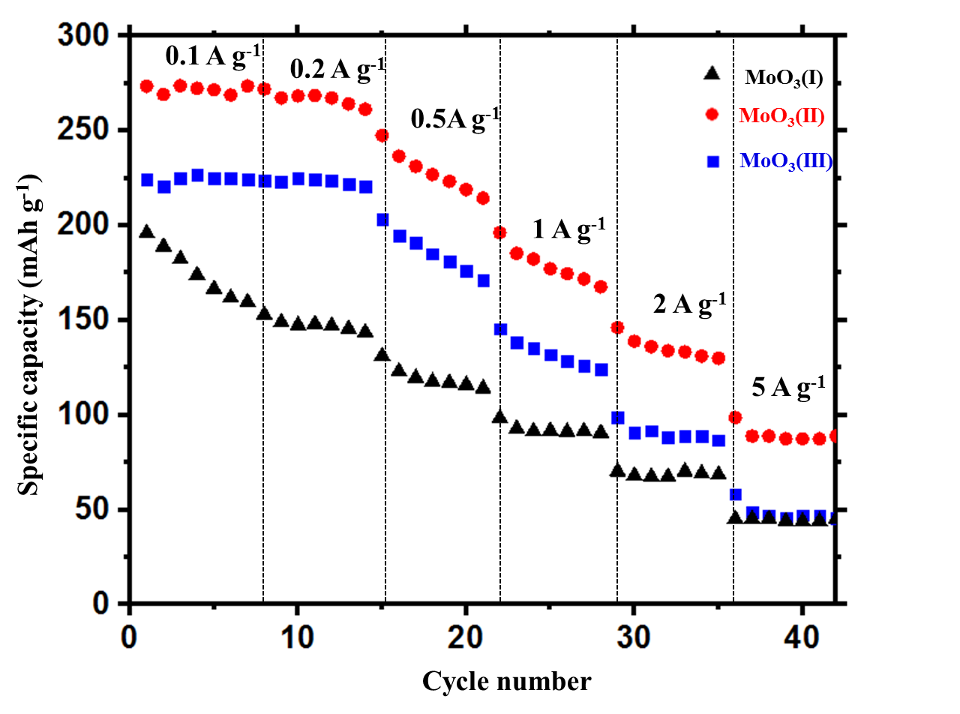
Figure S6 Rate capability of the pristine, MoO₃ (II) and MoO₃ (III).
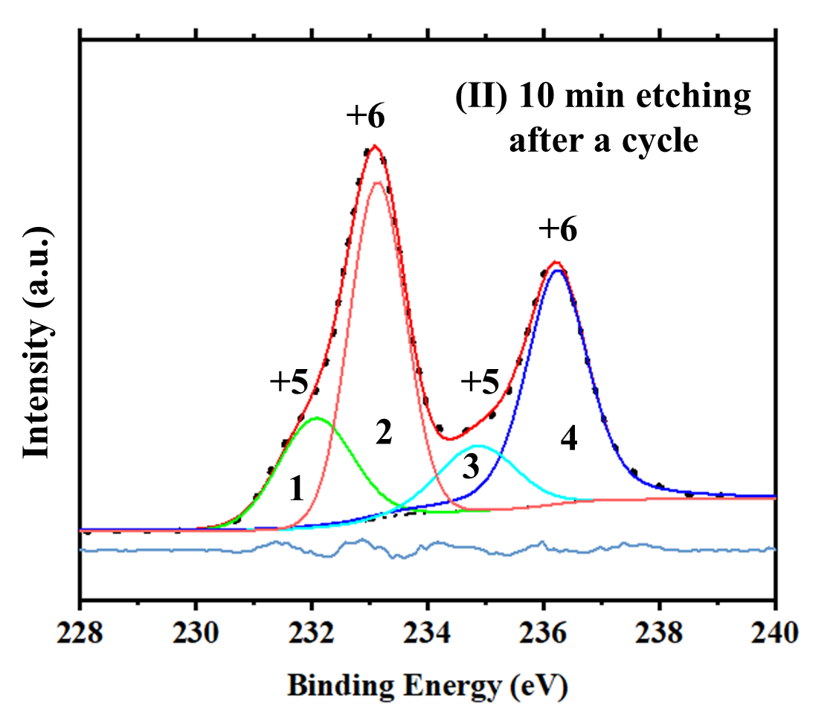
Figure S7 XPS spectrum of the MoO₃ (II) after the first cycle.
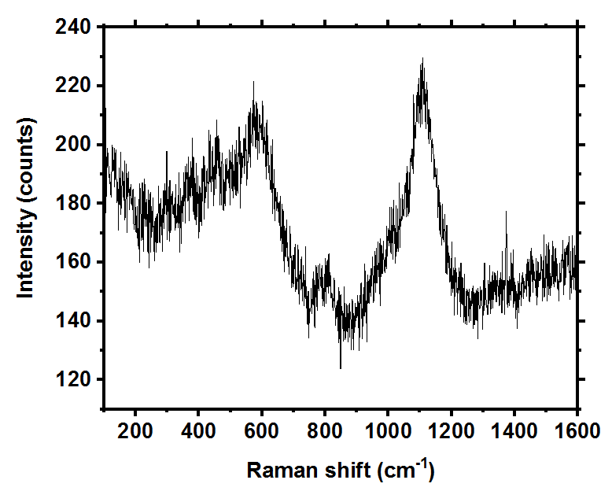
Figure S8 Raman spectrum of the MoO

