Supporting Information
Magnesium Storage Performance and Mechanism of CuS Cathode
Fangyu Xiong‡, Yuqi Fan‡, Shuangshuang Tan, Limin Zhou, Yanan Xu, Cunyuan Pei, Qinyou An* and Liqiang Mai*

State Key Laboratory of Advanced Technology for Materials Synthesis and Processing, International School of Materials Science and Engineering, Wuhan University of Technology, Wuhan, 430070 (P. R. China).
E-mail: (anqinyou86@whut.edu.cn, mlq518@whut.edu.cn)

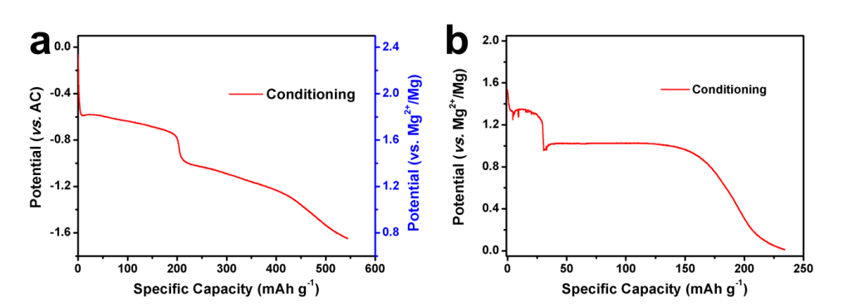
Fig. S1. The discharge curves for CuS cathode during conditioning at room temperature (25 °C) with different electrolyte: (a) Mg(ClO₄)₂/AN and (b) APC/THF.
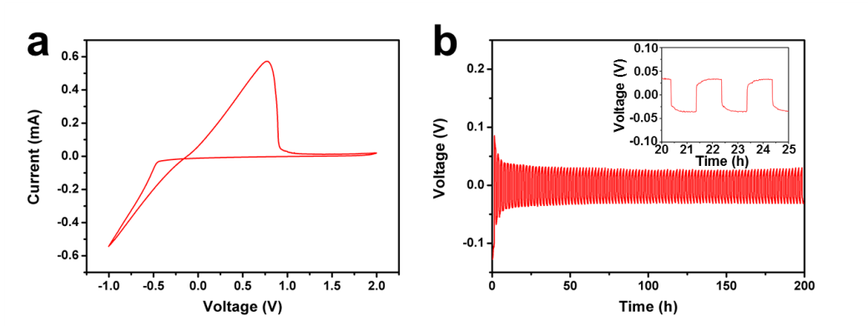
Fig. S2. (a) CV curve of Mg|APC|Mo cell at 100 mV s⁻¹ in −1.0-2.0 V; (b) the voltage-time curves of Mg|APC|Mg cell in galvanostatic charge/discharge test.

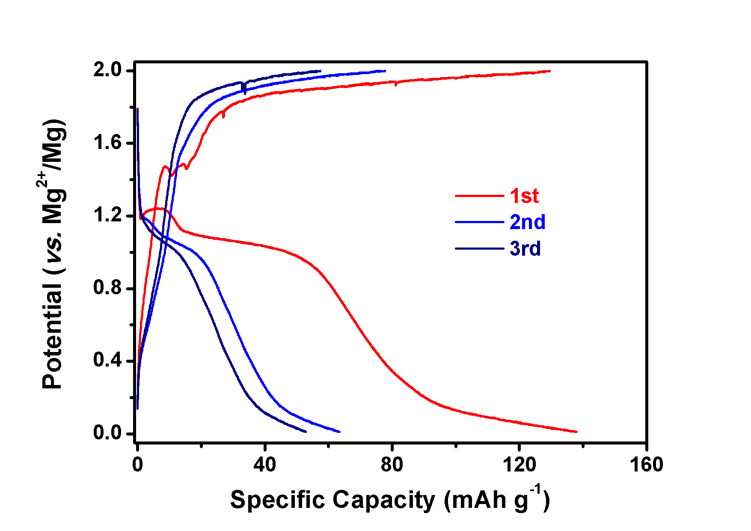
Fig. S3. The charge/discharge curves of CuS cathode in first three cycles at room temperature (25 °C).
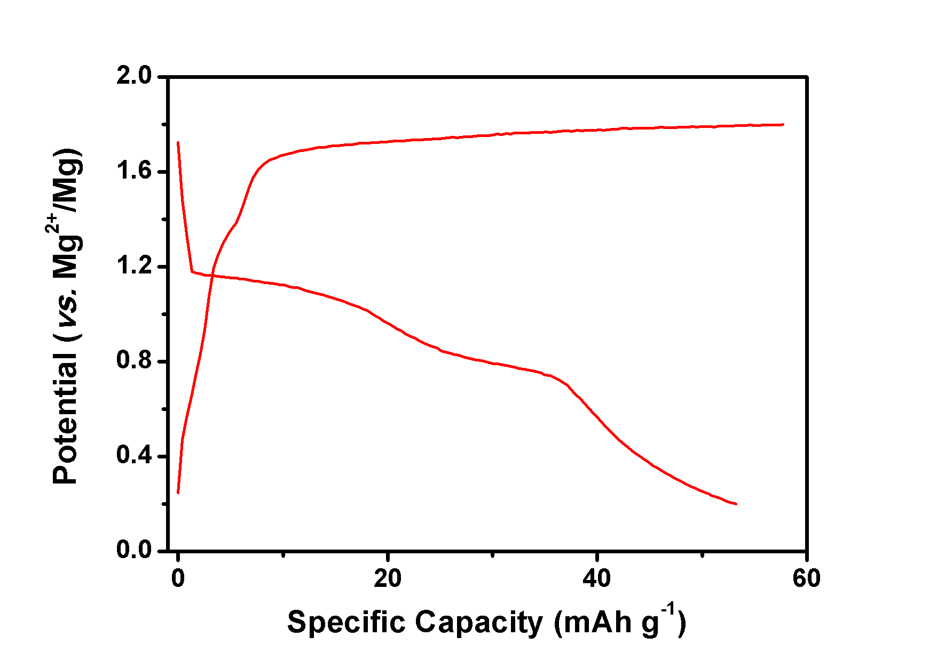
Fig. S4. The charge/discharge curves of CuS cathode at 55 °C with cut-off potential of 1.8 V.

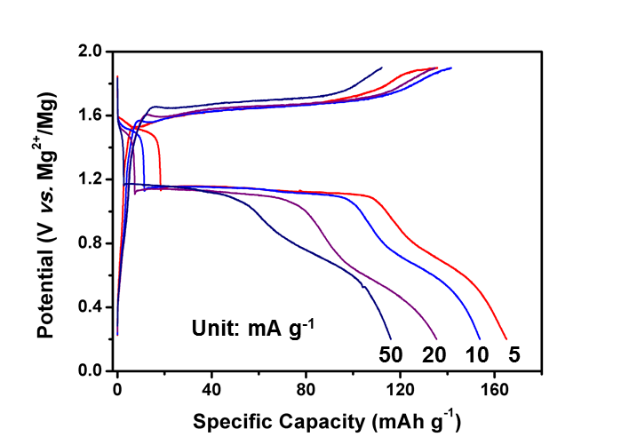
Fig. S5. The charge/discharge curves of CuS cathode at different current density at 50 °C.
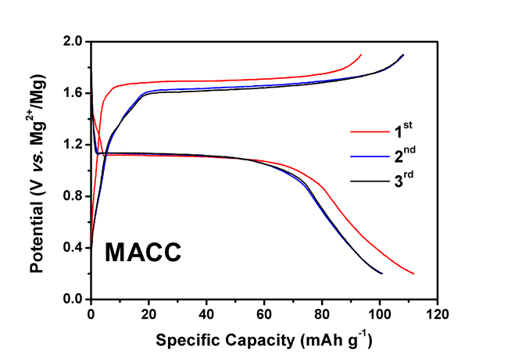
Fig. S6. The charge/discharge curves of CuS cathode with MACC electrolyte at 50 °C.
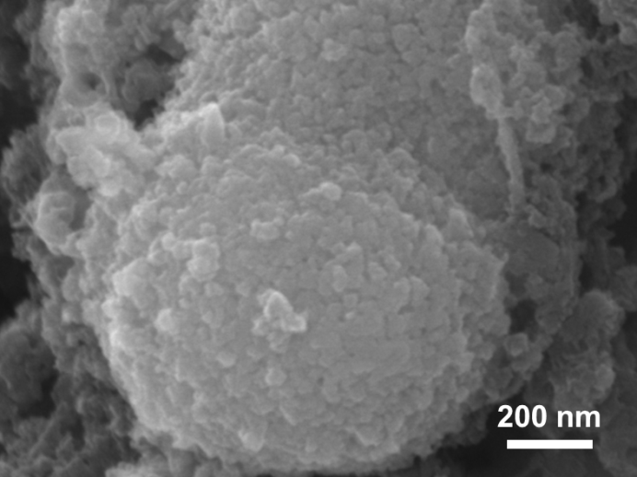
Fig. S7. The SEM image of CuS after first discharged process.
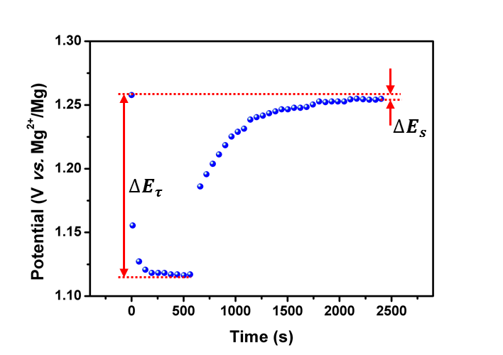
Fig. S8. The GITT potential response plot with time in one pulse period.

Calculation of Magnesium-ion diffusivities
$$D^{GITT}=\frac{4}{πτ}{\left(\frac{m_{B}V_{M}}{M_{B}S}\right)}^{2}{\left(\frac{△E_{s}}{△E_{τ}}\right)}^{2}$$
Where τ refers to constant current pulse time, m_{B}, V_{M}, M_{B}, and S are the mass, molar volume, molar mass of the cathode material, and electrode-electrolyte interface area, respectively. △E_{S} is voltage difference during a single-step experiment, and △E_{τ} is the total change of cell voltage during a constant current pulse (Figure S4).

