Supporting information

High-rate and Long-life VS₂ Cathodes for Hybrid Magnesium-Based Battery

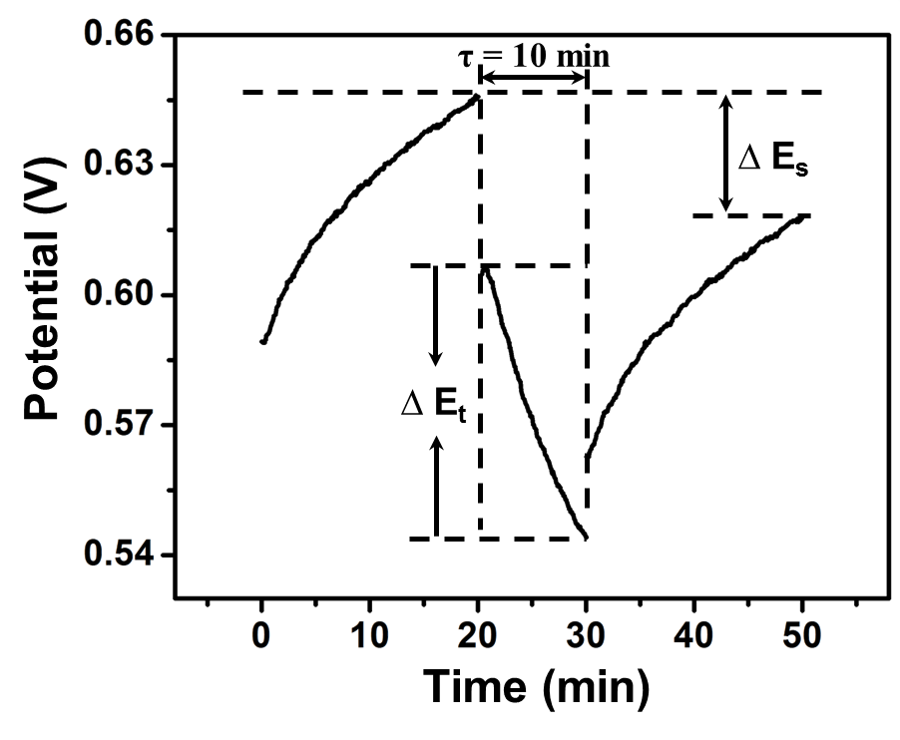
Fig. S1. GITT potential response curve with time. The experiment was carried out at constant current pulse of 20 mA g⁻¹ for 10 min followed by a relaxation period of 20 min. △E_{S} is voltage difference during a single-step experiment, and △E_{τ} is the total change of cell voltage during a constant current pulse.

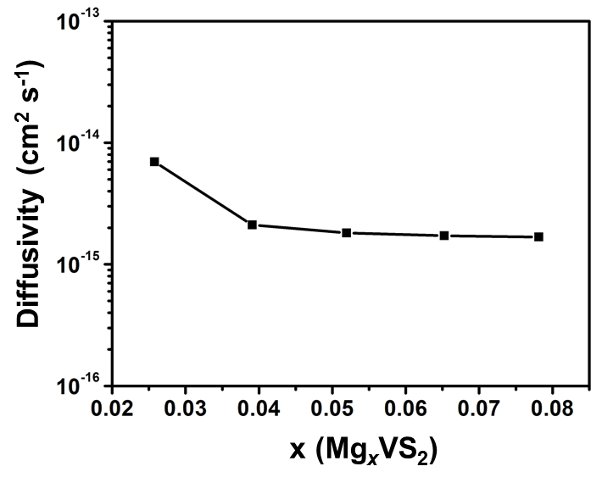
Fig. S2. Mg²⁺ diffusivity versus the state of discharge.

Table S1. The mass contents of V and S elements.
Elements | Mass Contents (wt.%) | Atom ratio
V | 43.05 | 1
S | 50.77 | 1.87

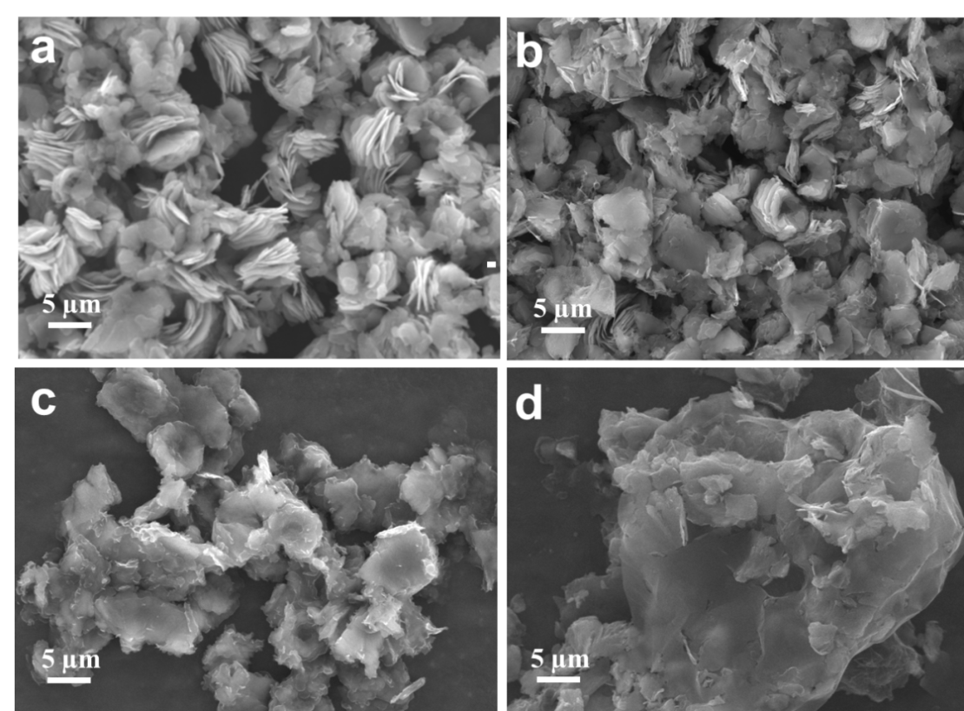
Fig. S3. SEM images of (a) VS₂, (b) VS₂-GO, (c) VS₂-GO-1 and (d) VS₂-GO-2.

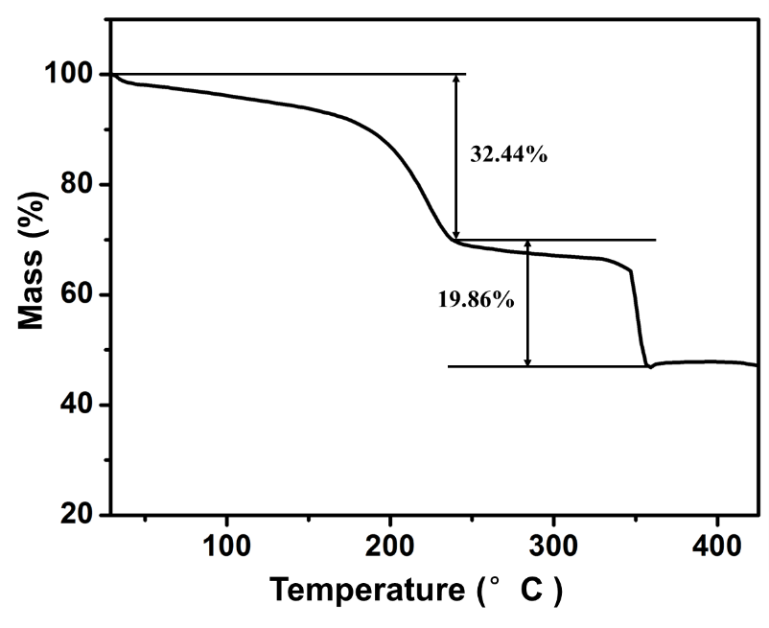
Fig. S4. TG curve of VS₂-GO.

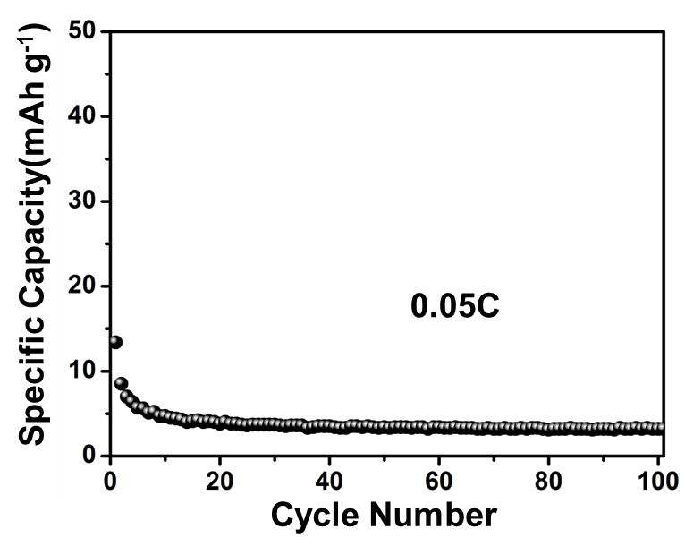
Fig. S5. Cycling performance of the pure GO electrode at 10 mA g⁻¹.

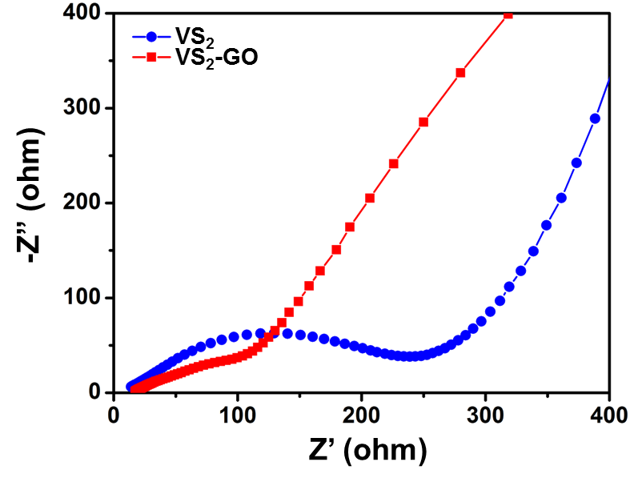
Fig. S6. Nyquist plots of VS₂-GO and VS₂ after 50 cycles.

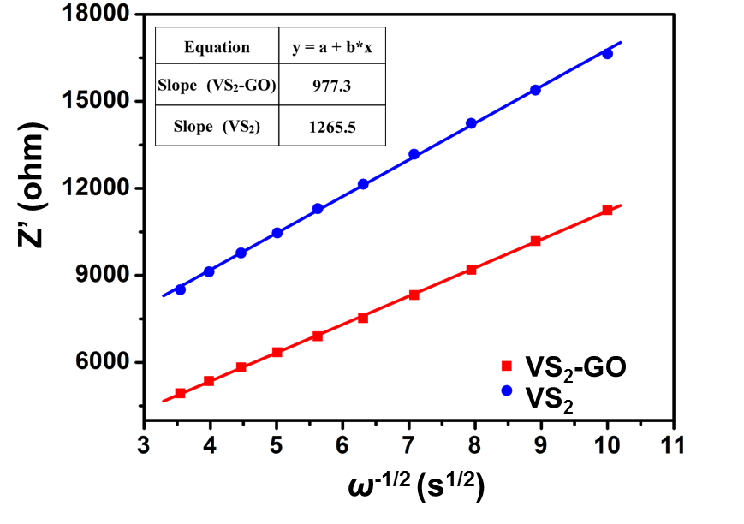
Fig. S7. The fitted lines and real part of the impedance versus ω^{−1/2} for VS₂-GO and VS₂.

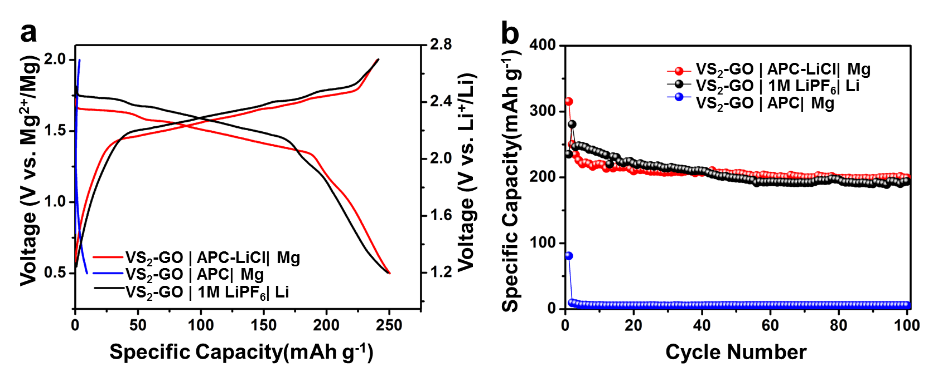
Fig. S8. (a) Discharge-charge curves of VS₂-GO cathode in the VS₂-GO|APC-LiCl|Mg hybrid battery (0.5-2 V), VS₂-GO|1 M LiPF₆/ EC+DMC+EMC (volume ratio of 1:1:1)|Li LIB (1.2-2.7 V) and VS₂-GO|APC|Mg MIB (0.5-2 V) at the same current density of 0.5 C. (b) corresponding cycling performance.

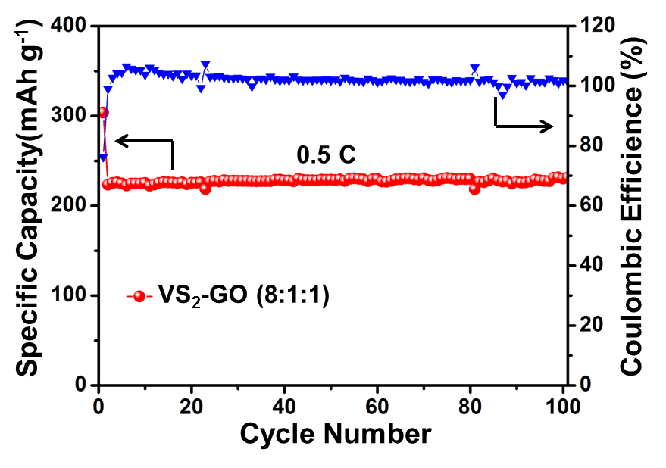
Fig. S9. Cyclic performance of VS₂-GO electrode prepared by mixing the active materials, acetylene black and PTFE in a weight ratio of 8:1:1.
Table S2. Carbon contents of the samples according to C-S analyzers.
Samples | Carbon Contents (%)
VS₂-GO | 6.10
VS₂-GO-1 | 9.36
VS₂-GO-2 | 19.48

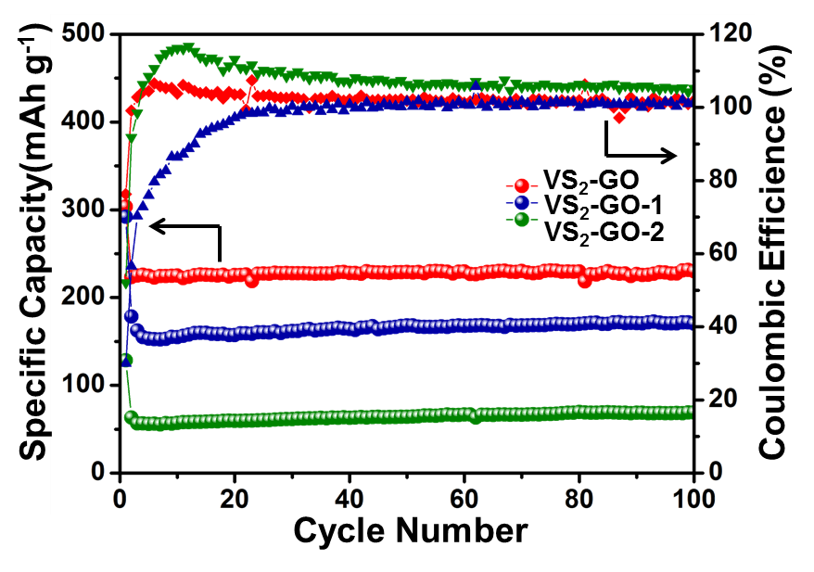
Fig. S10. Cycling performances of VS₂-GO, VS₂-GO-1 and VS₂-GO-2 at the rate of 0.5 C prepared by mixing the active materials, acetylene black and PTFE in a weight ratio of 8:1:1.

Table S3. Comparison of the electrochemical performance of the state-of-the-art intercalation cathodes for various reported MLIBs with low voltage (< 2.0 V)
Cathode | Average voltage (V vs. Mg²⁺/Mg) | Capacity (mA h g⁻¹) | Energy density (Wh Kg⁻¹) | Rate capability | Reference
Mo₆S₈ | 1.3 | 126 | 163.8 | 109 mA h g⁻¹ at 1.03 A g⁻¹ | Ref. 20
TiS₂ | 1.4 | 220 | 308 | 50 mA h g⁻¹ at 4.82 A g⁻¹ | Ref. 21
TiO₂ | 0.7 | 200 | 140 | 116 mA h g⁻¹ at 0.67 A g⁻¹ | Ref. 22
Li₄Ti₅O₁₂ | 0.7 | 175 | 122.5 | 120 mA h g⁻¹ at 0.3 A g⁻¹ | Ref. 23
MoS₂ | 1.0 | 225 | 225 | 150 mA h g⁻¹ at 1.0 A g⁻¹ | Ref. 41
d-Ti₃C₂T_{x} | 0.75 | 105 | 78.8 | 40 mA h g⁻¹ at 1.0 A g⁻¹ | Ref. 47
MoO₂ | 0.75 | 217 | 162.8 | 150 mA h g⁻¹ at 0.1 A g⁻¹ | Ref. 46
VS₂ | 1.5 | 250 | 375 | 129 mA h g⁻¹ at 14.4 A g⁻¹ | Our present work

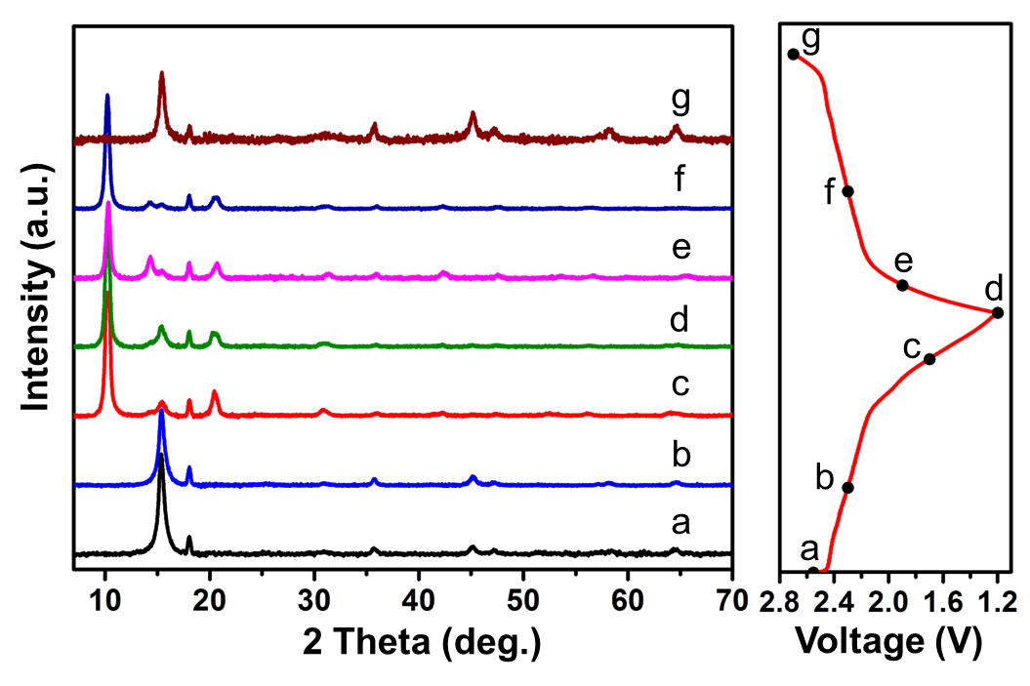
Fig. S11. Ex-situ XRD patterns of VS₂-GO during galvanostatic charge and discharge at 0.5 C.
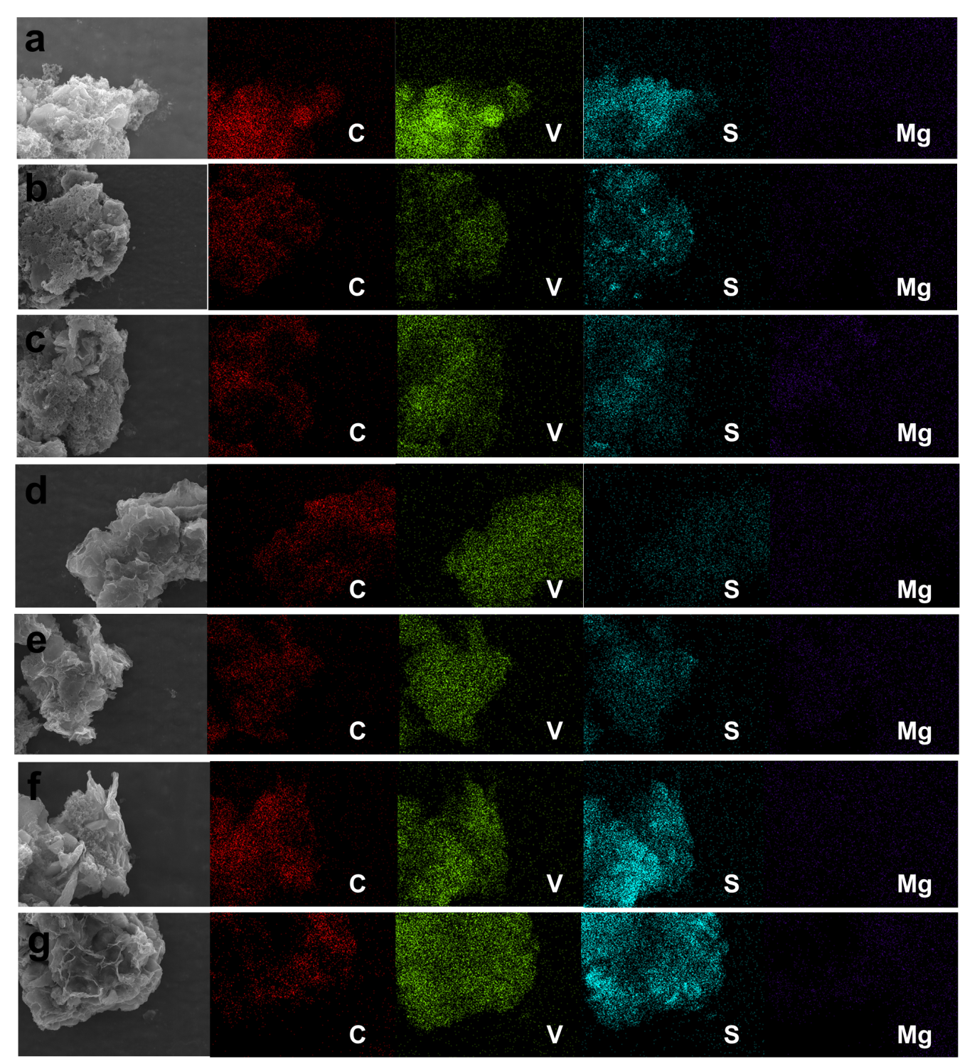
Fig. S12. Ex-situ EDS Mapping of VS2-GO during first discharged and charged states. discharged to (a) 1.2 V, (b) 0.8 V, (c) 0.5 V and charged to (d) 0.8 V, (e) 1.2 V, (f) 1.6 V, (g) 2.0 V.

S1. Calculation of energy density for the Mg-Li hybrid battery:
Positive electrode: VS₂ + 2Li⁺ + 2e⁻ = Li₂VS₂
Negative electrode: Mg + 2Cl⁻ = MgCl₂ + 2e⁻
Overall reaction: VS₂ + Mg + LiCl = Li₂VS₂ + MgCl₂
Specific capacity = 2*26800/( Li₂VS₂ + MgCl₂)
=2*26800/(128.94+95.21)=239.14 mAh/g
Theoretical specific energy density for Mg-Li/VS₂ = 1.5 V * 239.14 mAh/g = 358.71 Wh/kg, where 1.5 V is the average discharge voltage.
Experimental demonstrated energy density: [1.966*26800/(128.94+95.21)] * 1.5 = 352.59 Wh/kg.
Where 1.966 Li⁺ is reversibly inserted/deinserted into VS₂-GO framework instead of 2 Li⁺ in theoretical calculation.

