Supplementary information
Pseudocapacitive Layered Iron Vanadate Nanosheets Cathode for Ultrahigh-Rate Lithium Ion Storage

Qiulong Wei¹, Qinqin Wang³, Qidong Li¹, Qinyou An^{1,}*, Yunlong Zhao⁴, Zhuo Peng¹, Yalong Jiang¹, Shuangshuang Tan¹, Mengyu Yan¹ and Liqiang Mai^{1,2}*

¹ State Key Laboratory of Advanced Technology for Materials Synthesis and Processing, International School of Materials Science and Engineering, Wuhan University of Technology, Wuhan 430070, P.R. China
² Department of Chemistry, University of California, Berkeley, California 94720, USA
³ Institute of Physics, Chinese Academy of Sciences, Beijing 100190, P.R. China
⁴ Department of Chemistry and Chemical Biology and Harvard John A. Paulson School of Engineering and Applied Sciences, Harvard University, Cambridge, Massachusetts 02138, USA

KEYWORDS: two-dimensional materials, pseudocapacitive cathode, layered iron vanadate, lithium storage, high rate

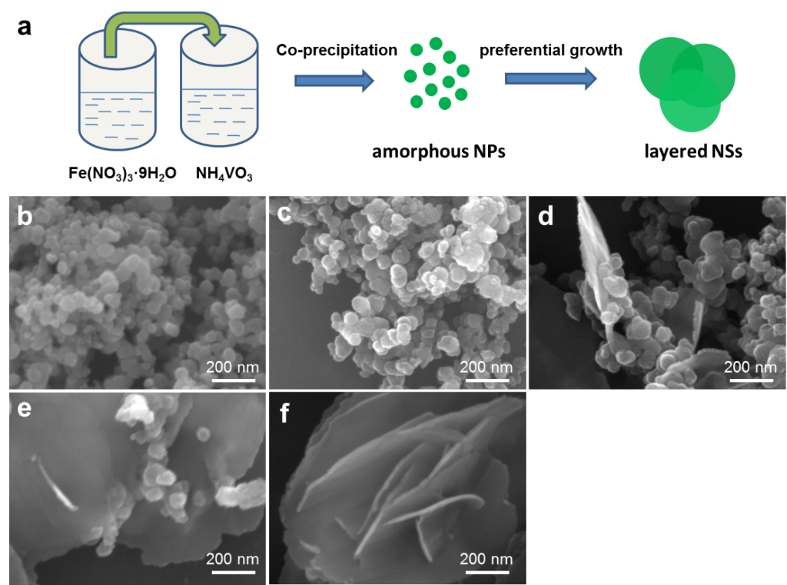
Figure S1. (a) Schematic illustration of the formation process from amorphous NPs to layered NSs. (b-f) The SEM images of the products with various bath reaction times: 1 min (b), 10 min (c), 20 min (d), 40 min (e), and 1 hour (f), respectively.

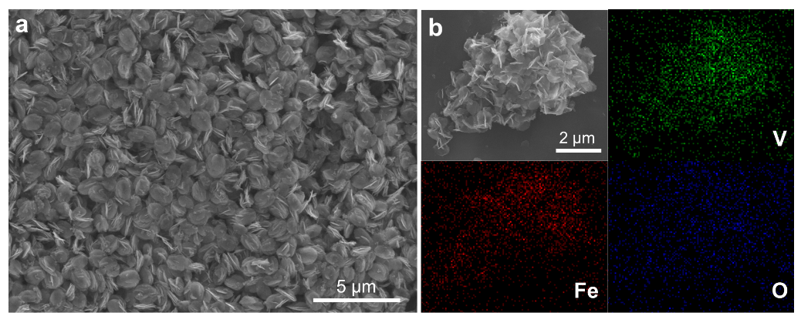
Figure S2. (a) Low magnification SEM of layered FeVO NSs showing a relatively large area of the nanosheets. (b) The EDS element mapping showing the uniform distribution of Fe, V and O.

Table S1. The V : Fe ratio of the FeVO NSs from ICP analysis.
sample | V (wt.%) | Fe (wt.%) | V : Fe (atomic ratio)
FeVO NSs | 35.86 | 13.05 | 3.013:1

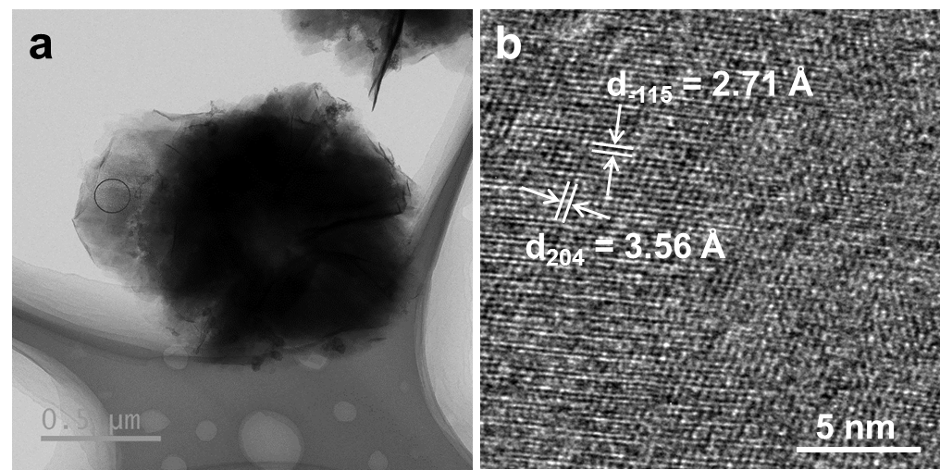
Figure S3. (a) TEM image of layered NSs. (b) HRTEM image of NS from the marked area in (a), showing the inner-layer information with the lattice spacing of 3.56 and 2.71 Å corresponds to (204) and (-115) planes, respectively.

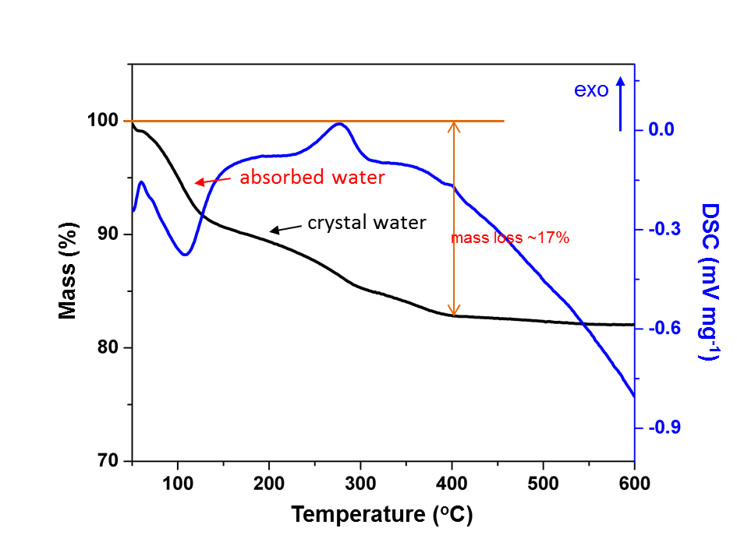
Figure S4. TG and DSC curves of the layered FeVO NSs. The multi-step mass losses indicate different type of water in the materials.
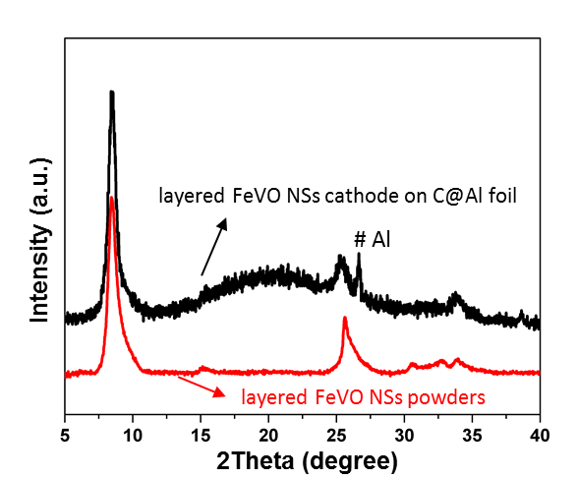
Figure S5. The XRD patterns of layered FeVO NSs cathode (mixed with Ketjen black and binder and then coated on C@Al foil) after drying at 120 °C in vacuum. The layer spacing of FeVO NSs does not change during the electrode preparation processes.

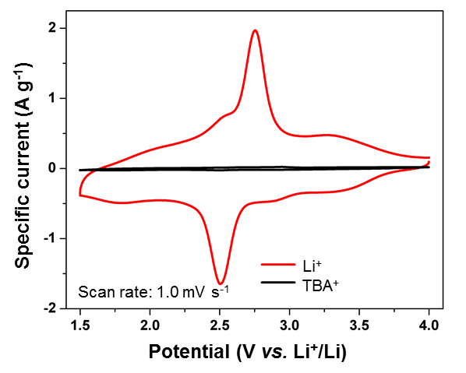
Figure S6. CV curves of layered NSs tested in Li⁺ and TBA⁺ based electrolyte at a scan rate of 1.0 mV s⁻¹.

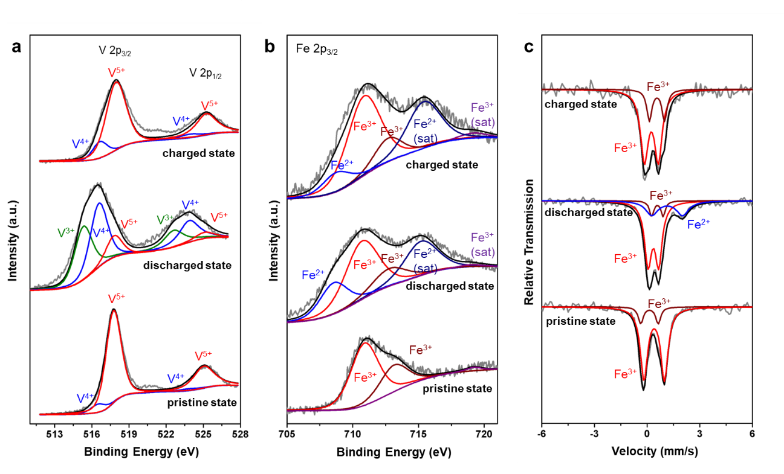
Figure S7. V 2p XPS spectra (a), Fe 2p XPS spectra (b), and ⁵⁷Fe Mössbauer spectra (c) of pristine, fully discharged state and charged state of FeVO NSs. [ref. S1-3]

Table S2. The detailed analyses of the XPS results. Peak fit is carried out as the same condition.
FeVO NSs |  | V 2p_{3/2} (3+) | V 2p_{3/2} (4+) | V 2p_{3/2} (5+) | Fe³⁺ | Fe³⁺ | Fe³⁺ (sat) | Fe²⁺ | Fe²⁺ (sat)
 |  | 515.3 | 516.5 | 517.8 | 710.9 | 713.1 | 719.2 | 708.8 | 715.5
Pristine state | area | -- | 4929 | 57662 | 23374 | 10006 | 1040 | -- | --
 | percentage | -- | 7.9% | 92.1% | 67.9% | 29.1% | 3.0% | -- | --
Discharged state | area | 14046 | 14218 | 4173 | 26274 | 7981 | 760 | 11757 | 15450
 | percentage | 43.3% | 43.8% | 12.9% | 42.2% | 12.8% | 1.2% | 18.9% | 24.8%

The relation between the charge storage number and the capacity can be figured out based on the equation: n = (3.6MC)/F, where n represents the inserted ion amount (mol), F represents the Faraday constant (C mol⁻¹), C represents the capacity (mAh g⁻¹), and M represents the molecular weight (g mol⁻¹). The FeVO NSs deliver a capacity of 312 mAh g⁻¹, that is according to 23.1 mol Li⁺ per unit formula. Based on the detailed calculation of the valence changes from XPS data, the detailed change of the average valence of vanadium is from +4.92 to +3.69, while the that of iron is from +3 to +2.56. According to the chemical formula of Fe₅V₁₅O₃₉(OH)₉·9H₂O, the total charge from the vanadium is 18.45 mol e⁻ per unit formula, while that from the iron is 2.2, indicating that the contributed capacity from vanadium is much higher than that of iron. The total redox reaction number (20.65 mol e⁻ per unit formula) obtained from the XPS analyses, very closed to the delivered capacity (23.1 mol Li⁺ per unit formula), confirming the pseudocapacitive charge storage mechanism.

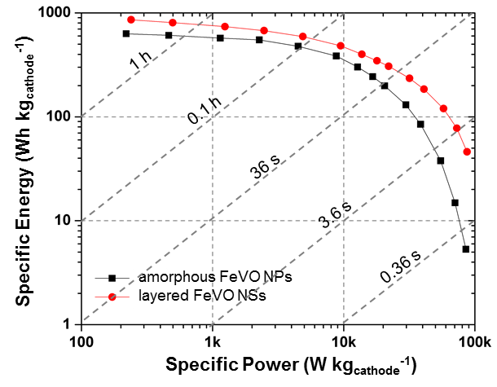
Figure S8. The Ragone plot of layered FeVO NSs and amorphous FeVO NPs for lithium storage. The value is calculated based on the mass of active cathode to show the promising application of the layered NSs for high energy and high power lithium storage application.
The specific energy and power were calculated according to the Equations S1 and S2.
$E= \int_{t1}^{t2}{IVdt}$ (S1)
$P= \frac{E}{t}$ (S2)
where I (A g⁻¹) is the constant current density, V (V) is working voltage, and t is the time.

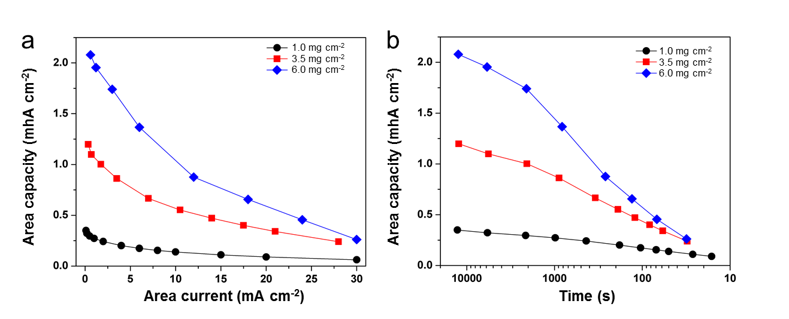
Figure S9. Area capacity vs. area current plots (a) and times vs. area capacity plots (b) of FeVO NSs cathode with different mass loading.

Reference
[S1] Q. Wei, Z. Jiang, S. Tan, Q. Li, L. Huang, M. Yan, L. Zhou, Q. An, L. Mai, ACS Appl. Mater. Interfaces, 7 (2015) 18211-18217.
[S2] D. Wilson, M.A.Langell, Applied Surface Sci., 303 (2014) 6-13.
[S3] Q. Li, Q. Wei, W. Zuo, L. Huang, W. Luo, Q. An, V. O. Pelenovich, L. Mai, Q. Zhang, Chem. Sci. 8 (2017) 160-164.

