Supporting information
In situ nitrogen-doped helical mesoporous carbonaceous nanotubes for superior-high lithium anodic performance
Xiang Ao^{,b}, Huayan Sunª, Chundong Wang^{b,}*, Jiangang Liª, Yunjun Ruan^{b}, Baozong Liª, Qi-Hui Wu^{c}, Yi Li^{a,}**, Jianjun Jiang^{b}, Yonggang Yangª, Liqiang Mai^{d,}***
Jiangsu Key Laboratory of Advanced Functional Polymer Design and Application, College of Chemistry, Chemical Engineering and Materials Science, Soochow University, Suzhou 215123, P.R. China.
^{b}School of Optical and Electronic Information, Huazhong University of Science and Technology, Wuhan 430074, P.R. China.
^{c}Department of Materials Chemistry, School of Chemical Engineering and Materials Science, Quanzhou Normal University, Quanzhou 362000, P.R. China.
^{d}State Key Laboratory of Advanced Technology for Materials Synthesis and Processing, Wuhan University of Technology, Wuhan 430070, P. R. China.

Supporting Figures:
During the preparation process, the LL-1 was mixed with resorcinol firstly, and then formaldehyde and TEOS were added into the reaction mixture simutaneously. The resorcinol-formaldehyde (RF) oligomers and silica oligomers were adsorbed on the surfaces of the nanoribbons owing to the electrostatic interactions.

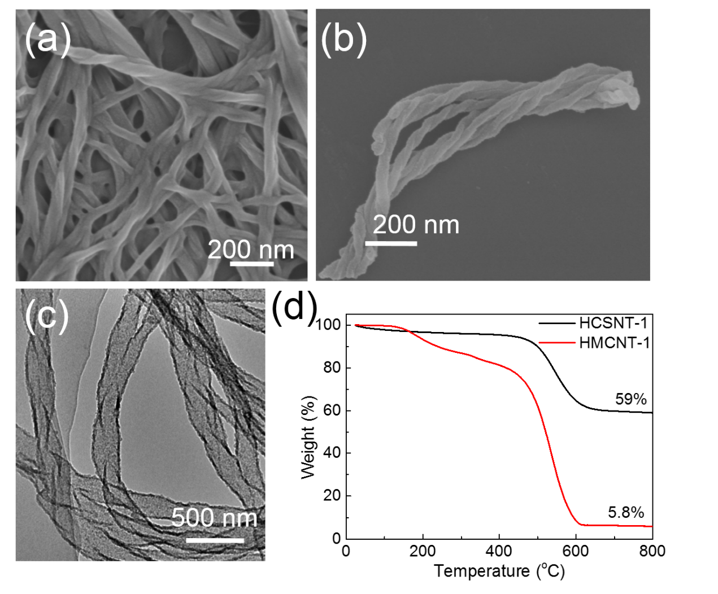
Fig. S1. (a) FE-SEM image of LL-1 xerogel prepared in anhydrous ethanol at a concentration of 20.0 mg mL⁻¹ at 25 °C, (b) FE-SEM and (c) TEM image of the silica sample prepared by calcining HCSNT-1 at 550 ºC in the air for 5.0 h to remove the carbon, (d) TGA curves for HCSNT-1 and HMCNT-1.
Element analysis shows that HMCNT-1 are composed of 87.0 wt% carbon and 2.5 wt% nitrogen, while HMCNT-2 contains 88.8 wt% carbon and 3.1 wt% nitrogen. Since HMCNT-2 are derived from resin-silica/template composites, the nitrogen content in HMCNTs might come from the templates within the nanotubes. For comparison, sample HCSNT-1 was also calcined at 550 ºC in air for 5 h to remove the carbon, following which left-handed helical silica nanotubes were obtained, as shown in Fig. S1b and S1c. The tubular nature and helical nanostructure are well preserved, which indicates that carbon and silica form an interwoven framework (the carbon-silica composite). Thus, it can be well understood that when the silica moiety is removed from the carbon-silica composites, mesopores are left within the walls of the carbonaceous nanotubes, as proved in Fig. 1f. To determine the percentage of SiO₂ in HCSNT-1, themogravimetric analysis (TGA) was implemented on HCSNT-1 and HMCNT-1 in air with a flow rate of 10 ml min⁻¹ (Fig. S1d), disclosing that SiO2 is taken up ~59% of the weight.
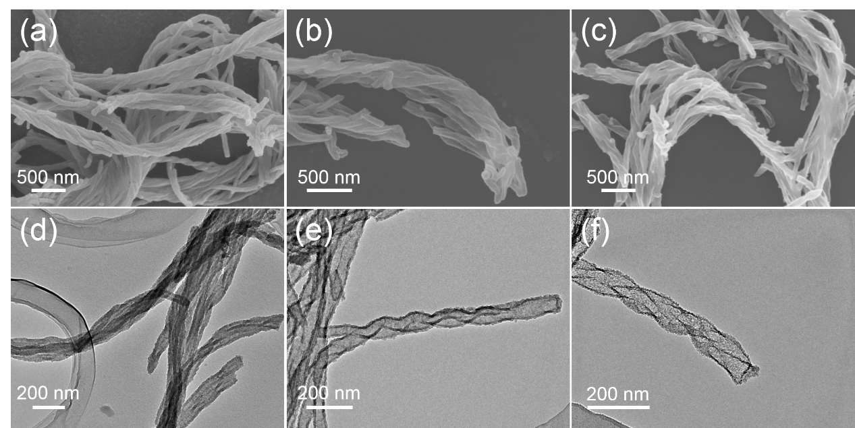
Fig. S2. FE-SEM and TEM images of samples HRSNT-2(a, d), HCSNT-2(b, e) and HMCNT-2(c, f)

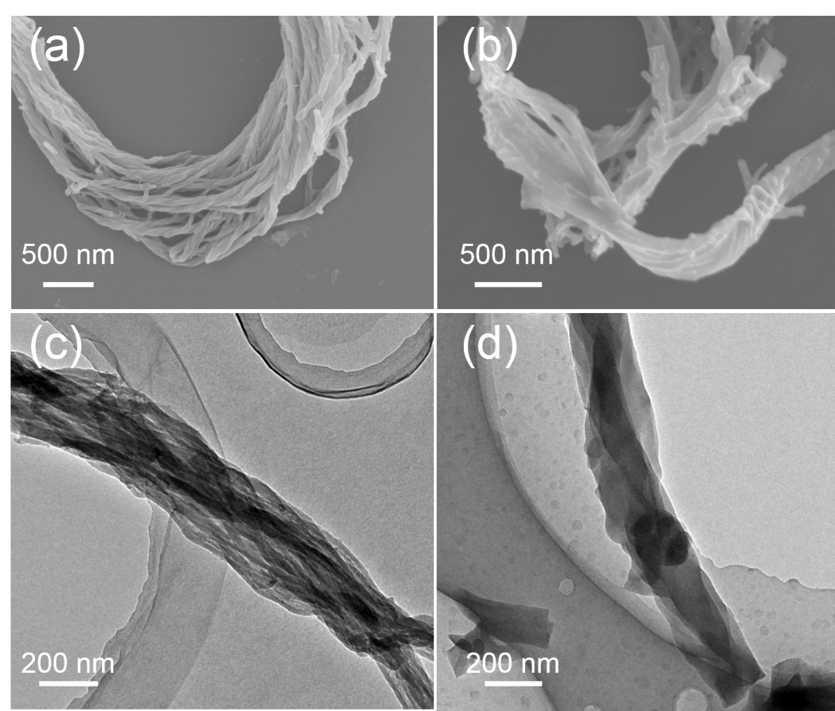
Fig. S3. FE-SEM and TEM images of samples HRNT(a, c) and HCNT(b, d)

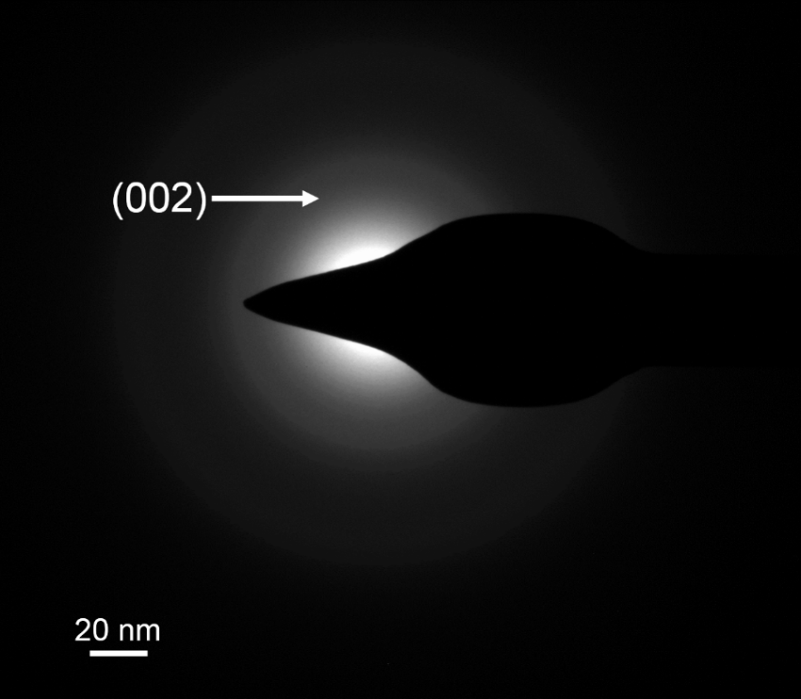
Fig. S4. Selected-area electron diffraction pattern of HMCNT-1

Fig. S5. (a) XPS survey spectra of HMCNT-1, HMCNT-2 and HCNT, (b) the selected region (320 to 500 ev) in the XPS survey spectra (dots line highlighted in (a))

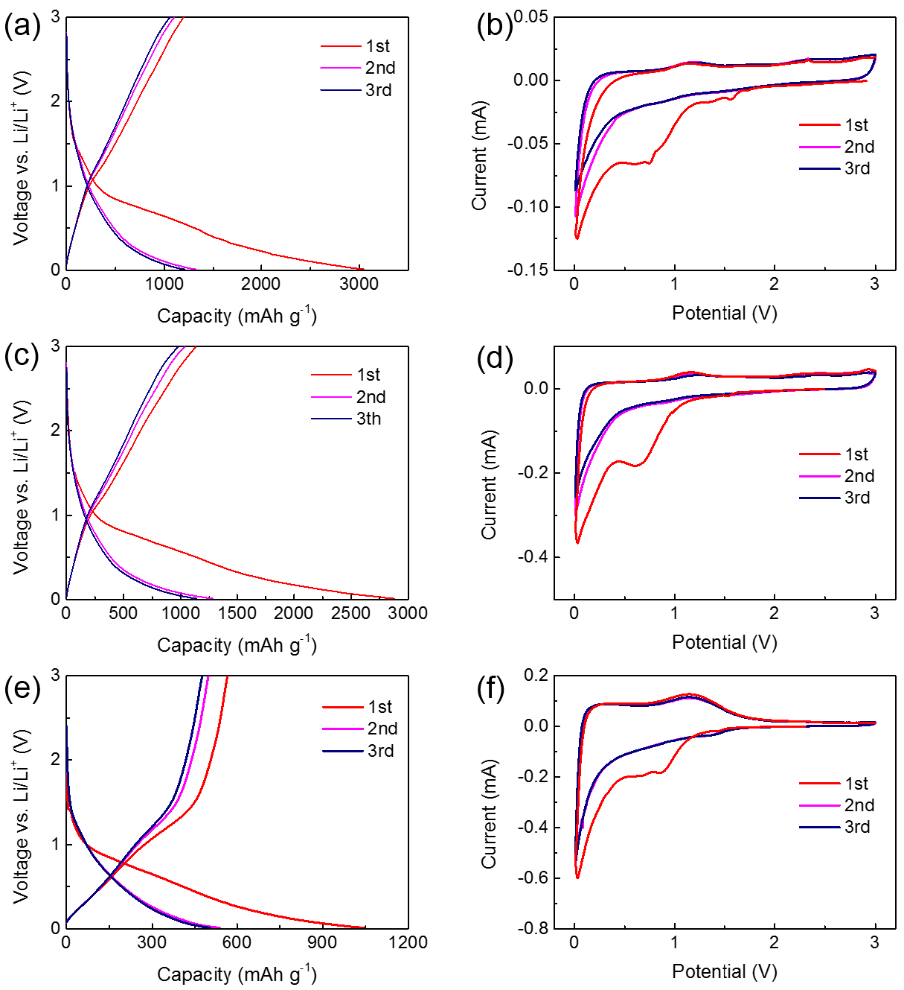
Fig. S6. Voltage profiles of (a) HMCNT-1, (c) HMCNT-2 and (e) HCNT, and cyclic voltammogram curves of (b) HMCNT-1, (d) HMCNT-2 and (f) HCNT.

Fig. S6a, c and e show the voltage profiles of HMCNT-1, HMCNT-2 and HCNT for the initial three cycles at a current density of 0.33C in the voltage range of 0.01 to 3 V. The first discharge capacities of HMCNT-1, HMCNT-2 and HCNT are 3047, 2876 and 1046 mAh g⁻¹, respectively, while the initial reversible capacities are 1195, 1134 and 564 mAh g⁻¹, respectively. The irreversible capacities are suggested to be related to the formation of solid electrolyte interphase (SEI) [1, 2]. In the first cycle, a plateau at 0.6-0.9 V were observed in all the three samples, being due to the lithium-ions intercalation into the graphene layers [3]. Besides, it is also noticed that the initial discharge capacity is much higher than that of commercial graphite, indicating that the lithium storage mechanism of the helical configuration is different from the conventional interaction in graphite.
The cyclic voltammogram (CV) curves of these three samples at the first three cycles were also shown in Fig. S6b, d and f. All of the three curves displayed the typical CV curves of carbonaceous anode materials [4], such as showing an obvious peak at 0.7 V, being consistent with the observations in the voltage profiles that talked aforementioned. In the second and third cycles, the curves nearly overlap, informing that the passivation layer has been formed in the first cycle.
Fig. S7. Cycling performance of HMCNT-1 under different current densities.
Fig. S8. The cross-section SEM images of (a) HMCNT-1 electrode and (b) graphite electrode.

Fig. S9. (a) Gravimetric capacities of HMCNT-1 and graphite, (b) Volumetric capacities of HMCNT-1 and graphite
Fig. S10. Voltage profiles of (a) HMCNT-1 and (b) graphite in full cells. Nyquist plots recorded for the HMCNT-1 and graphite in (c) half-cells and (d) full cells.
Fig. S11. Cycling performance of HMCNT-1 under different mass loading.
Fig. S12. SEM image of HMCNT-1 electrode after 100 cycles.
Fig. S13. Typical Nyquist plots recorded for the HMCNT-1, HMCNT-2 and HCNT.

Table S1. Comparison of cycling performance between HMCNT-1 and other carbon-based or silicon-based anode materials reported previously
Carbon based anode materials | Current density  (mA g⁻¹) | Specific capacity (mAh g⁻¹) | Cycling number | Ref
Hetero-atoms-rich carbon nanobubbles | 1000 | 1317 | 50 | [5]
Hierarchically porous nitrogen-rich carbon | 370 | 676 | 300 | [6]
Nitrogen and sulfur codoped graphene | 200 | 1090 | 500 | [7]
Nitrogen-rich porous carbon | 100 | 1178 | 100 | [8]
Nitrogen-doped porous carbon nanofiber webs | 2000 | 943 | 600 | [3]
Interconnected hollow carbon nanaspheres | 37.2 | 630 | 50 | [9]
Graphene nanoribbons | 123 | 437 | 100 | [4]
Hollow carbon-nanotube/carbon-nanofiber hybrid | 100 | 1150 | 70 | [10]
Phosphorus-doped graphene | 100 | 460 | 80 | [11]
Nitrogen-doped graphene nanoribbon aerogels | 500 | 910 | 300 | [12]
Helical mesoporous carbonaceous nanotubes | 123 | 1812 | 150 | Present work
Silicon based anode materials | Current density  (mA g⁻¹) | Specific capacity (mAh g⁻¹) | Cycling number | Ref
Silicon-carbon nanocables sandwiched between RGO | 840 | 1650 | 50 | [13]
Si RGO carbon composite | 100 | 1445 | 100 | [14]
Core-shell Si/C nanospheres embedded in bubble sheet-like carbon film | 1000 | 1018 | 200 | [15]
Interconnected porous silicon/carbon composites | 50 | 1036 | 100 | [16]
Dual yolk-shell structure of carbon and SiO₂-coated Si | 460 | 956 | 430 | [17]

References
[1] N.A. Kaskhedikar, J. Maier, Lithium storage in carbon nanostructures, Adv. Mater. 21 (25-26) (2009) 2664-2680.
[2] Z.-S. Wu, Y. Sun, Y.-Z. Tan, S. Yang, X. Feng, K. Müllen, Three-dimensional graphene-based macro-and mesoporous frameworks for high-performance electrochemical capacitive energy storage, J. Am. Chem. Soc. 134 (48) (2012) 19532-19535.
[3] L. Qie, W.M. Chen, Z.H. Wang, Q.G. Shao, X. Li, L.X. Yuan, X.L. Hu, W.X. Zhang, Y.H. Huang, Nitrogen‐doped porous carbon nanofiber webs as anodes for lithium ion batteries with a superhigh capacity and rate capability, Adv. Mater. 24 (5) (2012) 2047-2050.
[4] C. Wang, Y.-S. Li, J. Jiang, W.-H. Chiang, Controllable tailoring graphene nanoribbons with tunable surface functionalities: an effective strategy toward high-performance lithium-ion batteries, ACS Appl. Mat. interfaces 7 (31) (2015) 17441-17449.
[5] H. Song, N. Li, H. Cui, C. Wang, Enhanced storage capability and kinetic processes by pores-and hetero-atoms-riched carbon nanobubbles for lithium-ion and sodium-ion batteries anodes, Nano Energy 4 (2014) 81-87.
[6] L. Chen, Y. Zhang, C. Lin, W. Yang, Y. Meng, Y. Guo, M. Li, D. Xiao, Hierarchically porous nitrogen-rich carbon derived from wheat straw as an ultra-high-rate anode for lithium ion batteries, J. Mater. Chem. A 2 (25) (2014) 9684-9690.
[7] W. Ai, Z. Luo, J. Jiang, J. Zhu, Z. Du, Z. Fan, L. Xie, H. Zhang, W. Huang, T. Yu, Nitrogen and sulfur codoped graphene: multifunctional electrode materials for high‐performance Li‐ion batteries and oxygen reduction reaction, Adv. Mater. 26 (35) (2014) 6186-6192.
[8] J. Ou, Y. Zhang, L. Chen, Q. Zhao, Y. Meng, Y. Guo, D. Xiao, Nitrogen-rich porous carbon derived from biomass as a high performance anode material for lithium ion batteries, J. Mater. Chem. A 3 (12) (2015) 6534-6541.
[9] F.D. Han, Y.J. Bai, R. Liu, B. Yao, Y.X. Qi, N. Lun, J.X. Zhang, Template‐Free Synthesis of Interconnected Hollow Carbon Nanospheres for High‐Performance Anode Material in Lithium‐Ion Batteries, Adv. Energy Mater. 1 (5) (2011) 798-801.
[10] Y. Chen, X. Li, K. Park, J. Song, J. Hong, L. Zhou, Y.-W. Mai, H. Huang, J.B. Goodenough, Hollow carbon-nanotube/carbon-nanofiber hybrid anodes for Li-ion batteries, J. Am. Chem. Soc. 135 (44) (2013) 16280-16283.
[11] C. Zhang, N. Mahmood, H. Yin, F. Liu, Y. Hou, Synthesis of phosphorus‐doped graphene and its multifunctional applications for oxygen reduction reaction and lithium ion batteries, Adv. Mater. 25 (35) (2013) 4932-4937.
[12] Y. Liu, X. Wang, W. Wan, L. Li, Y. Dong, Z. Zhao, J. Qiu, Multifunctional nitrogen-doped graphene nanoribbon aerogels for superior lithium storage and cell culture, Nanoscale 8 (4) (2016) 2159-2167.
[13] B. Wang, X. Li, X. Zhang, B. Luo, M. Jin, M. Liang, S.A. Dayeh, S. Picraux, L. Zhi, Adaptable silicon–carbon nanocables sandwiched between reduced graphene oxide sheets as lithium ion battery anodes, ACS nano 7 (2) (2013) 1437-1445.
[14] K. Feng, W. Ahn, G. Lui, H.W. Park, A.G. Kashkooli, G. Jiang, X. Wang, X. Xiao, Z. Chen, Implementing an in-situ carbon network in Si/reduced graphene oxide for high performance lithium-ion battery anodes, Nano Energy 19 (2016) 187-197.
[15] W. Li, Y. Tang, W. Kang, Z. Zhang, X. Yang, Y. Zhu, W. Zhang, C.S. Lee, Core–Shell Si/C Nanospheres Embedded in Bubble Sheet‐like Carbon Film with Enhanced Performance as Lithium Ion Battery Anodes, Small 11 (11) (2015) 1345-1351.
[16] Z. Zhang, Y. Wang, W. Ren, Q. Tan, Y. Chen, H. Li, Z. Zhong, F. Su, Scalable Synthesis of Interconnected Porous Silicon/Carbon Composites by the Rochow Reaction as High‐Performance Anodes of Lithium Ion Batteries, Angew. Chem. 126 (20) (2014) 5265-5269.
[17] L. Yang, H. Li, J. Liu, Z. Sun, S. Tang, M. Lei, Dual yolk-shell structure of carbon and silica-coated silicon for high-performance lithium-ion batteries, Sci. Rep. 5 (2015) 10908.

* Corresponding author. ** Corresponding author. *** Corresponding author. E-mail address: apcdwang@hust.edu.cn (C. Wang), liyi@suda.edu.cn (Y. Li), mlq518@whut.edu.cn (L. Mai)

