Supplementary Material

Towards enhancing photocatalytic hydrogen generation: which is more important, alloy synergistic effect or plasmonic effect?

Zhenhe Xu,†‡ Md Golam Kibria,§ Bandar AlOtaibi,§ Paul N. Duchesne,# Lucas V. Besteiro,$ Yu Gao,‡ Zetian Mi,§ Peng Zhang,# Alexander O. Govorov,$ Liqiang Mai,# Mohamed Chaker,† Dongling Ma*†

†Institut National de la Recherche Scientifique (INRS), Centre Énergie, Materiaux et Télécommunications, Université du Québec, 1650 Boulevard Lionel-Boulet, Varennes, Québec J3X 1S2, Canada

‡The Key Laboratory of Inorganic Molecule-Based Chemistry of Liaoning Province, College of Applied Chemistry, Shenyang University of Chemical Technology, Shenyang, 110142, China

§Department of Electrical and Computer Engineering, McGill University, 3480 University Street, Montreal, Québec, H3A 0E9, Canada

#Department of Chemistry, Dalhousie University, Halifax, NS, B3H 4R2, Canada

$Department of Physics and Astronomy, Ohio University, Athens, OH 45701, USA

#State Key Laboratory of Advanced Technology for Materials Synthesis and Processing, Wuhan University of Technology, Wuhan, 430070, China

**Theoretical Supporting Information**

# Drude-broadened dielectric function

We characterize the electromagnetic response of materials in the mixed NP by using data obtained from published tables.1-2 Then, to account for crystal impurities in the nanofabricated samples into our theoretical description of gold we use the Drude model of metals. It describes the permittivity of a material due to the electronic intraband transitions as an oscillator with a resonance centered at the plasma frequency of the material, , and width proportional to the inverse of the electron mean collision rate :

,

The parameter  is the permittivity value at infinite frequency.

Such impurities broaden the plasma resonance in the material, so we can use the expression above to reconstruct the experimental permittivity data of the material while at the same preserving the intraband information:

.

We have used the following values for our calculations:



# Effective medium theory: Maxwell-Garnett formula

In order to calculate the expected absorption of the NPs we need to model the permittivity data for the Au-Pt complexes. To this end we have used the Maxwell-Garnett formula3 for an effective medium, which provides the effective permittivity for the alloy created from a host material and inclusions of volume fraction  of a guest material:

.

This expression that can be reordered to the explicit form

.

The variables involved are the effective permittivity of the complex,, that of the host metal, , and that of the guest metal, . Given that gold and platinum atoms have similar size, we computed the volume fraction  simply as the atomic fraction of the less abundant species. For example, for the AuPt NPs with Au as a guest crystal, we have: , and . For this particular case, the volume fraction  is related with the atomic fraction  via the following equations:



Here,are the numbers of the corresponding atoms in the NP and are the particle densities of Pt (Au).

# Absorption

Having a model for the permittivity of the alloy we can calculate the absorption cross section of the NPs through their optical absorption:



in where we have used a water matrix, with . Furthermore, given that we are studying spherical NPs well within the quasistatic approximation, we can describe the fields with a simple field enhancement term. We then use the final expression



(1) Johnson, P. B.; Christy, R. W., Optical Constants of the Noble Metals. *Phys. Rev. B* **1972**, *6*, 4370-4379.

(2) Rakić, A. D.; Djurišić, A. B.; Elazar, J. M.; Majewski. M. L.; Optical properties of metallic films for vertical-cavity optoelectronic devices. *Appl. Opt.* **1998**, *37*, 5271-5283.

(3) T. C. Choy, Repr. ed., Oxford: Clarendon Press, **2007**.

**Table S1.** Structural information derived from EXAFS fitting for Pt50Au50 nanoparticles. Numbers in parentheses indicate the uncertainty in each value.

|  |  |  |  |  |  |
| --- | --- | --- | --- | --- | --- |
| Absorption Edge | Chemical Bond | Coordination Number | R (Å)  (Bond Distance) | σ2 (Å2)  (Debye Waller Factor) | ΔE0 (eV) (Energy Shift) |
| Pt L3 | Pt-M | 11 (2) | 2.772 (8) | 0.004 (2) | 0 (1) |
| Au L3 | Au-M | 11 (1) | 2.838 (4) | 0.0046 (5) | 2 (1) |

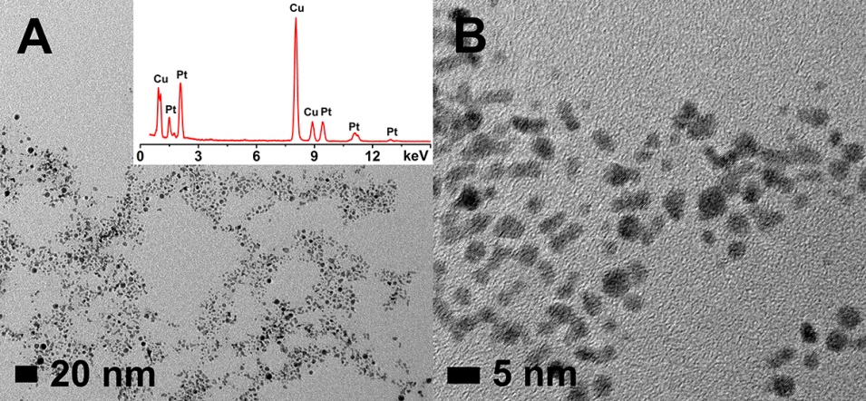

**Figure S1.** (A, B) TEM images of Pt NPs prepared by PLAL. The inset in (A) shows their EDX spectrum.

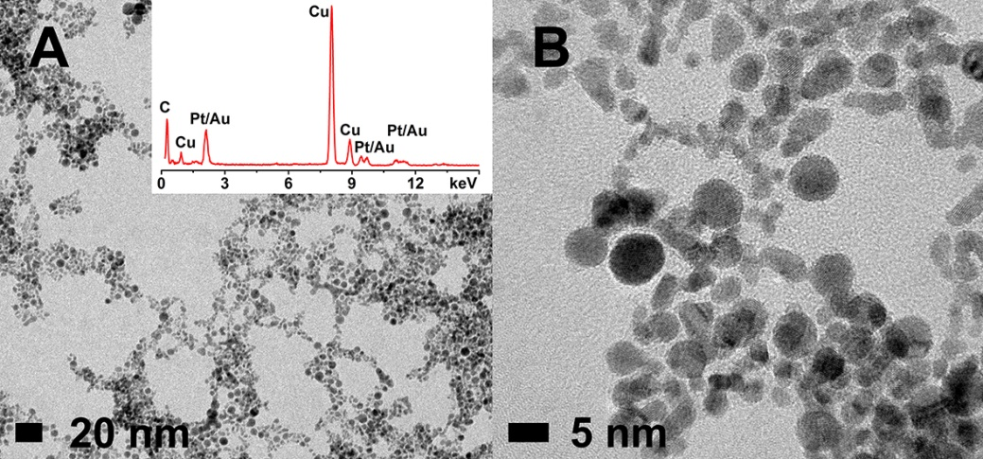

**Figure S2.** (A, B) TEM images of Pt70Au30 alloy NPs prepared by PLAL. The inset in (A) shows their EDX spectrum.

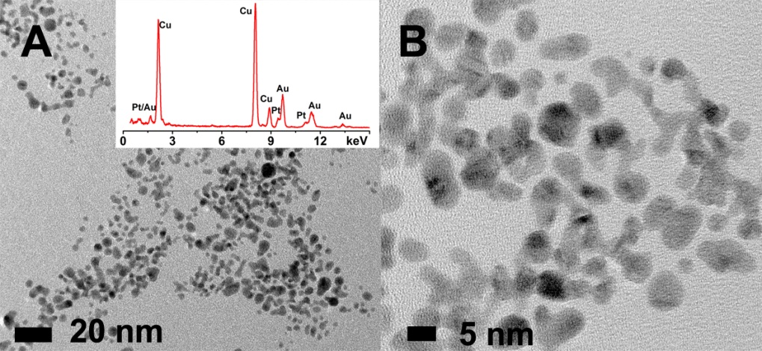

**Figure S3.** (A, B) TEM images of Pt30Au70 alloy NPs prepared by PLAL. The inset in (A) shows their EDX spectrum.

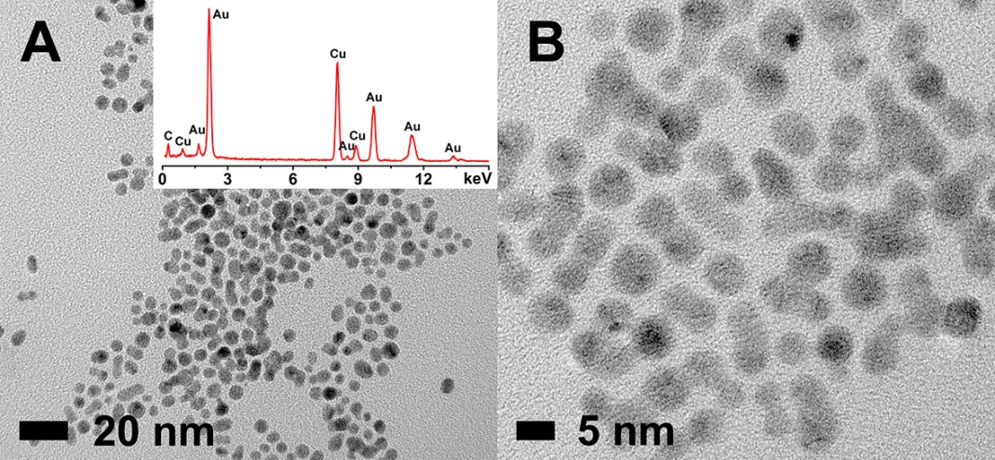

**Figure S4.** (A, B) TEM images of Au NPs prepared by PLAL. The inset in (A) shows their EDX spectrum.

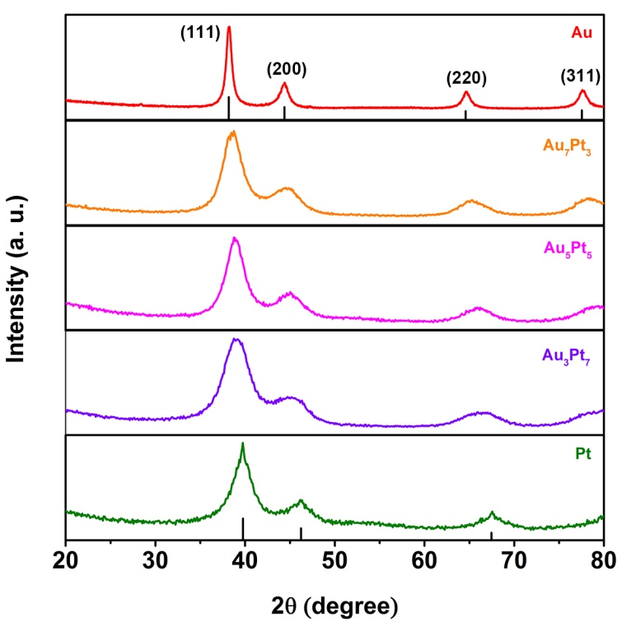

**Figure S5.** XRD patternsof PLAL-PtxAu100-x (x = 100, 70, 50, 30, 0) NPs.

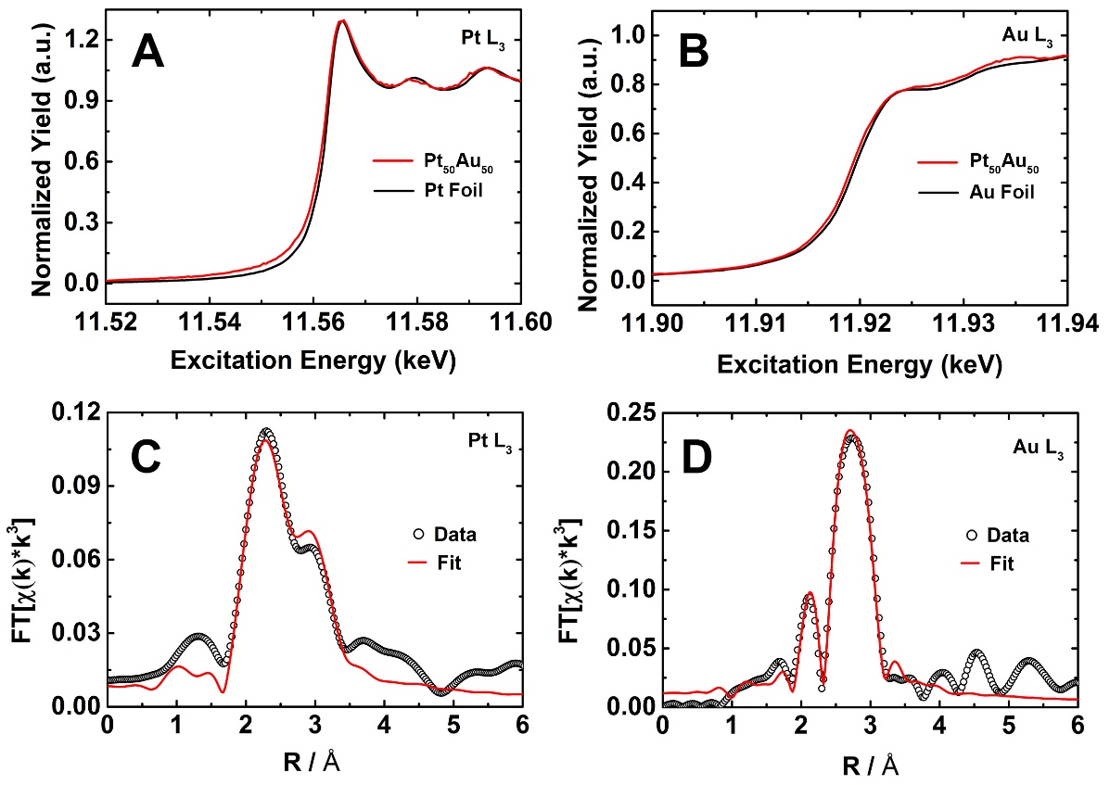

**Figure S6.** X-ray absorption fine structure analysis of Pt50Au50 NPs. (A, B) XANES spectra acquired at the Pt and Au L3 absorption edges for Pt50Au50 and corresponding metal foils. The first peak following the rising edge of the spectrum reflects the number of vacancies in the 5d orbitals of that element; the greater the area under the curve, the greater the number of vacancies. Both the Pt and Au L3 edge spectra of the Pt5Au5 sample strongly resembled those of the metal foils, indicating that they are both highly metallic and that there is no observable electronic change in these samples due to Pt-Au interactions. This, however, does not absolutely exclude the possible d-band center shift; the subtle d-band shift could simply not be resolved at such high energy measurements in the current case. A slight broadening of the Pt5Au5 spectra was observed, but this has been previously confirmed to be due to the use of a fluorescence detector instead of direct absorption measurements.

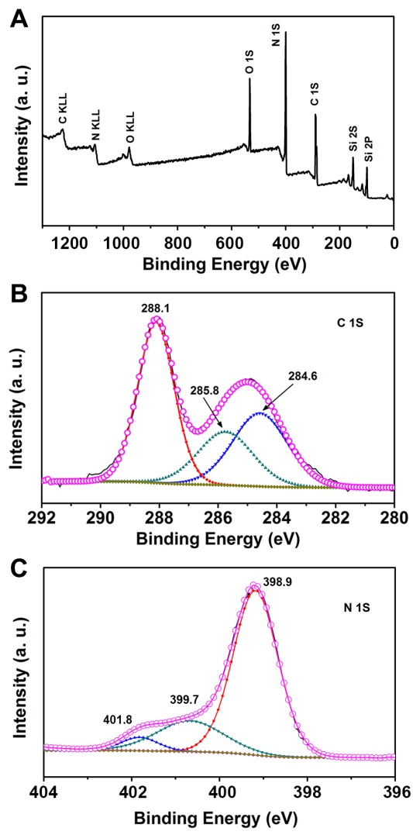

**Figure S7.** XPS spectra of C3N4: (A) survey spectrum, (B) C 1S, (C) N 1S. The XPS spectrum of C3N4 exhibits C1s and N1s signals with a C/N ratio of 0.73, close to the ideal C3N4 composition (C/N=0.75). The C1s spectrum shows three deconvoluted peaks centering at 284.6, 285.8, and 288.1 eV, which are assigned to *sp*2 C atoms bonded to N in an aromatic ring (N−C=N), *sp*3 hybridized C atoms (C−(N)3), and the pure graphitic sites in a CN matrix, respectively. Meanwhile, the high resolution N1s spectrum can also be deconvoluted into three peaks. The peak at 398.9 eV is assigned to *sp*2 hybridized aromatic N atoms bonded to C atoms (C−N=C). The peak at 399.7 eV is related to either tertiary nitrogen (N−(C)3) groups linking the structural motif (C6N7) or amino groups carrying hydrogen ((C)2−N−H) in connection with structural defects and incomplete condensation. A weak peak at 401.8 eV corresponds to N atoms bonded to three C atoms in the aromatic ring.

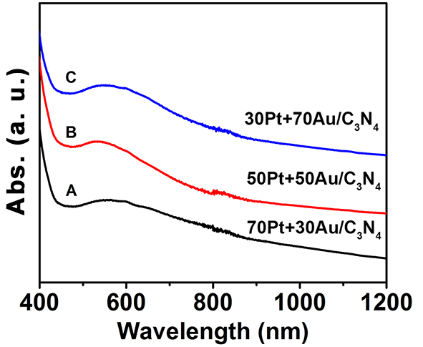

**Figure S8.** Absorption spectra of mixed NP samples: (A) 70Pt + 30Au/C3N4, (B) 50Pt + 50Au/C3N4 and (C) 30Pt + 70Au/C3N4.

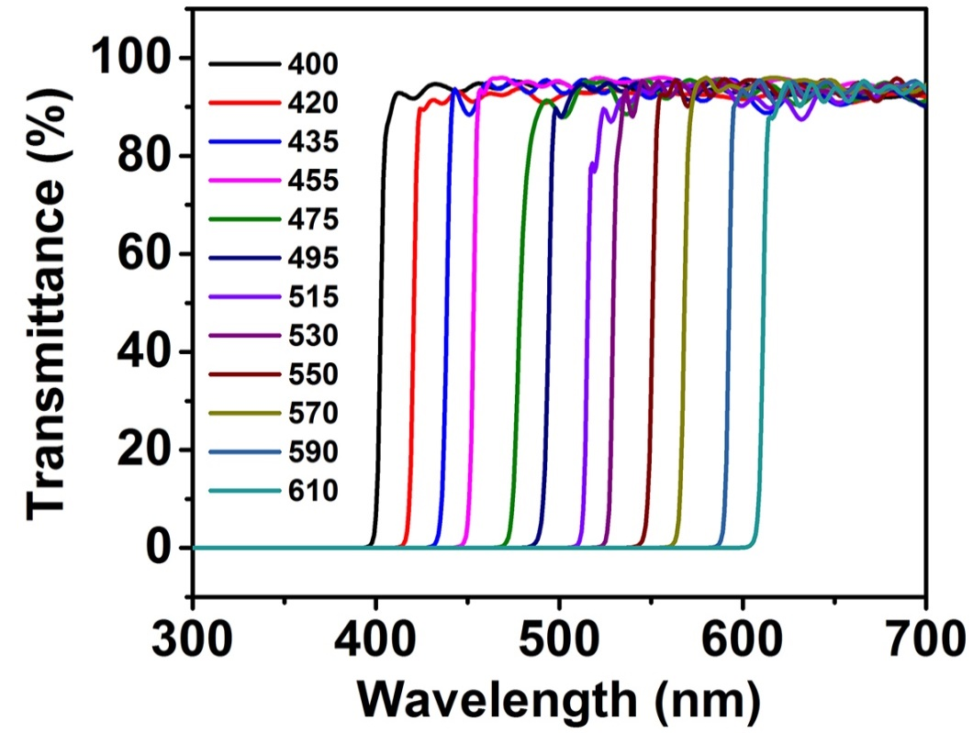

**Figure S9.** Transmission spectra of long-pass filters with cut-on wavelengths from 400 to 610 nm used for wavelength-dependent water splitting measurements.