Supplementary Information
Robust Three-Dimensional Graphene Skeleton Encapsulated
Na₃V₂O₂(PO₄)₂F Nanoparticles as a High-Rate and Long-Life Cathode of Sodium-Ion Batteries
Yameng Yinª, Fangyu Xiongª, Cunyuan Peiª, Yanan Xuª, Qinyou An*ª, Shuangshuang Tanª Zechao Zhuangª, Jinzhi Shengª, Qidong Liª, and Liqiang Mai*^{a,b}
ª State Key Laboratory of Advanced Technology for Materials Synthesis and Processing, International School of Materials Science and Engineering, Wuhan University of Technology, Wuhan, 430070, P. R. China.
^{b} Department of Chemistry, University of California, Berkeley, California 94720, United States
*Corresponding Authors: E-mail: anqinyou86@whut.edu.cn ; mlq518@whut.edu.cn

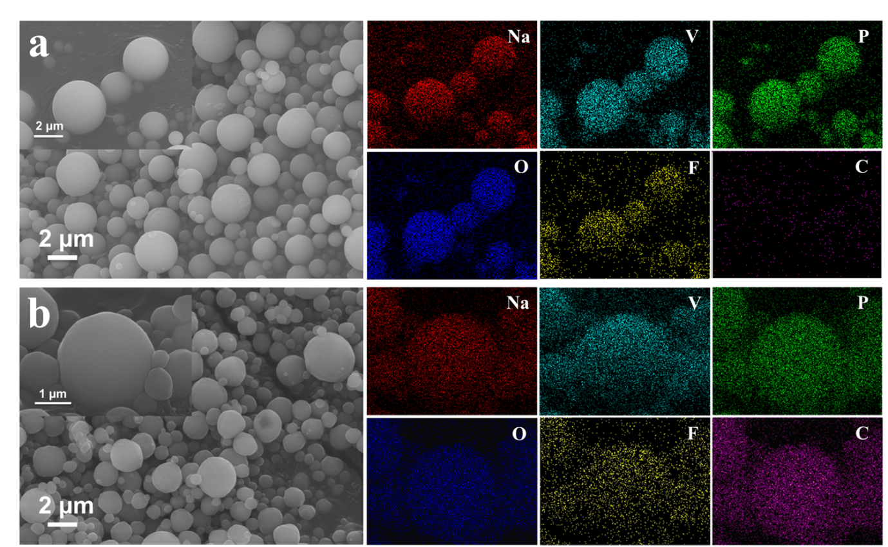
Fig. S1 The FESEM images and elemental mapping images of NVOPF (a) and NVOPF/rGO (b) before calcination.

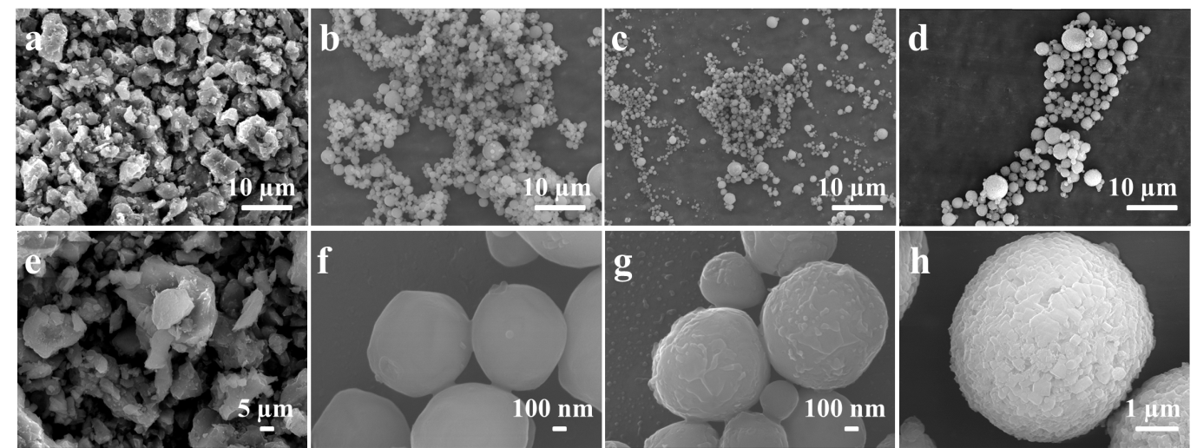
Fig. S2 The FESEM images of S1 (a, e), S2 (b, f), S3 (c, g) and S4 (d, h).
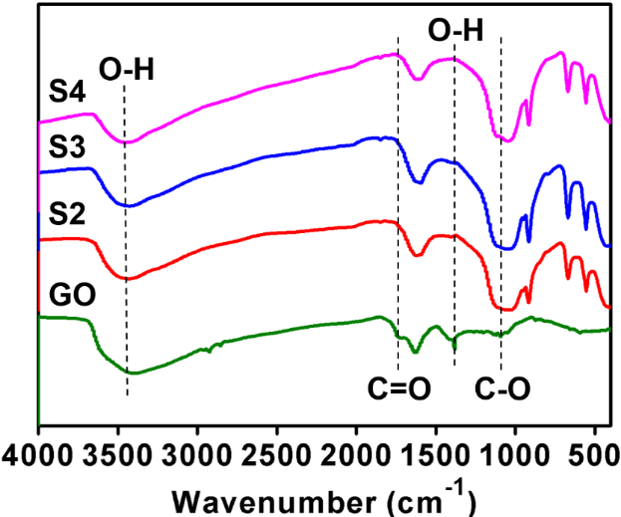
Fig. S3 FTIR spectra of graphite oxide and three annealing samples (S2-S4).

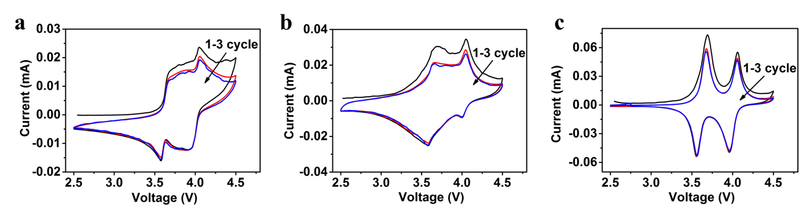
Fig. S4 The CV curves of S1 (a), S2 (b) and S3 (c) in first three cycles at a scan rate of 0.1 mV s⁻¹ in the potential range from 2.5 to 4.5 V.

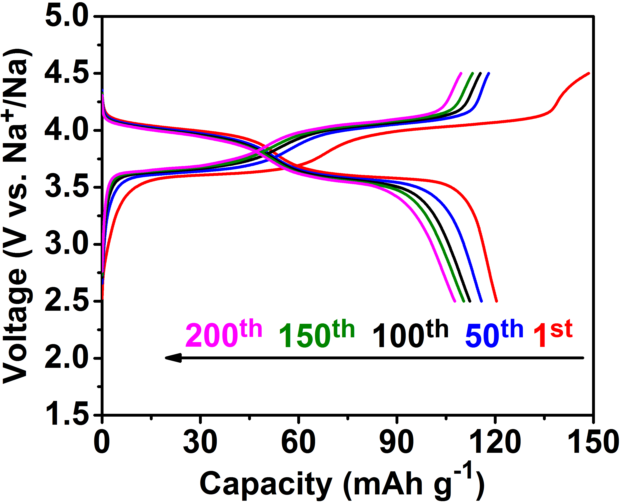
Fig. S5 The charge/discharge curves of S4 in different cycles at 0.5 C.
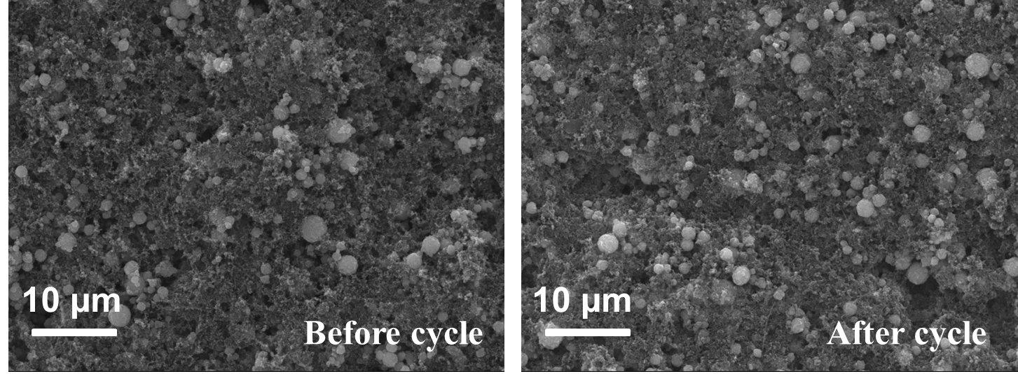
Fig. S6 The FESEM images of S4 before and after 2000 cycles at 30 C.

Table S1. The performance comparison of the Na₃V₂O₂(PO₄)₂F electrodes in the references.
NVOPF samples | Carbon content | Preparation method | Voltage window | Rate capacity
NVOPF/RGO¹⁴ | 5.8 wt% | solvothermal | 2.5-4.5 V | 29 mA h g⁻¹ at 20 C
NVOPF-MWCNT¹⁵ | / | hydrothermal | 2.5-4.5 V | 59 mA h g⁻¹ at 20 C
NVOPF@C/GO¹⁶ | 8.1 wt% | hydrothermal | 2.0-4.3 V | 78.5 mA h g⁻¹ at 10 C
RuO₂-coated NVOPF¹⁷ | / | Micro-emulsion-  mediated hydrothermal | 2.5-4.3 V | 71 mA h g⁻¹ at 40 C
RuO₂-coated Ru-doping NVOPF¹⁸ | / | solvothermal | 2.5-4.5 V | 82 mA h g⁻¹ at 50 C  44.9 mA h g⁻¹ at 100 C
This work | 1.9 wt% | Spray-drying | 2.5-4.5 V | 83.6 mA h g⁻¹ at 50 C  70.3 mA h g⁻¹ at 100C

