Supporting information

Novel Layer-by-Layer Stacked VS₂ Nanosheets with Intercalation Pseudocapacitance for High-Rate Sodium Ion Charge Storage

Ruimin Sunª, Qiulong Weiª, Jinzhi Shengª, Changwei Shiª, Qinyou Anª*, Sijie Liuª, and Liqiang Mai^{a, b}*

ªState Key Laboratory of Advanced Technology for Materials Synthesis and Processing, Wuhan University of Technology, Luoshi Road 122, Wuhan, 430070, P. R. China
^{b}Department of Chemistry, University of California, Berkeley, California, 94720, United States

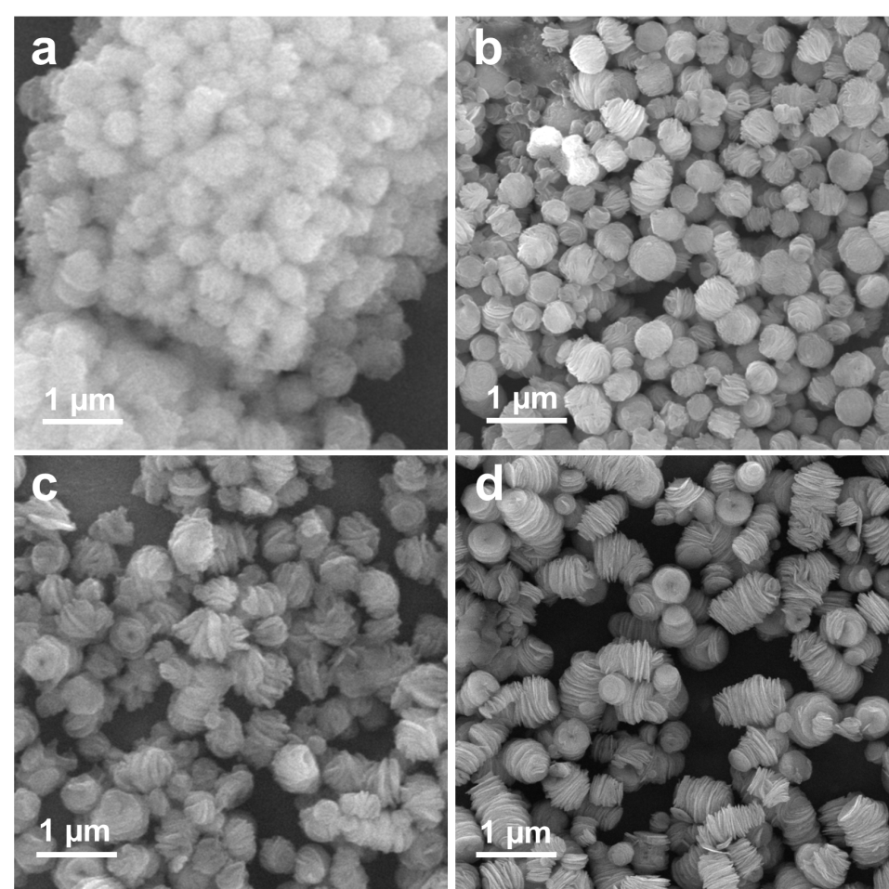
Figure S1. SEM images of the products with 1g PVP taken from different reaction times. (a) 2 h, (b) 6 h, (c) 10 h, (d) 20 h.

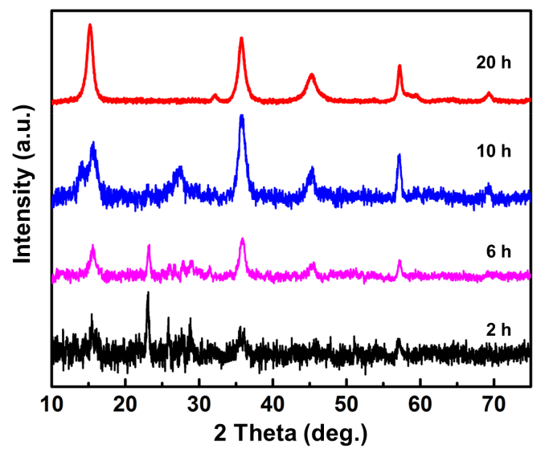
Figure S2. XRD patterns of the products with PVP obtained by hydrothermal reaction for different time.

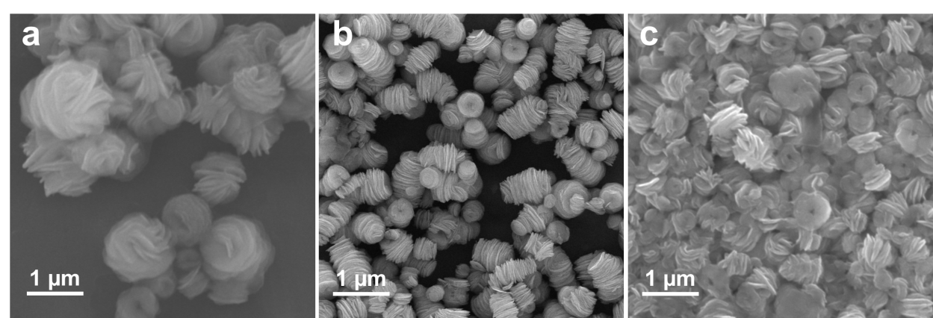

Figure S3. SEM images of the products with different PVP amounts during synthesis. (a) 0.5 g, (b) 1 g, (c) 2 g.

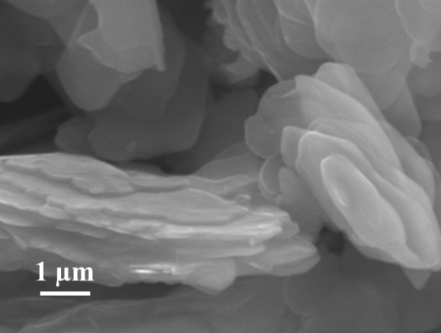
Figure S4. SEM image of VS₂-MNSs.

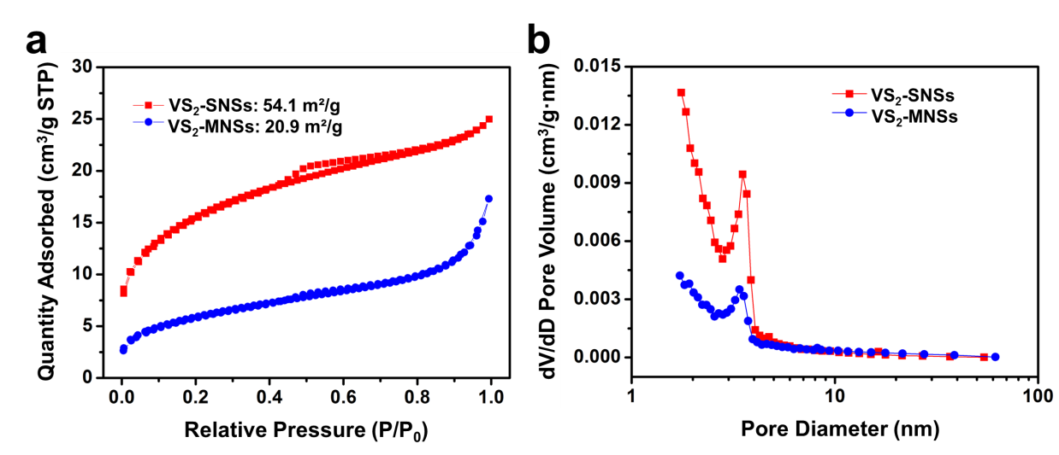
Figure S5. (a) Nitrogen adsorption-desorption isotherms and (b) the corresponding pore size distribution curve of VS₂-MNSs and VS₂-SNSs.

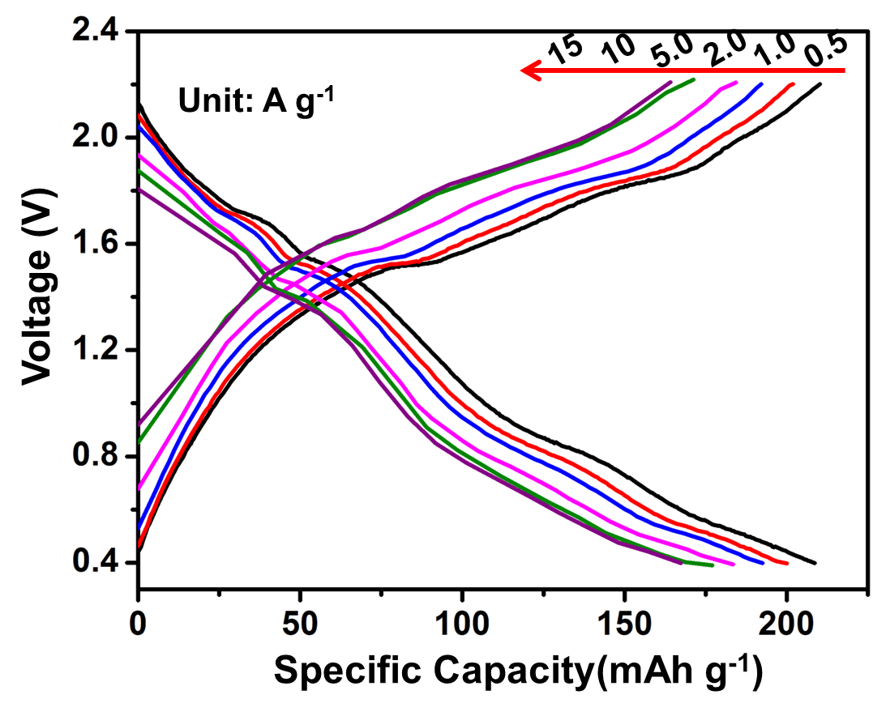
Figure S6. Discharge-charge curves in different rates of the VS₂-SNSs electrode.
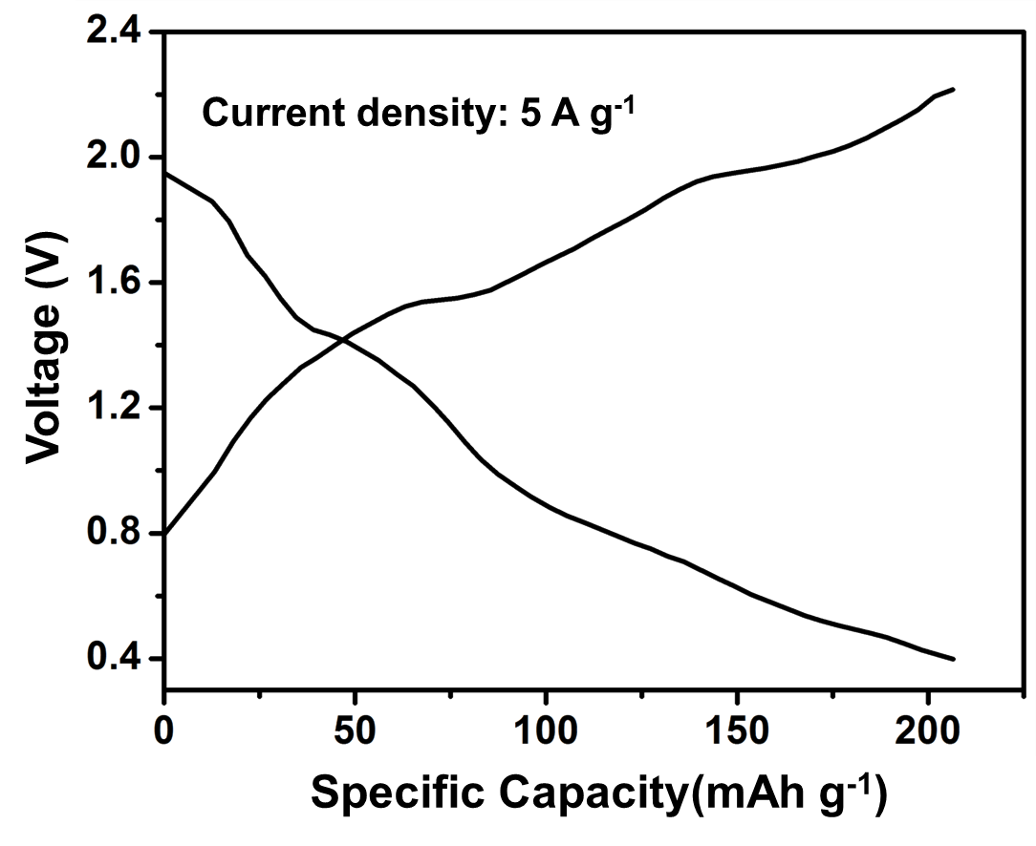
Figure S7. Discharge-charge curves of VS₂-SNSs electrode after 600 cycles.

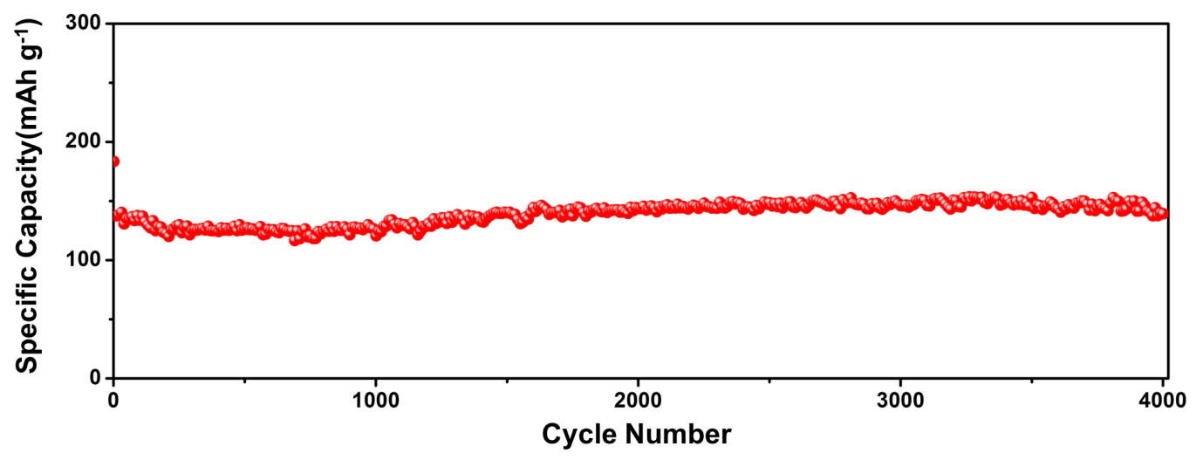Figure S8. Cyclic performance of VS₂-SNSs at a current density of 20 A g⁻¹.

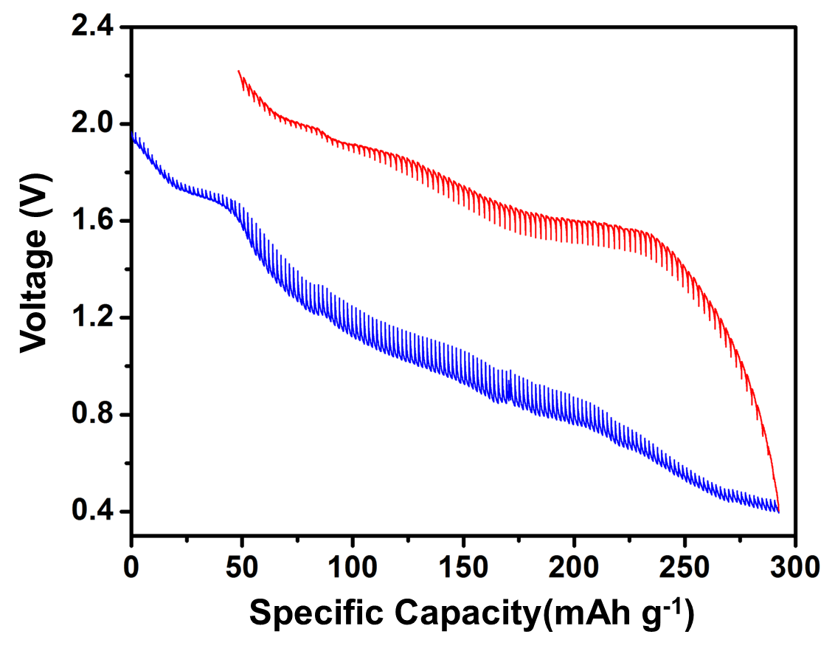
Figure S9. GITT curves of the VS₂-SNSs electrode in a half cell. The applied current was 20 mA g⁻¹.

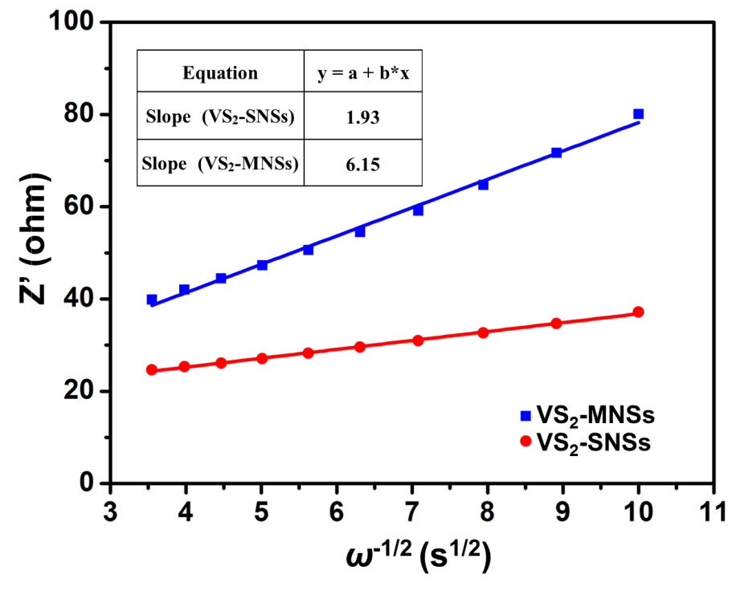
Figure S10. The fitted lines and real part of the impedance versus ω^{−1/2} for VS₂-MNSs and VS₂-SNSs.

The ion diffusion coefficient can also be calculated by the following equation:
D = 0.5(RT/An²F²Cσ)²
where D represents the diffusion coefficient (cm² s⁻¹), R represents the gas constant, T represents the absolute temperature, A represents the surface area of the anode (cm²), n is the number of electrons transferred electrochemical reaction, F is the Faraday constant, C represents the concentration of ions and σ is the Warburg factor relative to Z_{re}. From the slope of the lines in the above Figure S5, σ can be obtained.
Z_{re} = R_{D} + R_{L} + σω^{−1/2}
The ions diffusion coefficients at room temperature are calculated to be 1.54×10⁻⁸ and 1.52×10⁻⁹ cm² s⁻¹ for the VS₂-SNSs and VS₂-MNSs, respectively.

Equation S1
The electrochemical process during Na⁺ insertion/extraction is described by the following Equation S1:
VS₂ + xNa⁺ + xe⁻ Na_{x}VS₂
The theoretical capacity of VS₂ (233 mAh g⁻¹) is obtained at x = 1 using C = Fx/M. in this equation, C is the theoretical capacity, F is Faraday constant, x is the molar number of embedded ions and M is the molecular weight.

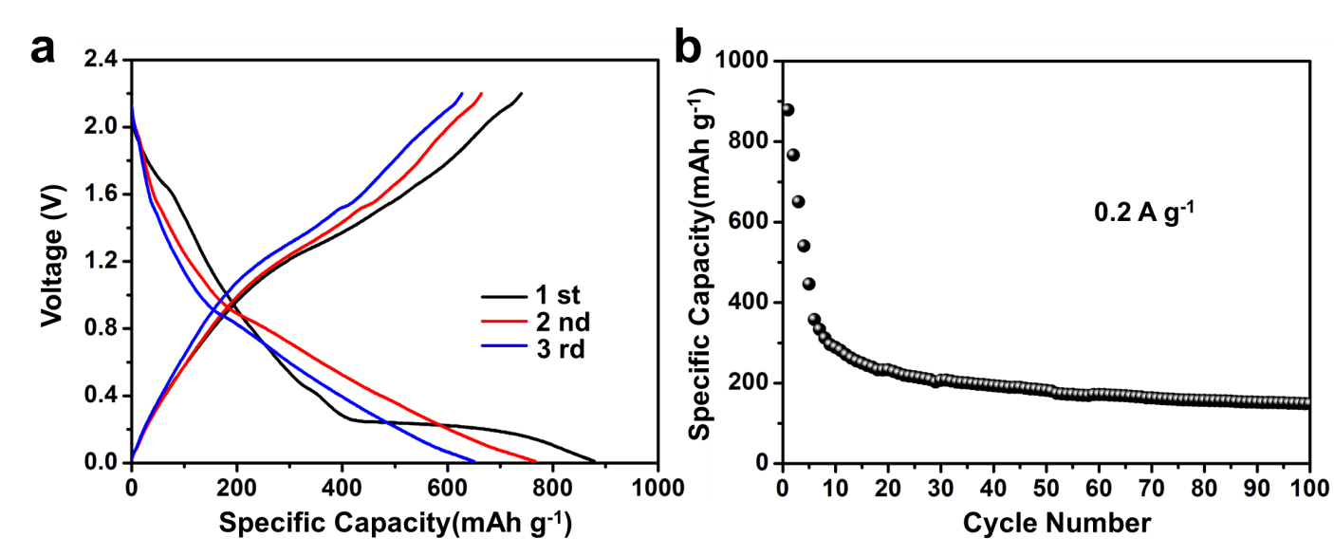
Figure S11. (a) Discharge-charge curves and (b) cycling performance of the VS₂-SNSs electrode in the voltage range of 0.01−2.2 V at 0.2 A g⁻¹.

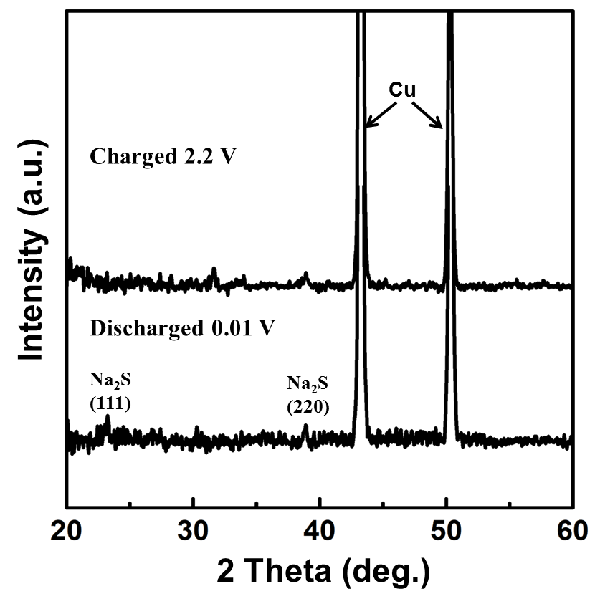
Figure S12. The XRD patterns of VS₂-SNSs electrode material at the discharged state of 0.01 V and at charged state of 2.2 V at 1st cycle.
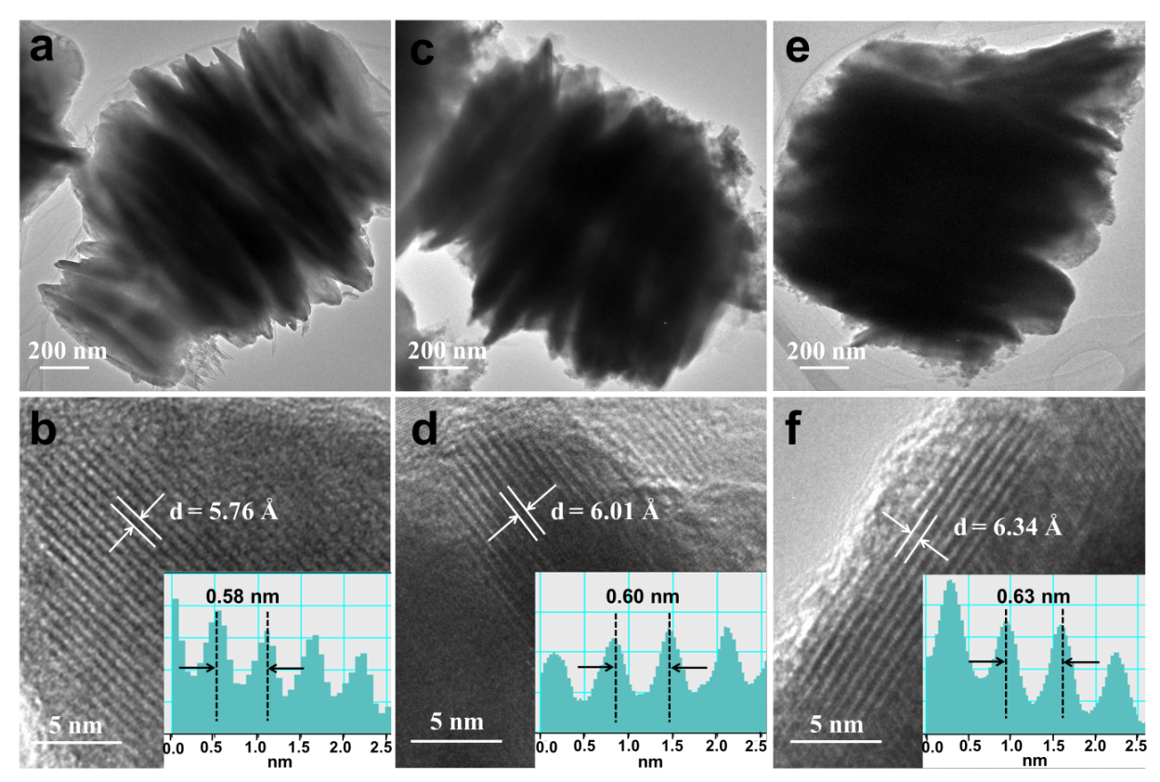Figure S13. TEM and HRTEM images of the electrode materials. (a, b) Original VS₂-SNSs. Electrode material after charging to 2.2 V after (c, d) 300 cycles, (e, f) 600 cycles. The HRTEM images (Figure S7c,d) after 300 cycles show that the morphology of the stacked nanosheets remains almost unchanged and the VS₂ layers are expanded. After 600 cycles, the VS₂ layers (Figure S7e,f) are more expanded and the whole morphology still keeps well. Only a few nanoplates on the side of the stacked nanosheets crack into small ones, leading to more exposed active sites.

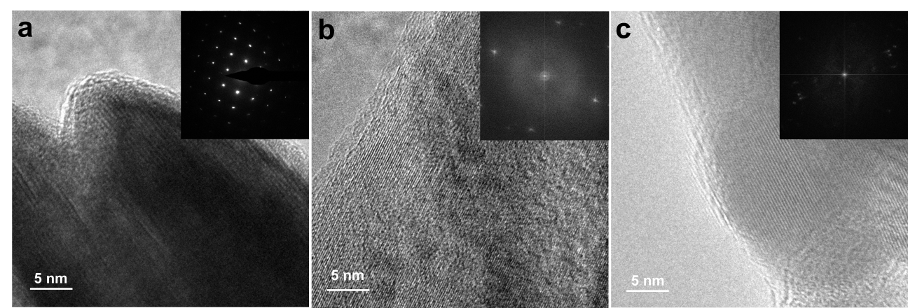
Figure S14. HRTEM images of the electrode materials from the edge of VS₂-SNSs. (a) Original VS₂-SNSs. Electrode material after charging to 2.2 V after (b) 300 cycles, (c) 600 cycles.

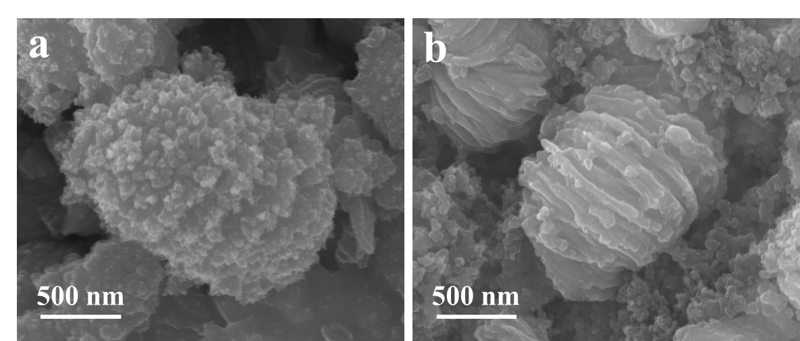
Figure S15. SEM images of the electrode materials at discharged state. (a) After first cycle to 0.01 V, (b) after 600 cycles to 0.4 V.

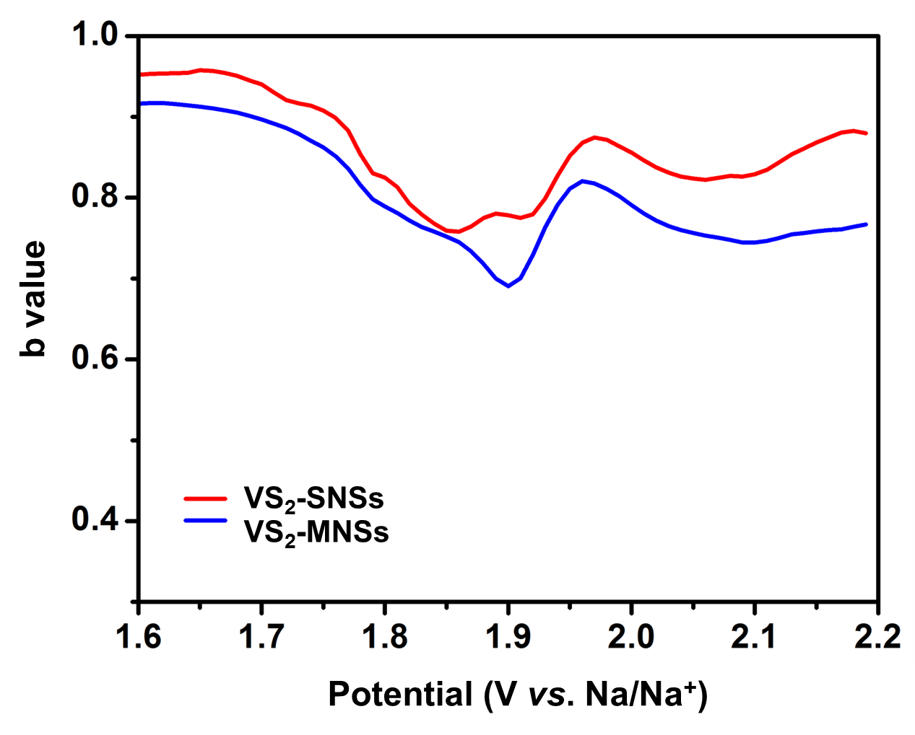
Figure S16. Determination of the anodic b-values at different potential during charging for VS₂-MNSs and VS₂-SNSs.

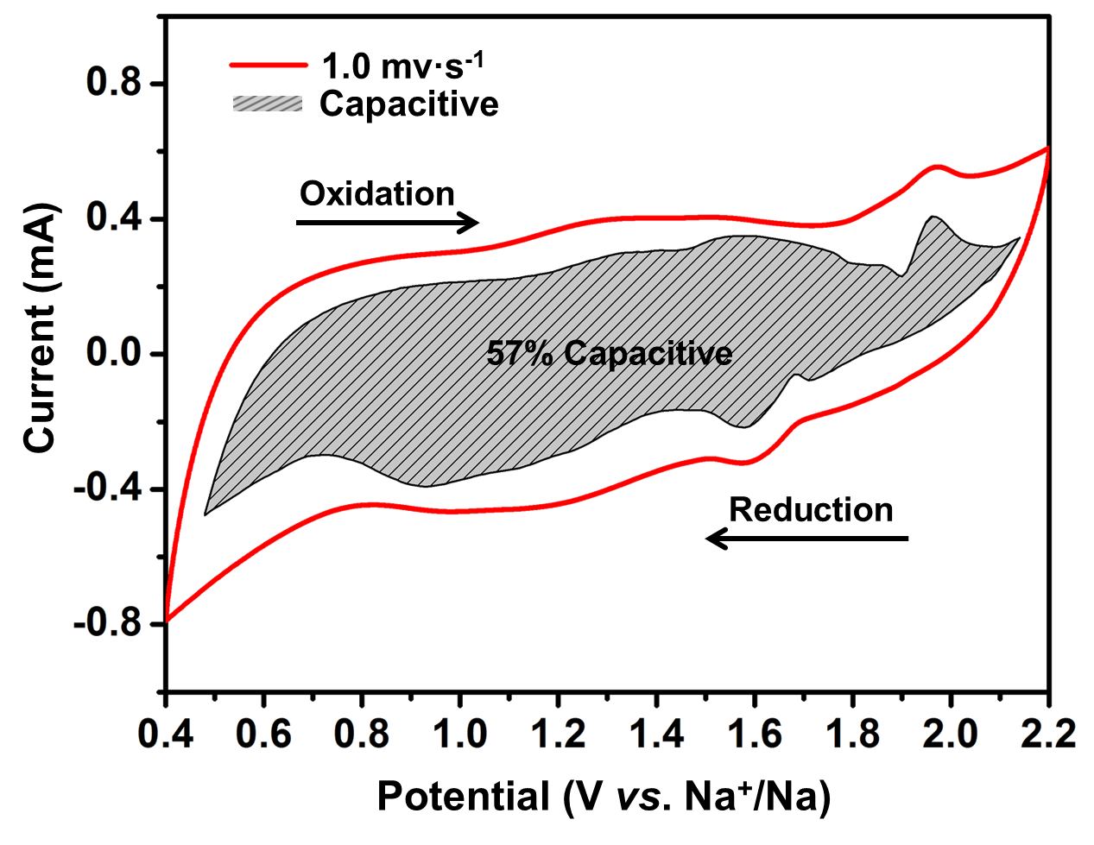
Figure S17. VS₂-MNSs with the capacitive contribution (1 mV s⁻¹) of 57% and is shown by the shaded region.

Table S1. Comparison of the electrochemical performance of intercalation based anode for various reported sodium-ion battery.
