Supporting Information

Structural and Chemical Synergistic Effect of CoS Nanoparticles and Porous Carbon Nanorods for High-Performance Sodium Storage

Limin Zhou ª, Kai Zhang ^{b}, Jinzhi Sheng ª, Qinyou An ª, Zhanliang Tao ^{c}, Yong-Mook Kang ^{b}, Jun Chen ^{c,}*, Liqiang Mai ^{a,d,}*

ª State Key Laboratory of Advanced Technology for Materials Synthesis and Processing, Wuhan University of Technology, Hubei, Wuhan 430070, P. R. China
^{b} Department of Energy and Materials Engineering, Dongguk University-Seoul, Seoul 100-715, Republic of Korea
^{c} Key Laboratory of Advanced Energy Materials Chemistry (Ministry of Education), Collaborative Innovation Center of Chemical Science and Engineering, College of Chemistry, Nankai University, Tianjin 300071, P. R. China
^{d} Department of Chemistry, University of California, Berkeley, California 94720, United States

*Corresponding authors:
E-mail: mlq518@whut.edu.cn (L. Q. Mai)
E-mail: chenabc@nankai.edu.cn (J. Chen)

Fig. S1. TGA curve for the 7-CoS/C between room temperature and 800˚C measured with a heating rate of 5 ˚C /min under air atmosphere.
With the increasing of temperature, the final obtained-product calcinated in air condition is Co₃O₄. Considering the existence of adsorbed water, the difference value of mass is calculated from 93.5 % to 71 % between 100 and 600 ˚C, including the oxidization of carbon and CoS. Then, we translate 93.5 % and 71 % into hundred-mark system, that is 100 % and 75.9 %. According to the proportion of Co in Co₃O₄, it comes to the conclusion that the mass content of Co, S, and C is 55.7, 30.2, and 14.1 wt%, respectively.

Fig. S2. SEM image (a), TEM image (b) (inset: CoS particle size distribution diagram) of the as-prepared 18.5-CoS/C.

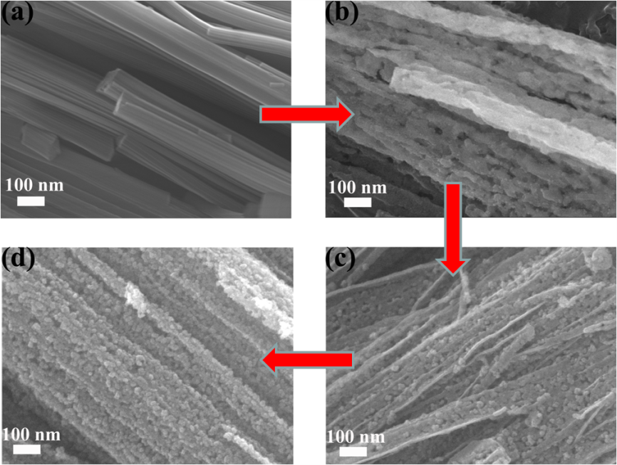
Fig. S3. SEM images of the 7-CoS/C with different calcination temperature and heating time (a. Co-MOF precursor; b. 400 ˚C, 0 h; c. 600 ˚C, 0 h; and d. 600 ˚C, 2 h).

Fig. S4. N₂ adsorption-desorption isotherm (a) and pore size distribution curve (b) of the 18.5-CoS/C.

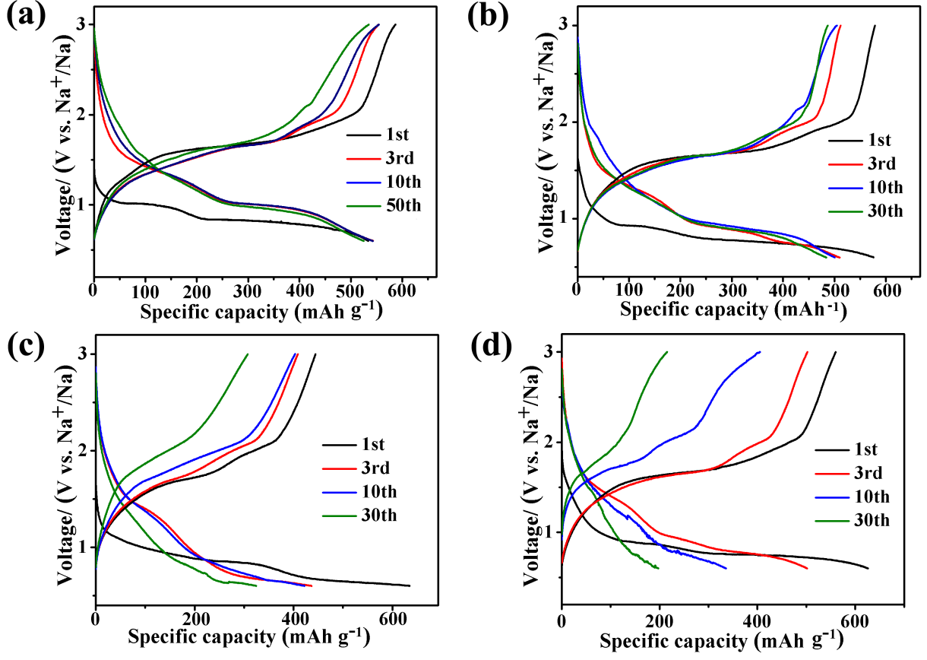
Fig. S5. Electrolyte optimization of 7-CoS/C-Na batteries. Discharge–charge curves at the current density of 1 A g⁻¹ in (a) NaSO₃CF₃/DGM, (b) NaClO₄/DGM, (c) NaClO₄/EC-DMC, and (d) NaClO₄/PC.

Fig. S6. The Nyquist plots of 7-CoS/C-Na cell in (a) NaSO₃CF₃/DGM, (b) NaClO₄/DGM, (c) NaClO₄/EC-DMC, and (d) NaClO₄/PC. The equivalent circuit is put inside each image.
The EIS plot is charateristic of a compressed semicircle at high-frequency range and a line at low-frequency range, which reveals the charge transfer and electrolyte diffusion process. The EIS analysis of the 7-CoS/C-Na system with various electrolyte was taken under different temperature from 298.15 K to 323.15 K shown in Figure S6. We can obviously observe that the 7-CoS/C-Na cell has the lowest charge tranfer impedance in NaSO₃CF₃/DGM electrolyte.

Fig. S7. (a) Apparent activation energy calculation: the relationship between ln(T/R_{ct}) and 1000/T.
The activiation energy (E_{a}) was calculated from the EIS data at differnet temperature according to the equations: i₀=RT/nFR_{ct} (Equation S1) and i₀=Aexp(-E_{a}/RT) (Equation S2), where R is the gas constant, T is the absolute temperature, n is the number of transferred electrons, and F is the Faraday constant.[1,2] NaSO₃CF₃/DGM displays the lowest E_{a}, proving that electrons are easy to transport in the 7-CoS/C-Na system with NaSO₃CF₃/DGM electrolyte than the other three electrolytes.
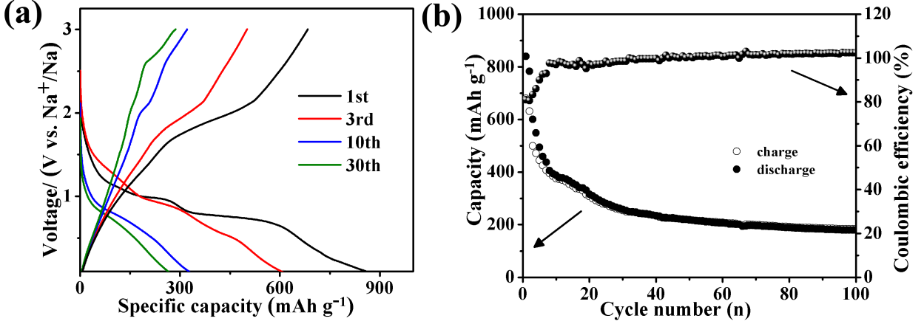
Fig. S8. (a) galvanostatic discharge/charge profiles and (b) cycling performance of the 7-CoS/C electrode tested at a current density of 0.5 A g⁻¹ in the voltage range of 0.01–3 V vs Na⁺/Na.

Fig. S9. The Nyquist plots of the 7-CoS/C-Na and 18.5-CoS/C-Na electrodes before and after 50 cycles in NaSO₃CF₃/DGM.

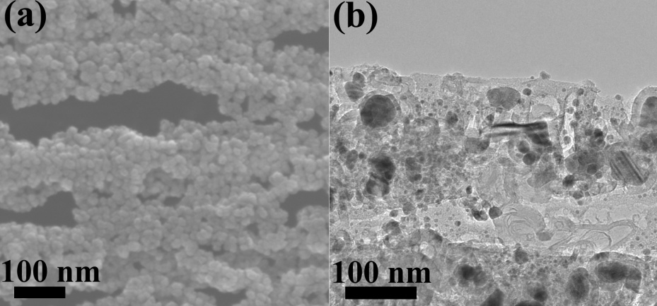
Fig. S10. SEM and TEM images of the 18.5-CoS/C electrode after 200 cycles at a current density of 1 A g⁻¹.
Fig. S11. Collected XRD profiles of the 7-CoS/C electrode at different charge and discharge states after 200 cycles.
Table S1. The average voltage of 7-CoS/C and 18.5-CoS/C
Current density (mA cm⁻²) | 7-CoS/C average voltage (V) |  |  | 18.5-CoS/C average voltage (V)
 | charge | discharge | difference | charge | discharge | difference
0.64 | 1.71 | 1.12 | 0.59 | 1.72 | 1.11 | 0.62
3.19 | 1.74 | 1.11 | 0.63 | 1.78 | 1.10 | 0.67
6.37 | 1.76 | 1.10 | 0.66 | 1.85 | 1.10 | 0.75
31.85 | 1.86 | 1.08 | 0.78 | 1.98 | 1.05 | 0.94
63.70 | 1.93 | 1.05 | 0.88 | 2.12 | 1.01 | 1.12

References:
1. H. Ma, S. Zhang, W. Ji, Z. Tao, J. Chen, J. Am. Chem. Soc. 130 (2008) 5361-5367.
2. H. Gao, Z. Hu, K. Zhang, F. Cheng, J. Chen, Chem. Commun. 49 (2013) 3040-3042.

