Supplementary Information:

A N-self-doped carbon catalyst derived from pig blood for oxygen reduction with high activity and stability
Jian Zhang,ª Qidong Li,^{b} Chenyu Zhang, ª Liqiang Mai,^{b} Mu Panª and Shichun Mu*ª
ªState Key Laboratory of Advanced Technology for Materials Synthesis and Processing, Wuhan University of Technology, Wuhan 430070, PR China
Fax: +86 27 87879468. E-mail: msc@whut.edu.cn.
^{b}WUT-Harvard Joint Nano Key Laboratory, Wuhan University of Technology, Wuhan 430070, China.

Fig. S1 Schematic of the synthesis process of the CPB-Fe catalyst.
Table S1 The content of C, N, O and different types of N contents of CPL and CPL-Fe catalysts.
Table S2 Comparison of ORR activity of the literature reports.
The Koutecky-Levich (K-L) equation
Fig. S2 ORR polarization curves for CPB, CPB-Fe and Pt/C catalysts before and after continuous potential cycles for 5000 times.
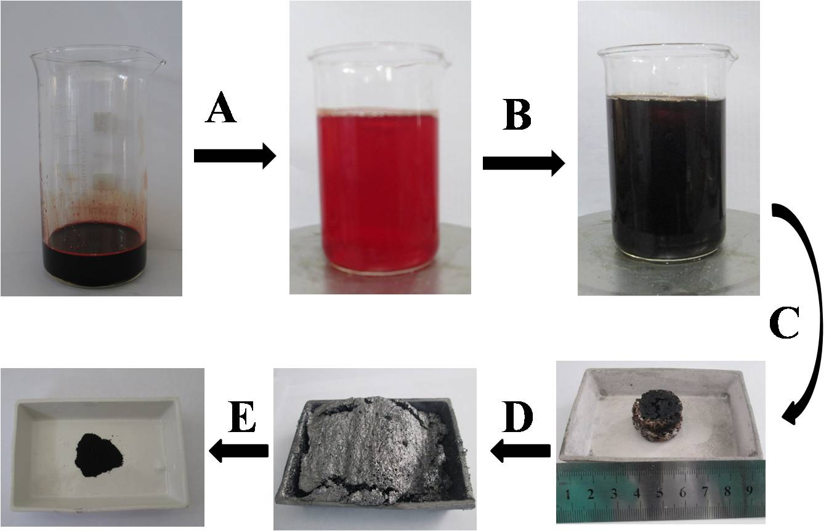

Fig. S1 Schematic of the synthesis process of the CPB-Fe catalyst. (A) PB was diluted with an equal amount of water (In order to clearly observe the experiment, the proportion of PB and water is 1:5 in Fig. S1). (B) Adding FeCl₃ solution. (C) Cooking and drying the mixture. (D) The precursor is carbonized in an inert atmosphere. (E) Post-treatment (PTs) including ball milling, acid leaching and the second heat treatment.

Table S1 The content of C, N, O and different types of N contents of CPL and CPL-Fe catalysts.

Sample | C at% | O  at% | N  at% | Oxidized N % | Graphitic N % | Pyrrolic N % | Pyridinic N %
CPL | 93.22 | 3.91 | 2.87 | 14.4 | 39.4 | 16.1 | 30.1
CPL-Fe | 92.92 | 4.73 | 2.35 | 12.1 | 39.2 | 13.6 | 35.1

Table S2 Comparison of the onset potential (E_{onset},) and half-wave potential (E_{1/2}) of the literature.
Catalyst | N sources | E_{onset} (V) /  relative to Pt/C | E_{1/2} (V) /  relative to Pt/C | Reference  electrode | Medium | Ref.
CPB | Pig blood | -0.08 V /  -50 mV | -0.24 V /  -100 mV | SCE | 0.1 M KOH  at 1600 rpm | this work
CPB-Fe | Pig blood | -0.04 V /  -10 mV | -0.16 V /  -20 mV | SCE | 0.1 M KOH  at 1600 rpm | this work
N-doped  MWNT | Melamine | -0.114 V /  Ca. -30 mV | -0.184 V /  -42 mV | SCE | 0.1 M KOH  at 1600 rpm | ¹
PANI-4.Fe-HT2(SBA-15) | Aniline | 0.95 V /  -40 mV | 0.84 V /  10 mV | RHE | 0.1 M KOH  at 1600 rpm | ²
N-doped  MWNT | Pyridine | −0.135 V /  -34 mV | - /  - | SCE | 0.1 M KOH  at 800 rpm | ³
CoPy/C | pyridine | 0.11 V /  -100 mV | -0.117 V /  - | Saturated calomel electrode | 0.1 M KOH  at 1500 rpm | ⁴
N-doped CNT/graphene | NH₃ | 0.88 V /  -80 mV | - /  - | RHE | 0.1 M KOH  at 1225 rpm | ⁵
Fe/Fe3C-melamine | Melamine  foam | Ca. -0.05 V /  Ca. -30 mV | - /  - | Hg/HgO | 0.1 M KOH  at 2000 rpm | ⁶
N-doped  MWNT | Melamine | -0.06 V /  -30 mV | - /  - | SCE | 0.1 M KOH  at 1600 rpm | ⁷
ZIF-derived carbons | Zeolitic imidazolate frameworks | 0.861 V /  -63 mV | 0.697 V /  -103 mV | RHE | 0.1 M KOH  at 1600 rpm | ⁸
HP-NPCs-2 | Cyanamide | -0.03 V /  -10 mV | - /  - | Ag/AgCl | 0.1 M KOH  at 1600 rpm | ⁹
Hollow nitrogen-doped carbon spheres | Iron(III) diethylenetriaminepentaacetate | -0.97 /  -50 mV | 0.79V /  -30 mV | RHE | 0.1 M KOH  at 1600 rpm | ¹⁰

1. W. J. Jiang, J. S. Hu, X. Zhang, Y. Jiang, B. B. Yu, Z. D. Wei and L. J. Wan, Journal of Materials Chemistry A, 2014.
2. X. H. Yan and B. Q. Xu, Journal of Materials Chemistry A, 2014, 2, 8617.
3. G. Tuci, C. Zafferoni, A. Rossin, A. Milella, L. Luconi, M. Innocenti, L. Truong Phuoc, C. Duong-Viet, C. Pham-Huu and G. Giambastiani, Chemistry of Materials, 2014, 26, 3460-3470.
4. J. Qiao, L. Xu, Y. Liu, P. Xu, J. Shi, S. Liu and B. Tian, Electrochimica Acta, 2013, 96, 298-305.
5. G. L. Tian, M. Q. Zhao, D. Yu, X. Y. Kong, J. Q. Huang, Q. Zhang and F. Wei, Small, 2014.
6. J. S. Lee, G. S. Park, S. T. Kim, M. Liu and J. Cho, Angewandte Chemie, 2013, 52, 1026-1030.
7. J. Liang, Y. Jiao, M. Jaroniec and S. Z. Qiao, Angewandte Chemie, 2012, 51, 11496-11500.
8. P. Zhang, F. Sun, Z. Xiang, Z. Shen, J. Yun and D. Cao, Energy & Environmental Science, 2014, 7, 442.
9. H. Jiang, Y. Zhu, Q. Feng, Y. Su, X. Yang and C. Li, Chemistry, 2014, 20, 3106-3112.
10. J. Sanetuntikul, T. Hang and S. Shanmugam, Chem Commun, 2014.

The Koutecky-Levich (K-L) equation

The K–L equation as given below:
(1)
(2)
where J denotes the measured current density, J_{K} is the kinetic current density, J_{L} is the diffusion-limited current density, ω is the electrode rotation rate, F is the Faraday constant (96485 C mol⁻¹), C₀ is the bulk concentration of O₂ (1.2×10⁻³ mol L⁻¹), D₀ is the diffusion coefficient of O₂ (1.9 ×10⁻⁵ cm² s⁻¹) and v is the kinetic viscosity of the electrolyte (1.0×10⁻² cm² s⁻¹).

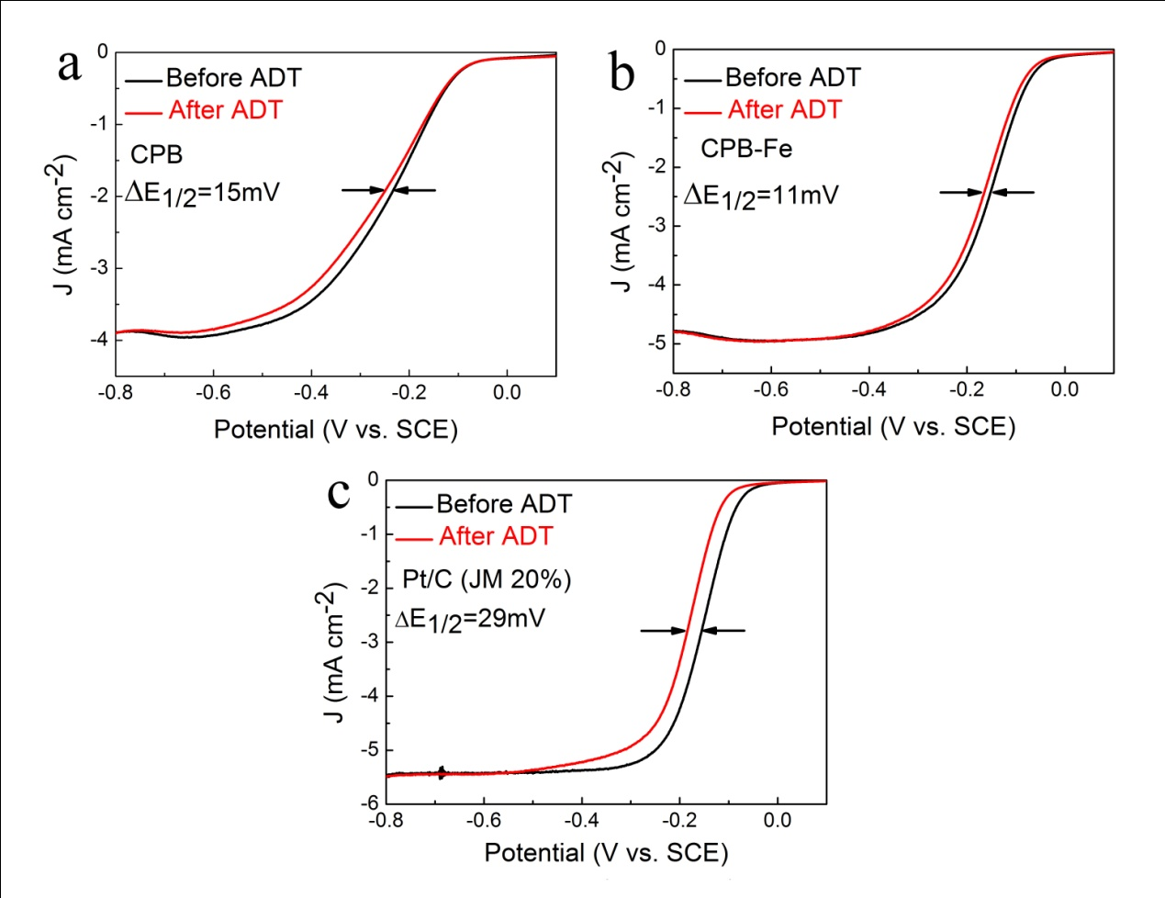
Fig. S2 ORR polarization curves for CPB, CPB-Fe and Pt/C catalysts before and after continuous potential cycles for 5000 times from -0.4 to 0.2 V.

