Supporting Information

Tellurium Filled Carbon Nanotubes Cathodes for Li-Te Batteries with High Capacity and Long-term Cyclability
Shaoqing Rao^{a, #}, Ruizhe Wu^{c, #}, Zhu Zhu^{b}, Jinsong Wu^{b, *}, Yao Ding^{a, *}, Liqiang Mai^{a, b, *}
ªSchool of Materials Science and Engineering, Wuhan University of Technology, Wuhan 430070, PR China.
^{b}State Key Laboratory of Advanced Technology for Materials Synthesis and Processing, Wuhan University of Technology, Wuhan 430070, PR China.
^{c}Collaborative Innovation Center for Advanced Organic Chemical Materials Co-constructed by the Province and Ministry, Ministry of Education Key Laboratory for the Synthesis and Application of Organic Functional Molecules, College of Chemistry and Chemical Engineering, Hubei University, Wuhan 430062, PR China.

⁎ Corresponding authors.
# S. Rao and R. Wu contributed equally to this work.
E-mail addresses: wujs@whut.edu.cn (J. Wu); ydingaf@whut.edu.cn (Y. Ding); mlq518@whut.edu.cn (L. Mai)
Keywords: Li-Te batteries, Carbon nanotubes, Nanoconfinement, Cycling stability
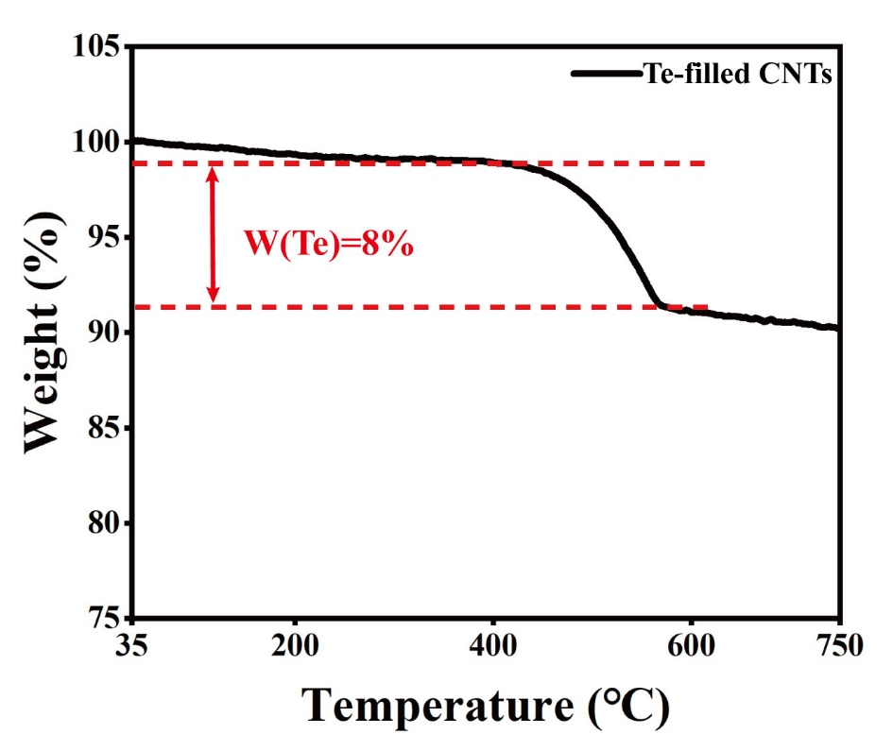
Fig. S1. Thermogravimetric analysis of Te-filled CNTs.

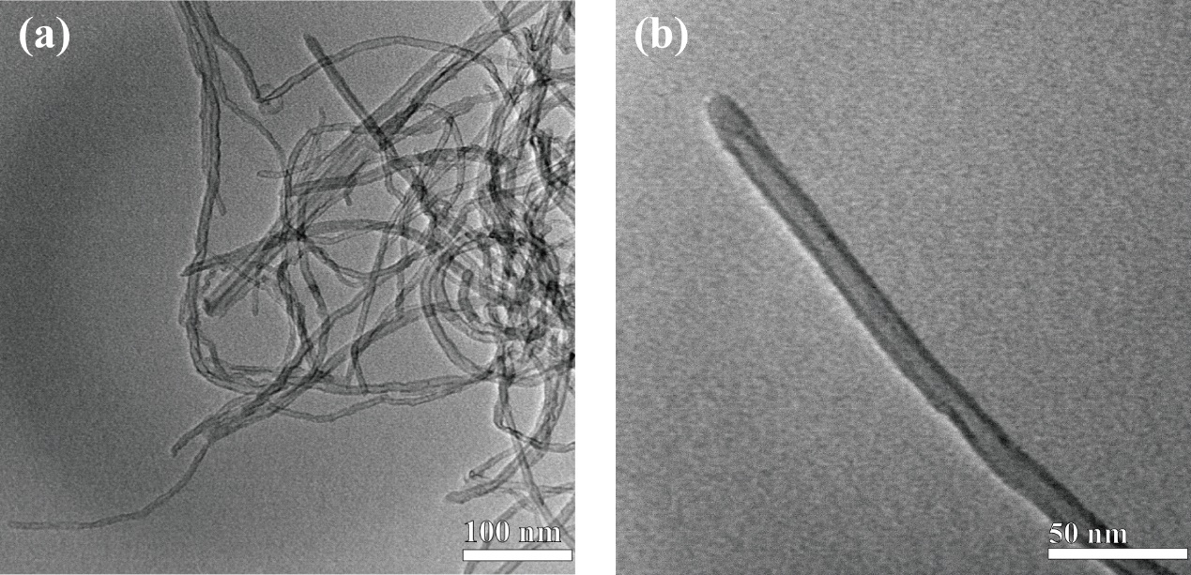
Fig. S2. TEM characterization of pristine MWCNTs. (a) Low-magnification and (b) high-magnification TEM images of CNTs.

Fig. S3. The digital image of the sealed ampoule tube with Te and CNTs.

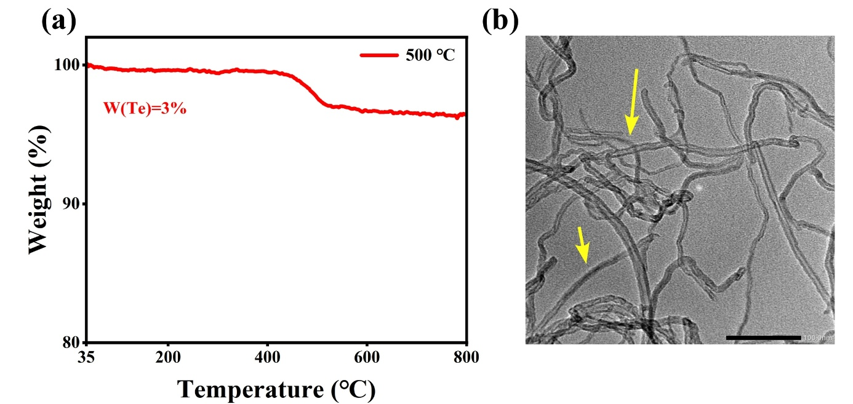
Fig. S4. The Te-filled CNTs at 500 ℃ annealing temperature. (a) Thermogravimetric analysis. (b) TEM image.
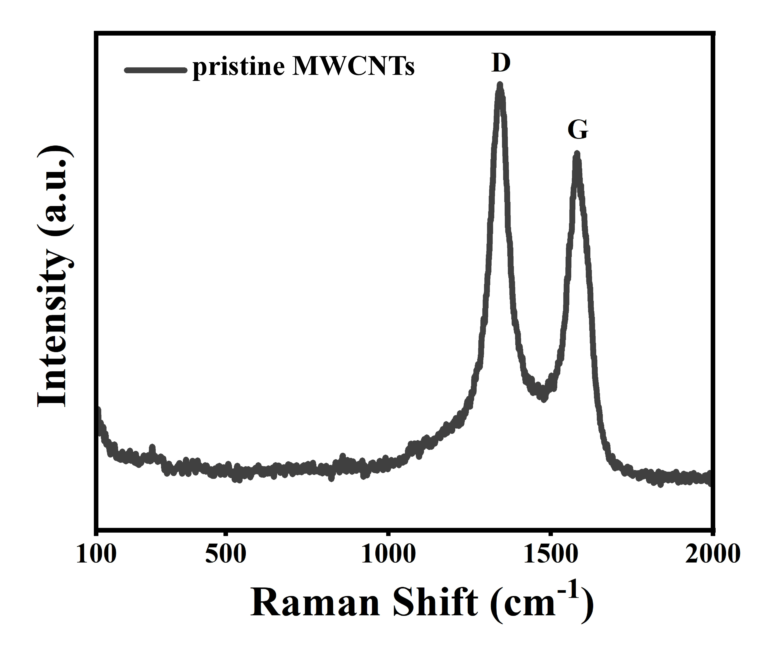
Fig. S5. Raman spectra of the pristine MWCNTs.

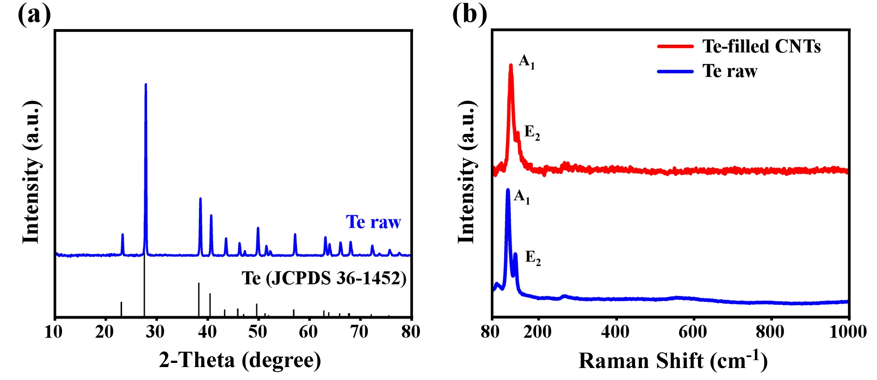
Fig. S6. Synthesis and characterizations of the Te raw materials. (a) XRD characterization of Te raw materials, compared with standard Te crystals. (b) Raman spectra of the Te-filled CNTs and Te raw.

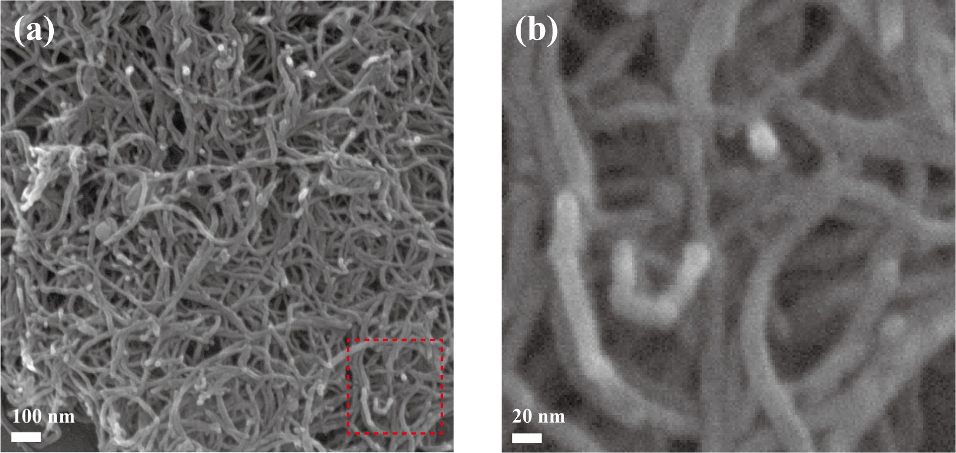
Fig. S7. Scanning electron microscopy (SEM) characterization of Te-filled CNTs. (a) SEM image of Te-filled CNTs. (b) The zoom-in image of the red rectangular area in (a).

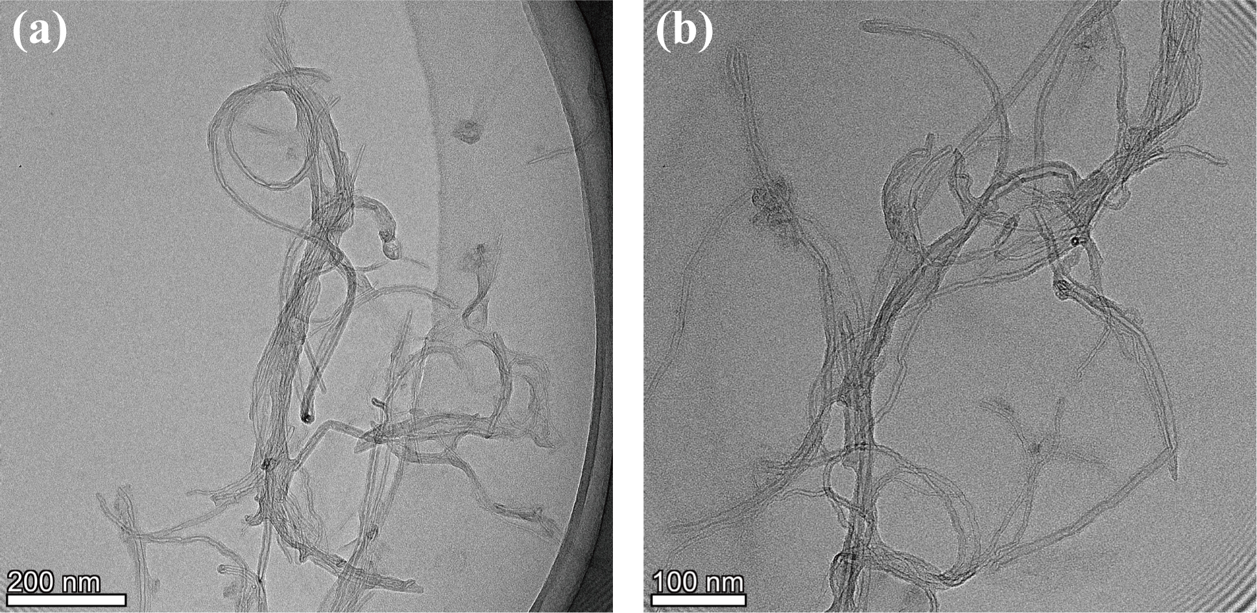
Fig. S8. TEM characterization of CNTs without acid treatment and with the PVT step to encapsulate Te. No Te can be observed in CNTs.

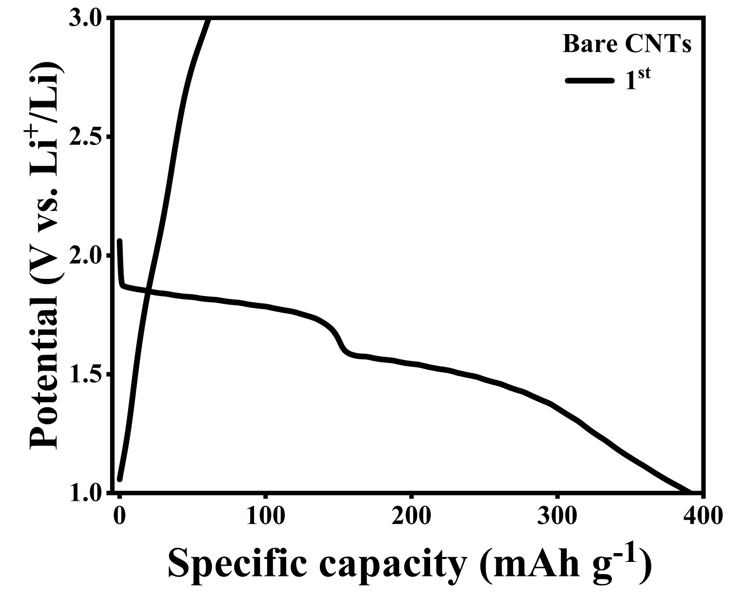
Fig. S9. GCD curves of Bare CNTs cathode at a current density of 50 mA g⁻¹.

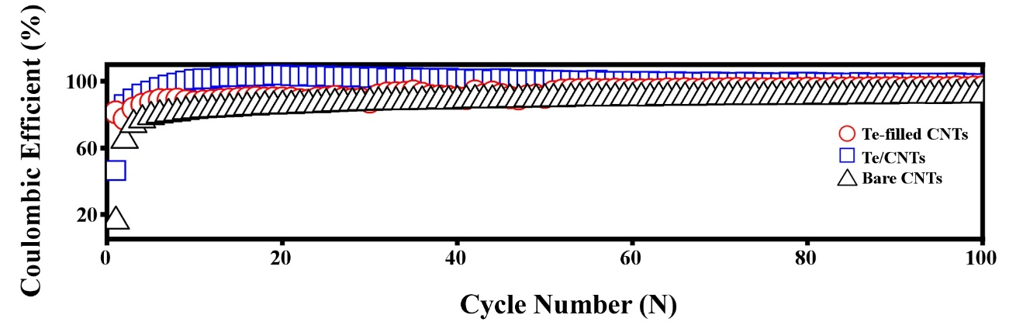
Fig. S10. Coulombic efficiency corresponding to the cyclic performance data of the three cathodes.

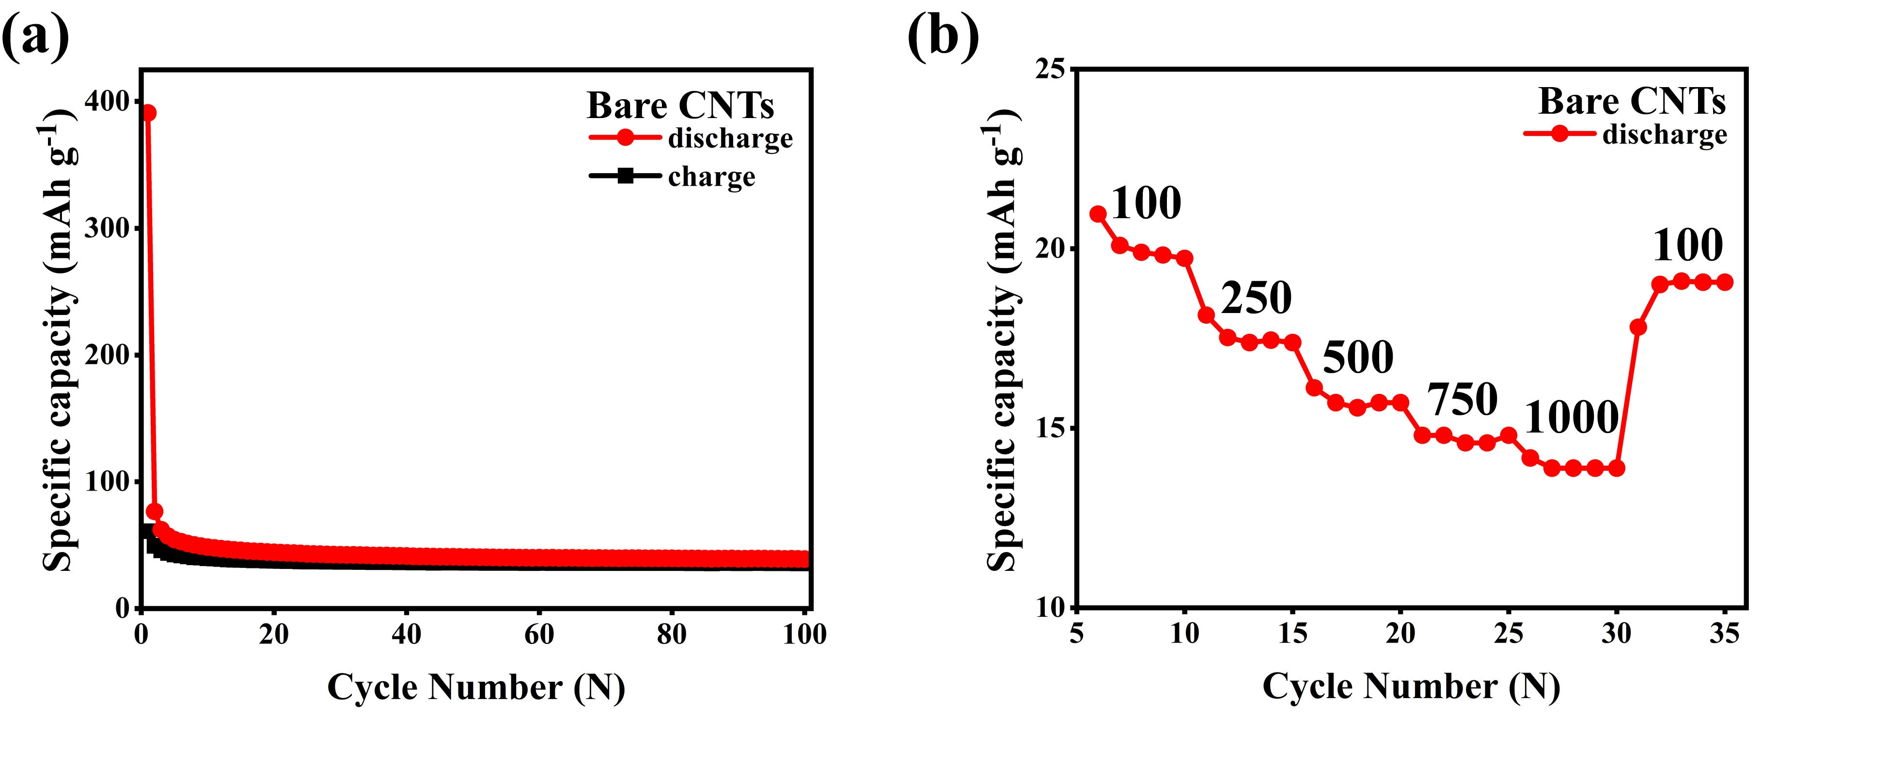
Fig. S11. Electrochemical properties of Bare CNTs cathode. (a) Cyclic performance of bare CNTs at a current density of 50 mA g⁻¹ for 100 cycles. (b) Rate performance at various current density for bare CNTs.

Here, the Gravimetric Capacity of Te was calculated by
$$C_{Te}={(CAP-C_{CNTs}×M_{CNTs})}/{M_{Te}}$$
(where C_{Te} is the Gravimetric Capacity of Te, CAP is the capacity of these cathodes, M_{Te} is the mass of Te in Te-filled CNTs cathode, M_{CNTs} is the mass of CNTs in Te-filled CNTs cathode, C_{CNTs} is the Gravimetric Capacity of bare CNTs cathode).

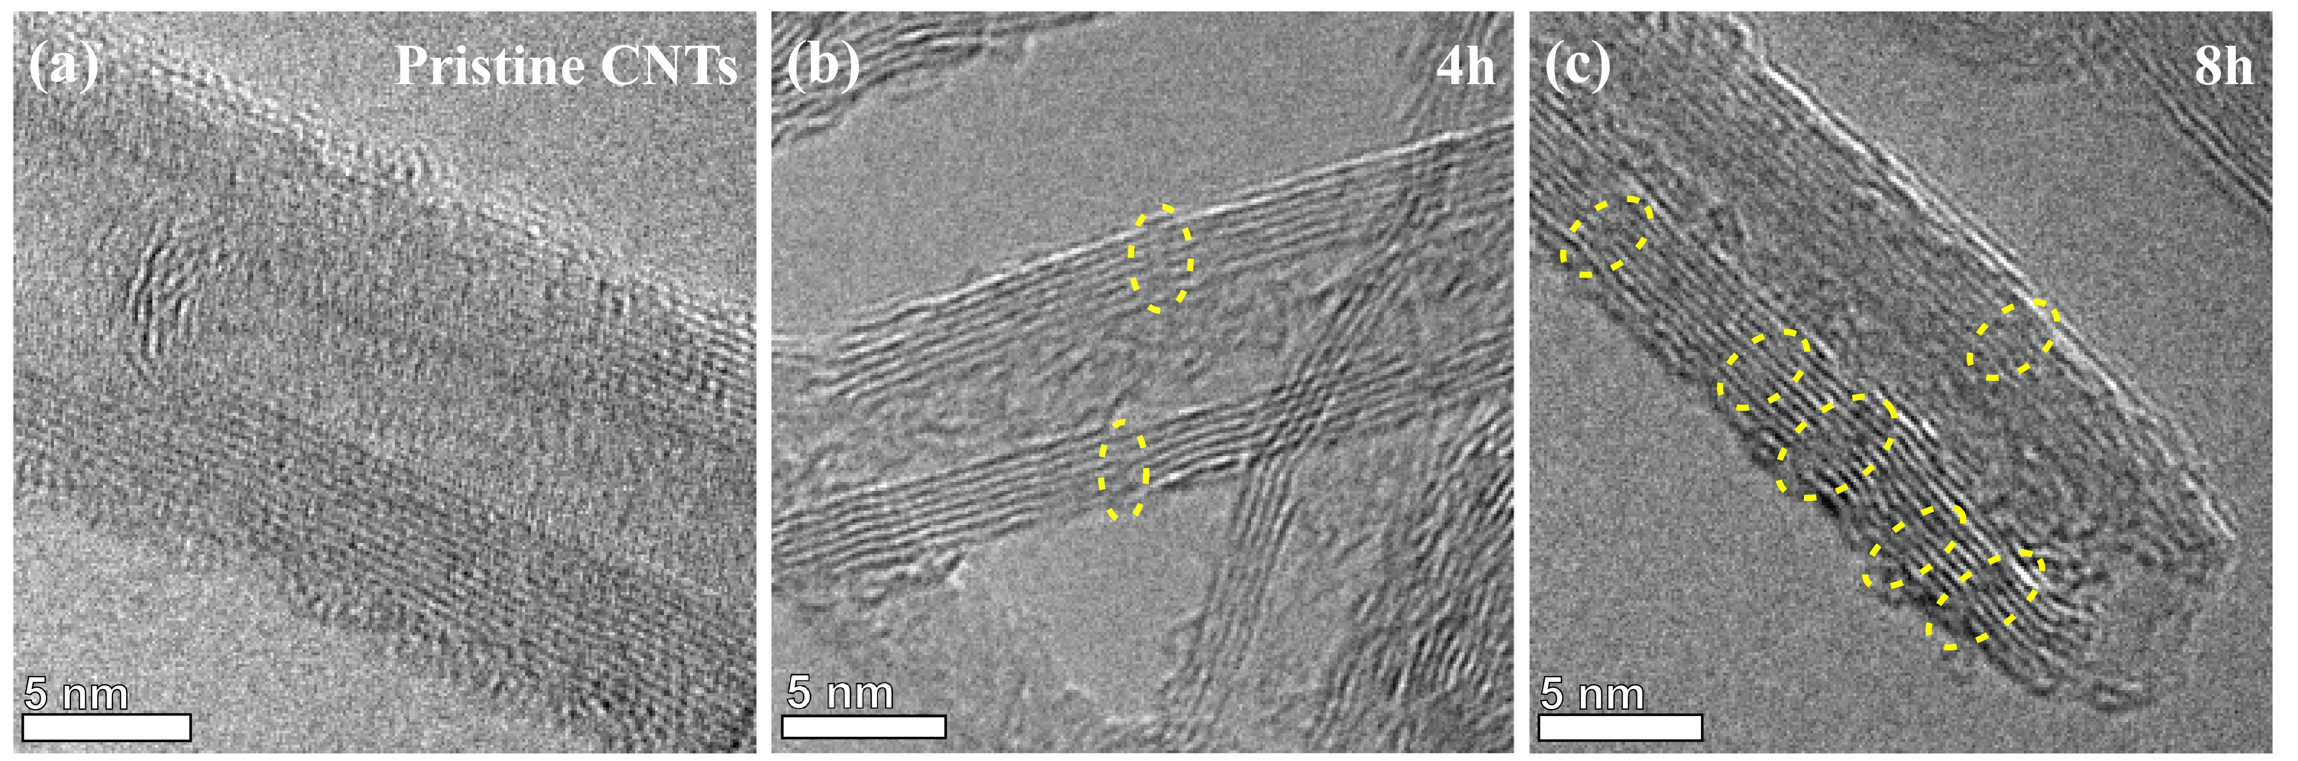
Fig. S12. The TEM images of pristine CNTs (a) and CNTs under acid treatment at 100 ℃ for 4 h (b) and 8 h (c).
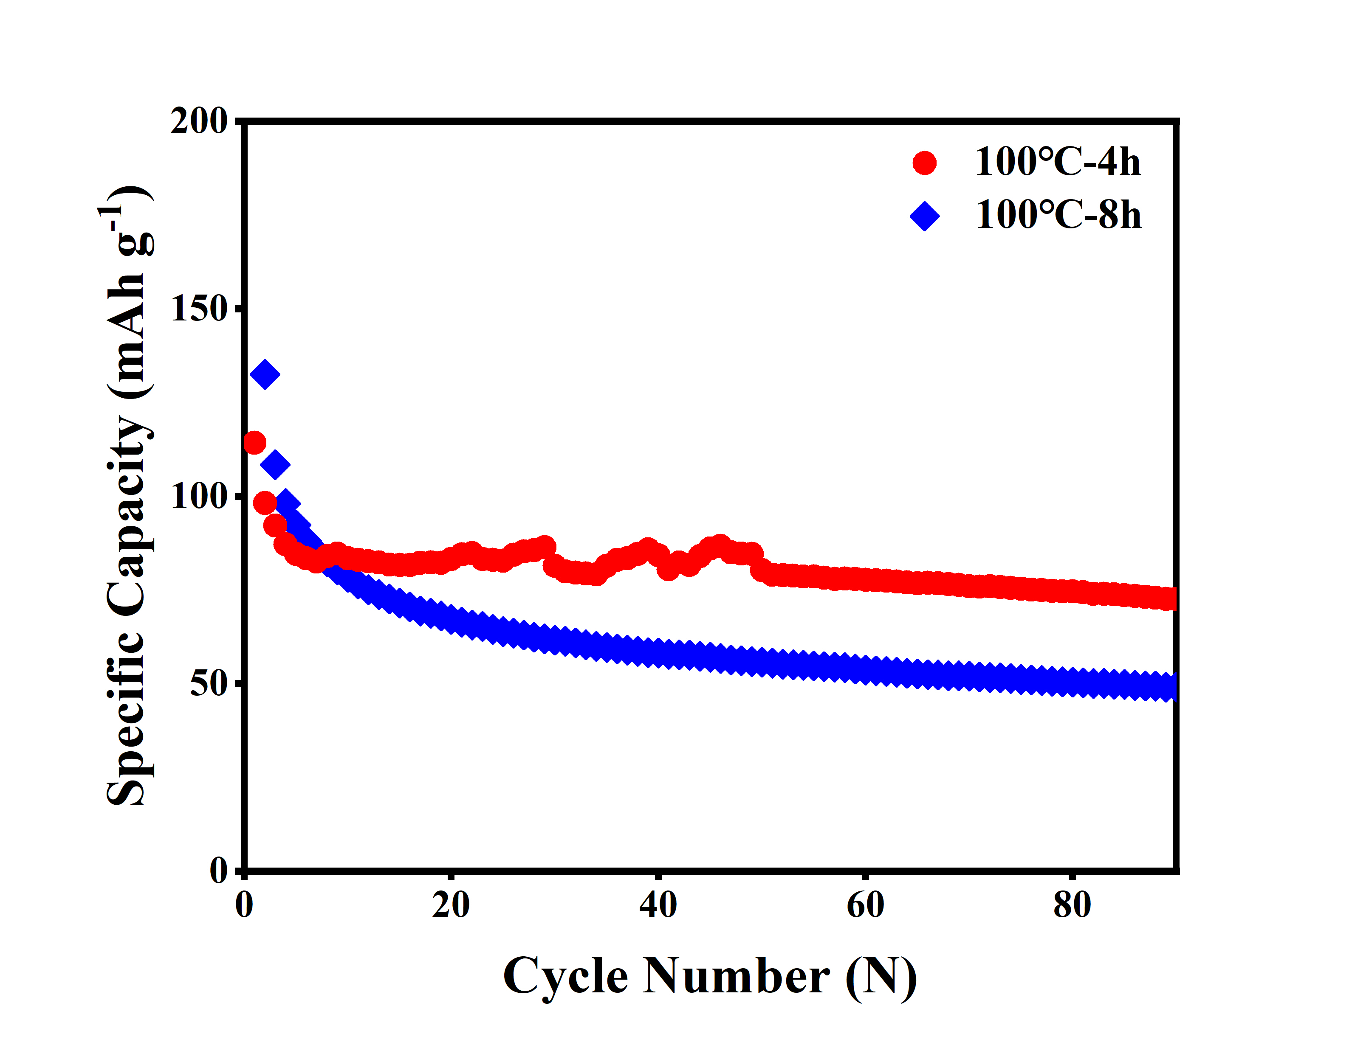
Fig. S13. Cyclic performance of two Te-filled CNTs cathodes with different acid treatment duration.

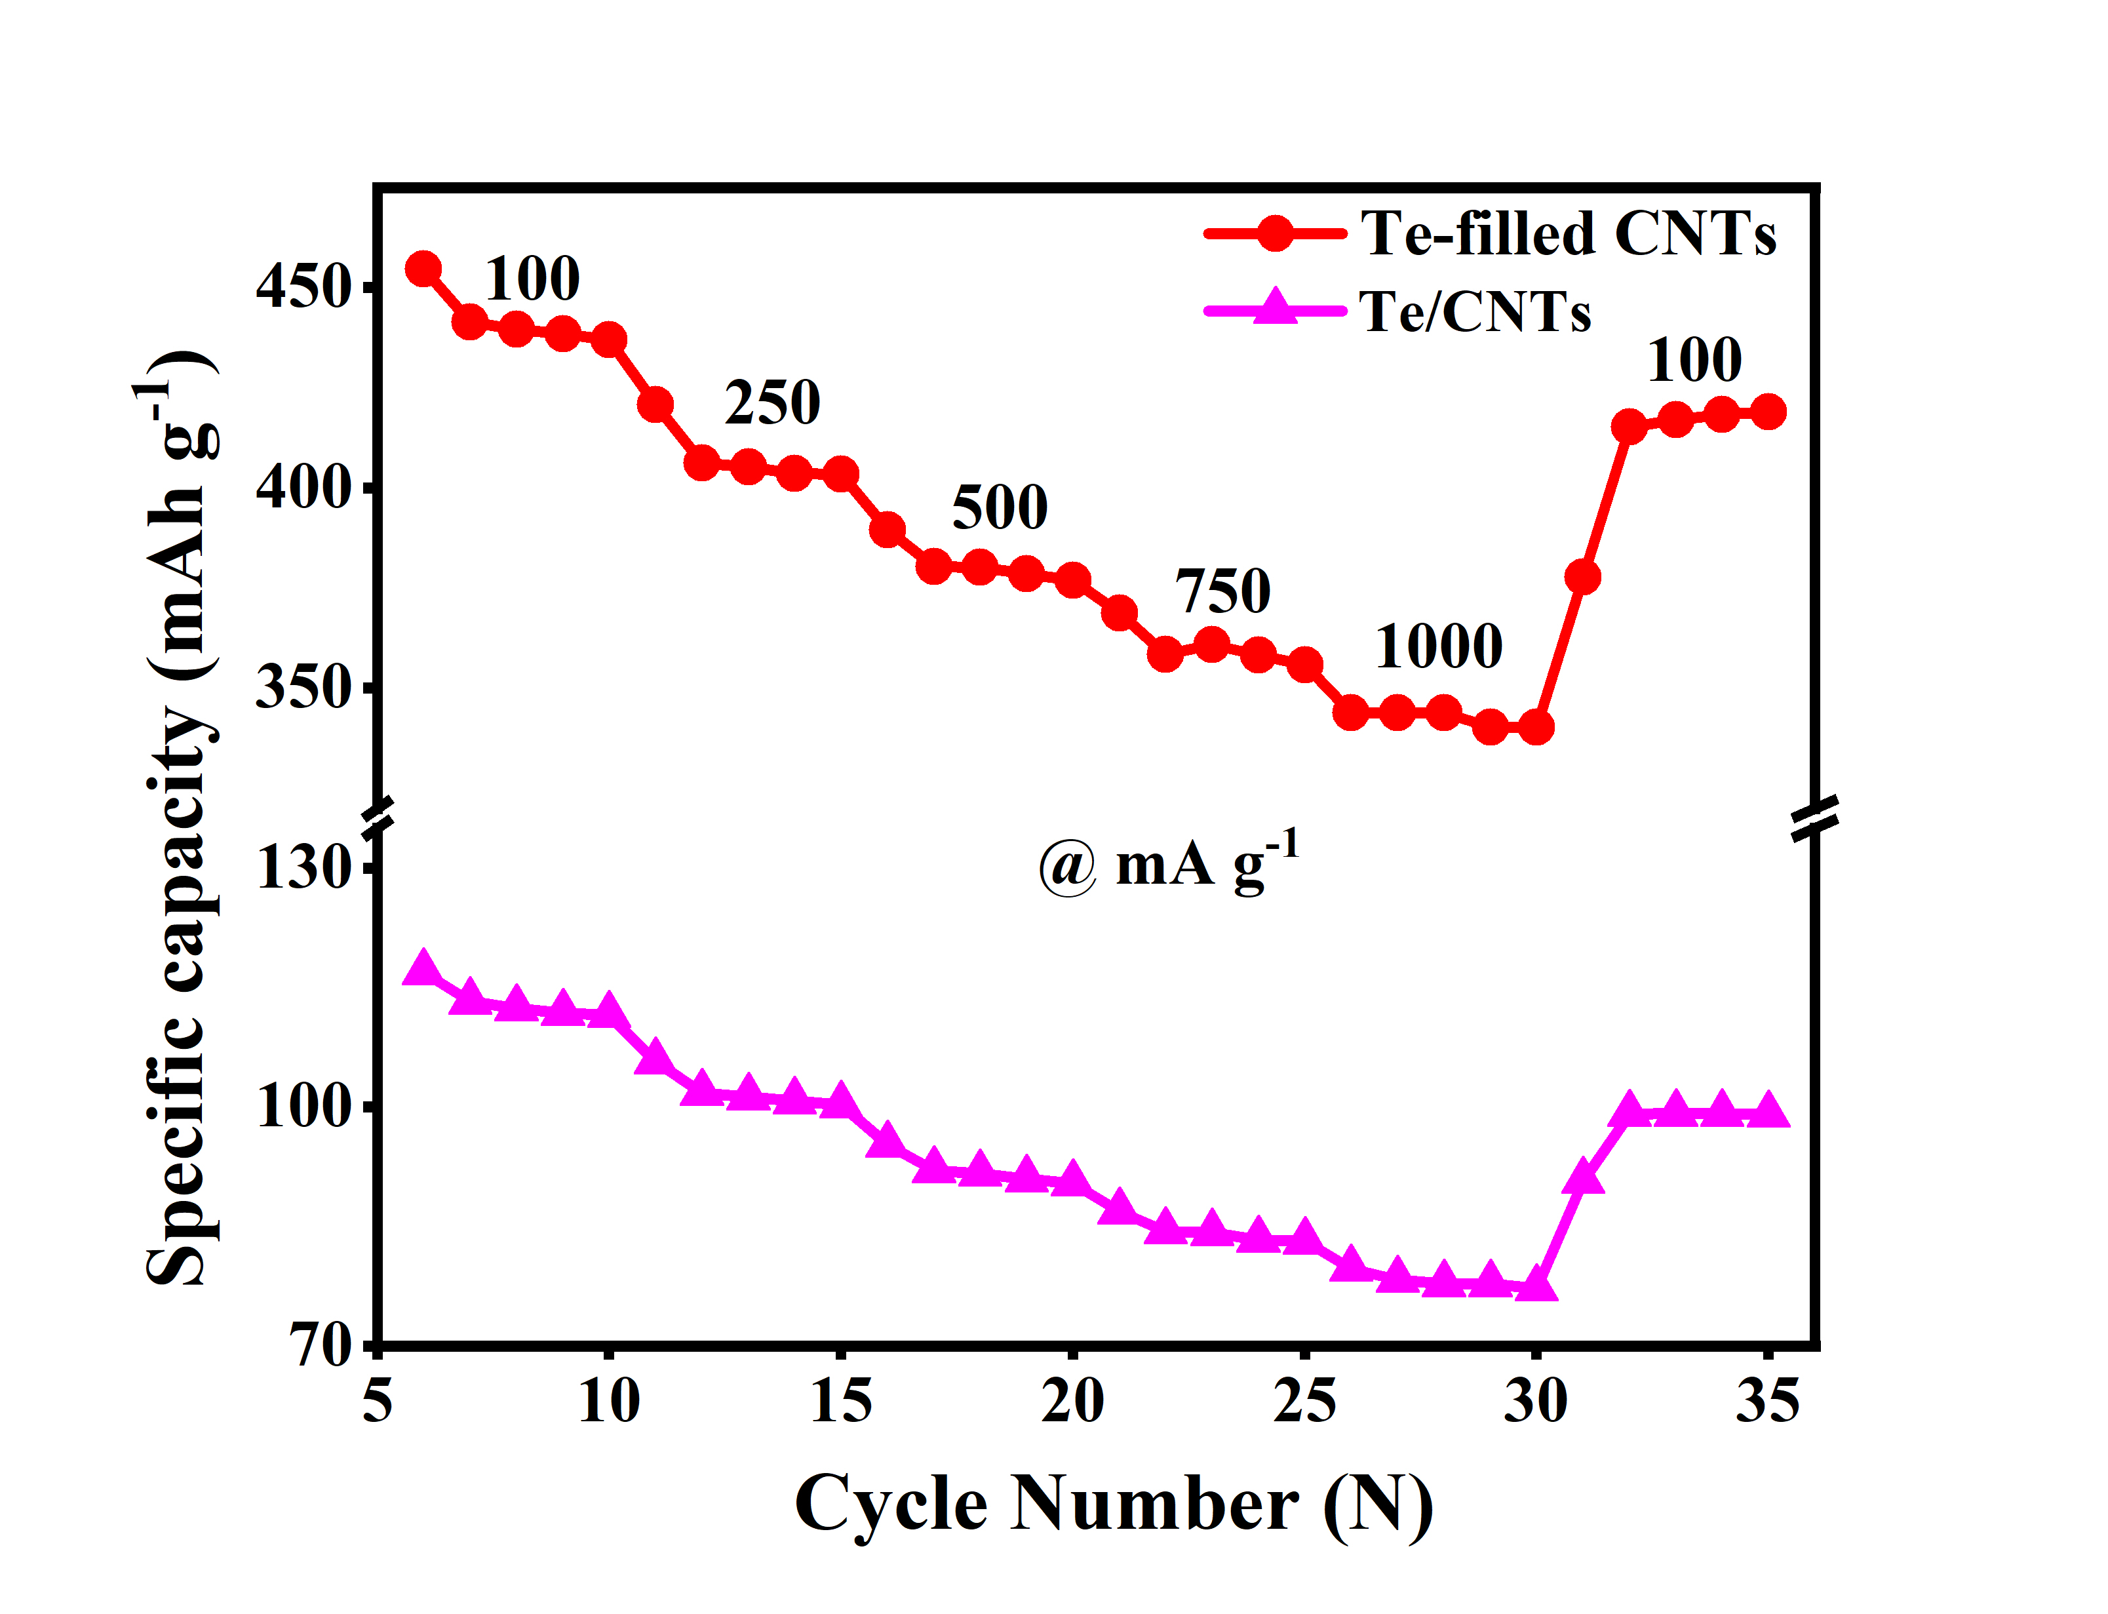
Fig. S14. The separate specific capacity of Te-filled CNTs and Te/CNTs cathodes for the rate performance.

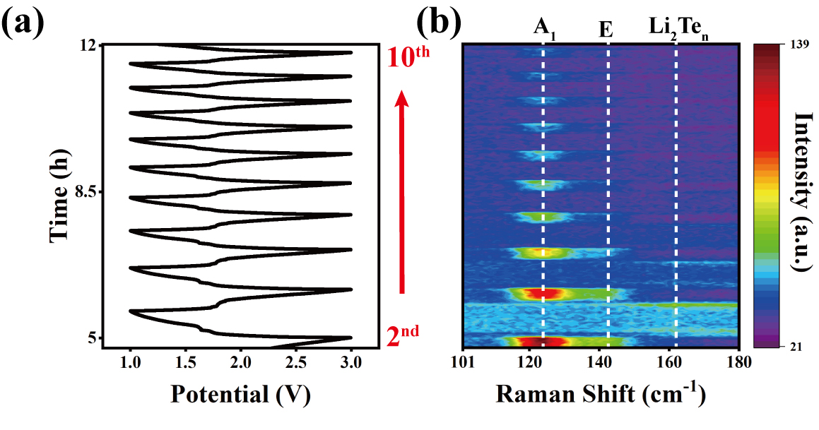
Fig. S15. In situ Raman characterization of Te-filled CNTs during the 2nd to 10th cycles. (a) GCD curves corresponding the in situ Raman measurement. (b) Contour plot of Raman spectra for Te-filled CNTs, corresponding to (a).

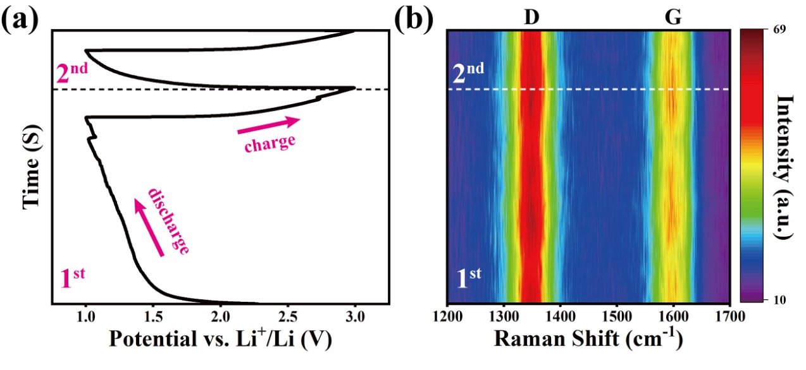
Fig. S16. In situ Raman characterization of bare CNTs during the charge/discharge process. (a) GCD curves corresponding the in situ Raman measurement. (b) Contour plot of Raman spectra for bare CNTs, corresponding to (a).

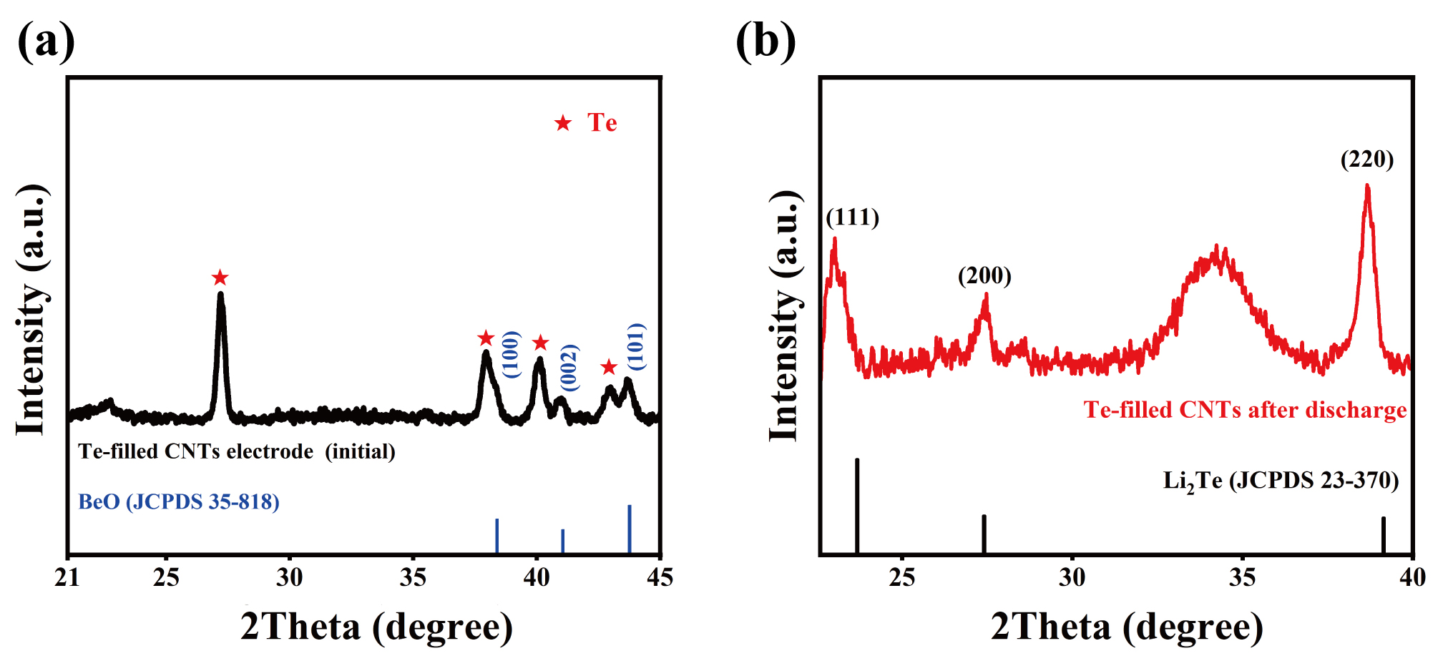
Fig. S17. Ex situ X-ray diffraction patterns of (a) Te-filled CNTs electrode with Be collector. (b) Te-filled CNTs electrode after discharge.
The ex situ XRD curves in Fig. S17 is characterized using in situ XRD equipment (VANTEC-500 detector). In order to eliminate the interference of BeO and Be, no Be collector is used in Fig. S17b.

