Supplementary materials
Facile formation of tetragonal-Nb₂O₅ microspheres for high-rate and stable lithium storage with high areal capacity

Zhiquan Hu¹, Qiu He², Ziang Liu¹, Xiong Liu¹, Mingsheng Qin¹, Bo Wen¹, Wenchao Shi¹, Yan Zhao², Qi Li^{1,*}, Liqiang Mai ^{1,*}

¹ State Key Laboratory of Advanced Technology for Materials Synthesis and Processing, International School of Materials Science and Engineering, Wuhan University of Technology, Wuhan 430070, China
² State Key Laboratory of Silicate Materials for Architectures, International School of Materials Science and Engineering, Wuhan University of Technology, Wuhan 430070, China.
*Correspondence author: E-mail: qi.li@whut.edu.cn (Li Q.), mlq518@whut.edu.cn (Mai L.)

Fig. S1 Schematic illustrations of the crystal structures of (a) TT-Nb₂O₅, (b) T-Nb₂O₅, (c) M-Nb₂O₅ and (d) H-Nb₂O₅. Oxygen and niobium sites are represented by red and dark cyan spheres, respectively.
Fig. S2 TG-DSC curves of the Nb powder from 25 to 1000 ℃ at a heating rate of 10 ℃ min⁻¹ in flowing air atmosphere.
Fig. S3 XRD patterns of evolutive phases observed upon heating the Nb powder precursor at different temperatures ranging from 500 to 1000 ℃

Fig. S4 SEM images of the Nb powder.

Fig. S5 Characterizations of the TT-Nb₂O₅, T-Nb₂O₅, M-Nb₂O₅ and H-Nb₂O₅ samples. (a) XPS spectra of wide survey. (b) High-resolution Nb 3d XPS spectra. (c) High-resolution O 1s XPS spectra. (d) Raman spectra.

Fig. S6 Electrochemical analysis of the obtained TT-Nb₂O₅, T-Nb₂O₅, M-Nb₂O₅ and H-Nb₂O₅ samples. (a-d) CV curves tested at various current densities from 0.1 to 1 mV s⁻¹. (e) Determination of the b values using the relationship between peak current and scan rate (the b1 values are according to the anodic peaks and the b2 values are for the cathodic peaks).

Generally, the CV curves follows the power law:
i = av^{b} (1)
Where a and b are adjustable parameters, i is the current, and v is the sweep rate. Equation (1) can be equally converted to Equation (2)
log(i) = log(a) + blog(v) (2)
The value of b can be calculated from log(i) versus log (v) plots. The b-value is close to 0.5 and 1, which corresponds to the diffusion-controlled process and surface-controlled pseudocapacitive reaction, respectively^{[1-4]}.
Fig. S7 (a) The Nyquist plots of the TT-Nb₂O₅, T-Nb₂O₅, M-Nb₂O₅ and H-Nb₂O₅ fresh electrodes. (b) The corresponding kinetics calculations based on the frequency (ω^{-1/2}) and Z′ values at low frequency region.

As shown in the Fig. S7a, the Nyquist plots of the TT-Nb₂O₅, T-Nb₂O₅, M-Nb₂O₅ and H-Nb₂O₅ pristine electrodes all display a single semicircle in the high frequency region and a straight line in the low-frequency range. The diameter of the semicircle reflects the interfacial charge-transfer impedance (R_{ct}) in the assembled cells. The low-frequency Warburg contribution of the impedance response is directly related to the lithium-ion diffusion process in an electrode material^{[5]}.

Calculation of the Lithium-ion Diffusion Kinetics for EIS^{[6]}:
${\text{D}}_{\text{Li}} \text{=} \frac{{\text{(RT)}}^{\text{2}}}{\text{2}{\text{(A}{\text{n}}^{\text{2}}{\text{F}}^{\text{2}}{\text{C}}_{\text{Li}}\text{σ)}}^{\text{2}}}$ (3)
${\text{Z}}^{\text{'}} \text{=}{ \text{R}}_{\text{D}}\text{+}{\text{R}}_{\text{L}}\text{+σ}{\text{ω}}^{\text{-}\frac{\text{1}}{\text{2}}}$ (4)
Where D_{Li} is the lithium-ion diffusion coefficient, R is the gas constant, T is the absolute temperature, A is the surface area of cathode, n is the number of electrons per molecule during oxidization, F is Faraday's constant, C_{Li} is the concentration of lithium ion, ω is the angular frequency, and σ is the Warburg factor which could be obtained by equation 4. By linear fitting of Z' and ω^{-1/2}, the slope is described as σ value. Combining with equation 3, the square of σ value has an inverse relationship with D_{Li}.

Fig. S8 High symmetric point path in the brillouin zones of (a) TT-N₂O₅ (Γ-Y-F-L-I-Z-Γ-X-Q-M-N-X|Z-N), (b) T-N₂O₅ (Γ-M-X-Γ-Z-A-R-Z|A-M|R-X), (c) M-N₂O₅ (Γ-M-X-Γ-Z-A-R-Z|M-A|X-R) and (d) H-N₂O₅ ((Γ-Y-F-L-I|S-Z-Γ-X|T-Y|M-Γ-N|Z-R).

Fig. S9 In-situ XRD pattern of M-Nb₂O₅ samples during galvanostatic charge and discharge at 0.2 A g⁻¹.

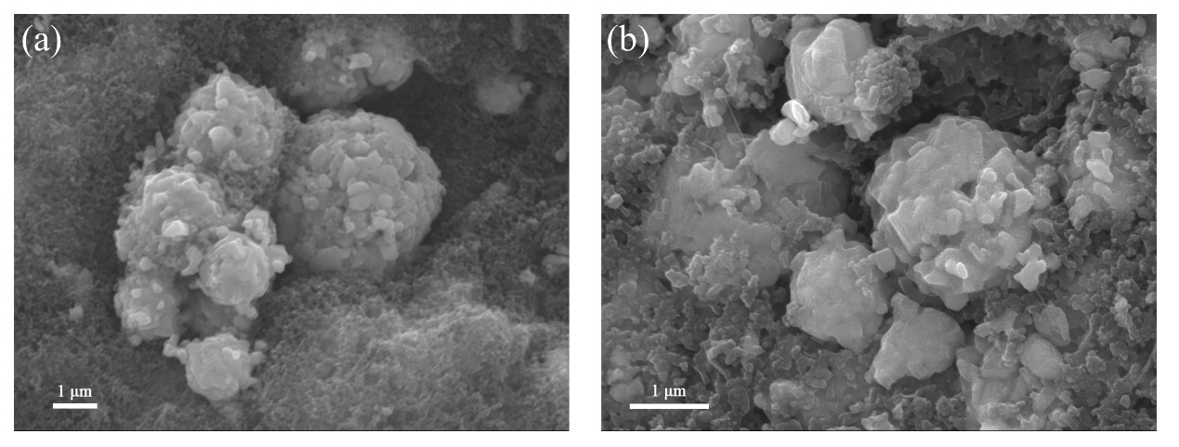
Fig. S10 SEM images of M-Nb₂O₅ electrodes at high mass loading of 12.58 mg cm⁻². (a) Before cycling; (b) After 100 cycles for lithium storage.

References
[1] Lindström H, Södergren S, Solbrand A, et al. Li⁺ ion insertion in TiO₂ (anatase). 2. Voltammetry on nanoporous films. J Phys Chem B, 1997, 101: 7717-7722.
[2] Brezesinski K, Wang J, Haetge J, et al. Pseudocapacitive contributions to charge storage in highly ordered mesoporous group v transition metal oxides with iso-oriented layered nanocrystalline domains. J Am Chem Soc, 2010, 132: 6982-6990.
[3] Wang J, Polleux J, Lim J, et al. Pseudocapacitive contributions to electrochemical energy storage in TiO₂ (anatase) nanoparticles. J Phys Chem C, 2007, 111: 14925-14931.
[4] Augustyn V, Come J, Lowe MA, et al. High-rate electrochemical energy storage through Li⁺ intercalation pseudocapacitance. Nat Mater, 2013, 12: 518-522.
[5] Reddy MV, Jose R, Le Viet A, et al. Studies on the lithium ion diffusion coefficients of electrospun Nb₂O₅ nanostructures using galvanostatic intermittent titration and electrochemical impedance spectroscopy. Electrochim Acta, 2014, 128: 198-202.
[6] Meng JS, He Q, Xu LH, et al. Identification of phase control of carbon-confined Nb₂O₅ nanoparticles toward high-performance lithium storage. Adv Energy Mater, 2019, 9: 1802695.

