Supporting Information

Tailoring Topology of Terpolymers via In Situ Programmed Click Chemistry for Stable Polymer Electrolytes

Lei Shi, # Hantao Xu, #, * Jingyuan Yu, # Ruixiang Xu, Li Yang, Wei Deng, Zixin Xiao, Shidong Li, * Lin Xu *

L. Shi, H. Xu, J. Yu, L. Yang, W. Deng, Z. Xiao, Prof. L. Xu
State Key Laboratory of Advanced Technology for Materials Synthesis and Processing, School of Materials Science and Engineering, Wuhan University of Technology, Wuhan 430070, P. R. China
E-mail: linxu@whut.edu.cn

L. Shi, L. Yang, S. Li, Prof. L. Xu
Hubei Longzhong Laboratory, Wuhan University of Technology (Xiangyang Demonstration Zone), Xiangyang 441000, Hubei, P. R. China
E-mail: lishidong@lz-lab.com

H. Xu
Institute for Science and Applications of Molecular Ferroelectrics, Key Laboratory of the Ministry of Education for Advanced Catalysis Materials, Zhejiang Normal University, Jinhua, Zhejiang 321004, P.R. China
E-mail: hantaoxu@zjnu.edu.cn

R. Xu
Key Laboratory of Advanced Structural Materials, Ministry of Education & Advanced Institute of Materials Science, Changchun University of Technology, Changchun 130012, P. R. China

W. Deng
Dongfeng Motor Corporation Research & Development Institute, No.663 Zhushanhu Street, Caidian District, Wuhan 430058, P. R. China

Prof. L. Xu
Hainan Institute, Wuhan University of Technology, Sanya 572000, P. R. China

Prof. L. Xu
Zhongyu Feima New Material Technology Innovation Center (Zhengzhou) Co., Ltd., High Technology Industrial Development Zone, Zhengzhou 450001, P. R. China

Keywords: in situ programmed click chemistry, lithium metal batteries, polymer electrolytes, topological polymers

1. Experimental Section
1.1. Materials
Glycidyl methacrylate (GMA), trifluoroethyl methacrylate (TFMA), 2-isocyanatoethyl methacrylate (IEMA), 2,2'-Azobis (2-methylpropionitrile) (AIBN, recrystallized), and dimethyl sulfoxide-d6 were purchased from Aladdin Company. Liquid electrolyte (LB-002) and ethylene glycol dimethyl ether (DME) were purchased from DuoDuo Chemical Reagent Platform. Anhydrous ethanol, tetrahydrofuran (THF), N,N-dimethylformamide (DMF) and anhydrous ethyl ether were purchased from Sinopharm Chemical Reagent Co. Ltd.
1.2. Preparation of polymer electrolytes
The polymer electrolytes of GTI-PE and GT-PE were synthesized and prepared in an argon atmosphere glovebox. First, to prepare the GTI-PE, 18 wt% polymer monomers GMA, TFMA, and IEMA were added into the electrolyte (1M LiPF₆ in DMC: EC: EMC=1:1:1 vol%) with a molar ratio of 1:1:1, and stirred thoroughly to form a homogeneous solution. Then 0.5 wt% of AIBN (based on the total mass of all components) as an initiator was added to the solution. Next, 50 µL of the resulting solution was injected into CR2016 coin lithium batteries, wherein a 5 µm polyethylene (PE) separator was adopted as the supporting matrix to separate the cathodes and Li metal anodes. These cells were then kept at 60 °C for 8 h to obtain the GTI-PE. The GT-PE was prepared in a similar manner.
2. Materials characterization
The surface and cross-section of GTI-PE and the surface morphology of SEI on lithium metal anodes were observed by the JEOL JSM-IT700HR scanning electron microscope at an accelerating voltage of 15kV. Lithium metal anode sampling requires firstly rinsing the samples with DME in order to remove the impurities on the surface of SEI and the electrolyte components. The surface EDS mapping images of GTI-PE were obtained by the Oxford Xplore 30. The PE structure was characterized using a Fourier transform infrared spectrometer (FT-IR, Thermo Nicolet Corporation; 7800-350/cm 0.01/cm/6700), nuclear magnetic resonance (NMR, Bruker 500 MHz,¹H, DMSO-d6), and characterization of the PE structure. Raman spectra were acquired by a Raman spectrometer (Horiba XploRA plus) using a 532 nm excitation laser. A tensile testing machine (Shimadzu AGS-X-50N) was used to obtain the stress-strain curves with the tensile speed of 0.2 cm min⁻¹. AFM (Asylum Research, Bruker Dimension Icon) was used to measure the morphology, force curves and Young's modulus of the surface of polymer electrolyte films. The self-healing phenomenon of GTI-PE was observed through the Axioscope 5 high-temperature material microscope of ZEISS Company. The thermal stability was executed by thermogravimetric analysis (TGA) using a NETZSCH STA 449F5 instrument over the temperature range between 30 and 600 °C under Ar condition at a heating rate of 10 °C min⁻¹. The circulating electrolyte was precipitated in ether to completely remove residual small molecules of the electrolyte, and then dissolved in DMSO-d6 for ⁷Li NMR characterization by Bruker AVANCE (400MHz). X-ray photoelectron spectroscopy (XPS, ESCALAB 250 Xi spectrometer) was used to analyze the SEI surface composition and elemental content of the lithium metal surfaces, and the samples need to be rinsed with DME beforehand in order to remove impurities on the SEI surface and the electrolyte composition. TOF-SIMS measurements were conducted with a PHI nano TOF Ⅲ. A Bi3⁺⁺ beam (30 kV, 2 nA) with raster size of 100 μm was used as the primary beam to detect the samples, sputtering with an Cs⁺ beam (2 kV, 100 nA, 400×400 μm²), and the pre-treatment process of the sample is similar to that of XPS. The ultrasonic scanning results were obtained by Ultrasonic Lithium ion Battery Scanner of the Wuxi Topsound Technology UBSC-LD40. The ultrasonic scanning rate was 0.2 mm/s. The nail penetration test was conducted using the Cavendi CA-SF-10T cell crushing and nail penetration Tester.
3. Calculations and simulations
In this study, two types of molecules: GT-PE and GTI-PE calculations have been performed using the DFT method implemented in the commercial Gaussian 16 program package. The geometries of GT-PE and GTI-PE were all optimized under the framework of density functional theory (DFT) with B3LYP functional and 6-31G(d) basis set.
The mapping of electrostatic surface potential (ESP) was calculated using Multiwfn program and then rendered using Visual Molecular Dynamic program.
The electronic properties of the complex were analyzed by investigating the highest occupied molecular orbital (HOMO), lowest unoccupied molecular orbital (LUMO), and the energy gap (△E) between them (HOMO-LUMO). The global hardness (η) of the molecule uses the following relation.
$η=\frac{1}{2}\left(E_{HOMO}-E_{LUMO}\right)$ (1)
Electron affinity and ionization make electronic chemical potential
$μ=\frac{1}{2}\left(E_{HOMO}+E_{LUMO}\right)$ (2)
The global electrophilicity index obtained through the following formula.
$ω=\frac{μ^{2}}{2η}$ (3)
The binding energies between Li⁺ and GT-PE, and GTI-PE were respectively calculated by DMol3 module in materials studio (MS) 2017. Firstly, the generalized gradient approximation (GGA) with Perdew–Burke–Ernzerhof (PBE) exchange-correlation functional was employed to fully relax GT-PE and GTI-PE. The double-numeric quality basis sets with polarization functions was used. The global orbital cutoff was 5.1 Å. The iterative tolerances for energy change, force and displacements were 1 × 10⁻⁵ Ha, 0.002 Ha Å and 0.005 Å, respectively. In the self-consistent field (SCF) procedure, 10⁻⁶ a.u. was used for the convergence standard electron density. After structure optimization, the Adsorption Locator Tools in MS were used to construct interaction pairs, i.e. Li⁺/GT-PE, Li⁺/GTI-PE. Then each pair was freely optimized by DMol3 module. Finally, single point energy calculation was executed. The binding energies E_{b} between Li⁺ and GT-PE, and GTI-PE were calculated according to the following equation:
$E=E_{total}-E_{{Li}^{+}}-E_{adsorbent}$ (4)
Where E_{total} is the total energy each composites, E_{Li}⁺ and E_{adsorbent} are the energies of isolated Li⁺ and adsorbent molecules by Li⁺.
The MD simulations were performed were calculated by Forcite module with COMPASS Ⅱ force field in MS 2017. Two solution systems were respectively constructed into cubic simulation boxes. The GTI-PE/LiPF₆ system contained 7 GTI molecules and 30 LiPF₆. The GT-PE/LiPF₆ system consisted of the same number of GT and LiPF₆ molecules as GTI-PE/LiPF₆ system. Van der Waals and Coulomb interactions were respectively considered by atom based and Ewald methods with a cut-off value of 12.5 Å. Equations of motion were integrated with a time step of 1 fs. After energy minimization, each system was fully relaxed under periodic boundary conditions for 400 ps in the NPT (P=1 atmosphere, T = 333.15 K) ensemble using the Nose thermostat and Berendsen barostat, which was long enough for system temperature, potential and total energy to get stable. After reaching equilibrium state, another 400 ps simulation under NVT ensemble was performed to extract trajectory and data. The dynamic trajectory for each system was outputted at 4 ps interval and used for RDF and coordinate number calculation. The coordination number N_{i} of molecules i in the first solvation shell surrounding Li⁺ was calculated as:
N_{i} = 4πρ$\int_{0}^{R_{M}}{g}\left(r\right)r^{2}dr$ (5)
in which R_{M} is the distance of the first minimum following the first peak in the RDF g(r) and ρ is the number density of molecules i.
A simplified 2D model was established using COMSOL Multiphysics to simulate the electric field and stress field distribution on the surface of lithium ions, demonstrating that the prepared electrolyte helps to suppress dendrite growth. The simulation domain is a cubic element with dimensions of 0.06 mm × 0.06 mm. On the exposed lithium electrode, surface protrusions represent irregular deposition structures of dendritic growth. The improved electrolyte model exhibits smoother dendrite growth on the anode surface, demonstrating excellent control over dendrite characteristics. The simulation adopts a multi physics coupling framework based on the Nernst Planck equation to describe ion mass transport and stress/strain fields. The initial potential of the anode is set to -2.7 V, and the initial potential of the cathode is set to 0 V. The initial current density is defined as 100 mA/m².

4. Electrochemical performance measurements
4.1. Ionic conductivity and activation energy
Stainless steel SS||PEs||SS cells were assembled, and electrochemical impedance spectroscopy (EIS) was measured using BioLogic EC Lab VMP3 with an amplitude of 10 mV in the frequency range of 10⁶ Hz to 1 Hz. A 52 µm thick electrolyte layer is formed by fully impregnating the electrolyte precursor into a 16 µm porous PE separator followed by polymerization, and then a battery is assembled to test its ionic conductivity. The intrinsic ionic conductivity of PEs was calculated by the following formula：
$σ=\frac{L}{R_{b}S}$ (6)
Where L is the thickness of the electrolyte, S is the contact area between the two stainless steel sheets, and R (Ω) is the bulk resistance of the electrolyte.
The resistance of SS||PEs||SS cell in the temperature range of 20-80 °C was measured by Autolab PGSTAT302N electrochemical workstation and activation energy (Ea) of Li⁺ in PEs was calculated according to the following formula：
$σ=Aexp(-E_{a}/RT)$ (7)
Where A is the conductivity pre-exponential factor, Ea is the activation energy, T is the absolute temperature and R is the ideal gas constant.
4.2. Electrochemical stability window
Electrochemical stability windows of electrolytes can be measured by constructing Li||PE||SS cells，and linear sweep voltammetry (LSV) measurements were performed by the BioLogic EC Lab VMP3 at a sweep rate of 1 mV s⁻¹ over a range of 0-6 V.
4.3. Lithium-ion transference number
The Li||PE||Li symmetrical cells were tested with BioLogic EC Lab VMP3. The current measured by EIS and the DC method was used to determine the cell resistance before and after polarization, where the DC potential is 10 mV and the polarization is 6000 seconds. t_{Li}⁺ is obtained from the following equation：
$t_{{Li}^{+}}=\frac{I_{s}(ΔV-I_{0}R_{0})}{I_{0}(ΔV-I_{s}R_{s})}$ (8)
Where I₀ and I_{s} are the initial and steady-state currents. The R₀ and Rs are the resistances before and after polarization of the cell, respectively. ΔV is the DC potential applied across the cell.
4.4. Lithium-ion diffusion energy barrier
Lithium-ion diffusion energy barrier (E_{a}) through the SEI was obtained by calculating the resistance of the Li||GTI-PE||Li and Li||GT-PE||Li symmetric cells after 10 cycles at 0.1 mA cm⁻² performed at different temperatures (25-65℃) via DH7001D electrochemical workstation according to the Arrhenius law:
$R_{SEI}^{-1}=Aexp(-E_{a}/RT)$ (9)
Where R_{SEI} corresponds to the interface impedance between the electrode and electrolyte, E_{a} represents the lithium-ion diffusion energy barrier through the SEI, A is conductivity pre-exponential factor, T is the absolute temperature and R is the ideal gas constant.
4.5. Exchange current density
The exchange current density was evaluated by fitting CV curves of symmetrical Li||Li cells after 10 cycles at 0.1 mA cm⁻² via DH7001D electrochemical workstation at a scan rate of 1 mV s⁻¹. according to the Tafel equation:
$η=-\left(\frac{2.303RT}{αF} \right)logi_{0}+\left(\frac{2.303RT}{αF} \right)logi$ (10)
Where i is the current density, 𝜂 is the overpotential, and 𝛼 is the transfer coefficient. The Tafel curve represents the logarithm of the current density versus the overpotential. Using the extrapolation method, on the linear Tafel region, the intercept with the Y-axis at the overpotential of 0 represents the exchange current density.
4.6. Cell assembly and testing
The Li||Li symmetrical cells were assembled in an argon-filled glove box (H₂O<0.01 ppm, O₂<0.01 ppm) and tested at 30 °C by a multi-channel battery test system (Land CT2001A, Wuhan Land Electronic Co., Ltd., China). The cathode slurry of LiFePO₄ was prepared by commercially available cathode powder, acetylene black and PVDF powder with a mass ratio of 8:1:1. The obtained cathode slurry was scraped on a carbon-coated aluminum foil and then dried in a vacuum oven at 120 ° C for 12 hours. Then, the cathode foil was stamped into an electrode sheet with a diameter of 10 mm and a mass load of 0.8 ~ 1.5 mg cm⁻². The same mass ratio was applied to the preparation of LiNi_{0.8}Co_{0.1}Mn_{0.1}O₂ (NCM811) cathode with a mass load of about 0.8 ~ 1 mg cm⁻². LiFePO₄||Li (100 μm,14 mm) and NCM811||Li coin cells were assembled using an argon-filled glove box. The rate and cycle performance of PE-based cell at 25 °C were tested by LAND test system and NEWARE test system. The C rate in all electrochemical measurements is defined according to 1 C = 170 mA g⁻¹ (LiFePO₄) and 1 C = 200 mA g⁻¹ (NCM811), where the charge-discharge voltage of LiFePO₄||Li is 4 V-2.5 V, and the charge-discharge voltage of NCM811||Li is 4.3 V-2.7 V. The pouch cells comprised of a LiFePO₄ (LFP) cathode and a graphite anode and were second vacuum sealed after the first formation cycle at 0.05 C and the second formation cycle at 0.1 C, and then it was charged/discharged at a constant current of 0.5 C at room temperature on NEWARE CT-4008Tn-5V12A-204n battery test system.
Figure S1. Digital photographs of GT-PE and GTI-PE.
The electrolyte obtained after in situ polymerization is shown in Figure S1. The polymer electrolyte, with a mass fraction of 18 wt% (LE=82 wt%), appears as a transparent solid with no free liquid, indicating that the liquid electrolyte is completely confined within the polymer matrix.

Figure S2. Raman spectra of GTI-PE, GMA, IEMA and TFMA.
Figure S3. ¹H NMR spectra of GTI-PE.

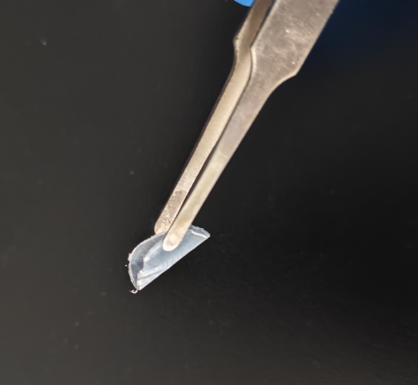
Figure S4. Digital photographs of GTI-PE polymer electrolyte membrane.

Figure S5. SEM images of the surface and cross-section of GTI-PE.

Figure S6. Surface EDS mapping images of C, O, F and N elements of GTI-PE.

Figure S7. Atomic Force Microscopy (AFM) 2D mages of GTI-PE and GT-PE films surfaces.

Figure S8. Force-displacement curves of the surface nanoindentation experiment of GT-PE (inset is the 3D image of GT-PE film surface).

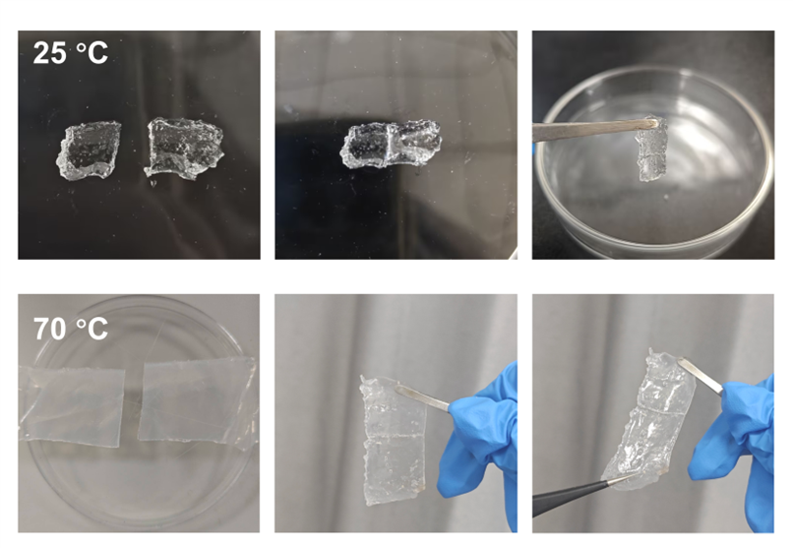
Figure S9. The self-healing process of GTI-PE at different temperatures.

Figure S10. Optical microscope images of scratches on the GTI-PE film before and after healing at 60 °C for 2 hours.

Figure S11. Temperature-dependent FT-IR spectra of GTI-PE.

Figure S12. TGA curves for LE, GT-PE, and GTI-PE.

Figure S13. Flame retardant experiments on LE and GTI-PE.

Figure S14. Room temperature ionic conductivities of GTI-PEs with different monomer concentrations.
Through a comparison of the ionic conductivities of GTI-PEs containing different polymer monomer concentrations, it was found that the PE with polymer monomers of 18 wt% exhibited the highest ionic conductivity while still maintaining a solid, non-flowing state. Therefore, this system was selected for subsequent electrolyte studies.

Figure S15. Polarization curve of Li||GT-PE||Li; insets are Nyquist curves before and after polarization.

Figure S16. Snapshots of the GT-PE MD simulation.

Figure S17. The calculated electrostatic potential map of GT-PE and GTI-PE fragments.

Figure S18. Nyquist plots of impedance for Li||GTI-PE||Li symmetric cells at different cycle stages.

Figure S19. Nyquist plots of impedance for Li||GT-PE||Li symmetric cells at different cycle stages.

Figure S20. Top-view SEM images of Li anode surfaces after 50 cycles in Li||GT-PE||Li and Li||GTI-PE||Li configurations, respectively.

Figure S21. Tafel curves of the Li||GT-PE and Li||GTI-PE interfaces from the linear sweep voltammetry tests.

Figure S22. FT-IR spectra of GTI-PE before and after 50 cycles.

Figure S23. The depth profiles of TOF-SIMS for several interested ion fragments.

Figure S24. FT-IR spectra of GTI-PE.

Figure S25. Charge-discharge curves of LFP||GTI-PE||Li and LFP||GT-PE||Li cell with different multiplicities.

Figure S26. Long-term cycling performance of LFP||Li cells at 1 C.

Figure S27. Rate capability of NCM811||Li cells.

Figure S28. The time-domain waveforms of ultrasonic transmission signal of GT-PE
LFP-based pouch cell.

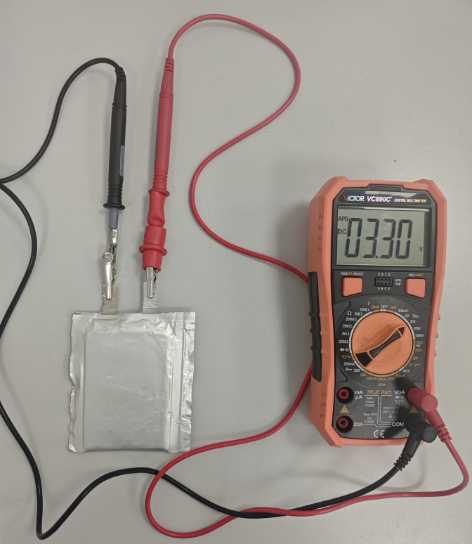
Figure S29. Photographs of the open-circuit voltage of the 2Ah LFP||GTI-PE||Graphite pouch cell.

Table S1. Ionic conductivity (unit: S cm⁻¹) of GT-PE and GTI-PE at different temperature.
 | 20 ºC | 30 ºC | 40 ºC | 50 ºC | 60 ºC | 70 ºC | 80 ºC
GT-PE | 6.51×10⁻⁵ | 7.35×10⁻⁵ | 1.13×10⁻⁴ | 1.26×10⁻⁴ | 1.43×10⁻⁴ | 1.55×10⁻⁴ | 1.76×10⁻⁴
GTI-PE | 1.18×10⁻⁴ | 1.59×10⁻⁴ | 1.96×10⁻⁴ | 2.09×10⁻⁴ | 2.28×10⁻⁴ | 2.53×10⁻⁴ | 2.77×10⁻⁴

Table S2. The parameters utilized to build phase-field model
Symbol | Parameter | Value | Unit
$$L_{σ}$$ | Interface mobility | $$1.0×10^{-6}$$ | $$m^{3}{⋅J}^{-1}{⋅s}^{-1}$$
$$L_{η}$$ | Reaction constant | 1 | $$s^{-1}$$
$$σ_{s}$$ | Conductivity in electrolyte | 0.1 | $$S⋅m^{-1}$$
$$σ_{e}$$ | Conductivity in electrode | $$1.0×10^{7}$$ | $$S{⋅m}^{-1}$$
k | Gradient energy coefficient | $$1.0×10^{-7}$$ | $$J{⋅m}^{-1}$$
δ | Anisotropy | 0.1 | 1
α | Symmetric factor | 0.5 | 1
$$c_{0}$$ | Litbulk concentration | 1.0 | $$mol⋅L^{-1}$$
$$c_{s}$$ | Li metal atom concentration | $$7.69×10^{4}$$ | $$mol⋅m^{-3}$$
Theta1 | Comparison of Young's modulus of the comparison sample | $$1.3$$ | $$GPa$$
Theta2 | Comparison of Young's modulus of the main sample | $$3.7$$ | $$GPa$$
$$D_{Li^{+}}$$ | Lithium ion diffusion coefficient of comparison sample | $$2.21×10^{-9}$$ | $$m^{2}{⋅s}^{-1}$$
$$D_{Li^{+}}$$ | Lithium ion diffusion coefficient of the main sample | $$4.81×10^{-9}$$ | $$m^{2}⋅s^{-1}$$
φl,up,0 | Initial boundary electric potential in liquid | -10 | $$mV$$
φs,0 | Initial electric potential in solid | 10 | mV
R | Gas constant | 8.314 | $$J⋅mol^{-1}⋅K^{-1}$$
F | Faraday constant | 96485 | C·mol⁻¹

Table S3. Fitting results of R_{SEI} (unit: Ω) of Li||Li cells assembled with GTI-PE and
at different temperatures after 10 cycles.
 | 25 ºC | 35 ºC | 45 ºC | 55 ºC | 65 ºC
GT-PE | 326.79 | 147.86 | 87.06 | 49.10 | 32.71
GTI-PE | 234.15 | 107.91 | 62.50 | 42.55 | 32.20

References
[1] P. Dhiman, F. Yavari, X. Mi, H. Gullapalli, Y. Shi, P. M. Ajayan, N. Koratkar, “Harvesting Energy from Water Flow over Graphene,” Nano Letters 11 (2011): 3123-3127, https://doi.org/10.1021/nl2011559.
[2] Z. Qu, Y. Muhammad, W. He, J. Li, Z. Gao, J. Fu, S. Jalil Shah, H. Sun, J. Wang, Z. Huang, Z. Zhao, “Designing C-Fe-O Bonded MIL-88B(Fe)/Jasmine Petal-Derived-Carbon Composite Biosensor for the Simultaneous Detection of Dopamine and Uric Acid,” Chemical Engineering Journal 404 (2021): 126570, https://doi.org/10.1016/j.cej.2020.126570.
[3] Yin J, Zhang Z, Li X, et al., “Harvesting Energy from Water Flow over Graphene,” Nano Letters 12 (2012): 1736-1741, https://doi.org/10.1021/nl300636g.
[4] F. Marsusi, N. Drummond, “Binding Energy and Nature of the Orbitals in Dluorinated Graphene: A Density Functional Theory Study,” (2017), https://doi.org/10.48550/arXiv.1709.05339.
[5] A. Chami Khazraji, S. Robert, “Interaction Effects between Cellulose and Water in Nanocrystalline and Amorphous Regions: A Novel Approach Using Molecular Modeling,” Journal of Nanomaterials 2013 (2013): 409676, https://doi.org/10.1155/2013/409676.
[6] V. A. J. J. o. C. Basiuk, T. Nanoscience, “Interaction of Porphine with Closed-End Zigzag (6,0) Single-Walled Carbon Nanotube: The Effect of Parameters in DMol³ DFT Calculations,” Journal of Computational and Theoretical Nanoscience 5 (2008): 2114-2118, https://doi.org/10.1166/jctn.2008.1106.
[7] H. Sun, P. Ren, J. R. Fried, “The COMPASS Force Field: Parameterization and Validation for Phosphazenes,” Computational and Theoretical Polymer Science 8 (1998): 229-246, https://doi.org/10.1016/S1089-3156(98)00042-7.
[8] H. Sun, “COMPASS: An ab Initio Force-Field Optimized for Condensed-Phase Applications-Overview with Details on Alkane and Benzene Compounds,” The Journal of Physical Chemistry B 102 (1998): 7338-7364, https://doi.org/10.1021/jp980939v.
[9] O. Borodin, M. Olguin, P. Ganesh, P. R. C. Kent, J. L. Allen, W. A. Henderson, “Competitive Lithium Solvation of Linear and Cyclic Carbonates from Quantum Chemistry,” Physical Chemistry Chemical Physics 18 (2016): 164-175, https://doi.org/10.1039/C5CP05121E.

