Supplementary Information
Zincophilic Nanowire Array with Hydrophobic Iodine Elimination Layer for Ultrastable Zinc-Iodine Battery
Changning Ma,ª Chenxu Dong,ª Penglin Zhao,ª Kao Wang,ª Cheng Zhou,ª Lihua Pei,^{b} Jiapei Gu,ª Juan Ji,ª Minjian Gong,ª Yanzhu Luo, ^{*b} Xu Xu, ^{*ac} Liqiang Mai, ^{*a}

^{a.}State Key Laboratory of Advanced Technology for Materials Synthesis and Processing, International School of Materials Science and Engineering, Wuhan University of Technology, Wuhan 430070, P. R. China
^{b.} College of Chemistry, Huazhong Agricultural University, Wuhan 430070, P. R. China
^{c.} Zhongyu Feima New Material Technology Innovation Center (Zhengzhou) Co., Ltd., High Technology Industrial Development Zone, Zhengzhou 450001 P.R. China
- mails: luoyanzhu@mail.hzau.edu.cn; xuxu@whut.edu.cn; mlq518@whut.edu.cn

Supplemental information
Methods
Preparation of I₂@AC electrode
The I₂@AC composite was prepared by an I₂ sublimation method. In detail, I₂ (99.99%, metals basis, Aladdin) and activated carbon (XFNANO, INC) were mixed in a ratio of 1:4 and ground with mortar for 30 minutes. Then the mixed material was transferred into an autoclave and heated at 100 ℃ for 8 h. When it was natural cooling down, the mixed material was grinding again to obtain a homogeneous I₂@AC composite. The I₂@AC electrode was fabricated by manually grinding I₂@AC powder with Super P and PVDF (8:1:1 mass ratio) in NMP solvent in the air atmosphere, followed by blade-coating the slurry onto carbon paper current collectors using an automated coater. The coated carbon paper current collector was vacuum-dried at 40 °C for 10 h, then punched into 10 mm diameter disks to prepare the I₂@AC electrode (Figure S60).

Preparation of ZnOHF@Zn electrode
Prior to use, Zn foil was ultrasonically cleaned in ethanol and deionized water, then masked with Kapton tape on the backside. The processed Zn foil was hydrothermally treated in 1 M NH₄F solution at 120 °C for 2 h in a Teflon-lined autoclave. After drying in a vacuum drying oven, ZnOHF@Zn electrodes were obtained.

Preparation of PVDF-ZnOHF@Zn electrode
PVDF-ZnOHF@Zn electrode was prepared by spin coating method. 200 mg of PVDF was added to 20 mL of N-methyl-2-pyrrolidine (NMP) to form a homogeneous solution. The solution was spin-coated (5000 rpm, 3 min) onto ZnOHF@Zn electrode to form a uniform coating. Subsequently, the PVDF-ZnOHF@Zn electrode was obtained by drying in a vacuum oven at 60 ℃ for 2 hours to remove NMP solvent.

Preparation of ZnOHF@Cu and PVDF-ZnOHF@Cu electrode
The preparation of the ZnOHF@Cu and PVDF-ZnOHF@Cu electrodes were similar to that for the ZnOHF@Zn and PVDF-ZnOHF@Zn electrodes, apart from an added pre-Zn deposition process. The zinc electrodeposition electrolyte contained 0.2 M ZnSO₄ and 0.5 M Na₃C₆H₅O₇·2H₂O. The electrolytic Zn was deposited on Cu foil via chronoamperometry at -1.4 V (vs. SCE) for 20 minutes. The remaining steps are similar to the preparation of the ZnOHF@Zn and PVDF-ZnOHF@Zn electrodes, substituting Cu for Zn in the subsequent process.

Materials characterization
Morphological information was obtained by scanning electron microscopy (SEM) using a JEOL JSM-7100F scanning electron microscope at a voltage of 10 kV. Microstructural characterization was conducted using a Titan G2 60-300 microscope equipped for HAADF-STEM, TEM, and HRTEM imaging with concurrent EDX spectroscopy. Crystallographic analysis employed a D8 Advance diffractometer with Cu Kα radiation (λ = 1.054056 Å). X-ray photoelectron spectroscopy (XPS) was performed using a VG MultiLab 2000 instrument. Time of flight-secondary ion mass spectrometer (TOF-SIMS) was obtained using nano TOFIII. Surface wettability was quantified via contact angle measurements (DSA 25, KRUSS). The in situ optical observations were obtained using an optical microscope equipped with EMCCD and a monochromator. UV-Vis spectra were acquired on a PerkinElmer Lambda 750 spectrophotometer. Raman characterization employed a Horiba LabRAM HR Evolution system (532 nm excitation).

Electrochemical measurements
CR2025 coin cells were assembled for Zn//Zn, Zn//Cu, and half-cell configurations using commercially sourced Zn foil (machine-cut). Electrochemical testing included: Galvanostatic charge/discharge (GCD), rate capability, and long-term cycling tests (NEWARE system). Cyclic voltammograms (CV), electrochemical impedance spectra (EIS), and chronoamperometry (CA) with voltage windows of 0.6-1.6 V (Bio-logic VMP-3 workstation). All electrochemical measurements were conducted in an environmental chamber at 25 °C to ensure standardized testing conditions. The thickness, diameter, area and mass loading of cathode electrode are 0.4 mm, 10 mm, 0.785 cm⁻² and 1.5 mg cm⁻² respectively. The thickness and area of the anode zinc electrode are 0.1 mm and 1.13 cm⁻² respectively. The thickness, diameter, and area of the glass-fiber separator is 1 mm, 17 mm, and 2.26 cm⁻², and the amount of electrolyte droplets added to each coin cell is 100 μL. The cathode loading, anode thickness, and electrolyte volume of the pouch cell are 10.5 mg cm⁻², 60 μm and 0.1 mL cm⁻², respectively. The cathode loading of the stacked soft pouch battery with five layers of cathode and six layers of anode are 20.8 mg cm⁻² with a loading mass of 5000 mg I₂.

Electric field simulation
A two-dimensional numerical model was employed to investigate the comparative distributions of electric field intensity, zinc ion (Zn²⁺) transport flux, and localized current density during electrochemical cycling processes. The simulation parameters included an electrolyte ionic conductivity of 4 S m⁻¹ for 2 M ZnSO₄ solution, consistent with established literature values. The current density distribution was numerically solved based on Butler-Volmer electrochemical kinetics as expressed in Equation 1:
i_{loc} = i₀(exp(α_{a}$\frac{Fη}{RT}$) - exp(α_{c}$\frac{Fη}{RT}$))
where i_{loc} denotes exchange current density, α_{a} and α_{c} are the anodic and cathodic charge transfer coefficients respectively, F is Faraday's constant (96485 C/mol), η represents activation overpotential, R is the universal gas constant (8.314 J/mol·K), and T is absolute temperature (K). Ion transport was modeled by coupling diffusion and electric field migration terms in the Nernst-Planck equation:
N_{Zn} = -D_{Zn}∇c_{Zn} - Z_{Zn}μ_{m,Zn}Fc_{Zn}∇φ_{l}
where N_{Zn} is the Zn²⁺ diffusion flux, D_{Zn} represents the Zn²⁺ diffusion coefficient, ∇c_{Zn} is the Zn²⁺ concentration gradient. μ_{m,Zn} represents the Mobility of Zn²⁺, Z_{Zn} is the Zn²⁺ band charge and Φ_{l} represents the electric potential in solution.

DFT calculation for adsorption energy and charge density difference
All calculations were performed using the Vienna Ab Initio Simulation Package (VASP), employing density functional theory (DFT) with the Generalized Gradient Approximation (GGA) and the Perdew-Burke-Ernzerhof (PBE) exchange-correlation functional. The projector augmented-wave (PAW) method was used to model the interactions between valence electrons and atomic cores. Van der Waals interactions were considered using the DFT-D3 correction. For the surface calculations, the Zn (001) surface was modeled using a 2√3×4 supercell, and the ZnOHF (110) surface was modeled with a 3×1 supercell. A 9-atom-long carbon chain was used to represent polyvinylidene fluoride (PVDF). A vacuum layer of at least 15 Å was added along the z-direction to avoid artificial interactions between periodic images. Convergence criteria for the calculations were set to 1.0×10⁻⁵ eV/atom for the energy and 0.05 eV/Å for the forces. The k-point sampling was set to a density of 0.04 Å⁻¹ for all calculations.
The adsorption energies were calculated for the adsorption of water molecules and Zn ions on the Zn, ZnOHF@Zn, and PVDF-ZnOHF@Zn surfaces using the following formula:
E_{ads}=E_{total}−(E₁+E₂)
where E_{total} is the total energy of the system, while E₁ and E₂ are the energies of the isolated systems.
Additionally, the decomposition energy of I₃⁻ into I⁻ and I₂ was computed, along with the binding energy of I₃⁻ with PVDF. All visualizations of crystal structures and simulation results were carried out using the VESTA software package. DFT calculations are intended to provide a preliminary insight at the level of thermodynamics and electronic structure. Consequently, the calculations mainly reveal plausible trends and qualitative mechanisms, and the outcome will be interpreted in conjunction with dynamic simulations and experimental evidence.

Supplemental figures
Figure S1. Schematic diagram of an intermolecular complex triiodide (I₃⁻) formed by I⁻ and iodine (I₂).

Figure S2. The molecular electrostatic potential (ESP) analysis of (a) PVDF, (b) I₃⁻ and (c) I₅⁻.

The PVDF repeating unit is -CF₂-CF₂-, in which the fluorine atom (F) has a very high electronegativity, resulting in the strong polarity of the C-F bond. The electron cloud is significantly biased towards the F atom, and the area around the F atom presents a strong negative electrostatic potential (ESP<0) due to electron enrichment, forming localized regions of intense negative electrostatic potential. The polarity of the C-H bond is weak, which leads to the electrostatic potential in the CF₂ region close to neutral or slightly positive. Consequently, the overall surface of PVDF remains predominantly electronegative. I₃⁻ is a linear symmetrical structure with significant negative electrostatic potential. Through ESP quantitative analysis and calculation, although the CH₂ region of PVDF may be neutral or weakly positive, its area and electrostatic potential strength are far less than the negative region of CF₂, which cannot form effective attraction. The strongly negative region (CF₂ group) on the PVDF surface is in direct contact with the negative I₃⁻/I₅⁻ species, resulting in Coulomb repulsion between the same-sex charges. It shows that electrostatic repulsion dominates the interaction.
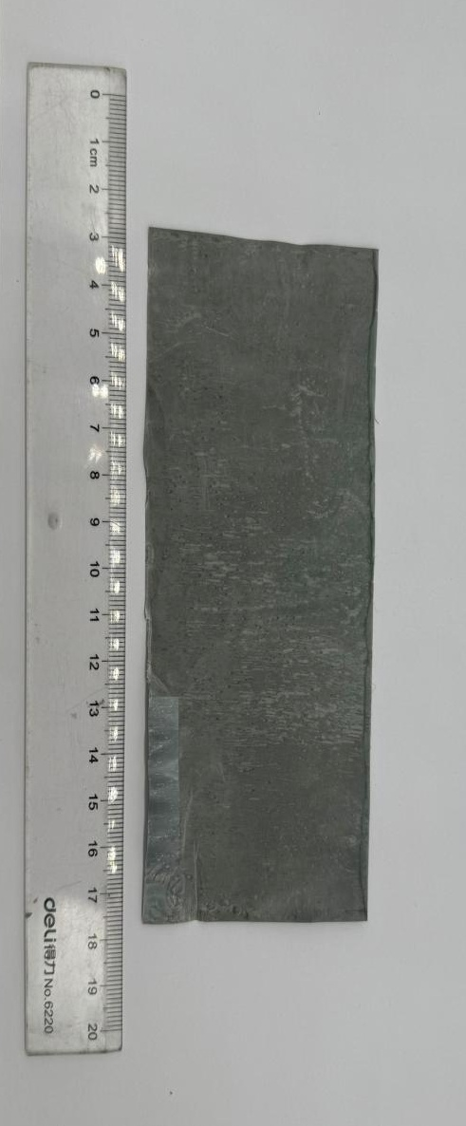
Figure S3. Digital photo of PVDF-ZnOHF@Zn electrode with a large size.

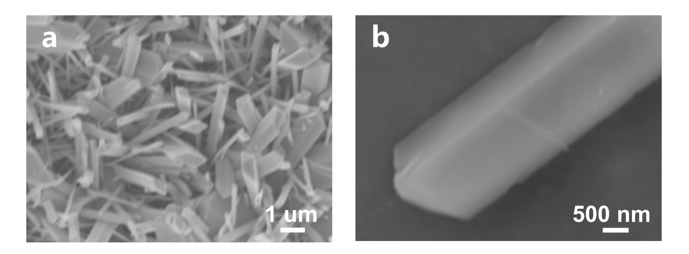
Figure S4. SEM image of ZnOHF@Zn grown only with ZnOHF NWs. (a) Whole morphology and (b) single nanowire morphology.

Figure S5. SEM energy dispersive spectroscopy (EDS) mapping image of the ZnOHF nanowires.

Single nanowires were successfully detached from the parent nanowire array and subjected to scanning electron microscopy (SEM) and energy-dispersive X-ray spectroscopy (EDS) analyses. The results demonstrated that individual nanowires exhibit well-defined crystallinity, confirming their structural integrity. Elemental mapping revealed a homogeneous distribution of zinc (Zn), fluorine (F), and oxygen (O) across the corresponding regions of the nanowire.
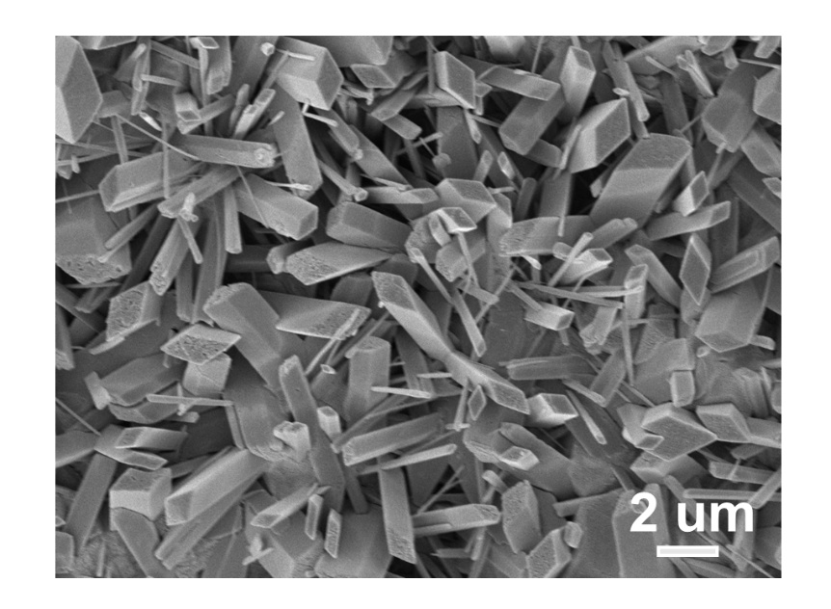
Figure S6. SEM images of PVDF-ZnOHF@Zn electrode with PVDF coating.

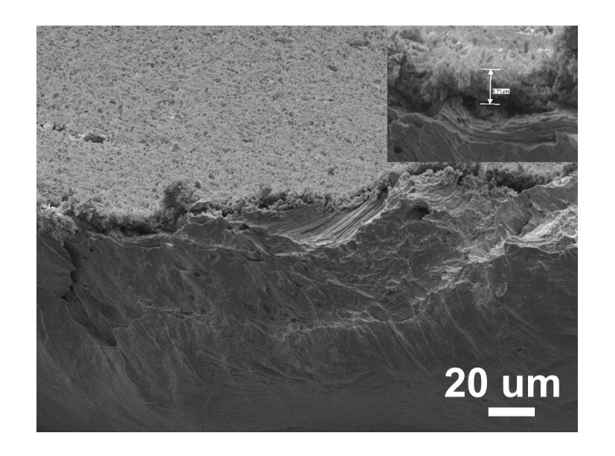
Figure S7. The cross-sectional SEM image of PVDF-ZnOHF@Zn electrode.

Figure S8. The corresponding cross-sectional elemental mapping images of PVDF-ZnOHF@Zn electrode.

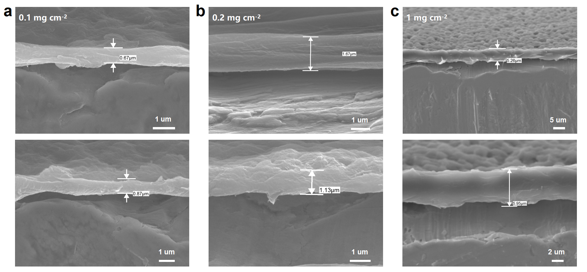
Figure S9. The cross-sectional SEM images of the Zn foils coated with different loading amounts of PVDF.

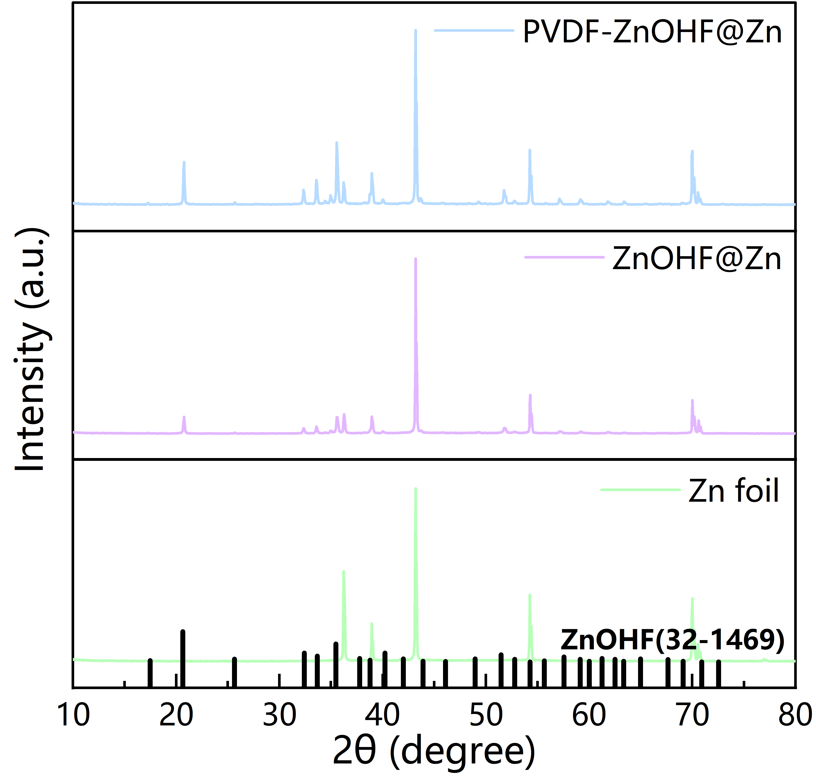
Figure S10. XRD pattern of PVDF-ZnOHF@Zn, ZnOHF@Zn and Zn foil.

Figure S11. XPS spectra of PVDF-ZnOHF@Zn.

Figure S12. High-resolution XPS spectra of (a) C 1s, (b) O 1s, (c) Zn 2p and (d) F 1s of PVDF-ZnOHF@Zn.

Figure S13. Digital photos of different electrodes in the initial state and after immersion in 2 M ZnSO₄ electrolyte for 7 days.

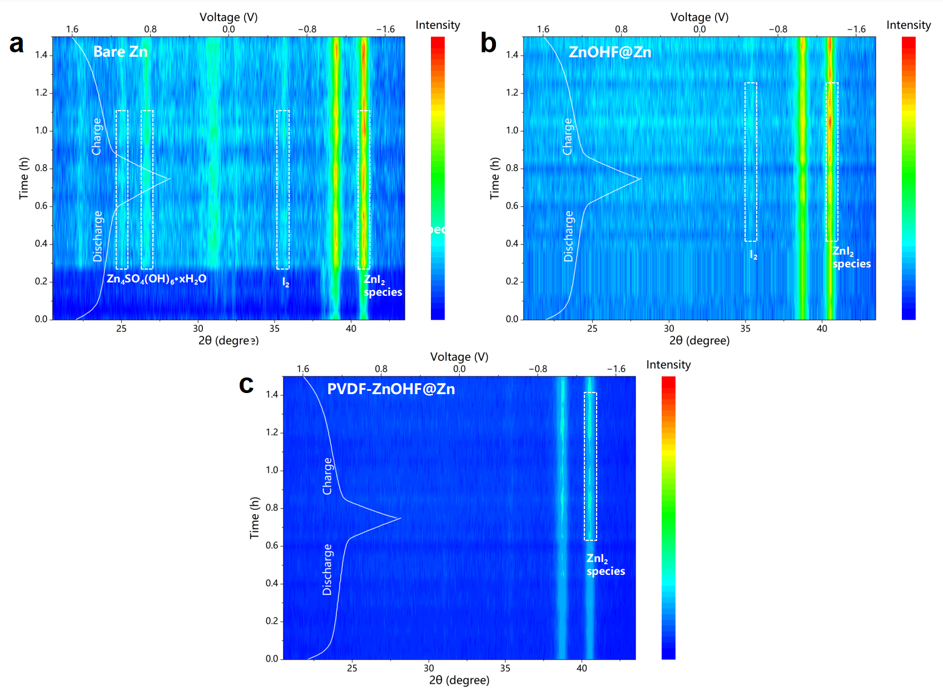
Figure S14. In-situ XRD pattern of (a) bare Zn, (b) ZnOHF@Zn and (c) PVDF-ZnOHF@Zn.

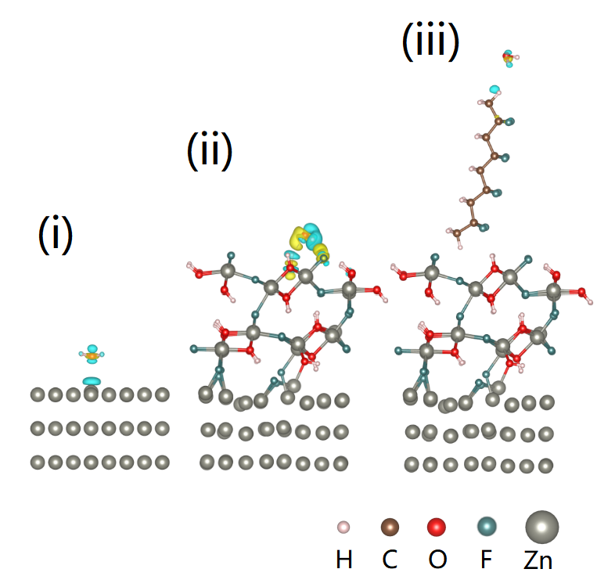
Figure S15. The charge density difference of (i) bare Zn, (ii) ZnOHF@Zn and (iii) PVDF-ZnOHF@Zn induced by H₂O molecule adsorption.

Figure S16. Visualization experiment of different electrodes in the initial state and after immersion in 2 mmol L⁻¹ I₃⁻ solution for 48 h. The volume of the solution is 4 ml and the weight of different electrodes is 50 mg.

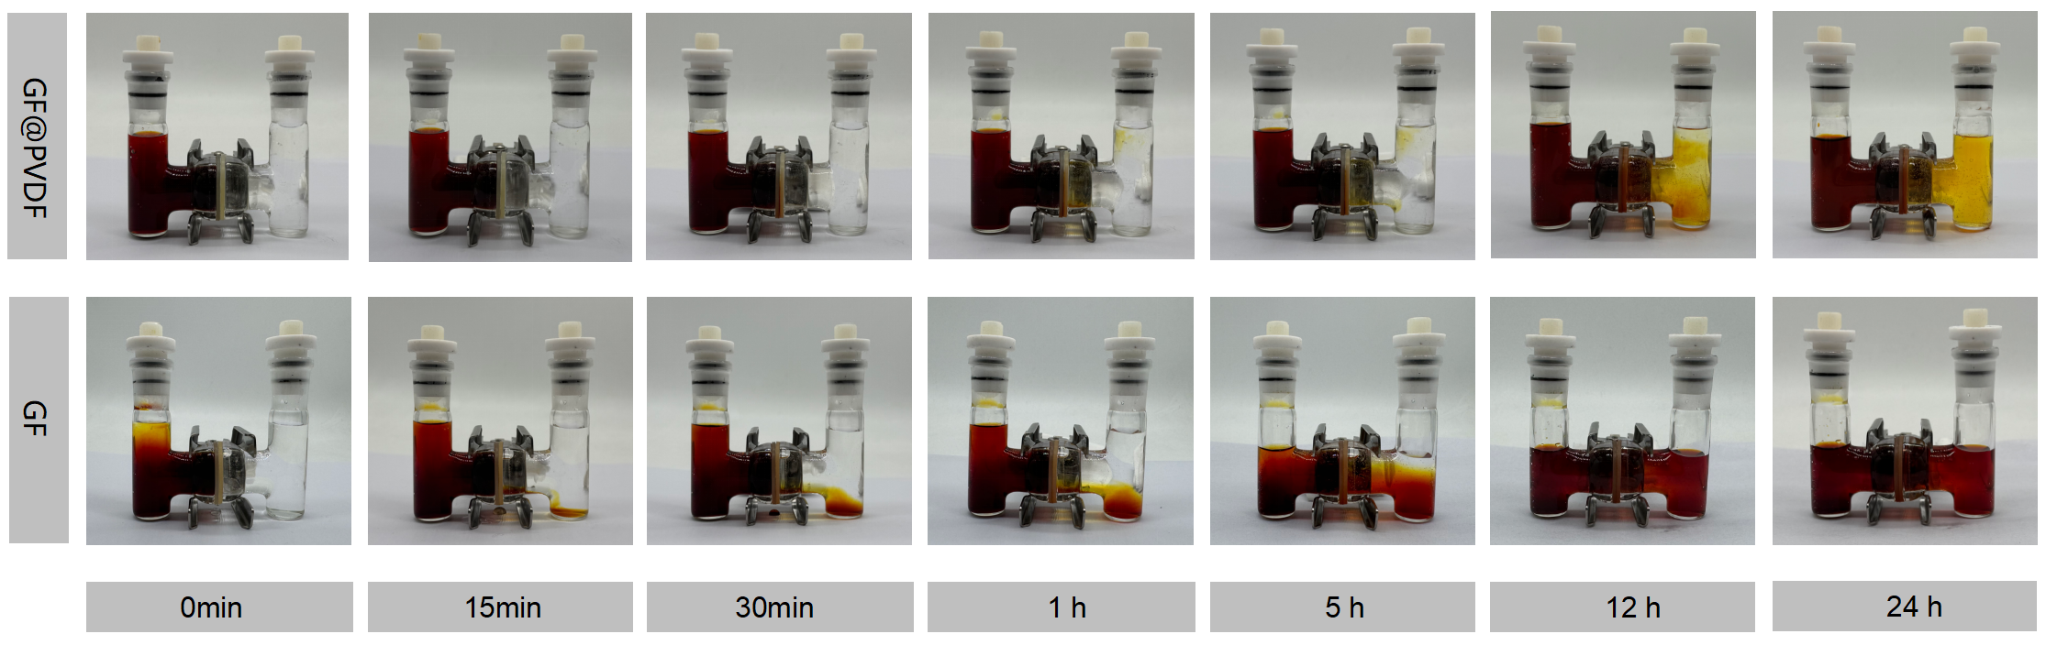
Figure S17. Optical images of visual shuttle effect by H-type glass cells with the 0.5 M I₃⁻ solution for GF separator and GF separator with PVDF.

Figure S18. Possible configurations of I₅⁻ species.

Figure S19. Optimized configurations of (a) Zn(I₅)₂ and (c) Zn(I₅)₂-Zn(I₅)₂. (c) The optimized adsorption configurations of Zn(I₅)₂ on PVDF.

Figure S20. Energy comparison of ∆ E_{CE}, ∆E_{SE} and ∆P for I₅⁻.

We analyzed the possible molecular configurations and the most stable structure of Zn(I₅)₂. Zn²⁺ typically adopts coordination numbers of 4 or 6, favoring tetrahedral or octahedral geometries. The I₅⁻ ion adopts a linear symmetric configuration, where the terminal I⁻ atoms provide lone pairs for coordination with Zn²⁺, while the central I atoms do not directly participate in bonding. Density Functional Theory (DFT) calculations revealed that the most stable configuration involves one terminal I⁻ from each I₅⁻ coordinating to Zn²⁺, with both I₅⁻ ligands retaining their linear symmetry. Type 1 was identified as the most stable structure, exhibiting significantly lower energy compared to other configurations.
We optimized the adsorption configurations of Zn(I₅)₂ species (type 1) on autogenous aggregation (Zn(I₅)₂-Zn(I₅)₂) and PVDF molecular configuration (PVDF-Zn(I₅)₂). The results reveal that the cohesion strength (∆E_{CE}: -2.219 eV) of I₅⁻ species is far less than the solvation energy (∆E_{SE}: -0.173 eV) of that in PVDF molecular, different from the strong redox reaction tendency of polyiodide with bare Zn directly. Besides, the calculated ∆P value shows the negative "∆P" values (-2.046 eV), confirming that polyiodide is insoluble in PVDF-ZnOHF@Zn, which effectively prevents the corrosion of polyiodide ions on zinc anode.

Figure S21. C 1s XPS spectra of PVDF-ZnOHF@Zn after etching.

Etching XPS analysis revealed that the content of C-F bonds in the F 1s spectra decreased significantly (58.92% at 0 s, 19.68% at 60 s, and 15.01% after 180 s), which is attributed to the decrease of PVDF content after etching part of the electrode surface.

Figure S22. TOF-SIMS (a) I⁻ and (b) C⁻ element mappings on the top surface of PVDF-ZnOHF@Zn.

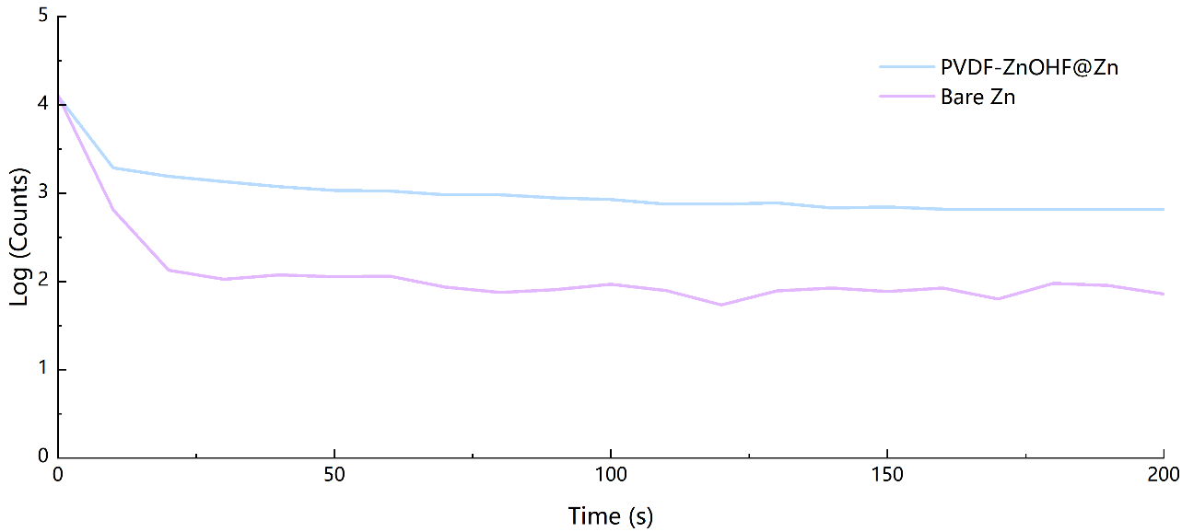
Figure S23. The corresponding TOF-SIMS depth profiles for C⁻ of different electrodes.

Figure S24. TOF-SIMS (a) I⁻ and (b) C⁻ element mappings on the top surface of bare Zn.

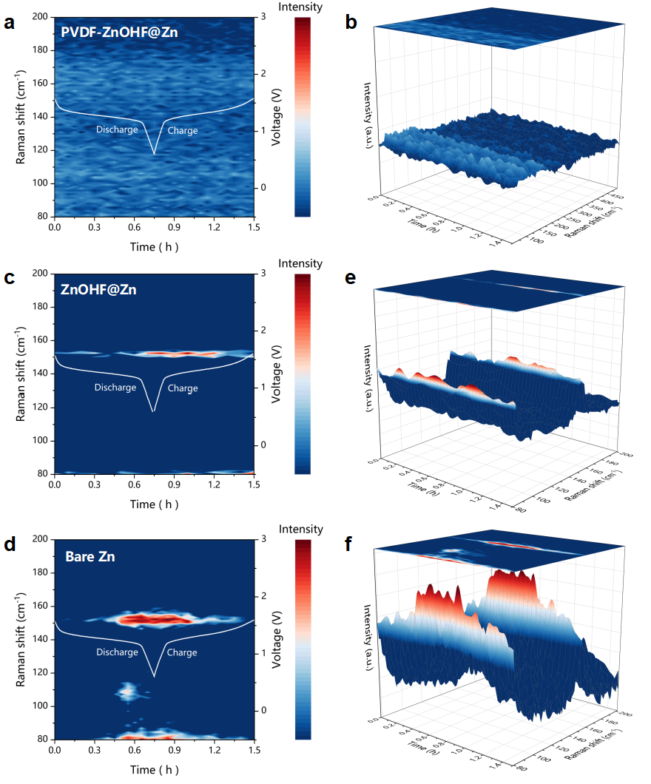
Figure S25. In-situ Raman spectroscopy of PVDF-ZnOHF@Zn, ZnOHF@Zn and bare Zn.

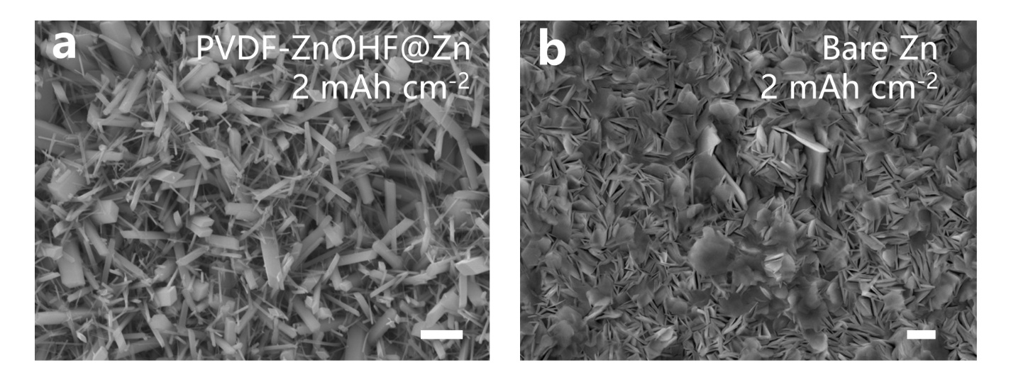
Figure S26. SEM images of (a) PVDF-ZnOHF@Zn and (b) bare Zn electrodes after Zn deposition with capacities of 2 mAh cm⁻². Scale bar, 10 μm for a-b.

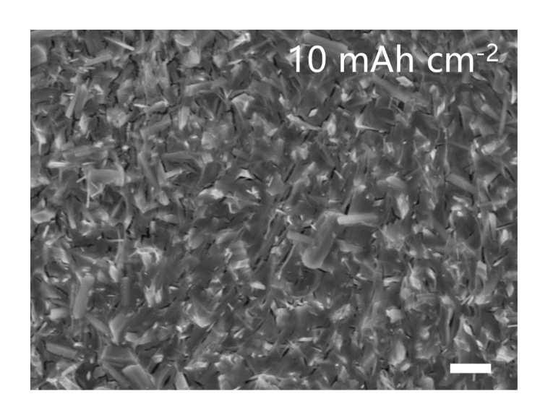
Figure S27. SEM images of PVDF-ZnOHF@Zn electrode after Zn deposition with capacities of 10 mAh cm⁻². Scale bar, 20 μm.

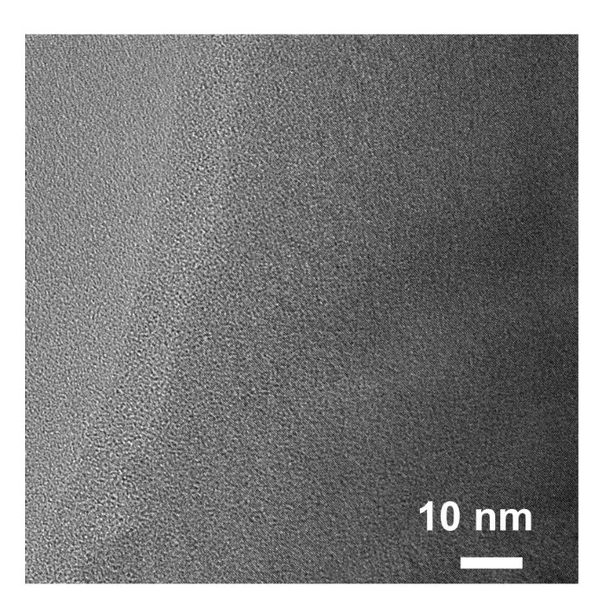
Figure S28. HRTEM image of SEI formed on PVDF-ZnOHF@Zn electrode surface after cycling.

Figure S29. Corresponding elemental mapping of SEI formed on PVDF-ZnOHF@Zn electrode surface after cycling.

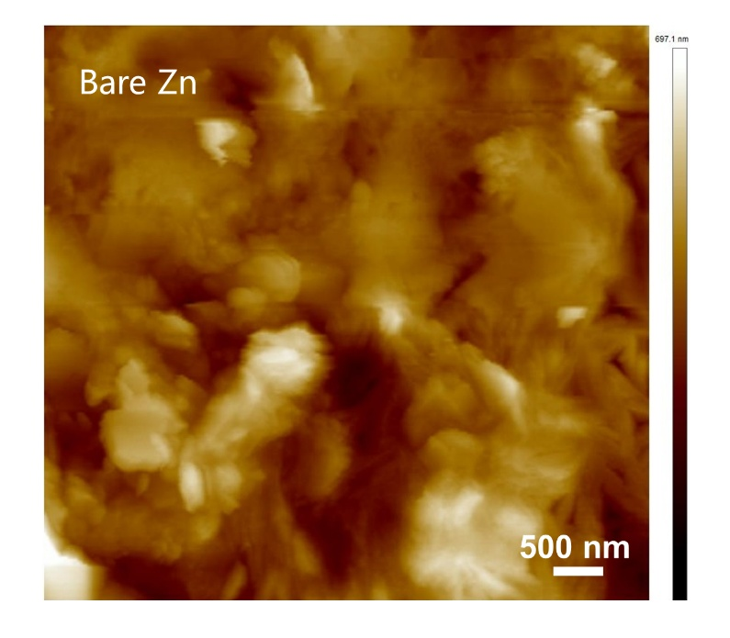
Figure S30. AFM topography images of bare Zn after cycling.

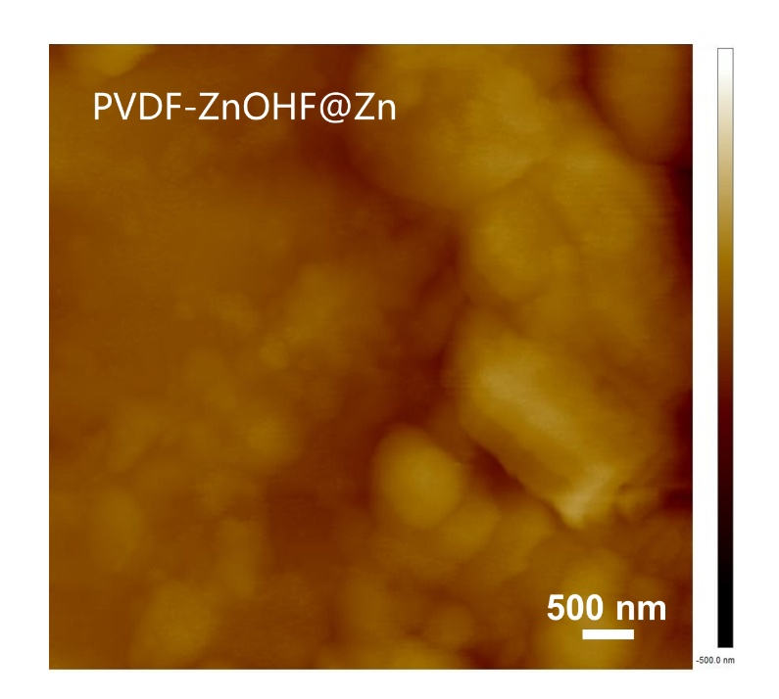
Figure S31. AFM topography images of PVDF-ZnOHF@Zn electrode after cycling.

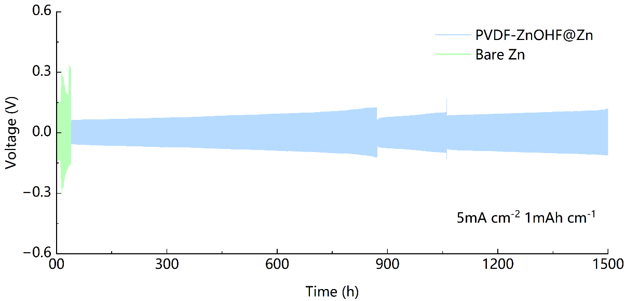
Figure S32. Voltage profiles of symmetrical cells at current densities/capacities of 5 mA cm⁻²/1 mAh cm⁻².

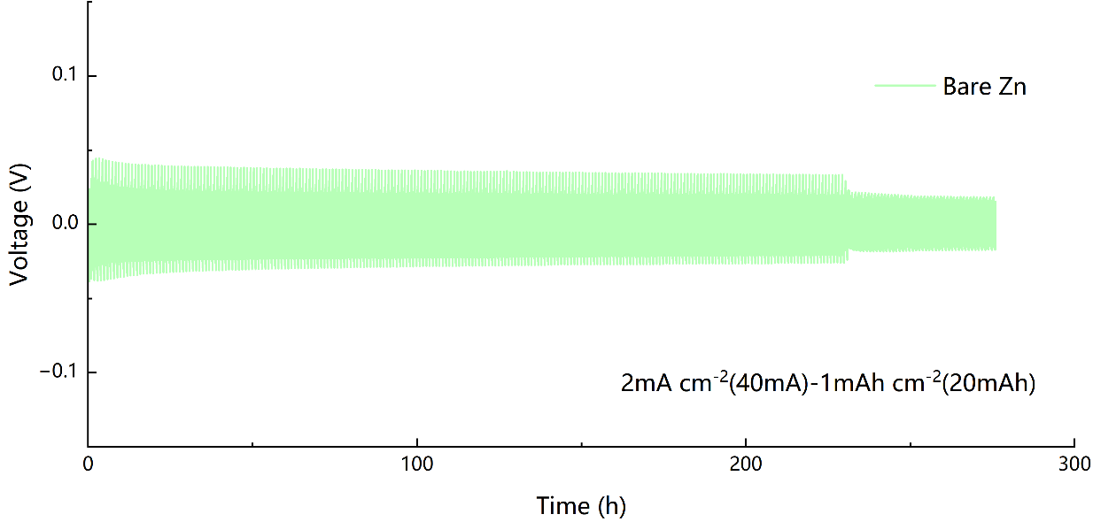
Figure S33. Stability of Zn//Zn symmetric pouch cells at a current density of 2 mA cm⁻² (40 mA) with a capacity of 1 mAh cm⁻² (20 mAh).

To further evaluate the stability and reversibility of the Zn anodes, a 4 cm² × 5 cm² large-size pouch symmetrical battery was assembled and its electrochemical performance was tested at certain temperature and pressure. It is worth noting that compared with button battery, the dimensions of the zinc anode are expanded by nearly 20 times, so the issues caused by corrosion reactions and zinc dendrite growth will be more woeful. As depicted in Figure S33, the Zn//Zn pouch battery has a poor cycle of 230 h under a current density/capacity of 2 mA cm⁻² (40 mA)/1 mAh cm⁻² (20 mAh), which is attributed to the battery short circuit caused by more rampant corrosion side reactions and zinc dendrite growth problems.

Figure S34. Simulations of local current density of (a) bare Zn and (b) PVDF-ZnOHF@Zn electrodes.

The current density distribution reveals that the roughness of Zn foil leads to localized current density concentration at protrusions, resulting in severe polarization. By contrast, the porous PVDF layer on the PVDF-ZnOHF@Zn electrode surface mitigates current density at the top region. Meanwhile, the highly ordered ZnOHF nanowire array and fully exposed zincophilic channels enable rapid Zn²⁺ transport and uniform deposition within the channels, thus enhancing the cycling performance.

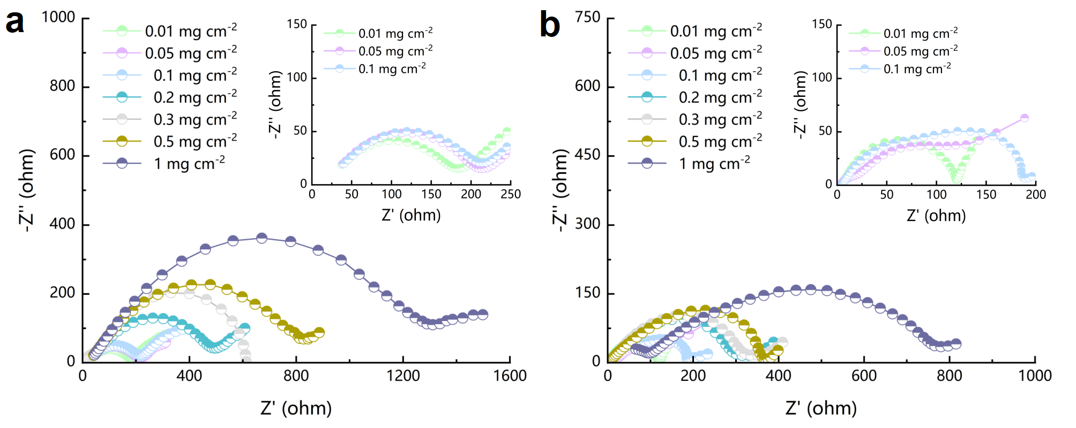
Figure S35. EIS plots of (a) symmetric cells and (b) full cells based on PVDF-ZnOHF electrodes with different PVDF contents.

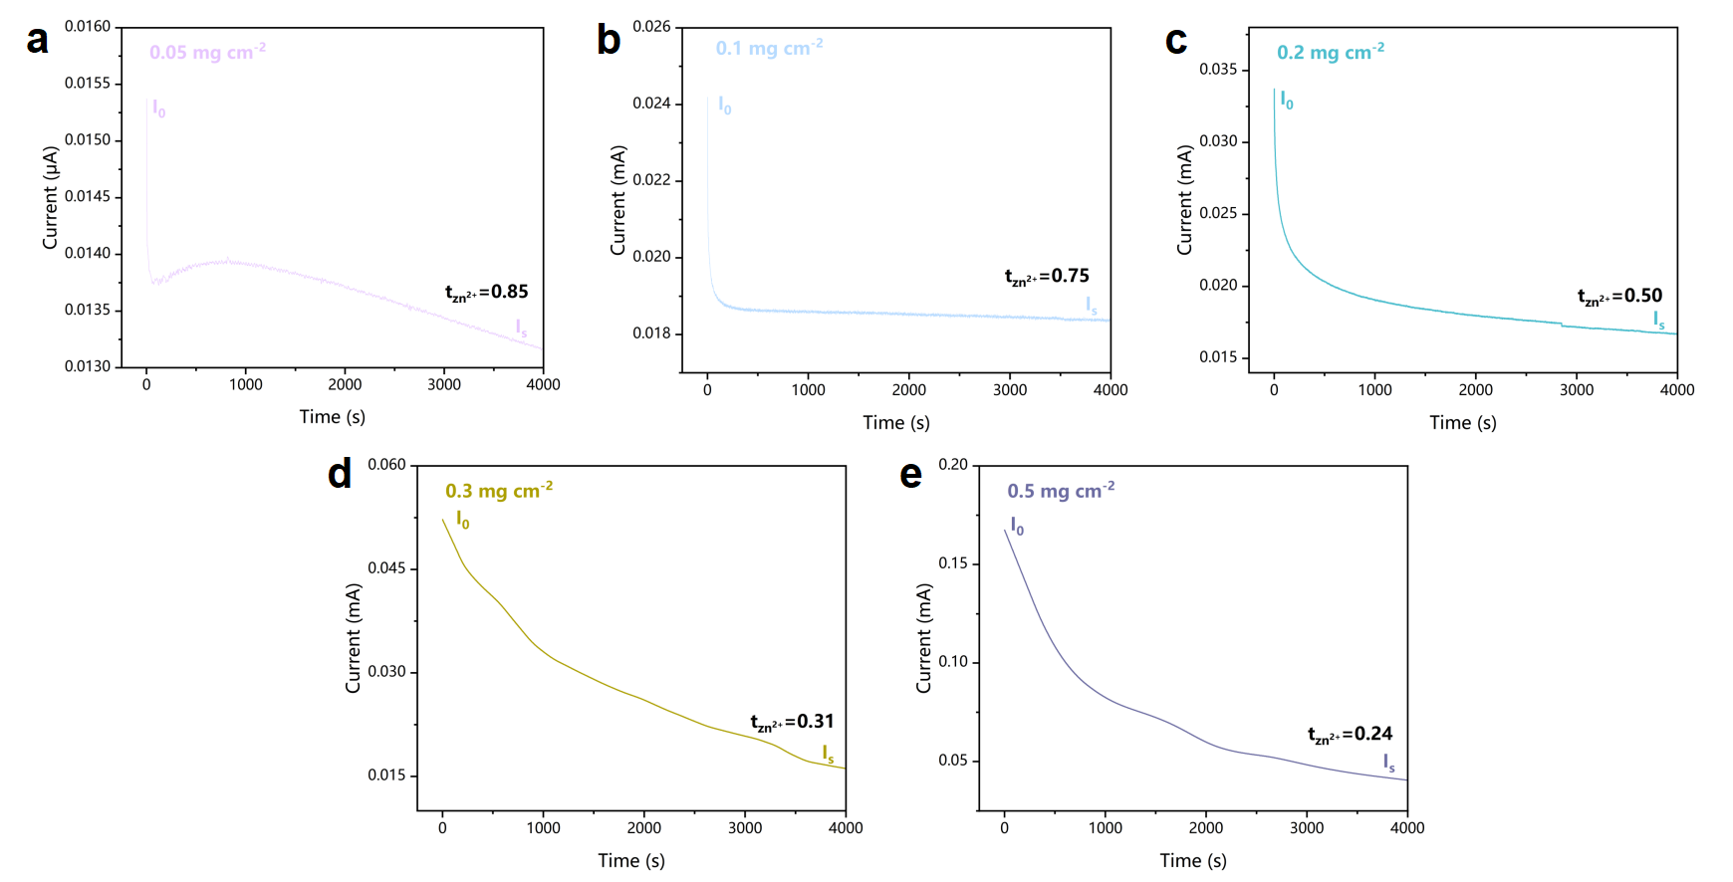
Figure S36. Zn²⁺ transference number of PVDF-ZnOHF@Zn electrodes with different PVDF contents.

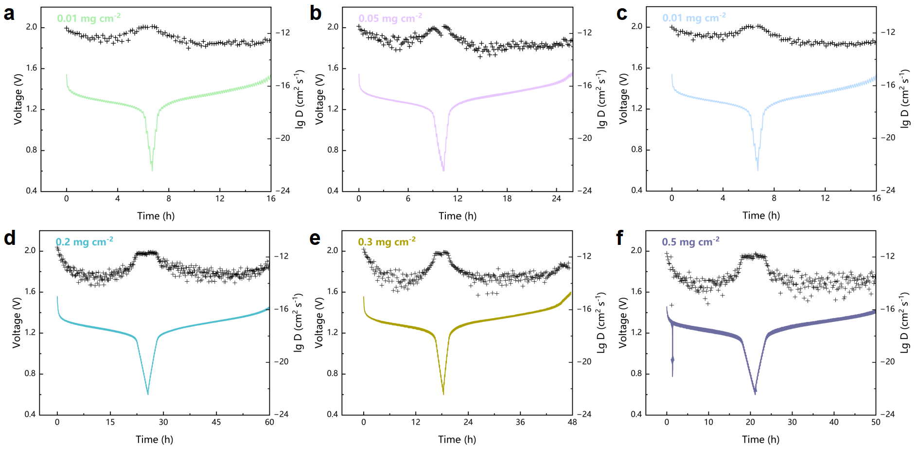
Figure S37. The galvanostatic intermittent titration technique (GITT) curves and corresponding D_{Zn} of PVDF-ZnOHF@Zn electrodes with different PVDF contents.

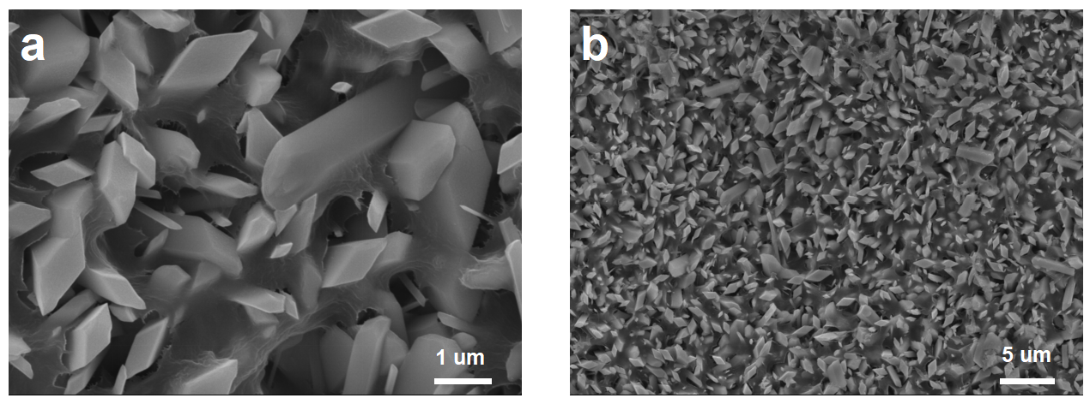
Figure S38. SEM images of PVDF-ZnOHF@Zn electrodes after cycling.
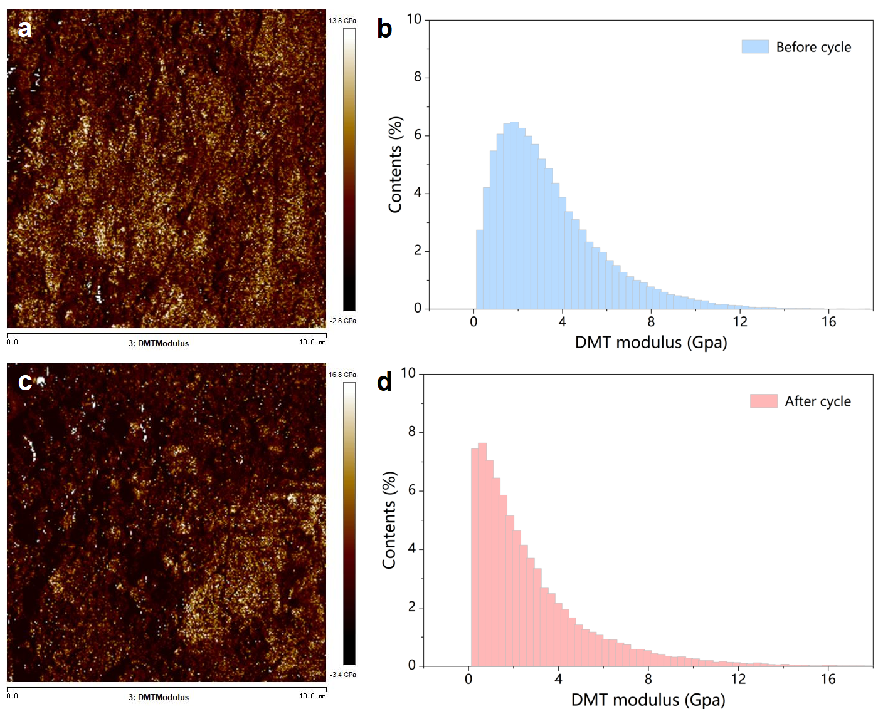
Figure S39. DMT modulus distribution and corresponding AFM images of PVDF-ZnOHF@Zn electrodes with 0.1 mg cm⁻² PVDF before and after cycling.
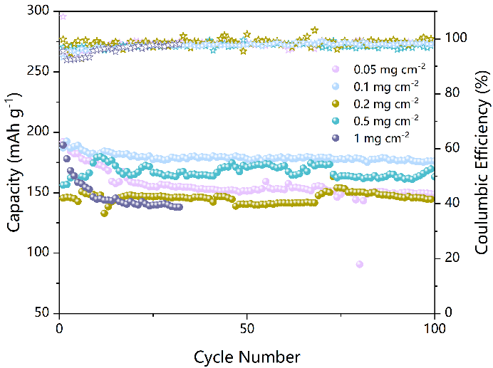
Figure S40. Cycling performances of PVDF-ZnOHF@Zn electrodes with different PVDF contents at current density of 0.5 C.

Figure S41. (a) Cycle performance of the PVDF-ZnOHF@Zn electrodes prepared with different PVDF content. SEM images of PVDF-ZnOHF@Zn electrode with (b) 0.05 mg cm⁻² and (c) 0.5 mg cm⁻² PVDF.

To achieve optimal cycling sustainability, the cycling performance of PVDF-ZnOHF@Zn electrodes fabricated with varying PVDF contents was tested. As shown in the SEM image of Figure S41b, the electrode containing 0.05 mg cm⁻² PVDF exhibited a short circuit after about 150 hours, attributed to limited corrosion resistance improvement due to the thinner PVDF coating and incomplete coverage. For the electrode with 0.5 mg cm⁻² PVDF (Figure S41c), the voltage increased significantly after about 85 hours, likely caused by interface deterioration from excessive PVDF, leading to elevated Zn²⁺ transfer resistance and poor ionic conductivity. Compared to other contents, the PVDF-ZnOHF@Zn electrode with 0.1 mg cm⁻² PVDF demonstrated superior cycling performance, effectively enhancing corrosion resistance and enabling uniform Zn deposition on the electrode surface.

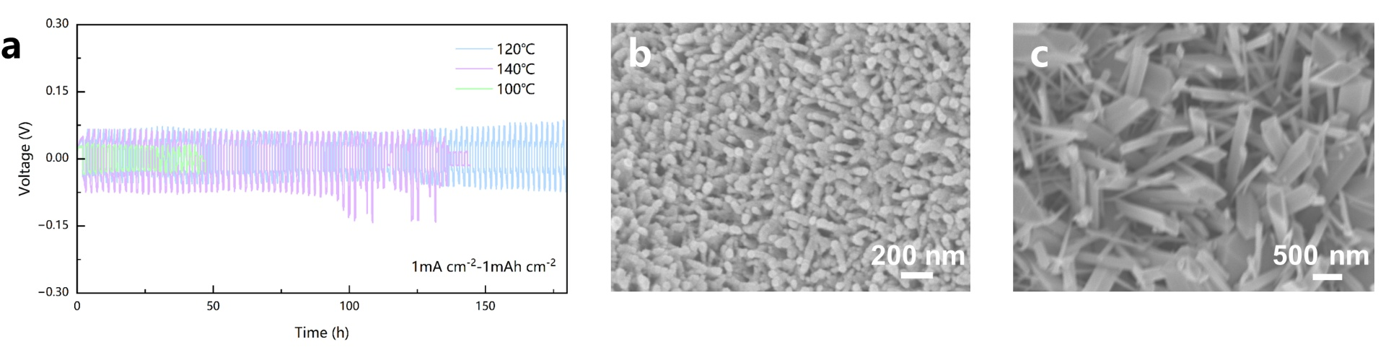
Figure S42. (a) Cycle performance of the PVDF-ZnOHF@Zn electrodes prepared under the different synthesis conditions. SEM images of PVDF-ZnOHF@Zn electrode under the synthesis of (b) 100 ℃ and (c) 140 ℃.

The nanowire synthesis conditions were optimized by controlling temperature. Figure S42b reveals that nanowire arrays synthesized at 100 °C lacked structural integrity, displaying amorphous features due to incomplete reactions. This electrode suffered short-circuit after 40 hours, linked to poor crystallinity and inadequate Zn²⁺ transport. At 140 °C (Figure S42c), larger nanowires resulted in only 140 hours of stable cycling, suggesting insufficient active surfaces for efficient Zn²⁺ conduction. In contrast, the electrode synthesized at 120 °C for 2 h exhibited more stable performance, ascribed to the improved crystallinity and ordered zincophilic channels in the ZnOHF nanowire array under these conditions.

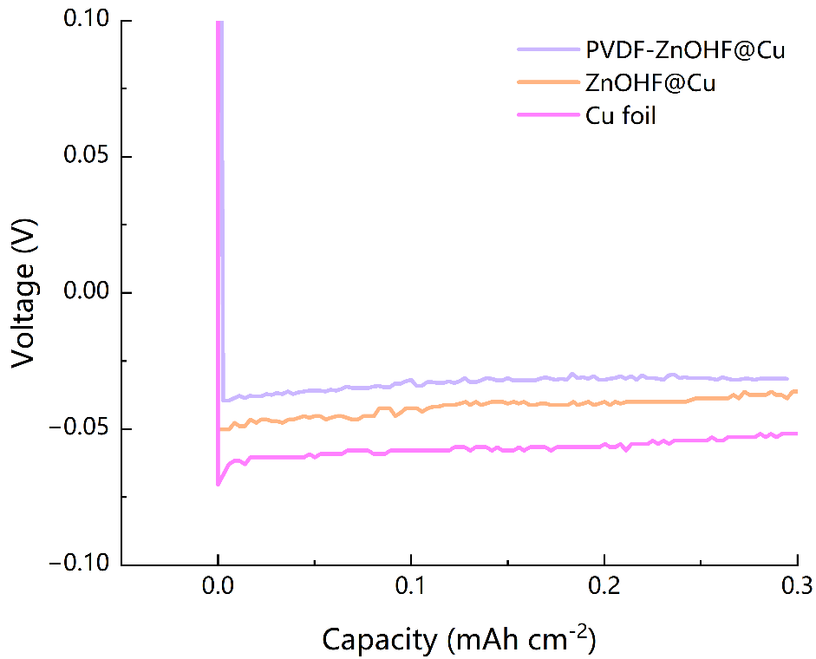
Figure S43. Nucleation overpotential of different electrodes.

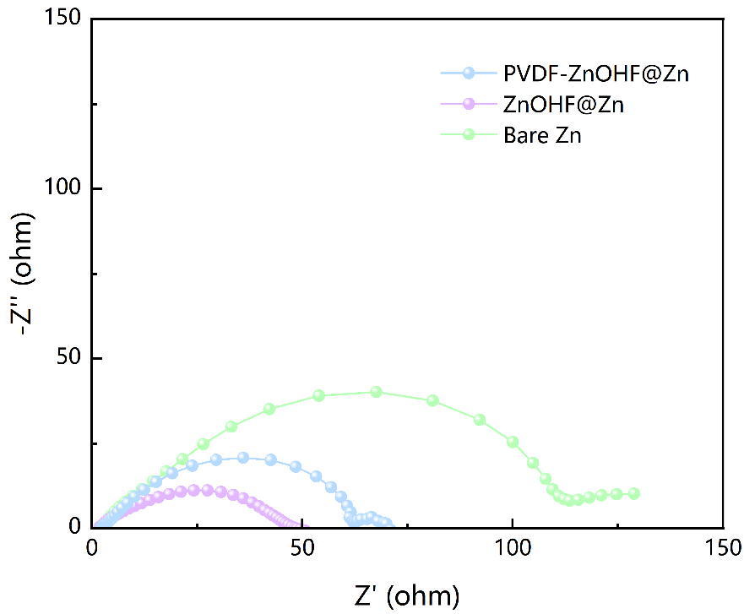
Figure S44. EIS plots of different symmetric cells.

Figure S45. The corresponding potential-capacity curves of Cu//Zn, ZnOHF@Cu//Zn and PVDF-ZnOHF@Cu//Zn cells at different cycles.

Figure S46. (a) Short cycling performances at current density of 2 C. (b) Galvanostatic charge-discharge curves at current density of 2 C.

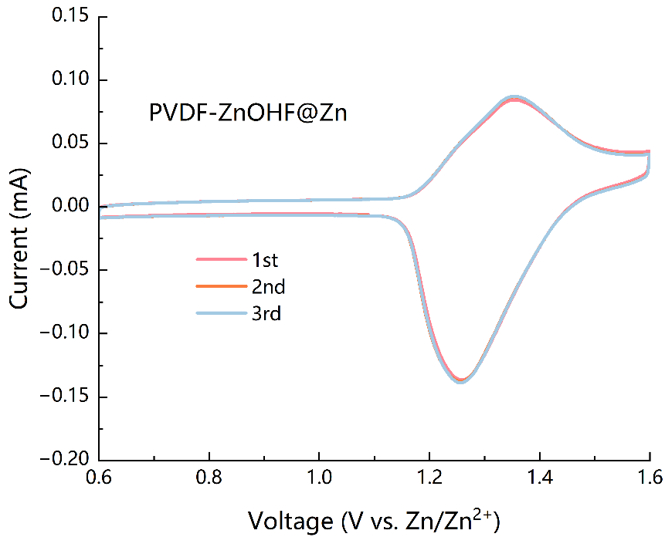
Figure S47. The initial three CV curves of PVDF-ZnOHF@Zn electrode at 0.1 mV s⁻¹.

Figure S48. CV curves of (a) bare Zn, (b) ZnOHF@Zn and (c) PVDF-ZnOHF@Zn electrodes at different scan rates in the range of 0.1-5 mV s⁻¹.

Figure S49. Galvanostatic charge-discharge curves of (a) bare Zn, (b) ZnOHF@Zn and (c) PVDF-ZnOHF@Zn electrodes at current density of 2 C-50 C in a potential window from 0.6 to 1.6 V.

As shown in Figure S49, compared to bare Zn and ZnOHF@Zn electrodes, the PVDF-ZnOHF@Zn electrode provides a stable voltage platform in rate performance testing, especially even at a high current density of 50 C. This indicates that the outstanding stability of the redox reaction of the battery at ultra-high current densities, attributed to the fast conductivity of Zn²⁺ ions and excellent corrosion resistance of the electrode.

Figure S50. Self-discharge tests of (a) PVDF-ZnOHF@Zn, (b) ZnOHF@Zn and (c) bare Zn electrodes.

As shown in Figure S50, the excellent self-discharge test results of the electrode highlight the sustainability of the battery in the actual energy storage demand and cycle process.

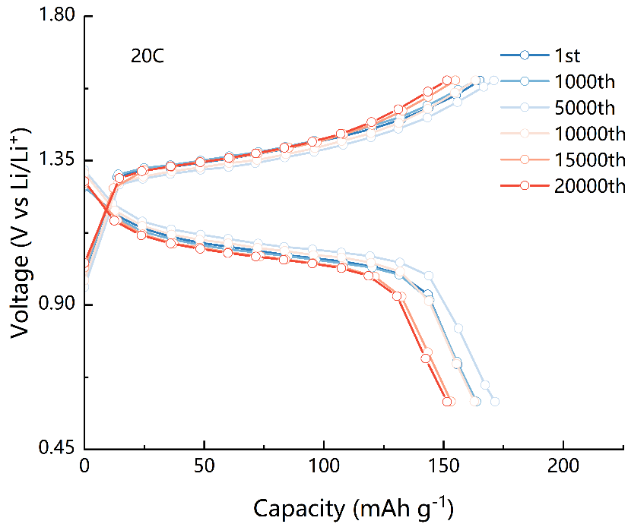
Figure S51. Galvanostatic charge-discharge profiles of the PVDF-ZnOHF@Zn electrode at current density of 20 C.

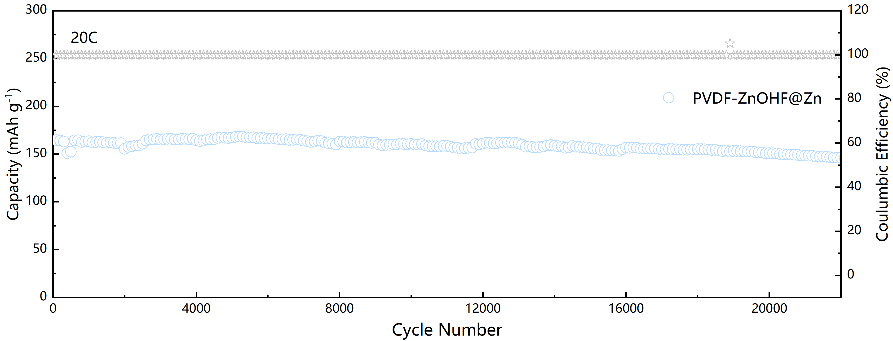
Figure S52. Cycling performance of PVDF-ZnOHF@Zn electrode at current density of 20 C.
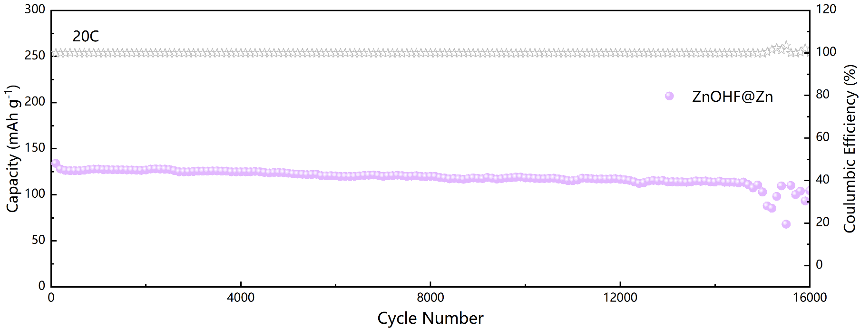
Figure S53. Cycling performance of ZnOHF@Zn electrode at current density of 20 C.

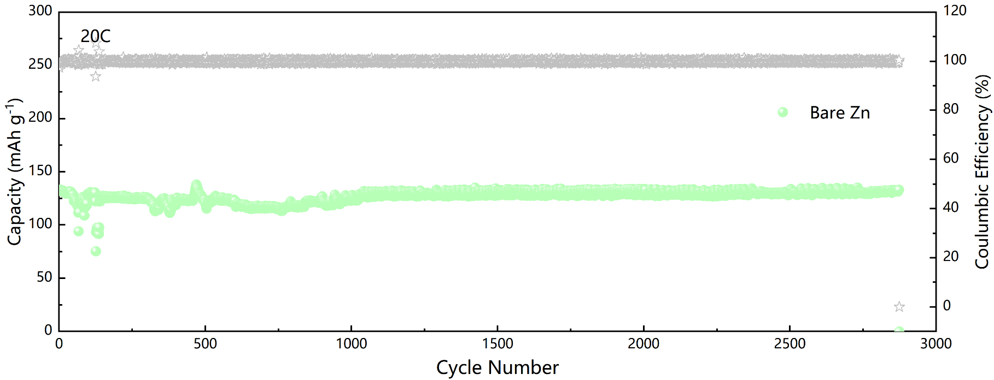
Figure S54. Cycling performance of Bare Zn at current density of 20 C.

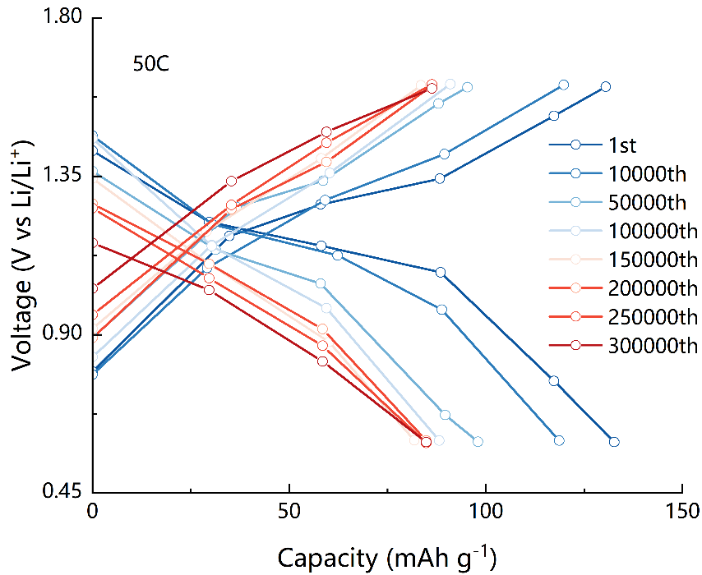
Figure S55. Galvanostatic charge-discharge curves of the PVDF-ZnOHF@Zn electrode at current density of 50 C.

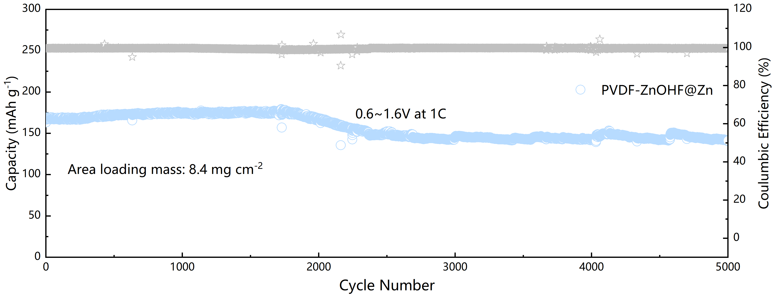
Figure S56. Cycling stability of high-load button battery at current density of 1 C.

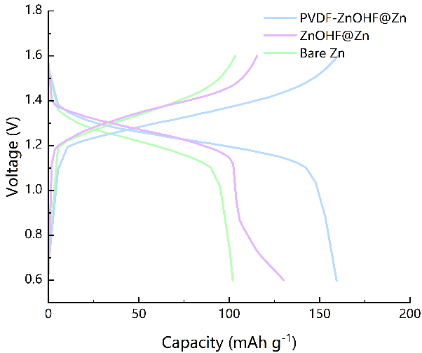
Figure S57. The charge-discharge curves of the pouch cell after 10 cycles.

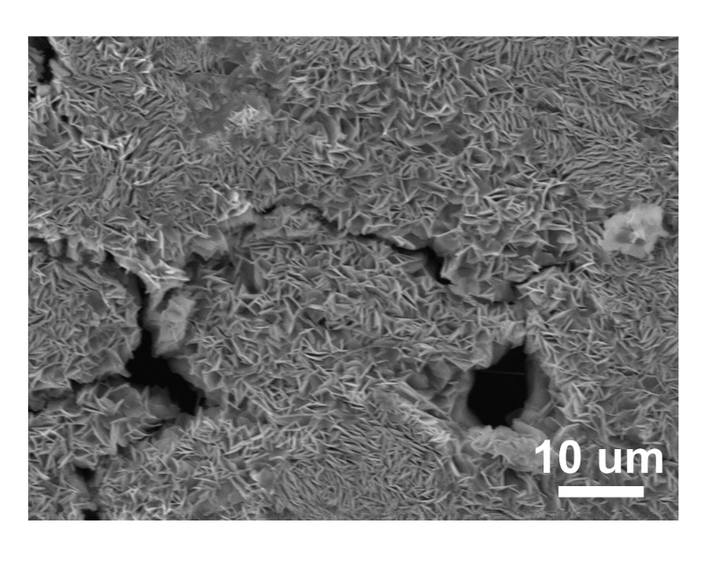
Figure S58. SEM image of bare Zn recycling from pouch battery.

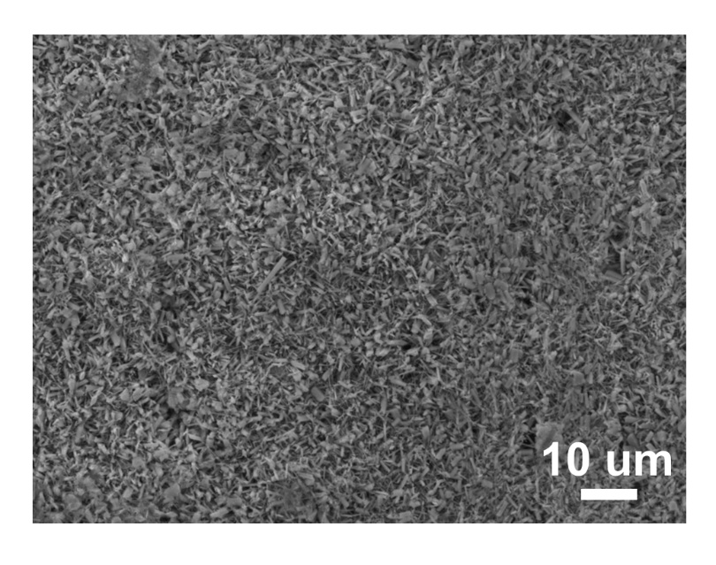
Figure S59. SEM image of PVDF-ZnOHF@Zn recycling from pouch battery.

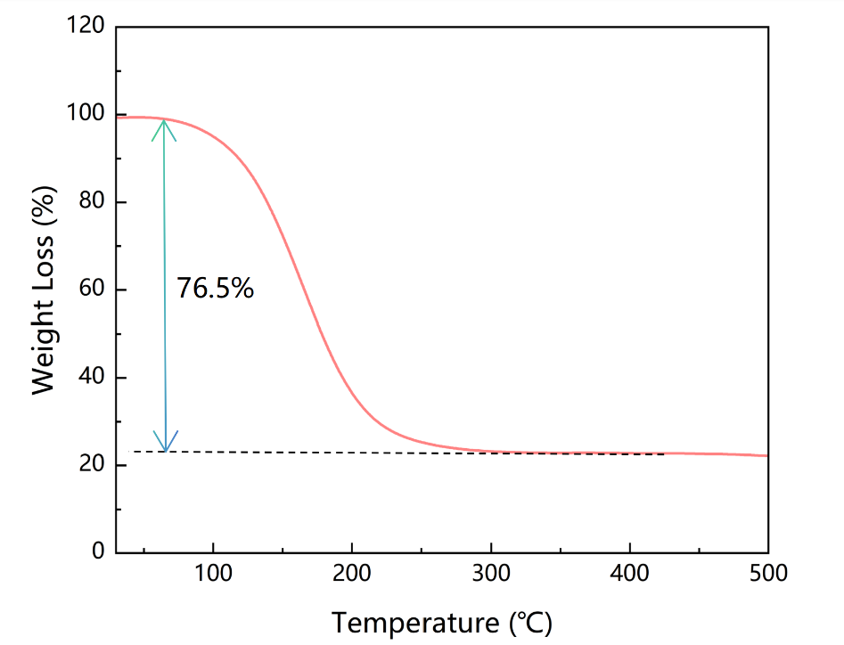
Figure S60. TGA curve of sulfur content with normal I₂ loading.
Table S1. Comparison of voltage hysteresis of reported advanced Zn anodes with our work.

Optimized materials | Specific current  (mA cm⁻²) | Areal capacity  (mAh cm⁻²) |  | Lifespan  (h) | Function mechanism | Reference
Zeolite-Zn | 2.5 |  | 2.5 | 470 | Coating strategy | [1]
Zn@Sn-ZnF₂ | 1 |  | 1 | 500 | Coating strategy | [2]
SC-PPS@Zn | 1 |  | 1 | 600 | Coating strategy | [3]
Zn_{0.73}Al_{0.27}@Zn | 2 |  | 2 | 500 | Structural design | [4]
Zn@ZnO-3D | 5 |  | 1.25 | 500 | Structural design | [5]
Zn@Sb | 1 |  | 1 | 800 | Coating strategy | [6]
Zn@PFSA | 1 |  | 1 | 800 | Coating strategy | [7]
PS-Zn | 10 |  | 1 | 500 | Electrolyte optimization | [8]
Sn@NHCF | 1 |  | 1 | 370 | Structural design | [9]
Cu NBs@NCFs-Zn | 5 |  | 2 | 250 | Structural design | [10]
PVDF-ZnOHF@Zn | 10  2(40mA) |  | 1  1(20mAh) | 600  1100 | Structural design  Surface Film adjustment | This work

Table S2. Summary of electrochemical performance between our work and other reported zinc-iodine battery design.

Optimized materials | Rate capacity  (mAh g⁻¹) | Current density  (C) | Cycle number | Fading rate  (%) | Reference
LiVS₂ | 117 | 25 | 30000 | 0.0005% | [11]
Starch | 75 | 50 | 60000 | 0.0002% | [12]
OSTC | 175 | 15 | 10000 | 0.0015% | [13]
PBI | 100 | 50 | 3500 | 0.043% | [14]
Zn@Sn-ZnF₂ | 120 | 10 | 20000 | 0.001% | [2]
Zeolite-Zn | 147 | 10 | 5600 | 0.0014% | [1]
Dowex | 140 | 25 | 30000 | 0.0014% | [15]
SR | 105 | 15 | 16000 | N/A | [16]
ZSI-n | 150 | 25 | 30000 | 0.0004% | [17]
Zn@L-I₂ | 87 | 30 | 35000 | N/A | [18]
SC-PPS@Zn | 85 | 15 | 6000 | 0.0017% | [3]
MeOH-TI | 119 | 50 | 20000 | 0.00025% | [19]
Zn@TOP/Carra | 180 | 5 | 4500 | 0.004% | [20]
PVDF-ZnOHF@Zn | 125 | 50 | 350000 | 0.00011% | This work

Table S3. Summary of electrolyte composition and mass loading between our work and other reported zinc-iodine battery design.
Optimized materials | Total mass (mg) | Area loading (mg cm⁻²) | electrolyte composition | Reference
HC@FeNC | 10.5 | 5 | 2M ZnSO₄ | [21]
Fe SAC-MNC | 140 | 3 | 10-0-8 electrolyte | [22]
I₂-HPCM-NP | N/A | 2 | 2M ZnSO₄ | [23]
Zn@Sn-ZnF₂ | 75.8 | 8 | 2M ZnSO₄ | [2]
Zeolite-Zn | 58.6 | 13.3 | 1M ZnSO₄ | [1]
Dowex | N/A | 20 | 1M ZnSO₄ | [15]
ZSI-n | N/A | 1.45 | ZSI-n+ZnSO₄ | [17]
Zn@ZSO | N/A | 1.5 | 2 M ZnSO₄ + KI | [24]
PVDF-ZnOHF@Zn | 5000 | 20.8/10.5 | 2M ZnSO₄ | This work

Table S4. Basic cost analysis of zinc-iodine batteries compared with other battery systems.
Type of battery/Component | Lithium-ion Batteries (LIBs) ($/kg) | Aqueous Zinc-ion Batteries (Manganese-based) ($/kg) | Aqueous Zinc-ion Batteries (Vanadium-based) ($/kg) | Aqueous Zinc-iodine Batteries ($/kg)
Cathode (include host materials) | 25-30 | 5 | 15-25 | 45
Anode | 5-10 | 3 | 3 | 3
Electrolyte | 3 | 0.75 | 0.75 | 0.75
Separator | 0.1/m² | 0.5/m² | 0.5/m² | 0.5/m²
Current Collector | Al foil: 2.5  Cu foil: 13.5 | Al foil: 2.5 | Al foil: 2.5 | Al foil: 2.5
Packaging Manufacturing | 70-100 | 0.5 | 0.5 | 0.5

References
[1] W. Shang, Q. Li, F. Jiang, B. Huang, J. Song, S. Yun, X. Liu, H. Kimura, J. Liu and L. Kang, Nano-Micro Lett., 2022, 14, 82.
[2] G. Wang, Q. Yao, J. Dong, W. Ge, N. Wang, Z. Bai, J. Yang and S. Dou, Adv. Energy Mater., 2024, 14, 2303221.
[3] L. Zhang, J. Huang, H. Guo, L. Ge, Z. Tian, M. Zhang, J. Wang, G. He, T. Liu, J. Hofkens, D. J. L. Brett and F. Lai, Adv. Energy Mater., 2023, 13, 2203790.
[4] J. Zheng, Z. Huang, Y. Zeng, W. Liu, B. Wei, Z. Qi, Z. Wang, C. Xia and H. Liang, Nano Lett., 2022, 22, 1017-1023.
[5] X. Xie, S. Liang, J. Gao, S. Guo, J. Guo, C. Wang, G. Xu, X. Wu, G. Chen and J. Zhou, Energy Environ. Sci., 2020, 13, 503-510.
[6] L. Hong, L.-Y. Wang, Y. Wang, X. Wu, W. Huang, Y. Zhou, K.-X. Wang and J.-S. Chen, Adv. Sci., 2022, 9, 2104866.
[7] L. Hong, X. Wu, L.-Y. Wang, M. Zhong, P. Zhang, L. Jiang, W. Huang, Y. Wang, K.-X. Wang and J.-S. Chen, ACS Nano, 2022, 16, 6906-6915.
[8] Q. Li, A. Chen, D. Wang, Y. Zhao, X. Wang, X. Jin, B. Xiong and C. Zhi, Nat. Commun., 2022, 13, 3699.
[9] H. Yu, Y. Zeng, N. W. Li, D. Luan, L. Yu and X. W. Lou, Sci. Adv., 8, eabm5766.
[10] Y. Zeng, P. X. Sun, Z. Pei, Q. Jin, X. Zhang, L. Yu and X. W. Lou, Adv. Mater., 2022, 34, 2200342.
[11] Y. Du, R. Kang, H. Jin, W. Zhou, W. Zhang, H. Wang, J. Qin, J. Wan, G. Chen and J. Zhang, Adv. Funct. Mater., 2023, 33, 2304811.
[12] S.-J. Zhang, J. Hao, H. Li, P.-F. Zhang, Z.-W. Yin, Y.-Y. Li, B. Zhang, Z. Lin and S.-Z. Qiao, Adv. Mater., 2022, 34, 2201716.
[13] M. Chen, W. Zhu, H. Guo, Z. Tian, L. Zhang, J. Wang, T. Liu, F. Lai and J. Huang, Energy Storage Mater., 2023, 59, 102760.
[14] W. Gao, S. Cheng, Y. Zhang, E. Xie and J. Fu, Adv. Funct. Mater., 2023, 33, 2211979.
[15] W. Yuan, X. Qu, Y. Wang, X. Li, X. Ru, D. Jia, L. Zhao, Y. Hou, J. Shen, Z. Shen and N. Zhang, Energy Storage Mater., 2025, 76, 104130.
[16] T. Su, W. Ren, M. Xu, P. Xu, J. Le, X. Ji, H. Dou, R. Sun and Z. Chen, Adv. Energy Mater., 2024, 14, 2401737.
[17] W. Yan, Y. Liu, J. Qiu, F. Tan, J. Liang, X. Cai, C. Dai, J. Zhao and Z. Lin, Nat. Commun., 2024, 15, 9702.
[18] W. Li, L. Huang, H. Zhang, Y. Wu, F. Wei, T. Zhang, J. Fu, C. Jing, J. Cheng and S. Liu, Matter, 2023, 6, 2312-2323.
[19] W. Deng, R. Feng and X. Wang, Energy Environ. Sci., 2024, 17, 8643-8657.
[20] Y. Xu, M. Zhang, R. Tang, S. Li, C. Sun, Z. Lv, W. Yang, Z. Wen, C. C. Li, X. Li and Y. Yang, Energy Environ. Sci., 2024, 17, 6656-6665.
[21] Y. Wang, X. Jin, J. Xiong, Q. Zhu, Q. Li, R. Wang, J. Li, Y. Fan, Y. Zhao, X. Sun, Adv. Mater. 2024, 36, 2404093.
[22] T. Liu, C. Lei, H. Wang, C. Xu, W. Ma, X. He and X. Liang, Science Bulletin, 2024, 69, 1674-1685.
[23] K. Lu, Z. Hu, J. Ma, H. Ma, L. Dai and J. Zhang, Nat. Commun., 2017, 8, 527.
[24] H. Peng, Y. Fang, J. Wang, P. Ruan, Y. Tang, B. Lu, X. Cao, S. Liang and J. Zhou, Matter, 2022, 5, 4363-4378.

