SUPPORTING INFORMATION
A High-Energy Aluminum-Fluorinated Carbon Battery Enabled By Chemical Bond Activation in Molten Salt Electrolytes
Xiaoxue Yan ^{[a]}, Jiashen Meng*^{[a] [b]}, Kai Luo ^{[a]}, Ziyang Liu ^{[a]}, Yao Ding ^{[a]}, Hao Zhang ^{[a]}, Yu Wang ^{[a]}, Fang Liu ^{[a]}, Longting Song ^{[c]}, Zhenjun Song*^{[c]}, Xuanpeng Wang ^{[b]}, Wei Chen ^{[a]}, Liqiang Mai*^{[a]}
[a] Xiaoxue Yan, Jiashen Meng, Kai Luo, Ziyang Liu, Yao Ding, Hao Zhang, Yu Wang, Fang Liu, Wei Chen, Liqiang Mai
State Key Laboratory of Advanced Technology for Materials Synthesis and Processing, School of Materials Science and Engineering
Wuhan University of Technology
Wuhan 430070, China
E-mail: mlq518@whut.edu.cn; jsmeng@whut.edu.cn.
ORCiD: 0000-0003-4259-7725; 0000-0003-2972-8815
[b] Jiashen Meng, Xuanpeng Wang
Hubei Longzhong Laboratory
Wuhan University of Technology (Xiangyang Demonstration Zone)
Xiangyang 441000, Hubei, China
[c] Longting Song, Zhenjun Song
Engineering Research Center of Recycling & Comprehensive Utilization of Pharmaceutical and Chemical Waste of Zhejiang Province, School of Pharmaceutical and Chemical Engineering
Taizhou University
Taizhou 318000, China
E-mail: songzj@tzc.edu.cn.
ORCiD: 0000-0002-0493-9037

Methods
Electrolyte preparation
All operations were performed in an argon-filled glovebox (O₂ < 0.01 ppm, H₂O < 0.01 ppm). High-purity NaCl (Aladdin, 99.9%), LiCl (Aladdin, 99.9%), KCl (Aladdin, 99.9%), and anhydrous AlCl₃ (Thermo Fisher, 99.9%) were mixed in a heat-resistant glass container at a molar ratio of 0.43:0.42:0.15:1.3. The sealed container was heated in a muffle furnace at 150°C for 12 h to yield a homogeneous, transparent liquid melt. After cooling, the solidified electrolyte was ground into a fine powder for further experiments. For the organic ionic liquid electrolyte, 1-ethyl-3-methylimidazolium chloride (EMIC, Sigma-Aldrich, 98%) was dried at 160°C for 12 h and recrystallized to remove residual water. Anhydrous AlCl₃ was then gradually added to EMIC at a molar ratio of 1.3:1 under continuous stirring, affording a clear, transparent ionic liquid electrolyte.
Synthesis of MnO₂@CF_{x} composites
MnO₂@CF_{x} composites were successfully synthesized via a facile hydrothermal method. Briefly, 0.41 g fluorinated carbon fibers (CF_{x}, x = 0.89, Hubei Zhuoxi Fluoride Co., Ltd.) were used as the substrate. A 100 mL Teflon-lined stainless-steel autoclave was charged with 70 mL deionized water and 5 mL emulsifier (OP-10), followed by addition of preweighed CF_{x}. The mixture was magnetically stirred for 1 h to achieve uniform dispersion of CF_{x} and ensure reaction system stability. Subsequently, 0.0829 g KMnO₄ (Aladdin, 99.6%) was introduced into the dispersion, stirred for 5 min. Thereafter, 225 μL concentrated H₂SO₄ (98 wt%) was added dropwise, and stirring was continued for an additional 1 h to complete precursor homogenization. The autoclave was then sealed and transferred to a preheated oven, where the hydrothermal reaction was conducted at 180°C for 3.5 h. After the reaction and cooling to room temperature, the resulting products were repeatedly centrifuged and washed with deionized water and ethanol to remove residual impurities. Finally, the purified samples were dried in a vacuum oven at 60°C for 24 h to afford the target MnO₂@CF_{x} composites.
Cathode Slurry Preparation and Electrode Fabrication
The cathode slurry was prepared by mixing 70 wt% CF_{x} or MnO₂@CF_{x}, 20 wt% Super P, and 10 wt% polytetrafluoroethylene (PTFE) in isopropanol, with subsequent grinding to homogeneity. The slurry was then calendared using a roller press to obtain a dense, uniform cathode sheet, which was then precision-cut into rectangular pieces (0.5 cm × 1 cm). After shaping, the electrodes were vacuum-dried at 60°C for 12 h to remove residual solvents. For both CF_{x} and MnO₂@CF_{x} electrodes, the active material mass was determined as 70% of the total mass of the respective electrode sheet.
Materials characterizations
X-ray diffraction (XRD) measurements were performed using a Bruker D8 Discover diffractometer (Bruker, Germany) with Cu Kα radiation. Raman spectroscopic measurements were conducted using a LabRAM HR Evolution & SmartSPM Raman spectrometer-AFM system (HORIBA, Japan). X-ray photoelectron spectroscopy (XPS) tests were carried out using an AXIS SUPRA spectrometer (Shimadzu, Japan). Scanning electron microscopy (SEM) images were obtained using a JEOL JSM-7100F microscope (JEOL, Japan) at an acceleration voltage of 20 kV. Elemental mapping was performed with an EDX-GENESIS 60S spectrometer. Transmission electron microscopy (TEM), scanning transmission electron microscopy (STEM) and energy dispersive spectrometer (EDS) images were obtained using a ThermoFisher Titan Themis G2 60-300 microscope. Time-of-flight secondary ion mass spectrometry (TOF-SIMS) measurements were performed using a nanoTOF III system (Ulvac-Phi, Japan).
Electrochemical characterizations
For hermeticity and structural stability, Swagelok®-type cells were employed for battery assembly. The Al–CF_{x} battery configuration consisted of a circular aluminum (Al) foil anode (12 mm in diameter, 0.2 mm thick), a glass fiber membrane separator, a circular molybdenum (Mo) foil cathode current collector (12 mm in diameter, 0.08 mm thick), and a molten salt electrolyte, with the cathode material being either pristine CF_{x} or the MnO₂@CF_{x} composite. Each cell was filled with 110 mg of molten salt electrolyte. Battery tests were performed in an oven maintained at 85°C, which was selected as the optimal temperature to achieve a fully molten state while preserving high stability. This ensured complete wetting of the glass fiber separator by the molten salt electrolyte. Ionic liquid-based batteries were assembled analogously, using 85 μL of ionic liquid electrolyte pre-impregnated into the glass fiber separator at either 25°C or 85°C prior to testing. The Al–MnO₂@CF_{x} battery was assembled identically to its molten salt-based counterpart, differing only in the use of the MnO₂@CF_{x} composite cathode. Constant current discharge tests and galvanostatic intermittent titration technique (GITT) measurements were performed using a NEWARE multi-channel battery testing system.
Electrochemical measurements at 85°C included: Tafel polarization analysis to determine the exchange current density of the Al–Al symmetric cell; linear sweep voltammetry (LSV) to evaluate the electrochemical behavior of the Al–Mo cell; and electrochemical impedance spectroscopy (EIS) measurements over a frequency range of 100 kHz to 0.01 Hz to investigate interfacial charge transfer kinetics and electrolyte resistance. Additionally, the exchange current densities of the Al–CF_{x} and Al–MnO₂@CF_{x} batteries were quantified via Tafel analysis. All electrochemical measurements were performed using a Shanghai Chenhua CHI 760E electrochemical workstation.
Thermodynamic calculation
Gibbs free energy calculations were performed using HSC Chemistry software to theoretically validate the feasibility of the proposed electrochemical reactions and evaluate the thermodynamic stability of the target battery systems.
Theoretical calculations
Density-functional calculations utilized a plane-wave cutoff energy of 450 eV and an augmentation charge cutoff of 645 eV, sampling the Brillouin zone with a k-point density of 0.04 Å^{–1}. Structural optimization was performed using the conjugate gradient algorithm over a maximum of 1500 ionic relaxation steps, with a force convergence threshold of 0.03 eV Å^{–1}. Both atomic positions and cell shapes were optimized during this process. Electronic structure calculations employed the RPBE functional^{[1]} with an electronic step convergence criterion of 0.00001 eV, which was efficient for predicting properties of energy-storage materials^{[2]}. Grimme's DFT-D3(BJ) dispersion correction^{[3]} was incorporated, using key parameters: s₆=1.0000, s₈=0.8318, a₁=0.1820, and a₂=4.0094. This correction contributed significantly to the dispersion energy (E_{disp}), with the 8th-order term accounting for approximately 46% of the total. Charge density was initialized via atomic charge superposition. Real-space projection was enabled to enhance computational efficiency. Crystallographic symmetry was intentionally disabled throughout the calculations. Fine-grained charge density grid was implemented to ensure numerical precision. Vienna Ab Initio Simulation Package (VASP)^{[4]} was utilized to calculate the structures and properties of Al₂Cl₇– and Na⁺ adsorption on the 2D flat CF_{x} substrate.
This study employed Gaussian program to perform quantum chemical calculations on anionic clusters (Al₂Cl₇– and AlCl₄–) to obtain averaged bonding energies.^{[5]} The computational protocol included three key components: full geometry optimization (FOPT) using the Berny algorithm to locate energy minima; vibrational frequency analysis to confirm stable structures (absence of imaginary frequencies) and derive thermodynamic properties; high-precision electronic structure calculations. The B3LYP hybrid functional paired with the def2-TZVP triple-zeta basis set^{[6]} was used to effectively describe electron correlation. The binding energies between ions are also obtained at B3LYP/def2-TZVP level. The ab initio molecular dynamics (AIMD) was carried out with a 2 fs timestep. With all atoms added with polarization functions, the Dmol3 software and Multiwfn 3.7 software^{[7]} were used for plotting the frontier orbitals and Wiberg bond index. The system evolves under the NVT ensemble, regulated by a Nosé-Hoover thermostat maintaining a constant temperature of 358.15 K throughout the run. Trajectory data is written in blocks of 20 ionic steps. Amorphous cell calculation was conducted using atom-based summation method and cubic spline truncation with buffer with 0.5 and cutoff distance 12.5 Å utilizing AC module of Material Studio 2020 software for fluorinated quaternary salt. The densities and optimized structures for amorphous cell were obtained using NPT dynamics with 500000 steps at a decay constant of 0.1 ps and timestep 1 fs. The volume and density were determined to be 151018 Å³ and 1.43 g cm^{–3} analyzed with Forcite code. The Compass III force field^{[8]} and Ewald summation technique were used to simulate the NVT dynamics (353 K) and the production process was longer than 1000 ps for analyzing the RDF and CN results.
Data Availability: The data supporting the plots and other findings of this study are available from the corresponding authors upon reasonable request.

Figure S1. Temperature-dependent Gibbs free energy change (ΔG) for Al–CF_{x}, Li–CF_{x}, K–CF_{x}, and Na–CF_{x} primary battery systems. (a) Al–CF_{x}. (b) Li–CF_{x}. (c) K–CF_{x}. (d) Na–CF_{x}.
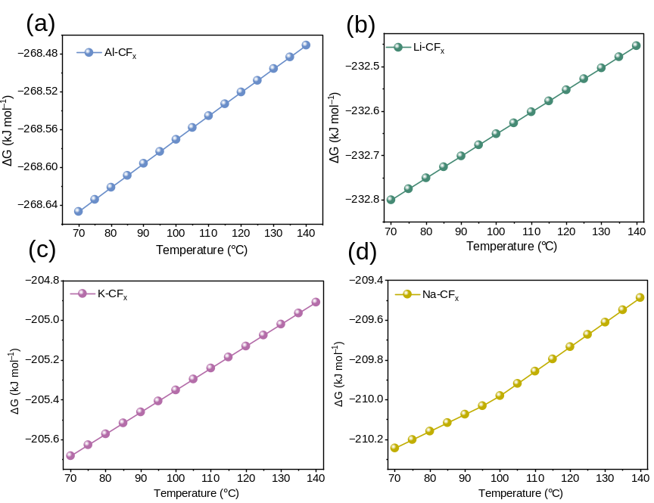
Figure S2. Fundamental characterization of CF_{x} powder. (a) XPS spectrum showing its elemental composition. (b) SEM image of its surface morphology.
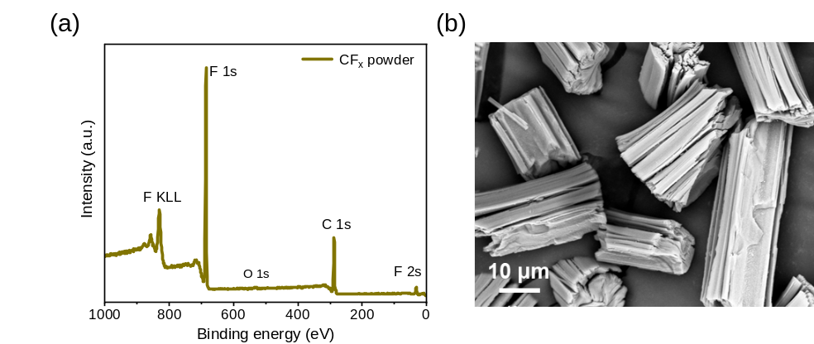

Figure S3. CV profiles for kinetic characterization of Al–Mo batteries with different electrolytes. (a) Al–Mo half-cells with MS electrolyte. (b) Al–Mo half-cells with IL electrolyte.
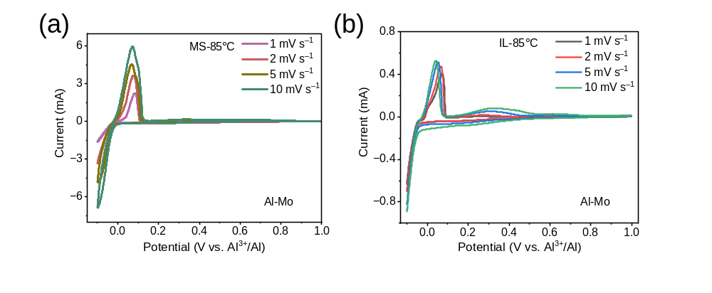

Figure S4. EIS measurements and fitting analyses of Al–CF_{x} batteries after 8 h storage in MS and IL electrolytes at 85°C. (a, b) EIS curves in MS and IL electrolytes. (c, d) Equivalent circuit fittings of the EIS curves in MS and IL electrolytes, respectively. (e, f) Local fitting results of the EIS curves in MS and IL electrolytes, respectively.
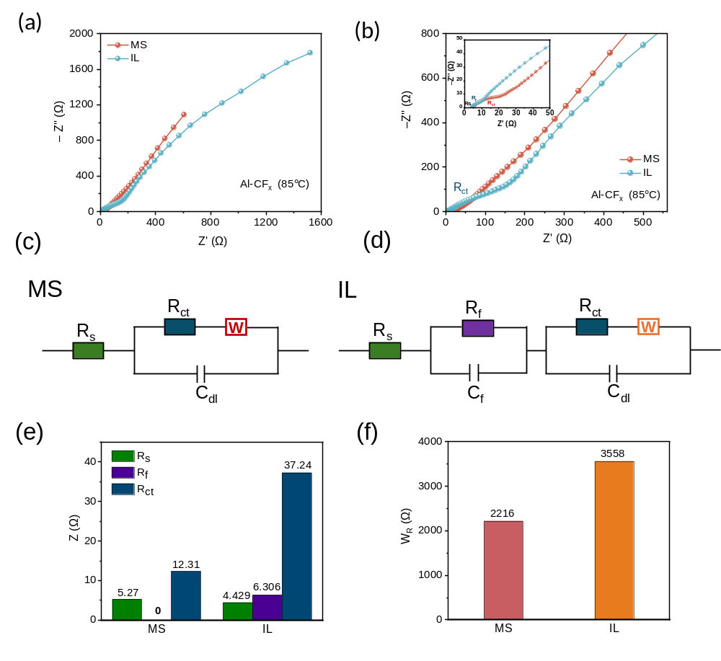

Figure S5. In situ EIS of Al–CF_{x} batteries at different states of discharge in ionic liquid electrolytes.
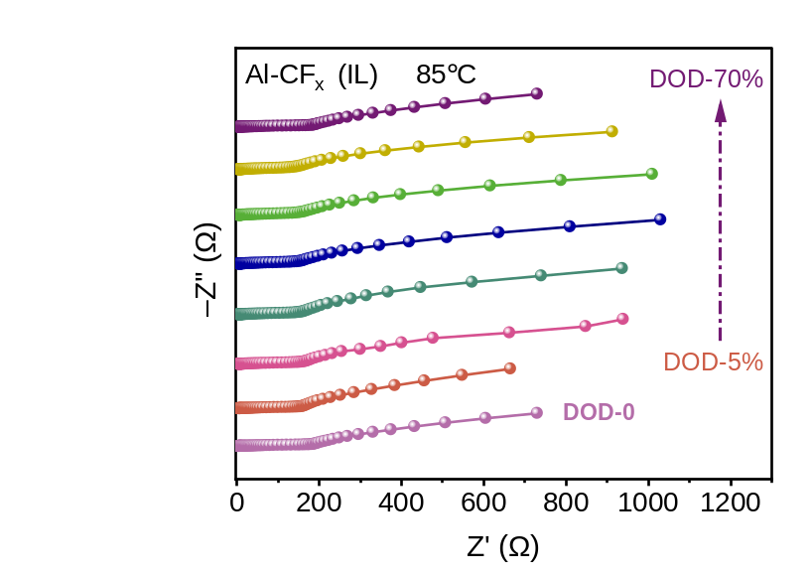

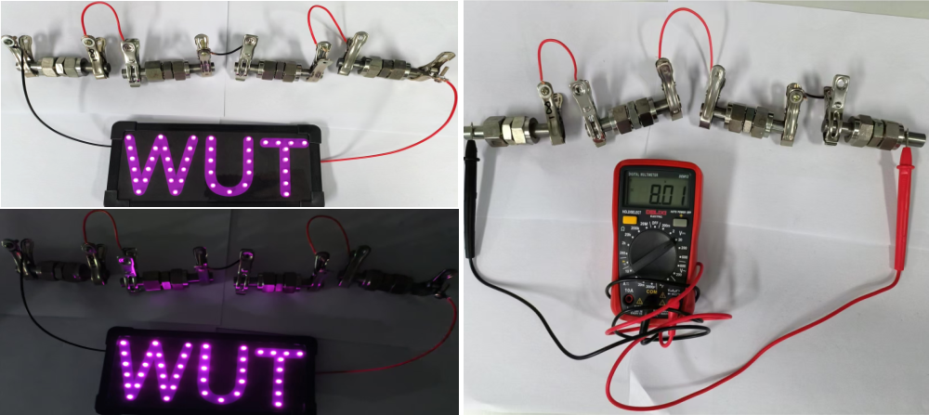
Figure S6. Lighting demonstration and total voltage measurement results of a series-connected molten salt-based Al–CF_{x} battery pack (4 cells).

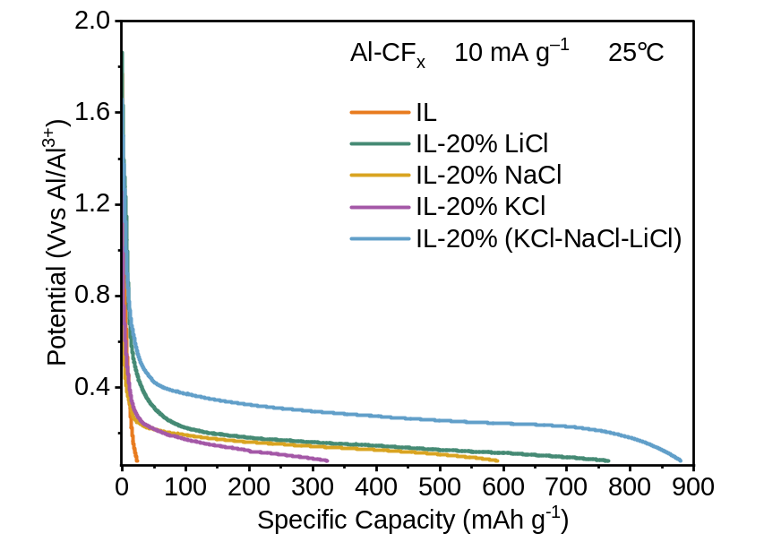
Figure S7. Room-temperature electrochemical performance of Al–CF_{x} batteries using ionic liquid electrolytes with 20% EMIC substituted by LiCl, NaCl, KCl, or a ternary LiCl–NaCl–KCl mixture.
Figure S8. Discharge product characterizations of Al–CF_{x} batteries in ionic liquid electrolytes. (a) XRD pattern of the discharged CF_{x} cathode. (b, c) XPS spectra of C 1s and Al 2p of the CF_{x} cathode in initial and discharged states. (d) HADDF-STEM images and corresponding elemental mapping of the discharged CF_{x} cathode. (e) SAED pattern of the discharged CF_{x} cathode. (f-h) TOF-SIMS 2D images, depth profiles and 3D reconstructions of the discharged CF_{x} cathode.

Figure S9. XPS analysis of Al 2p spectra of CF_{x} cathodes from Al–CF_{x} batteries at different discharge depths in molten salt electrolytes.
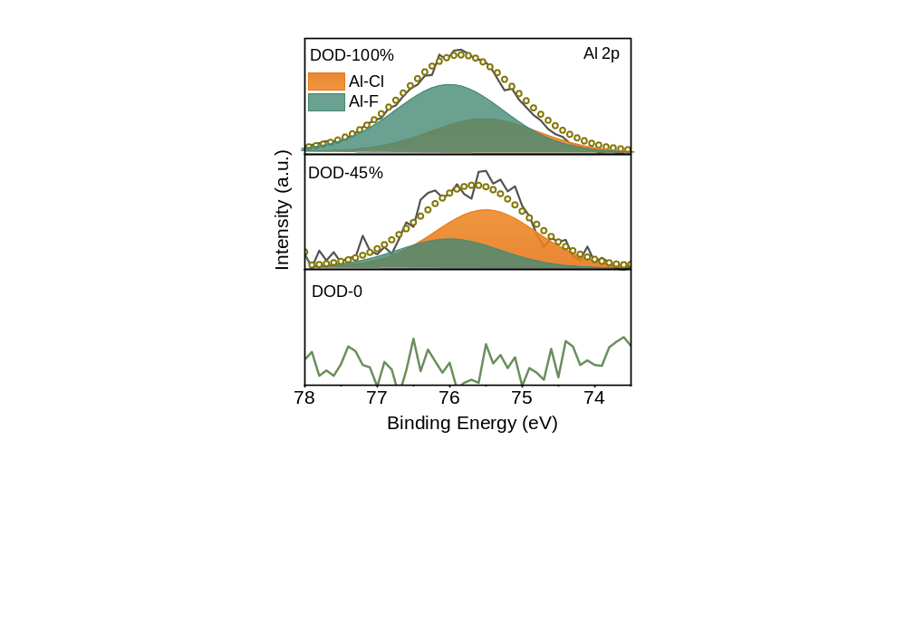

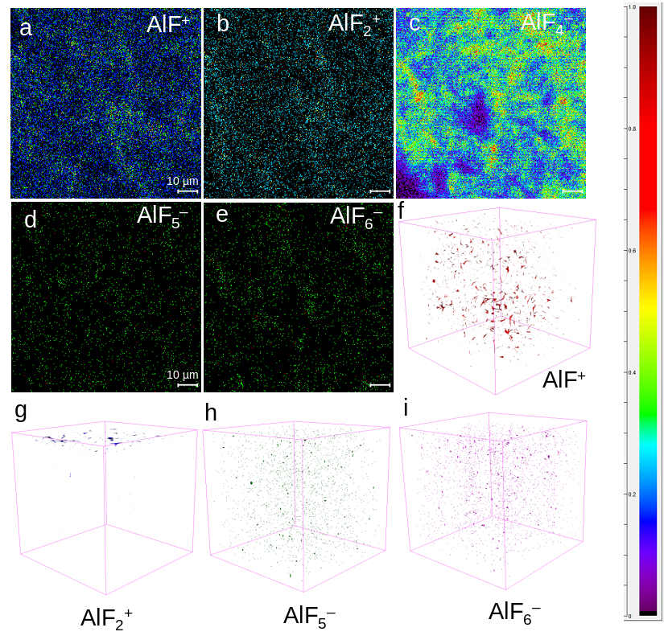
Figure S10. TOF-SIMS 2D/3D characterizations of discharged CF_{x} cathodes from Al–CF_{x} molten salt batteries.

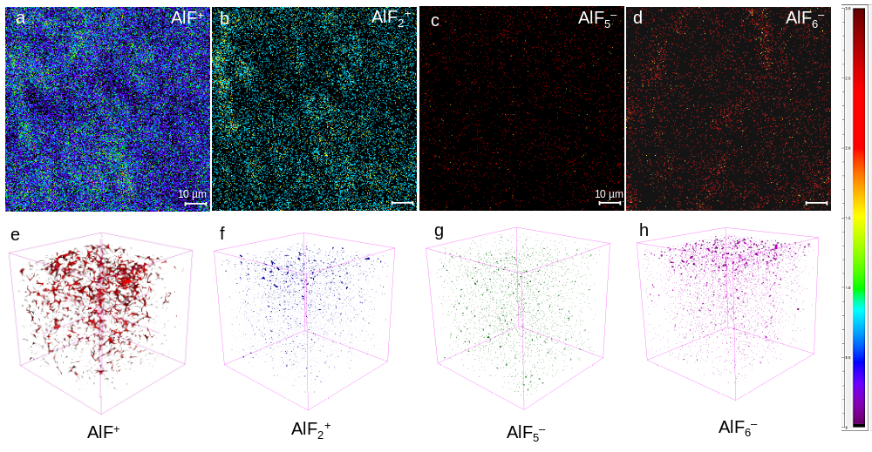
Figure 11. TOF-SIMS 2D/3D characterizations of discharged CF_{x} cathodes from Al–CF_{x} batteries with ionic liquid electrolytes.

Figure S12. IPCOHP and PCOHP analyses of Al–Cl and Al–Cl–Al bonds in Al₂Cl₇– clusters based on first-principles calculations. (a, b) IPCOHP simulation results and analysis. (c) PCOHP simulation results. IPCOHP results confirm six Al-Cl bonds and one Al–Cl–Al bond in Al₂Cl₇– clusters. IPCOHP values reflect the strength of atomic interactions, with more negative values indicating stronger bonding. Four Al-Cl bonds have IPCOHP values of ~ –6.4, and the remaining two of ~ –6.88, while the Al–Cl–Al bond has an IPCOHP value of ~ –4.6. The Al–Cl–Al bond thus shows weaker interaction with reduced electron cloud overlap, making it more prone to cleavage during reactions. Positive PCOHP values for the Al–Cl–Al bond further confirm an anti-bonding effect, which stems from orbital interactions causing electron cloud repulsion and weakening atomic attraction. This pronounced anti-bonding effect renders the Al–Cl–Al bond highly susceptible to dissociation under external stimuli.
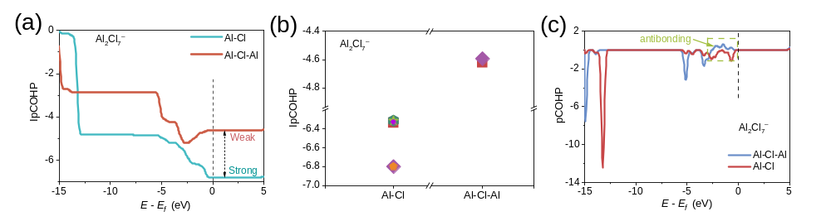
Figure S13. DFT Study on cation-CF_{x} interactions. (a) Cation volumes in molten salt and ionic liquid electrolytes. (b) The effect of cation-CF_{x} interaction on the maximum valence electron number (MVE) of fluorine. (c) Variation of the interaction bond length between cations and CF_{x}. MVE calculations show that fluorine’s MVE increases upon interaction with Li⁺, Na⁺, K⁺ or EMI⁺. Notably, Li⁺, Na⁺, and K⁺ enhance fluorine’s ionic character, facilitating fluorine detachment from the carbon plane to bond with these cations. In contrast, EMI⁺ does not produce a comparable effect. Structural analysis indicates that Na⁺ induces spontaneous fluorine dissociation from CF_{x}, with fluorine preferentially coordinating to Al³⁺ and Na⁺. Bond length changes demonstrate that Li⁺, Na⁺, and K⁺ elongate the C–F bond, confirming effective activation of this bond in the CF_{x} system.
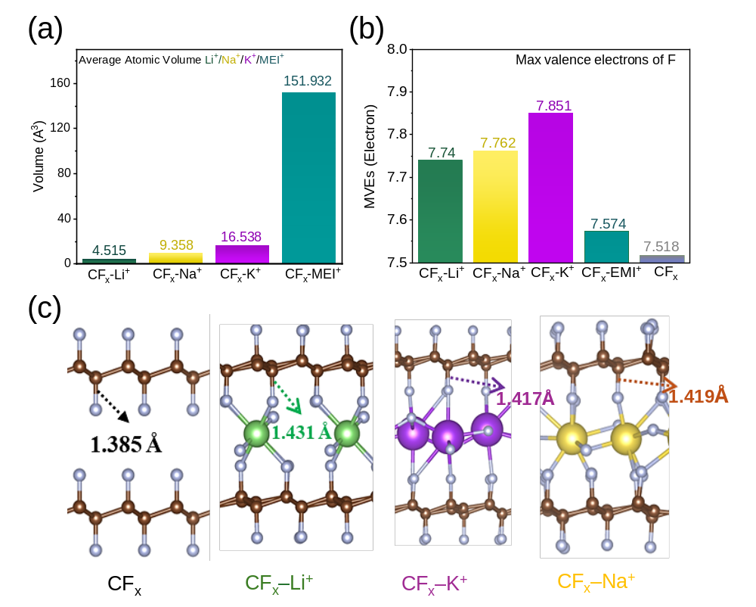

Figure S14. DFT simulation and calculation of the electronic structures of complexes in the MS electrolytes. (a) Density of states (DOS) of various complexes. (b) Valence band maximum (VBM) and conduction band minimum (CBM) of these complexes. (c) Electronic band gaps of the complexes. (d, e) PDOS results for carbon atoms in CF_{x}. (f) PDOS results for unfluorinated carbon (UFC) atoms. We investigated the electronic structure of the Al₂Cl₇– cluster in the electrolyte, where each Al atom is coordinated by four Cl atoms, with coordination complexes transitioning from [AlCl₄]– to [AlF]²⁺, [AlF₂]⁺, [AlF₃], and [AlF₄]–. DOS calculations reveal prominent peaks at the Fermi level (0 eV) for the [AlF₂]⁺ and [AlF₃] coordination structures, suggesting partial overlap between the valence and conduction bands. This overlap enables free electron mobility, endowing the system with metallic characteristics and high conductivity.
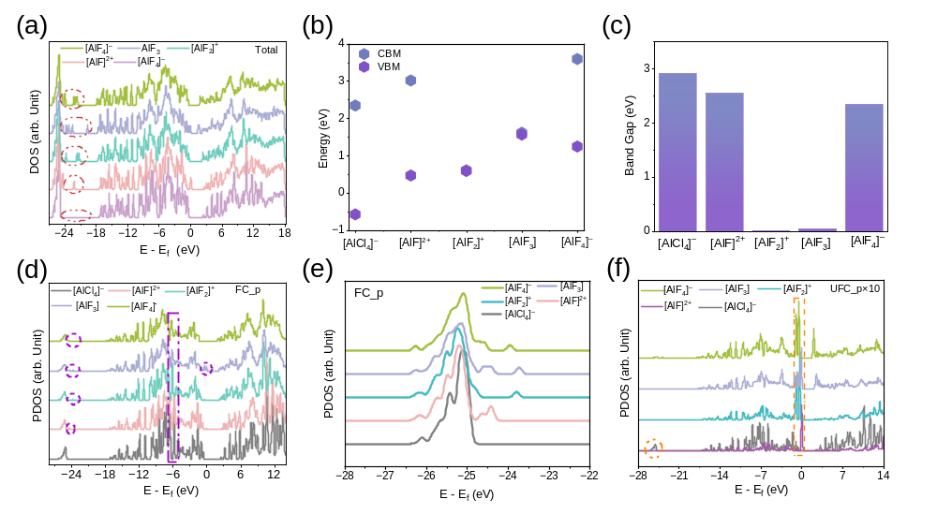
Before the reaction, C atoms in fluorinated carbon (FC) adopt sp³ hybridization with F, and their C 2p orbitals exhibit a highly localized deep-level electronic state at –25 eV, originating from C–F σ bonding electrons and not contributing to conduction. The p-orbitals of UFC form a delocalized state near the Fermi level, with enhanced electron occupation conferring high conductivity. As CF_{x} defects increase during the reaction, the local dangling bonds or π-electron systems of UFC are significantly enhanced, increasing the density of states near the Fermi level to form charge transport channels and improve material conductivity.
Figure S15. Chemical bond properties of CF_{x} based on DFT calculations. DFT calculations show that fluorine defect formation results in a more negative iCOHP value for the UFC–UFC bond than for the FC–FC bond, indicating stronger bonding in the reaction-formed UFC–UFC bond. Following fluorine reaction, the FC–FC bond transitions from sp³ hybridization (σ bond) to sp² hybridization (σ+π bonds), resulting in a significant increase in bond energy. This enhancement contributes to enhanced mechanical stability and electrical conductivity of the carbon framework.
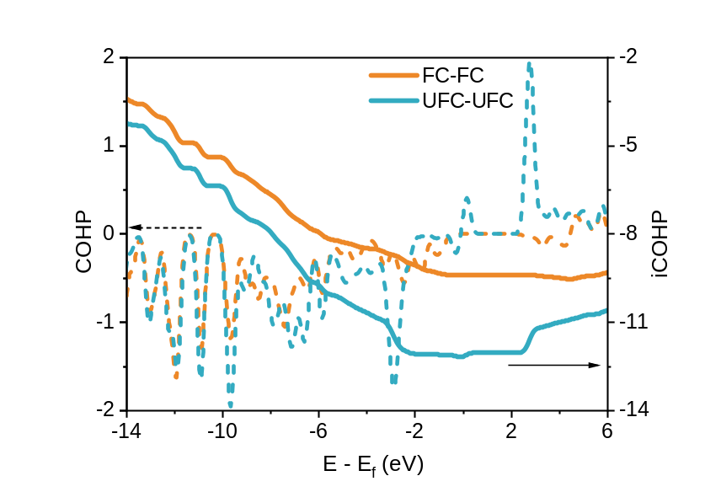

Figure S16. Radial distribution function (RDF) and coordination number analysis of layered coordination structures of alkali metal ions via molecular dynamics (MD) simulations. (a) Al³⁺: RDF and coordination number. (b) Li⁺: RDF and coordination number. (c) Na⁺: RDF and coordination number. (d, e) K⁺: RDF and coordination number. (f) MD simulation of Al³⁺ initial coordination with F–. (g) MD simulation of Li⁺, Na⁺, K⁺ coordination with F– and Cl–. MD calculations show strong affinity of Li⁺ and Na⁺ for F–: Li⁺ has the shortest Li–F bond length (1.93 Å) and a relatively low coordination number (2.0), indicating strong local Li⁺–F– coordination; Na–F bond length is 2.27 Å (longer than Li–F). K⁺ exhibits the highest K–Cl coordination number (4.1), with a bond length (3.12 Å) close to that of KCl crystal (~3.14 Å), suggesting predominant K⁺–Cl⁻ coordination and weaker F⁻ interaction. Na⁺ shows relatively high Na–F (1.8) and Na–Cl (3.4) coordination numbers, reflecting a mixed coordination characteristic intermediate between Li⁺ and K⁺.
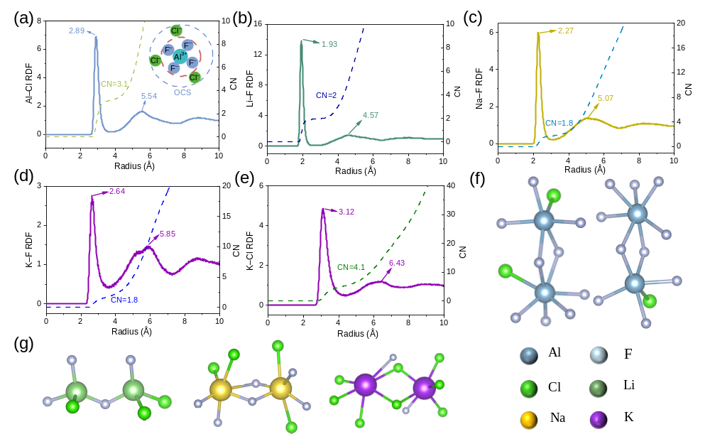

Figure S17. Snapshots of ab initio molecular dynamics (AIMD) simulations over 0–30 ps.

Figure S18. Minimum and maximum C–C bond length variations in CF_{x} during the discharge reaction of Al–CF_{x} batteries: An AIMD study. During the Al fluorination reaction, the maximum C–C bond length is partially elongated, indicating potential local stress induced by fluorination. The minimum C–C bond length decreases from 1.405 Å to 1.358 Å within 15 ps, followed by fluctuations, approaching the sp²-hybridized C=C bond length (1.34 Å in ethylene). This indicates graphitization and conjugated structure formation in localized regions, thereby enhancing the overall carbon skeleton stability.
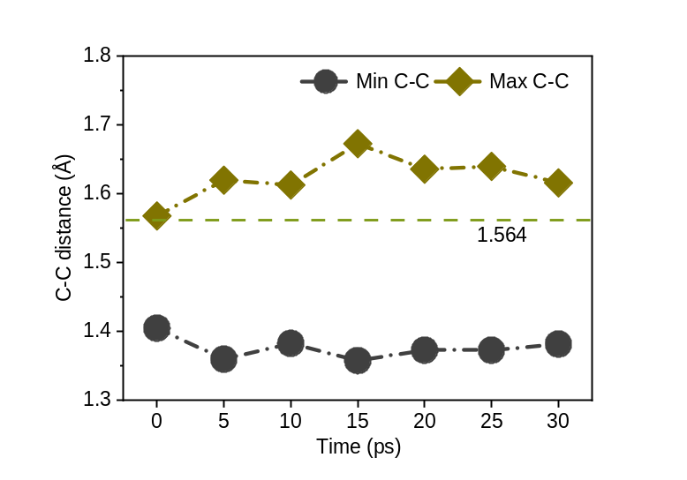

Figure S19. Mean square displacement (MSD) and diffusion coefficient (D) evolution of F atoms and Al³⁺ ions over time in Al–CF_{x} batteries: MD study. (a) Time-dependent MSD of F atoms. (b) Time-dependent MSD of Al³⁺ ions. (c) D variation for F atoms. (d) D fluctuation for Al³⁺ ions. F atoms exhibit a steep MSD slope within the first 1 ps, which gradually decreases afterward. Initially, the MSD slope of Al³⁺ ions is steeper than that of F atoms, and Al³⁺ ions’ overall slope is slightly higher. Both species exhibit constrained motion behavior. The MSD component in the y-direction (y-MSD) is the largest, followed by the x-direction, with the z-direction being the smallest. This suggests that the carbon plane exerts a stronger binding force on F atoms. Additionally, the co-directional movement of F atoms towards Al³⁺ ions in the y-direction facilitates effective collisions, facilitating the Al–F bonding substitution reaction. The diffusion coefficient (D) calculation results indicate that the diffusion coefficient of Al³⁺ ions gradually decreases from an initial value of approximately 2.3 × 10^{–5} cm² s^{–1} and stabilizes at 2.5 × 10^{–6} cm² s^{–1}, while the diffusion coefficient of F atoms is lower than that of Al³⁺ ions, with an initial value of 1.5 × 10^{–5} cm² s^{–1}, which eventually stabilizes at 2.2 × 10^{–6} cm² s^{–1}. This suggests a decrease in the degree of freedom and an increase in rigidity after Al³⁺ ions coordination recombination, with the final product AlF₃ exhibiting high stability.
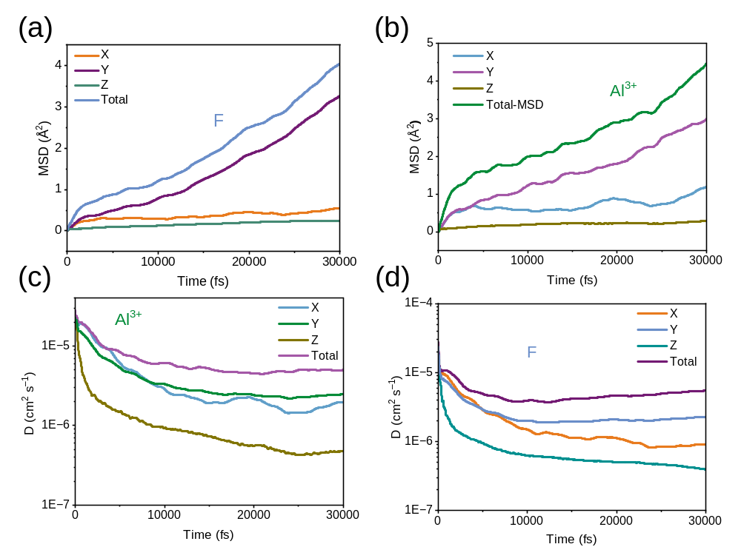

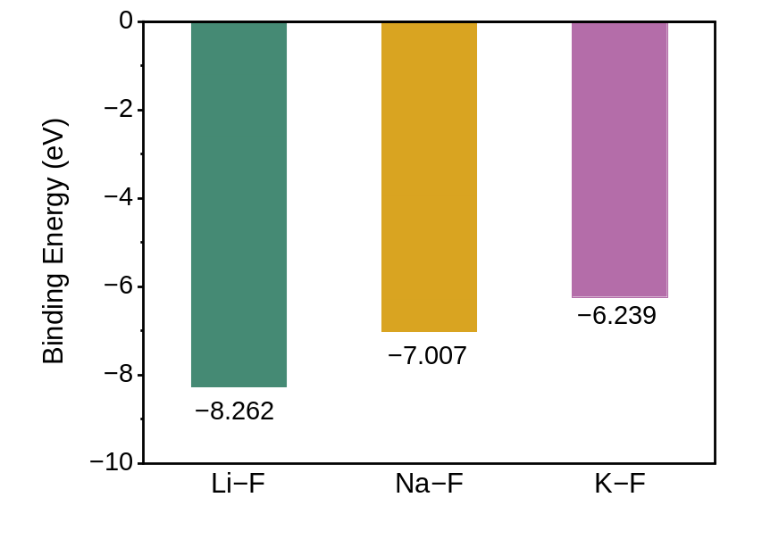
Figure S20. Calculated binding energies (ΔE_{b}) of alkali metal cations (Li⁺, Na⁺, K⁺) on the CF_{x} cathode surface. Density functional theory (DFT) calculations reveal a clear cation-dependent trend in interaction strength with fluorine. K⁺, characterized by its larger ionic radius and lower charge density, exhibits the weakest binding energy (ΔE_{b} (K−F)= −6.239 eV). This “mild adsorption” enables K⁺ to electrostatically polarize and activate C−F bonds without permanently occupying active sites, thereby facilitating initial C−F bond cleavage and Al³⁺ coupling. Consequently, K⁺-containing systems exhibit a higher initial discharge plateau. In contrast, Li⁺ and Na⁺ exhibit substantially stronger binding energies (ΔE_{b} (Li−F)= −8.262 eV and ΔE_{b} (Na−F)= −7.007 eV, respectively). While thermodynamically favorable, this stronger interaction induces transient site-blocking effects that impose a kinetic penalty on the initial Al-fluorination reaction, resulting in lower initial discharge plateaus. As discharge proceeds and the system transitions to a diffusion-controlled regime, Li⁺/Na⁺-containing systems gain advantage through two synergistic factors. First, their smaller ionic radii facilitate faster solid-state diffusion through the progressively thickening discharge product layer (comprising AlF₃, carbon, and alkali metal fluorides), sustaining cation transport to the fresh CF_{x} interface. Second, their stronger Li−F/Na−F interactions provide a greater thermodynamic driving force for deep CF_{x} conversion. Once the initial surface site-blocking is overcome, these advantages manifest as superior discharge performance in the later stages.
Figure S21. Basic characterization of MnO₂@CF_{x} powders. (a) XRD pattern. (b-d) XPS spectra. (e, f) SEM images of MnO₂@CF_{x}. XRD characterization confirms that the synthesized MnO₂@CF_{x} retains the original phase structure of CF_{x}, suggesting no structural alteration of CF_{x} during synthesis. Comparison with the MnO₂ standard JCPDS card exhibits weak diffraction peaks in the MnO₂@CF_{x} pattern, attributed to the low MnO₂ loading (10 wt% of the composite). XPS survey spectra show dominant C and F peaks, with weak Mn and O peaks also present. High-resolution C 1s spectra reveal that the carbon chemical state in MnO₂@CF_{x} is nearly identical to that of pristine CF_{x}, further confirming the structural integrity of CF_{x} throughout the synthesis process. Analysis of Mn 2p spectra shows a binding energy difference of 11.6 eV between Mn 2p^{1/2} and Mn 2p^{3/2} peaks, consistent with pure MnO₂, verifying the successful synthesis of MnO₂@CF_{x}. SEM images show that MnO₂@CF_{x} retains the morphology of pristine CF_{x}, indicating that the synthesis process does not disrupt the CF_{x} structure. High-magnification images confirm that MnO₂ is uniformly coated on the CF_{x} surface as a filamentous nanostructure.
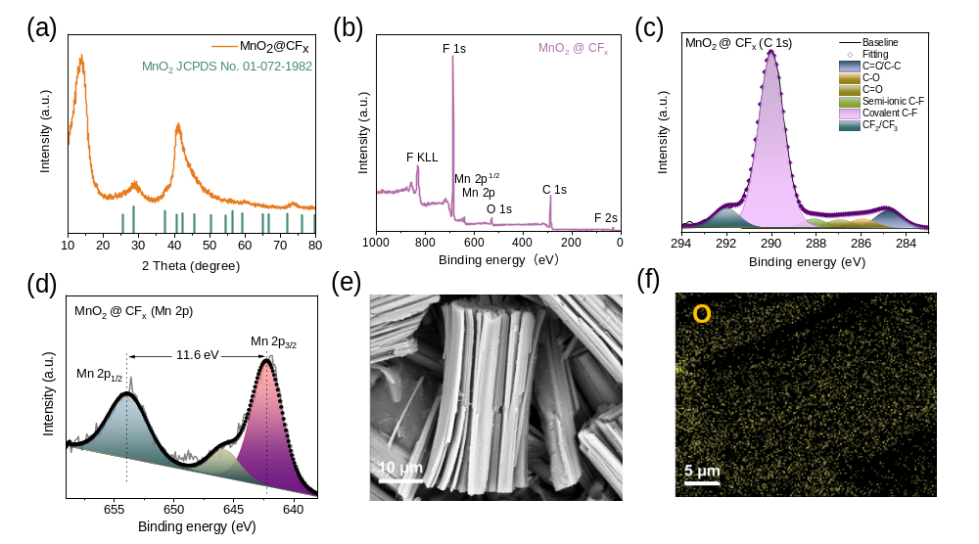

References
[1] B. H. L. B. Hammer, L. B. Hansen, J. K. Nørskov, Phys. Rev. B 1999, 59, 7413.
[2] D. H. Jung, Y. H. Park, D. W. Kim, J. H. Choi, S. Cho, K. H. Kim, J. K. Kang, Adv. Sci. 2025, 2413425.
[3] S. Grimme, J. Antony, S. Ehrlich, H. Krieg, J. Chem. Phys. 2010, 132, 15.
[4] G. Kresse, J. Furthmüller, Phys. Rev. B 1996, 54, 11169.
[5] M. J. Frisch, G. W. Trucks, H. B. Schlegel, G. E. Scuseria, M. A. Robb, J. R. Cheeseman, H. Nakatsuji, Gaussian 2009, 9, 227.
[6] F. Weigend, R. Ahlrichs, Phys. Chem. Chem. Phys. 2005, 7, 3297–3305.
[7] T. Lu, J. Chem. Phys. 2024, 161, 082503.
[8] R. L. Akkermans, N. A. Spenley, S. H. Robertson, Mol. Simul. 2021, 47, 540–551.

