**Supporting Information**

**In-situ Study of Photo-rechargeable Aqueous Zinc-ion Batteries with the Bifunctional a-MnO2 Photoelectrodes**

*Zhaobo Zheng1,#, Chenzhi Ding1,#, Md Saif Hasan4, Kao Wang1, Yue Liu1, Wei Yang1, Jingzhao Cheng2, Zhengtang Luo4, Shaowen Cao2*, *Yao Ding*,1,3*

**1**School of Materials Science and Engineering, Wuhan University of Technology, Wuhan 430070, P.R. China.

**2**State Key Laboratory of Advanced Technology for Materials Synthesis and Processing, Wuhan University of Technology, Wuhan 430070, P.R. China.

**3**Hubei Longzhong Laboratory, Xiangyang 441000, P.R. China.

**4**Department of Chemical and Biological Engineering and William Mong Institute of Nano Science and Technology, Hong Kong University of Science and Technology, Clear Water Bay, Kowloon, Hong Kong 999077, P.R. China.

#These authors contributed equally to this work.

\**Corresponding author:* Y. Ding

*E-mail address:* ydingaf@whut.edu.cn (Y. Ding)

**Keywords:** Photo-rechargeable batteries, a-MnO2, H+/Zn2+ co-intercalation, In-situ study, Zinc-ion batteries

**Experimental Section**

*Chemicals and materials*

All the chemicals for the synthesis, including potassium permanganate (KMnO4), hydrochloric acid (HCl, 98%), Zinc sulfate heptahydrate (ZnSO4·7H2O), Manganese sulfate monohydrate (MnSO4·H2O), were purchased from Aladdin Reagent. Carbon cloth (CC) was purchased from Taiwan carbon energy Co., Ltd. Graphene oxide (GO, 1.0 wt% in water) solution was purchased from Graphenea.

*Synthesis of* *α-MnO2 nanowires*

α-MnO2 nanowires were synthesized by a modified one-step hydrothermal method.[1] In a typical preparation, A homogeneous solution was obtained by first dissolving 0.79 g of KMnO4 into 24 mL of 1.0 M HCl solution. Then, 46 ml of deionized water was added and stirred for 30 min. After string at room temperature for 30 min, the solution was transferred to a 100 ml Teflon lined stainless steel autoclave. The kettle temperature was maintained at 140 °C and the reaction time was 18 hours. After the reaction the kettle was cooled to room temperature, the α-MnO2 was collected by centrifugation (10,000 rpm, 1 min), then washed several times with deionized water and ethanol, and dried at 60 °C.

*Synthesis of rGO*

GO was collected from graphene oxide solution by drying at 120 °C for 12 h. As obtained GO was reduced at 350 °C in argon gas (100 sccm, used as a carrier gas) and hydrogen gas (100 sccm) environment for 3 h using tubular CVD furnace.[2]

*Preparation of photocathodes*

The photocathode was prepared by mixing the active material (α-MnO2), the conductive agent (acetylene black: rGO=1:1) and the binder (PVDF) with NMP (N-methyl-2-pyrrolidone) in a weight ratio of 7:2:1 to obtain a homogeneous paste, which was then drop-coated onto a carbon cloth and finally dried overnight in an oven at 60°C. The area loading of the active material was 1.0-1.5 mg cm-2.

*Assembling of* *photo-rechargeable ZIBs*

The electrochemical performance of the photoelectrochemical cell was measured using a CR2025 coin cell. An 8.0 mm hole was machined in the case on the positive side of the CR2025 coin cell for illumination. A 0.1 mm zinc foil was used directly as the negative electrode and a separator (Whatman glass, GF/D) was placed on top of the negative electrode. Subsequently, 2 M ZnSO4 + 0.2 M MnSO4 aqueous electrolyte was added and the open-hole positive electrode was placed on top of the separator. The open-hole positive electrode was sealed with Ethylene-Tetra-Fluoro-Ethylene (ETFE) solar fluorine film and petroleum jelly.

*Assembling of interdigital micro-**ZIBs*

The cut cathode and anode were assembled on the polyimide glue, then covered with a layer of polyimide film, sealed with ultraviolet solid glue around, injected with an appropriate amount of electrolyte with a needle, and finally sealed with ultraviolet solid glue again to ensure no leakage.

*Electrochemical measurements of photo-rechargeable ZIBs*

The electrochemical performance of the cells under dark and light conditions was tested at room temperature on a LAND CT2001A multichannel battery test system (Wuhan, China). In this work, the wavelength and intensity of light was 1 sun (100 mW cm-2) (300 W xenon lamp, Perfect Light Co., Ltd., Beijing, China). Cyclic voltammetry (CV), photocurrent response (I-T) and electrochemical impedance spectroscopy (EIS) tests were performed on a CHI 660E electrochemical workstation (Shanghai, China.) GITT curves were plotted by alternately applying current for 5 min and standing for 10 min at a current density of 0.2 A g-1.

**Materials Characterization**

The microstructure and morphology of the samples and discharge products were investigated by field emission scanning electron microscopy (FESEM, JSM-7100F) and transmission electron microscopy (TEM, Talos F200S). The crystal structures of the samples and discharge products were characterized by Powder X-ray diffraction (XRD) patterns obtained using a Bruker D8 Discover X-ray diffractometer equipped with Cu Kα radiation (λ = 1.5418 Å). The X-ray photoelectron spectroscopy (XPS) and XPS valence band spectra of the samples and discharge products were performed on an AXIS SUPRA+ spectrometer. Raman spectra were obtained on a LabRAM HR 800 Raman spectrometer at an excitation wavelength of 532 nm. A Shimadzu-UV 2401/2 UV-Vis spectrometer was used to characterize the UV-Vis diffuse reflectance spectra of the samples. In addition, in situ XRD measurements were performed using a Bruker D8 Discover X-ray diffractometer. The instrument uses a non-monochromatic Cu Kα X-ray source and scans in the 2θ range from 22-45°. During charging and discharging, the in situ XRD signal was acquired in static mode using a planar detector with a pattern acquisition time of 120 seconds per pattern. Fourier Transform Infrared (FT-IR) spectra and the corresponding in situ IR tests were measured using a Nicolt iS50 FT-IR spectrometer in attenuated total reflection (ATR) mode.

*b-value calculation and ion diffusion coefficient calculation by GITT*

The capacitive and diffusive energy storage contributions can be derived from the peak current (*i*) versus the scanning rate (*v*):

$i=av^{b}$ or $\log\left(i\right)=\log\left(a\right)+blog⁡(v)$

Where *i* denotes the peak current, and *a* and *b* are adjustable parameters. The value of *b* determines the type of electrochemical charge storage reaction; if *b* = 0.5, the charge storage is dominated by a diffusive process, whereas if *b* = 1, the process is capacitive.[3]

GITT measurements were used to test the diffusion coefficient of zinc ions ($D_{{Zn}^{2+}}$) in the cathode based on the following equation:

)2()2

Where m (g) and M (g mol-1) are assigned to the loading mass and molecular weight of active material; V (cm3 mol-1) represents the molar volume of materials deduced from crystallographic data; τ (s) is constant current pulse time; A (cm2) is the surface area of electrode; ΔEs (V) and ΔEt (V) denote the change of steady-state voltage and the total change of the voltage during a constant pulse for a single-step GITT curve, respectively.[4]

**Supplementary results and discussion**



**Figure S1. Raman spectrum of α-MnO2.**



**Figure S2. TEM images of α-MnO2.**

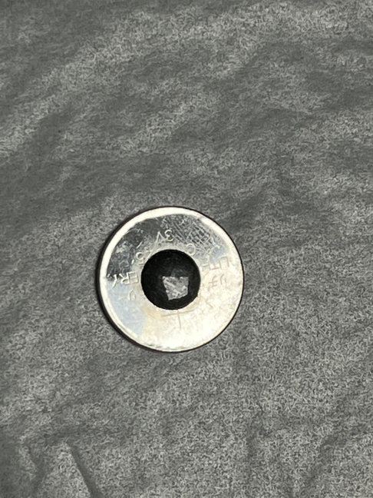

**Figure S3**. The optical image of α-MnO2 PRZIBs



**Figure S4**. The GCD curves of α-MnO2 PRZIBs show the voltage changes when switching to light condition (200 mAh g-1).



**Figure S5.** **GCD curves at (a)** **0.3 A g-1, (b) 0.5 A g-1,** **(c) 0.8 A g-1, (d) 1.0 A g-1 and (e) 2.0 A g-1 in dark and light conditions, respectively. (f) GCD curve in dark conditions at current densities from 0.2 A g-1 to 2 A g-1.**



**Figure S6. Compared capacity increment percentage under various current densities from 0.2 to 2 A g-1.**



**Figure S7. GITT curves and diffusion rates** **in dark and light conditions.**

GITT curves were plotted by alternately applying current for 5 min and standing for 10 min at a current density of 0.2 A g-1.



**Figure S8. Cycling performance of α-MnO2 ZIBs at 0.5 A g-1 in dark conditions.**



**Figure S9. Comparison of CV curves of ZIBs based on α-MnO2/rGO photoelectrodes** **at** **(a) 0.4 mV s-1, (b) 0.6 mV s-1 and (c) 0.8 mV s-1 in dark and light conditions.**



**Figure S10. The b-values of the two pairs of redox peaks under dark and under light conditions.**



**Figure S11. Schematic diagram of capacitance and diffusion contributions on electrode/electrolyte interface.**



**Figure S12. Capacitance contribution** **at (a) 0.2 mV s-1,** **(b) 0.4 mV s-1, (c) 0.4 mV s-1 and (d) 0.8 mV s-1 in dark conditions.**



**Figure S13. Capacitance contribution at (a) 0.2 mV s-1, (b) 0.4 mV s-1, (c) 0.4 mV s-1 and (d) 0.8 mV s-1 in light conditions.**



**Figure S14. The ex situ XPS spectra of Mn 2*p* peaks (a) in dark conditions and (b) in light** **conditions.**



**Figure S15. The ICP of the electrolyte after the first and second cycles under dark and light conditions.**



**Figure S16. The ex-situ Raman spectroscopy under dark and light conditions**



**Figure S17. Schematic diagram of in situ XRD test.**



**Figure S18. The ex-situ XRD under dark, thermal, and light conditions**

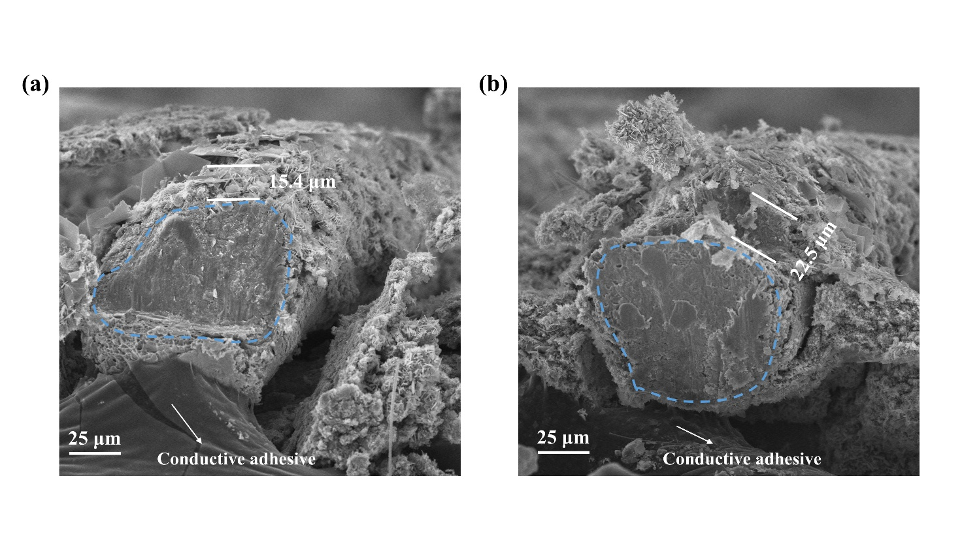

**Figure S19.** **The cross-sectional SEM images of the samples discharged to 0.8 V under dark and light conditions.**



**Figure S20. Schematic diagram of in situ FT-IR test.**



**Figure S21. IR spectra of 2M ZnSO4 and 2M ZnSO4+0.2M MnSO4 electrolytes.**



**Figure S22. The in situ FT-IR spectra of Zn-Zn symmetry batteries (a)** **2D contours of in situ FT-IR patterns and (b)** **Hydrogen bonding changes in light conditions.**



**Figure S23. The disassembled cathode shells (a) in dark conditions and (b) in light** **condition** **after 2 cycles at 0.2 A g -1.**

**Figure S24. Schematic of bulk solvation structure in ZnSO4 electrolyte** **by the proton donor-acceptor mechanism (D and A represent the donor/H and acceptor/O of H-bond, respectively.)**

**Figure S25. The changes of O-H stretching vibration in electrolyte after saturated evaporation by photothermal effect.**

After completing the in situ infrared testing under illumination conditions, remove the light source and perform infrared spectroscopy on the remaining electrolyte. This process aims to determine the concentration changes induced by the photothermal effect and, consequently, the resulting changes in hydrogen bonding.

**Table S1 Comparison of performances of PRZIBs.**

|  |  |  |  |  |  |  |
| --- | --- | --- | --- | --- | --- | --- |
| **Cathode**  **material** | **Current rate**  **(A g-1)** | **Specific capacity(mA h g-1 dark and light)** | **Cyclic stability** | **ηconversion (%)** | **ηconversion**  **(Elight-Edark)(%)** | **Refs.** |
| ***MnO2/rGO*** | ***0.2*** | ***207.2/308.1*** | ***150*** | ***0.68 (1 sun)*** | ***0.46*** | ***This work*** |
| MoS2/SnO2 | 0.5 | 209.7/318.3 | 200 | 0.46 (1 sun) | 0.4 | [5] |
| V2O3@CS | 0.5 | 305/463 | 100 | 0.011 (1 sun) | - | [6] |
| MoSe2-VSe | 0.1 | 186.3/234.7 | 100 | 0.58 (1sun) | - | [7] |
| MoS2/ZnO | 0.1 | 245/340 | 200 | 0.2 (1sun) | - | [8] |
| VO2/rGO | 0.2 | 282/315 | 250 | 0.18 (455nm) | - | [9] |
| ZnO/VO2 | 0.2 | 367/432 | 5 | 0.51 (455 nm) | - | [10] |
| Te/CH3NH3PbI3/TiO2 | 0.1 | 358/720 | 20 | 0.31 (380-780nm) | - | [11] |

**Table S2 Mn-O-Mn ratios in *ex situ* XPS.**

|  |  |  |
| --- | --- | --- |
| **Status** | **In Dark** | **In Light** |
| 1stC@0.8V | 5.4% | 2.1% |
| 1stC@1.55V | 7.9% | 11.3% |
| 2nd@1.8V | 28.2% | 30.4% |
| 2nd@1.3V | 17.2% | 7.3% |
| 2nd@0.8V | 9.5% | 5.9% |

**Table S3 Mn-O-H ratios in *ex situ* XPS.**

|  |  |  |  |  |
| --- | --- | --- | --- | --- |
| **Status** | **In Dark** | **Location of Peaks** | **In Light** | **Location of Peaks** |
| 1stC@0.8V | 44.9% | 532.6 eV | 42.1% | 532.5 eV |
| 1stC@1.55V | 71.6% | 532.3 eV | 66.1% | 532.3 eV |
| 2nd@1.8V | 46.3% | 531.6 eV | 56.4% | 531.9 eV |
| 2nd@1.3V | 57.7% | 532.0 eV | 63.2% | 532.3 eV |
| 2nd@0.8V | 76.4% | 532.3 eV | 73.8% | 532.3 eV |

**Table S4 H-O-H ratios in *ex situ* XPS.**

|  |  |  |  |  |
| --- | --- | --- | --- | --- |
| **Status** | **In Dark** | **Location of Peaks** | **In Light** | **Location of Peaks** |
| 1stC@0.8V | 49.7% | 533.8 eV | 55.8% | 533.2 eV |
| 1stC@1.55V | 20.5% | 533.4 eV | 22.6% | 533.1 eV |
| 2nd@1.8V | 25.5% | 532.6 eV | 13.2% | 533.6 eV |
| 2nd@1.3V | 25.1% | 533.2 eV | 29.5% | 533.3 eV |
| 2nd@0.8V | 14.1% | 533.5 eV | 20.3% | 533.4 eV |

**References**

[1] X. Zhang, W.-L. Song, M. Wang, J. Tu, H. Jiao, S. Jiao, *Energy Storage Mater.* **2022**, 45, 586.

[2] B. D. Boruah, A. Mathieson, B. Wen, C. Jo, F. Deschler, M. De Volder, *Nano Lett.* **2020**, 20, 5967.

[3] Z. Xu, J. Wang, W. Zhang, Z. Shi, Y. Feng, C. Liu, H. Fu, Z. Yong, Q. Li, *J. Mater. Chem. A* **2024**, 12, 25491.

[4] Q. Li, C. Wang, Y. Zhu, W. Du, W. Liu, M. Yao, Y. Wang, Y. Qian, S. Feng, *Chem. Eng. J.* **2024**, 485, 150077.

[5] X. Y. Du, L. N. Song, S. Liang, Y. F. Wang, Y. Wang, H. F. Wang, J. J. Xu, *Angew. Chem. Int. Ed.* **2024**, e202411845.

[6] Y. Zhao, T. He, J. Li, C. Zhu, Y. Tan, K. Zhu, S. Chou, Y. Chen, *Angew. Chem. Int. Ed.* **2024**, 63, e202408218.

[7] X. Chen, A. Zhang, H. Zou, L. Li, Q. Zhu, W. Zhang, *Energy Storage Mater.* **2024**, 70, 103457.

[8] B. D. Boruah, B. Wen, M. De Volder, *ACS Nano* **2021**, 15, 16616.

[9] B. Deka Boruah, A. Mathieson, S. K. Park, X. Zhang, B. Wen, L. Tan, A. Boies, M. De Volder, *Adv. Energy Mater.* **2021**, 11, 2100115.

[10] B. D. Boruah, M. De Volder, *J. Mater. Chem. A* **2021**, 9, 23199.

[11] H. Liu, P. Wu, R. Wang, H. Meng, Y. Zhang, W. Bao, J. Li, *ACS Nano* **2023**, 17, 1560.