**Supplementary Information**

**Electrostatic-Induced** **Crystal-Rearrangement of Benzoquinones Cathode for Large-Scale** **All-Organic Aqueous Proton Batteries**

*Jianyong Zhang1, Jingyuan Yu1, Wenwei Zhang1, Ahmed Eissa Abdelmaoula5, Chunhua Han1, Zhenzhen Dou1*, Feng Liang2* and Lin Xu1,3,4,6\**

1. State Key Laboratory of Advanced Technology for Materials Synthesis and Processing, School of Materials Science and Engineering, Wuhan University of Technology, Wuhan 430070, China.

2. The Faculty of Metallurgical and Energy Engineering, Kunming University of Science and Technology, Kunming 650093, China.

3. Hubei Longzhong Laboratory, Wuhan University of Technology (Xiangyang Demonstration Zone), Xiangyang 441000, China.

4. Hainan Institute, Wuhan University of Technology, Sanya 572000, China.

5. Mining and Metallurgical Department, Faculty of Engineering, Al-Azhar University, Cairo 11884, Egypt.

6. Zhongyu Feima New Material Technology Innovation Center (Zhengzhou) Co., Ltd., Zhengzhou 450001, China.

*Corresponding Author: E-mail: [linxu@whut.edu.cn](mailto:linxu@whut.edu.cn) (L. Xu); [liangfeng@kust.edu.cn](mailto:liangfeng@kust.edu.cn) (F. Liang); [dzz0881@whut.edu.cn](mailto:dzz0881@whut.edu.cn) (Z. Dou)

**Experimental section**

**Materials preparation:** The following materials are commercially available: BQ (Sigma-Aldrich), 2ClAQ (Sigma-Aldrich), H2SO4 (Macklin), and CDD (created defective-deficiency) carbon cloth (Taobao). Polyvinylidene fluoride (PVDF) was purchased from Guangdong Canrd New Energy Technology Co Ltd. Ethylene glycol (≥ 99.5 %, Ar) was purchased from Sinopharm Chemical Reagent Co Ltd. All of the reagents were used directly without further purification.

PANI synthesis: One dissolves 0.5 mL of aniline in 500 mL of 1 M sulfuric acid (The solubility of PANI in NMP is 0.25 grams per milliliter). Stir the mixture for 5 minutes. Subsequently, slowly add 3 g of ammonium persulfate. Then, stir the resulting solution for 6 hours. After that, filtration is carried out to obtain the residue. Wash the precipitate six times. Finally, dry the washed precipitate at 60 degrees Celsius overnight (The materials do not undergo separate precipitation). The conductive PANI was obtained.

**Electrode Preparation:** The P-BQ-50% electrode was synthesized as follows: First of all, disperse pure BQ (99.98%) powder and PANI and acetylene black and PVDF with the mass ratio of 4:4:1:1 (total mass 0.1g) into 0.125 mL of organic solvent, N-Methylpyrrolidone (NMP), to form a slurry. Specifically, in our experiments, the solid-liquid ratio of the materials was determined to be 1:1.25. Then, grind the slurry continuously in a mortar for 10 min until the dispersion is uniform. Later, the slurry was dried on Ti foil with an oven temperature of 50 °C for 6 h for further battery research. The P-BQ-0%, P-BQ-25%, P-BQ-50%, P-BQ-75%, and P-BQ-100% were obtained via the same process by changing the proportion of PANI and BQ. The P-2ClAQ electrodes are obtained via the same approach. The addition of PANI to 2ClAQ is 50%.

**Material Characterizations:** The in-situ X-ray diffraction (XRD) patterns were probed using a D8 Discover X-ray diffractometer with a monochromator Cu source Kα X-ray (λ = 1.5406 Å) and D2 phase. The pair distribution function (PDF) was tested using a D8 Advance X-ray diffractometer with a monochromator Ag source Kα X-ray (λ = 0.56 Å). GASA and Jade's software were used to perform XRD analysis. SEM and EDS mapping were taken via a JEOL JSM-7100F at 20 kV (voltage). TEM images were collected with a JEM-2100F and a Thermo Fischer Titan G2 60-300 microscope. Nuclear magnetic resonance (NMR) (Bruker 400 MHz, DMSO−d6) was used to analyze the structure of the samples. X-ray photoelectron spectroscopy (XPS) was introduced to evaluate the valence of elements (Type: VG MultiLab 2000). FTIR was conducted on a Thermo Nicolet Nexus instrument. The Raman spectra were probed with 532 nm laser resources by Horiba LabRAM HR Evolution.

**Electrochemical characterization:** The electrochemical performance was evaluated using Swagelok cells, coin cells, and pouch cells. The electrolyte used in the experiment has a concentration of 1 molar (1M) sulfuric acid (H2SO4). The potassium sulfate in the reference electrode solution is replaced by sulfuric acid, and the voltage difference between the two reference electrodes below ±5 mV is reliable. The Swagelok cell was employed to facilitate the proximity between the current collector and the cell's assembly. The conventional electrode utilized in the three-electrode cell features a significant separation between the electrodes. This spatial arrangement leads to an elevated level of polarization in the electrode, hence introducing greater uncertainty in the electrochemical testing of batteries. The three-electrode cell configuration involves the utilization of the electrode material as the working electrode, while the CDD carbon cloth is employed as the counter electrode. The mercury sulfate electrode (MSE) functions as a reference electrode. In both the coin cell and pouch cell configurations, the anode material utilized is P-2ClAQ (2-Chloroanthraquinone), while the cathode material employed is P-BQ. It is noteworthy that the N/P ratio of the full cell is 1.27 based on the capacity of both the anode and the cathode. In the in-situ X-ray diffraction (XRD) experiment, the working electrode utilized is P-BQ, whereas the counter electrode employed is P-2ClAQ. The mass per unit area of the electrode materials that were put onto the current collector ranged from approximately 2 to 4 mg cm-2. The electrochemical characteristics were evaluated using the LAND CT3002A Biologic VMP1 and Biologic VMP2 instruments.

**Theoretical Calculations:** The density functional theory (DFT) method of the Dmol3 module in Materials Studio 2020 was used with the Hybrid-B3LYP functional, custom Grimme DFT-D parameters, and DNP 3.5 basis set in the same software. The GGA with the PBE exchange-correlation energy (Perdew, Burke, and Ernzerhof) was employed. The convergence of energy, forces, and maximum displacement was set to 1×10−5 Ha, 0.002 Ha/Å and 5.0 × 10−3 Å, respectively.

**Calculation formula：**  
The binding energy (EB) of the ion group is defined by the following equation.  
EB = ETotal – E1 – E2  
Where ETotal is the total energy of the molecule-composite, E1 and E2 are the energies of molecule-1 and molecule-2, respectively.

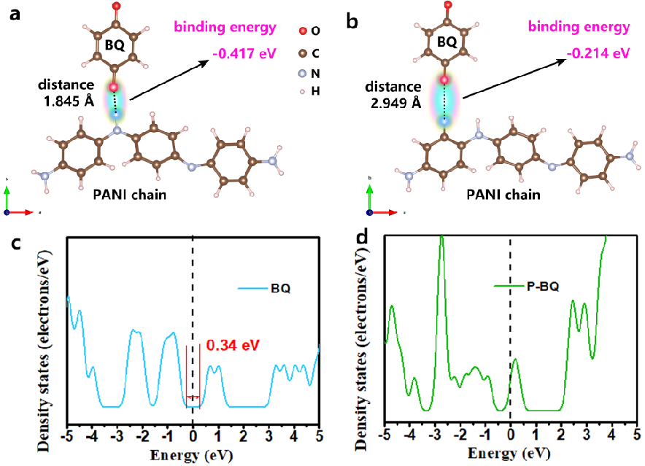

Figure S1. DFT calculation of BQ spatial configuration concerning the interaction between BQ and PANI in the P-BQ framework. (a) The relationship between the C=O and N-H groups. (b) The relationship between the C=O and C-H groups. (c, d) The electronic density states of BQ and P-BQ.

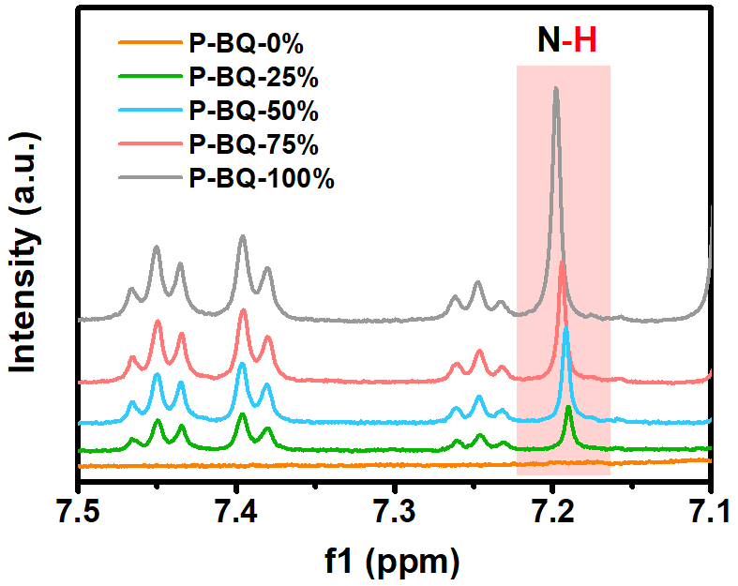

Figure S2. The 1H NMR spectra of P-BQ-0%, P-BQ-25%, P-BQ-50%, P-BQ-75%, P-BQ-100%.



Figure S3. PDF full spectra of P-BQ-0%, P-BQ-25%, P-BQ-50%, P-BQ-75%, P-BQ-100%.

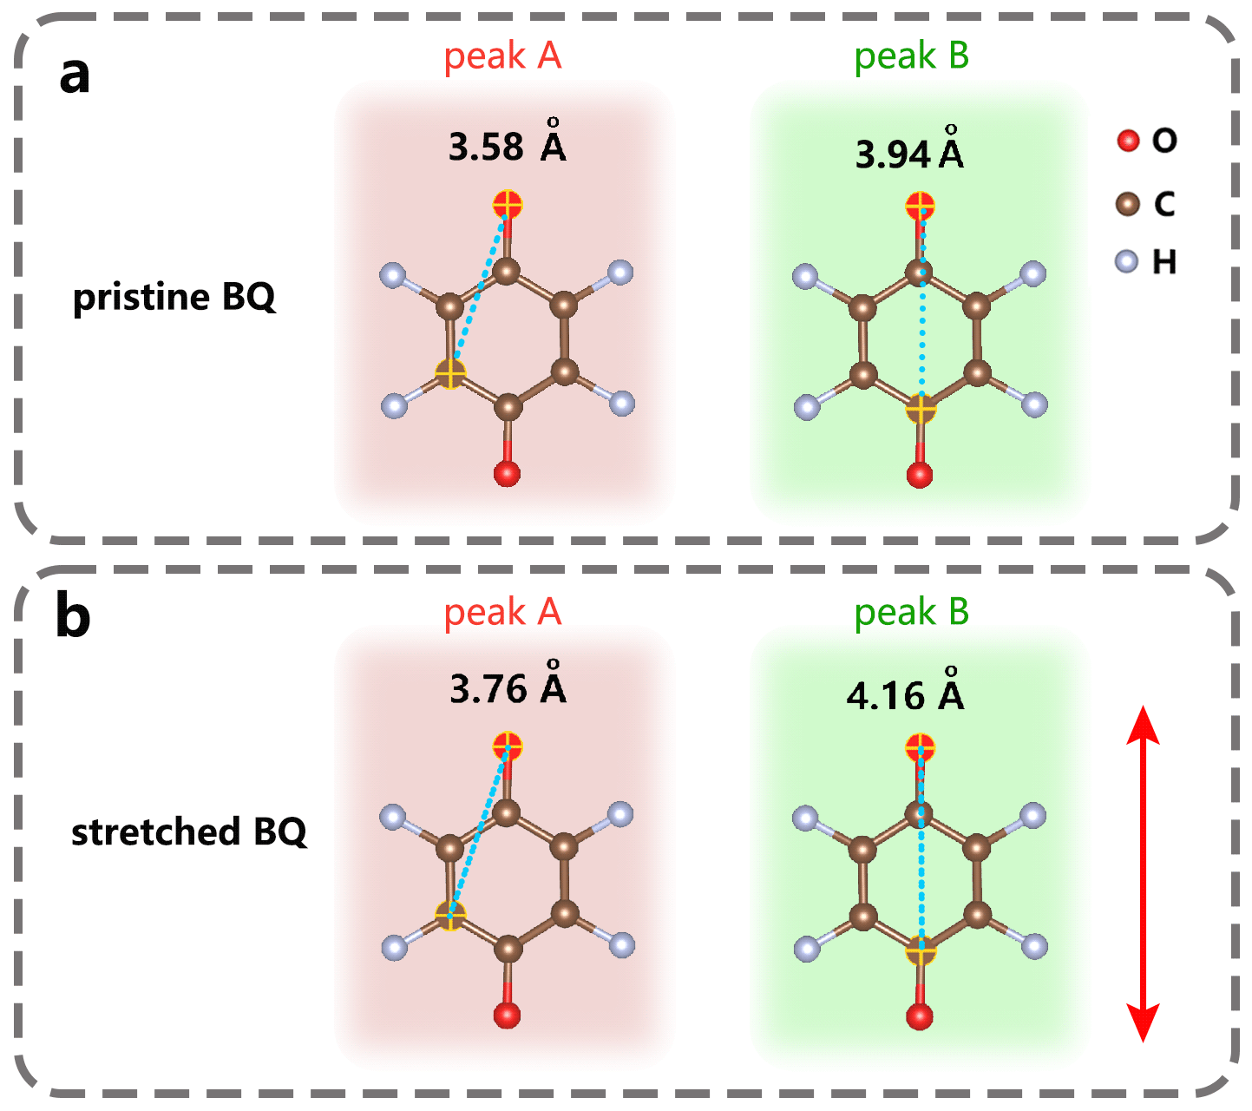

Figure S4. Schematic illustration of pristine BQ (a) and stretched BQ (b) calculated via DFT.

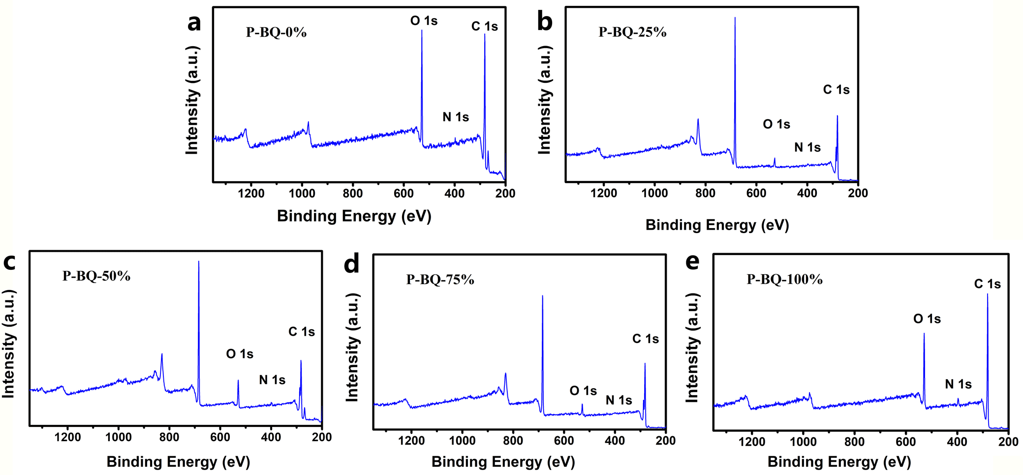

Figure S5. (a-e) XPS full spectra of P-BQ-0%, P-BQ-25%, P-BQ-50%, P-BQ-75%, P-BQ-100%.

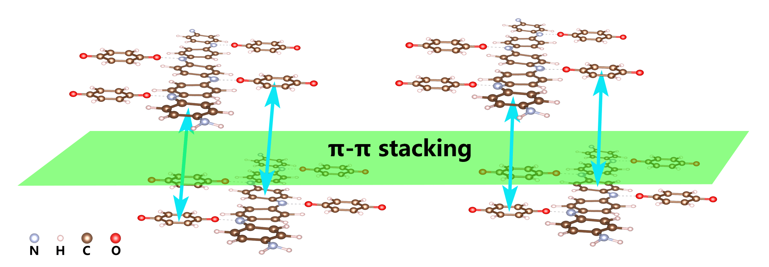

Figure S6. Schematic illustration of π-π stacking.

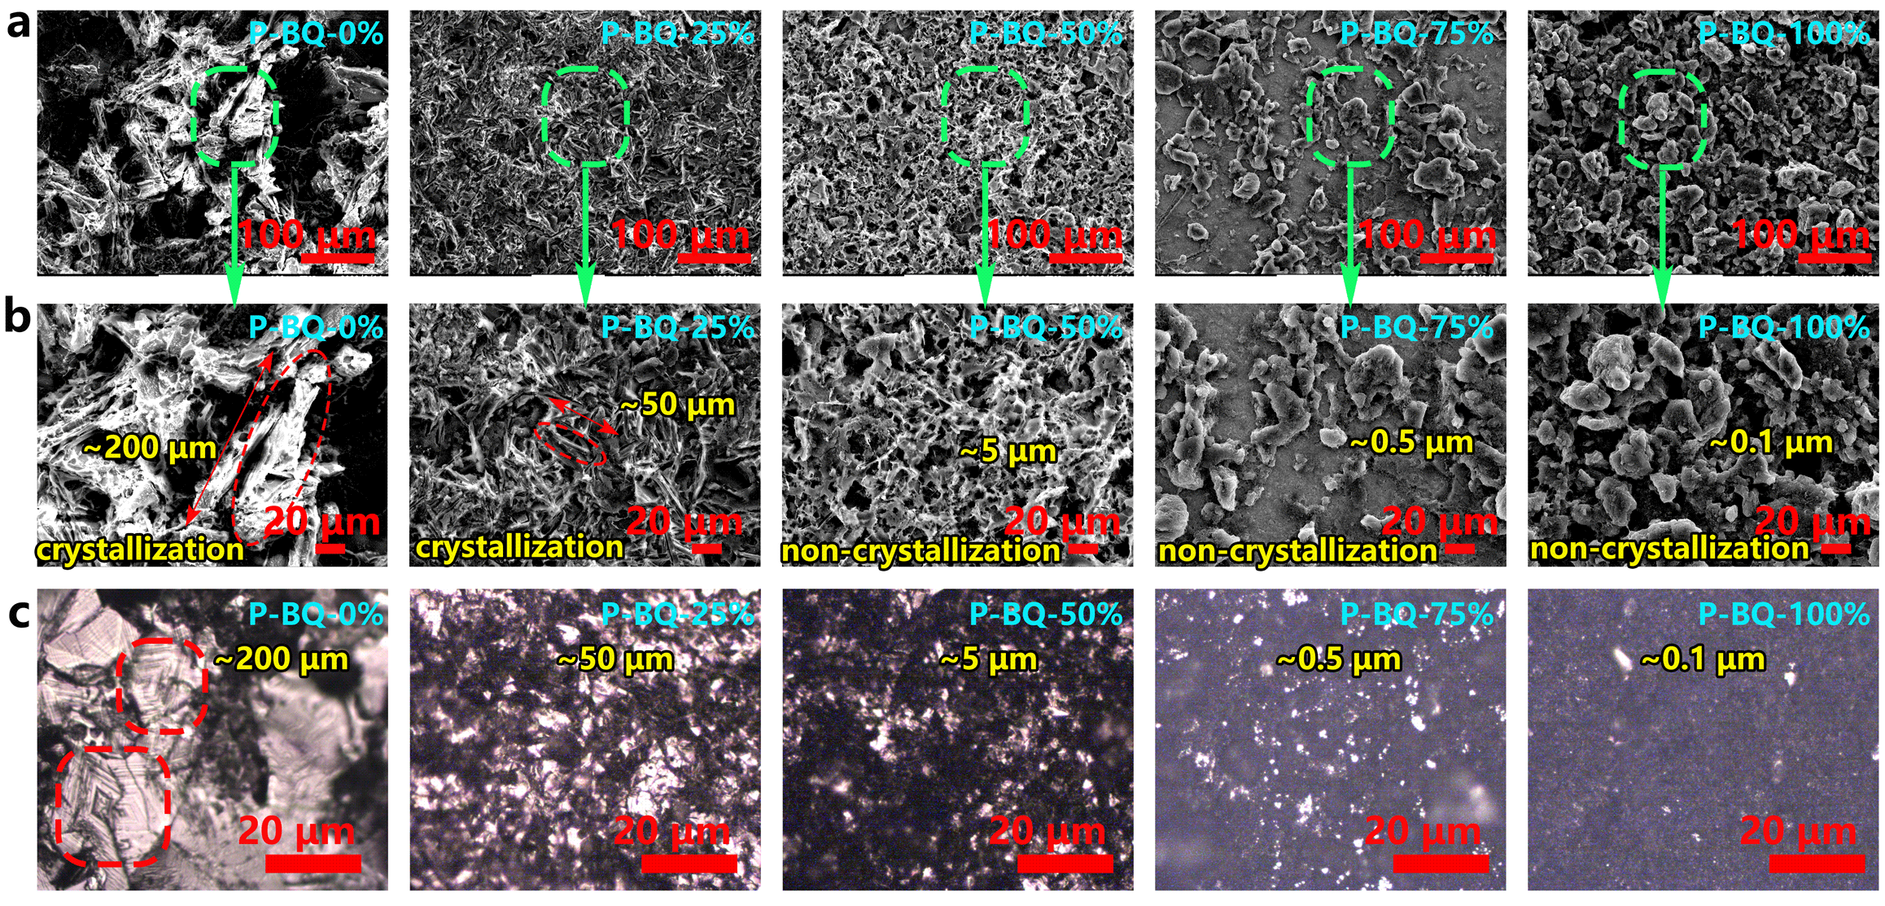

Figure S7. Investigating the influence of hydrogen bonding coupling on the configuration of P-BQ through morphological structure. (a, b) SEM images of P-BQ-0%, P-BQ-25%, P-BQ-50%, P-BQ-75%, and P-BQ-100% samples and (c) optical microscope images thereof.

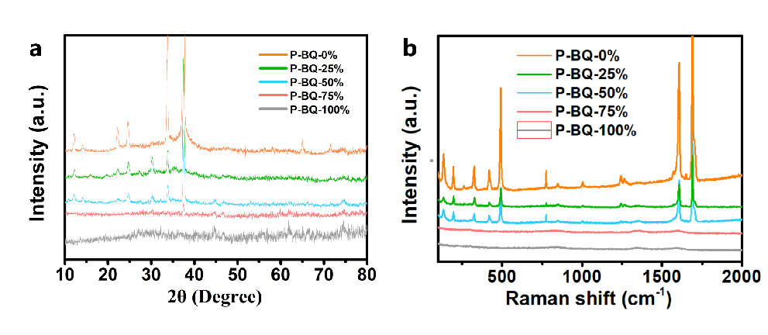

Figure S8. (a) XRD spectra and (b) Raman spectra of P-BQ-0%, P-BQ-25%, P-BQ-50%, P-BQ-75%, P-BQ-100%.

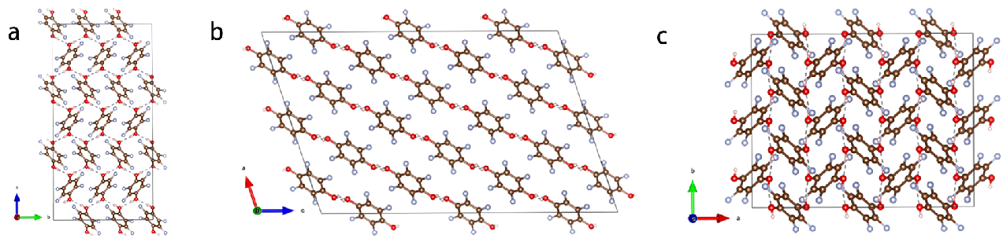

Figure S9. (a, b, c) Crystal structure of HBQ in a, b, and c directions with the ball-and-stick model.

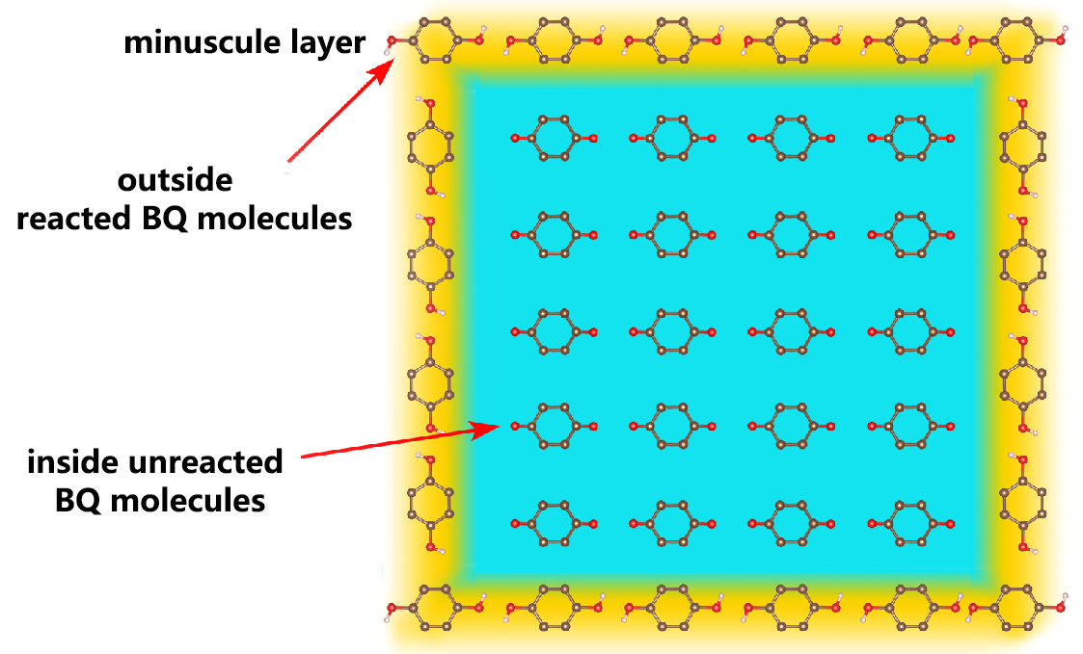

Figure S10. Partial reaction bulk structure of the BQ particle.

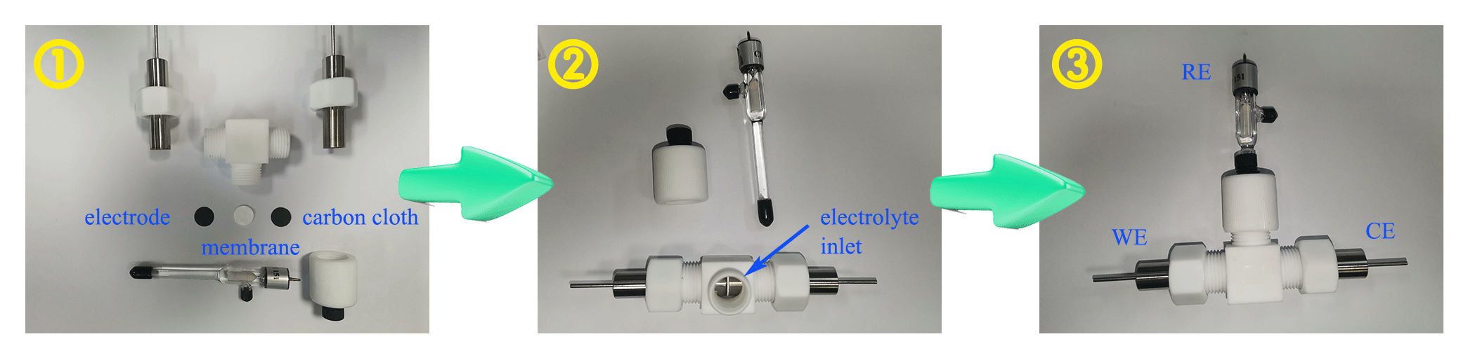

Figure S11. Assembling orders of the Swagelok cell.

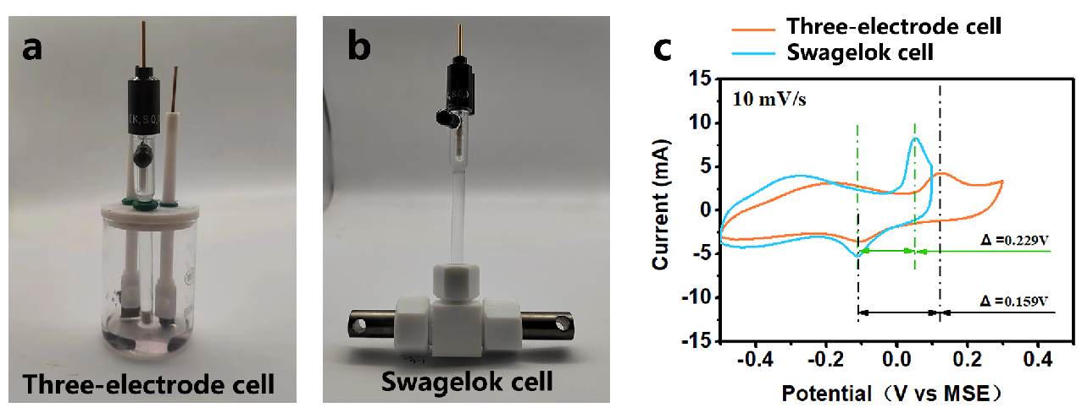

Figure S12. (a) Digital photo of the traditional three-electrode cell. (b) Digital photo of Swagelok cell. (c) Comparison of the electrochemical polarization for the Swagelok cell and the three-electrode cell via CV curves.

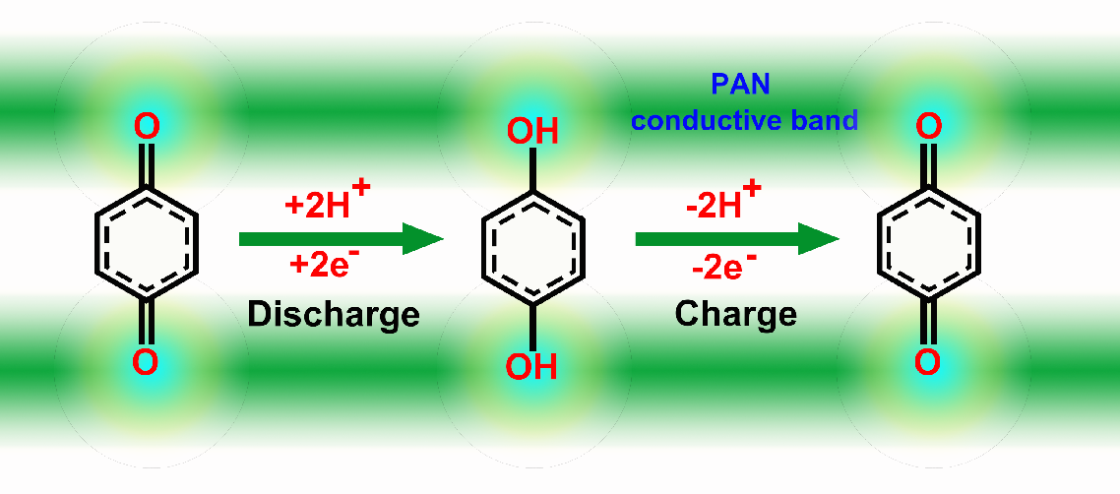

Figure S13. Schematic illustration of the BQ reaction during charge and discharge.

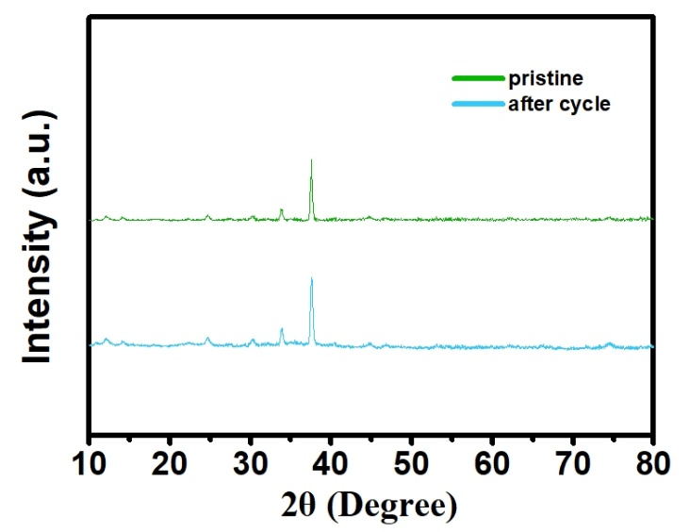

Figure S14. The XRD pattern of P-BQ-50% with the pristine sample and the cycled sample.

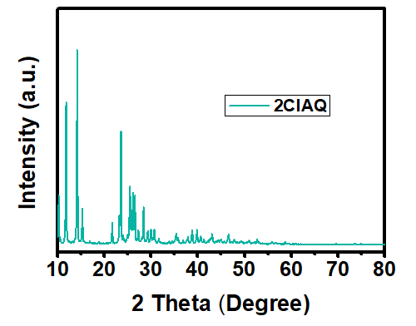

Figure S15. XRD spectrum of 2ClAQ.

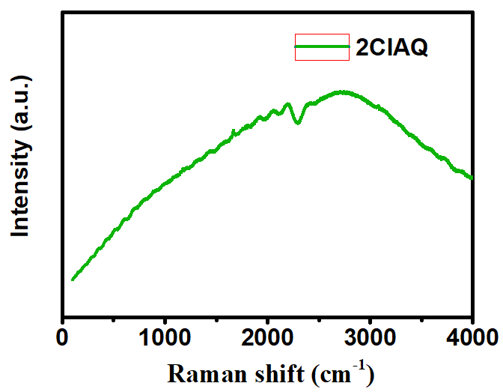

Figure S16. Raman spectrum of 2ClAQ.

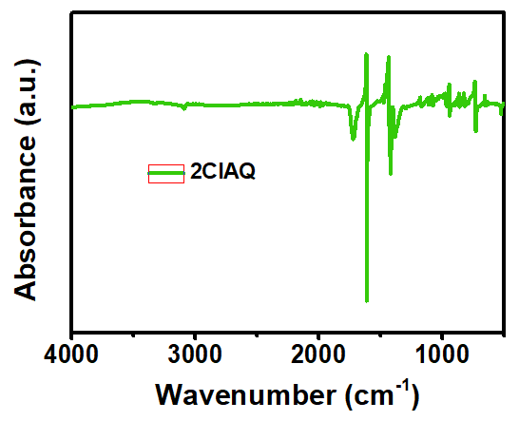

Figure S17. FTIR spectrum of 2ClAQ.

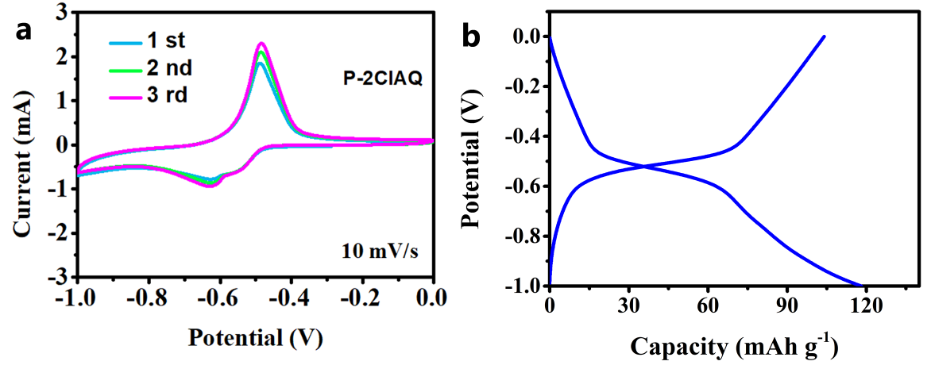

Figure S18. (a) CV curves of P-2ClAQ. (b) GCD curve of P-2ClAQ at 500 mA g-1.

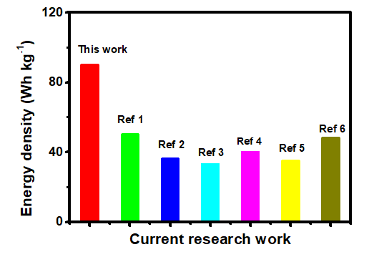

Figure S19. Comparison of the energy density for current pouch cells in PBs.

Table S1. Comparison of electrochemical performance for current pouch cells in PBs.

|  |  |  |  |  |
| --- | --- | --- | --- | --- |
| Cathode | Anode | Capacity scale (mAh) | Energy density  (Wh kg-1) | Ref |
| P-BQ | P-1ClAQ | **264** | **90** | **This work** |
| H-TBA  (Cu[Fe(CN)6]0.63∙▫0.37∙3.4H2O) | MoO3 |  | 50 | [1] |
| H-TBA  (Cu[Fe(CN)6]0.63∙▫0.37∙3.4H2O) | MoO3 |  | 36 | [2] |
| pre-protonated vanadium hexacyanoferrate (H-VHCF) | MoO3 |  | 33 | [3] |
| H-TBA  (Cu[Fe(CN)6]2/3∙3.4H2O) | MoO3 | 0.72 | 40 | [4] |
| Quinone TCBQ and BQ | H2 | 12 | 35 | [5] |
| Ni-PBA | MoO3 |  | 48 | [6] |

Reference

[1] J. Zhang, K. Fu, K. Du, C. Wen, J. Yu, C. Han, Y. Hu, L. Xu, Realizing a mildly acidic proton battery via surface functionalization, ACS Energy Lett. 9 (4) (2024) 1853, DOI: 10.1021/acsenergylett.3c02571.

[2] S. Wang, H. Jiang, Y. Dong, D. Clarkson, H. Zhu, C.M. Settens, Y. Ren, T. Nguyen, F. Han, W. Fan, S.Y. Kim, J. Zhang, W. Xue, S.K. Sandstrom, G. Xu, E. Tekoglu, M. Li, S. Deng, Q. Liu, S.G. Greenbaum, X. Ji, T. Gao, J. Li, Acid-in-clay electrolyte for wide-temperature-range and long-cycle proton batteries, Adv. Mater. 34 (23) (2022) e2202063, DOI: 10.1002/adma.202202063.

[3] X Dong, Z. Li, D. Luo, K. Huang, H. Dou, X. Zhang, Pre‐Protonated Vanadium Hexacyanoferrate for High Energy‐Power and Anti‐Freezing Proton Batteries, Adv. Funct. Mater. 33 (11) (2023), DOI: 10.1002/adfm.202210473.

[4] H. Jiang, W. Shin, L. Ma, J.J. Hong, Z. Wei, Y. Liu, S. Zhang, X. Wu, Y. Xu, Q. Guo, M.A. Subramanian, W.F. Stickle, T. Wu, J. Lu, X. Ji, A high‐rate aqueous proton battery delivering power below −78 °c via an unfrozen phosphoric acid, Adv. Energy Mater. 10 (28) (2020) 2000968, DOI: 10.1002/aenm.202000968.

[5] S. Liu, S. Jin, T.L. Jiang, M. Sajid, J.W. Xu, K. Zhang, Y.P. Fan, Q. Peng, X.H. Zheng, Z.H. Xie, Z.C. Liu, Z.X. Zhu, X.Y. Wang, Q.S. Nian, J.H. Chen, K. Li, C.Y. Shen, W. Chen, Aqueous organic hydrogen gas proton batteries with ultrahigh-rate and ultralow-temperature performance, Nano Lett. 23 (20) (2023) 9664, DOI: 10.1021/acs.nanolett.3c01304.

[6] H. Dong, L.-L. Wang, Z.-R. Feng, J. Song, Q. Qiao, Y.-P. Wu, X.-M. Ren, A freezing-tolerant superior proton conductive hydrogel comprised of sulfonated poly(ether–ether–ketone) and poly(vinyl alcohol) as a quasi-solid-state electrolyte in a proton battery, Journal of Materials Chemistry C 11 (38) (2023) 13113, DOI: 10.1039/d3tc02665e.