Supporting Information

Harnessing Electron Delocalization for Enhanced Capacity and Stability in Heterostructured Cathode for All-solid-state Thin Film Battery

Yongkun Yu, Sheng Cao, Chenxu Dong, Hanxiao Wang, Cheng Zhou, Zhiying Miao, Kaijian Yan, Minjian Gong, Liqiang Mai, and Xu Xu *

Y. K. Yu, S. Cao, C. X. Dong, H. X. Wang, C. Zhou, Z. Y. Miao, K. J. Yan, M. J. Gong, L. Q. Mai, and X. Xu*

State Key Laboratory of Advanced Technology for Materials Synthesis and Processing, School of Materials Science and Engineering, Wuhan University of Technology, Wuhan 430070, Hubei, P. R. China.

Prof. L. Q. Mai, Prof. X. Xu

Hubei Longzhong Laboratory, Wuhan University of Technology (Xiangyang Demonstration Zone), Xiangyang 441000, Hubei, China.
Hainan Institute, Wuhan University of Technology, Sanya 572000, China.

Prof. X. Xu
Zhongyu Feima New Material Technology Innovation Center (Zhengzhou) Co., Ltd., High Technology Industrial Development Zone, No. 60 Xuelan Road, Zhengzhou, 450001 P. R. China

Email: xuxu@whut.edu.cn; mlq518@whut.edu.cn

Keywords: magnetron sputtering, heterostructure, vanadium pentoxide, high capacity, thin film batteries

Experimental section

Materials synthesis.
The VO, VOC1, and VOC2 thin films were deposited on various substrates including SiO₂/Si, glass, Ni foil, and Al foil by RF magnetron sputtering (PD400CS, Pudi Vacuum Technology Co., Ltd, China) using a pure V₂O₅ target (2 inches in diameter, purchased from Beijing Licheng Chuangxin Metal Material Technology Co., Ltd) under Ar and O₂ atmosphere. Before the deposition, the chamber background pressure was first reached to 3×10⁻⁴ Pa. Subsequently, 100 W power was applied to the target for 10 min pre-sputtering. The distance between the target and substrate was fixed at 7 cm and the substrate rotation speed was 10 rpm. Thin films were deposited at 298 K, in a working pressure of ~0.5 Pa introduced by mass flow controllers with 50.0 sccm Ar and 5.0 sccm O₂. The VO thin film was deposited using a pure V₂O₅ target with 100 W power. The VOC1 thin film was co-sputter deposited by adding a Cu target applying a power of 1 W. The VOC2 thin film was similar to the VOC1, with a Cu target co-sputtered at 2W. All the films were deposited for 2 h and then annealed in the air atmosphere at 573 K for 2 h to obtain the final V₂O₅, V₂O₅-Cu₂V₂O₇, and amorphous Cu₂V₂O₇ thin films. The average thickness of VO, VOC1, and VOC2 thin films are about 300, 300, and 420 nm, respectively.

Materials characterization.
The crystal structure information of the samples was characterized using Raman (HORIBA Scientific, LabRam HR Evolution), XRD (Bruker, D8 Advance X-ray diffractometer) with Cu Kα radiation. XPS and UPS measurements were conducted using a VG MultiLab 2000 instrument. The XPS test utilizes a monochromatic Al Kα X-ray of 24.8 W power with a beam size of 100 μm. All peaks were calibrated using C 1s peak at 284.8 eV to correct the charge shift of binding energies. SEM images were obtained by using a JEOL JSM-7100F at a voltage of 10 kV to get morphological information. HAADF-STEM, TEM, and HRTEM images were recorded with a Talos F200S at an accelerating voltage of 200 kV, step size of 0.2 nm, dwell time of 5 μs, and electron dose of 10² e-/nm². TOF-SIMS surface mass spectrometry and depth profiling tests were performed using the PHI Nano TOF3 instrument, ULVAC-PHI, Inc. The ultraviolet-visible absorption spectrum was characterized by a Lambda 750 S equipment with a wavelength range from 200 to 800 nm.

Electrochemical performance tests.
Li metal coin cells (2025-type) were assembled in an argon filled glovebox. The VO, VOC1, and VOC2 thin films deposited on Ni foil were directly used as the cathode, and lithium foil was utilized as the anode. The electrolyte was a mixing solution of 1 M LiTFSI in 1,2-dimethoxyethane (DME) and 1,3-Dioxlane (DOL) (volume ratio 1:1), and LiNO₃ (1 wt%) was regarded as an additive. The Galvanostatic charge/discharge cycling was conducted on the Neware battery test system (CT-4008Tn-5V50mA-HWX, Shenzhen, China) with a potential range of 2.15-3.8 V versus Li/Li⁺. The cyclic voltammetry (CV) measurements were carried out on an electrochemical workstation (CHI 760e) with a 0.1 mV/s sweep rate. EIS measurements were performed on an electrochemical workstation (Biologic VSP) by applying an AC amplitude of 5 mV over the frequency range of 100 kHz to 0.01 Hz with 12 points per decade. The data were fitted and analyzed using Zview software.
DFT calculation.
The first-principle-based geometry optimization calculations were carried out within density-functional theory (DFT), implemented in the Vienna Ab Initio Simulation Package (VASP) code,^{[1]} using the frozen-core projector augmented-wave (PAW) method to describe the interaction between the atomic cores and the valence electron density.^{[2]} The exchange-correlation potential was approximated within the generalized gradient approximation (GGA) using the Perdew-Burke Ernzerhof (PBE) functional.^{[3]} The dispersion corrected DFT-D3 schemes were employed to describe the Van der Waals (vdW) interactions.^{[4]} Plane-wave cutoff energy was set to 450 eV. The conjugate gradient algorithm was used in ionic optimization, convergence threshold was set to 10-5 eV atom⁻¹ in electronic relaxation and 0.05 eV Å⁻¹ in Hellmann-Feynman force on each atom. The Brillouin zone in reciprocal space was sampled a Γ-centered Monkhorst-Pack scheme with gamma-point grids for geometry optimization and electronic structure calculations.^{[5]}

Figure S1. Raman spectrum of VOC2 thin films annealed at 773 K.

Figure S2. XRD pattern of VOC2 thin films annealed at 773 K.

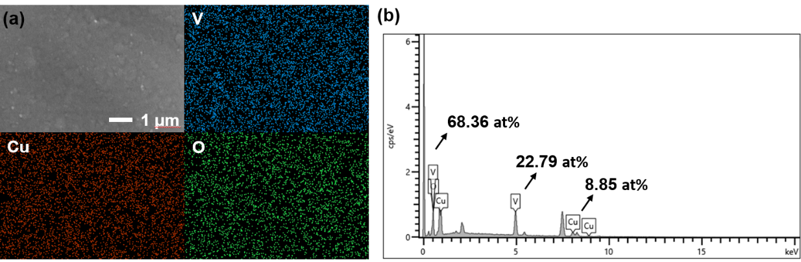
Figure S3. a) FESEM image and EDS mapping, and b) corresponding EDS spectrum of VOC1 thin film.

Figure S4. FESEM images of the a) VO, b) VOC1, and c) VOC2 thin films.

Figure S5. Cross-section FESEM images of a) VO, and b) VOC2 thin films.

Figure S6. HAADF-STEM images for the VOC1 sample at different magnifications.

Figure S7. TOF-SIMS surface spectral distribution of VOC1 thin film.

Figure S8. (a) CV curves at step-rising scan rates and (b) the correspondingly derived log(i)-log(v) plots, (c) the separation of pseudocapacitance and diffusion-controlled capacity at 0.5 mV s-1 for the VOC1 cathode, and (c) the pseudocapacitive contribution at various scan rates.

Figure S9. EIS curves at different SOC states.

Figure S10. Galvanostatic charge/discharge profiles of the a) VO, and b) VOC2 electrodes at the 1st, 2nd, and 5th cycles.

Figure S11. CV curves of the a) VO, b) VOC1, and c) VOC2 electrodes.

Figure S12. Calculated dQ/dV profiles of the a) VO, and b) VOC2 electrodes for the first three cycles.

Figure S13. Galvanostatic charge/discharge profiles of the a) VO b) VOC1, and c) VOC2 electrodes at 3 μA cm⁻².

Figure S14. FESEM images of a) VO, b) VOC1 thin films collected at the 300th cycle, and c) VOC2 thin film after 100th cycle. d) Corresponding EDS mapping of the VOC1 thin films.

Figure S15. Galvanostatic charge/discharge profiles of the a) VO, and b) VOC2 electrodes at the different specific currents.

Figure S16. Cycle performance comparison between the VOC1 electrode in this work and the reported thin-film cathodes in literature.^{[6–12]}

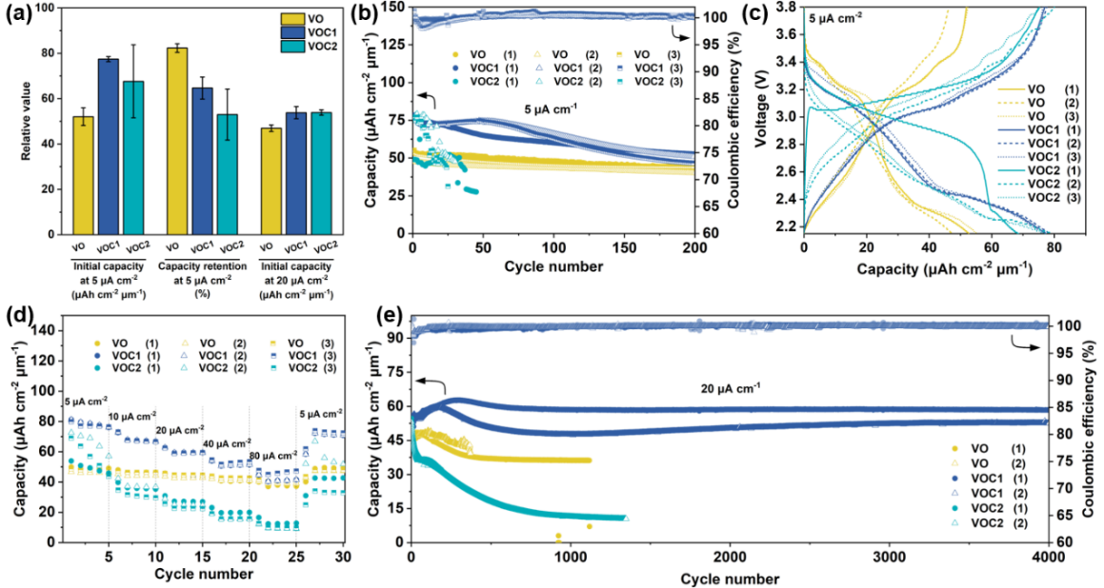
Figure S17. (a) Averaged results of major electrochemical performance with error bars. (b) Cycle performance comparison at 5 μA cm⁻², and (c) corresponding galvanostatic charge/discharge profiles at the 1st cycle. (d) Rate capabilities of the VO, VOC1, and VOC2 electrodes. (e) Long-term cycle performance at 20 μA cm⁻².
Figure S18. In-situ Raman measurements of the VO electrode during the discharge-charge processes in a voltage range between 2.15 and 3.8 V (vs. Li/ Li⁺).

Figure S19. Band structure diagrams determined by ultraviolet-visible absorption spectroscopy and UPS spectra of VO, VOC1, and VOC2 thin films.

Figure S20. The optimized atomic structure models of V₂O₅-Cu₂V₂O₇.

Figure S21. The ELF of a₁) V₂O₅-Cu₂V₂O₇ heterojunction (Cu₂V₂O₇ side), a₂) V₂O₅-Cu₂V₂O₇ heterojunction (V₂O₅ side), b) Cu₂V₂O₇, and c) V₂O₅.

Figure S22. The DOS of a) V₂O₅, b) V₂O₅-Cu₂V₂O₇ heterojunction, c) Cu₂V₂O₇, and d) Cu₂V₂O₇ in the V₂O₅-Cu₂V₂O₇ heterojunction.

Figure S23. The adsorption sites and corresponding adsorption energy values of Li-V₂O₅, the Li-V₂O₅-Cu₂V₂O₇ heterostructure, and Li-Cu₂V₂O₇.

Figure S24. Li diffusion paths and diffusion energy barriers on the a) V₂O₅, b) V₂O₅-Cu₂V₂O_{7,} and c) Cu₂V₂O₇ surfaces.

Figure S25. Cross-section FESEM image of the VOC1-LiPON interface.

Figure S26. Galvanostatic charge/discharge profiles of ATFBs based on the a) VO, and b) VOC2 cathodes.

Figure S27. CV curves of ATFBs based on the a) VO, b) VOC1, and c) VOC2 cathodes.

Figure S28. Calculated dQ/dV profiles ATFBs based on the a) VO, b) VOC1, and c) VOC2 cathodes.
Figure S29. All-solid-state thin-film batteries constructed on a) quartz, b) silicon, c) stainless steel foil, and d) 5 μm ultrathin polyimide film.

Figure S30. Radar plots illustrating crucial metrics to assess VOC1, LiCoO₂, LiMn₂O₄, and LiFePO₄ positive electrodes in all-solid-state batteries.

Table S1. Fitting parameters between the raw and fitted data for EIS spectra of VO, VOC1, and VOC2 electrodes.
Electrodes | R_{s} | R_{ct}
VO | 1.94 | 89.85
VOC1 | 2.57 | 62.45
VOC2 | 2.09 | 65.27

Table S2. Comparison of the electrochemical performances of V₂O₅-based cathodes in lithium batteries. The double asterisks represent the undefined information.
Cathodes | Max capacity  (μAh cm⁻² μm⁻¹) | Capacity retention | Potential range  (V vs. Li⁺/Li) | Thickness (nm) | Ref.
a-V₂O₅ | 91 | 90% after 50 cycles | 2.0-4.0 | ** | ^{[13]}
V₂O₅ | 40.24 | 80% after 1530 cycles | 2.75-3.8 | 10 | ^{[14]}
V₂O_{5-x} | 70.38 | 93.8% after 1000 cycles | 2.15-3.8 | 100 | ^{[10]}
V₂O₅ | 49 | ** | 0.5-3.3 | 70 | ^{[15]}
Li₂Ag_{0.5}V₂O₅ | 60 | 60% after 100 cycles | 1.0-3.5 | ** | ^{[16]}
V₂O₅ | 16 | 73% after 30 cycles | 0.5-4.0 | 500 | ^{[17]}
V₂O₅-Cu₂V₂O₇ | 76.44 | 93% after 4000 cycles | 2.15-3.8 | 300 | This work

References
[1] G. Kresse, J. Furthmüller, Efficient iterative schemes for ab initio total-energy calculations using a plane-wave basis set, Phys. Rev. B 54 (1996) 11169.
[2] G. Kresse, D. Joubert, From ultrasoft pseudopotentials to the projector augmented wave method, Phys. Rev. B 59 (1999) 1758.
[3] J.P. Perdew, K. Burke, M. Ernzerhof, Generalized gradient approximation made simple, Phys. Rev. Lett. 77 (1996) 3865-3868.
[4] S. Grimme, J. Antony, S. Ehrlich and H. Krieg, J. Chem. Phys., 2010, 132, 154104-154123.
[5] H. J. Monkhorst and J. D. Pack, Phys. Rev. B: Solid State, 1976, 13, 5188-5192.
[6] B. Ke, S. Cheng, C. Zhang, W. Li, J. Zhang, R. Deng, J. Lin, Q. Xie, B. Qu, L. Qiao, D. Peng, X. Wang, Advanced Energy Materials 2024, 2303757.
[7] Q. Xia, Q. Zhang, S. Sun, F. Hussain, C. Zhang, X. Zhu, F. Meng, K. Liu, H. Geng, J. Xu, F. Zan, P. Wang, L. Gu, H. Xia, Adv. Mater. 2021, 33, 2003524.
[8] R. Deng, B. Ke, Y. Xie, S. Cheng, C. Zhang, H. Zhang, B. Lu, X. Wang, Nano-Micro Lett. 2023, 15, 73.
[9] Q. Xia, S. Sun, J. Xu, F. Zan, J. Yue, Q. Zhang, L. Gu, H. Xia, Small 2018, 14, 1804149.
[10] C.-F. Xiao, J. H. Kim, S.-H. Cho, Y. C. Park, M. J. Kim, K.-B. Chung, S.-G. Yoon, J.-W. Jung, I.-D. Kim, H.-S. Kim, ACS Nano 2021, 15, 4561.
[11] X. Chen, J. Sastre, A. Aribia, E. Gilshtein, Y. E. Romanyuk, ACS Appl. Energy Mater. 2021, 4, 5408.
[12] S. Sun, Z. Han, W. Liu, Q. Xia, L. Xue, X. Lei, T. Zhai, D. Su, H. Xia, Nat Commun 2023, 14, 6662.
[13] F. Mattelaer, K. Geryl, G. Rampelberg, J. Dendooven, C. Detavernier, ACS Appl. Mater. Interfaces 2017, 9, 13121.
[14] E. Østreng, K. B. Gandrud, Y. Hu, O. Nilsen, H. Fjellvåg, J. Mater. Chem. A 2014, 2, 15044.
[15] A. Pearse, T. Schmitt, E. Sahadeo, D. M. Stewart, A. Kozen, K. Gerasopoulos, A. A. Talin, S. B. Lee, G. W. Rubloff, K. E. Gregorczyk, ACS Nano 2018, 12, 4286.
[16] F. Huang, Z. Fu, Q. Qin, Electrochemistry Communications 2003, 5, 262.
[17] K. Tsuji, M. Yoshida, I. Kanno, in 2021 IEEE 20th International Conference on Micro and Nanotechnology for Power Generation and Energy Conversion Applications (PowerMEMS), IEEE, Exeter, United Kingdom, 2021, pp. 216-219.

