**Supporting Information**

**Stacking pressure modulated deposition and dissolution of zinc anode**

Yuehua Wen, Kesong Yu, Shouren Zhan, Xiaobin Liao, Zhipeng Zhang, Xiaqing Ran, Bowei Li, Suttipong Wannapaiboon, Mengyu Yan*

Y.Wen, K.Yu, S.Zhan, X.Liao, Z.Zhang, X.Ran, B.Li, M.Yan

State Key Laboratory of Advanced Technology for Materials Synthesis and Processing, State Key Laboratory of Silicate Materials for Architectures, School of Materials Science and Engineering, International School of Materials Science and Engineering, Wuhan University of Technology, Wuhan, 430070, China.

E-mail: ymy@whut.edu.cn

S. Wannapaiboon

Synchrotron Light Research Institute, 111 University Avenue, Muang District, Nakhon Ratchasima 30000, Thailand.

M.Yan

Zhongyu Feima New Material Technology Innovation Center (Zhengzhou) Co., Ltd., High Technology Industrial Development Zone, No. 60 Xuelan Road, Zhengzhou, 450001, China.

**Methods**

**Synthesis method of VO2**

The 0.5 g oxalic acid dihydrate, 0.36 g V2O5, and 40 ml deionized water were mixed in an autoclave. The mixture was stirred at room temperature for 4 hours at 2000 r min-1. Subsequently, the autoclave was transferred to an oven and heated with the temperature of 180°C for 24 hours. The resulted product was washed with deionized water for three times and dried at 60℃ in a vacuum oven for 10 h. Afterwards the deep blue powders were obtained and collected.

**Materials Characterization**

Scanning electron microscopy (SEM) images were collected on Thermo Phenom Pro Desktop SEM at 15 kV and JEOL-7100F microscope at 20 kV. The Thermo Phenom Pro Desktop SEM working distance is 8.2 mm and the pressure inside the chamber is 1 Pa and the JEOL-7100F microscope working distance is 12 mm and the pressure inside the chamber is 9.6E-5 Pa. X-ray diffraction (XRD) patterns were obtained at room temperature by Bruker D8 and EVASTAR Y2 X-ray diffractometer with a Cu Kα X-ray source (λ = 1.5418 Å), and the scanning rate is 5° min-1. The synchrotron XRD patterns were performed incollected at Beamline 7.2W of the Synchrotron Light Research Institute (Public Organization), Thailand using monochromatic X-ray with an energy of at 15 keV.

**Electrochemical measurements**

The Zn||Ti symmetric cells are assembled using *in-situ* pressure-electrochemical coupled XRD devices, in which the Ti plates as the cathode electrodes, the Zn as the anode electrodes, 1 M ZnSO4 as the electrolyte. The Whatman separator, GF/A (17 mm in diameter) and cellulose acetate(CA)(which was used to test the cross-section SEM) separator are selected as the separator in the cells. The cells were charged and discharged at a current density of 1 mA cm-2 and an areal capacity of 1 mAh cm-2 with the NEWARE battery testing systems. The Zn||VO2 cells were assembled with VO2 as the cathode electrodes, Zn as the anode electrodes, GF/A as the separators and 1 M ZnSO4 as the electrolyte. The VO2 cathode electrodes was obtained by coating a mixture of VO2: Super P: polytetrafluoroethylene (PTFE) in a mass ratio of 7:2:1 on Ti foil collectors. Then the electrodes are punched into 10 mm circles. The mass loading of the VO2 electrode is ~5.5 mg cm-2. The Zn||VO2 cells were cycled between 0.2 - 1.2 V at 1A/g. The galvanostatic charge-discharge measurements were performed with battery testing systems (NEWARE CT4008Q).

***In-situ* XRD measurements**

A lab-made *in-situ* cell was designed for this study. In this cell the Be window with a ~100 nm Ti metal layer as the cathode, the Zn foil as the anode electrode, the 1 M ZnSO4 as the electrolyte and the GF/A as separators were used. The 100 nm Ti metal was deposited on beryllium windows by magnetron sputtering through the Pudi Vacuum K-mate with a DC mode parameter of 50 W at 5E-2 Pa. The *in-situ* cells were discharged at 1 mA cm-2 for 1 hour, subsequently charged until approaching the 0.5 V cutoff potential, and then cycled. The *in-situ* XRD data was collected simultaneously.

**TOF-SIMS measurements**

The TOF-SIMS measurements of Zinc 3D mapping were conducted with a PHI nano TOF III. A Bi3+ beam (30 kV, 2 nA, 200 μm) with a raster size of 100 μm was used as the primary beam for sample detection, while sputtering was performed with an Ar+ beam (2 kV, 100 nA, 400 × 400 μm²). The sputtering rate on SiO2 was 0.25 nm/s.

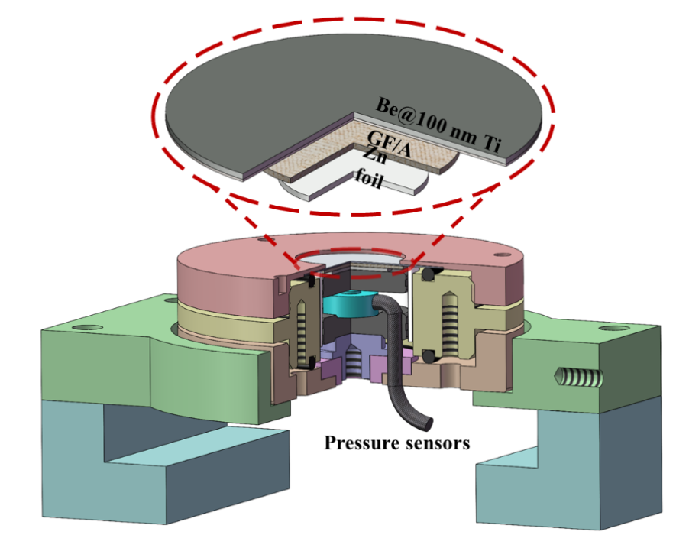

Figure S1 The *in-situ* pressure-electrochemical coupled XRD 3D mold.

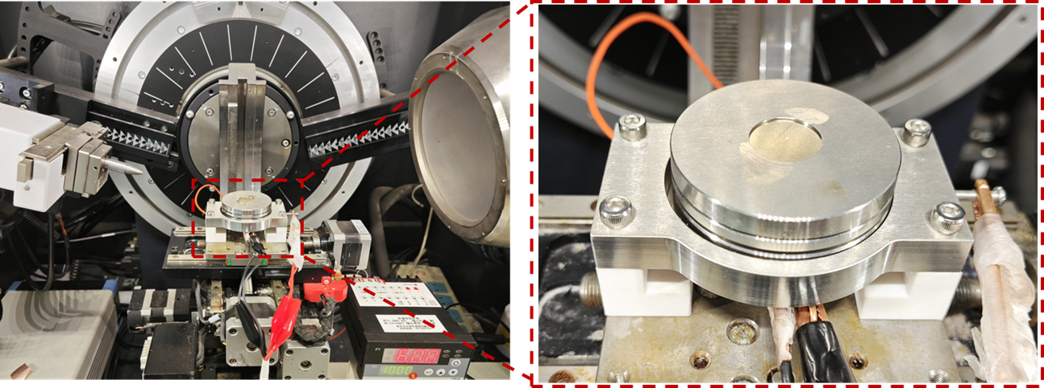

Figure S2 The *in-situ* pressure-electrochemical coupled XRD optical picture.

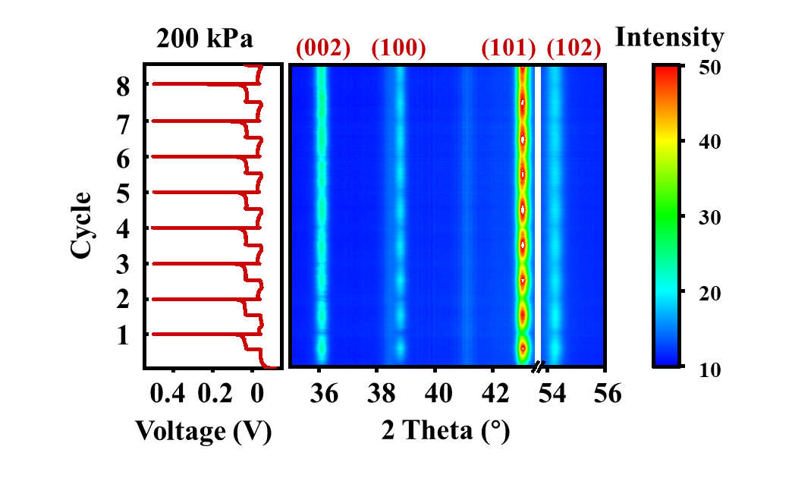

Figure S3 The cell cycling diagrams and *in-situ* XRD profiles of Zn||Ti batteries at 1 mA cm-2 and 200 kPa.

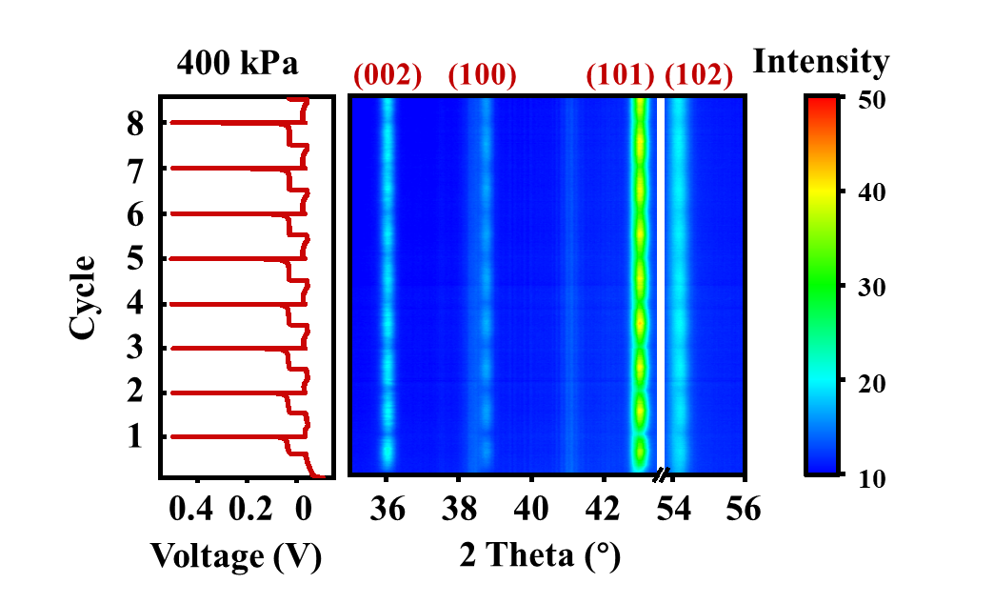

Figure S4 The cell cycling diagrams and *in-situ* XRD profiles of Zn||Ti batteries at 1 mA cm-2 and 400 kPa.

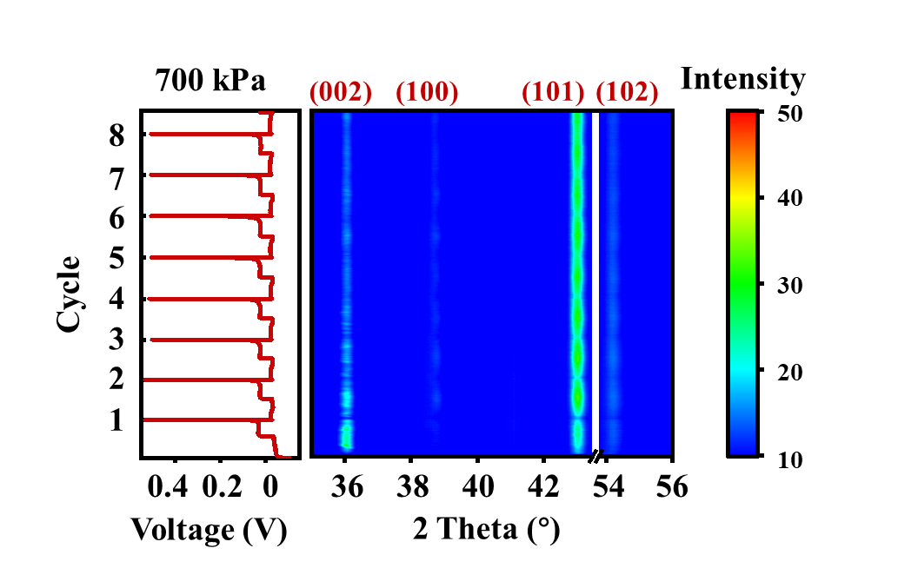

Figure S5 The cell cycling diagrams and *in-situ* XRD profiles of Zn||Ti batteries at 1 mA cm-2 and 700 kPa.

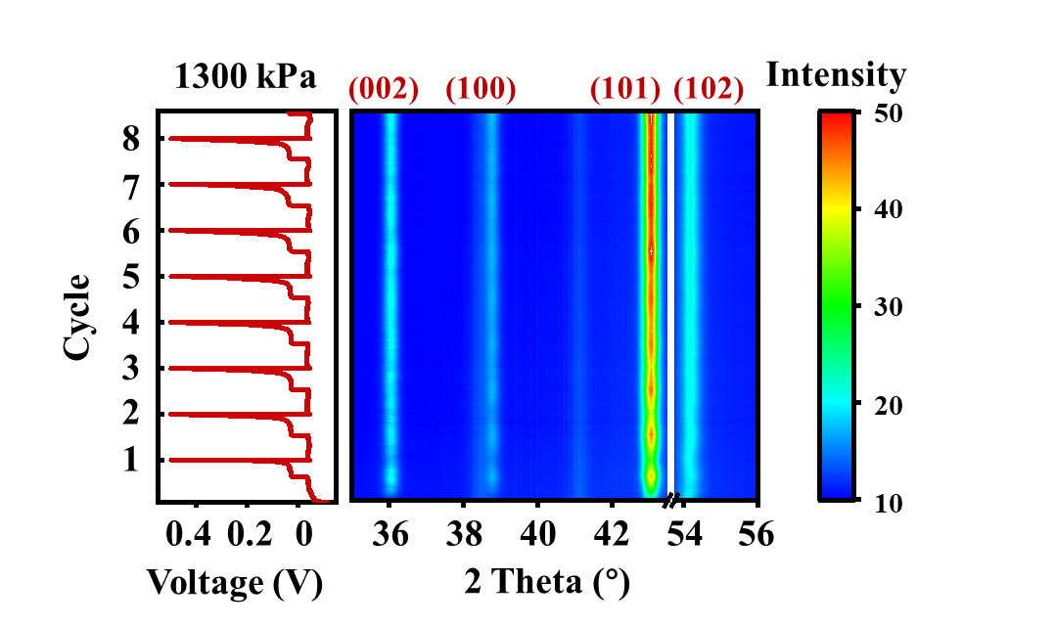

Figure S6 The cell cycling diagrams and *in-situ* XRD profiles of Zn||Ti batteries at 1 mA cm-2 and 1300 kPa.

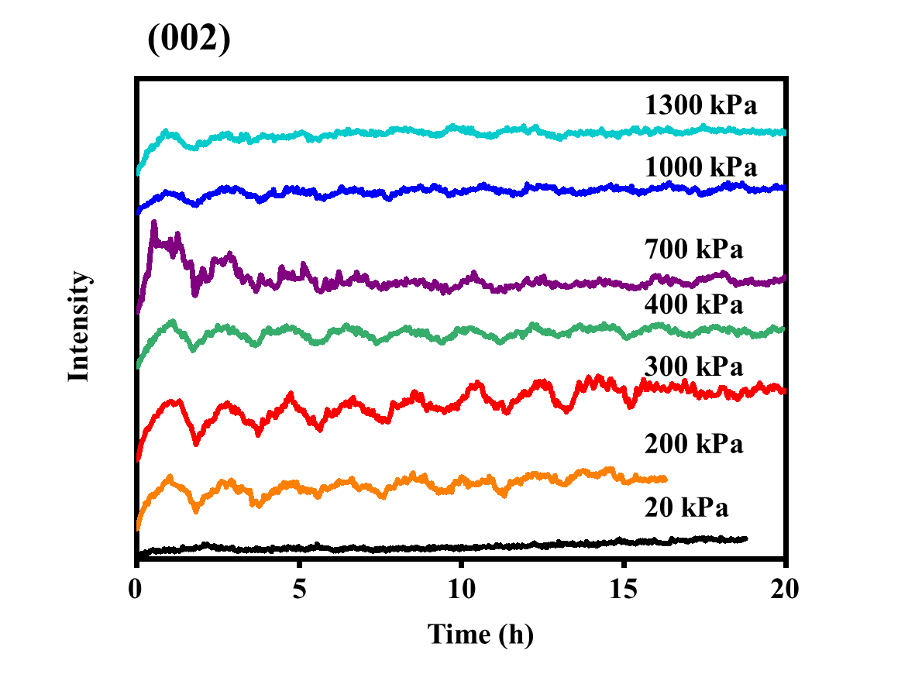

Figure S7 The Zn(002) peak intensity offset plots at different pressures.

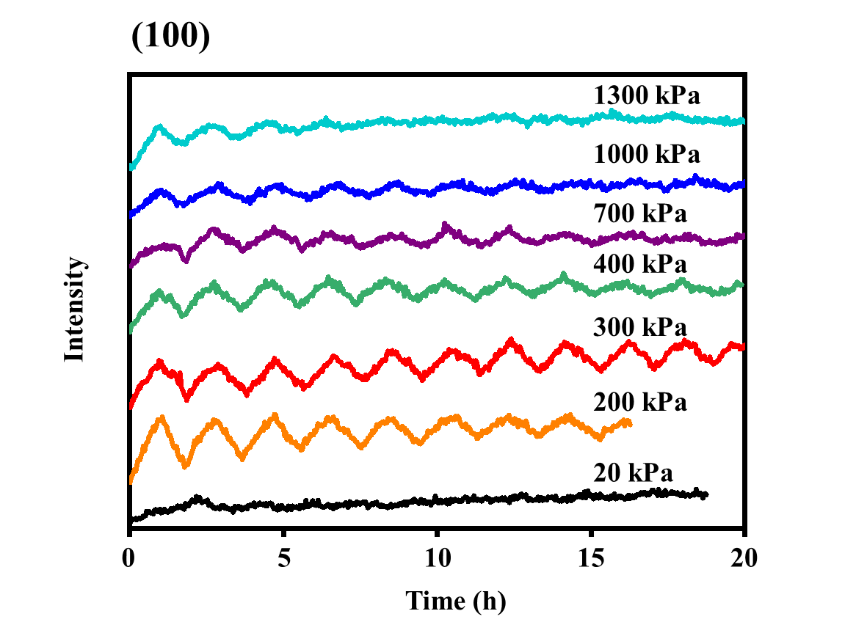

Figure S8 The Zn(100) peak intensity offset plots at different pressures.

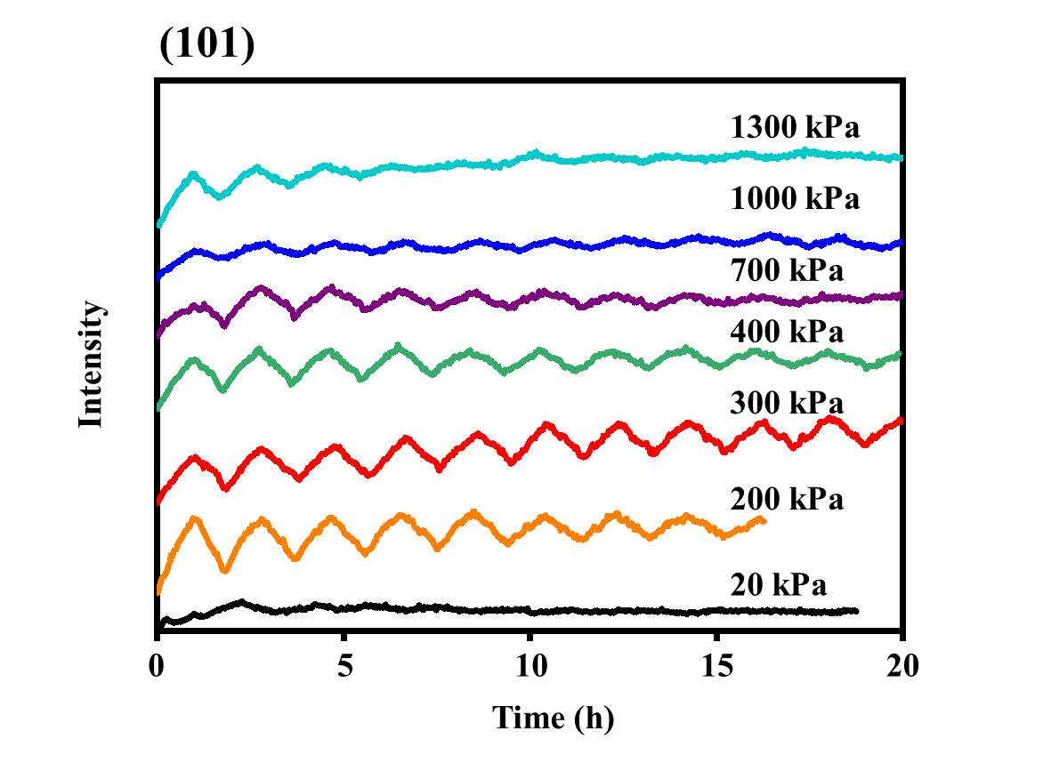

Figure S9 The Zn(101) peak intensity offset plots at different pressures.

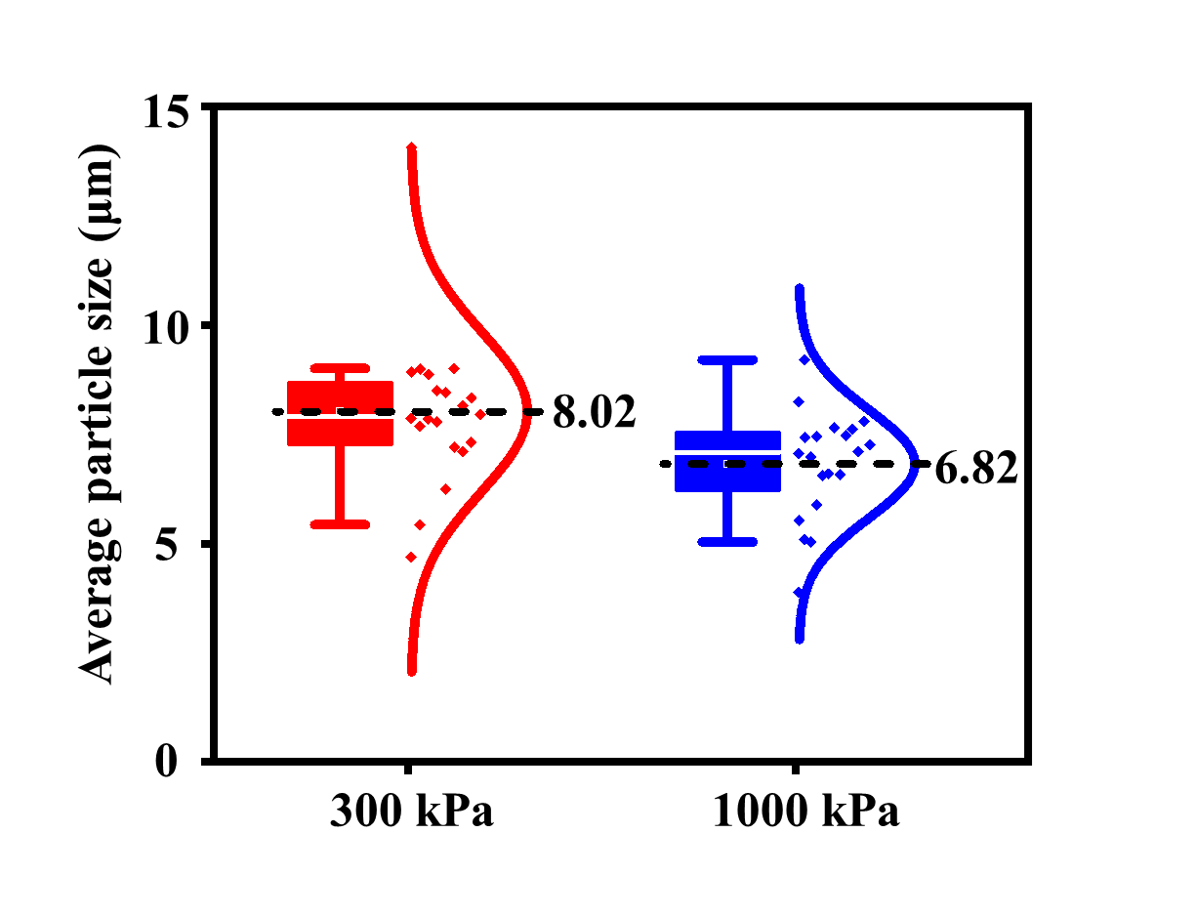

Figure S10 Comparison of average particle size at 300 kPa and 1000 kPa after cycling to the 8th deposition turn.

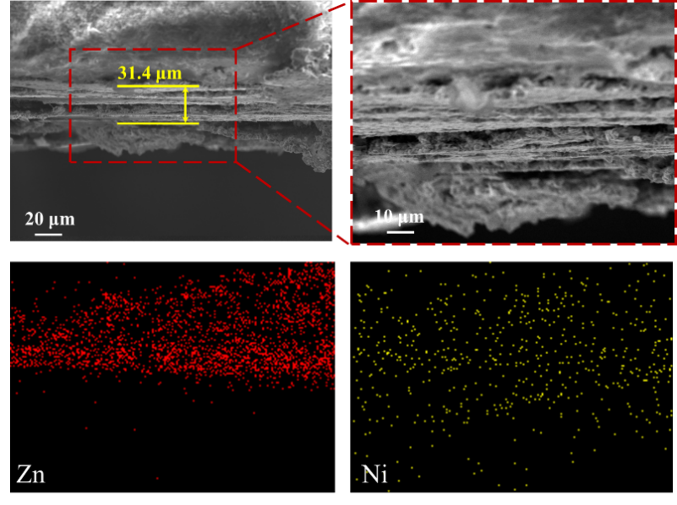

Figure S11 The cross-section SEM images of the Zn deposition layer at 20 kPa and the corresponding EDS mapping.

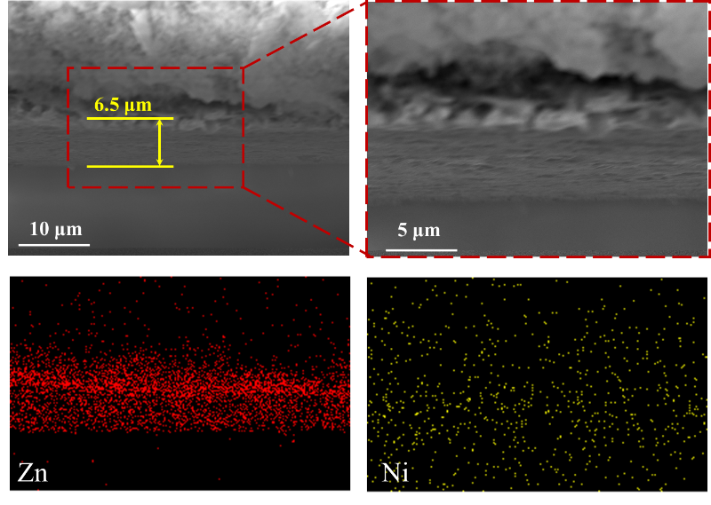

Figure S12 The cross-section SEM image of the Zn deposition layer at 300 kPa and the corresponding EDS mapping.

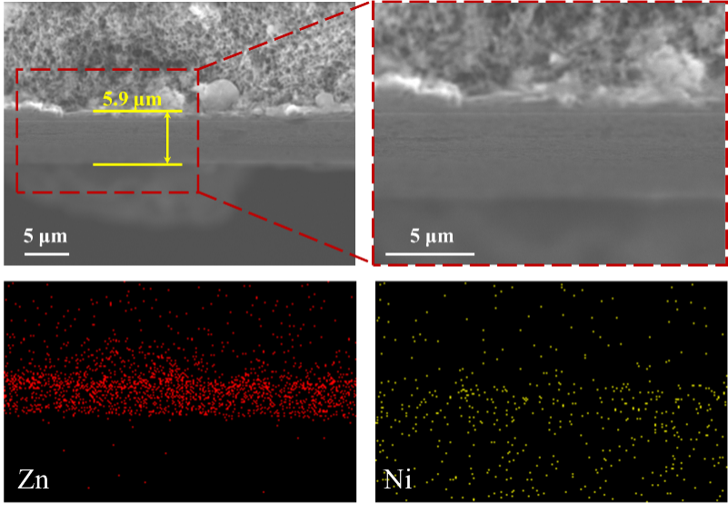

Figure S13 The cross-section SEM image of the Zn deposition layer at 1000 kPa and the corresponding EDS mapping.

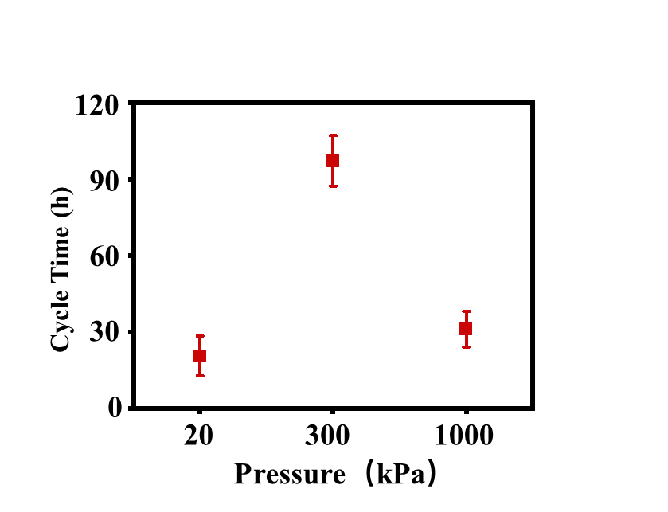

Figure S14 The cell cycle life error plots at 20 kPa, 300 kPa and 1000 kPa.



Figure S15 The cycling performances of Zn||VO2 cells with 3M Zn(CF₃SO₃)₂ at 1A g-1

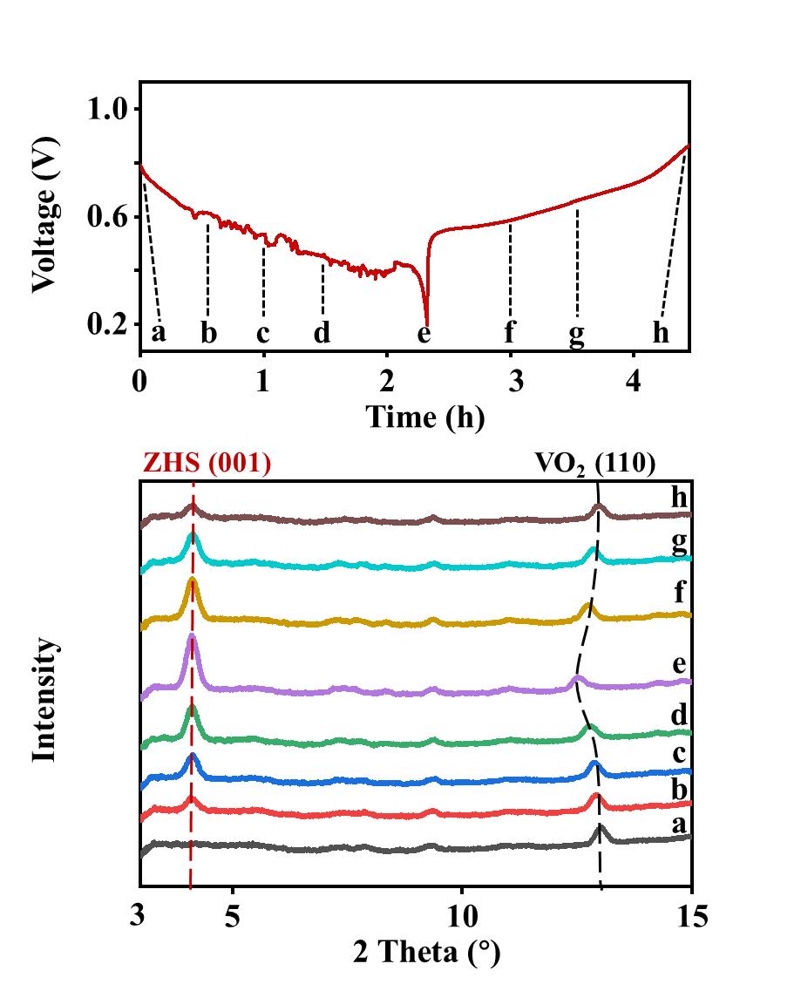

Figure S16 The synchrotron transmission *in-situ* XRD patterns of Zn||VO2 pouch cell in the first charge/discharge at 20 kPa.

**Table S1** **The comparison of Zn/VO2 full cell performance in basic system**

|  |  |  |  |  |
| --- | --- | --- | --- | --- |
| **Separator** | **Electrolyte** | **Current density** | **Cycles/Capacity retention** | **Ref.** |
| Glass fiber (Whatman GF/A) | 1 M ZnSO4 | 1 A g-1 | 100/77.3% | This work |
| Glass fiber (GF/A) | 2 M Zn(CF3SO3)2 | 0.1 A g-1 | 120/57.1% | [1] |
| Qualitative filter paper | 1 M Zn(CF3SO3)2 | 0.62 C | 50/72.7% | [2] |
| Glass fiber (GF/A) | 3 M Zn(CF3SO3)2 | 0.1 A g-1 | 70/71.4% | [3] |
| Glass fiber (GF/A) | 2 M ZnSO4 | 0.2 A g-1 | 50/69.7% | [4] |
| Glass fiber (GBR) | 1 M ZnSO4 | 2 A g-1 | 100/68.6% | [5] |
| Glass fiber | 2 M ZnSO4 | 0.5 A g-1 | 100/73.7% | [6] |
| Glass microfiber (Whatman) | 1 M ZnSO4 | 0.2 A g-1 | 100/44.1% | [7] |
| Glass fiber | 1 M ZnSO4 | 2 A g-1 | 100/32.1% | [8] |
| Glass fiber | Solid-state | 0.5 A g-1 | 100/15.0% | [9] |
| Glass fiber | 2 M ZnSO4 | 1 A g-1 | 100/43.2% | [10] |
| Glass fiber | 1 M ZnSO4 | 1 A g-1 | 100/63.7% | [11] |
| glass fiber  (whatman GF/D) | 2 M ZnSO4 | 1 A g-1 | 100/71.7% | [12] |

**Note S1 The formulas derivation of nucleation rate($J_{n}$) and overpotential($η$)**

For homogeneous nucleation, the free energy change per molecule($∆g$) is given by the sum of bulk($∆g_{b}$) and surface terms($∆g_{s}$) namely,

$$\begin{aligned}∆g=∆g_{b}+∆g_{s}\#\left(1\right)\end{aligned}$$

$$\begin{aligned}=-\frac{\frac{4}{3}πr^{3}∆μ}{Ω}+4πr^{2}α\#\left(2\right)\end{aligned}$$

where Ω is the volume per molecule, ∆μ is the change in chemical potential of the crystallizing species and α is the interfacial free energy.

The critical radius($r_{c}$) is given by $\frac{d∆g}{dr}=0$, in which

$$\begin{aligned}r_{c}=\frac{2Ωα}{∆μ}\#\left(3\right)\end{aligned}$$

The same analysis can be performed for heterogeneous nucleation, i.e., nucleation at a

foreign surface.

$$\begin{aligned}∆g=-\frac{\frac{2}{3}πr^{3}∆μ}{Ω}+πr^{2}\left(2α_{lc}+α_{sc}-α_{ls}\right)\#\left(4\right)\end{aligned}$$

where the subscripts “sc”, “lc”, and “ls” refer to substrate-crystal, liquid-crystal, and liquid-substrate respectively. The new expression for $r_{c}$ becomes,

$$\begin{aligned}r_{c}=\frac{2Ωα^{'}}{∆μ}\#\left(5\right)\end{aligned}$$

$$\begin{aligned}α^{'}=α_{lc}\left(1-\frac{α_{ls}-α_{sc}}{2α_{lc}}\right)\#\left(6\right)\end{aligned}$$

The nucleation barrier $∆g_{n}$ can be determined by substituting (3) or (5) into (2) to get:

$$\begin{aligned}{∆g}_{n}=\frac{\frac{16}{3}πα^{3}Ω^{2}}{{∆μ}^{2}}\#\left(7\right)\end{aligned}$$

The nucleation probability is proportional to the exponential of the barrier height divided by $k_{B}T.$ Thus the nucleation rate(Jn) is given by:

$$\begin{aligned}J_{n}=Ae^{-\frac{{∆g}_{n}}{k_{B}T}}\#\left(8\right)\end{aligned}$$

where A is a factor that depends on many parameters, $k_{B}$ is the Boltzmann constant, and *T* is the absolute temperature (The room temperature is 298.15 K).

Actually, In electrochemical nucleation processes, the overpotential (η) induced by an applied voltage directly modifies the nucleation barrier (where surface free energy inherently opposes nucleation). By dynamically reducing the hindering effect of surface energy through electrochemical work, the overpotential effectively counteracts the energy cost of surface formation and lowers the nucleation energy barrier, thereby increasing the nucleation rate. This mechanism aligns with the role of surface free energy, as the electrochemical driving force provided by overpotential compensates for surface energy consumption. Consequently, the overpotential can be conceptually treated as a component of the effective surface free energy in this framework. Thus, during the battery charging and discharging, the new nucleation barrier $∆g_{E}$ becomes:

$$\begin{aligned}∆g_{E}=∆g_{n}+∆g_{m}\#\left(9\right)\end{aligned}$$

$$\begin{aligned}∆g_{m}=ηe\#\left(10\right)\end{aligned}$$

where $∆g_{m}$ is related to the overpotential($η$), e is elementary charge, and in here $∆g_{n}$ is constant relating to the interfacial free energy and the chemical potential of the crystallizing species.

So the Jn becomes:

$$\begin{aligned}J_{n}=Ae^{-\frac{{∆g}_{n}+∆g_{m}}{k_{B}T}}\end{aligned}$$

$$\begin{aligned}=Ae^{-\frac{{∆g}_{n}+ηe}{k_{B}T}}\#\left(11\right)\end{aligned}$$

**References**

[1] W. Zheng, L. Zhu, H. Huang, Z. Sun, H. Zhou, K. Zhang, *ACS Sustainable Chemistry & Engineering* **2024**, 12, 8070.

[2] L. Ma, X. Wang, J. Sun, *Journal of Electroanalytical Chemistry* **2020**, 873, 114395.

[3] C. Zhao, Y. Liu, X. Wu, S. Luo, *Advanced sustainable Systems* **2024**, 8, 2400077.

[4] Y. Ai, C. Yang, Z. Yin, T. Wang, T. Gai, J. Feng, K. Li, W. Zhang, Y. Li, F. Wang, D. Chao, Y. Wang, D. Zhao, W. Li, *Journal of the American Chemical Society* **2024**, 146, 15496.

[5] H. Liang, J. Wu, J. Li, J. Wang, Z. Yang, Y. Wu, *Small* **2024**, 20, 2402595.

[6] L. Wang, B. Zhang, W. Zhou, Z. Zhao, X. Liu, R. Zhao, Z. Sun, H. Li, X. Wang, T. Zhang, H. Jin, W. Li, A. Elzatahry, Y. Hassan, H. J. Fan, D. Zhao, D. Chao, *Journal of the American Chemical Society* **2024**, 146, 6199.

[7] S. Olidan, J. Kim, K. Y. Cho, S. Yoon, *Electrochimica Acta* **2024**, 476, 143704.

[8] X. Li, W. Zhang, J. Yu, L. Wu, A. Zhang, J. Zhang, H. Wang, X. Liao, Y. Zhao, *Advanced Functional Materials* **2024**, 34, 2316474.

[9] F. Li, D. Ma, K. Ouyang, M. Yang, J. Qiu, J. Feng, Y. Wang, H. Mi, S. Sun, L. Sun, C. He, P. Zhang, *Advanced Energy Materials* **2023**, 13, 2204365.

[10] J. Cao, X. Wang, S. Qian, D. Zhang, D. Luo, L. Zhang, J. Qin, X. Zhang, X. Yang, J. Lu, *Advanced Materials* **2024**, 36, 2410947.

[11] H. Zhang, J. Li, H. Ren, J. Wang, Y. Gong, B. Wang, D. Wang, H. Liu, S. Dou, *iScience* **2024**, 27, 110237.

[12] J. Cao, X. Wang, D. Zhang, R. Chanajaree, L. Zhang, J. Qin, X. Yang, *Journal of Alloys and Compounds* **2024**, 972, 172773.