Supporting Information

Unveiling the Curvature-Dependent Electrocatalytic Kinetics for Sulfur Redox Reaction in Li-S Chemistry

Kao Wang^{#,1}, Yang Wang^{# ,3}, Jun Wang⁴, Hong Wang¹, Chenzhi Ding¹, Zhaobo Zheng¹, Yue Liu¹, Zhengtang Luo⁴, Yao Ding^{*,1,2}

K. Wang, H. Wang, C. Ding, Z. Zheng, Y. Liu, Y. Ding
¹School of Materials Science and Engineering, Wuhan University of Technology, Wuhan 430070, P.R. China.

Prof. Y. Ding
²Hubei Longzhong Laboratory, Xiangyang 441000, P.R. China.

Y. Wang
³Chongqing University of Posts and Telecommunications, School of Optoelectronic Engineering, Chongqing 400065, P.R. China.

J. Wang, Z. Luo
⁴Department of Chemical and Biological Engineering and William Mong Institute of Nano Science and Technology, Hong Kong University of Science and Technology, Clear Water Bay, Kowloon, Hong Kong 999077, P.R. China.

# K. Wang and Y. Wang contributed equally to this work.
*Corresponding author: Y. Ding
E-mail address: ydingaf@whut.edu.cn (Y. Ding)

Keywords: Circumferential strain engineering, Li-S chemistry, Sulfur redox reaction, Heterostructures, Single-atom catalysts

Experimental section
Materials.
All CNTs were bought from Nanjing XFNANO Materials Tech Co. Ltd. MoCl₅ were obtained from Macklin Chemistry Reagent Co. Ltd. Isopropanol, ethanol, 1-Methyl-2-pyrrolidinone, anhydrous ethanol, tetraglyme solution and Li₂S were obtained from Aladdin Chemistry Reagent Co. Ltd. LiNO₃ (99.9%), VCl₃, and sublimed sulfur powder were purchased from Alfa Aesar. 1,3-dioxolane (DOL) and 1,2-dimethoxyethane (DME) were purchased from Fisher.
Acid treatment of CNTs.
To improve the hydrophilicity of SWCNTs, 200 mg of pristine SWCNTs (ϕ ≈ 2 nm) were first sonicated in 100 ml of HNO₃ (65 %, wt /wt %) for 10 min, followed by stirring for 4 h at 100 ℃. The cooled mixture solution was then diluted with deionized water (DI water) and filtered with a vacuum filter until the pH was neutral. After freeze-drying, the acid-treated SWCNT was obtained. The samples with other diameters (i.e. ϕ ≈ 15 nm and ϕ ≈ 50 nm) were treated in the same way.
Synthesis of MoS₂@CNT heterostructures.
40 mg acidified CNTs were dispersed in 50 mL of anhydrous ethanol, then 2 mL of 0.3 M MoCl₅ ethanol solution was added, followed by 300 mg of NH₄HCO₃, and the mixture was stirred at 800 rpm/min for 24 h. The precipitates were then centrifuged at 10,000 rpm/min, and the precipitates were rapidly frozen with liquid nitrogen, and then freeze dried to obtain CNTs loaded with molybdenum sources. 60 mg of solid product was placed in a quartz boat and placed in the center of the quartz tube containing 300 mg of sulfur powder was placed 9 cm upstream of the quartz tube from the solid product. The quartz tube was cleaned three times with high-purity nitrogen, and the tube furnace was heated to 700 °C at a rate of 10 ℃/min, held at this temperature for 1 h, and then cooled naturally to room temperature (no nitrogen was passed during the heating process). And finally obtained MoS₂@CNT heterostructures.
Synthesis of V-MoS₂@CNT heterostructures.
30 mg of MoS₂@CNT was added to 50 mg of anhydrous ethanol and dispersed homogeneously, followed by the addition of 0.2 mL of 0.3 M VCl₃ ethanol solution, magnetic stirring at 600 rpm for 8 h, centrifugation to obtain the precipitation, and then vacuum drying at 60 ℃ for 12 h. The solid material obtained was finally heated up under argon gas at a rate of 10 ℃/min to 700 ℃ and held for 1h to obtain V-MoS₂@CNT heterostructures.
Synthesis of V-MoS₂@CNT₁/S, V-MoS₂@CNT₂/S, V-MoS₂@CNT₃/S and MoS₂@CNT₁/S composites.
V-MoS₂@CNT₁/S, V-MoS₂@CNT₂/S, V-MoS₂@CNT₃/S and MoS₂@CNT₁/S cathodes were prepared by the direct melt diffusion technique, in which the host material was mixed with sulfur in a ratio of 25:75 and then milled for 30 minutes, and assembled the Teflon-liner stainless steel autoclave in a glove box and kept it at 160 ℃ for 16 hours.
Synthesis of Li₂S₆ and adsorption tests.
S and Li₂S were mixed in 1,2-Dimethoxyethane (DME) and 1,3-Dioxlane (DOL) (V: V=1:1) solutions according to a molar ratio of 5:1, and the mixture was stirred at 60 ℃ for 48 h to obtain a Li₂S₆ solution with a concentration of 2 mmol L⁻¹. Subsequently, 15 mg of V-MoS₂@CNT₁, V-MoS₂@CNT₂, V-MoS₂@CNT₃ and MoS₂@CNT were added to 5 mL of Li₂S₆ solution, respectively, and the resulting mixture was left to stand for 6 hours.
The nucleation of Li₂S tests.
A 0.25 mol L⁻¹ Li₂S₈ solution was prepared by dissolving 115 mg Li₂S and 280 mg S₈ in 10 mL of tetraglyme solution, and stirred at 60 °C for power dissolving. A slurry consisting of 80 wt% active material (V-MoS₂@CNT₁, V-MoS₂@CNT₂, V-MoS₂@CNT₃ and MoS₂@CNT), Super P (10 wt%) and PVDF (10 wt%) was coated on an aluminum foil, dried overnight at 60 ℃, and then cut into 10 mm diameter cathodes. Lithium foil was used as anode and polypropylene (Celgard 2500) as the separator. Coin batteries were assembled by adding 15 µl of Li₂S₈ electrolyte on the cathode side and 15 µl of blank electrolyte on the anode side. The coin cell was first discharged to 2.06 V at a constant current of 0.112 mA, and then Li₂S nucleation experiments were carried out at a constant voltage of 2.05 V. To dissolve Li₂S, the assembled battery was first discharged to 1.70 V at a current of 0.112 mA and then charged with constant voltage at 2.35 V. The nucleation capacity of Li₂S was obtained by the integral area of the plotted curve with the Faraday’s Law.
Synthesis of symmetrical cells and measurements.
The symmetric cell uses two identical electrodes, which are prepared as described above. 40 μL of electrolyte containing Li₂S₆ 0.25 M dissolved in DOL/DME (V/V= 1:1) was added to the coin batteries. The symmetric batteries were tested at a scan rate of 2 mV s⁻¹.
In-situ measurements.
The in-situ batteries for XRD and Raman testing were assembled by using mold cells, with beryllium sheet and sapphire serving as the windows, respectively. In-situ XRD tests were carried out using a Bruker D8Advance X-ray diffractometer (Cu Kα radiation, λ= 1.5418 Å). The in-situ XRD singles were collected by the VANTEC-500 detector in a still mode during the charge−discharge processes and each pattern took 120 s. In the comparison of the intensities of the different phases, in order to minimize the influence of peak intensities at other positions, if the position of the strongest peak deviates from the position of the phase, the intensity of the peak at that position is taken to be 0. (e.g., at the beginning of the discharge, the intensity appearing at 26.8° is due to the peak of α-S₈(311) appearing at 26.4°). In-situ Raman measurements were conducted by using a HORIBA HREVO Raman system (532 nm laser), and the Raman spectra were recorded with a time interval of 360 s. Current density of 0.2 C was used in both in-situ measurements. The 80 wt% active material (V-MoS₂@CNT₁/S and V-MoS₂@CNT₃/S) and Super P (5 wt%) were ground in a mortar for 30 min, and then PTFE emulsion (15 wt%) was added, after which the in-situ tested electrodes were prepared by tumbling. Sulfur loading of 1-1.3 mg for in-situ tested electrodes.
Electrochemical measurements.
Coin cells (CR2025-type) assembled in an argon-filled glove box, the cathode was prepared by mixing 80wt% of active material (V-MoS₂@CNT₁/S, V-MoS₂@CNT₂/S,V-MoS₂@CNT₃/S and MoS₂@CNT/S), Super P (10wt%) and PVDF (10wt%) milled in NMP, the obtained slurry was coated on aluminum foil and then dried at 60 ℃ overnight and then cut into 10 mm diameter discs. The raw sheets were used directly as the cathode, while the lithium foil is used as the anode. The 80 wt% V-MoS₂@CNT₂ active material and 20 wt% PVDF were mixed uniformly, after which NMP was added to prepare slurry to be coated on the Celgard 2500 separator (V-MoS₂@CNT₂-PP) as a separator for the battery. The electrolyte was obtained by dissolving 1.0 M LiTFSI in a mixture of DOL and DME (V: V=1:1) with LiNO₃ (1 wt%) as an additive. The amount of electrolyte for each coin cell was about 30 μL. Before electrochemical testing, all cells were allowed stand to ensure adequate electrolyte penetration. Cycling tests were conducted at a low current density during the initial few cycles. The galvanostatic charge/discharge cycling was conducted using the Neware (CT-4008-5V6A-S1-F) and LAND (CT2001A) battery test system with a potential range of 1.7-2.8 V vs. Li/Li⁺. The cyclic voltammetry (CV) and electrochemical impedance spectroscopy (EIS) curves were performed using an electrochemical workstation (Autolab PGSTAT302N).
Material characterization.
X-ray diffraction (XRD) measurement was performed using a Bruker AXS D2 Advance powder X-ray diffractometer with a detector using Cu Kα X-ray source. Raman characterizations were measured with green laser (532 nm) using LABRAM HR Evolution Raman spectrometer. X-ray photoelectron spectroscopy (XPS) was performed using a VG MultiLab 2000 instrument. Aberration-corrected high-angle annular dark field scanning transmission electron microscopy (HAADF-STEM), transmission electron microscopy (TEM), and high-resolution transmission electron microscopy (HRTEM) images were acquired using a Titan G2 60-300 with an energy-dispersive X-ray (EDX) spectrometer. Element content was detected by using an inductive coupled plasma emission spectrometer (ICP) on a PerkinElmer Optima 4300DV spectrometer.
Density Functional Theory (DFT) Calculation Methods.
All spin-polarized density functional theory calculations in this study were performed using the Vienna ab initio simulation package^{[1]}. The projector augmented wave method was applied to describe the electron-ion interaction^{[2]}. The Perdew-Burke-Ernzerhof functional within the generalized gradient approximation was used to represent the electron exchange-correlation interactions^{[3]}. The plane-wave expansion energy cutoff was set to 500 eV to ensure the calculation accuracy and proper convergence^{[4]}. The D3 method with Becke-Johnson damping function was utilized to boost the description of van der Waals interactions^{[5]}. A monolayer (4 × 4) MoS₂ (001) surface and a MoS₂ nanotube with a diameter of 10 Å were constructed for the simulation of slab and curvature models, respectively. The Γ-centered 2 × 2 × 1 and 4 × 4 × 1 grids were applied for geometry relaxation and electronic structural calculations of the slab MoS₂ models. The Γ-centered 1 × 1 × 1 grid was used for geometry relaxation and electronic structural calculations of the curved MoS₂ models. A vacuum layer of 15 Å thickness was applied to prevent unphysical interaction between the periodical images. The convergence standards of energy and residual force in all calculations were set to be 10⁻⁵ eV and 0.02 eV⋅Å⁻¹, respectively. In addition, to evaluate the oxidation kinetic of electrochemical oxidation of *Li₂S during charging , the decomposition energy barriers of *Li₂S group into *LiS and *Li was investigated by the climbing image nudged elastic band method^{[6]}.
The adsorption energy of adsorbate X was calculated as,
$$E_{ads} = E_{X/surf} – E_{surf} – E_{X}$$
Where E_{X/surf} and E_{surf} represent the optimized energies of the surface with and without X adsorbed. E_{X} is the energy of isolated X species.
The Gibbs free energy (G) was determined by,
$$G = E + ZPE – TS$$
Where E represent the optimized energy of systems, ZPE ad S are the zero-point energy and entropy of a species, respectively. T was set to be 298.15 K. Thus, the change in Gibbs free energy (ΔG) can be calculated as: ΔG = ΔE + ΔZPE – TΔS. The entropies and zero-point energies of all adsorption systems were obtained based on the vibrational frequencies. Entropies of the species was taken from the NIST database.

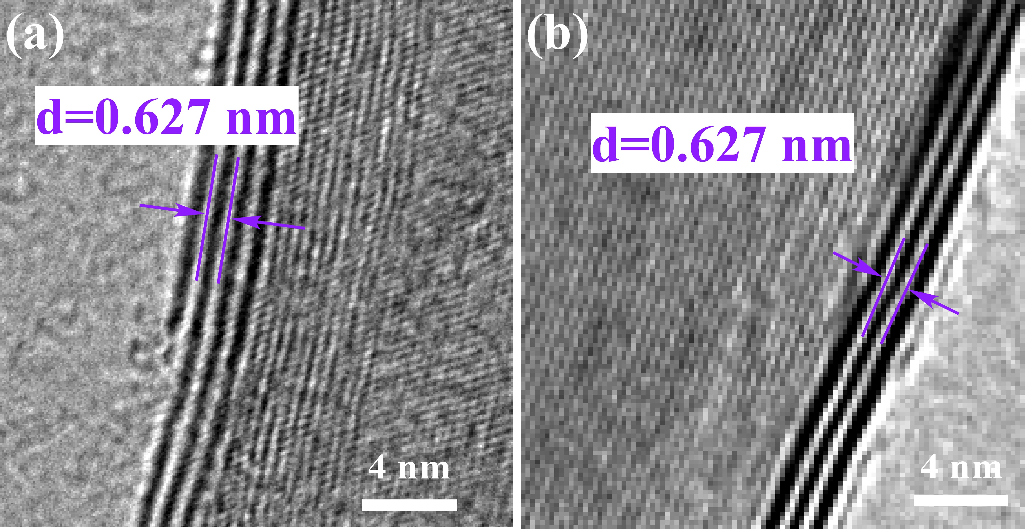
Figure S1. The crystal plane MoS₂ (200) of V-MoS₂@CNT₂ and V-MoS₂@CNT₃.
Figure S2. HADDF-STEM image and EDX results of (a) V-MoS₂@CNT₂ and (b) V-MoS₂@CNT₃
Figure S3. XPS survey spectra of V-MoS₂@CNT₁, V-MoS₂@CNT₂, V-MoS₂@CNT₃ and MoS₂@CNT₂

Figure S4. High-resolution V 2p XPS spectra of V-MoS₂@CNT₂, V-MoS₂@CNT₃ and MoS₂@CNT₂

Figure S5. XANES characterization of V-MoS₂@CNT₁, V-MoS₂@CNT₂ and V-MoS₂@CNT₃. (a, c, e) V K-edge EXAFS (points) and fit (line) for the samples, shown in k² weighted R-space. (b, d, f) V K-edge EXAFS (points) and fit (line) for the samples, shown in k² weighted k-space.
EXAFS fitting is applied through Athena and Artemis software. Wavelet transformation (WT) is also employed using the software package developed by Funke and Chukalina using Morlet wavelet with ĸ = 10, σ = 1.

Figure S6. The dissolution profiles of Li₂S with (a)V-MoS₂@CNT₁, (b)V-MoS₂@CNT₂, (c)V-MoS₂@CNT₃ and (d)MoS₂@CNT₂ electrodes.

Figure S7. Corresponding Tafel plots of Peak A for V-MoS₂@CNT₁, V-MoS₂@CNT₂, V-MoS₂@CNT₃ and MoS₂@CNT electrodes.

Figure S8. GITT voltage profiles of the Li-S batteries with (a) V-MoS₂@CNT₂/S, (b) V-MoS₂@CNT₃/S and (c) MoS₂@CNT/S cathode at 0.2 C.

Figure S9. Galvanostatic charge-discharge profiles of the Li-S batteries with (a) V-MoS₂@CNT₂/S, (b) V-MoS₂@CNT₃/S and (c) MoS₂@CNT/S cathode at different rates in a potential window from 1.7 to 2.8 V
Figure S10. Cycling performances of V-MoS₂@CNT₁/S, V-MoS₂@CNT₂/S, V-MoS₂@CNT₃/S and MoS₂@CNT₂/S cathodes at 0.5 C.

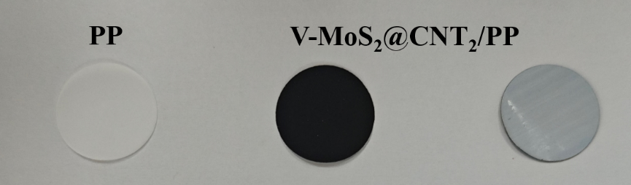
Figure S11. Photographs of PP and V-MoS₂@CNT₂ modified separators.
Figure S12. The electrochemical impedance spectroscopic (EIS) spectra of symmetric batteries assembled with PP and V-MoS₂@CNT₂ separators.

Figure S13. Rate performance of Li||Li symmetric batteries with PP and V-MoS₂@CNT₂ separators.

Figure S14. The internal structure and discharge capacity of pouch cell.

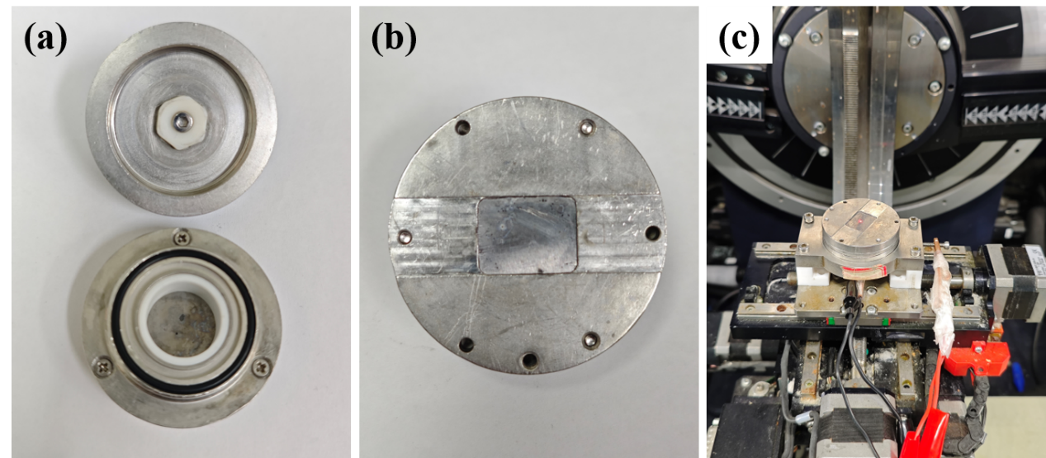
Figure S15. The photograph of (a)(b) in-situ XRD battery and (c) the test process of in-situ XRD test.

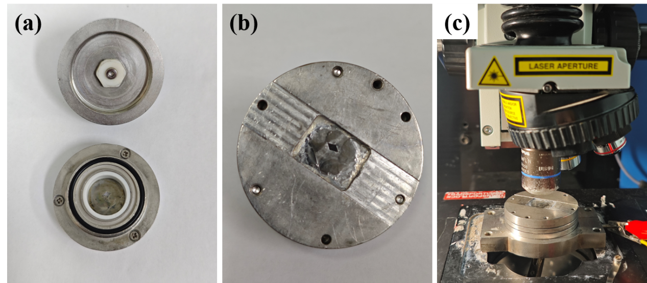
Figure S16. The photograph of (a)(b) in-situ Raman battery and (c) the test process of in-situ Raman test.

Figure S17. Side view and top view and of the optimized configurations for (a) MoS₂, (b) V-MoS₂, (c) curved MoS₂ and (d) curved V-MoS₂.

Figure S18. The adsorption energy of various sulfur species adsorbed on MoS₂, V-MoS₂, curved MoS₂ and curved V-MoS₂.

Figure S19. Side view of the optimized configurations for the binding of S₈, Li₂S₈, Li₂S₆, Li₂S₄, Li₂S₂ and Li₂S to MoS₂.

Figure S20. Side view of the optimized configurations for the binding of S₈, Li₂S₈, Li₂S₆, Li₂S₄, Li₂S₂ and Li₂S to V-MoS₂.
Figure S21. Side view of the optimized configurations for the binding of S₈, Li₂S₈, Li₂S₆, Li₂S₄, Li₂S₂ and Li₂S to curved MoS₂.
Figure S22. Side view of the optimized configurations for the binding of S₈, Li₂S₈, Li₂S₆, Li₂S₄, Li₂S₂ and Li₂S to curved V-MoS₂.
Figure S23. The structures of each state along the reaction path on MoS₂. (Purple: Mo atoms; yellow: S atoms in substrates; red: S atoms in Li₂S; green: Li atoms)
Figure S24. The structures of each state along the reaction path on V-MoS₂. (Purple: Mo atoms; yellow: S atoms in substrates; red: S atoms in Li₂S; green: Li atoms; blue: V atoms)
Figure S25. The structures of each state along the reaction path on curved MoS₂.

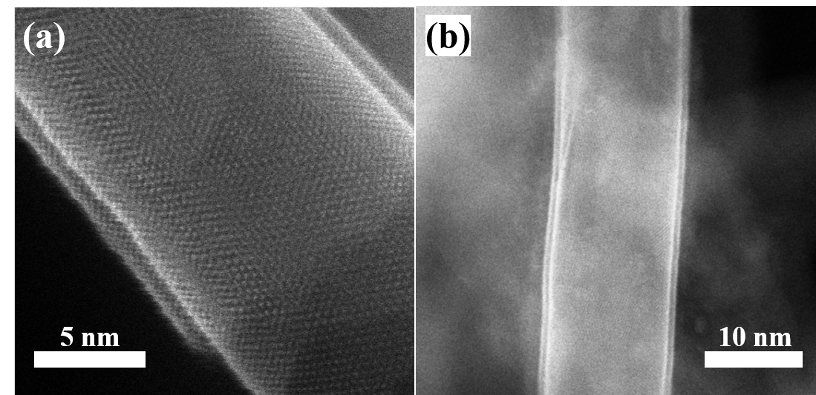
Figure S26. HAADF HRTEM images of V-MoS₂@CNT₂.

Figure S27. High-resolution S 2p XPS spectra of V-MoS₂@CNT₁, V-MoS₂@CNT₂, V-MoS₂@CNT₃ and MoS₂@CNT₂
Figure S28.TGA of (a) V-MoS₂@CNT₁, (b) V-MoS₂@CNT₂, (c) V-MoS₂@CNT₃.

Figure S29. TGA of sulfur content in V-MoS₂@CNT₁/S, V-MoS₂@CNT₂/S, V-MoS₂@CNT₃/S and MoS₂@CNT₂/S
Figure S30. The PXRD pattern of V-MoS₂@CNT₁/S

Figure S31. (a) Digital image of standard Li₂S₆ adsorption test for V-MoS₂@CNT₁ and MoS₂@CNT₁. (b) CV curves of V-MoS₂@CNT₁/S and MoS₂@CNT₁/S electrodes at 0.1 mV s⁻¹. (c) Corresponding Tafel plots of Peak A, Peak B and Peak C in (b) for different electrodes. (d) Nyquist plots of V-MoS₂@CNT₁/S and MoS₂@CNT₁/S cathodes. (e) GCD profiles at 0.2 C for different cathodes. (f) Rate performance of MoS₂@CNT₁/S cathode. (g) Charge/discharge profiles at different current densities with MoS₂@CNT₁/S cathode. Cycling performances of V-MoS₂@CNT₁/S and MoS₂@CNT₁/S cathodes at (h) 0.5 C and (i) 1 C.

Figure S32. Plot of energy density of V-MoS₂@CNT₁ electrodes at different discharge rate.

Energy density (Wh kg⁻¹) is calculated using the following equation (1):
$W=C×V_{cell}$ equation (1)
Where $C$ represents the capacity of the full cell, $V_{cell}$ represents the potential difference between the cathode and anode, Capacity ($C$) is based on the total mass of cell.

Table S1. Vanadium and molybdenum element contents of V-MoS₂@CNT₁, V-MoS₂@CNT₂ and V-MoS₂@CNT₃ using ICP-OES.
Heterostructure | V content (wt %) | Mo content (wt %)
V-MoS₂@CNT₁ | 1.06 | 28.98
V-MoS₂@CNT₂ | 1.05 | 28.26
V-MoS₂@CNT₃ | 0.99 | 28.63

Table S2. EXAFS fitting parameters at the V K-edge for various heterostructures.
Heterostructure | Shell | Nª | R(Å)^{b} | σ²(Å²)^{c} | ∆E₀(eV)^{d} | R factor
V-MoS₂@CNT₁ | V-S | 5.84 | 2.44 | 0.0010 | 2.59 | 0.0119
 | V-Mo | 5.68 | 3.24 | 0.0080 | 2.59
V-MoS₂@CNT₂ | V-S | 5.77 | 2.40 | 0.0020 | -0.97 | 0.0178
 | V-Mo | 5.42 | 3.24 | 0.0062 | -0.97
V-MoS₂@CNT₃ | V-S | 5.61 | 2.40 | 0.0017 | -2.52 | 0.0040
 | V-Mo | 5.28 | 3.23 | 0.0141 | -2.52
ªN: coordination number, ^{b}R: bond distance, ^{c}σ²: Debye-Waller factor, ^{d}∆E₀: the inner potential correction. R factor: goodness of fit. 1<R<3.4 Å, 3<k<8.4 Å⁻¹.

Table S3. Other recently reported literatures
 | Current Density | Cycle Numbers / Specific Capacity (mAh g⁻¹)
Adv. Funct. Mater 2024, 2420351. | 1 C | 500/555.9^{[7]}
Adv. Funct. Mater 2024, 2419105. | 1 C | 500/570^{[8]}
Adv. Funct. Mater 2024, 2417776. | 1 C | 300/571.7^{[9]}
Adv. Funct. Mater 2023, 33, 2305624. | 1 C | 500/727^{[10]}
Angew. Chem. Int. Ed 2023, 62, e202306791 | 2 C | 500/682^{[11]}
Adv. Funct. Mater 2024, 34, 2412253. | 1 C | 400/490.5^{[12]}

Reference
[1] a) J. F. G. Kresse, Physical Review B 1996, 54, 11169; b) J. F. G. Kresse, Comput. Mater. Sci. 1996, 6, 15.
[2] P. E. Blöchl, Phys. Rev. B 1994, 50, 17953.
[3] K. B. John P. Perdew, Matthias Ernzerhof, Phys. Rev. Lett 1996, 77, 3865.
[4] Y. Wang, C. Ban, Y. Feng, J. Ma, J. Ding, X. Wang, L. Ruan, Y. Duan, M. G. Brik, L. Gan, X. Zhou, Nano Energy 2024, 124, 109494.
[5] S. Grimme, J. Antony, S. Ehrlich, H. Krieg, J. Chem. Phys 2010, 132, 154104.
[6] G. Henkelman, B. P. Uberuaga, H. Jónsson, J. Chem. Phys 2000, 113, 9901.
[7] P. Chen, T. Huang, T. Wei, B. Ding, H. Dou, X. Zhang, Adv. Funct. Mater 2024, 2420351.
[8] Z. Bai, Z. Wang, T. Wang, Z. Wu, X. Gao, Y. Bai, G. Wang, K. Sun, Adv. Funct. Mater 2024, 2419105.
[9] X. Ye, F. Wu, Z. Xue, H. Yuan, S. Mei, J. Wang, R. Yang, X. Wu, X. Zhao, H. Pan, Q. Zhang, Y. Xiang, M. Huang, F. Li, Adv. Funct. Mater 2024, 2417776.
[10] C. Huang, J. Yu, C. Li, Z. Cui, C. Zhang, C. Zhang, B. Nan, J. Li, J. Arbiol, A. Cabot, Adv. Funct. Mater 2023, 33, 2305624.
[11] Y. Sun, J. Wang, T. Shang, Z. Li, K. Li, X. Wang, H. Luo, W. Lv, L. Jiang, Y. Wan, Angew. Chem. Int. Ed 2023, 62, e202306791.
[12] C. Sun, L. Gao, W. Rong, R. Kang, J. Li, X. Tian, Y. Bai, X. Bian, Adv. Funct. Mater 2024, 34, 2412253.

