**Supporting information**

**Electric-Dipole Coupling Ion-Dipole Engineering Induced Rational Solvation-Desolvation Behavior for Constructing Stable Solid-State Lithium Metal Batteries**

Feng Tao,[a, b, †] Kaijian Yan,[b, †] Chenxu Dong,[b] Jiajing Wang,[b] Qianmu Pan,[b] Minjian Gong,[b] Jiapei Gu,[b] Chunli Shen,[b] Ruohan Yu,[a] Yuanzhi Jiang,[d] Mingjian Yuan,[d] Cheng Zhou,[b] Meng Huang,[a] Xu Xu[a, b, c] and Liqiang Mai*[b]

[a] Dr. F. Tao, Dr. R.H. Yu, Dr. M. Huang, Prof. X. Xu

Sanya Science and Education Innovation Park of Wuhan University of Technology, Sanya 572000, P. R. China

[b] Dr. F. Tao, Dr. K. J. Yan, Dr. C. X. Dong, Dr. J. J. Wang, Dr. Q. M. Pan, Dr. C. L. Shen, Dr. J. P. Gu, Dr. R. H. Yu, Dr. C. Zhou, Dr. M. Huang, Prof. X. Xu, Prof. L. Q. Mai

State Key Laboratory of Advanced Technology for Materials Synthesis and Processing, School of Materials Science and Engineering, Wuhan University of Technology, Wuhan 430070, Hubei, P. R. China.

E-mail: mlq518@whut.edu.cn

[c] Prof. X. Xu

Hubei Longzhong Laboratory, Wuhan University of Technology (Xiangyang Demonstration Zone), Xiangyang 441000, Hubei, China.

[d] Prof. Y. Z. Jiang, Prof. M. J. Yuan

State Key Laboratory of Advanced Chemical Power Sources, Frontiers Science Center for New Organic Matter, Key Laboratory of Advanced Energy Materials Chemistry (Ministry of Education), College of Chemistry, Nankai University; Tianjin 300071, P. R. China.

[†] These authors contributed equally to this work.

***KEYWORDS:*** *Electric-dipole; Ion-dipole; Solvation-desolvation Behavior; Residual Solvent; Solid-state Lithium Metal Batteries.*

**Methods**

**Materials****:** Polymethyl methacrylate (PMMA), BaTiO3, Lithium bis(fluorosulfonyl)imide (LiFSI) and DMAC were purchased from Aladdin. PVDF (Mw = 300000, 761) was obtained from Arkema. Bacterial cellulose (BC) dispersion was obtained from Guilin Qihong Technology Co. The aqueous solvent of BC dispersion was exchanged with DMAC by centrifugation before use. PVDF, PMMA, BaTiO3 and LiFSI powders were heated at 60 °C for 12 h before use.

**Preparation of solid-state electrolytes:** 265 mg LiFSI and 300 mg PVDF as well as 100 mg PMMA were added and dissolved into 15 ml DMAC solvent. Some fillers such as BC/BaTiO3 (different ratios, total 40 mg) were added to this mixed solution and then it was stirred at 70 °C for 12 h. The obtained homogenized slurry was dried at 55 °C for 48 h to form the solid-state electrolytes by the solution casting method.

**Fabrication of the composite cathode and cell assembly:** The LiFePO4 (1 C=170 mAh g−1) and LiNi0.8Co0.1Mn0.1O2 (NCM811) (1 C = 188 mAh g−1) composite cathode was fabricated by the same facile coating method. The active cathode powder, conductive additives (Super P), and PVDF powder (80:10:10 by solid weight ratio) were mixed with magnetic stirring for 12 hours. Then, the composite slurry was coated on an aluminum current collector and vacuum dried at 60 °C for 12 h. The active cathode material loading for the coin cells and pouch cells was 1-1.5 mg cm−2. No liquid additive was added during the cell assembling process.

**Materials Characterizations:** X-ray diffraction (XRD) patterns were recorded using a D8 discover X-ray diffractometer with Cu Kα radiation. The thermal stability was executed by thermogravimetric analysis (TGA) using a NETZSCH STA 449F5 instrument over the temperature range between 25 °C and 600 °C under nitrogen flux at a heating rate of 10 °C min−1. Differential scanning calorimetry (DSC) curves were tested by NETZSCH DSC 214 instrument over the temperature range between -60 °C and 550 °C under nitrogen flux at a heating rate of 10 °C min−1. Scanning electron microscopy (SEM) was represented by scanning electron microscope (JEOL-7100F). Energy dispersive spectrometer (EDS) was collected by an Oxford IE250 system. Transmission electron microscopy (TEM) and scanning transmission electron microscopy (STEM) patterns were performed by Talos F200 S. X-ray photoelectron spectroscopy (XPS) analysis was performed using a VG MultiLab 2000. Fourier transform infrared spectrometer (FT-IR) was measured via Thermo Nicolet Corporation. 1H solid-state Nuclear Magnetic Resonance (NMR) was measured by Bruker Avance Neo 400WB. Raman spectroscopy experiments were performed on the HORIBA LabRAM HR Evolution micro-Raman spectroscopy system with the 523 nm laser. The AFM examinations were performed with a Bruker Multimode 8. ToF-SIMS measurements were conducted with a PHI nano ToF Ⅲ. A Bi3++ beam (3 kV, 2 nA) with raster size of 100 um was used as the primary beam to detect the samples, sputtering with an Ar+ beam (2 kV, 100 nA, 400×400 μm2) was applied for depth profiling analysis. The sputtering rate is ~9.16 nm/min on SiO2.

**Electrochemical Measurements:** Electrochemical impedance spectroscopy (EIS) was tested by assembling blocking stainless steel|SSEs|stainless steel (SS) cell from 106 to 0.1 Hz with an amplitude of 10 mV via CORRTEST CS3150. The electrochemical stability window was tested by linear sweep voltammetry (LSV) on a lithium|SSEs|stainless steel cell from 0 to 6 V via Autolab PGSTAT302N at a scan rate of 0.1 mV s−1. The ionic conductivity (σ) was calculated according to Equation (1):

$$σ=\frac{L}{R×S} (1)$$

Which S as the effective contacting area among SPE and SS, R presents the resistance value of the bulk electrolyte, and L is the thickness of the SPE.

Arrhenius plots were obtained by calculating ionic conductivity at a temperature range of 25-80 ºC via CORRTEST CS3150. A is conductivity pre-exponential factor, Ea is the activation energy, and T is the absolute temperature, R is the ideal gas constant. The activation energies (Ea) of solid electrolytes were calculated by Arrhenius relation from Equation (2):

$$σ\left(T\right)=A exp \left(-\frac{Ea}{RT}\right) (2)$$

The Li||Li symmetrical cells assembled with GTSSE was measured by chronoamperometry method, a polarization of 10 mV (ΔV) was applied to the cells for 5,000 seconds. The polarization currents of cell including initial (I0) and steady-state (Is) were recorded. The interfacial resistances before (R0) and after (Rs) polarization were tested by alternating current impedance. Afterwards, tLi+ was calculated from Bruce-Vincent-Evans Equation (3):

$$t_{{Li}^{+}}=\frac{I^{SS}\left(ΔV-I^{0}R^{0}\right)}{I^{0}\left(ΔV-I^{SS}R^{SS}\right)} (3)$$

The cycling stability of lithium|SPEs|lithium and solid full cells was conducted using a multichannel battery testing system (LAND CT2001A). The full cells were assembled with composite cathode, SPEs, and lithium metal anodes via ordinal stacking. The cycle performance of Li||LFP cell was tested between 2.5 and 4.2 V. The cycle performance of Li||NCM811 cell was tested between 2.8 and 4.3 V. All the electrochemical properties of solid full cells and lithium symmetric cells were tested at 25 °C.

**Density functional theory (DFT) calculation:** The first-principle-based geometry optimization calculations were carried out within density-functional theory (DFT), implemented in the Vienna Ab Initio Simulation Package (VASP) code, using the frozen-core projector augmented-wave (PAW) method to describe the interaction between the atomic cores and the valence electron density. The exchange-correlation potential was approximated within the generalized gradient approximation (GGA) using the Perdew-Burke Ernzerhof (PBE) functional. The dispersion corrected DFT-D3 schemes were employed to describe the Van der Waals (vdW) interactions. Plane-wave cutoff energy was set to 450 eV. The conjugate gradient algorithm was used in ionic optimization. The convergence threshold was set to 10−5 eV atom−1 in electronic relaxation and 0.02 eV Å−1 in Hellmann–Feynman force on each atom. The Brillouin zone in reciprocal space was sampled by a Γ-centered Monkhorst-Pack scheme with 3 × 3 × 1 k-point grids for BaTiO3 geometry optimization. A 15 Å vacuum layer was added to the slab model of BaTiO3. For molecular systems, a 20 Å* 20 Å* 20 Å cell was built to avoid the interaction of periodic boundary conditions.

**Molecular Dynamics (MD) simulations:** The Molecular Dynamics (MD) simulations of these two electrolyte systems were carried out using the Gromacs program suite, with the hybridized force fields of OPLS-2009IL, CL&P and OPLS-AA/M. The FSI− anion and lithium cation were parameterized using OPLS-2009IL and CL&P forcefields, and a charge scaling of 0.8 was adopted to mimic polarization and charge transfer effects. The DMAC, PMMA, PVDF and BC molecules were simulated using OPLS-AA/M parameters and graph neural network predicted RESP2 charge (GNN-RESP) integrated in the AuToFF web server. All these topology files of these molecules and ions were generated directly using AuToFF.

The initial simulation boxes contained the system components, with dimensions of 80 x 80 x 80 nm3, which were created using the Packmol program. The structures were first energy-minimized and then annealed from 0 to 298.15 K over a 1 ns period with a time step of 1 ps to reach an equilibrium state. The temperature was maintained at 298.15 K using the velocity-rescale thermostatwith a relaxation constant of 1 ps. The pressure was maintained at 1.01325x105 Pa using Berendsen's barostat with an isothermal compressibility constant of 4.5x10-5. Periodic boundary conditions were applied in all directions, and the electrostatic interactions and van der Waals forces were treated using the Particle-mesh Ewald (PME) method with a cut-off distance of 15 Å.

Following the energy-minimization and equilibration steps, a 10 ns MD simulation was performed, with the trajectory saved every 1 ps. The results were analyzed using Gromacs tool-suites, the Visual Molecular Dynamic program (VMD), and additional scripts written by the researchers.

**Supplementary Figures**

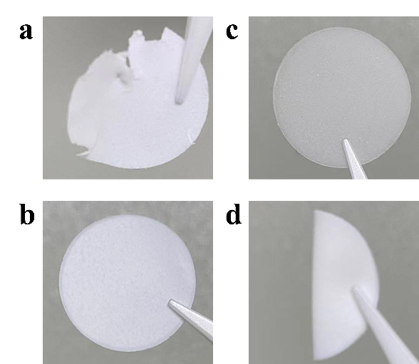

Figure S1. Optical photographs of various electrolyte membranes. a) PPBTO electrolyte, b) PPBB electrolyte, and c) PPBC electrolyte; d) The flexibility measurement of PPBB electrolyte.The poor mechanical strength of PPBTO electrolyte makes it easy to break during film cutting.

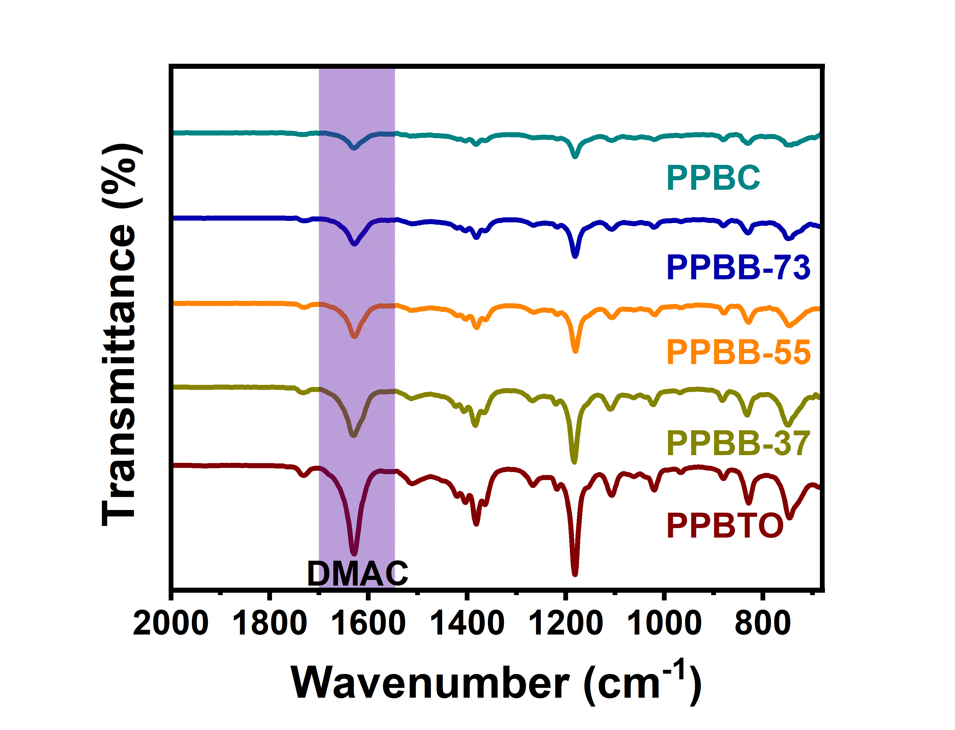

Figure S2. The FTIR spectra of various electrolytes.

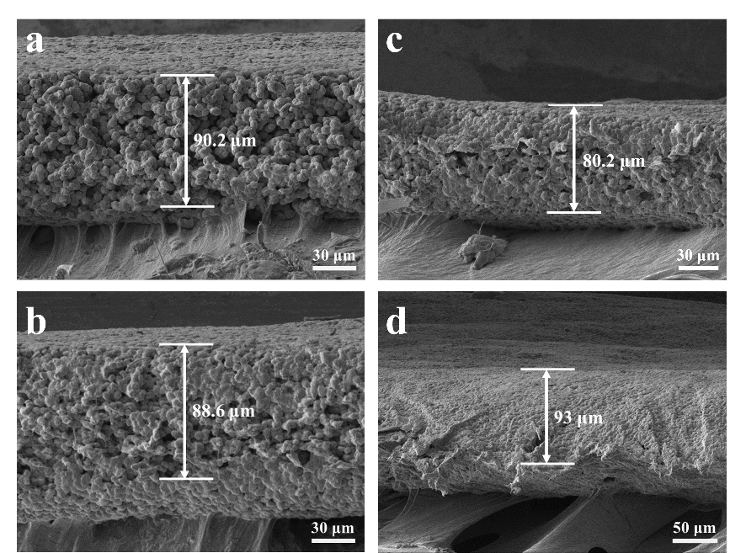

Figure S3. Cross-sectional SEM images of a) PPBTO electrolyte, b) PPBB-37 electrolyte, c) PPBB-73 electrolyte and d) PPBC electrolyte.

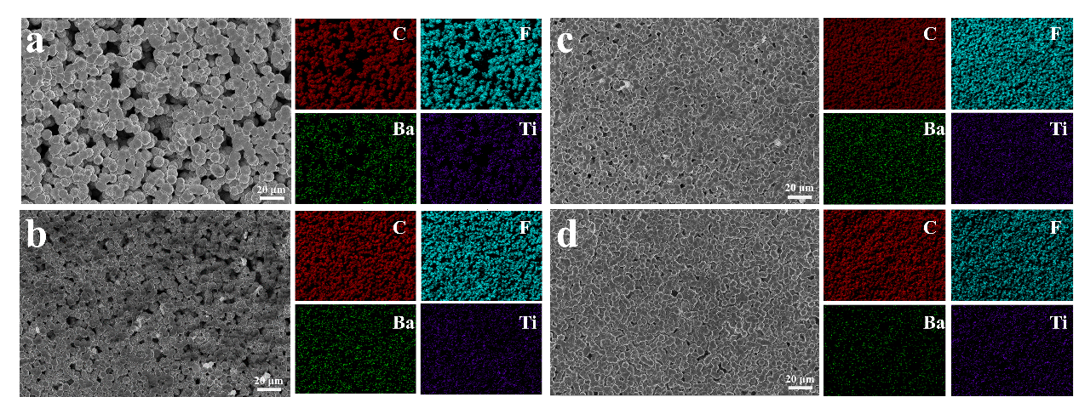

Figure S4. The bottom SEM images and corresponding EDS mapping of a) PPBTO, b) PPBB-37 electrolyte, c) PPBB-73 electrolyte and d) PPBC electrolyte.

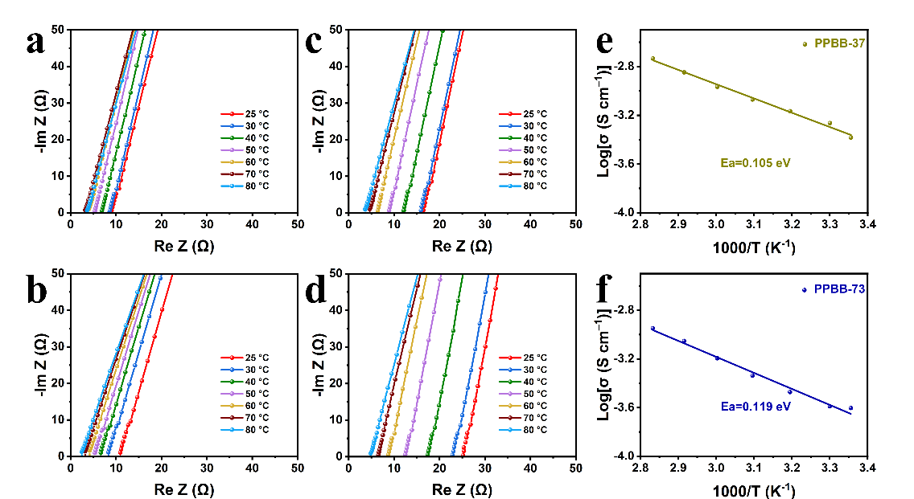

Figure S5. Nyquist plots of SS||SS cells with a) PPBTO, b) PPBB-37, c) PPBB-73 and d) PPBC at different temperatures. The activation energies of e) PPBB-37 and f) PPBB-73 by Arrhenius equation.

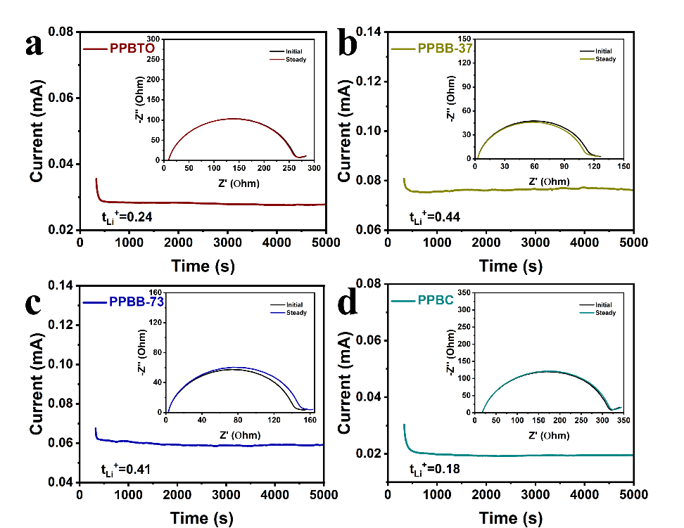

Figure S6. Chronoamperometry curves and corresponding EIS plots before and after the polarization of Li|SSE|Li symmetric cells by using a) PPBTO, b) PPBB-37, c) PPBB-73 and d) PPBC electrolytes.

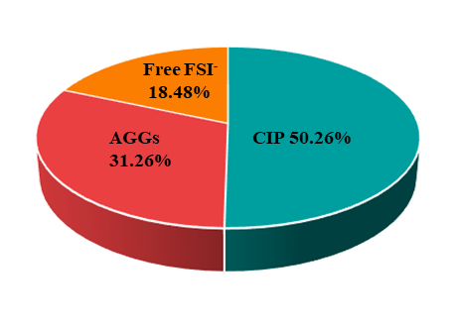

Figure S7. The quantification results of the FSI− anion states in the PPBB electrolyte.

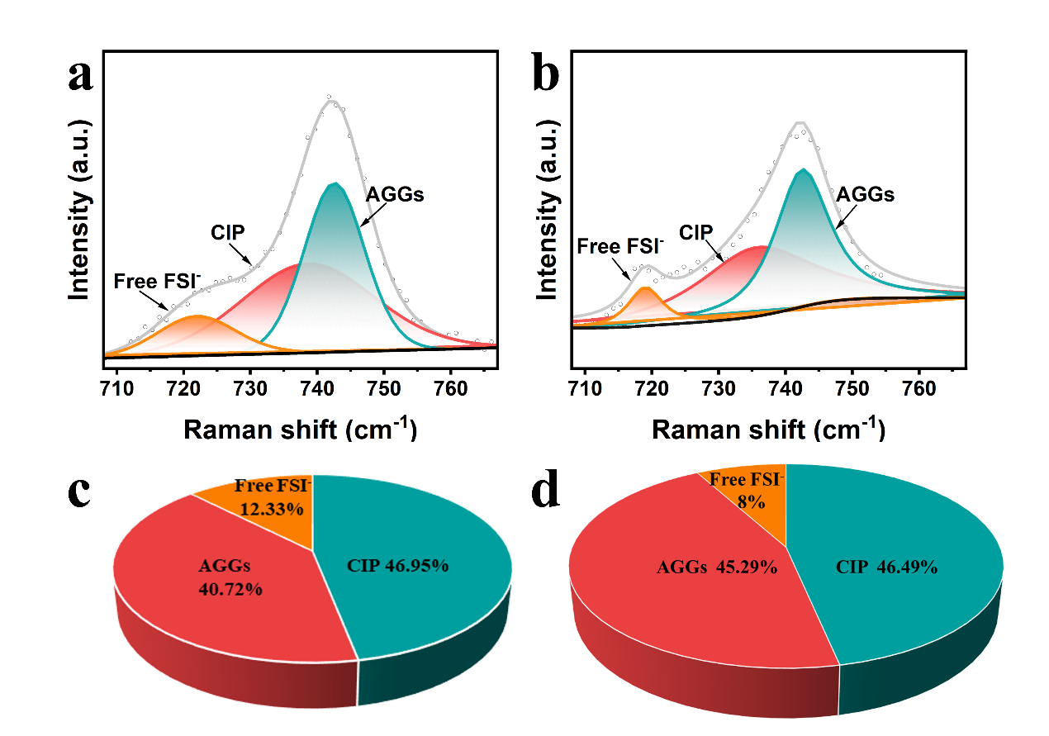

Figure S8. Raman spectra of the a) PPBTO and b) PPBC electrolytes and corresponding quantification results of the FSI− anion states in the electrolytes (c and d).

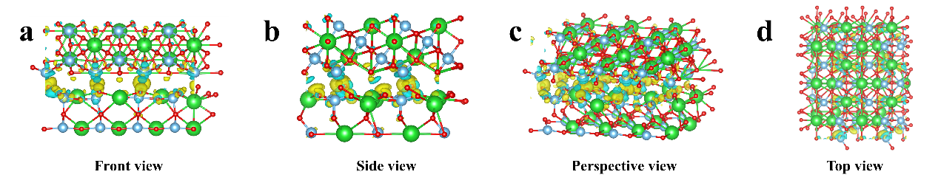

Figure S9. a-d) Schematic illustration of BaTiO3 generating built-in electric field along different directions.

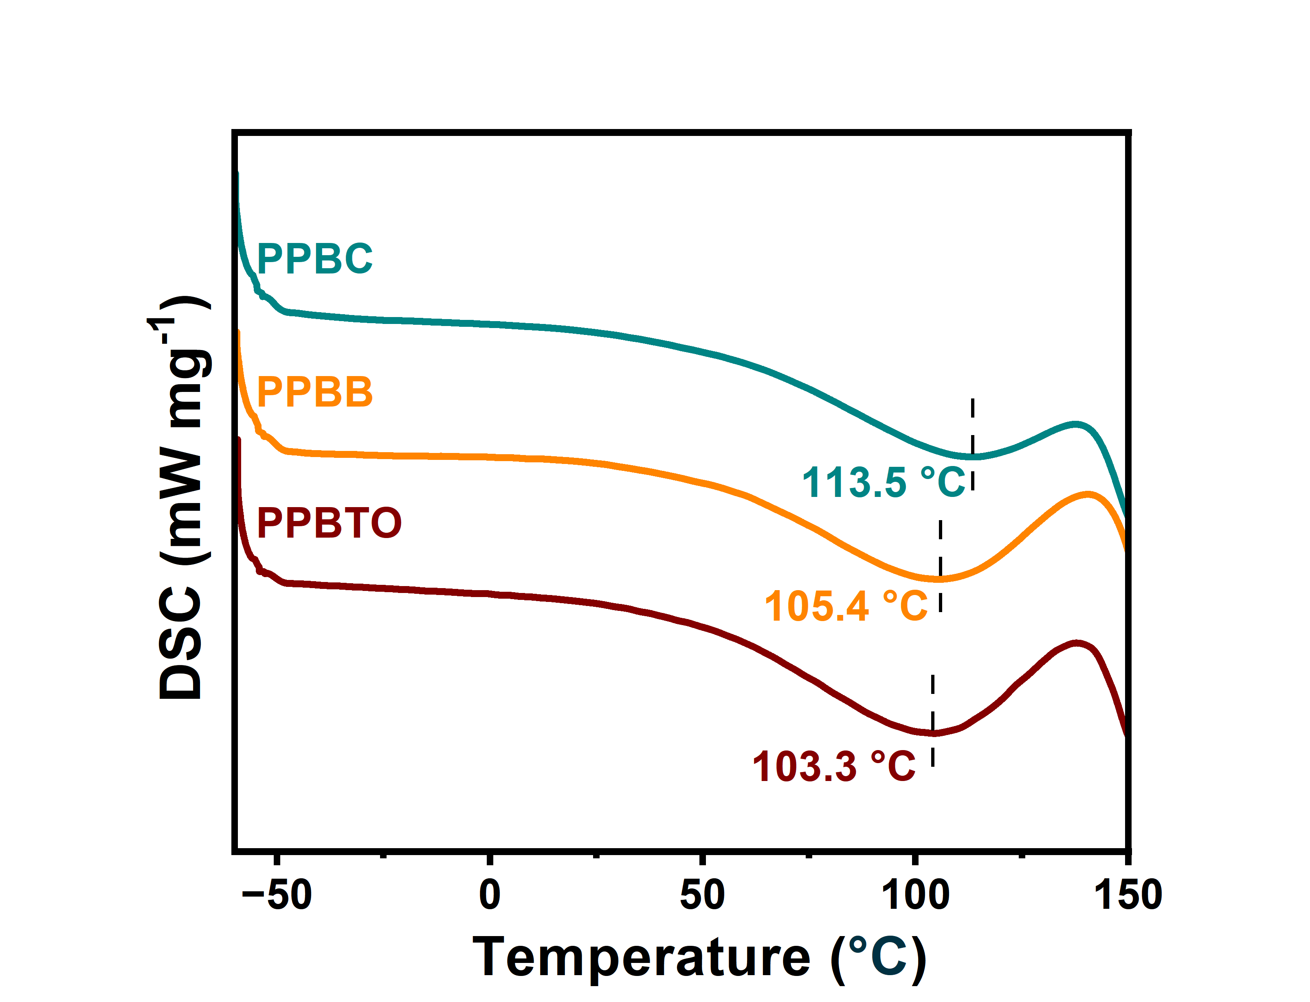

Figure S10. Differential scanning calorimetry curves of the various hybrid electrolytes.

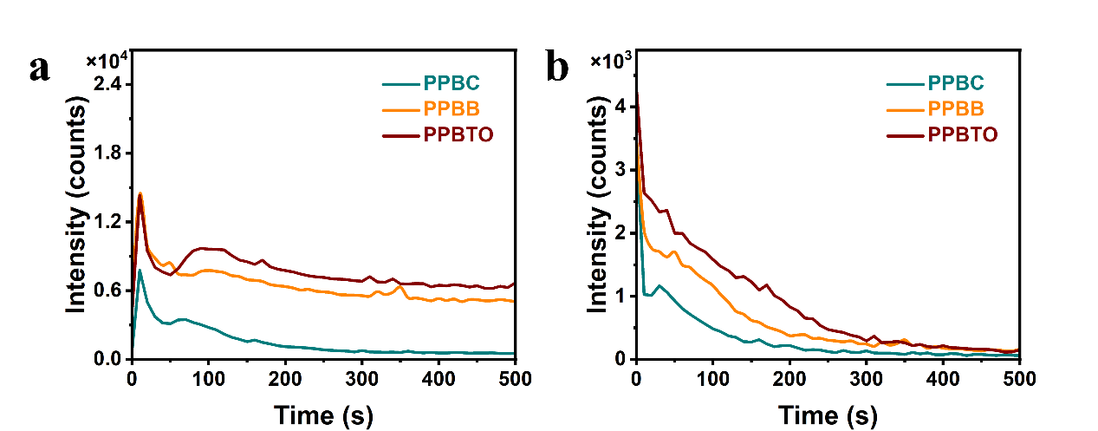

Figure S11. ToF-SIMS depth profiles of a) LiF− and b) C2HO− on the cycled Li anode surface.

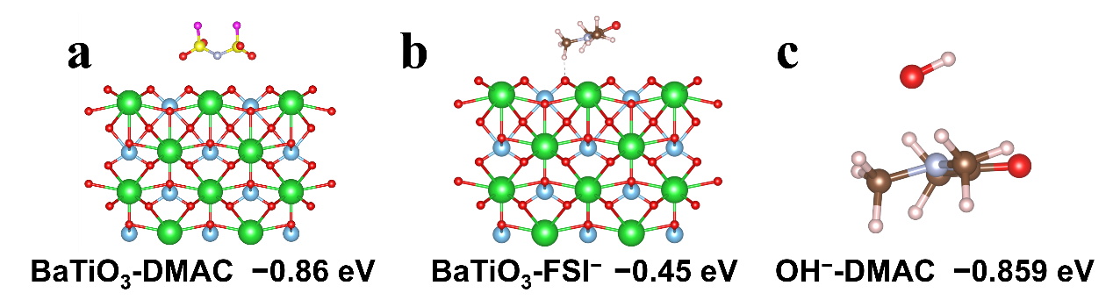

Figure S12. The DMAC adsorption energies on the surface of a) BaTiO3 and c) OH−. b) The FSI− adsorption energy on the surface of BaTiO3.

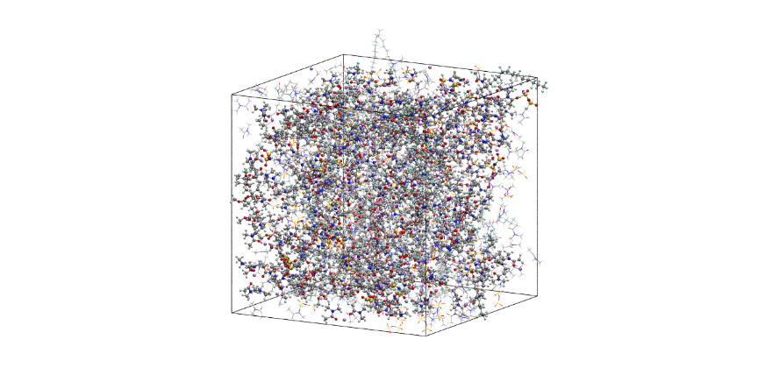

Figure S13. Snapshots obtained from MD simulations of the electrolyte without BC.

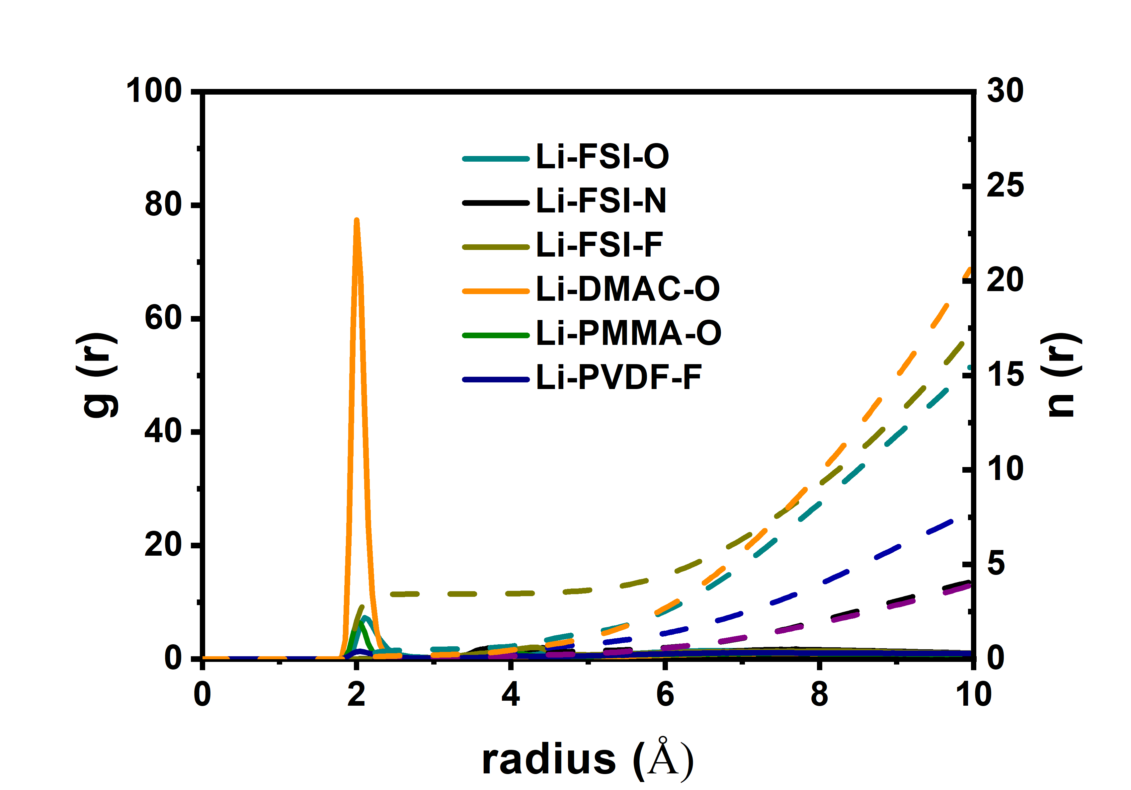

Figure S14. Radial distribution functions in the electrolyte without BC.

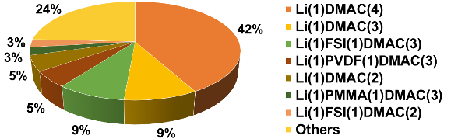

Figure S15. Statistically coordinated species distribution in the electrolyte without BC.

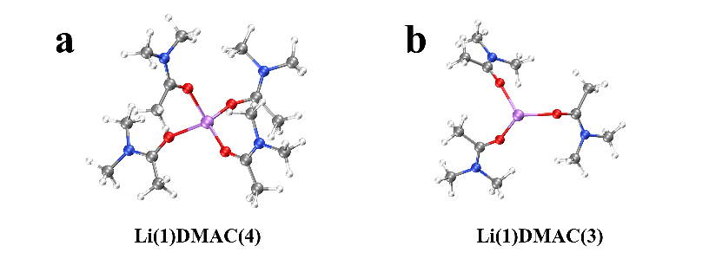

Figure S16. The typical solvation structures in the electrolytes.

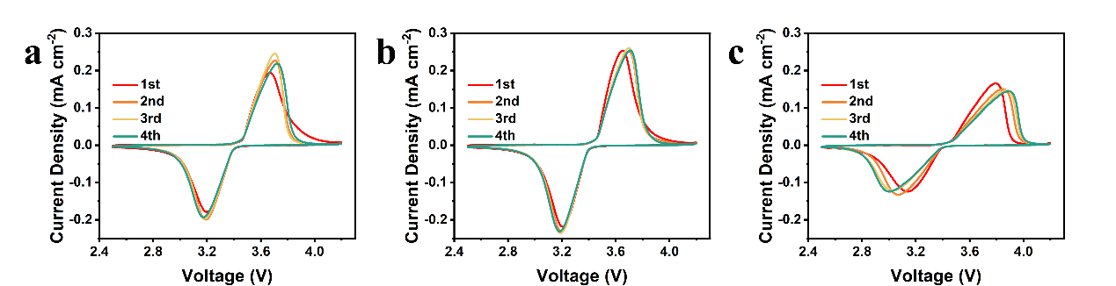

Figure S17. Cyclic voltammogram measurements of the a) LFP|PPBTO|Li, b) LFP|PPBB|Li and c) LFP|PPBC|Li cells.

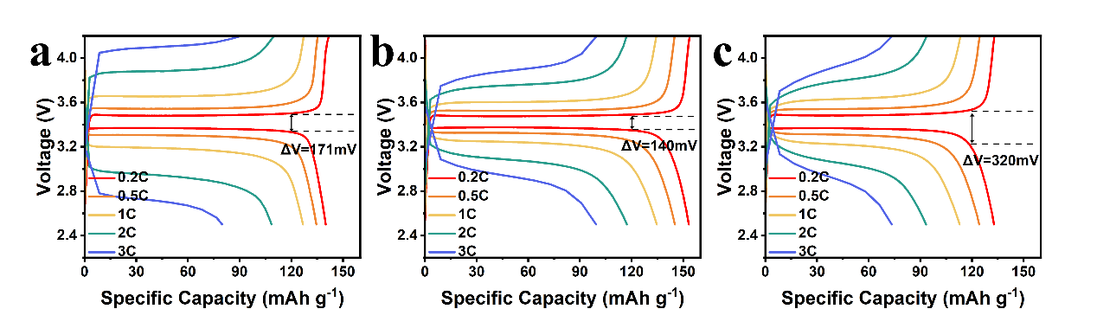

Figure S18. Charge-discharge voltage profiles of a) LFP|PPBTO|Li, b) LFP|PPBB|Li and c) LFP|PPBC|Li cells at various current densities.

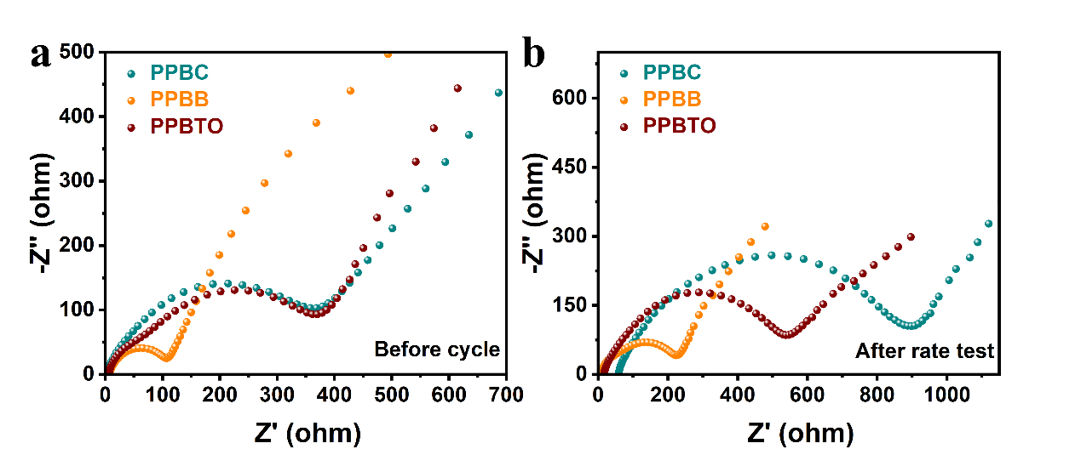

Figure S19. Electrochemical impedance plots of LFP|PPBTO|Li, LFP|PPBB|Li and LFP|PPBC|Li cells. a) before the rate test, b) after the rate test.

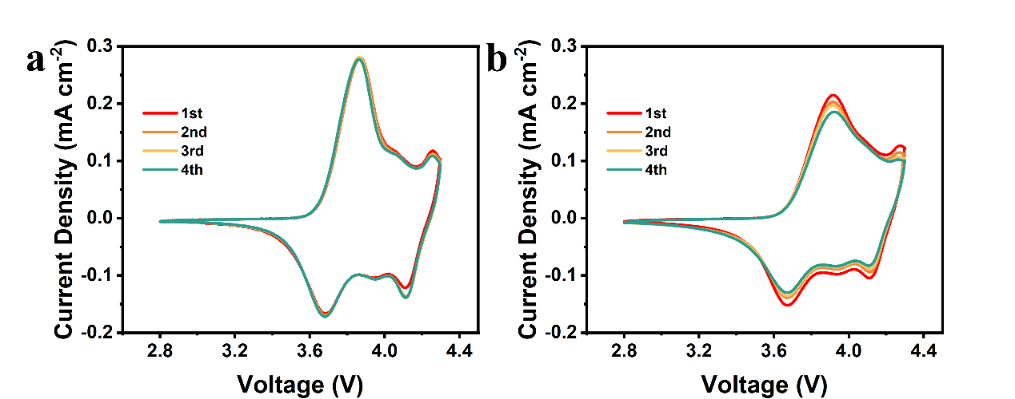

Figure S20. Cyclic voltammogram measurements of the a) NCM811|PPBB|Li, and b) NCM811|PPBC|Li cells.

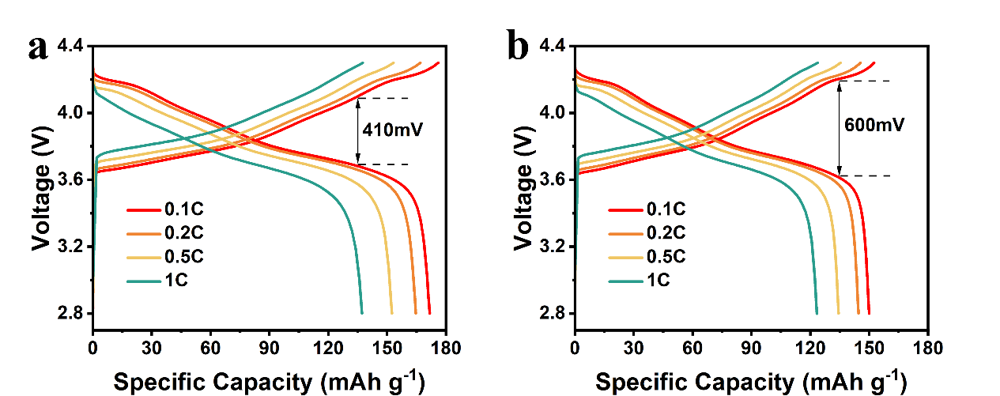

Figure S21. Charge-discharge voltage profiles of a) NCM811|PPBB|Li and b) NCM811|PPBC|Li cells at various current densities.

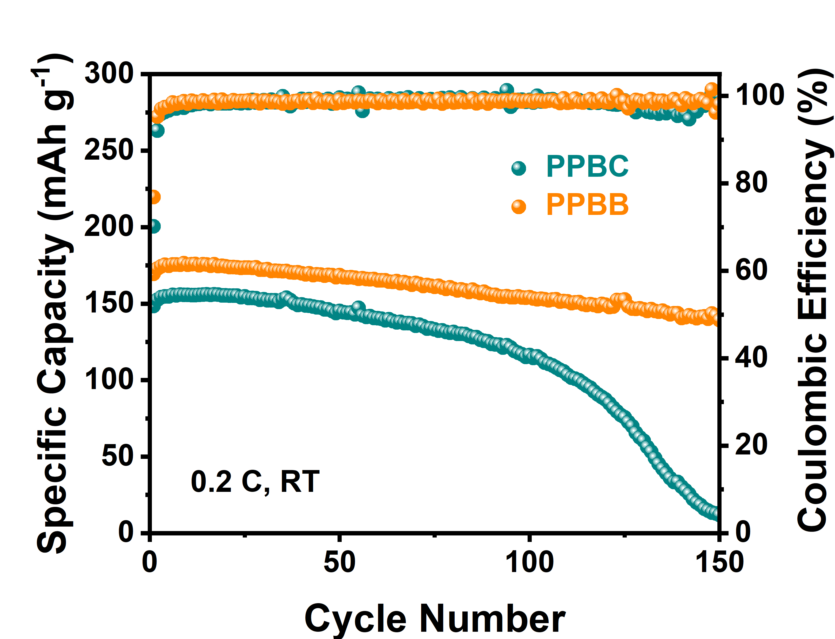

Figure S22. Cycling performance of the NCM811||Li solid-state cells at 0.2 C.

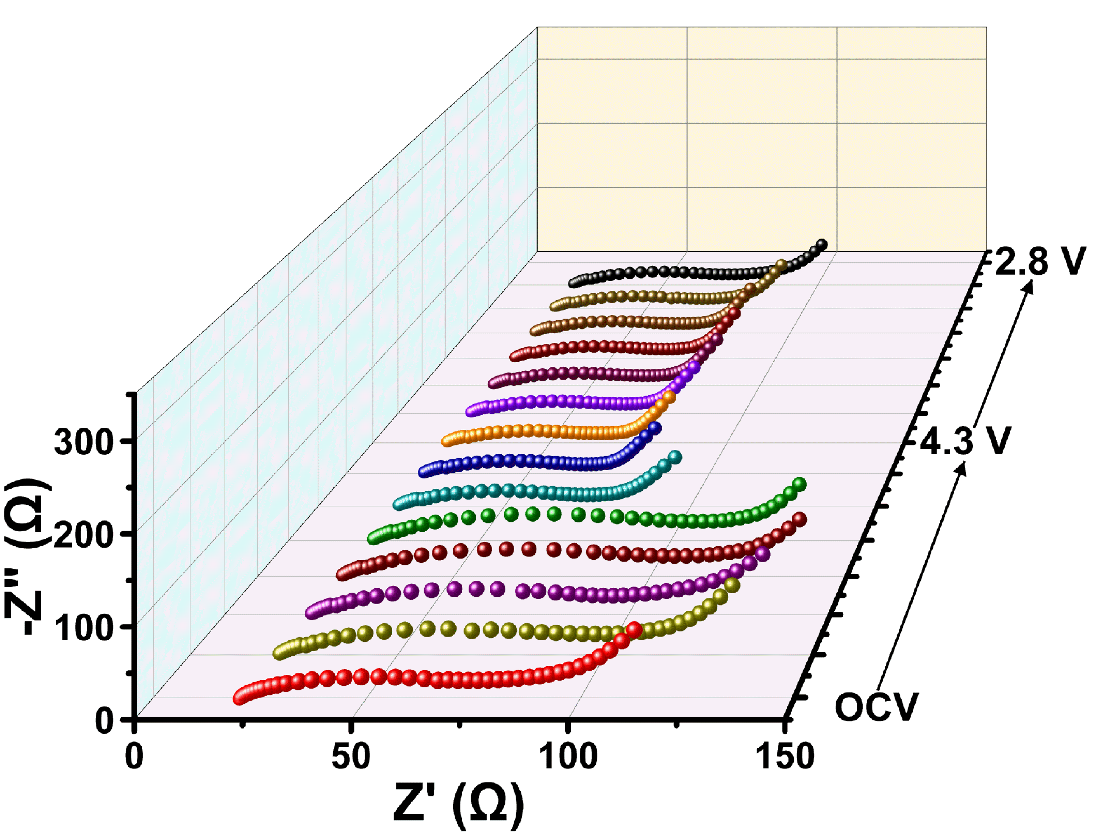

Figure S23. Nyquist plots of the NCM811|PPBC|Li cell obtained from the in-situ EIS test.

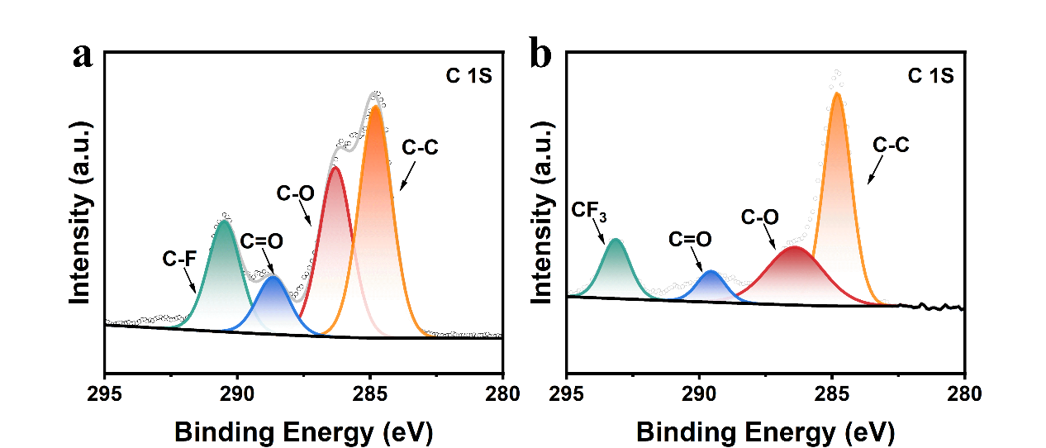

Figure S24. XPS spectra of C 1s collected from the cycled NCM811 surface with a) PPBB and b) PPBC electrolytes.

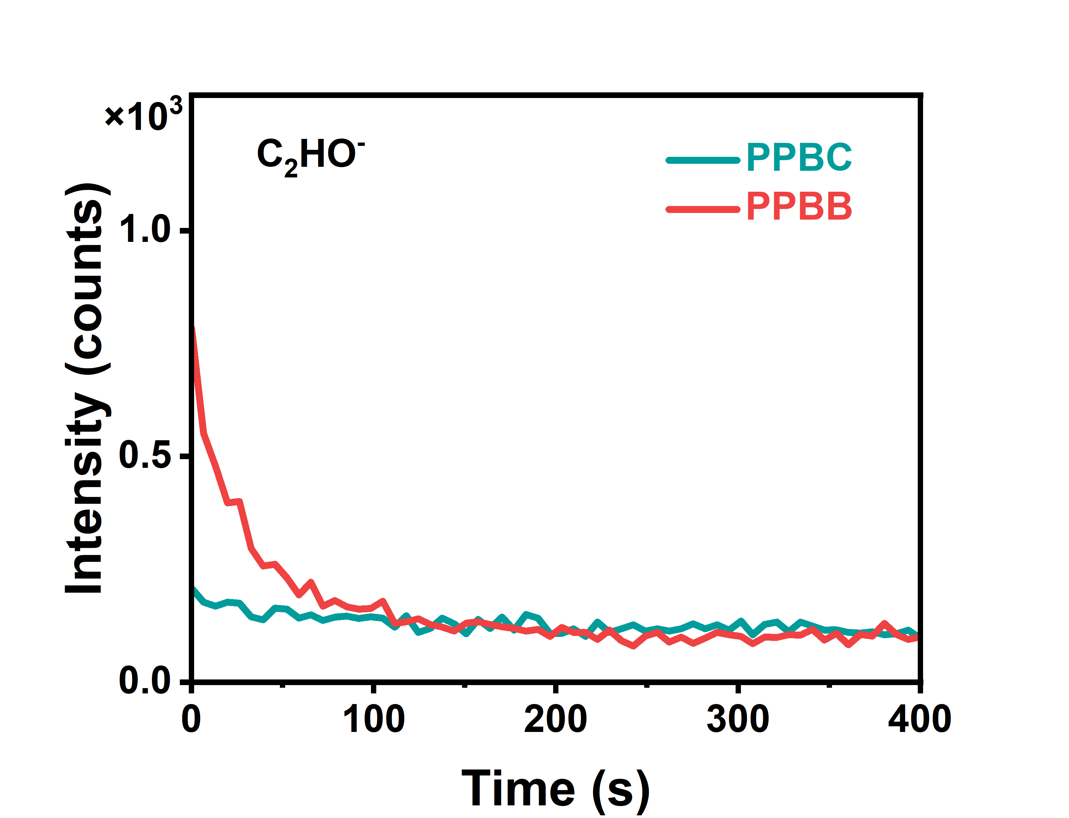

Figure S25. ToF-SIMS depth profiles of C2HO− on the cycled NCM811 cathode surface.

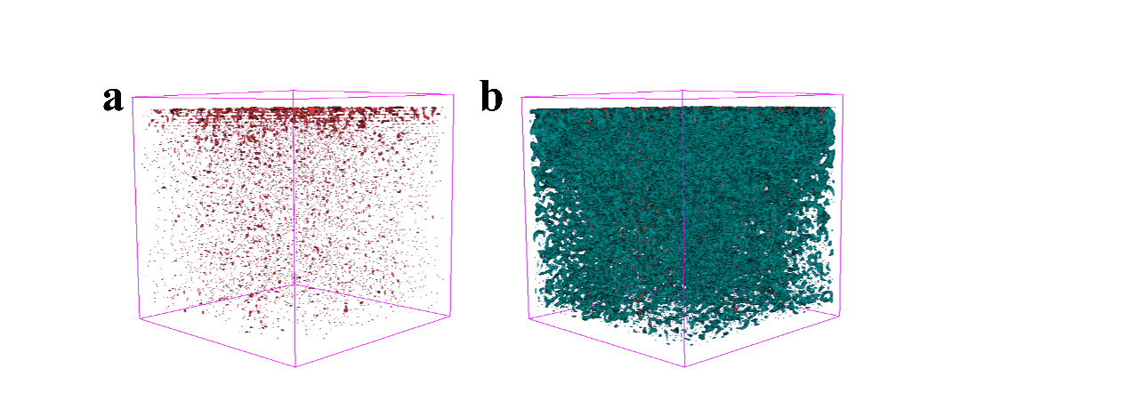

Figure S26. ToF-SIMS 3D reconstruction of the cycled NCM811 cathode surface in the NCM811|PPBB|Li cell. a) C2HO−, b) overlay.

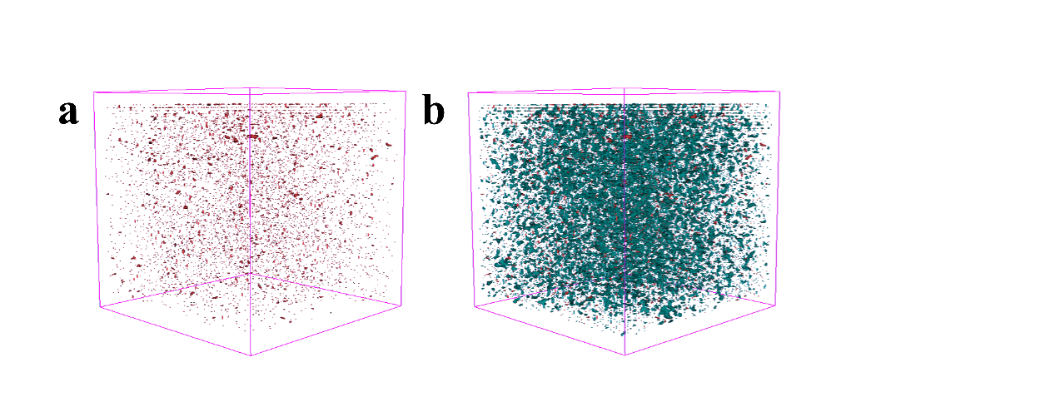

Figure S27. ToF-SIMS 3D reconstruction of the cycled NCM811 cathode surface in the NCM811|PPBC|Li cell. a) C2HO−, b) overlay.

**Supporting Tables**

Table S1: Comparison of ionic conductivities and Li+ transference numbers of different hybrid solid electrolytes.

|  |  |  |  |  |
| --- | --- | --- | --- | --- |
| Hybrid solid  electrolyte | Ionic conductivity  (S cm−1) | Li+ transference numbers | Test temperature  (°C) | Ref. |
| PVDF-g-PEGMEA | 3.03×10−4 | 0.546 | 25 | [1] |
| PVDF-HFP | 1.24×10−4 | 0.53 | 25 | [2] |
| PVDF@PEG | 8.03×10−5 | 0.432 | 30 | [3] |
| PEO/PVDF/LLZTO | 2.73×10−4 | 0.65 | 25 | [4] |
| P(VDF-TrFE-CTFE)/LiTFSI | 3.1×10−4 | 0.33 | 25 | [5] |
| PVDF/d-HNTs | 2.86×10−4 | 0.75 | 25 | [6] |
| PVDF-HFP/LLZTO | 1.11×10−4 | 0.6507 | 25 | [7] |
| (PVDF)-PbZrxTi1-xO3 | 1.16×10−4 | 0.37 | 25 | [8] |
| PPBB | 3.44×10−4 | 0.62 | 25 | This work | |

Table S2: The comparison of Li||Li symmetrical cell performance with different hybrid solid electrolytes.

|  |  |  |  |  |
| --- | --- | --- | --- | --- |
| Hybrid solid electrolyte | Current density (mA cm−2) | Areal Capacity (mAh cm−2) | Worked time (h) | Ref. |
| PVDF-HFP/La2O3 | 0.1 | 0.1 | 500 | [9] |
| PVDF-HFP/LLZTO@Li2CO3 | 0.1 | 0.1 | 1000 | [10] |
| PVDF/PI/LLZTO | 0.1 | 0.1 | 1000 | [11] |
| PNPU-PVDF-HFP | 0.1 | 0.1 | 1000 | [12] |
| PVDF@PEO | 0.1 | 0.1 | 1150 | [13] |
| PVDF/DEE/LiTFSI/DMIm | 0.1 | 0.05 | 800 | [14] |
| Si@LATP/PVDF/PVC | 0.1 | 0.1 | 500 | [15] |
| PEO-PVDF/LiTFSI-LLZTO/Li2ZrO3-CsPF6/2,4,6-TFA | 0.1 | 0.1 | 1100 | [16] |
| PPBB | 0.1 | 0.1 | 1700 | This work |
| 0.25 | 0.25 | 300 |

Table S3: Comparison of the Li|composite polymer electrolytes|Cathode cells with other previous reported works.

|  |  |  |  |  |  |  |
| --- | --- | --- | --- | --- | --- | --- |
| Hybrid solid  electrolyte | Cathode | Rate (C) | Cycle number | Capacity retention | Temperature (°C) | Ref. |
| Li-MMT/PVDF-HFP | LFP | 0.5 | 200 | 99.7% | 30 | [17] |
| Li-MMT/PVDF-HFP | NCM523 | 0.5 | 100 | 90% | 30 | [17] |
| PVDF-HFP/SLN | NCM811 | 0.2 | 85 | 85.3% | 25 | [18] |
| PVDF/LLZTO | LFP | 1 | 200 | 88% | 25 | [19] |
| (F−Mo2C)/C3H6N6/PVDF/PVDF−HFP | LFP | 2 | 500 | 51.6% | 25 | [20] |
| Zr-BDC-Fx/PVDF−HFP | LFP | 1 | 300 | 96.54% | 25 | [21] |
| PVDF/LTO-8 | LFP | 0.5 | 250 | 99.7% | 25 | [22] |
| PVDF-HFP/LLZO | LFP | 0.5 | 300 | 97.2% | 25 | [23] |
| PVDF-HFP/LLZO | NCM811 | 0.5 | 100 | 90% | 25 | [23] |
| PVDF/PPC | LFP | 0.2 | 100 | 89.7% | 30 | [24] |
| PVDF/PPC | NCM622 | 0.2 | 390 | 82.3% | 30 | [24] |
| PVDF/d-HNTs | LFP | 1 | 300 | 80% | 25 | [6] |
| PVDF/d-HNTs | NCM811 | 0.5 | 200 | 70% | 25 | [6] |
| IL-LZSP/PVDF | NCM811 | 0.1 | 200 | 81.4% | 25 | [25] |
| ISMN/PVDF | LFP | 0.5 | 500 | 88.9% | 25 | [26] |
| PVDF/PCL/LATP | LFP | 1 | 500 | 76% | 60 | [27] |
| PPBB | LFP | 1 | 400 | 99.5% | 25 | This work |
| LFP | 3 | 1500 | 47% | 25 |
| NCM811 | 0.5 | 200 | 80% | 25 |
| NCM811 | 0.2 | 150 | 82.5% | 25 |

**References**

[1] J. Yang，R. Li，P. Zhang，J. Zhang，J. Meng，L. Li，Z. Li，X. Pu, *Energy Storage Mater.* **2024**, *64*, 103088.

[2] W. Liu，C. Yi，L. Li，S. Liu，Q. Gui，D. Ba，Y. Li，D. Peng，J. Liu, *Angew. Chem., Int. Ed.* **2021**, *60*, 12931-12940.

[3] Z. Wang，Q. Guo，R. Jiang，S. Deng，J. Ma，P. Cui，X. Yao, *Chem. Eng. J.* **2022**, *435*, 135106.

[4] J. Sun，C. He，X. Yao，A. Song，Y. Li，Q. Zhang，C. Hou，Q. Shi，H. Wang, *Adv. Funct. Mater.* **2020**, *31*, 2006381.

[5] Y.-F. Huang，T. Gu，G. Rui，P. Shi，W. Fu，L. Chen，X. Liu，J. Zeng，B. Kang，Z. Yan，F. J. Stadler，L. Zhu，F. Kang，Y.-B. He, *Energy Env. Sci* **2021**, *14*, 6021-6029.

[6] S. Lv，X. He，Z. Ji，S. Yang，L. Feng，X. Fu，W. Yang，Y. Wang, *Adv. Energy Mater.* **2023**, *13*, 2302711.

[7] X. Li，L. Cong，S. Ma，S. Shi，Y. Li，S. Li，S. Chen，C. Zheng，L. Sun，Y. Liu，H. Xie, *Adv. Funct. Mater.* **2021**, *31*, 2010611.

[8] B.-H. Kang，S.-F. Li，J. Yang，Z.-M. Li，Y.-F. Huang, *ACS Nano* **2023**, *17*, 14114-14122.

[9] Y. Zeng，L. Zhao，J. Zhang，Q. Li，D. Sun，Y. Ren，Y. Tang，G. Jin，H. Wang, *Small Science* **2023**, *3*, 2300017.

[10] X. Yi，Y. Guo，S. Chi，S. Pan，C. Geng，M. Li，Z. Li，W. Lv，S. Wu，Q. H. Yang, *Adv. Funct. Mater.* **2023**, *33*, 2303574.

[11] J. Hu，P. He，B. Zhang，B. Wang，L.-Z. Fan, *Energy Storage Mater.* **2020**, *26*, 283-289.

[12] Y. Ye，X. Zhu，N. Meng，F. Lian, *Adv. Funct. Mater.* **2023**, *33*, 2307045.

[13] Q. Ye，H. Liang，S. Wang，C. Cui，C. Zeng，T. Zhai，H. Li, *J. Energy Chem.* **2022**, *70*, 356-362.

[14] X. Pei，Y. Li，T. Ou，X. Liang，Y. Yang，E. Jia，Y. Tan，S. Guo, *Angew. Chem., Int. Ed.* **2022**, *61*, e202205075.

[15] Y. Jin，X. Zong，X. Zhang，Z. Jia，H. Xie，Y. Xiong, *Energy Storage Mater.* **2022**, *49*, 433-444.

[16] T. Wang，B. Chen，C. Liu，T. Li，X. Liu, *Angew. Chem., Int. Ed.* **2024**, *63*, e202400960.

[17] L. Wang，S. Yi，Q. Liu，Y. Li，Y. Hu，H. Tu，Y. Wang，A. Sun，F. Zhu，F. Mushtaq，B. Liu，P. Xue，W. Li，M. Liu, *Energy Storage Mater.* **2023**, *63*, 102961.

[18] S. Xia，B. Yang，H. Zhang，J. Yang，W. Liu，S. Zheng, *Adv. Funct. Mater.* **2021**, *31*, 2101168.

[19] S. Zhang，Z. Li，Y. Guo，L. Cai，P. Manikandan，K. Zhao，Y. Li，V. G. Pol, *Chem. Eng. J.* **2020**, *400*, 125996.

[20] Y. Shan，L. Li，X. Chen，S. Fan，H. Yang，Y. Jiang, *ACS Energy Lett.* **2022**, *7*, 2289-2296.

[21] W. Huang，S. Wang，X. Zhang，Y. Kang，H. Zhang，N. Deng，Y. Liang，H. Pang, *Adv. Mater.* **2023**, *35*, 2310147.

[22] Q. Zhou，X. Yang，X. Xiong，Q. Zhang，B. Peng，Y. Chen，Z. Wang，L. Fu，Y. Wu, *Adv. Energy Mater.* **2022**, *12*, 2201991.

[23] J. Zhang，Y. Zeng，Q. Li，Z. Tang，D. Sun，D. Huang，L. Zhao，Y. Tang，H. Wang, *Energy Storage Mater.* **2023**, *54*, 440-449.

[24] Z. Jia，M. Jia，Q. Sun，N. Wang，Z. Bi，X. Guo, *Energy Storage Mater.* **2024**, *68*, 103325.

[25] L. Zhu，J. Chen，Y. Wang，W. Feng，Y. Zhu，S. F. H. Lambregts，Y. Wu，C. Yang，E. R. H. van Eck，L. Peng，A. P. M. Kentgens，W. Tang，Y. Xia, *J. Am. Chem. Soc.* **2024**, *146*, 6591-6603.

[26] S. Zhang，H. Liu，Z. Liu，Y. Zhao，J. Yan，Y. Zhang，F. Liu，Q. Liu，C. Liu，G. Sun，Z. Wang，J. Yang，Y. Ren, *Adv. Funct. Mater.* **2024**, 2401377.

[27] D. Pei，Y. Li，S. Huang，M. Liu，J. Hong，S. Hou，H. Jin，G. Cao, *Chem. Eng. J.* **2023**, *461*, 141899.