Supporting Information

Femtosecond Laser-Induced Nanostructured Sacrificial Layer for Stable Zinc Metal Anode

*Sitian Lian, Bo Mai, Zhijun Cai, Yunfan Yue, Zhongle Zeng, Kesong Yu, Xuewen Wang*, and Liqiang Mai\**

S. Lian, B. Mai, Z. Cai, Y. Yue, Z. Zeng, K. Yu, Prof. X. Wang, Prof. L. Mai

State Key Laboratory of Advanced Technology for Materials Synthesis and Processing

Wuhan University of Technology

Wuhan, 430070, P. R. China

E-mail: [xwwang@whut.edu.cn](mailto:xwwang@whut.edu.cn)

mlq518@whut.edu.cn

Z. Cai

Department of Physics, The Chinese University of Hong Kong, Shatin, New Territories, Hong Kong, 999077 (P. R. China)

Y. Yue, Z. Zeng, X. Wang

Center of Femtosecond Laser Manufacturing for Advanced Materials and Devices

State Key Laboratory of Advanced Technology for Materials Synthesis and Processing

Wuhan University of Technology

Wuhan 430070, P. R. China

**Methods**

**Preparation of Fs-Zn**

A commercial femtosecond system with Yb: KGW (PHAROS-10W, Light Conversion, Vilnius, Lithuania) was utilized to create parallel arrays on the commercial bare Zn. The laser’s fundamental wavelength is 1030 nm. The jump and mark speeds were set at 500 mm s-1. The output pulse duration is 260 fs, with an output pulse energy of 15 μJ per pulse at a repetition rate of 200 kHz. The galvo scanning system (ES112166, Aerotech Inc., USA) is fitted with a field lens having a focal length of 100 mm. An attenuator (2-EWP-R-0515-M, Altechna) was applied to regulate the laser pulse energy fluence, and a photodiode power meter (S120VC, Thorlabs) was used to measure the precise pulse energy. Femtosecond laser processing was carried out in the atmosphere.

**Structural characterizations**

The scanning electron microscopy (SEM) studies were conducted by employing the JEOL JSM-7100F Scanning Electron Microscope.

Ex situ X-ray diffraction (XRD) analysis was conducted using a Bruker D2 PHASER Benchtop XRD instrument equipped with a detector and a Cu Kα1 X-ray source at a wavelength of 0.15406 nm.

In situ XRD measurement was performed on a Bruker AXS D8 Advanced diffractometer equipped with an area detector and using a Cu Kα1 X-ray source at a wavelength of 0.15406 nm.

ATR-FTIR measurement was performed using a Thermo scientific iS50 spectrometer equipped with an ATR accessory.

EBSD was conducted using the Field Emission Scanning Electron Microscope (Zeiss Ultra Plus). The sample was polished in advance.

**Electrochemical measurements**

Electrochemical impedance spectroscopy (EIS) was performed with the Electrochemistry Lab System, covering a frequency range from 0.1 Hz to 1000 kHz.

Cyclic voltammetry (CV) was performed with the Electrochemistry Lab System at a scan rate of 0.1 mV/s, sweeping from 0.8 V to 1.8 V and then back to 0.8 V.

Chronoamperometry (CA) measurement was performed on a CHI 760E electrochemical workstation. Galvanostatic charge-discharge measurements were carried out at an ambient temperature of 26 °C using LAND battery testing instruments.

**Assembly of Zn-ion cells**

All the cells were assembled in the atmosphere.

The Zn metal foil utilized in the tests has a thickness of 50 μm.

MnO2 cathode films were fabricated by pressing a blend of active materials, Super P, and polyvinylidene fluoride (PVDF) at a mass ratio of 7:2:1. Carbon paper was used as the current collector.

The glass fiber filter (GF/A, Whatman) served as the separator for all the cells.

The electrolyte for the symmetrical cells was 2 M ZnSO4. For the full cells, 0.3 M MnSO4 was added to the 2 M ZnSO4 electrolyte.

The coin cells in the experiments were of the 2032-coin type. The MnO2 cathode films were punched into circular shapes with a diameter of 10 mm. The zinc foil also had a diameter of 10 mm. The amount of electrolyte used was 70 µL for the symmetrical coin cells and 100 µL for the full coin cells.

The CA test utilized a three-electrode cell configuration, with a Zn foil as the working electrode, a graphite rod as the counter electrode, and a Hg/Hg2SO4 electrode as the reference electrode. The electrolyte solution consisted of 1 M Na2SO4 and 0.1 M ZnSO4 solution.

**Table S1.** Key laser parameters and their dominant effects on nanostructure morphology

|  |  |  |
| --- | --- | --- |
| **Parameter** | **Value** | **Dominant Effect** |
| Pulse duration | 260 fs | Thermo confinement |
| Pulse energy | 15 μJ | Ablation control |
| Spot size  (diameter) | 15 μm | Feature  resolution |
| Wavelength | 1030 nm | Nonlinearity absorption |
| Scanning Speed | 500 mm s-1 | Overlap modulation |
| Repetition rate | 200 kHz |

**Table S2.** Comparative analysis of zinc anode surface engineering techniques

|  |  |  |  |
| --- | --- | --- | --- |
| **Technique** | **Principle** | **Advantages** | **Limitations** |
| Mechanical grinding | Abrasive material removal | Low cost,  Simple setup | Plastic deformation, Poor repeatability, Non-uniform surface |
| Chemical etching/polishing | Controlled chemical corrosion | Low cost,  Scalable | Damage to mechanical strength,  Chemical residues,  Water pollution |
| Picosecond laser lithography | Laser-material interaction | Rapid processing,  Non-contact,  High precision | Residual thermal damage,  Interface delamination,  High equipment costs |
| Femtosecond laser ablation | Laser-material interaction | Minimal thermal effects,  Rapid processing,  Non-contact,  High precision | Interface delamination,  High equipment costs |

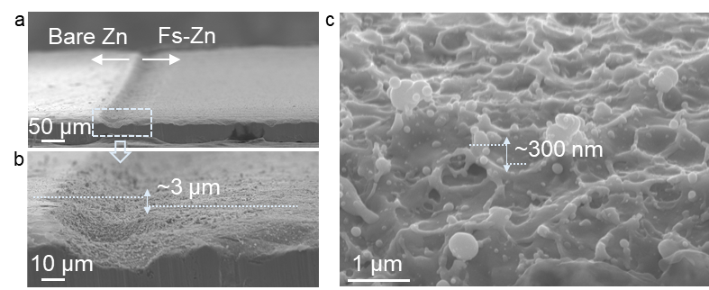**Figure S1**. Cross-sectional SEM images of untreated (left) and Fs-treated (right) surfaces based on one zinc foil a) with the enlarged section b). The dashed line in (b) represents the height of the untreated zinc over the treated zinc. The localized depression generated in the machining zone, resulting from initial scanning speed acceleration-induced energy concentration at the initiation point, is subsequently removed during the stamping process.The cross-sectional SEM image of Fs-Zn c). The dashed line in (c) represents the height of the nanocavity.

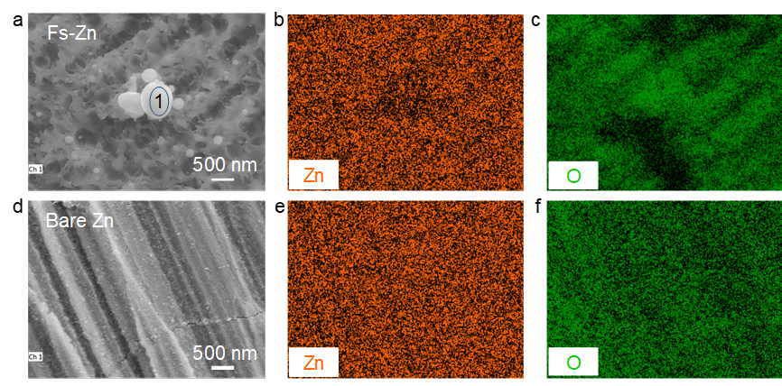

**Figure S2**. a) SEM images of Fs-Zn; EDS mappings for b) Zinc and c) Oxygen element distribution on the Fs-Zn foil; d-f) SEM images of bare Zn and the

corresponding EDS mappings. The inner marked 1 in a) is the EDS point analysis.

**Table S3.** The elements content of the above EDS surface and point analysis

|  |  |  |
| --- | --- | --- |
| **Sample** | **Zn Atomic Fraction (%)** | **O Atomic**  **Fraction (%)** |
| (a) Bare Zn | 90.09 | 9.91 |
| (d) Fs-Zn | 93.98 | 6.02 |
| Point 1 @Fs-Zn | 96.03 | 3.97 |

**Figure S3.** ATR-FTIR of bare Zn and Fs-Zn metal foil.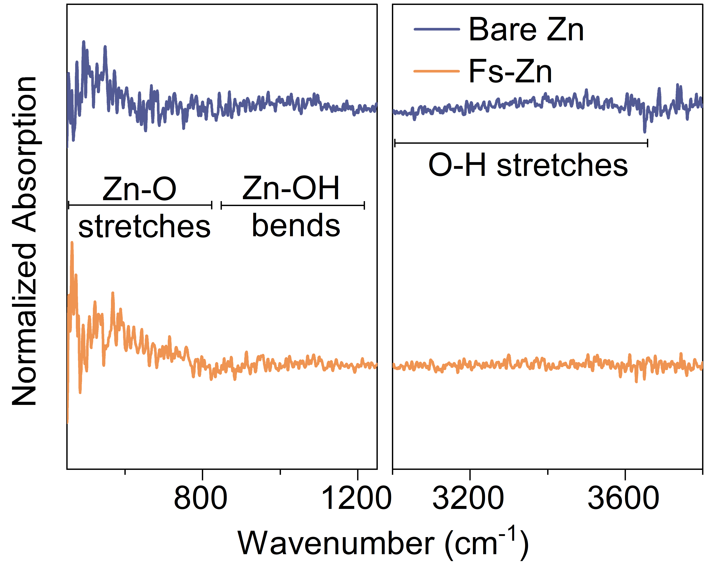 Noise is amplified due to the weak signal from low oxide content.

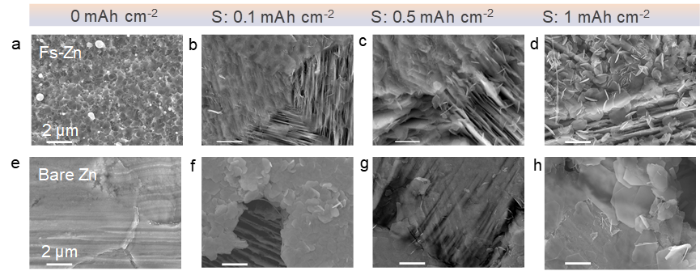

**Figure S4.** High-magnification SEM images of a) pristine and stripped Fs-Zn at 1 mA cm-2 with capacities of b) 0.1 mAh cm-2, c) 0.5 mAh cm-2, and d) 1 mAh cm-2, respectively; SEM images of e) pristine and stripped bare Zn at 1 mA cm-2 with capacities of f) 0.1 mAh cm-2, g) 0.5 mAh cm-2, and h) 1 mAh cm-2, respectively. All scale bars in these SEM images are set to an identical length.

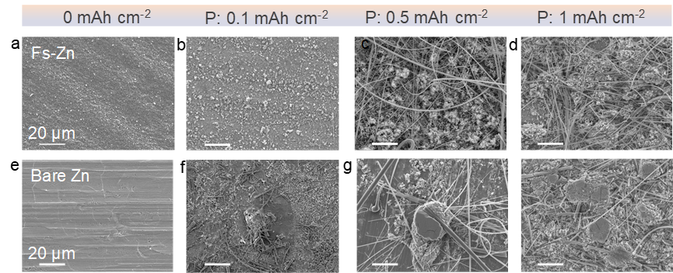**Figure S5.** SEM images of a) pristine and stripped Fs-Zn at 1 mA cm-2 with capacities of b) 0.1 mAh cm-2, c) 0.5 mAh cm-2, and d) 1 mAh cm-2, respectively; SEM images of e) pristine and stripped bare Zn at 1 mA cm-2 with capacities of f) 0.1 mAh cm-2, g) 0.5 mAh cm-2, and h) 1 mAh cm-2, respectively. All scale bars in these SEM images are set to an identical length.

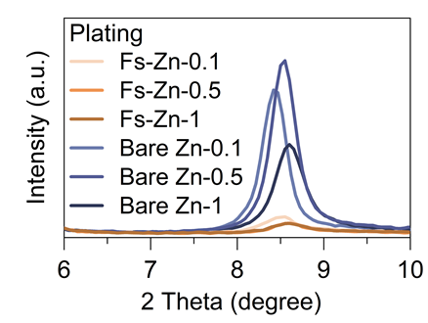**Figure S6.** Ex-situ XRD patterns of Fs-Zn electrode and bare Zn electrode after Zn plating at capacities of 0.1 mAh cm-2, 0.5 mAh cm-2 and 1 mAh cm-2 at 1 mA cm-2. All the experiments were uniformly performed on a 10 mm Zn electrode.

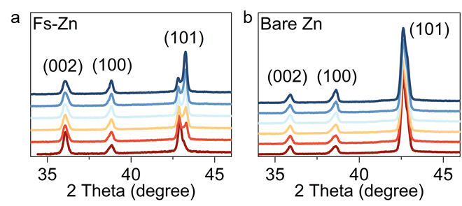**Figure S7.**Stack graphs of in-situ XRD spectra and corresponding discharge profiles for a) Fs-Zn and b) bare Zn electrodes at a capacity of 1 mAh cm-2 at 10 mA cm-2.

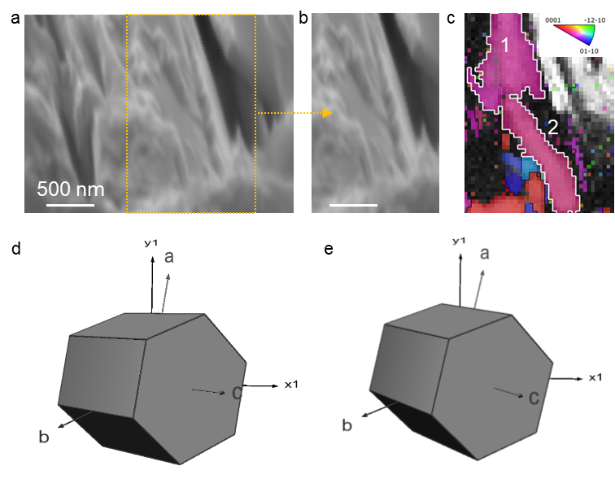**Figure S8.** SEM-EBSD analysis of Fs Zn electrode: Electrode at a stripped capacity of 1 mAh cm-2 a), corresponding section image b), pole figure map correspongding to (b) c). The sample tilt angle is 70°. The rough surface of Fs-Zn slightly affetc the quality of Kikuchi patterns. All scale bars in these SEM images are set to an identical length. d, e) 3D crystal unit cells corresponding to section 1 and section 2 in (c), respectively.

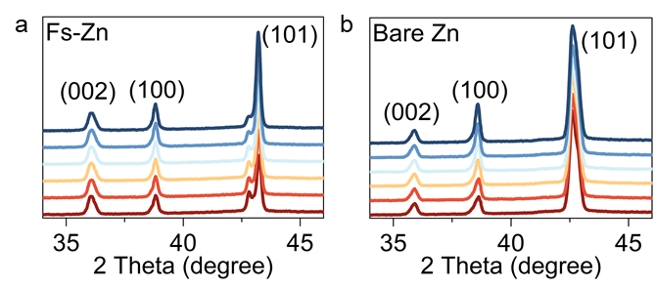**Figure S9.** Stack graphs of in-situ XRD spectra and corresponding charge profiles of electrodes with a capacity of 1 mAh cm-2 at 10 mA cm-2 after first discharge with a capacity of 1 mAh cm-2 at 10 mA cm-2.

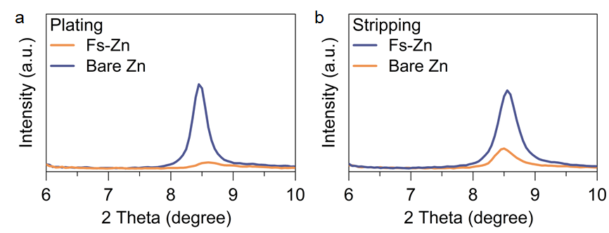**Figure S10.** Ex-situ XRD patterns of Fs-Zn and bare Zn electrodes after Zn a) plating and b) stripping with a capacity of 0.5 mAh cm-2 at 1.5 mAh cm-2. All the experiments were uniformly performed on a 10 mm Zn electrode.

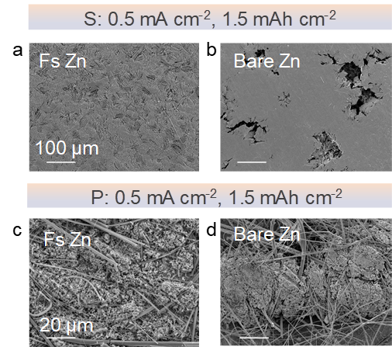**Figure S11.** SEM images of a) Fs-Zn and b) bare Zn electrodes after Zn stripping with a capacity of 0.5 mAh cm-2 at 1.5 mAh cm-2. SEM images of c) Fs-Zn and d) bare Zn electrodes after Zn plating with a capacity of 0.5 mAh cm-2 at 1.5 mAh cm-2. All scale bars in these SEM images are set to an identical length.