Supporting Information

**Pore Microstructure and Mass Transfer Dynamics in Thick Electrodes for High Energy Density Lithium-ion Batteries**

*Bowei Li,a, b Shanfeng Wang,d Pan He,c,* Zhenyao Huang,a Bo Mai,a Xia Zhang,f Yuhang Chen,a Yuehua Wen,a Xiaqing Ran,a Chunhua Han,a Ingo Manke,f Kang Dong,b,* and Mengyu Yan a, e,\**

a State Key Laboratory of Silicate Materials for Architectures, International School of Materials Science and Engineering, Wuhan University of Technology, Wuhan 430070, P. R. China

b Multi-disciplinary Research Division, Institute of High Energy Physics Chinese Academy of Sciences, Beijing 100049, P. R. China

c Department of Chemistry, University College London, London WC1H 0AJ, UK.

d Beijing Synchrotron Radiation Facility, X-ray Optics and Technology Laboratory, P. R. China

e Zhongyu Feima New Material Technology Innovation Center (Zhengzhou) Co., Ltd., High Technology Industrial Development Zone, No. 60 Xuelan Road, Zhengzhou 450001, P. R. China

f Institute of Electrochemical Energy Storage, Helmholtz-Zentrum Berlin für Materialien und Energie, Berlin 14109, Germany

**E-mail: pan.he@ucl.ac.uk; dongkang@ihep.ac.cn; ymy@whut.edu.cn**

**Methods**

***Preparation of LCO cathode:*** LCO was received from Canrd Company. The cathode slurry was prepared by mixing 90.5 wt% LCO, 1.5 wt% conductive carbon (Super P Li, Canrd), 2wt% carbon nanotubes (CNT-3213, Canrd), and 6wt% polyvinylidene difluoride (PVDF) binder (5130 from Canrd). Then, the slurry was coated onto 16 μm-thick Al foil by using the doctor blade, and then slowly dried at 60°C for 5h. After coating, the cathode was calendared and dried in a vacuum oven (105 °C, 48h) before cell assembly. The mass loadings of the active materials for the electrode are ~ 20mg/cm2 (LMLE-LCO) and 50mg/cm2 (HMLE-LCO).

When the electrode reaches a specific thickness, the surface may crack due to the active material's (LCO) intrinsic critical cracking thickness (CCT). The goal of this work is to investigate the effect of a single variable—electrode thickness—on the cell's performance, eliminating performance differences caused by factors such as variations in the preparation process. This approach aims to simulate the design and preparation conditions as closely as possible to those in actual industrial production. To prevent active material particles from shedding and the electrode from folding, the coated and dried electrodes are calendared to the thinnest possible thickness.

***LCO||Li coin cell assembly:*** The electrochemical properties of the electrodes were investigated using CR2032 coin cells (Canrd), assembled in an Ar-filled glovebox (Mikrouna). Each working electrode was punched into discs with a diameter of 10 mm. A Celgard 2500 separator was used for all coin cells. For half-cell electrochemical characterization, the coin cells were assembled by pairing the working electrode with a Li-metal disc (diameter 14 mm; China Energy Lithium Co.), which served as the counter/reference electrode. The electrolyte used for half-cell measurements was type "LB-726" (DoDochem Corp).

**Characterization**

***Electrochemical characterization:*** Battery charge-discharge testing was conducted using NEWARE battery cyclers. All charge-discharge tests were performed within a voltage range of 3.0–4.6 V. The areal capacities for electrodes with mass loadings of 20 mg/cm² and 50 mg/cm² were 4.4 mAh/cm² and 9.5 mAh/cm², respectively, at a current density of 0.1C.CV and EIS measurements were conducted using a BioLogic potentiostat (SP-300) at room temperature. EIS measurements were performed over a frequency range of 1 mHz to 10 MHz. The CV measurements were conducted at a fixed scan rate of 0.1 mV/s within an electrochemical window of 3.0−4.6 V. Galvanostatic charge−discharge processes were carried out at room temperature using NEWARE battery cyclers, with an electrochemical window of 3.0−4.6 V. GITT was performed at a current density of 0.1 C, with pulse and relaxation times of 0.5 and 2 hours, respectively. Prior to GITT measurements, the cells were activated at 0.1 C for one cycle.

***Material characterization:* Before disassembly, the samples were cleaned with dimethyl carbonate (DMC) and vacuum-stored. The sample morphologies were characterized using SEM (S-4800, HITACHI) at 10 kV extra high tension. XPS data were collected using an ESCALAB 250 Xi photoelectron spectrometer (Thermo Fisher Scientific), with all binding energies referenced to the C 1s peak at 284.8 eV. The content of various valence states of cobalt was identified by XPS. TOF-SIMS measurements of lithium content were conducted with a PHI nano TOF III. A Bi3+ beam (30 kV, 2 nA, 200 μm) with a raster size of 100 μm was used as the primary beam for sample detection, while sputtering was performed with an Ar+ beam (2 kV, 100 nA, 400 × 400 μm²). The sputtering rate on SiO2 was 0.25 nm/s.**

***Synchrotron characterization:*** The micro-CT test was conducted at the BAMline end-station at the BESSY II electron storage ring of the Helmholtz-Zentrum Berlin, Germany. Additional test parameters are listed in Table S1. The TXM-XANES test was performed at the BL18B beamline at SSRF. FIB (FEI Scios 2) was used to select suitable particles for testing on electrodes. The TXM-XANES images were collected from different LCO electrodes by scanning the Co K-edge ranging from 7638 to 7822 eV, with a 1 eV step size, as detailed in Table S2. All CT data (micro-CT, TXM) were processed using Avizo software.

**Note 1**

To obtain the tortuosity value, the pore distribution obtained previously is used. Further calculations are performed using image processing software (Avizo). A module called "Generate Properties" is used to simulate an experiment and calculate the absolute permeability and tortuosity of the extracted Pore Network Model.[1] Absolute permeability: The flow is assumed to be laminar throughout (Poiseuille flow). Tortuosity is defined as the ratio of the actual distance the electrolyte flows to the linear distance in space. To compute the model's absolute permeability, it is assumed that the network is filled with a single phase. Mass conservation for each pore body in the steady-state flow of an incompressible fluid is defined as follows: $\sum_{i→j}{q_{ij}}=0$ (1)

where qij is the flow rate between pore i and pore j, and the summation is carried out on all the j connected to the i. The relationship between pressure drop and flow rate is linear in laminar flow conditions:

$q_{ij}=g_{ij} \left(P_{i}-P_{j}\right)$ (2)

The conductance of the throat between pores i and j is denoted as gij. The hydraulic conductance is determined by Poiseuille's law, where µ is the fluid viscosity, since the conducting throats are represented by cylindrical pipes of radius rij and length lij:

(3)

A linear system of equations that can be solved numerically is produced by applying a pressure differential throughout the network: (1) (2) leads to the following matrix equation:

$G⋅P=S$ (4)

where P is a vector of size N that represents the pressure in each pore, which is unknown in the problem; S is a vector of size N that is limited by the pressure boundary conditions at the system's inlet and outlet; and G is the conductance matrix, a symmetrical matrix of dimension N·N, where N is the number of pores in the network. After that, the overall flow rate may be calculated:

$Q=\sum{(P_{i}}-P_{j}) g_{ij }$ (5)

An arbitrary cross section of surface A is intersected by each pair of pores i, j. Finally, the network's permeability k is inferred using Darcy's law:

$k=(Q⋅μ⋅L)/(ΔP⋅A)$ (6)

Where L is the network's length in the flow direction and ΔP is the pressure gradient supplied to the boundary (input pressure minus output pressure).

Tortuosity: The hydraulic tortuosity provided by the module is derived from velocities calculated through the absolute permeability analysis mentioned earlier.

The tortuosity can be deduced by calculating the ratio of the summed magnitudes of velocities in all throats to the summed projections of these velocities along the flow direction, given the velocities within each throat. This is expressed as：

$T=(\sum_{i=0}^{n}{\left\|v_{i}\right\|})/(\sum_{i=0}^{n}{\left\|vx_{i}\right\|})$ (7)

T is the tortuosity, n is the number of throats, vi is the velocity of the fluid passing through the throat i, and  vxi is the projection of the velocity along the flow direction of the fluid passing through the throat i.

**Note** **2**

Further,Nm can be calculated by the following equation 8:**[2]**

(8)

Rion is ion transport resistance. A is the area of the electrode; $σ$ is the electrolyte conductivity; D is the thickness of the electrode.

A = 0.785cm2 can be obtained by calculating the area formula of a circle; D can be seen from Figure 2a,b; σ =9.0mS/cm measured by conductivity tester; Rion is tested by EIS: Lengthen the low-frequency line segment in the Nyquist plot until it intersects the real axis **(Figure 3b)**. Some key parameters of the LMLE and HMLE are shown in Table S1.

**Note** **3**

The electrolyte's average diffusion coefficient ($D_{0}$) within the electrode can be determined using the Nernst-Einstein equation (Equation 9).**[3,4]**

(9)

σis the electrolyte conductivity; F is Faraday's constant; c is the concentration of lithium-ion; R is the gas constant; T is the temperature.

The values in the formula are utilized to calculate the diffusion coefficient (D0) of the electrolyte, which is equal to 2.4×10-6 cm2/s.

Because of the electrode's porous form, the electrolyte diffusion channel does not line perpendicularly with the collector's orientation. As a result, the actual diffusion efficiency (Deff) of the electrolyte should be calculated using equation 9.

$D_{eff}=D_{0}⋅(ε/τ)$ (10)

The porosity (ε) and totuosity (τ) of the two thickness measured by micro-CT are put into equation 10 repectively.

**Note 4**

Absolute permeability is defined as the ability of a porous medium material to transport a single-phase fluid. It is an intrinsic property of the porous media material, and its value is solely dependent on the pore structure of the material in question. It is not influenced by external conditions.[5–8]

(11)

In Equation (11): Q represents the overall flow rate through the porous medium of the intact electrode. S denotes the cross-sectional area of the fluid flowing through the intact electrode, while K is the permeability coefficient.[9–11]

(12)

In Equation (12): k represents the absolute permeability, while m denotes the viscosity of the fluid in question. The parameter ΔP signifies the pressure difference applied around the intact electrode sample, with L denoting the length of the sample in the direction of flow, expressed in metres. The term Q/S is referred to as the flow velocity v, which indicates the average velocity or Darcy velocity of the fluid through the surface of the intact electrode sample.

In order to calculate absolute permeability, it is necessary to solve the Stokes equation, which is a simplification of the Navier–Stokes equation. This is done by making a number of assumptions, including that water is an incompressible fluid, that its density is constant, that it is a Newtonian fluid, that its viscosity is constant, and that the seepage process is steady. Additionally, the seepage velocity is assumed to remain constant over time. This kind of flow within the undisturbed electrode is of the laminar flow type, characterised by a low flow velocity and the absence of turbulent flow.[12,13]

(13)

In Equation (13): $\vec{∇.}$ is the scattering operator; $\vec{∇}$ is the gradient operator; Vis the velocity of the fluid in the fluid phase (unit: m/s); µ is the viscosity of water (unit: Pa·s); $∇^{2}$ is the Laplace operator; P is the fluid pressure of the material in the fluid phase. Once equation system 13 has been solved, the estimation of the permeability coefficient requires the application of Darcy's law. All values of this equation can be derived from the solution of the system of equations (Q, ΔP). The calculation is performed by the absolute permeability experimental simulation module. The water employed for this percolation simulation is utilised as the fluid for the simulation, which is capable of satisfying the percolation conditions of the Stokes equations.

**Table S1.** The parameters of micro-CT for LMLE and HMLE.

|  |  |
| --- | --- |
| **Parameters** | **Value** |
| X-ray energy (keV, LMLE) | 28 |
| X-ray energy (keV, HMLE) | 30 |
| Magnification | 20 |
| Pixel size (μm) | 0.36 |
| Exposure time (ms) | 500 |
| Rotation angle range (°) | 180 |
| Field of view (mm2) | 0.92 × 0.78 |

**Table S2.** The parameters of TXM for LMLE and HMLE.

|  |  |
| --- | --- |
| **Parameters** | **Value** |
| X-ray energy (keV; LMLE, HMLE) | around 7.85 |
| Pixel size (nm) | 40 |
| Exposure time (s) | 1 |
| Rotation angle range (°) | 180 |

**Table S3.** Comparison of two parameters between LMLE and HMLE.

|  |  |  |
| --- | --- | --- |
| **Parameters** | **Low mass loading** | **High mass loading** |
| Thickness of the electrode (μm) | 68 | 190 |
| Ion transport resistance (Ω) | 6.21 | 42.42 |

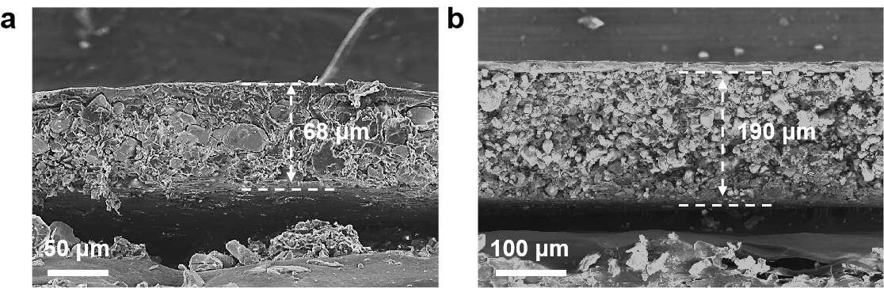

**Figure S1.** The SEM images of (a) LMLE and (b) HMLE show the thickness of ~68 µm and ~190 µm.

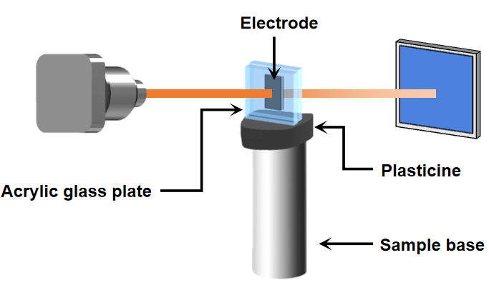

**Figure S2.** The sample test method for synchrotron micro-CT.

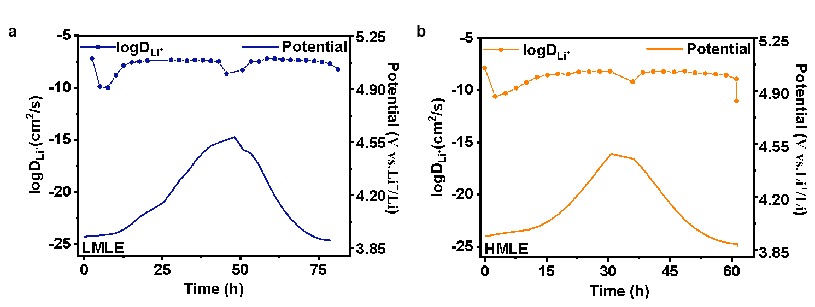

**Figure S3.** GITT of profiles of the (a) LMLE and (b) HMLE.

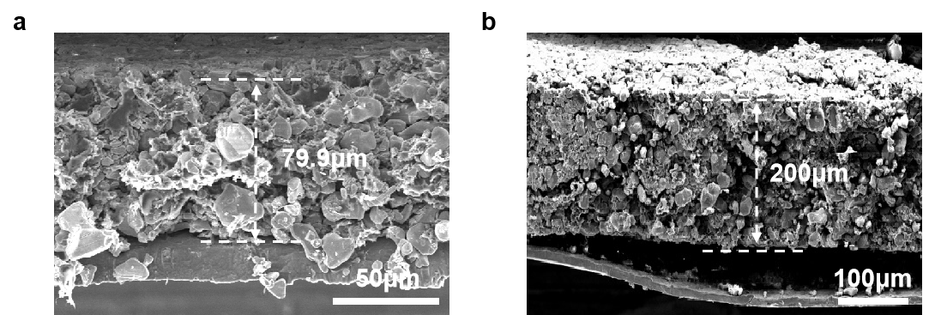

**Figure S4.** Cross-section SEM images of LMLE (a) and HMLE (b) after cycling.



**Figure S5.** Nyquist plots of LMLE and LCO cells using Li metal anode as the counter electrode after 1 and 100 cycles



**Figure S6.** Nyquist plots of the LMLE and HMLE cells using Li metal anode as the counter electrode before cycling.

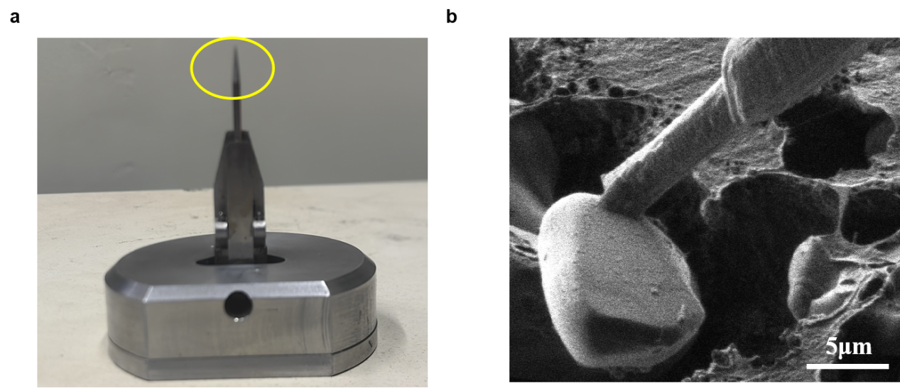

**Figure S7.** Using focused ion beam-SEM to select LCO particle for synchrotron TXM-XANES measurements.

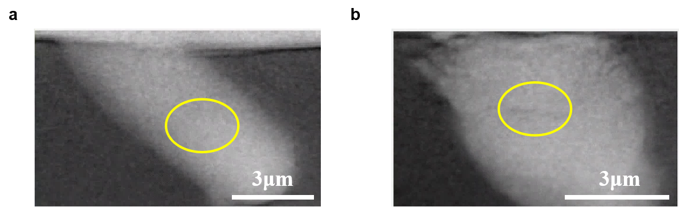

**Figure S8.** The random regions of the particle from (a) LMLE and (b)HMLE selected for XANES plots shown in Figure 5d.

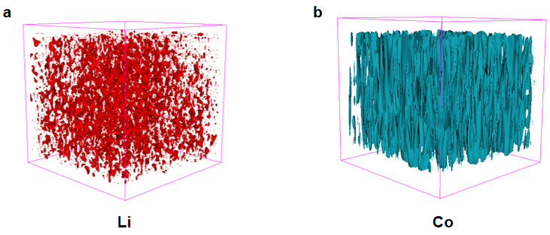

**Figure S9.** The distribution and content of Li (a) and Co (b) for LCO electrode (pristine) obtained from ToF-SIMS.

**References**

[1] Youssef, E. S.; Rosenberg, N.; Gland, F.; Kenter, J.A.M; Skalinski, M.; Vizika, O. High Resolution CT and Pore-Network Models to Assess Petrophysical Properties of Homogeneous and Heterogeneous Carbonates. *Soc. Pet. Eng. J.* **2007**,111427.

[2] Cooper, S. J.; Eastwood, D. S.; Gelb, J.; Damblanc, G.; Brett, D. J. L.; Bradley, R. S.; Withers, P. J.; Lee, P. D.; Marquis, A. J.; Brandon, N. P.; Shearing, P. R. Image based modelling of microstructural heterogeneity in LiFePO4 electrodes for Li-ion batteries. *J. of Power Sources* **2013**, 247 (1), 1033.

[3] France-Lanord, A.; Grossman, J. C. Correlations from Ion Pairing and the Nernst-Einstein Equation. *Phys. Rev. Lett.* **2019**, 122, 136001.

[4] Verma, A. K.; Thorat, A. S.; Thorat, J. K. Estimating Ionic Conductivity of Ionic Liquids: Nernst-Einstein and Einstein Formalisms. *J. Mol. Liq.* **2024**, 4,10089.

[5] Azizmohammadi, S.; Matthäi, S.K. Is the permeability of naturally fractured rocks scale dependent? *Water. Resour. Res.* **2017**, 53, 8041.

[6] Hamzehpour, H.; Khazaei, M. Effective Permeability of Heterogeneous Fractured

Porous Media. *Transp. Porous Media* **2016**, 113, 329.

[7] Sedaghat, M.; Azizmohammadi, S.; Matthäi, S. Dynamic wettability alteration in naturally fractured rocks? *J. Pet. Explor. Prod.* *Technol.* **2019**, 10, 455.

[8] Szewczyk, R. Generalization of the Model of Magnetoelastic Effect: 3D Mechanical Stress Dependence of Magnetic Permeability Tensor in Soft Magnetic Materials. *Materials* **2020**, 13, 4070.

[9] Elliot, T.R.; Reynolds, W.D.; Heck, R.J. Use of existing pore models and X-ray computed tomography to predict saturated soil hydraulic conductivity. *Geoderma* **2010**, 156, 133.

[10] Hong, B.; Li, X.; Wang, L.; Li, L.; Xue, Q.; Meng, J. Using the Effective Void Ratio and Specific Surface Area in the Kozeny–Carman Equation to Predict the Hydraulic Conductivity of Loess. *Water* **2019**, 12, 24.

[11] Liu, P.; Zhang, X.; Zhang, M.; Yang, X. Effect of Admixture on the Hydraulic Conductivity of Compacted Loess: A Case Study. *Adv. Civ. Eng.* **2020**, 2020, 1–12.

[12] Brze´zniak, Z.; Dhariwal, G.; Le Gia, Q.T. Stochastic Navier–Stokes Equations on a Thin Spherical Domain. *Appl. Math. Optim.* **2020**, 84, 1971–2035.

[13] Bear, J. Dynamics of Fluids in Porous Media. *Geoderma* **1972**, 7, 174