Supporting Information
Unlocking the Ligand-Dominated Redox Activity in π-d Conjugated Coordination Polymers for High-Capacity and Stable Potassium Storage

Kang Han^{1,3}, Zhenhang Zhong¹, Hao,Zhang¹, Guangwan Zhang¹, Xuanpeng Wang^{2,3,4}, Fang Liu,Chaojiang Niu^{5*},Liqiang Mai¹*
Experimental Section
1.1 Synthesis of TM-BTA
The synthesis of TM-BTA (transition metal-BTA) was adapted from a previously reported vapor-phase crystallization method^{[1]}. Taking Ni-BTA as an example, the synthesis process is detailed as follows:
A sufficiently large sealed box was prepared, containing two Petri dishes labeled A and B. Equimolar amounts of 1,2,4,5-benzenetetramine tetrahydrochloride and nickel chloride hexahydrate were dissolved in 15 mL of water. Once fully dissolved, the resulting solution was poured into Petri dish A. In Petri dish B, 15 mL of ammonia solution was added. The box was sealed to prevent ammonia evaporation, and the reaction was maintained under vapor-phase conditions for approximately 12 hours. It is worth noting that oxygen is essential for obtaining highly crystalline materials. To ensure sufficient oxygen supply, the sealed lid was opened every hour during the reaction to replenish oxygen. After completion, the product was washed three times each with water and acetone via centrifugation, then dried in an oven for storage. The synthesis procedures for Co-BTA and Mn-BTA were similar to that for Ni-BTA, with the only difference being the replacement of nickel chloride with cobalt(II) chloride and manganese(II) chloride tetrahydrate, respectively, in the first step.
1.2 Electrochemical Measurements
The potassium-ion batteries based on Ni-BTA electrodes were assembled in an argon-filled glove box, maintaining oxygen and water contents below 100 ppm. The working electrode was prepared by mixing active material, Super P, and sodium carboxymethyl cellulose (CMC) in a 70:20:10 weight ratio. The active material and Super P were ground together in a mortar, then dispersed in a pre-prepared CMC solution to form a uniform slurry. This slurry was coated onto copper foil and dried in a vacuum oven at 60°C for 12 hours. The coated foil was cut into 10 mm diameter electrode disks, with an average active material loading of approximately 1.5 mg cm⁻².
CR2016 coin cells were assembled, with the active electrode as the working electrode, Whatman GF/D glass fiber as the separator, and potassium metal as the reference electrode. The electrolyte used was 5 M KFSI in DME. Performance tests included galvanostatic charge-discharge measurements and quantitative analyses based on GITT and dynamic potential techniques, conducted using a Neware BTS-4008-5V-50mA system within the voltage range of 0.01–3.0 V. CV and EIS measurements were performed at room temperature using CHI760E and BioLogic EC Lab electrochemical workstations.
1.3 Theoretical Calculation Methods
First-principles calculations were performed using the open-source software CP2K^{[2]}. Structural optimization employed the PBE functional with D3 (BJ) dispersion corrections. For structural optimization, the DZVP-MOLOPT-SR-GTH basis set was used, while energy calculations utilized the TZV2P-MOLOPT-SR-GTH basis set. To ensure accuracy, the cutoff energy of the primary grid was set to 450 eV, with a relative cutoff of 55 Ry. Charge distribution and wavefunction analyses were carried out using Multiwfn^{[3,4]} and VMD^{[5]}, while modeling and data visualization were conducted with VESTA.
1.4 Material characterizations:
The morphology and elemental composition of the samples were examined using a JEOL JSM-7100FA field emission scanning electron microscope, combining Scanning Electron Microscopy (SEM) and Energy Dispersive X-ray Spectroscopy (EDS). The phase structures were analyzed via Powder X-ray Diffraction (XRD) with a Bruker D8 Discover diffractometer, employing Cu Kα radiation (λ = 1.5418 Å). Thermal stability was evaluated through Thermo-Gravimetric Analysis (TGA) using a Netzsch STA 449C simultaneous analyzer, conducted in air at a heating rate of 10°C/min from ambient temperature up to 800°C. Raman spectroscopy was performed on a Horiba Jobin Yvon Lab RAM HR800 spectrometer, utilizing a 532 nm He-Ne laser for standard Raman measurements. For in-situ Raman spectroscopy, a custom-designed cell with a sapphire window and a perforated Mo foil was used to ensure enhanced electrode contact. X-ray Photoelectron Spectroscopy (XPS) was conducted on a VG Multilab 2000 instrument, with all ex-situ characterizations being performed in an Ar atmosphere to prevent air or moisture exposure. Samples were disassembled and cleaned in a glovebox before transfer to a separate glovebox for preparation. Fourier Transform Infrared (FT-IR) spectroscopy, including in-situ IR tests, was undertaken using a Nicolt iS50 spectrometer in ATR mode.
1.5 Calculation of Projected Full-Cell Energy Density
The specific energy and power densities of the theoretical K-ion full cell, presented in the Ragone plot (Figure X), were estimated based on the electrochemical performance of the Ni-BTA anode and a benchmark K_{0.7}Mn_{0.7}Ni_{0.3}O₂ layered oxide cathode^{[6]}. The key parameters used for the calculation are listed in Table S1.
Table S1. Electrochemical parameters for full-cell energy density calculation.
Electrode | Material | Reversible Specific Capacity (Q) | Average Voltage (V) vs. K/K⁺ | Source
Anode | Ni-BTA | 452 mAh g⁻¹ (Qa) | 0.8 V (V_{a}) | This work
Cathode | K_{0.7}Mn_{0.7}Ni_{0.3}O₂ | 125.4 mAh g⁻¹ (Qc) | 3.0 V (V_{c}) | Ref. 6
The average operating voltage of the full cell (V_{cell}) was first calculated as the difference between the average potentials of the cathode (V_{c}) and the anode (V_{a}):
$$V_{cell}=V_{c}−V_{a}=3.0\text{ V}−0.8\text{ V}=2.2\text{ V}$$
Next, the electrode mass balance was established. To prevent hazardous potassium metal plating, a standard negative-to-positive capacity ratio (N/P ratio) of 1.1 was adopted. The required mass ratio of the anode active material (m_{a}) to the cathode active material (m_{c}) was then determined by:
$$\frac{m_{a}}{m_{c}}=\frac{N/P×Q_{c}}{Q_{a}}=\frac{1.1×125.4\text{ mAh }{\text{g}}^{−1}}{452\text{ mAh }{\text{g}}^{−1}}≈0.305$$
With the N/P ratio greater than 1, the full cell is cathode-limited. Therefore, the specific capacity of the full cell (Q_{cell}), normalized by the total mass of the active materials in both electrodes, was calculated as follows:
$$Q_{cell}=\frac{Q_{c}×m_{c}}{m_{c}+m_{a}}=\frac{Q_{c}}{1+m_{a}/m_{c}}=\frac{125.4\text{ mAh }{\text{g}}^{−1}}{1+0.305}≈96.2\text{ mAh }{\text{g}}^{−1}$$
The specific energy density (E_{active}), based on the total mass of active materials, was subsequently calculated by multiplying the full-cell specific capacity and its average operating voltage:
$$E_{active}=Q_{cell}×V_{cell}=96.2\text{ mAh }{\text{g}}^{−1}×2.2\text{ V}≈212\text{ Wh }{\text{kg}}^{−1}$$
Finally, the specific power density (P_{active}) at a given specific current (i_{c}, current per gram of cathode active material) was calculated using the following equation. The specific power values for the Ragone plot were determined using the various current densities from the rate performance test.
$$P_{active}=V_{cell}×\frac{i_{c}×m_{c}}{m_{c}+m_{a}}=V_{cell}×\frac{i_{c}}{1+m_{a}/m_{c}}$$

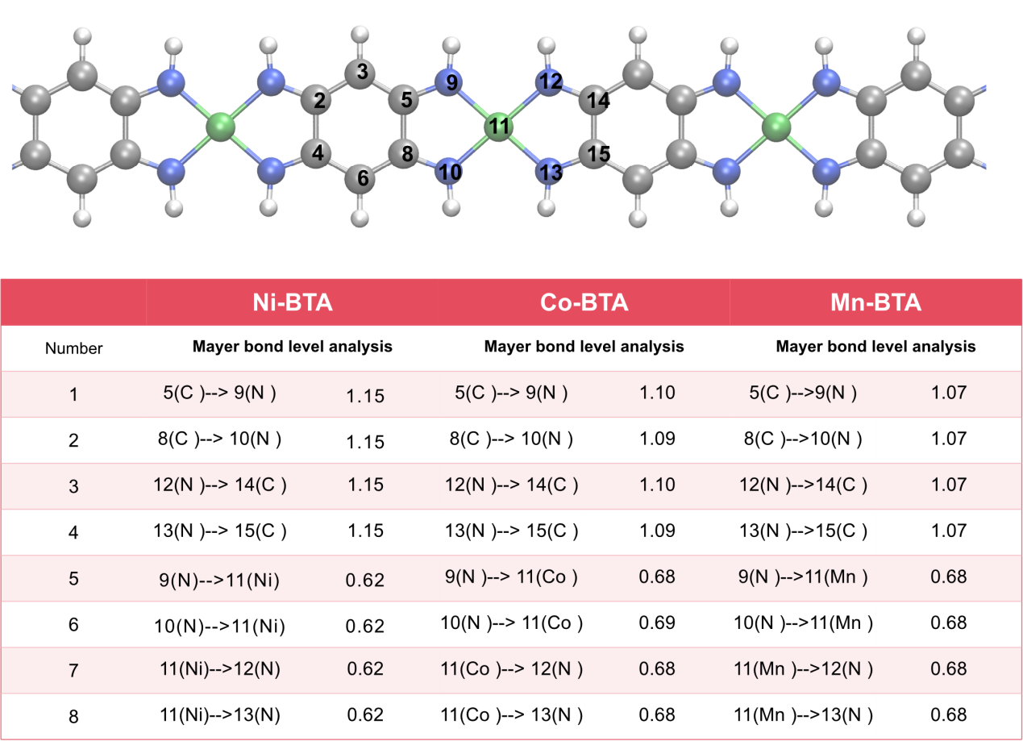
Figure S1 Molecular chain structure characteristics of TM-BTA (TM=Ni,Co,Mn) and corresponding atomic Mayer bond order analysis.

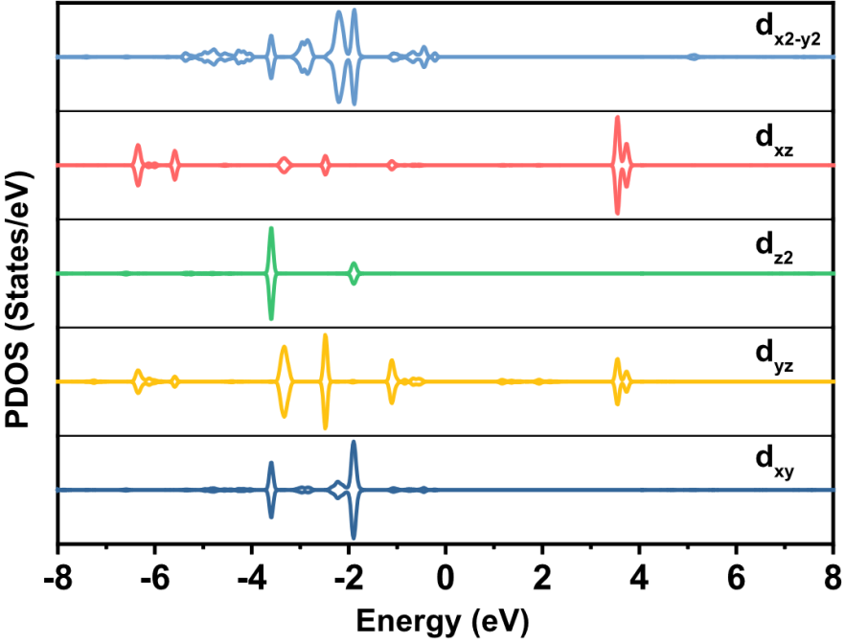
Figure S2 Analysis of PDOS for different d orbitals in Ni-BTA.
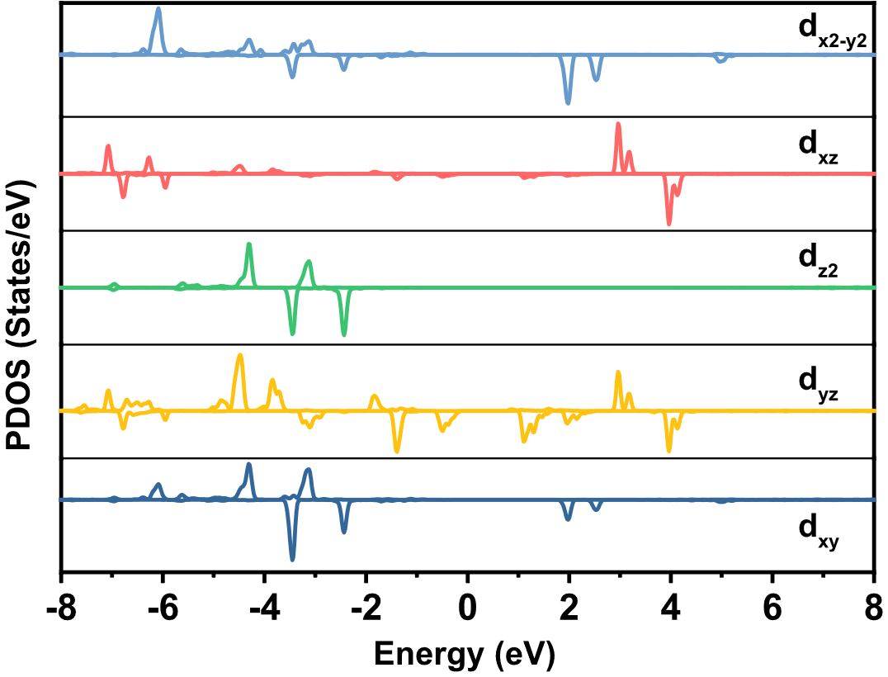
Figure S3 Analysis of PDOS for different d orbitals in Co-BTA.

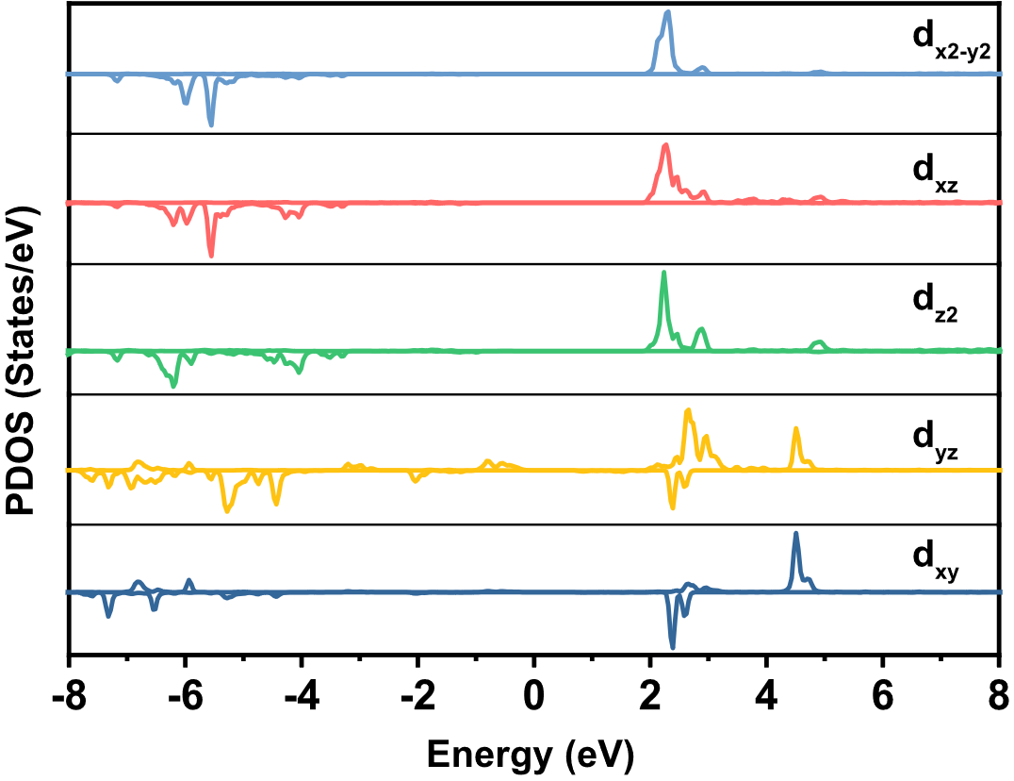
Figure S4 Analysis of PDOS for different d orbitals in Mn-BTA.
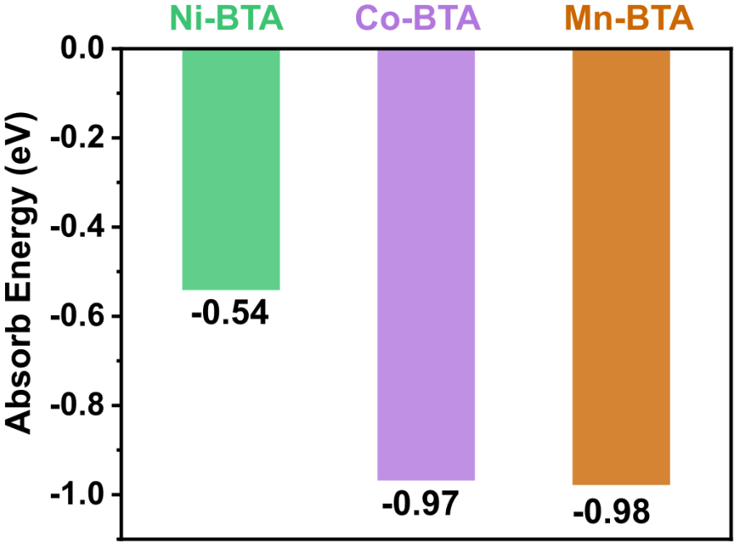
Figure S5 Comparison of adsorption energies for K atoms on Ni-BTA, Co-BTA, and Mn-BTA. (Ni-BTA exhibits the weakest adsorption for K atoms, indicating superior migration capability of K atoms along Ni-BTA chains.)

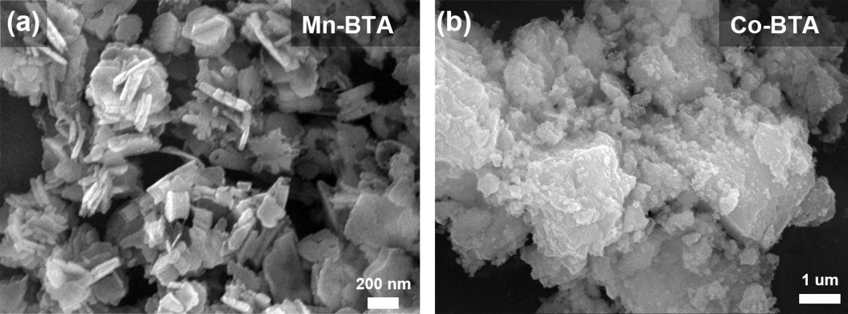
Figure S6 SEM images of Mn-BTA and Co-BTA. (a) Mn-BTA, (b) Co-BTA.

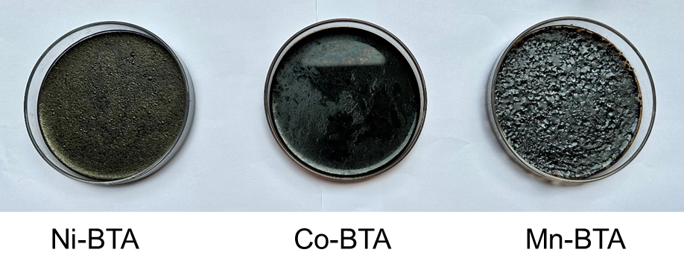
Figure S7 Surface crystallization of Ni-BTA, Co-BTA, and Mn-BTA prepared by vapor diffusion method after 10 minutes of reaction.
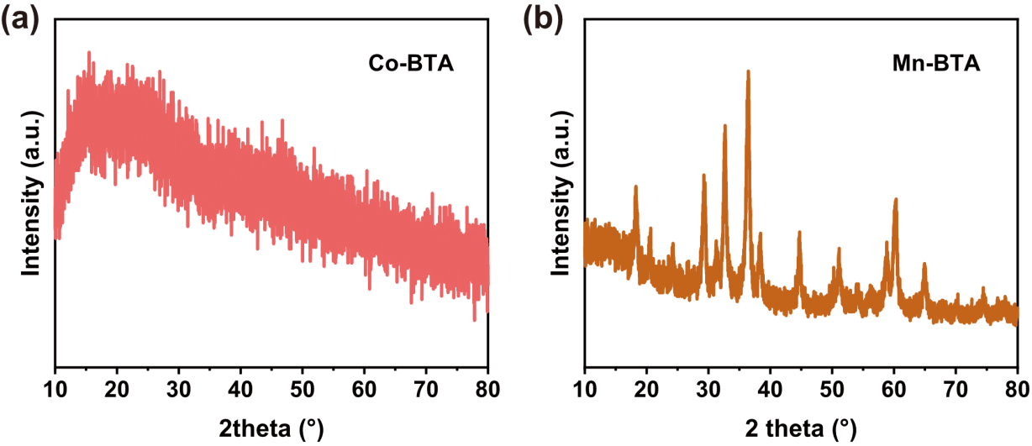
Figure S8 Co-BTA and Mn-BTA XRD characteristic diffraction peaks.
- Co-BTA, (b) Mn-BTA.

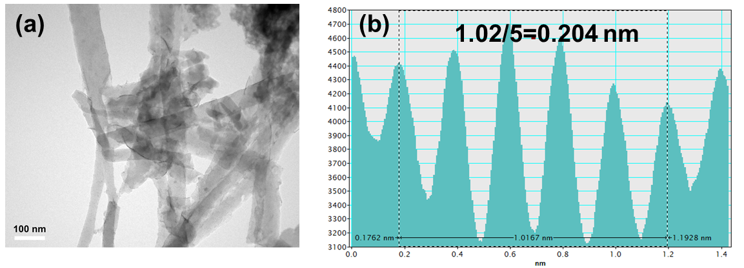
Figure S9 TEM images and lattice spacing characteristics of Ni-BTA.
(a) TEM image, (b) Lattice spacing corresponding to the (042) crystal plane.

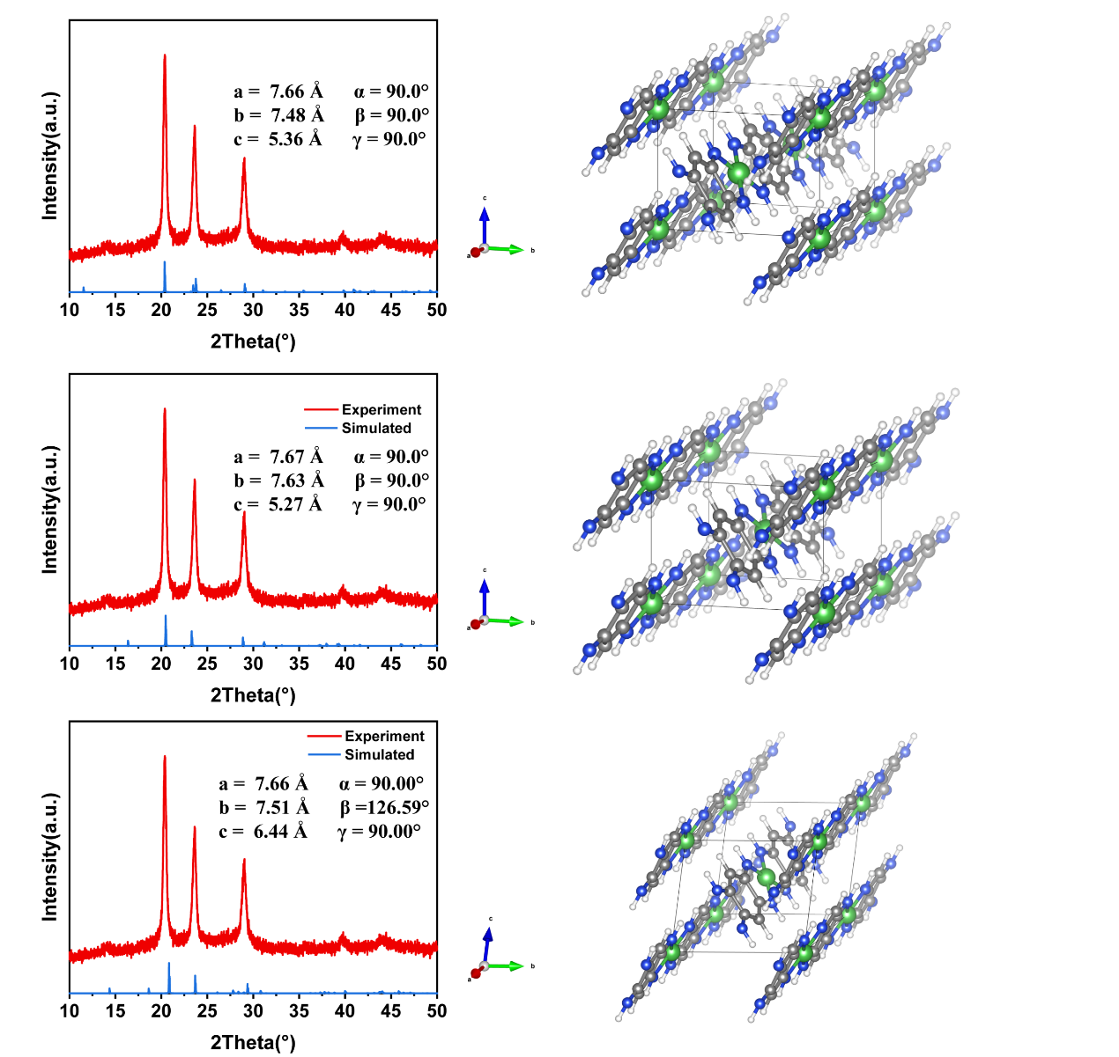
Figure S10 XRD simulations of Ni-BTA expansion along different axes based on herringbone packing.
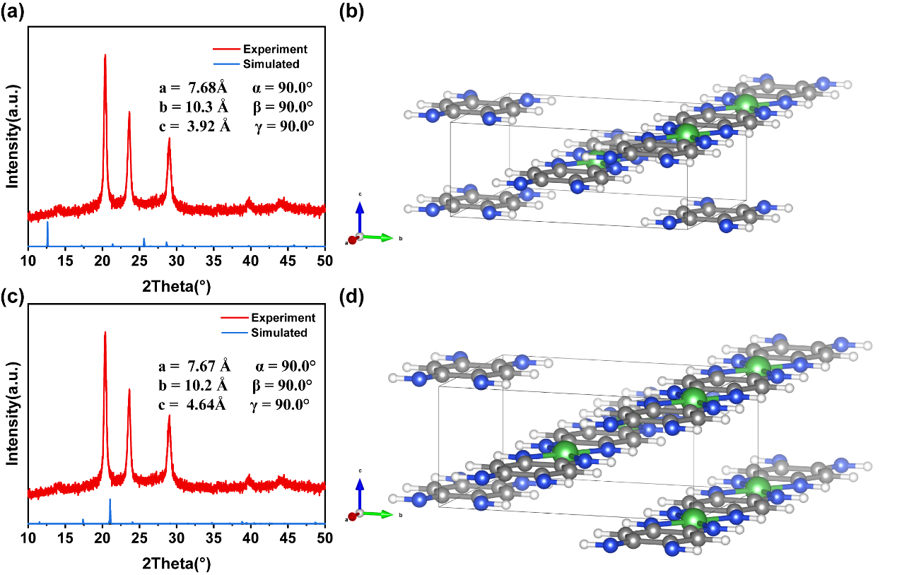
Figure S11 XRD simulations of Ni-BTA expansion along different axes based on two dimensional (2D) π–π stacking lamellar packing.

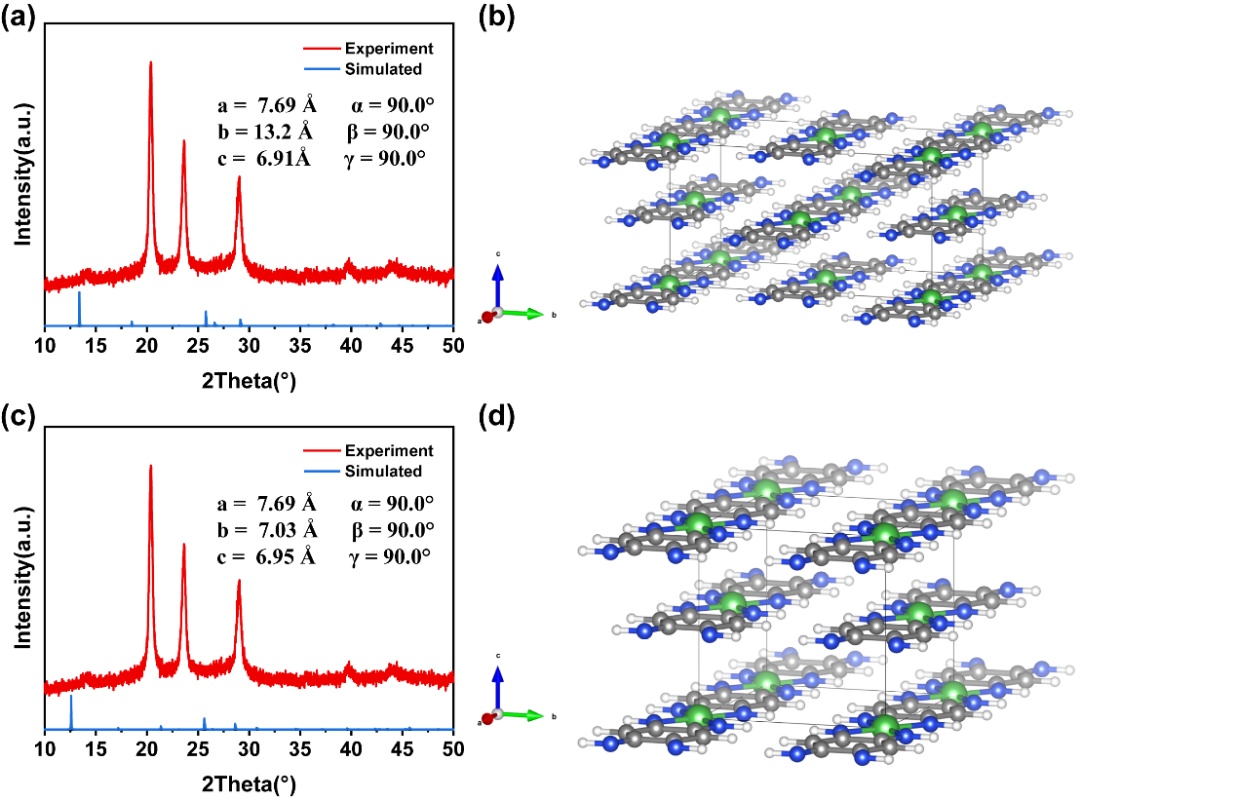
Figure S12 XRD simulations of Ni-BTA expansion along different axes based on one dimensional (1D) π–π stacking lamellar packing.
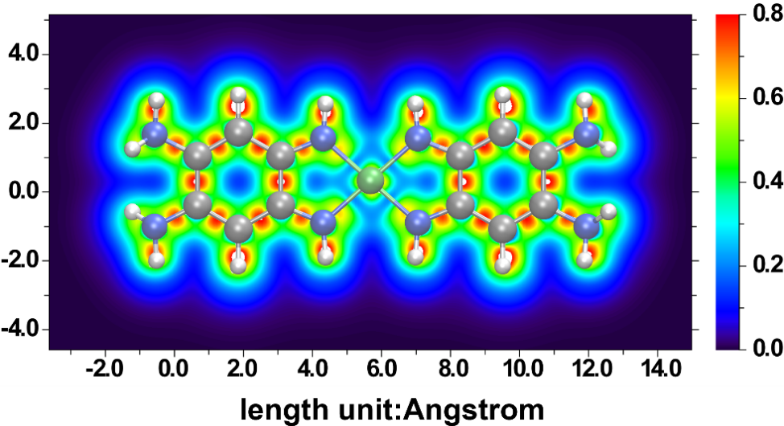

Figure S13 Electron localization function (ELF)-π analysis based on a single molecular unit of Ni-BTA. (In the structure of Ni-BTA, notably around the C-N and C-C bonds, pronounced regions of high localization were observed, indicating strong electron localization in these areas. In contrast, electron localization around the Ni atom was relatively low, suggesting a more dispersed d-electron cloud in Ni²⁺, consistent with the electronic characteristics of transition metal cations. The coordination bond between Ni and the BTA ligand exhibits moderate locality, indicating a mixed covalent-ionic nature of the bond. Along the one-dimensional chain, electron localization is relatively uniform, signifying a continuous distribution of electrons along this direction, contributing to the formation and stabilization of the one-dimensional chain.)
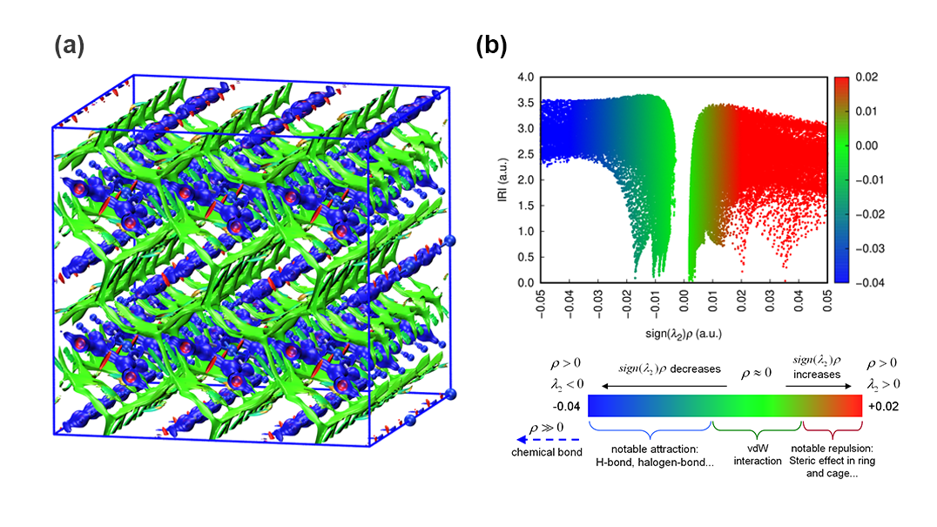
Figure S14 Graphical investigation of chemical bonds and weak interactions in Ni-BTA molecular crystals based on the IRI method. (In this figure, a predominantly green IRI isosurface indicates a van der Waals interaction region. A visibly red isosurface suggests the presence of steric hindrance, with bright red indicating strong steric effects. A noticeably blue isosurface indicates significant attractive interactions, such as moderate hydrogen bonds or halogen bonds. A completely blue isosurface signifies relatively strong weak interactions. In Ni-BTA, it shows significant weak interactions, including hydrogen bonding and π-π stacking between neighboring molecules, visually demonstrating the prominent presence of weak interactions within the Ni-BTA molecular crystal.)
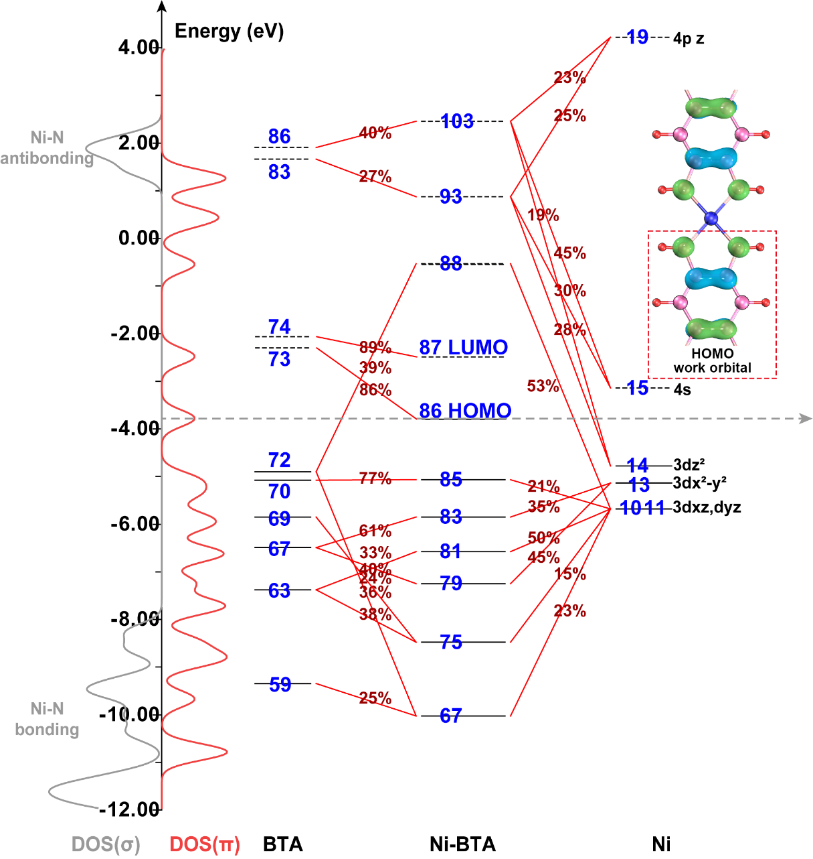
Figure S15 Molecular orbital and fragment charge interaction analysis based on a single molecular unit of Ni-BTA.
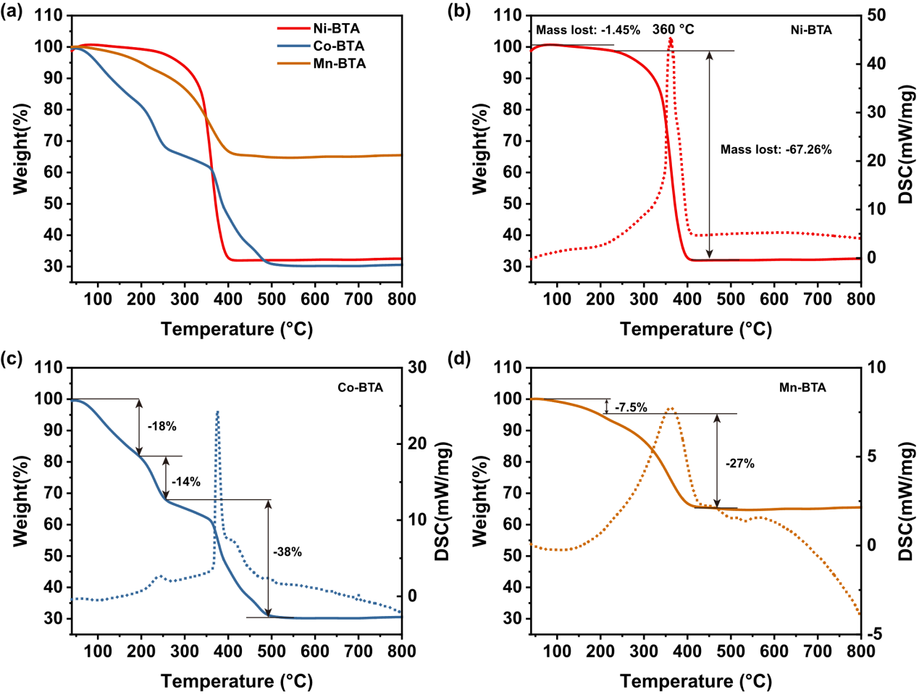
Figure S16 Thermogravimetric (TG) and differential scanning calorimetry (DSC) curves of TM-BTA under Air. (a) Ni, Co, MN-BTA TG curves. (b) Ni-BTA (c) Co-BTA (d) Mn-BTA.

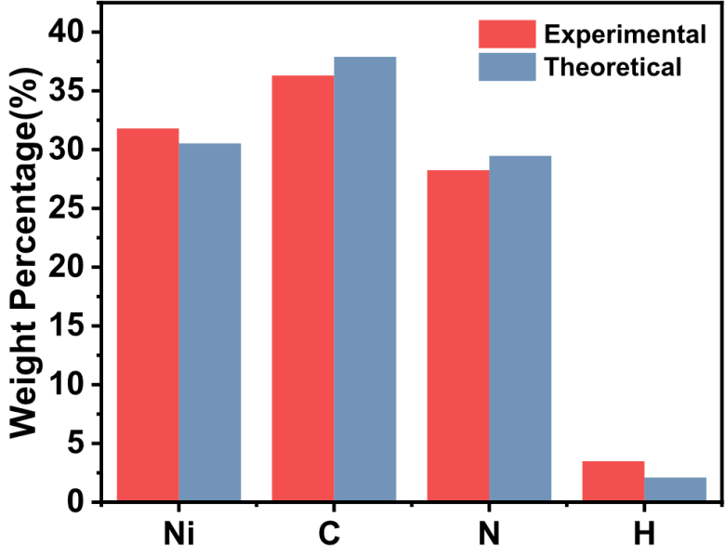
Figure S17 Comparison of experimental and theoretical CHNO analysis values for Ni-BTA.
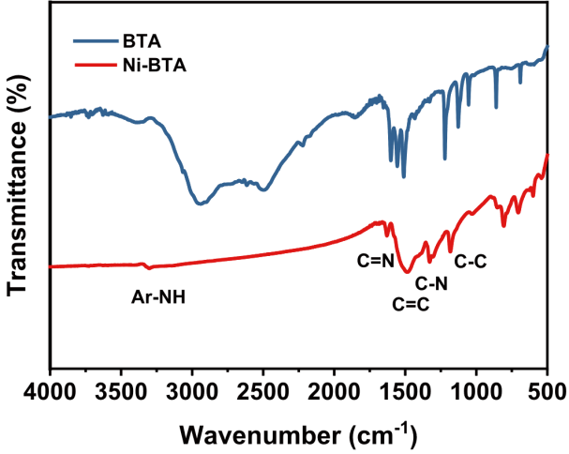
·Figure S18 Infrared characteristic spectra and functional group distribution of Ni-BTA and BTA monomer.
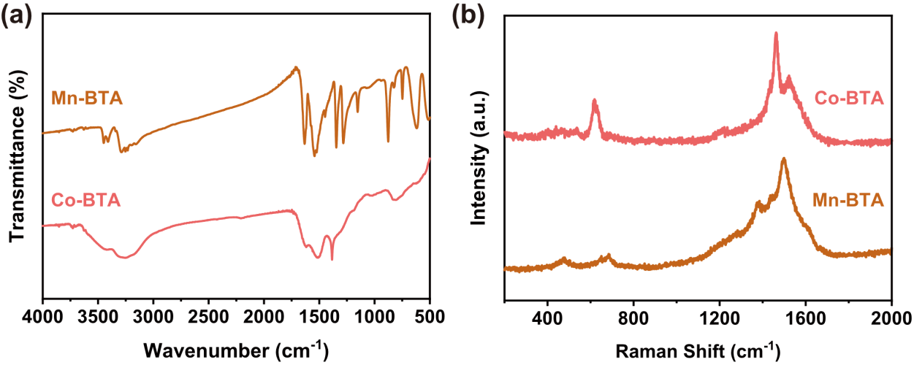
Figure S19 Co-BTA and Mn-BTA Raman and IR spectra. (a) IR spectra, (b) Raman spectra.

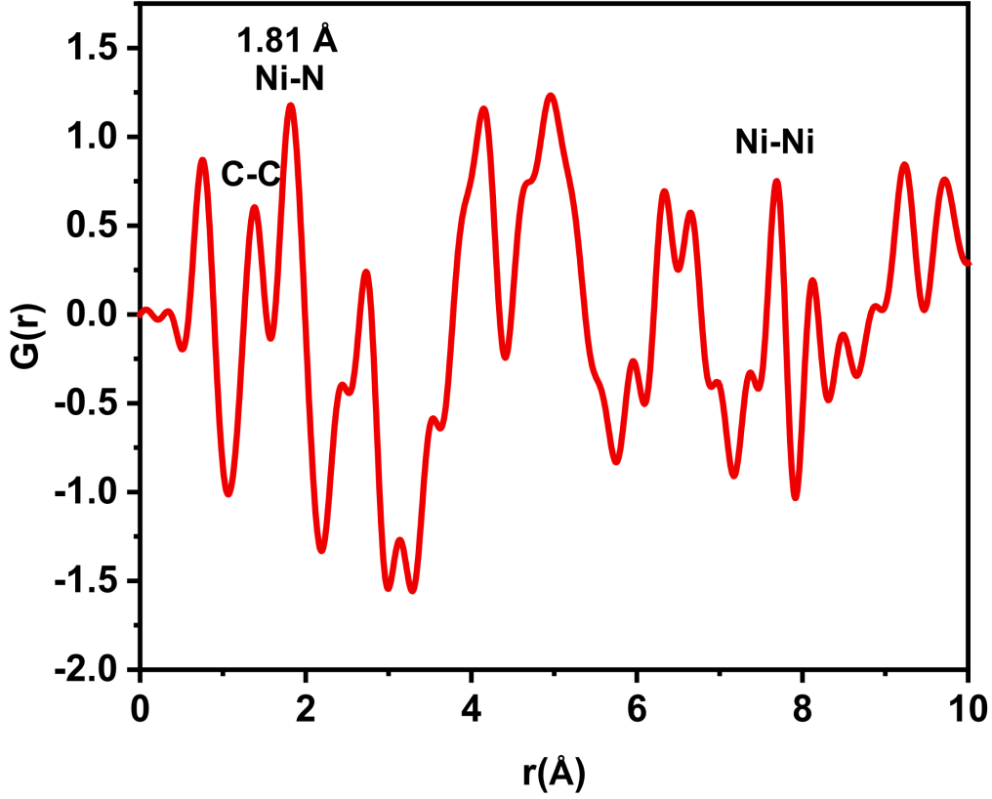
Figure S20 Reduced radial distribution function analysis of Ni-BTA.
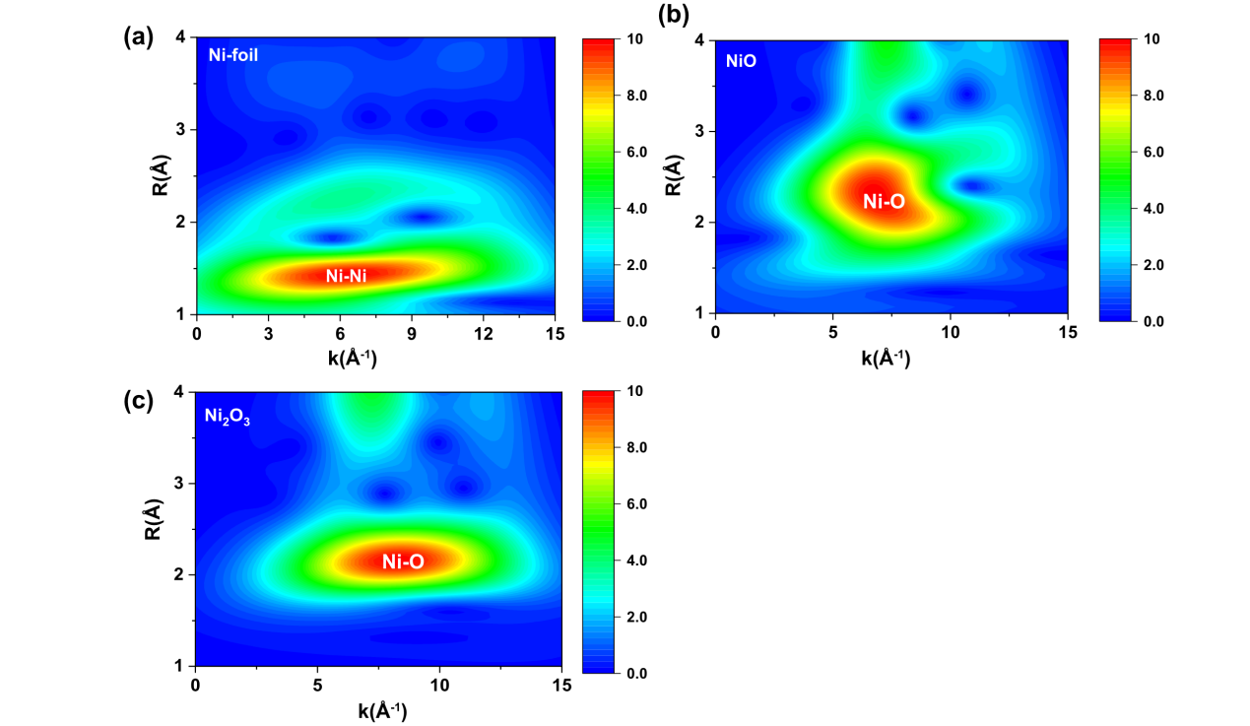
Figure S21 Synchrotron wavelet transform spectra of different nickel-based materials. (a) Ni foil, (b) NiO powder, (c) Ni₂O₃ powder.
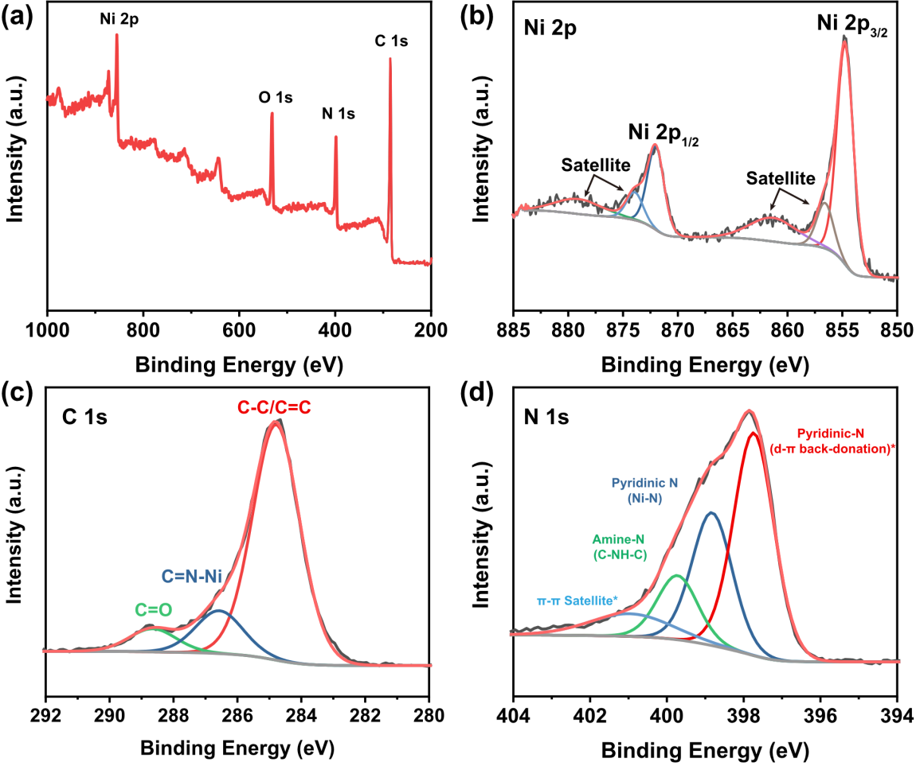
Figure S22 XPS spectral analysis of Ni-BTA. (a) Full spectrum of Ni-BTA, (b) High-resolution and fitted Ni 2p spectrum, (c) High-resolution and fitted C 1s spectrum, (d) High-resolution and fitted N 1s spectrum.

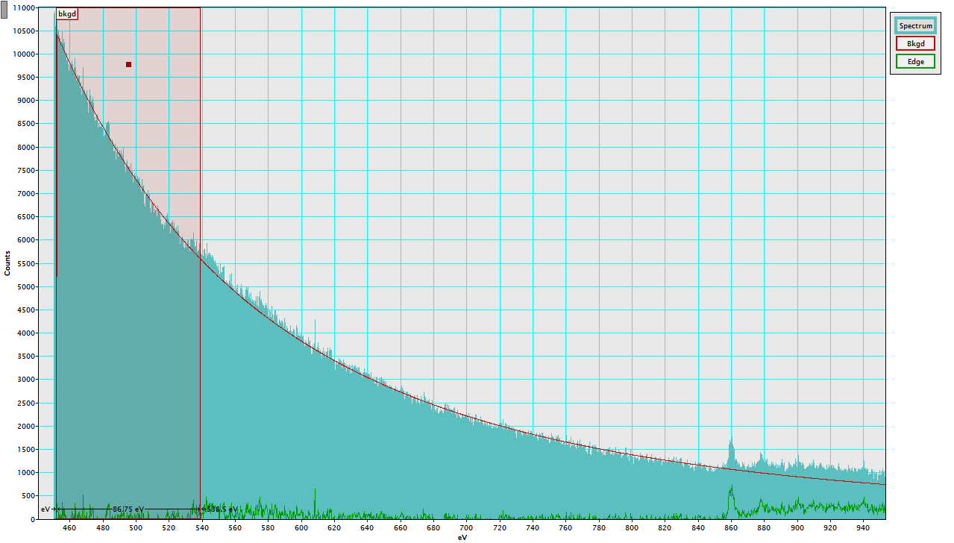
Figure S23 Electron energy loss spectrum (EELS) of Ni-BTA.
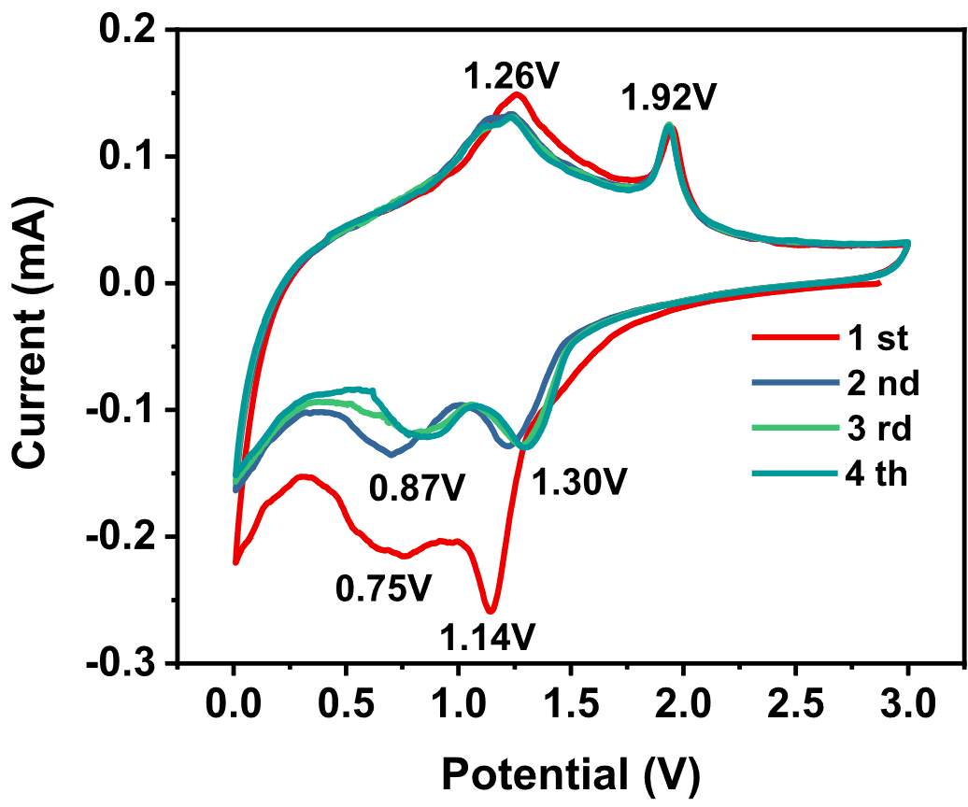
Figure S24 Cyclic voltammetry (CV) curves of Ni-BTA at a scan rate of 0.2 mV/s.
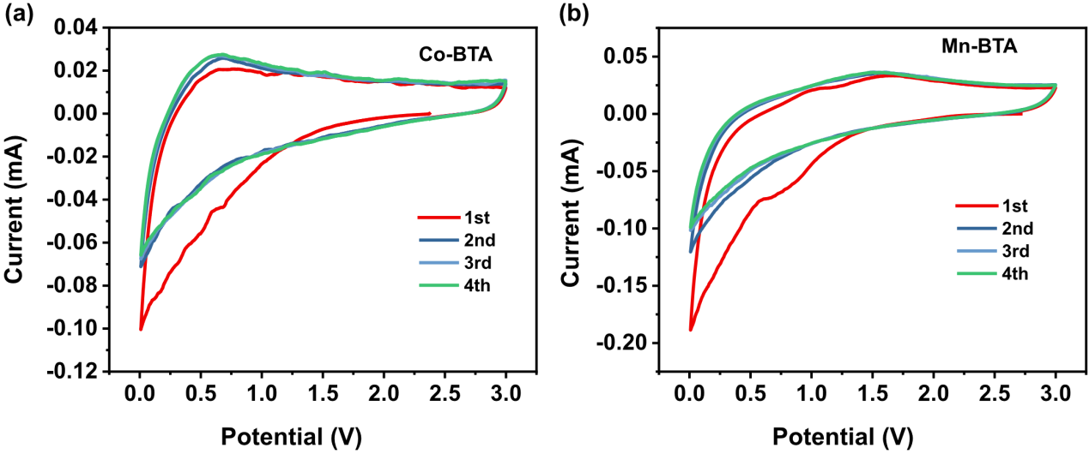
Figure S25 Cyclic voltammetry (CV) curves of TM-BTA at a scan rate of 0.2 mV/s.
(a) Co-BTA, (b) Mn-BTA.

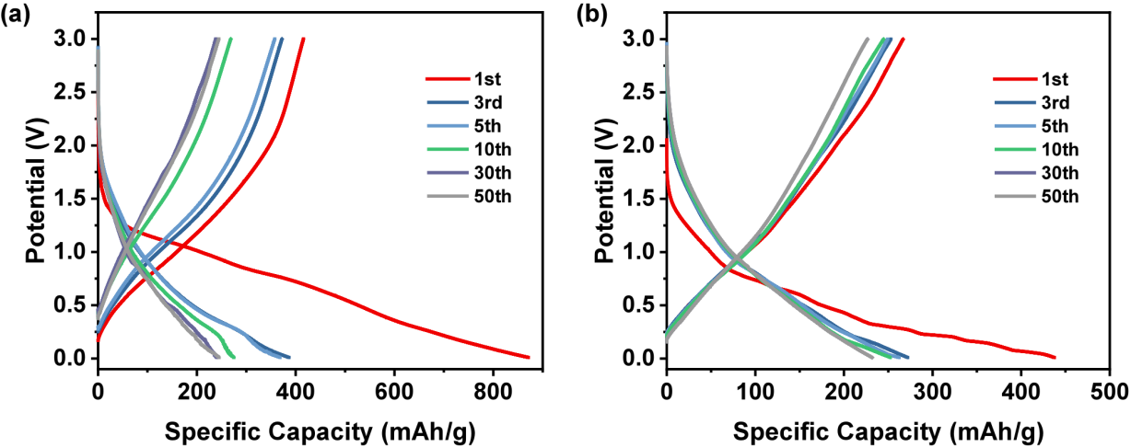
Figure S26 Characteristic charge-discharge curves of Co-BTA and Mn-BTA at 100 mA/g.
(a) Co-BTA, (b) Mn-BTA.

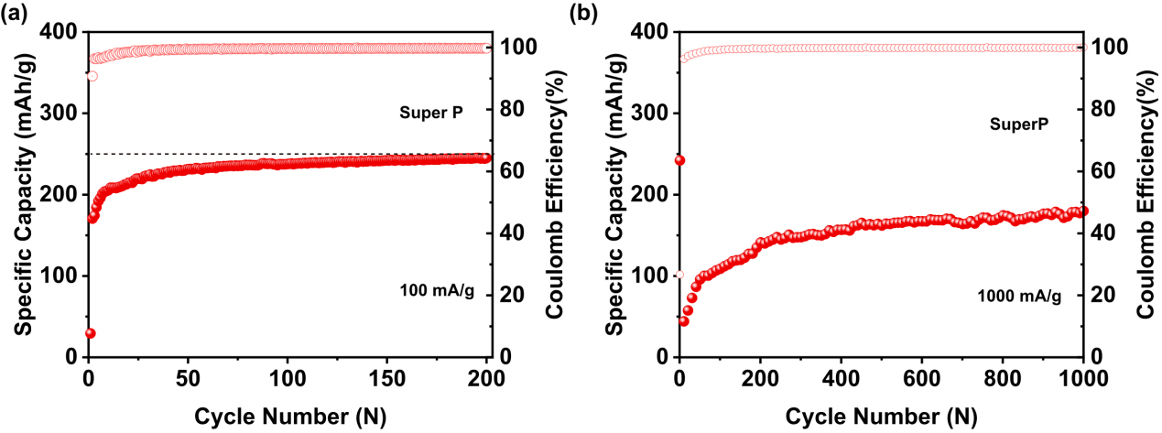
Figure S27 Electrochemical performance of Super P. (a) Reversible specific capacity over 200 cycles at 100 mA/g. (b) Reversible specific capacity over 200 cycles at 1000 mA/g. (Considering the conductive additive comprises only 20% of the total, it contributes an additional capacity of approximately 48 mAh/g at 100 mA/g and 30 mAh/g at 1000 mA/g.)

Figure S28 Ragone plot comparing the projected performance of the Ni-BTA based K-ion full cell with various established energy storage technologies.

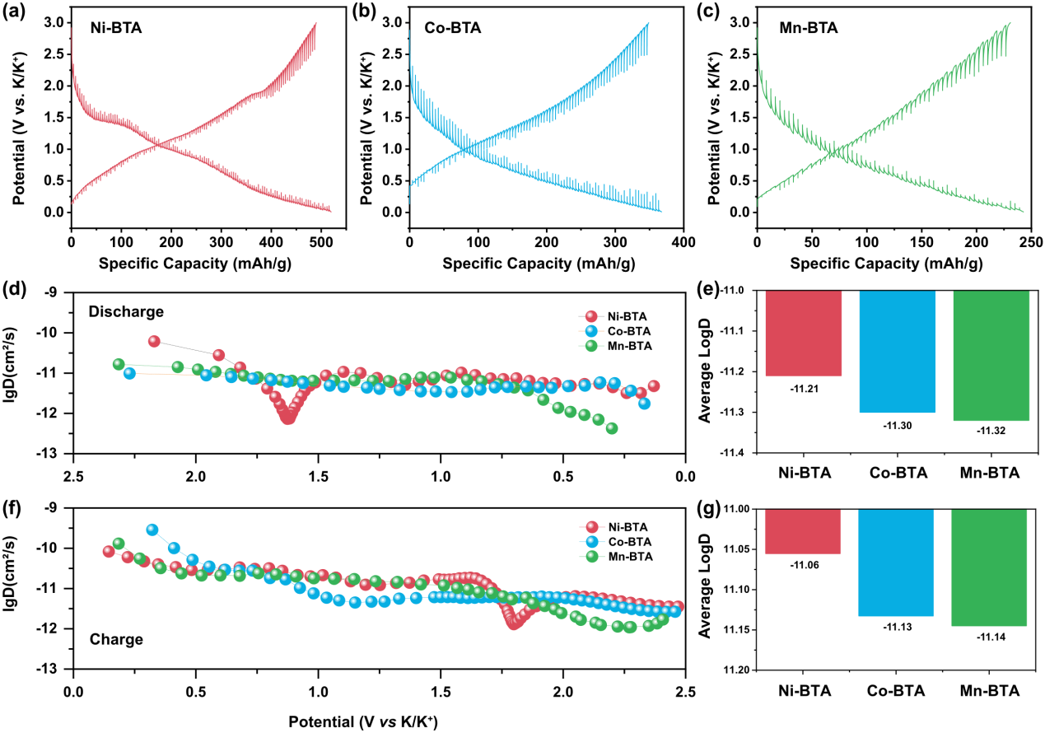
Figure S29 K⁺ Diffusion Kinetics Analysis via GITT. (a-c) GITT potential profiles of (a) Ni-BTA, (b) Co-BTA, and (c) Mn-BTA electrodes during a charge-discharge cycle. (d, f) Calculated K⁺ diffusion coefficients (logD) as a function of potential for the three electrodes during (d) discharge and (f) charge. (e, g) Comparison of the average log(D_{K⁺}) values during (e) discharge and (g) charge, highlighting the superior ionic transport kinetics of Ni-BTA.

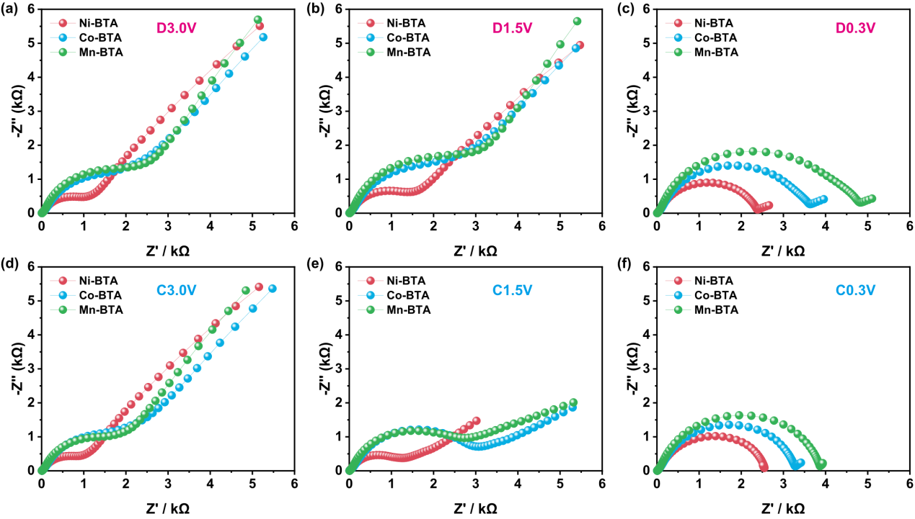
Figure S30 Electrochemical Impedance Spectroscopy (EIS) analysis of Ni Nyquist plots were collected after 5 cycles at various states of charge and discharge. (a) discharged to 3.0V of Ni-BTA, Co-BTA, and Mn-BTA electrodes. (b) discharged to 1.5 V, (c) discharged to 0.3 V, (d) charged to 3.0 V, (e) charged to 1.5 V, and charged to 0.3 V.

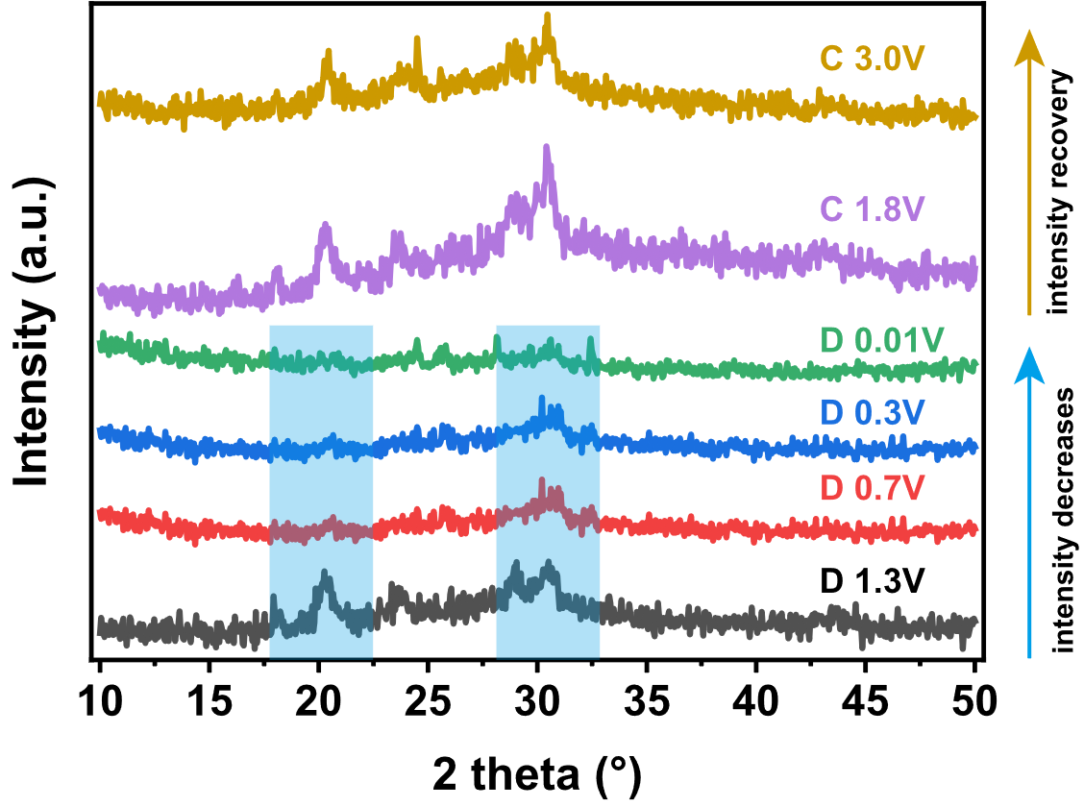
Figure S31 Ex-situ XRD spectra of Ni-BTA under different charging and discharging conditions, where D stands for Discharge and C stands for Charge.

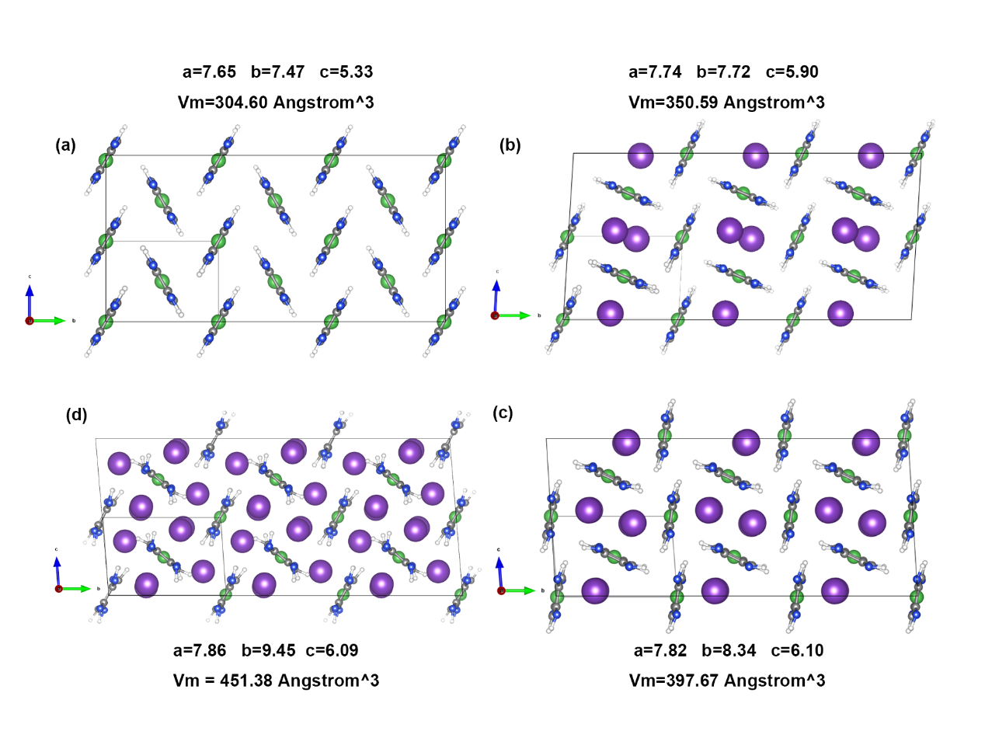
Figure S32 Molecular structural optimization characteristics at different potassium intercalation levels based on first-principles calculations
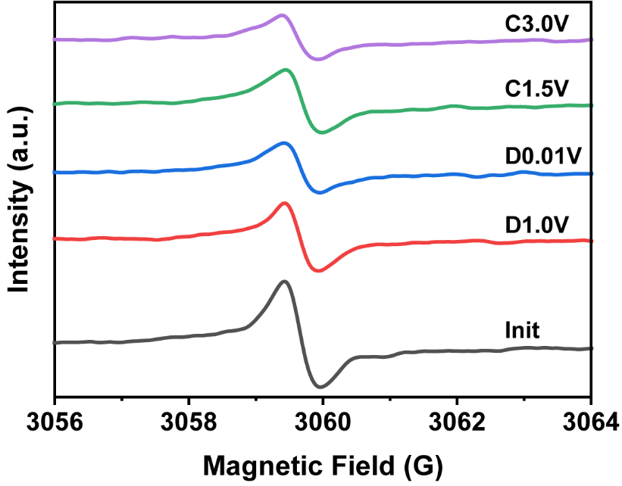
Figure S33 Ex situ EPR analysis of Ni-BTA. (In the figure, "D" denotes EPR measurements taken after discharging to the specified voltage, and "C" denotes EPR measurements taken after charging to the specified voltage.)

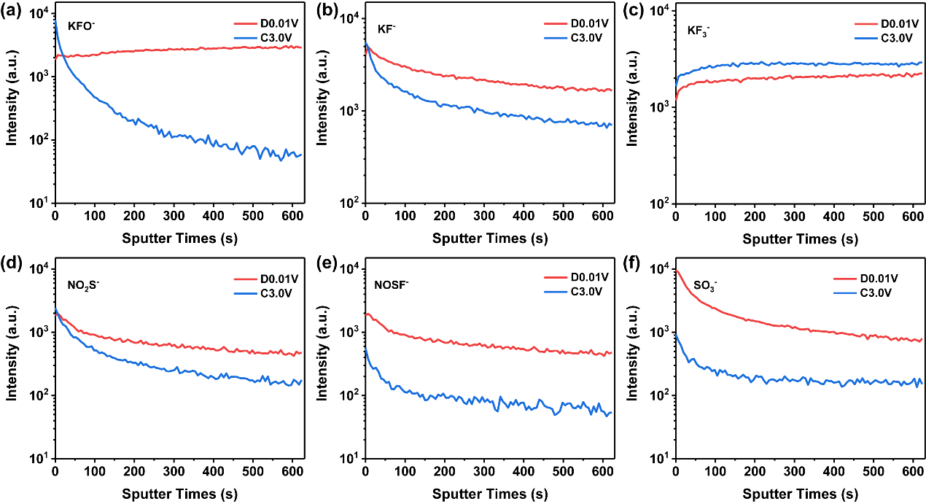
Figure S34 Comparison of the contents of different components on the Ni-BTA surface in the fully discharged and charged states. (a) KFO⁻, (b) KF⁻, (c) KF₃⁻, (d) NO₂S⁻, (e) NOSF⁻, and (f) SO₃⁻.
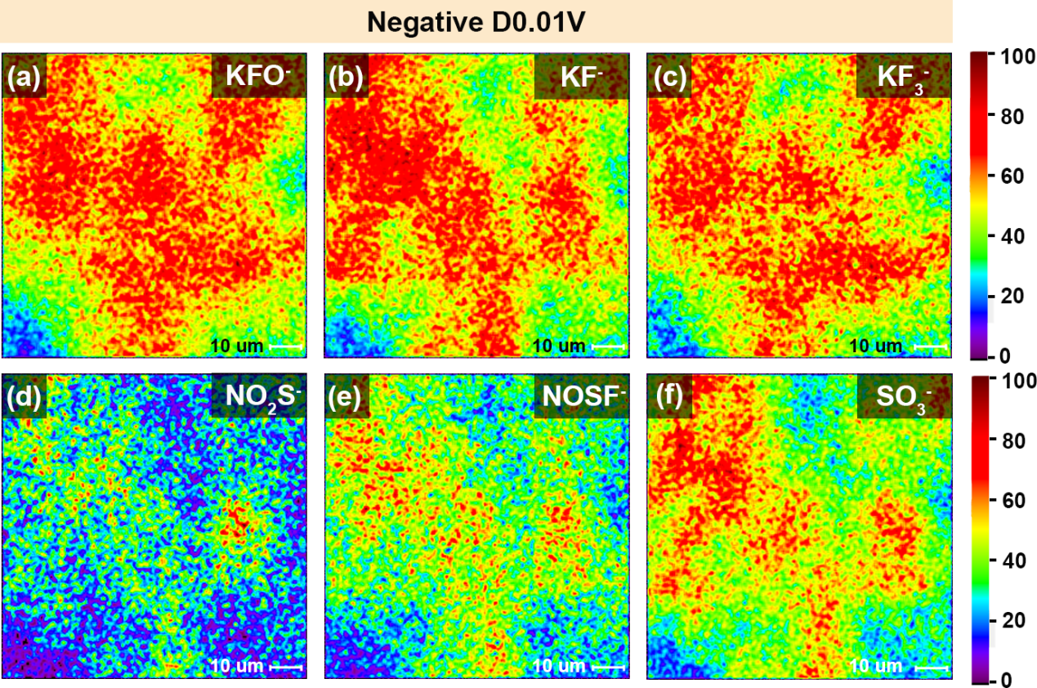
Figure S35 2D distribution maps of the component intensities of Ni-BTA discharged to 0.01V. (a) KFO-, (b) KF-, (c) KF3-, (d) NO2S-, (e) NOSF-, and (f) SO3-.
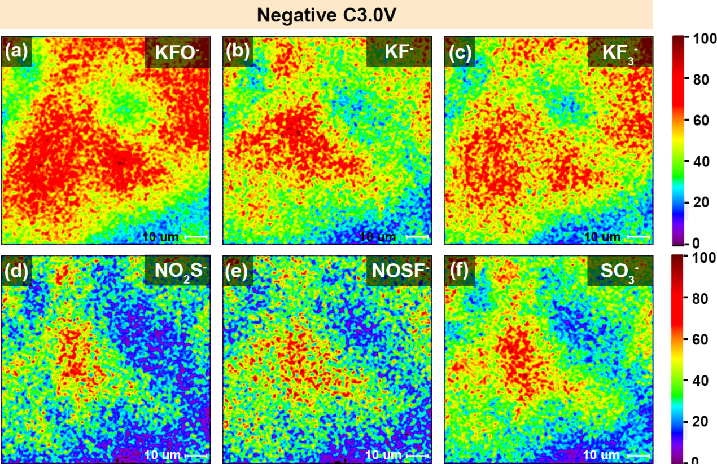
Figure S36 2D intensity distribution maps of different component concentrations in Ni-BTA charged to 3.0V. (a) KFO⁻, (b) KF⁻, (c) KF₃⁻, (d) NO₂S⁻, (e) NOSF⁻, and (f) SO₃⁻.

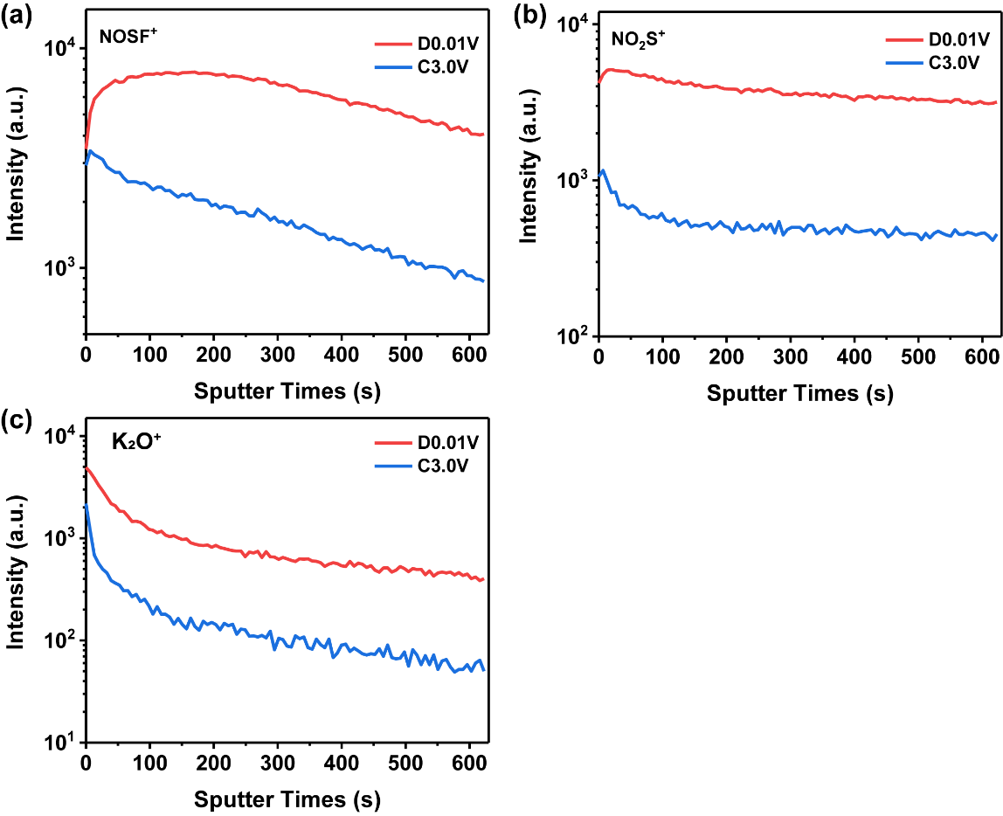
Figure S37 Comparison of the composition and content of cationic characteristic components on the surface of Ni-BTA at different potentials. (a-c) Comparison of different component contents in fully discharged and fully charged states; (a) NOSF⁺, (b) NO₂S⁺, (c) K₂O⁺.

Reference
[1] L. Wang, Y. Ni, X. Hou, L. Chen, F. Li, J. Chen, Angew Chem Int Ed 2020, 59, 22126.
[2] T. D. Kühne, M. Iannuzzi, M. Del Ben, V. V. Rybkin, P. Seewald, F. Stein, T. Laino, R. Z. Khaliullin, O. Schütt, F. Schiffmann, D. Golze, J. Wilhelm, S. Chulkov, M. H. Bani-Hashemian, V. Weber, U. Borštnik, M. Taillefumier, A. S. Jakobovits, A. Lazzaro, H. Pabst, T. Müller, R. Schade, M. Guidon, S. Andermatt, N. Holmberg, G. K. Schenter, A. Hehn, A. Bussy, F. Belleflamme, G. Tabacchi, A. Glöß, M. Lass, I. Bethune, C. J. Mundy, C. Plessl, M. Watkins, J. VandeVondele, M. Krack, J. Hutter, The Journal of Chemical Physics 2020, 152, 194103.
[3] T. Lu, F. Chen, J Comput Chem 2012, 33, 580.
[4] T. Lu, The Journal of Chemical Physics 2024, 161, 082503.
[5] W. Humphrey, A. Dalke, K. Schulten, Journal of Molecular Graphics 1996, 14, 33.
[6] Z. Xiao, J. Meng, F. Xia, J. Wu, F. Liu, X. Zhang, L. Xu, X. Lin, L. Mai, Energy Environ. Sci. 2020, 13, 3129.

