**Supporting Information**

**Constructing matching interfaces by amorphous engineering for enhanced lithium ion transport in quasi-solid-state lithium-iodine batteries**

Jiapei Gu,+[a],[b] Chenxu Dong,+[a] Yuxin Zhu,[a] Haoyun Liu,[a] Juan Ji,[a] Yongkun Yu,[a] Changning Ma,[a] Cheng Zhou,*[a] Liqiang Mai,[a] Xu Xu.*[a], [b]

[a] J. Gu, C. Dong, Y. Zhu, H. Liu, J. Ji, Y. Yu, C. Ma, Dr. C. Zhou, Prof. L. Mai, Prof. X. Xu

State Key Laboratory of Advanced Technology for Materials Synthesis and Processing, School of Materials Science and Engineering, Wuhan University of Technology,  
Wuhan, 430070, China.  
E-mail: zhoucheng1208@whut.edu.cn; xuxu@whut.edu.cn

[b] J. Gu, Prof. X. Xu

Zhongyu Feima New Material Technology Innovation Center (Zhengzhou) Co., Ltd., High Technology Industrial Development Zone,

Zhengzhou 450001 P.R. China.

[+] These authors contributed equally to this work

**Experiemental Section**

*Materials*: All the materials were purchased from commercial sources and directly used without further purification. Aramid fibers were supplied by Dupont. Potassium hydroxide (KOH, 95%), dimethyl sulfoxide (DMSO, 99.9%) and N-methyl-2-pyrrolidone (NMP, 99.9%) were purchased from Aladdin. Iron chloride hexahydrate (FeCl3·6H2O, 99.9%) and phenylphosphonic acid (H2PPA, 98%) were purchased from Macklin. 1,3-dioxolane (DOL, 99.5%), 1,2-dimethoxyethane (DME, 99.5%), LiNO3 (99.9%), Lithium bis(trifluoromethanesulfonyl)imide (LiTFSI) and polyvinylidene fluoride (PVDF) were provided by Dodochem.

*Preparation of ANFs suspension*: The ANFs suspension was fabricated according to the previously reported procedures. [1] Specifically, 1.0 g Aramid fibers and 1.5 g KOH were dissolved in 500 ml DMSO under magnetic stirring at room temperature. About 7 days later, the ANFs/DMSO well-dispersed mixture solution (2 mg mL-1) with dark red color was formed.

*Preparation of R-ANF-MOF and T-ANF-MOF membrane*:The R-ANF-MOF and T-ANF-MOF composite nanofibers were prepared by in-situ growth method. Firstly, 10 ml of the above ANF/DMSO dispersion was washed several times with deionized water to collect solid ANF fibers. Then 270 mg FeCl3·6H2O was dissolved in 30 mL deionized water. The solid ANF fibers were dispersed in the above solution, then ultrasonically dispersed and vigorously stirred for 12 h to adsorb metal cations, and denoted as solution A. H2PPA (158 mg) was dissolved in 30 mL ethanol, and then the solution A was added dropwise into the above solution with continuous stirring. After that, the mixed solution was left to stand for another 12 h at room temperature, the R-ANF-MOF composite nanofibers were successfully synthesized. For T-ANF-MOF composite nanofibers, the mixed solution was heated at 100 ℃ for 12 h. After the reaction system cooling down, the T-ANF-MOF composite nanofibers were successfully synthesized.R-ANF-MOF and T-ANF-MOF membranes were obtained by vacuum suction filtration and further washed several times with deionized water and ethanol, and dried at 80 ℃ for 12 h.

*Preparation of* *cathodes and electrolytes*:The iodine cathodes were meticulously crafted using the iodine sublimation technique. Precisely, 210 mg of activated carbon (AC) and 490 mg of iodine powder were combined thoroughly. The blend was then vacuum-sealed within a quartz tube and subjected to a thermal treatment at 80 °C for 10 h to synthesize the I2@AC composite cathode. Upon cooling, the I2@AC powder was retrieved. The iodine cathodes were prepared by thoroughly mixing activated carbon (AC), acetylene black and PVDF in a mass ratio of 8:1:1 with NMP. Subsequently, the resulting slurry mixture was cast onto Al foil and dried at 30 °C for 12 h. The sulfur loading of active material is about 1.0 mg cm-2. The LiFePO4 cathodes were prepared by thoroughly mixing LiFePO4, Super P and PVDF in a mass ratio of 7:2:1 with NMP. Subsequently, the resulting slurry mixture was cast onto Al foil and dried at 80 °C for 12 h. The mass loading of active material is about 2.0 mg cm-2. Quasi-solid-state electrolytes (QSSE) were obtained by dipping R-ANF-MOF and T-ANF-MOF membranes in the electrolyte (1M LiTFSI in DEM and DOL (1:1 ratio by volume) with 0.1 M LiNO3 as the additive) in a glove box filled with Ar atmosphere, removing the excess electrolyte.

*Material Characterizations*:The X-ray diffraction (XRD) patterns of the crystal structure were recorded on a D2 Advance X-ray diffractometer (Bruker, Germany) with a Cu Kα X-ray source. The morphology was investigated by the scanning electron microscopic (SEM) images using JEOL JSM-7100F microscope (JEOL, Japan). The high-resolution TEM (HRTEM) images and energy-dispersive X-ray spectroscopy (EDS) elemental mappings were obtained using a Titan G2 60-300 microscope (JEOL, Japan). X-ray photoelectron spectra (XPS) were recorded on Kratos Axis Supra XPS instrument (Shimadzu, Japan). Raman spectra were obtained on a HORIBA LabRAM HR Evolution & SmartSPM Raman spectroscopy system with the 523 nm laser (HORIBA, Japan). FT-IR spectra were collected using a Nicolet iS50 FTIR spectrometer in diffuse reflectance mode (Thermo Fisher Scientific Co, USA). TOF-SIMS measurements were conducted with a PHI nano TOF II (Ulvac-Phi, Japan).

*Electrochemical measurement*: CR2016 type coin cells were assembled in argon gas filled glovebox with lithium foil as the anode, the iodine cathodes and the as-prepared QSSEs, respectively. The electrochemical performance of the batteries was carried out in a multi-channel battery test system (LAND CT2001A) in the potential range from 2.0-3.6 V (vs. Li/Li+) at different current densities. The linear scan voltammetry (LSV), cyclic voltammetry (CV) curves and electrochemical impedance spectroscopy (EIS) tests (0.1 Hz-100 kHz, 5 mV) were conducted on a BioLogic VMP3 multichannel electrochemical workstation. All the electrolytes were sandwiched between two stainless steels to test ionic conductivity according to the following equation:

σ = L/(Rb A) (1)

where σ represents the ionic conductivity (S cm-1), L signifies the thickness of the separator (cm), Rb represents the resistance (Ω) and A is the area of the stainless steel electrode (cm2).

*Lithium-ion diffusion coefficient*:The lithium-ion diffusion coefficient was calculated using the CV plots of cells with different electrolytes in different scan rates according to the Randles-Sevick Equation:

Ip = 2.69 × 105 n1.5 ADLi+0.5 CLi ν0.5 (2)

Where Ip is the peak current (A), n corresponds to the charge transfer number, A stands for the area of cathode (cm2), DLi+ is the Li+ diffusion coefficient, CLi+ indicates the Li+ concentration (mol L-1) and ν stands for the scan rate (V s−1).

*Lithium-ion transference number*: The lithium-ion transference number (tLi+) for different electrolytes was measured by electrochemical working station at a constant step potential of 10 mV. Each electrolyte was sandwiched between two lithium metal electrodes and tLi+ was calculated by the following equation:

tLi+= Is(ΔV-I0R0)/I0(ΔV-IsRs) (3)

Where I0 and Is are initial and stable currents, R0 and Rs are the impedances before and after polarization, and ΔV set as 10 mV.

*Thermodynamic analysis:* The thermodynamic characteristics of the battery were analyzed by combining the experimental data of open circuit voltage (OCV) and cyclic voltammetry (CV). The Gibbs free energy change (ΔG) of the battery reaction was calculated through the measured OCV, with the formula: ΔG=−nFE,

* ΔG is the Gibbs free energy change
* n is the number of electrons transferred in the reaction
* F is Faraday's constant (about 96485 C/mol)
* E is the open circuit voltage of the battery

It is calculated that ΔG= −537.6 kJ/mol.

*Theoretical computations*:The first-principles calculations based on density functional theory (DFT) were implemented in the Vienna Ab Initio Simulation Package (VASP) [1], using the frozen-core projector augmented-wave (PAW) method to describe the interaction between the atomic cores and the valence electron density [2]. The exchange-correlation potential was approximated within the generalized gradient approximation (GGA) using the Perdew-Burke Ernzerhof (PBE) functional [3]. The dispersion corrected DFT-D3 schemes was employed to describe the Van der Waals (vdW) interactions [4]. Plane-wave cutoff energy was set to 500 eV. The conjugate gradient algorithm was used in ionic optimization, convergence threshold was set to 10-5 eV in electronic relaxation and 0.05 eV Å−1 in Hellmann–Feynman force on each atom. The Brillouin zone in reciprocal space was sampled by a Γ-centered Monkhorst–Pack scheme with 1 × 1 × 1 k-point grids for geometry optimization [5]. The climbing image nudged elastic (CI-NEB) method was used to calculate the diffusion barriers of Li atom [6].

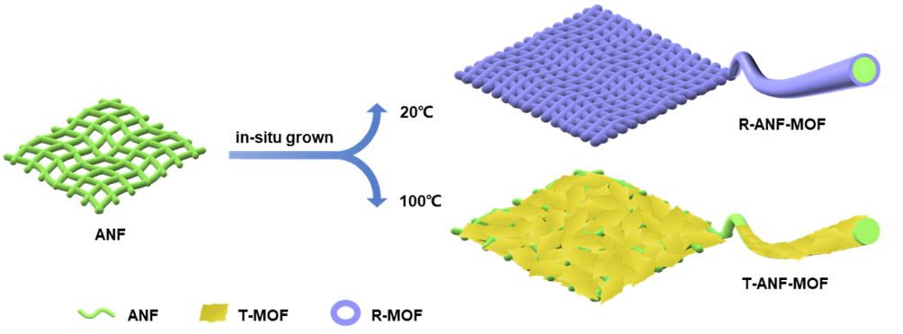

**Figure S1**. Schematic illustration of the preparation processes of R-ANF-MOF and T-ANF-MOF membranes.

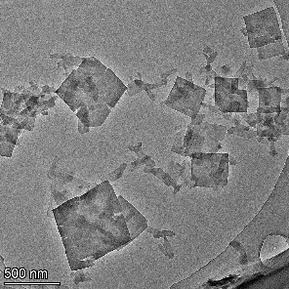

**Figure S2**. The HRTEM image of T-MOF.

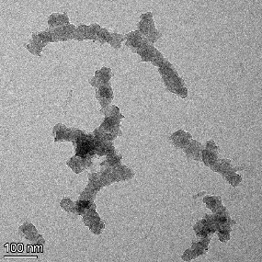

**Figure S3**. The HRTEM image of R-MOF.

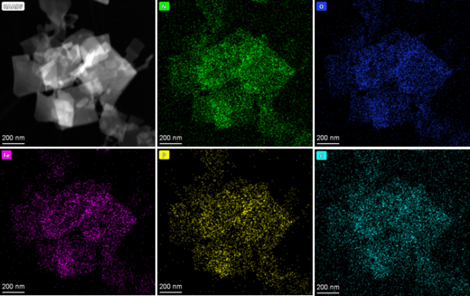

**Figure S4**. The elemental mapping images of Fe, C, O, N and P of T-MOF.

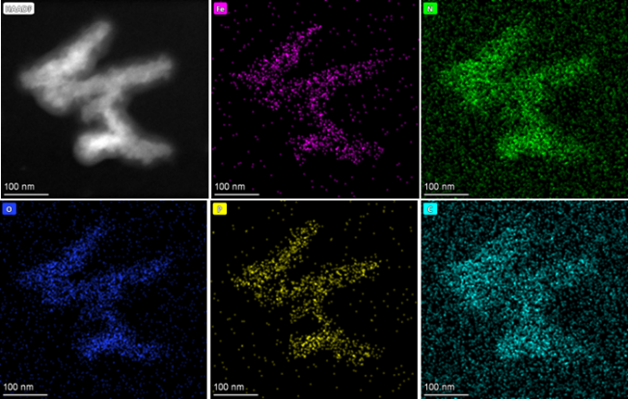

**Figure S5**. The elemental mapping images of Fe, C, O, N and P of R-MOF.

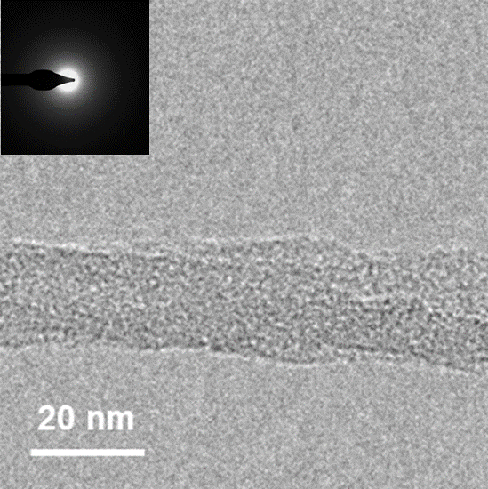

**Figure S6**. HRTEM image of ANF. The insets on the top left show the SAED pattern.

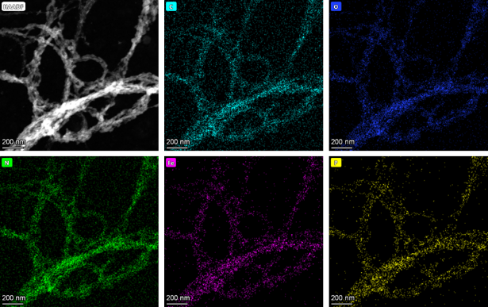

**Figure S7**. The elemental mapping images of Fe, C, O, N and P of R-ANF-MOF.

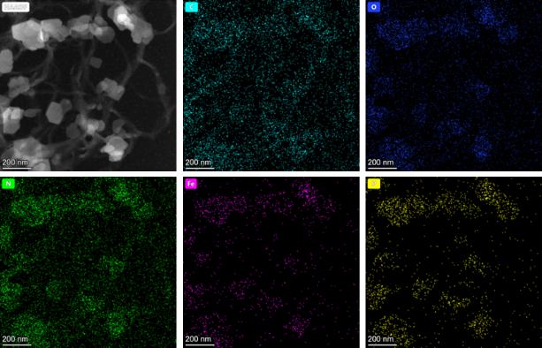

**Figure S8**. The elemental mapping images of Fe, C, O, N and P of T-ANF-MOF.

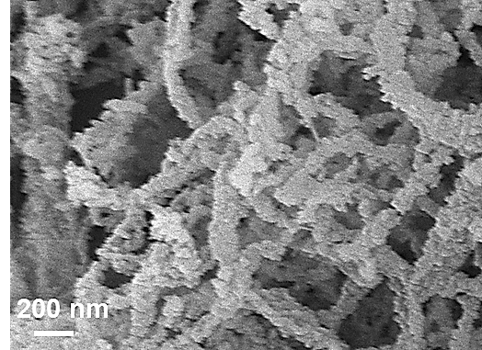

**Figure S9**. SEM image of R-ANF-MOF.

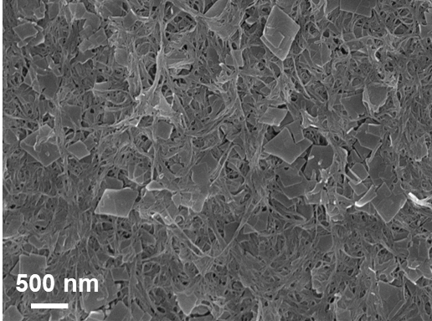

**Figure S10**. SEM image of T-ANF-MOF.

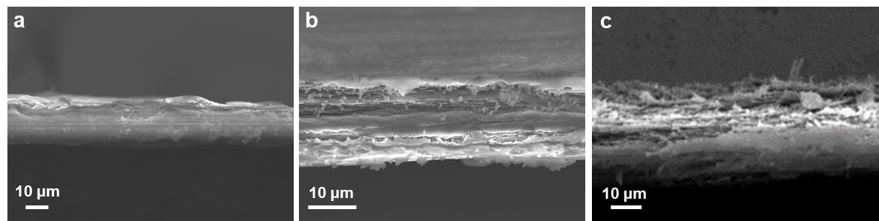

**Figure S11**. The cross-sectional SEM image of ANF (a), T-ANF-MOF (b), R-ANF-MOF (c) membranes.

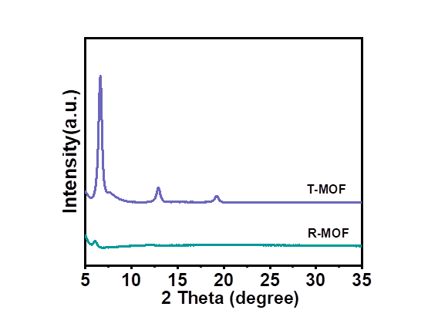

**Figure S12**. XRD patterns of T-MOF and R-MOF.

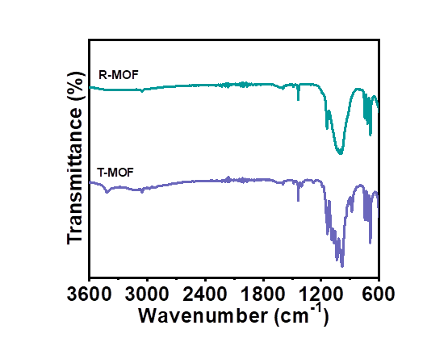

**Figure S13**. FTIR spectra of T-MOF and R-MOF.

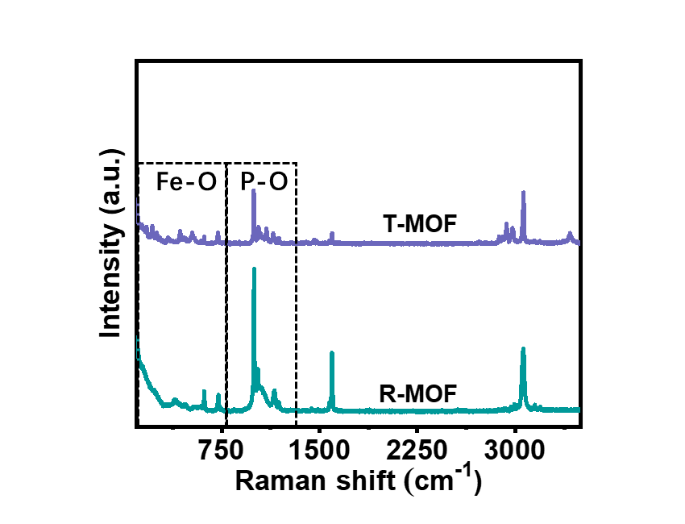

**Figure S14**. Raman spectra of T-MOF and R-MOF.

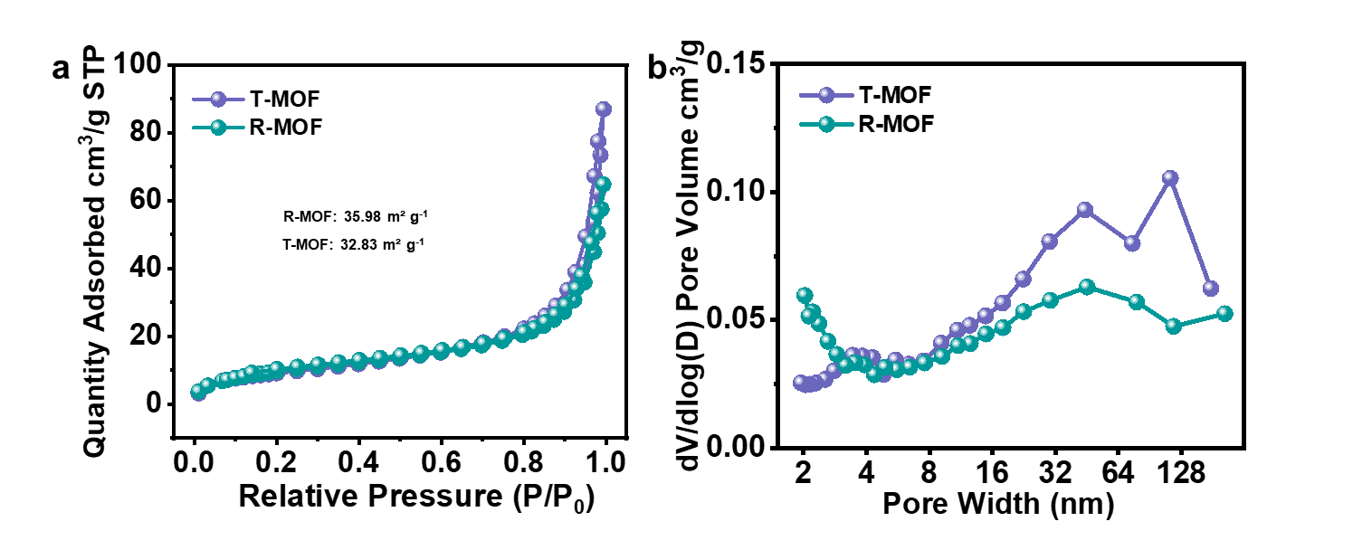

**Figure S15**. (a) N2 adsorption-desorption isotherm and (b) pore size distribution of T-MOF and R-MOF.

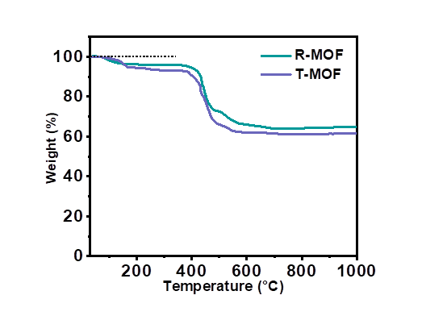

**Figure S16**. TGA curves of T-MOF and R-MOF.

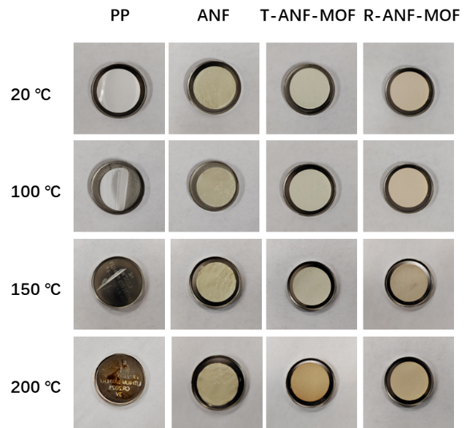

**Figure S17**. Thermal shrinkage of PP, ANF, T-ANF-MOF and R-ANF-MOF membranes.

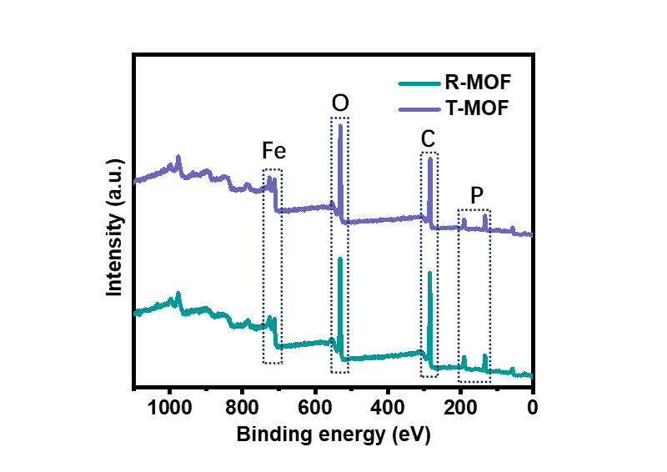

**Figure S18**. Full XPS profiles of T-MOF and R-MOF.

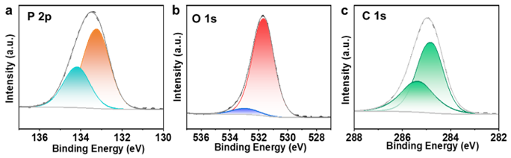

**Figure S19**. High-resolution XPS spectra for (a) P 2p, (b) O 1s and (c) C 1s of R-ANF-MOF.

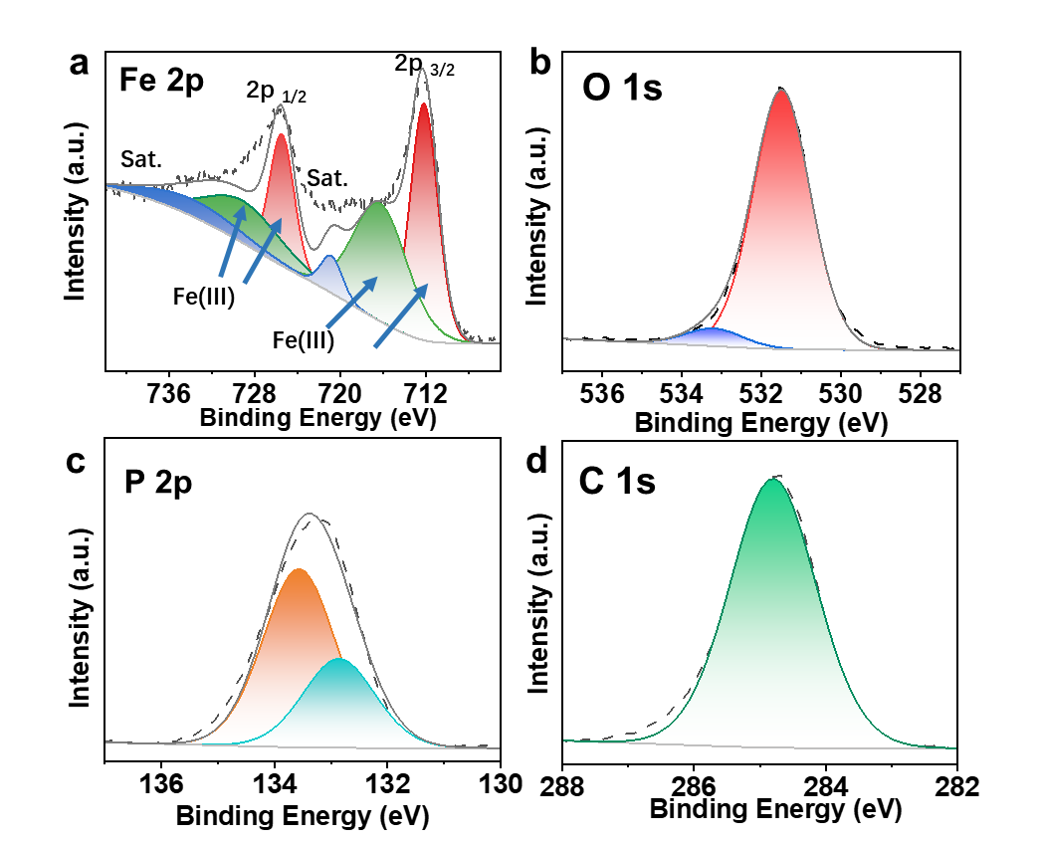

**Figure S20**. High-resolution XPS spectra for (a) Fe 2p, (b) O 1s, (c) P 2p and (d) C 1s of T-ANF-MOF.

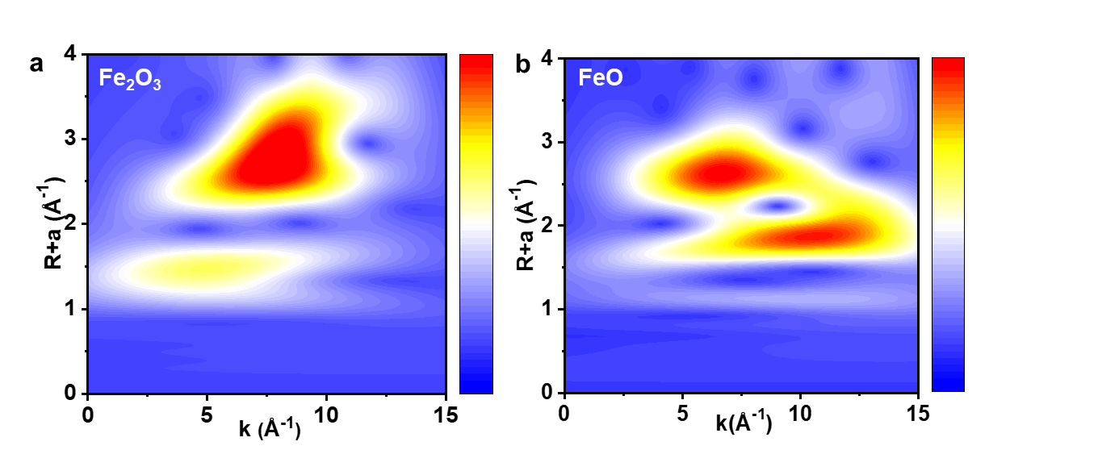

**Figure S21**. WT-EXAFS data of (a) Fe2O3 and (b) FeO.

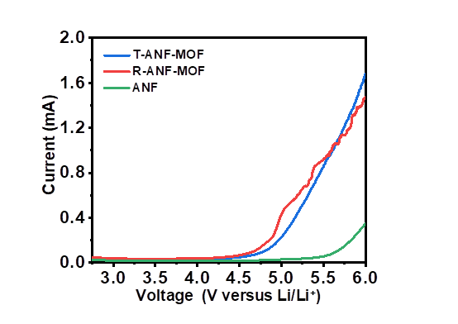

**Figure S22**. LSV curves of ANF, T-ANF-MOF and R-ANF-MOF.

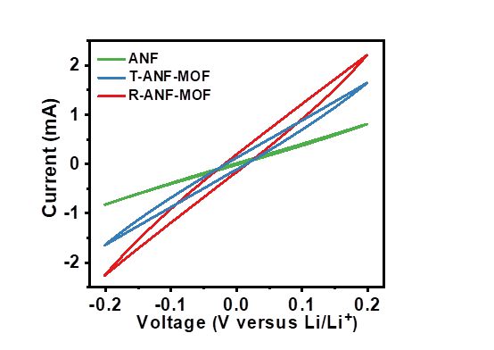

**Figure S23**. CV curves of the Li||Li symmetric cells with ANF, T-ANF-MOF and R-ANF-MOF at the scan rate of 10 mV s-1.

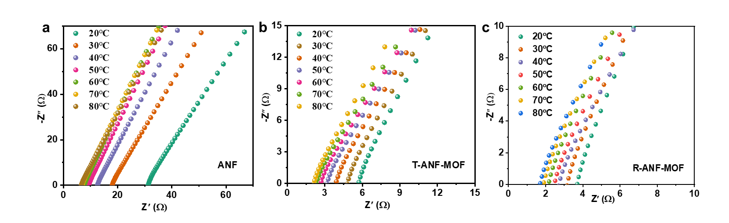

**Figure S24**. EIS plots of (a) ANF, (b) T-ANF-MOF and (c) R-ANF-MOF from 20 to 80 ℃.

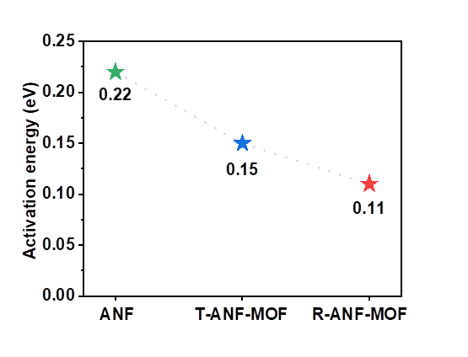

**Figure S25**. Activation energy of ANF, T-ANF-MOF and R-ANF-MOF.

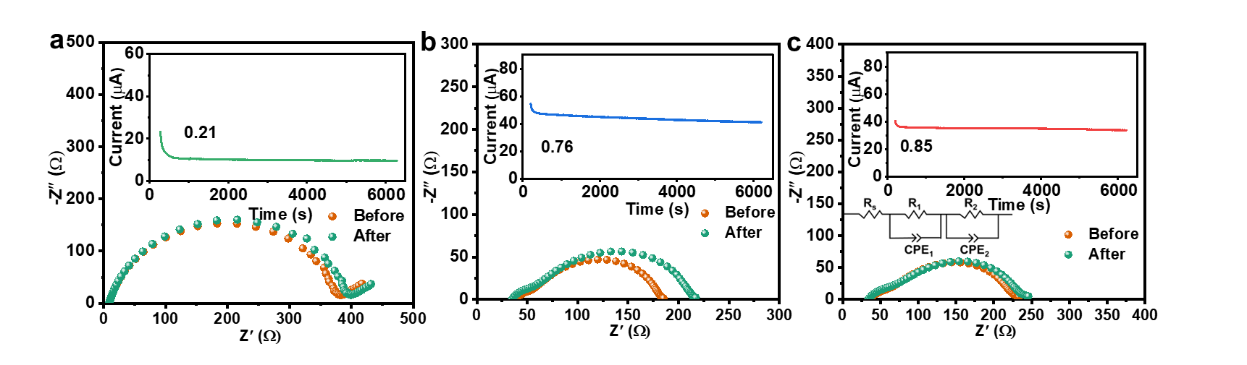

**Figure S26**. EIS before and after polarization of the Li||Li symmetric cells of with (a) ANF, (b) T-ANF-MOF and (c) R-ANF-MOF. The inset is the current-time curve.

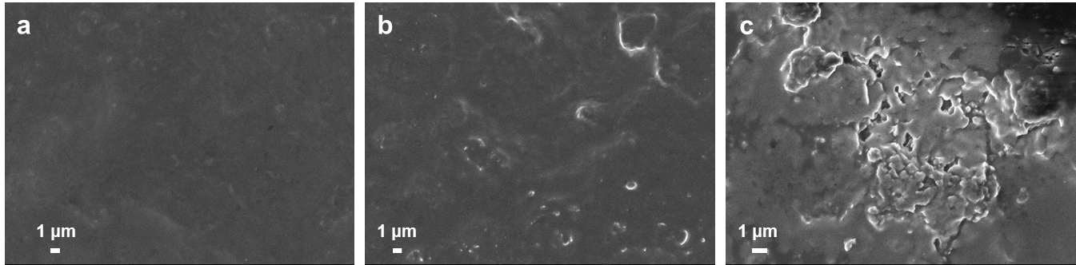

**Figure S27**. SEM images of the Li anodes for Li||Li symmetrical cells s after long-term cycling with the (a) R-ANF-MOF, (b) T-ANF-MOF and (c) ANF.

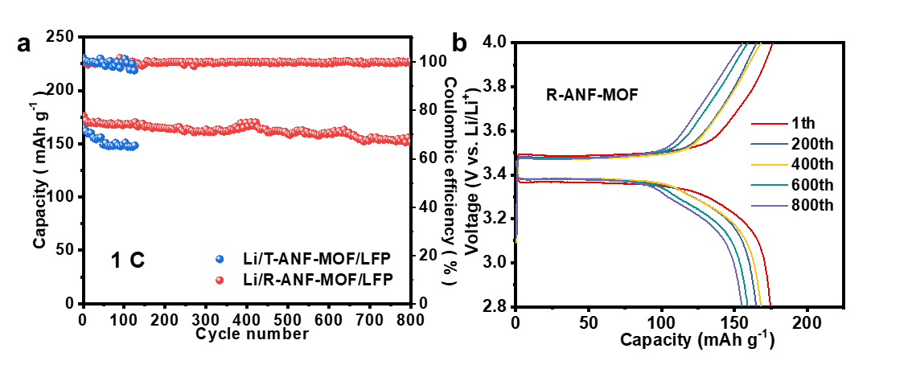

**Figure S28**. (a) Cycling performance and (b) charge-discharge profiles of Li||LiFePO4 cells with T-ANF-MOF and R-ANF-MOF at 1 C.

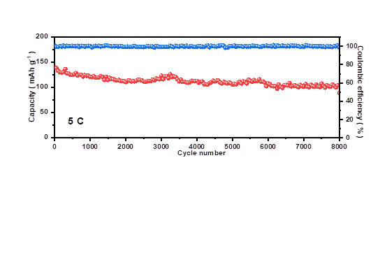

**Figure S29**. Long-term performance of Li||LiFePO4 cells with R-ANF-MOF at 5 C.

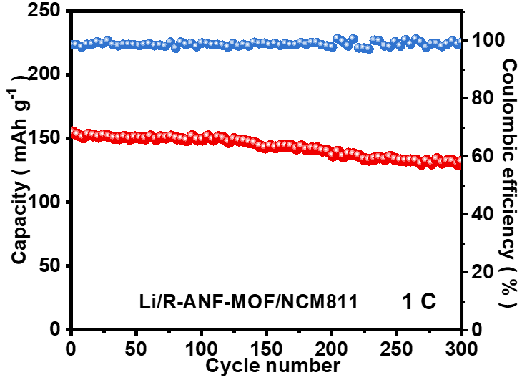

**Figure S30**. Cycling performances of Li|| NCM811 cells with R-ANF-MOF at 1 C.

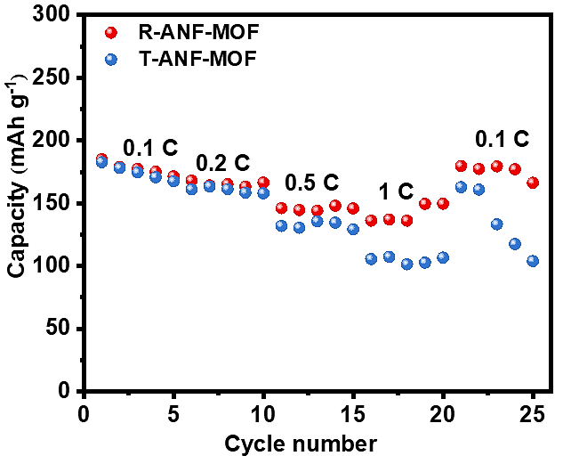

**Figure S31**. Rate performance of Li||NCM811 cells with T-ANF-MOF and R-ANF-MOF.

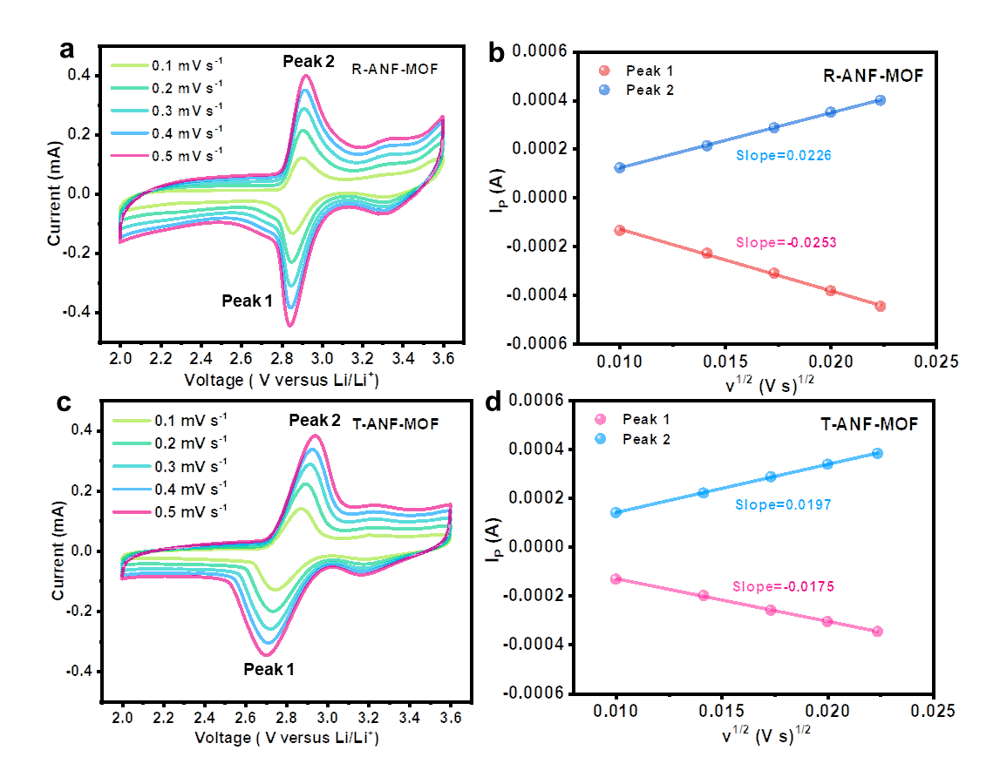

**Figure S32**. CV curves at 0.1-0.5 mV/s scan rate and the corresponding linear relation of peak current (Ip) versus the square root of scan rate of the Li-I2 cell with (a, b) R-ANF-MOF and (c, d) T-ANF-MOF.

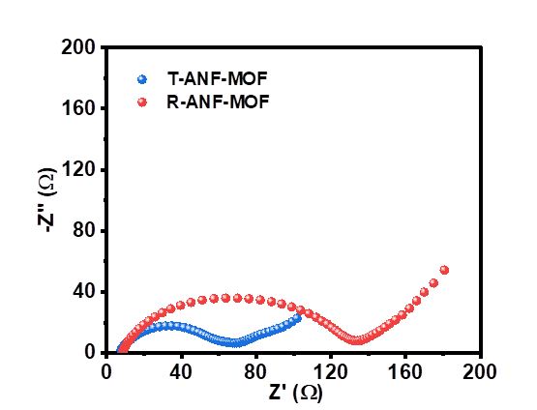

**Figure S33**. EIS spectra of Li-I2 cells with T-ANF-MOF and R-ANF-MOF.

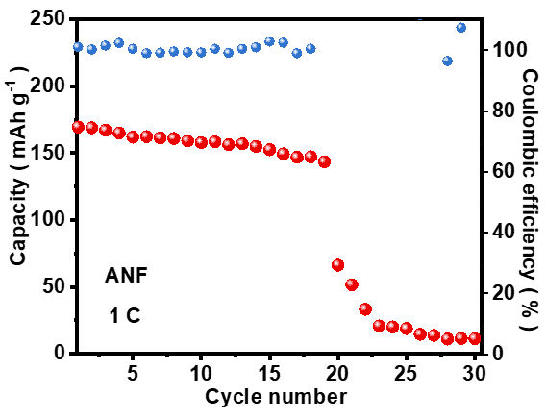

**Figure S34.** Cycling performance of Li-I2 cell with ANF at 1 C.

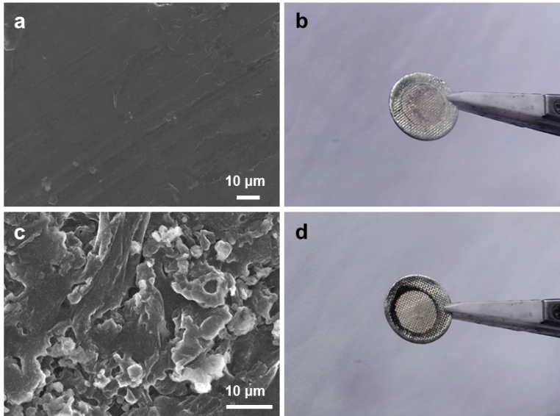

**Figure S35**. SEM images and digital photographs of the Li anodes for Li-I2 cells with (a, b) R-ANF-MOF and (c, d) T-ANF-MOF after 450 cycles at 5 C.

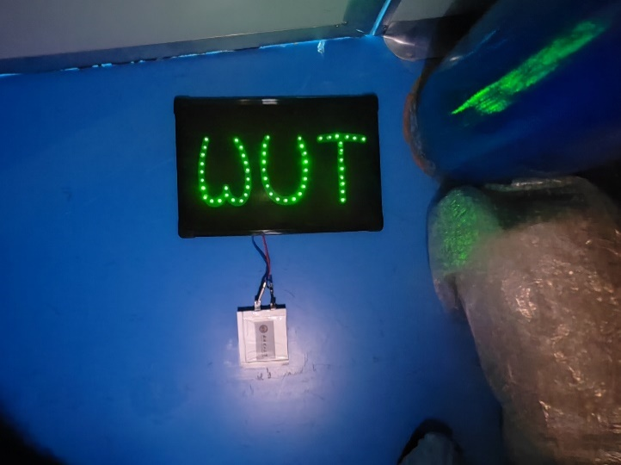

**Figure S36**. The digital photograph of LED powered by the Li-I2 pouch cell.

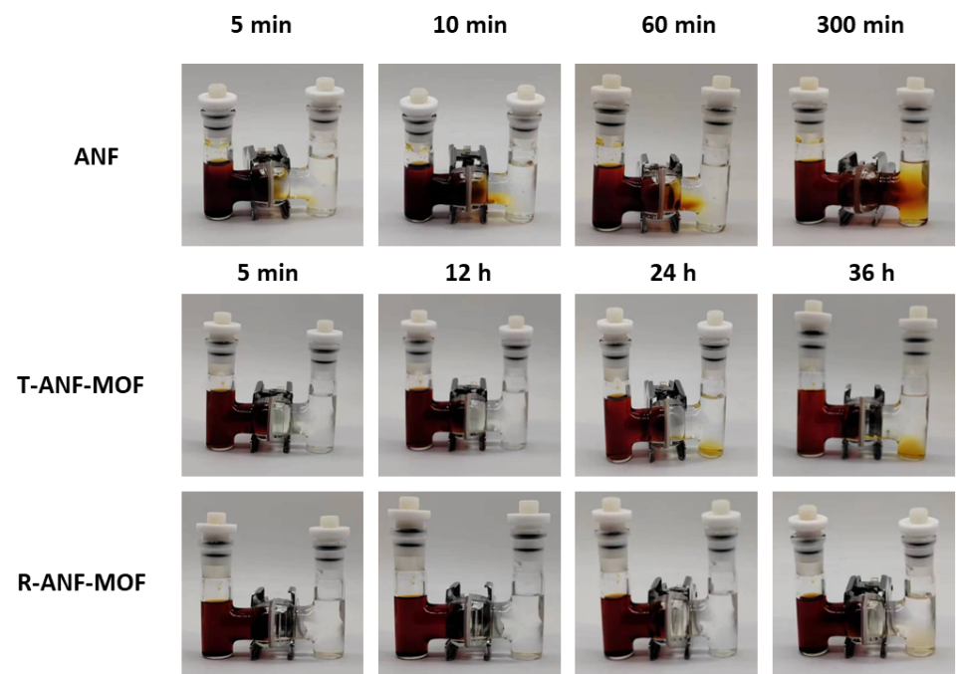

**Figure S37**. Permeation experiments with a double-L device for ANF, T-ANF-MOF, and R-ANF-MOF.

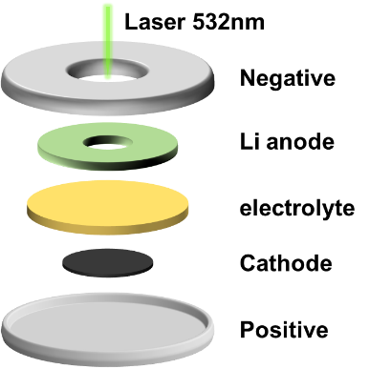

**Figure S38**. Schematic illustration of in situ Raman detection.

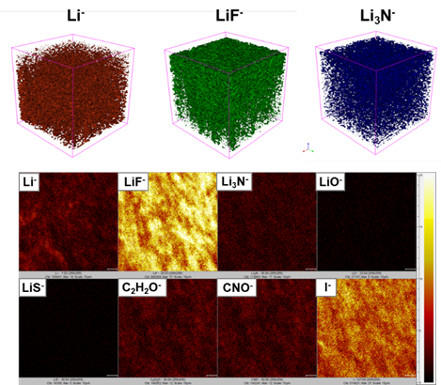

**Figure S39**. 2D spectra and 3D reconstructions of the ToF-SIMS signal detected for different secondary ions for the Li anode surface of the T-ANF-MOF.

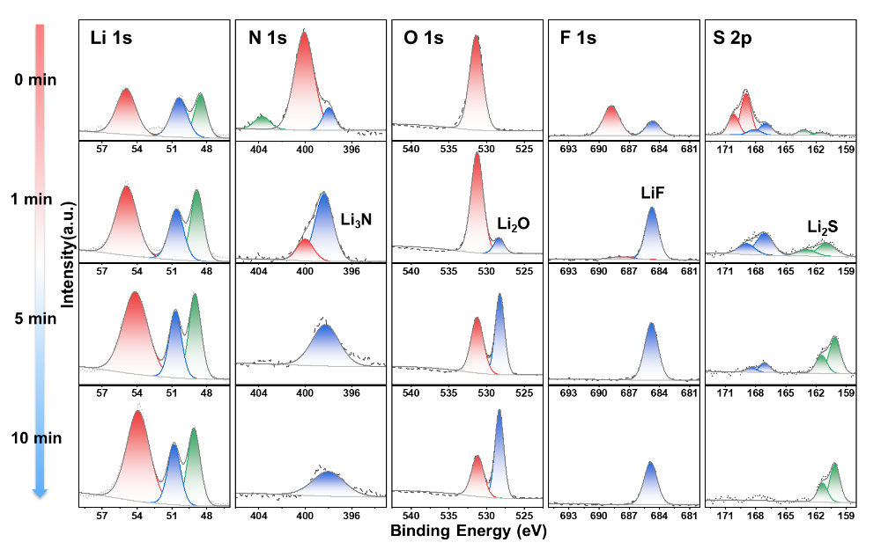

**Figure S40**. A depth profiling of the elements on the Li anode surface of the T-ANF-MOF by the XPS sputter etching technique.

**Table S1**. The elemental content in R-MOF and T-MOF determined by ICP.

|  |  |  |
| --- | --- | --- |
| Sample | ICP | |
| Fe | P |
| R-MOF | 18.99% | 13.87% |
| T-MOF | 19.48% | 11.25% |

**Table S2**. The elemental content in R-MOF and T-MOF determined by EA.

|  |  |  |  |
| --- | --- | --- | --- |
| Sample | EA | | |
| C | H | O |
| R-MOF | 34.18% | 3.61% | 21.97% |
| T-MOF | 34.44% | 4.14% | 24.86% |

**Table S3.** Pore structure parameters of of T-MOF and R-MOF.

|  |  |  |  |
| --- | --- | --- | --- |
| Sample | BET Surface Area (m²/g) | Adsorption average pore width (nm) | Pore volume (cm3/g) |
| T-MOF | 32.83 | 16.39 | 0.13 |
| R-MOF | 35.98 | 11.14 | 0.10 |

**Table S4.** The EIS results before and after polarization of the Li||Li symmetric cells.

|  |  |  |  |  |  |  |
| --- | --- | --- | --- | --- | --- | --- |
| Sample | Before  Rs (Ω) | Before  Rs+Rct (Ω) | After  Rs (Ω) | After  Rs+Rct (Ω) | Rct0 (Ω) | Rcts (Ω) |
| ANF | 9.0 | 378.6 | 9.1 | 396.3 | 369.6 | 387.2 |
| T-ANF-MOF | 42.0 | 183.2 | 34.1 | 217.1 | 141.2 | 183.0 |
| R-ANF-MOF | 40.0 | 229.3 | 33.8 | 246.5 | 189.3 | 212.9 |

**Table S5.** Electrochemical performance comparison of Li-I2 batteries using R-ANF-MOF in this work compared to other strategies in previous literatures.

|  |  |  |  |  |
| --- | --- | --- | --- | --- |
| Cathode | Electrolyte | Specific capacity  (mAh g-1) | Cycling  retention (%) | refs |
| I2/MC | 1 M LiTFSI  +DOL/DME+1 % LiNO3 | 175.4 (5 C) | 2000 (84.8 %) | 7 |
| I2/AC | PEO/PVDF/CD-Si/ | 120 (5 C) | 1000 (35 %) | 8 |
| 3DC/I2 | 1 M LiTFSI  +DOL/DME+1 % LiNO3 | 180 (5 C)  171 (10 C) | 3500 (90 %)  6000 (87.5 %) | 9 |
| I2/AG | 0.5 M LiTFSI  +DOL/TEGDME+0.2 M  LiNO3 | 146 (1 C)  161 (1 C) | 500 (67.5 %)  500 (73.8 %) | 10 |
| KB/I2 | LAGP | 112 (1 C)  117 (5 C) | 9000 (81.1 %)  4000 (83.5 %) | 11 |
| rGO/LiI | 1 M LiTFSI  +DOL/DME+1 % LiNO3 | 168 (10 C) | 200 (85 %) | 12 |
| I2/CC | GPETS | 207 (1 C)  98 (5 C) | 500 (61.4 %)  2000 (73.0 %) | 13 |
| **I2/AC** | **R-ANF-MOF** | **170.7 (5 C)**  **95.6 (20 C)** | **450 (97.8 %)**  **3000 (94.1 %)** | **This**  **work** |

**References**

[1] G. Kresse, J. Furthmüller, Phys. Rev. B 1996, 54, 11169.

[2] G. Kresse, D. Joubert, Phys. Rev. B 1999, 59, 1758.

[3] J.P. Perdew, K. Burke, M. Ernzerhof, Phys. Rev. Lett. 1996, 77, 3865-3868.

[4] S. Grimme, J. Antony, S. Ehrlich and H. Krieg, J. Chem. Phys. 2010, 132, 154104-154123.

[5] H. J. Monkhorst and J. D. Pack, Phys. Rev. B: Solid State 1976, 13, 5188-5192.

[6] G. Henkelman, B.P. Uberuaga, H. Jonsson, J. Chem. Phys. 2000, 113, 9901-9904.

[7] D. Yu, D. Liu, L. Shi, J. Qiu, L. Dai, J Mater. Chem. A 2021, 9, 538.

[8] Y Su, X Wang, S Zhou, B Tang, J Zhao, D Liu, D Liu, G Zhu, J. Energy Storage 2024, 84, 110820.

[9] Q. Chen, S. Chen, J. Ma, S. Ding, J. Zhang, Adv. Funct. Mater. 2023, 34, 2308272.

[10] Q. Zhang, Z. Wu, F. Liu, S. Liu, J. Liu, Y. Wang, T. Yan, J Mater. Chem. A 2017, 5, 15235.

[11] Z. Cheng, H. Pan, F. Li, C. Duan, H. Liu, H. Zhong, C. Sheng, G. Hou, P. He, H. Zhou, Nat. Commun. 2022, 13.

[12] S. Kim, S.-K. Kim, P. Sun, N. Oh, P. V. Braun, Nano Lett., 2017, 17, 6893.

[13] Y. Jiang, P. Huang, M. Tong, B. Qi, T. Sun, Z. Xian, W. Yan, C. Lai, Carbon Energy 2024, 6, e478.