Mitigating Jahn–Teller Effect of MnO2 viaCharge Regulation of Mn-Local Environment for Advanced Calcium Storage

**Experimental Procedures**

**1 Synthesis of the MnO2**

MnO2 was synthesized by a facile hydrothermal method[1]. First, 400 mg KMnO4 was dissolved in 40 mL deionized water with stirring at room temperature for 5 minutes. Then, add 78.3 mg of MnSO4∙H2O to the above solution and stirred at room temperature for 1 hour. The mixture solution was transferred into a 50 mL Teflon-lined autoclave and keep it at 160°C in an oven for 16 hours. Wash the product three times with deionized water. Finally, the MnO2 was acquired through the freeze-drying.

**2 Synthesis of the Mo-MnO2**

The synthesis of Mo-MnO2 involves adding varying amounts of (NH4)6Mo7O24·4H2O into the solution for synthesizing MnO2, with continuous stirring. The resulting samples are named MMO-20 (20mg), MMO-40 (40mg), MMO-60 (60mg) and MMO-80 (80mg), respectively.

**3 Materials Characterizations**

The crystal structure and morphology of the samples were characterized using X-ray diffraction (XRD) (D8 Advance, Bruker AXS GmbH, Karlsruhe, Germany) and scanning electron microscopy (SEM, JEOL-7100F). The morphology was also examined using transmission electron microscopy (TEM) and high-resolution TEM images obtained from TEM, JEM-2100F. Infrared spectra were collected using a Nicolt iS50 spectrometer. Thermogravimetric analysis (TGA) was performed on a NETZSCH-STA449c/3/G thermal analysis instrument with a temperature range of 30-600°C. XPS spectroscopy measurements were conducted using the AXIS SUPRA. The discharged electrode samples were tested using a time-of-flight secondary ion mass spectrometer (nano TOFII). Raman spectra were collected using a Raman spectrometer (LabRAM HR Evolution & SmartSPM). The electrochemical performance, including specific capacity, rate capability, and cycling performance, was evaluated using a Neware battery testing system (BTS80) with a constant current charge-discharge method.

**4 Electrochemical Measurements**

After thoroughly mixing 60 wt% of active material, 30 wt% of Ketjen Black, and 10 wt% of binder (polytetrafluoroethylene, PTFE), the working electrode was pressed. The mass loading of the cathode electrode is approximately~1.5 mg cm-2. It was dried under vacuum at 60°C for 12 hours. The electrochemical performance was tested using a CR2016 coin cells in a glovebox filled with argon (<0.1 ppm of H2O and <0.5 ppm of O2). The anode electrode used active carbon (AC), and a glass fiber membrane (GF/A What-man) was employed as the separator. The 0.5 M Ca(TFSI)2/AN serves as the electrolyte. Ca(TFSI)₂ has been widely reported as an electrolyte for CIBs for several key reasons[2]: a wide electrochemical stability window, high ionic conductivity, and low viscosity. These characteristics make Ca(TFSI)₂ an attractive choice for the development of CIBs.Galvanostatic charge–discharge measurements and galvanostatic intermittent titration technique (GITT) tests were conducted on a multi-channel battery testing system (CT2001A, LAND, Wuhan, China). According to our previous work, the potential of the alternating electrode can be calculated to be approximately 3.023 V vs. Ca/Ca2+[3]. The current pulse was set to 50 mA g−1, applied for 10 minutes, and then rested for 30 minutes to obtain the GITT curve. In-situ XRD measurements were performed between 20° and 45° using a stainless steel open-type coin cell connected to a multi-channel battery testing system (Neware, China). Cyclic voltammetry (CV) and electrochemical impedance spectroscopy (EIS) plots were collected using a VMP3 multichannel electrochemical workstation (Bio-Logic France).

**5 Computational details**

Density functional theory (DFT) calculations were performed using the projector augmented-wave (PAW) method, as implemented in the Vienna Ab initio Simulation Package (VASP)[4]. The exchange-correlation functional was treated within the generalized gradient approximation (GGA), utilizing the Perdew-Burke-Ernzerhof (PBE) scheme[5]. The plane-wave basis set was truncated at a cutoff energy of 500 eV, and the energy convergence criterion for the self-consistent field iterations was set to 10-5 eV. For Brillouin zone integration, a k-point mesh was generated with a spacing of 0.040 Å, ensuring comprehensive sampling. All structures underwent full relaxation until the forces on each atom were diminished to below 0.03 eV/Å. Furthermore, the DFT-D3 correction method was incorporated to accurately account for weak van der Waals interactions[6]. Charge transfers between Ca2+ and the host structure were analyzed using Bader charge analysis. To investigate the migration pathway and energy barriers of Ca2+ ions, we employed the Climbing Image Nudged Elastic Band (CI-NEB) method.

The vacancy formation energy for Mn in MnO2 is defined as

$$E_{\text{vac}}^{\text{Mn}}=E_{\text{Mn-vac}}-E_{\text{perfect}}+μ_{\text{Mn}}$$

Here, $E_{\text{Mn-vac}}$ and $E_{\text{perfect}}$ denote the total energies of MnO2 with a single Mn vacancy and the perfect MnO2 crystal, respectively, while $μ_{\text{Mn}}$ represents the chemical potential of Mn. The doping formation energy for doping Mo atom into MnO2 is categorized into four scenarios:

Without Mn vacancy, and one Mo atom is doped interlayer

$$E_{\text{dop-interlayer}}^{\text{Mo}}=E_{\text{Mo-interlayer}}-E_{\text{perfect}}-μ_{\text{Mo}}$$

Without Mn vacancy, and one Mn atom of layer is replaced by Mo atom

$$E_{\text{dop-layer}}^{\text{Mo}}=E_{\text{Mo-layer}}-E_{\text{perfect}}-μ_{\text{Mo}}+μ_{\text{Mn}}$$

With one Mn Vacancy, and one Mo atom is doped interlayer

$$E_{\text{dop-vac-interlayer}}^{\text{Mo}}=E_{\text{Mo-vac-interlayer}}-E_{\text{Mn-vac}}-μ_{\text{Mo}}$$

With one Mn vacancy, and the Mn vacancy is occupied by Mo atom

$$E_{\text{dop-vac}}^{\text{Mo}}=E_{\text{Mo-layer}}-E_{\text{Mn-vac}}-μ_{\text{Mo}}$$

Here, $E_{\text{Mo-interlayer}}$ and $E_{\text{Mo-vac-interlayer}}$ respectively represent the total energy of Mo atom doped into the interlayer of MnO2 without Mn vacancy and into the interlayer of MnO2 with one Mn vacancy. $E_{\text{perfect}}$, $E_{\text{Mn-vac}}$ and $E_{\text{Mo-layer}}$ denote the total energy of the perfect MnO2 structure, the total energy of MnO2 with a single Mn vacancy and Mo atom replace the Mn atom. $μ_{\text{Mn}}$ and $μ_{\text{Mo}}$ represent the chemical potential of Mn and Mo atom, respectively.

**6 Capacitive capacity contribution calculation**

According to previous reports[7], the peak current (*i*) and the sweep rate (*v*) meet the empirical formula *i* =*av*b, where a and b are adjustable parameters. Furthermore, the contributions of diffusion controlled and capacitive process can be determined by the following equation,

*i*(V) = *k*1v + *k*2*v*1/2  (1)

where *i* is the current (A g−1), *v* is the scan rate (mV s−1).

**7 Supplementary Figures and Tables**

**Table S1**. Electrochemical performances of reported cathodes for CIBs and the MMO-40 cathode in non-aqueous electrolyte (AC as counter electrode)

|  |  |  |  |  |  |  |
| --- | --- | --- | --- | --- | --- | --- |
| Materials | Electrolyte | Counter electrode | Operation range (V)  versus Ca/Ca2+ | specific capacity/current density (mA h g-1) | Voltage(V) | References |
| **MMO-40** | **Ca(TFSI)2/AN** | **AC** | **1.4 – 4.4 V** | **148/100 135/200 130/500 129/1000** | **0.2 V** | **This Work** |
| Mg0.25V2O5·H2O | Ca(TFSI)2 EC/PC/EMC/DMC | AC | 1.4 – 4.1 V | 120/20 90/50 72/100 | -0.15 V | [8] |
| VOPO4·2H2O | Ca(TFSI)2 EC/PC/EMC/DMC | AC | 0.9 – 4.2 V | 120/10 100/20 70/50 55/100 40/200 | 0.5 V | [9] |
| NaV2(PO4)3 | Ca(BF4)2 EC/PC | AC | 2.8 – 3.5 V | 72/5.8 70/11.7 65/23.4 58.8/58 53/117 | 0.4 V | [10] |
| CaxNa0.5VPO4.8F0.7 | Ca(PF6)2 | AC | 1.9 – 4.3 V | 88/10 82/20 72/50  62/100 53/200 42/500 | 0.5V | [11] |
| Na1V2(PO4)2F3 | 0.5 M Ca(PF6)/ EC/PC/EMC/DMC | AC | 2.8 – 4.4 V | 110/5 108/10 105/20  90/100 82/200 56/500 | 0.6 V | [12] |
| CaMn2O4 | Ca(TFSI)2/DME | AC | 1.7 –3.8 V | 60/50 | 0.15 V | [13] |
| MnO2-P | Ca(TFSI)2/AN | AC | 1.4 – 4.4 V | 140/100 140/200 134/500  129/1000 | 0.1 V | [14] |
| δ-MnO2 | Ca(TFSI)2/AN | AC | 1.4 – 4.4 V | 130/100 120/200 105/500 | 0.15 V | [15] |
| Cr-NH4V4O10 | Ca(TFSI)2/PC | AC | 2.37 – 3.52 V | 80/50 70/100 65/150  62/200 60/300 50/500 | -0.4 V | [16] |
| K0.31MnO2·0.25H2O | Ca (NO3)2∙4H2O/H2O | AC | 2.27 – 3.87 V | 84/25 | 0.1 | [17] |
| CaV6O16·2.8H2O | Ca(TFSI)2/DME | AC | 1.4 – 2.2 V | 170/50 134/100 104/500 | -0.6 V | [15] |
| β-Ag0.33V2O5 | Ca(PF6)2 EC/PC | AC | 1.87 – 3.87 V | 179/12.3 | -0.4 V | [18] |

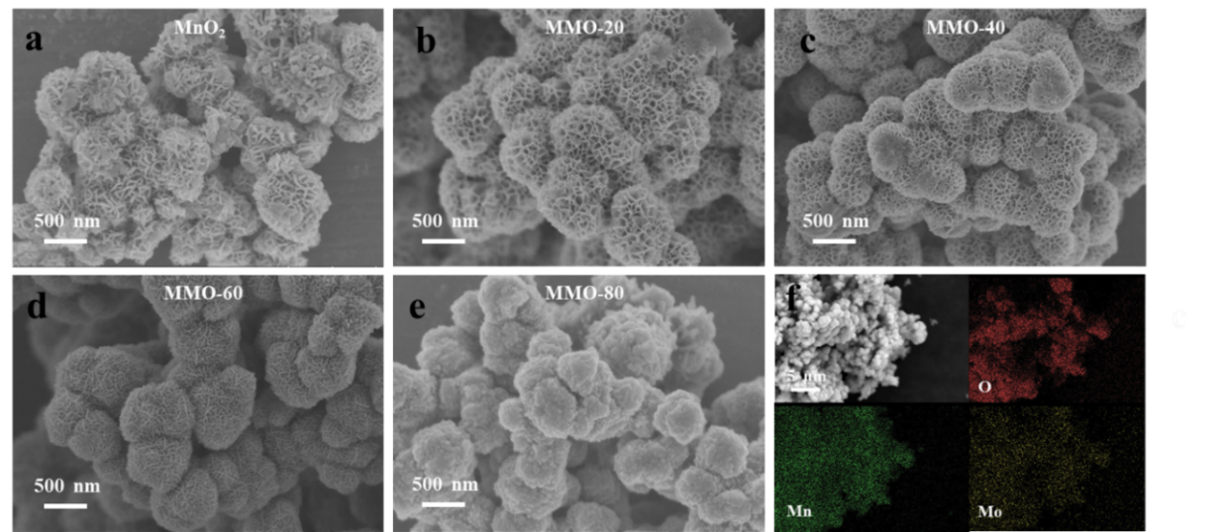

**Figure S1.** (a-e) The SEM image of pristine MnO2 and MMO-20, MMO-40, MMO-60, and MMO-80; (f) The EDS mapping images of MMO-40.

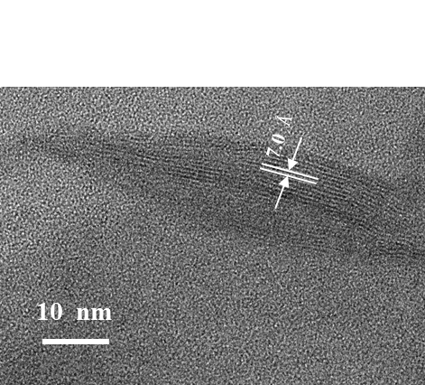

**Figure S2.** The HRTEM image of MnO2.

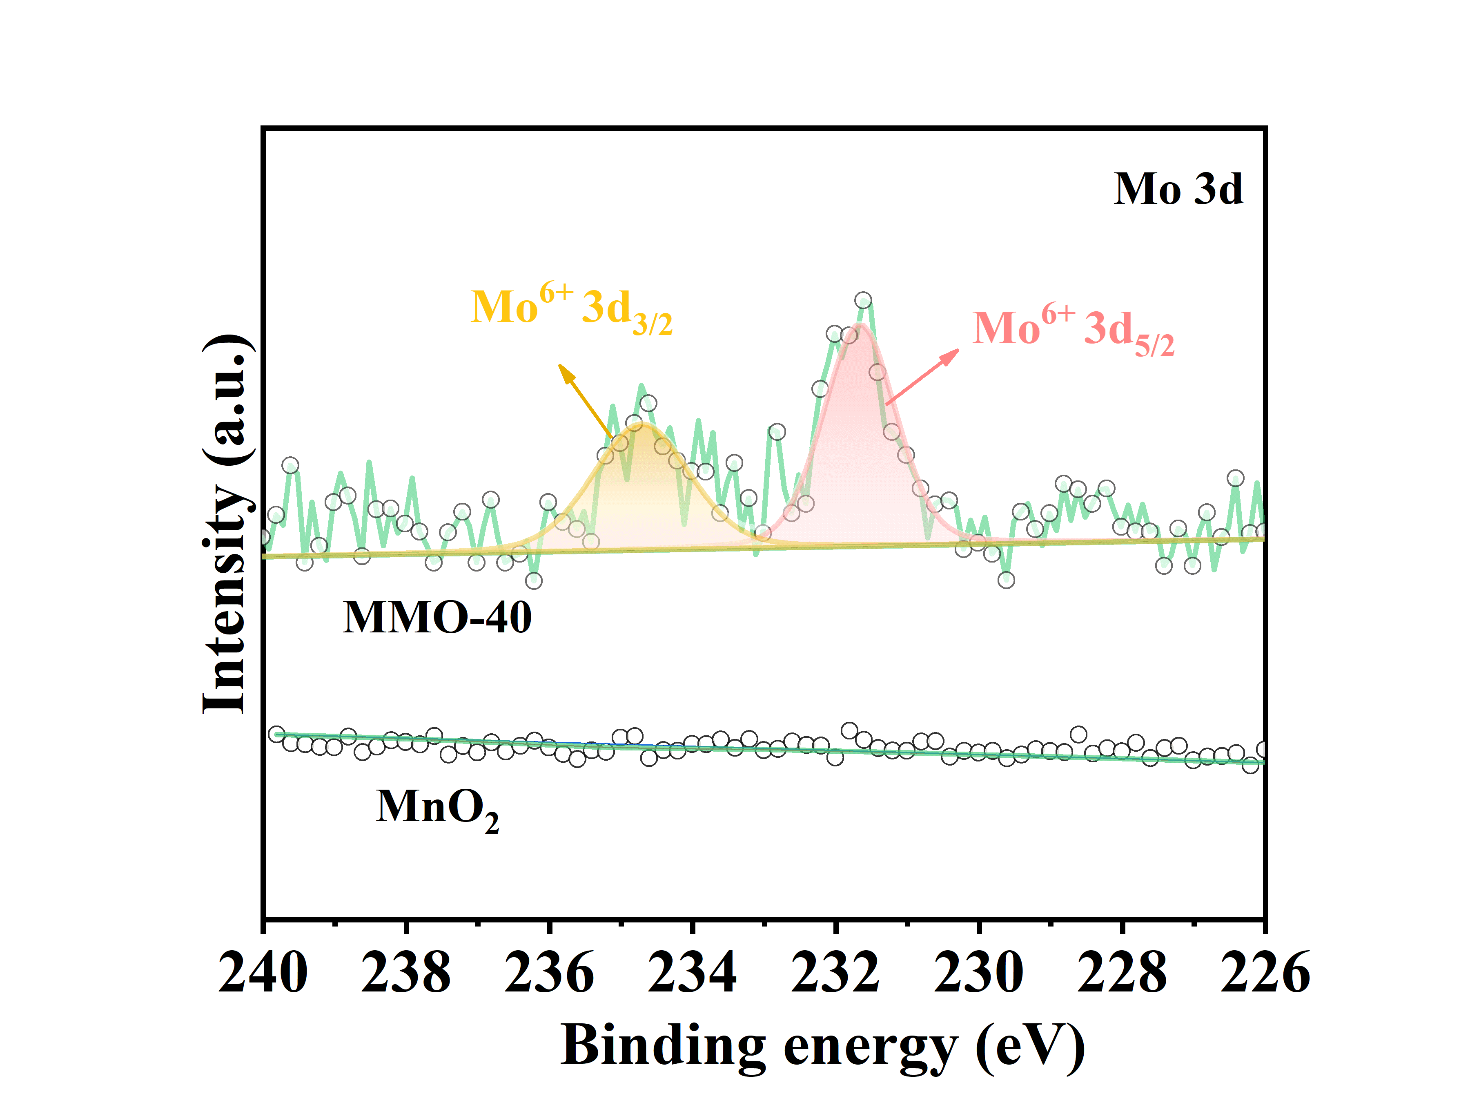

**Figure S3.** Mo 3d XPS spectra of pristine MnO2 and MMO-40.  
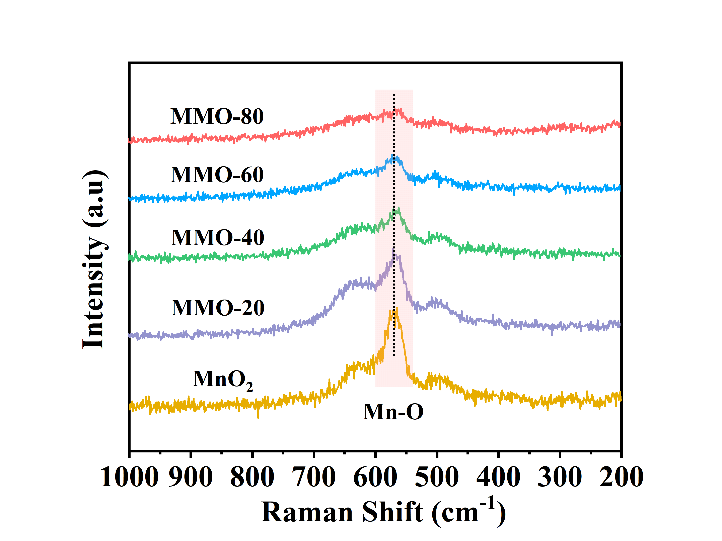

**Figure S4.** Raman spectra of pristine MnO2 and MMO-20, MMO-40, MMO-60, and MMO-80.   
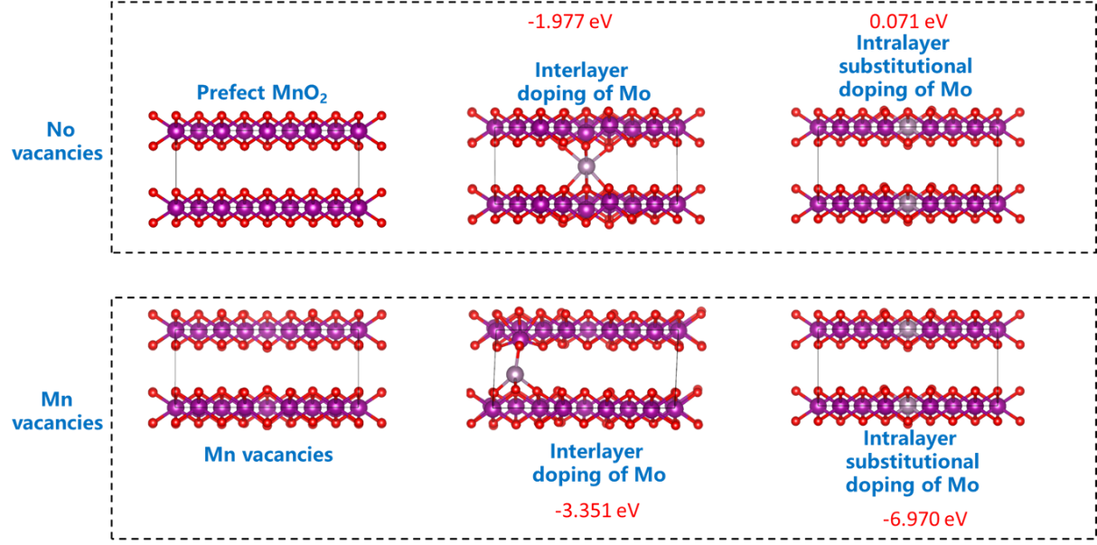

**Figure S5.** In a perfect MnO2 crystal, Mo atoms are more easily doped into the interlayer; In the case of Mn defects, Mo atoms are more easily doped into Mn vacancies

**Table S2.** The ICP result of MnO2, MMO-20, MMO-40, MMO-60 and MMO-80.

|  |  |  |  |  |  |
| --- | --- | --- | --- | --- | --- |
| **Sample**  **Element** | MnO2 | MMO-20 | MMO-40 | MMO-60 | MMO-80 |
| K | 10.86 | 11.20 | 10.85 | 9.31 | 8.48 |
| Mn | 48.42 | 43.62 | 45.84 | 43.3 | 44.04 |
| Mo | 0.002 | 0.29 | 2.02 | 2.53 | 3.46 |

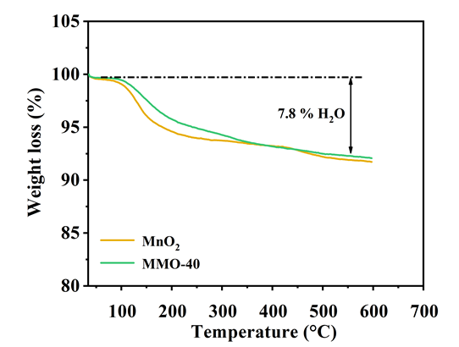

**Figure S6.** The TG curve of pristine MnO2 and MMO-40.

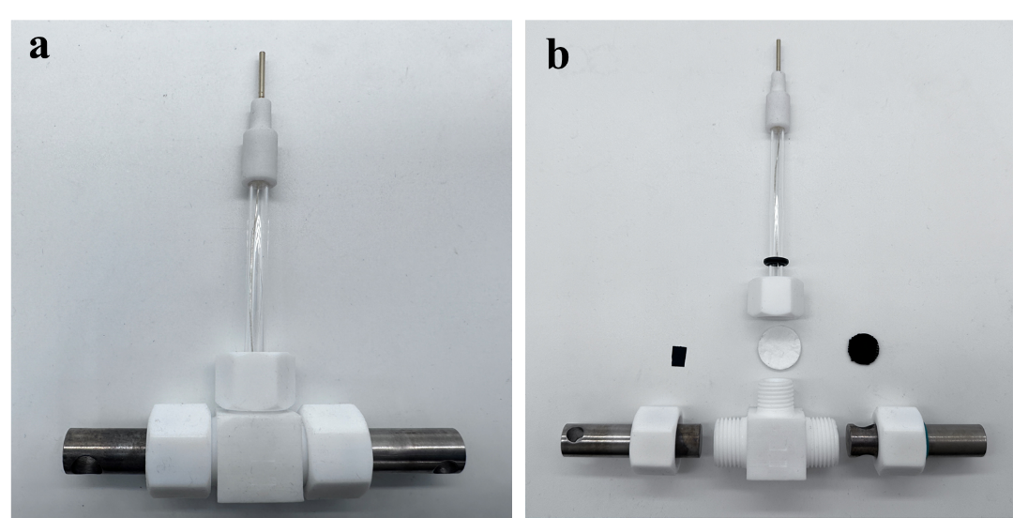

**Figure S7**. (a) The photograph of the Swagelok-type cell. (b) The photograph of each part for the assembly of Swagelok-type cell.

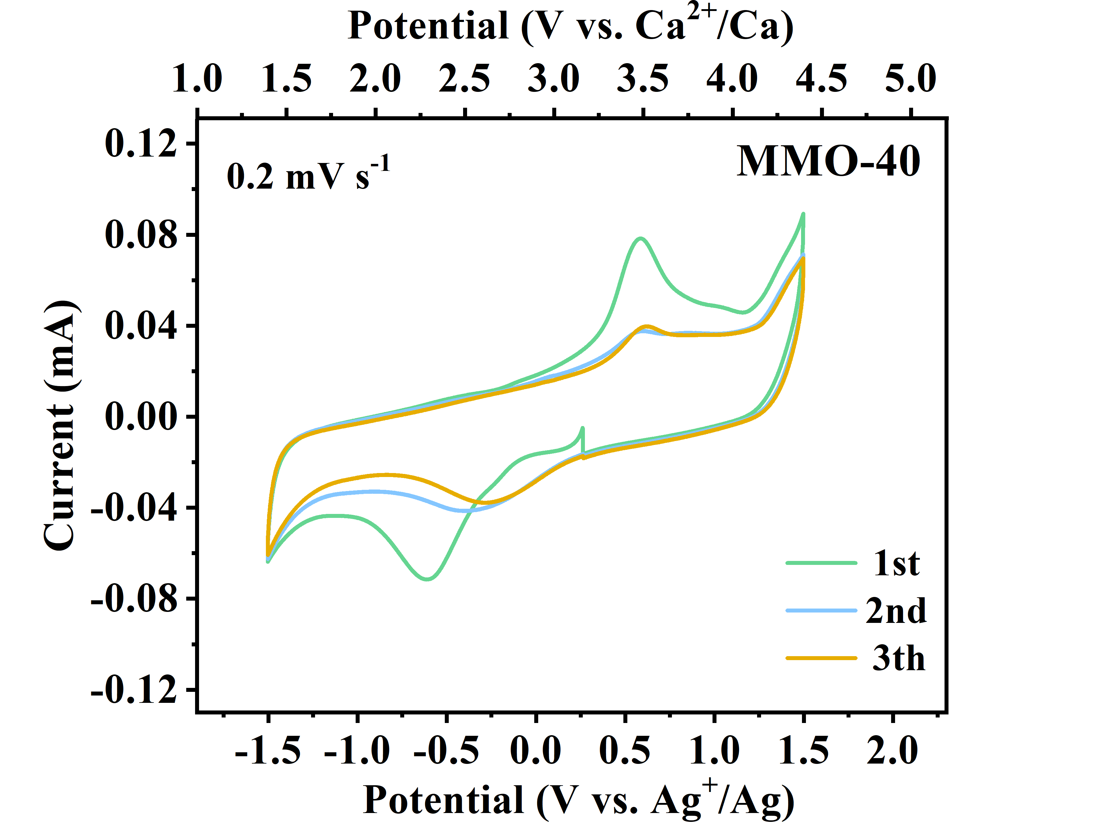

**Figure S8.** The CV curves of MMO-40 in Swagelock-type battery.

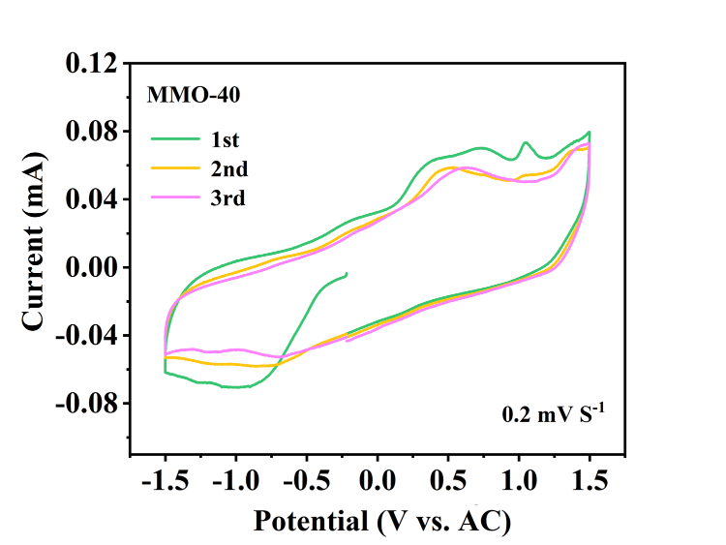

**Figure S9.** The CV curves of MMO-40.

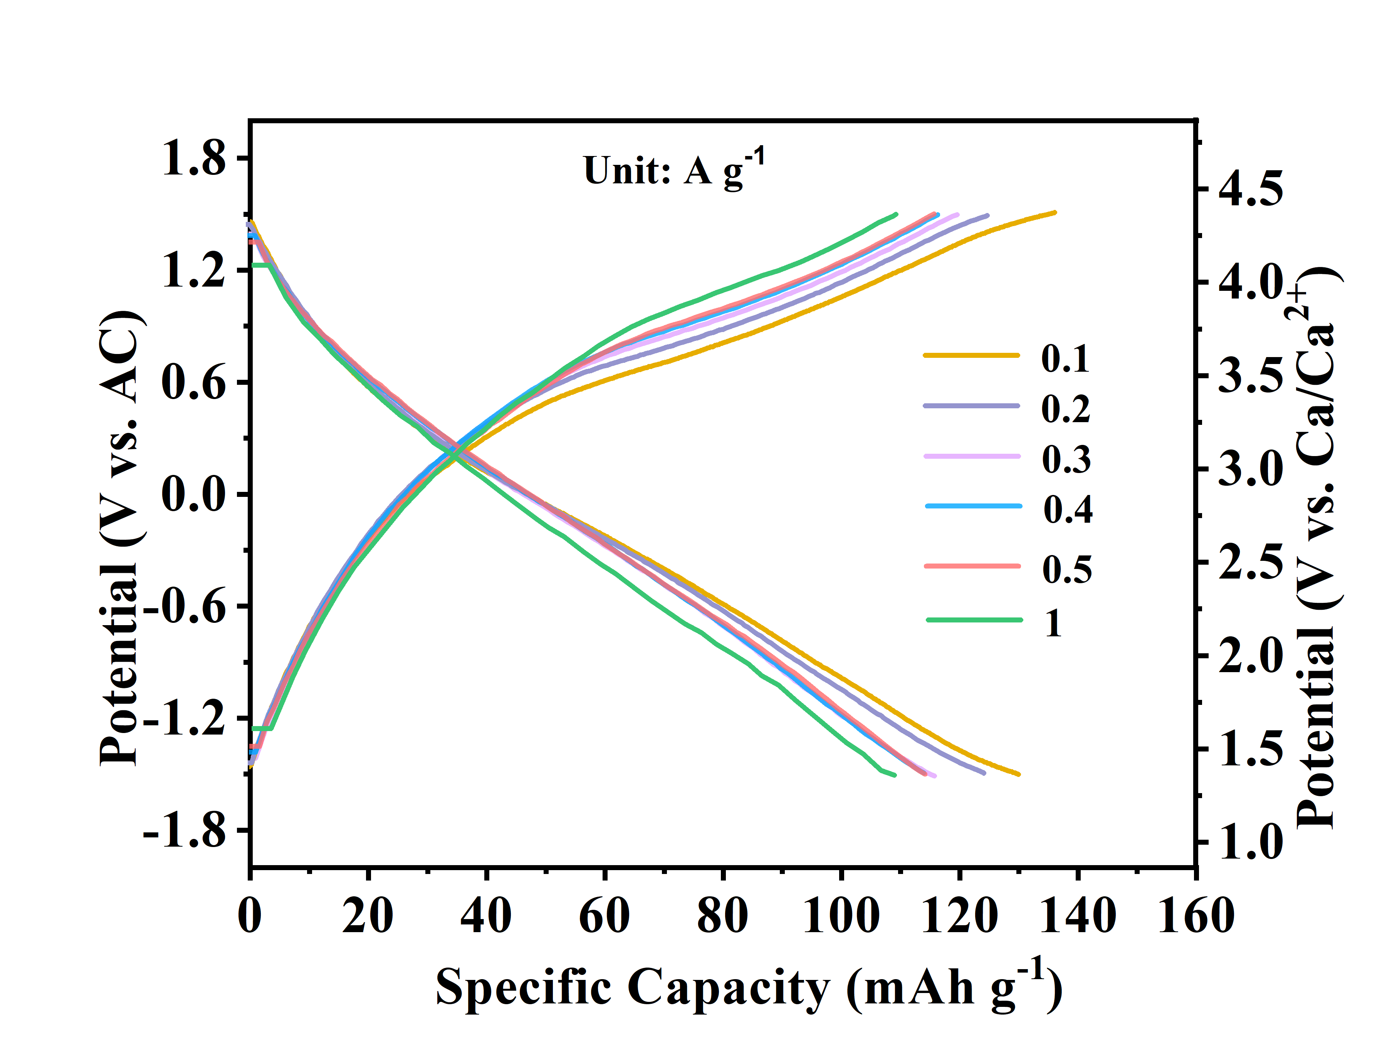

**Figure S10.** The GCD profiles of MMO-40 at current densities ranging from 0.1 to 1.0 A g−1.

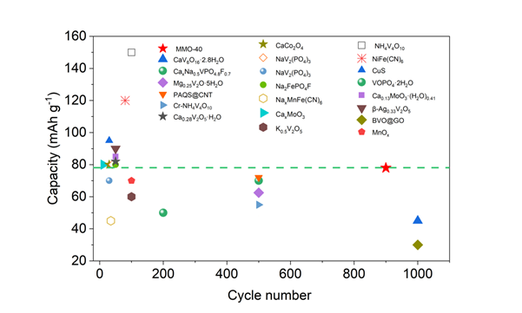

**Figure S11.** Comparison of rate capability and cycle stability of different materials used in CIBs.

**Table S3**. Electrochemical performances of reported cathodes for CIBs and the MMO-40 cathode in non-aqueous electrolyte

|  |  |  |  |  |  |  |
| --- | --- | --- | --- | --- | --- | --- |
| Materials | Electrolyte | Counter electrode | Operation range (V)  versus Ca/Ca2+ | Specific capacity/current density (mA h g-1) | Cycling performance after n cycle at z (mA h g-1/mA g-1) | References |
| **MMO-40** | **Ca(TFSI)2/AN** | **AC** | **1.4 – 4.4 V** | **140/100 124/200 117/300 115/300 114/500 112/1000** | **~ 78 after 1000 cycles (z=1000)** | **This Work** |
| δ-MnO2 | Ca(TFSI)2/AN | AC | 1.4 – 4.4 V | 130/100 120/200 105/500 88/1000 | ~ 80 after 50 cycles (z=500) | [19] |
| MnOx | Ca(TFSI)2/AN | AC | 1.47 – 3.87 V | 133/11.2 | ~ 70 after 100 cycles | [20] |
| CaV6O16·2.8H2O | Ca(TFSI)2/DME | AC | 1.4 – 2.2 V | 170/50 134/100 104/500  47/800 | ~ 45 after 1000 cycles  (z=500) | [21] |
| Mg0.25V2O5·H2O | Ca(TFSI)2 EC/PC/EMC/DMC | AC | 1.4 – 4.1 V | 120/20 90/50 72/100 | ~ 62.5 after 500 cycles | [22] |
| K0.5V2O5 | Ca(ClO4)2/PC | AC | 2 – 4.3 V | 50/133 | ~60 after 100 cycles | [23] |
| NH4V4O10 | Ca(ClO4)2 AN | AC | 2.6 – 3.9 V | 150/100 90/300 65/500 61/1000 | ~ 150 after 100 cycles (z=100) | [24] |
| VOPO4·2H2O | Ca(TFSI)2 EC/PC/EMC/DMC | AC | 0.9 – 4.2 V | 120/10 100/20 70/50 55/100 40/200 | ~ 50 after 200 cycles | [25] |
| Cr-NH4V4O10 | Ca(TFSI)2/PC | AC | 2.37 – 3.52 V | 80/50 70/100 65/150  62/200 60/300 50/500 | ~ 55 after 500 cycles | [26] |
| Ca0.28V2O5·H2O | Ca(ClO4)2/PC | AC | 1.67 – 4.07 V | 138/10 122/20 110/30  90/50 | ~ 82 after 50 cycles | [27] |
| β-Ag0.33V2O5 | Ca(PF6)2 EC/PC | AC | 1.87 – 3.87 V | 179/12.3 | ~ 90 after 50 cycles | [28] |
| CaxNa0.5VPO4.8F0.7 | Ca(PF6)2 | AC | 1.9 – 4.3 V | 88/10 82/20 72/50  62/100 53/200 42/500 | ~ 70 after 500 cycles | [29] |
| CaCo2O4  NaV2(PO4)3  NaV2(PO4)3  Na2FePO4F | Ca(ClO4)2/AN  Ca(TFSI)2/AN  Ca(BF4)2 EC/PC  Ca(PF6)2 EC/PC | Ag/Ag+  AC  AC  AC | 2.65 – 3.65 V  2.5 – 3.3 V  2.8 – 3.5 V  1.4 – 5 V | 50/0.03 70/0.04 80/0.1    80/7.5  72/5.8 70/11.7 65/23.4 58.8/58 53/117  70/10 | ~ 80 after 30 cycles  ~ 80 after 40 cycles  ~ 70 after 30 cycles  ~ 80 after 50 cycles | [30]  [31]  [32]  [33] |
| NiFe(CN)6 | Ca(PF6)2 EC/PC | AC | 2.1 – 3.97 V | 100/18 90/36 65/72 | ~ 120 after 80 cycles | [34] |
| NaxMnFe(CN)6 | Ca(PF6)2 EC/PC | CaxSn | 1.8 – 5.8 V | 10/100 | ~ 45 after 35 cycles | [35] |
| Ti2O(PO4)2(H2O) | Ca(PF6)2 EC/PC | AC | 1.87 – 3.87 V | 86/20 60/50 38.5/100  17.2/200 | ~ 60.8 after 1500 cycles | [36] |
| BVO@GO | Ca(TFSI)2 EC/PC/EMC/DMC | AC | 1.4 – 4.4 V | 170/300 | ~ 30 after 1000 cycles | [37] |
| PAQS@CNT | Ca(TFSI)2 EC/PC/EMC/DMC | Ag/Ag+ | 1.27 – 3.72 V | 118/50 115/100 90/200  85/500 78/1000 70/2000  60/4000 | ~ 72 after 500 cycles | [38] |
| α-MoO3 | Ca(TFSI)2/AN | AC | 2.07 – 3.37 V | 150/20 125/40 98/80  80/120 60/200 | ~ 100 after 500 cycles | [39] |
| Ca0.13MoO3·(H2O)0.4 | Ca(ClO4)2/AN | AC | 1.67 – 3.87 V | 192/85 138/171 108/342 | ~ 85 after 50 cycles | [40] |
| CuS | Ca(TFSI)2 EC/PC/EMC/DMC | AC | 1.5 – 3.2 V | 200/100 | ~ 95 after 30 cycles | [41] |

To explore the potential limitations or trade-offs of Mo doping, we tested the long-term stability of MMO-40 under practical conditions, such as high loading, low electrolyte volume, and high current density. First, we increased the cathode material loading from 1.5 mg cm⁻² to 4 mg cm⁻² (**Figure S12**), reduced the electrolyte volume from 80 μL to 40 μL, and applied a current density of 1000 mA g⁻¹ (which is currently a relatively high current density reported for calcium-ion battery cathode materials (**Table S3**)). As shown in the **Figure S13**, MMO-40 exhibits good specific capacity (63 mAh/g) and cycling performance (capacity retention of 78% after 1000 cycles). These results indicate that the introduction of Mo effectively enhances the material's conductivity and structural stability, significantly improving its long-term cycling performance under high current density and low electrolyte conditions.

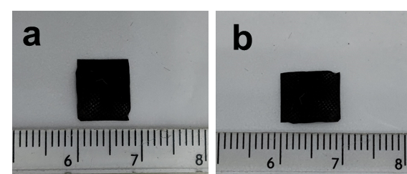

**Figure S12**. (a) The long side of the MMO-40 cathode material; (b) The short side of the MMO-40 cathode material

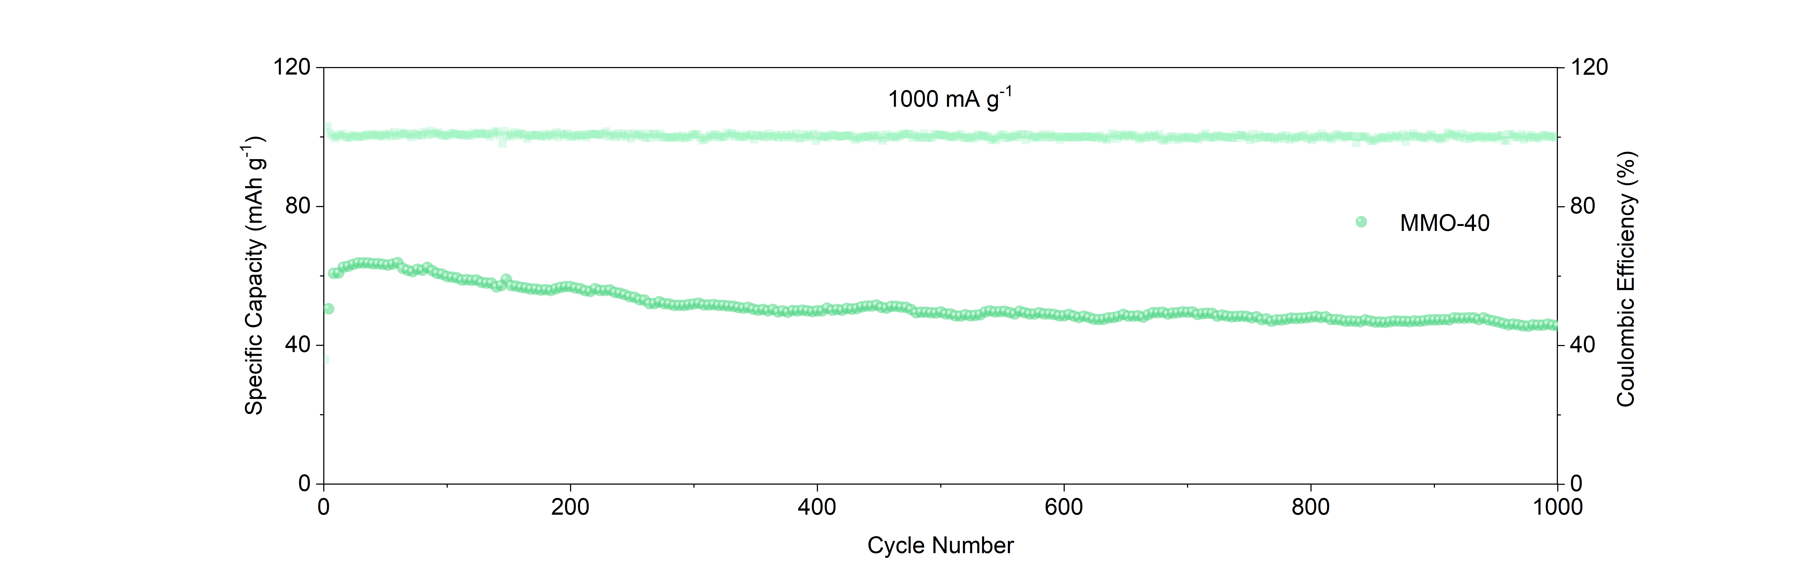

**Figure S13**. Cycling performance of MMO-40 at 1.0 A g−1.

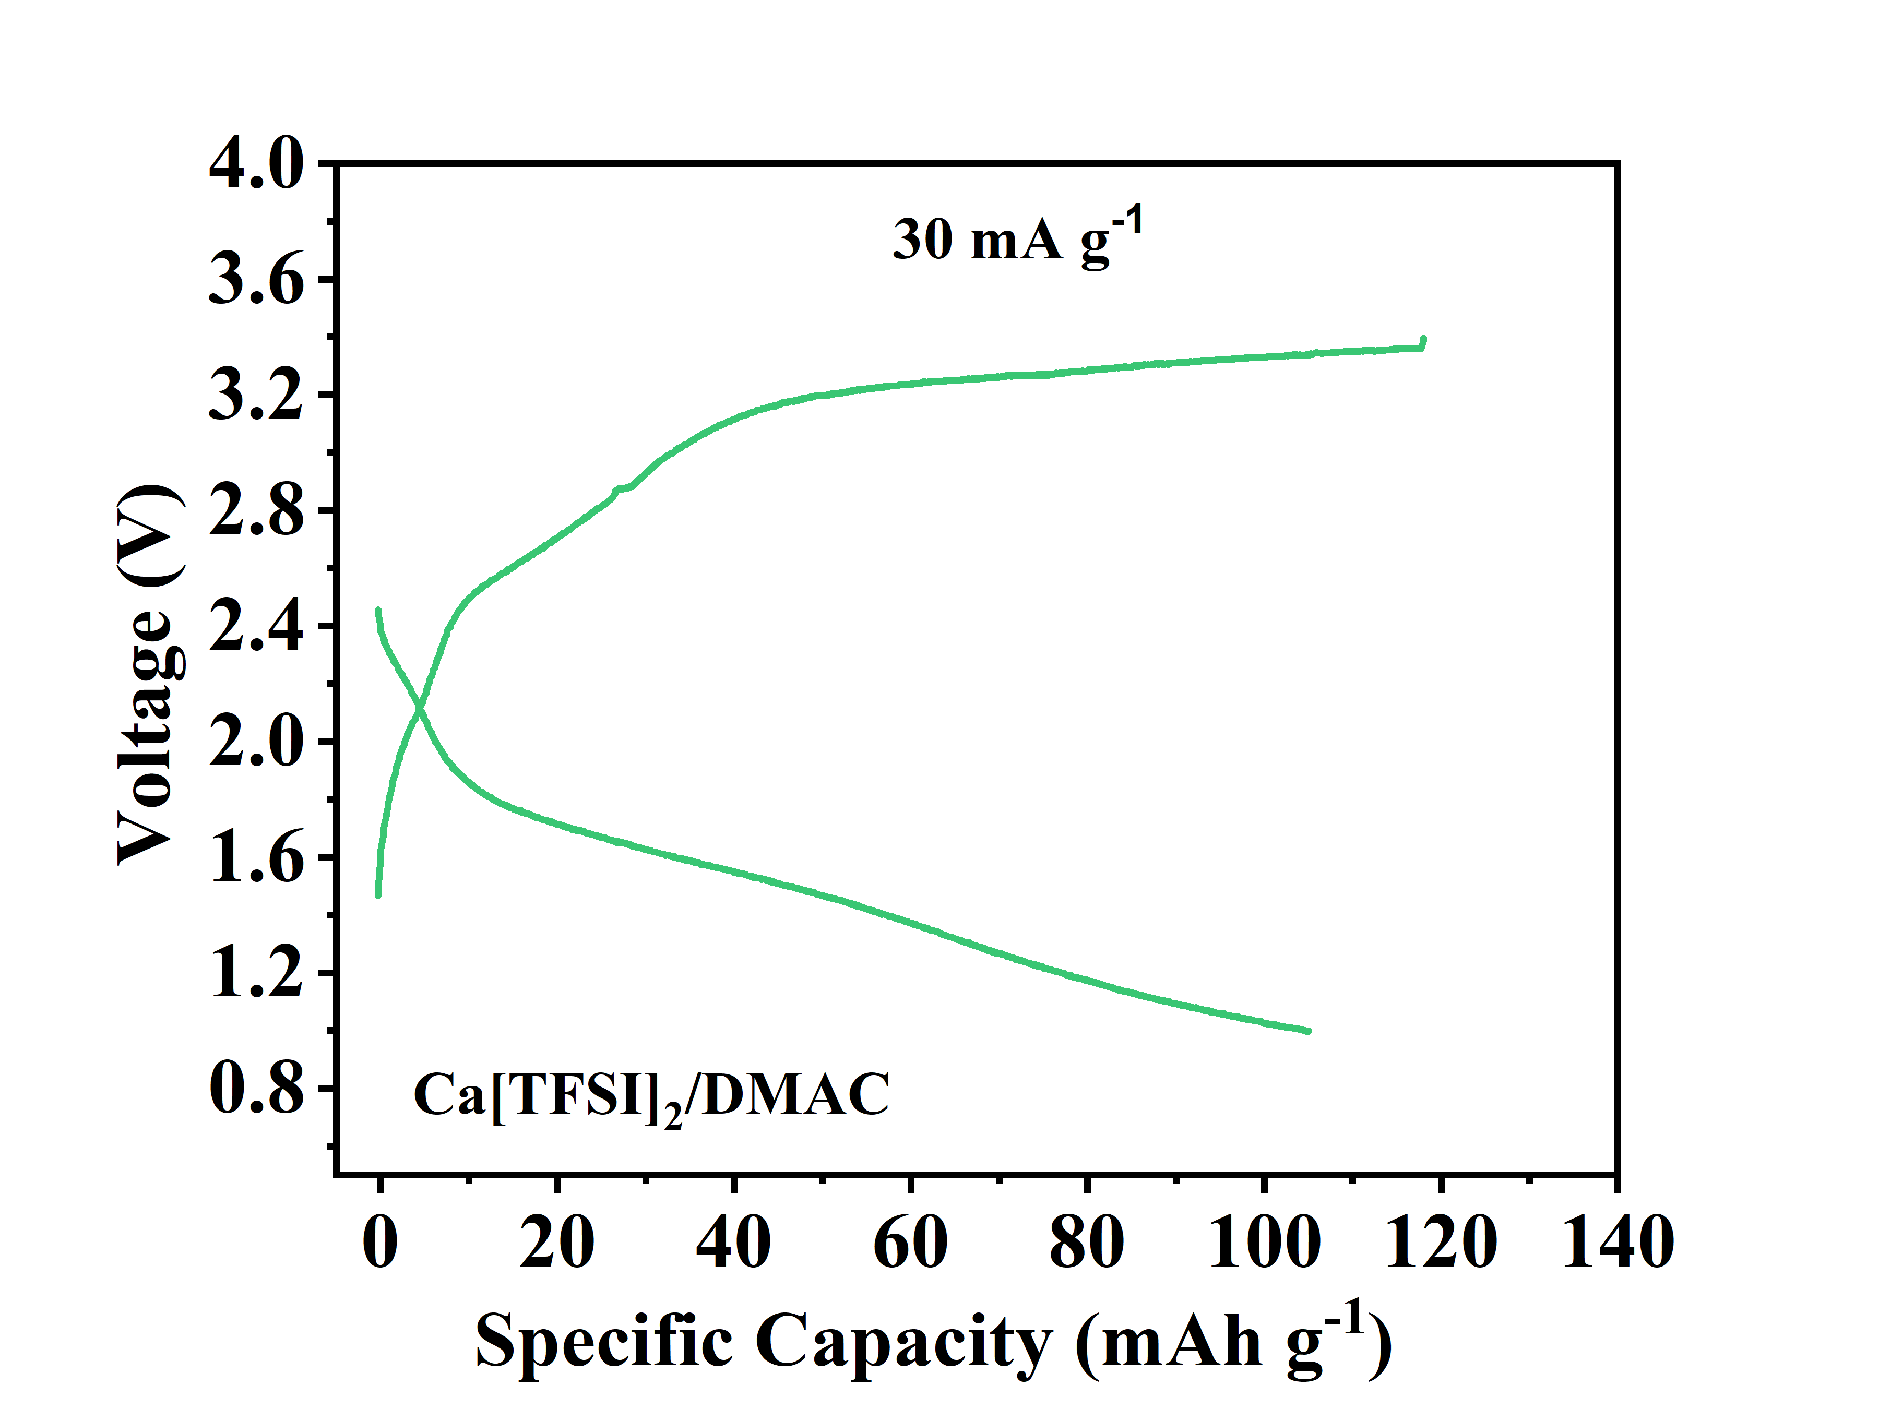

**Figure S14.** The charge/discharge curves of MMO-40 with Ca(TFSI)2/DMCA electrolyte at 30 mA g−1.

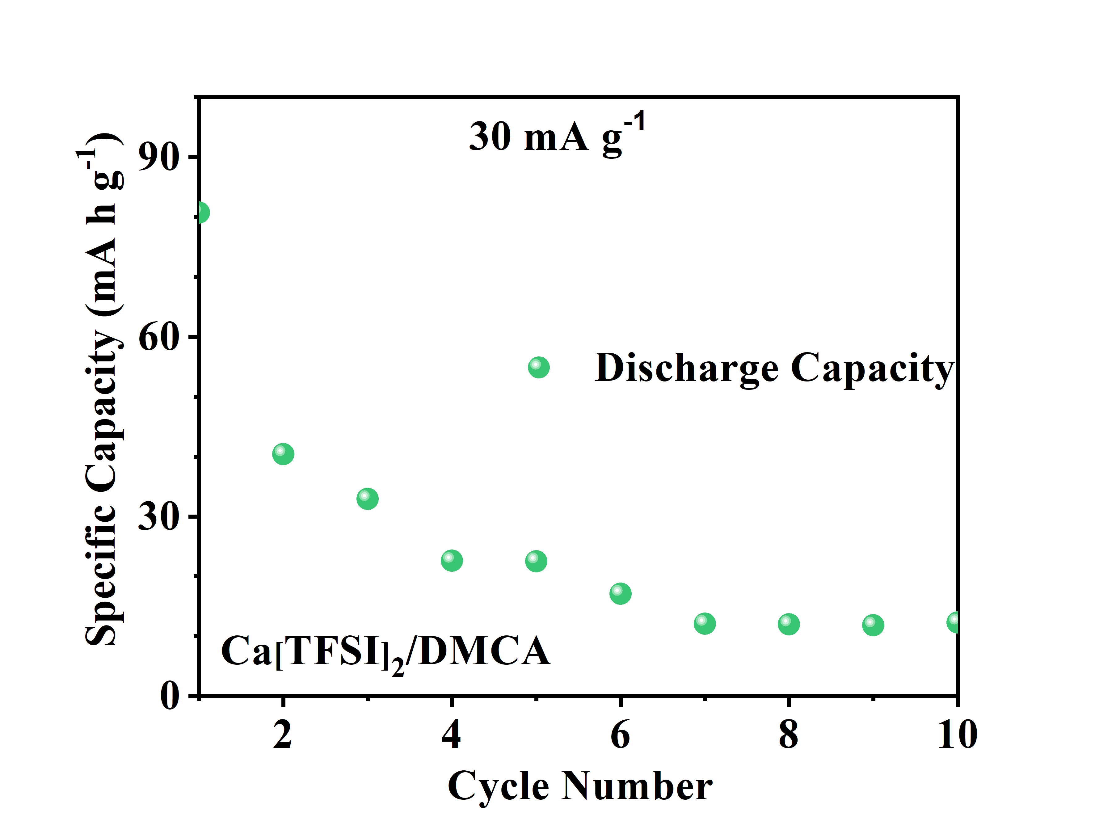

**Figure S15.** The cycling performance of MMO-40 with Ca(TFSI)2/DMCA electrolyte at 30 mA g−1.

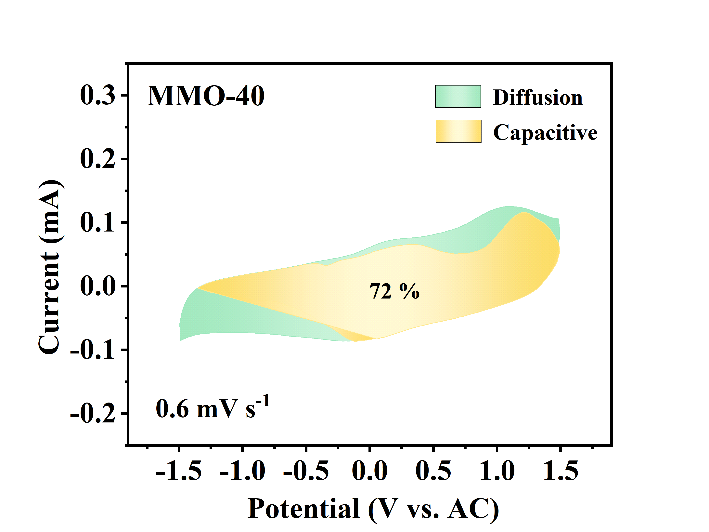

**Figure S16.** The calculated capacitive contribution to the charge storage of MMO-40 at 0.6 mV s−1.

**GITT test.**

The dynamics of Ca ion solid-state diffusion in MMO-40 cathode was evaluated by employing galvanostatic intermittent titration technique (GITT). The Ca2+ ion diffusion diffusivity (DGITT) was obtained via the following equation:

$D^{GITT}=\frac{4}{}{\left(\frac{m_{B}V_{M}}{M_{B}S}\right)}^{2}{\left(\frac{Es}{Eτ}\right)}^{2}$ (1)

Where τ , mB, VM, and MB are the constant current pulse duration, the mass loading, the molar volume, and the molar mass of the intercalated electrode material, respectively. S is the interface area between electrode and electrolyte. After a current pulse is conducted in a single step GITT experiment, ΔES and ΔEτ represent the changes in steady-state voltage and total cell voltage regardless of the IR-drop, respectively. ΔEs and ΔEτ can be obtained from the GITT curves (**Figure S17**).

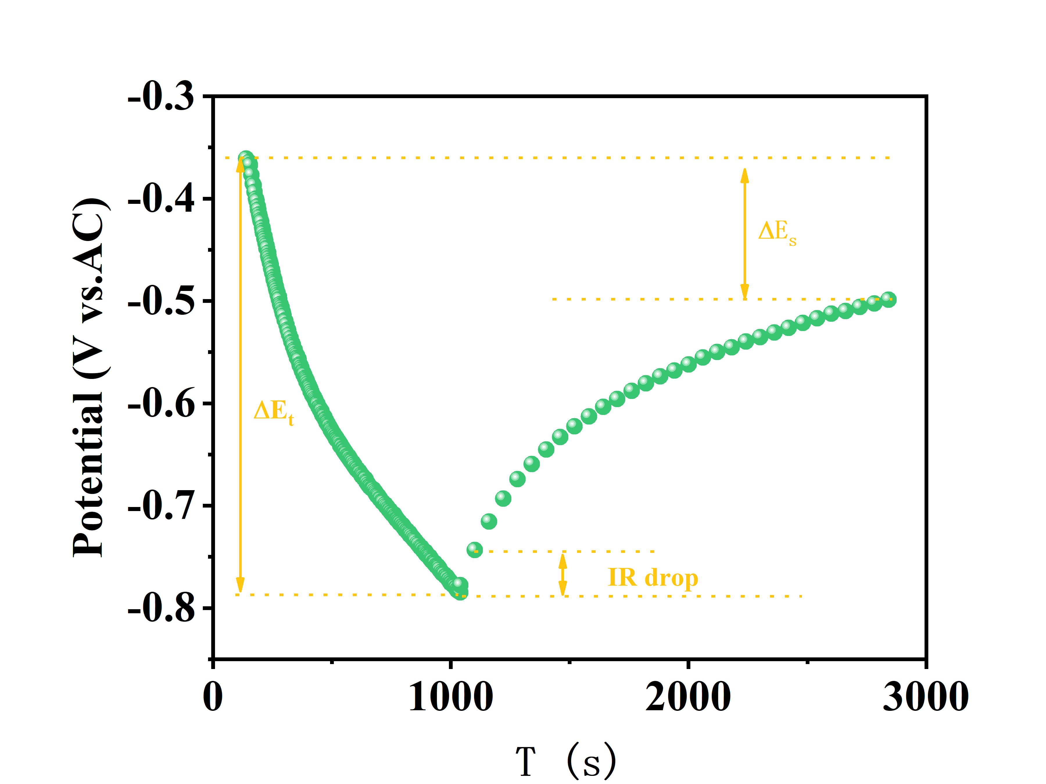

**Figure S17.** The potential-time curve in one pluse period of GITT test.

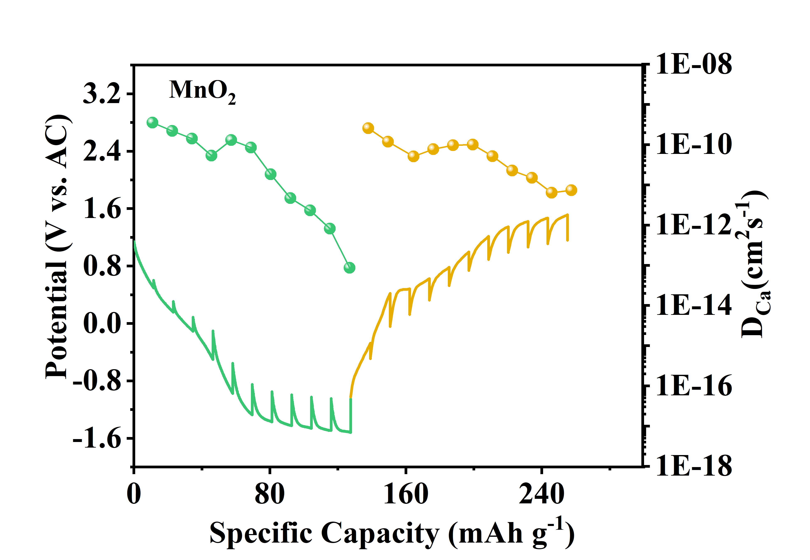

**Figure S18.** GITT profiles and the corresponding Ca2+ diffusion coefficients of MnO2 cathode.

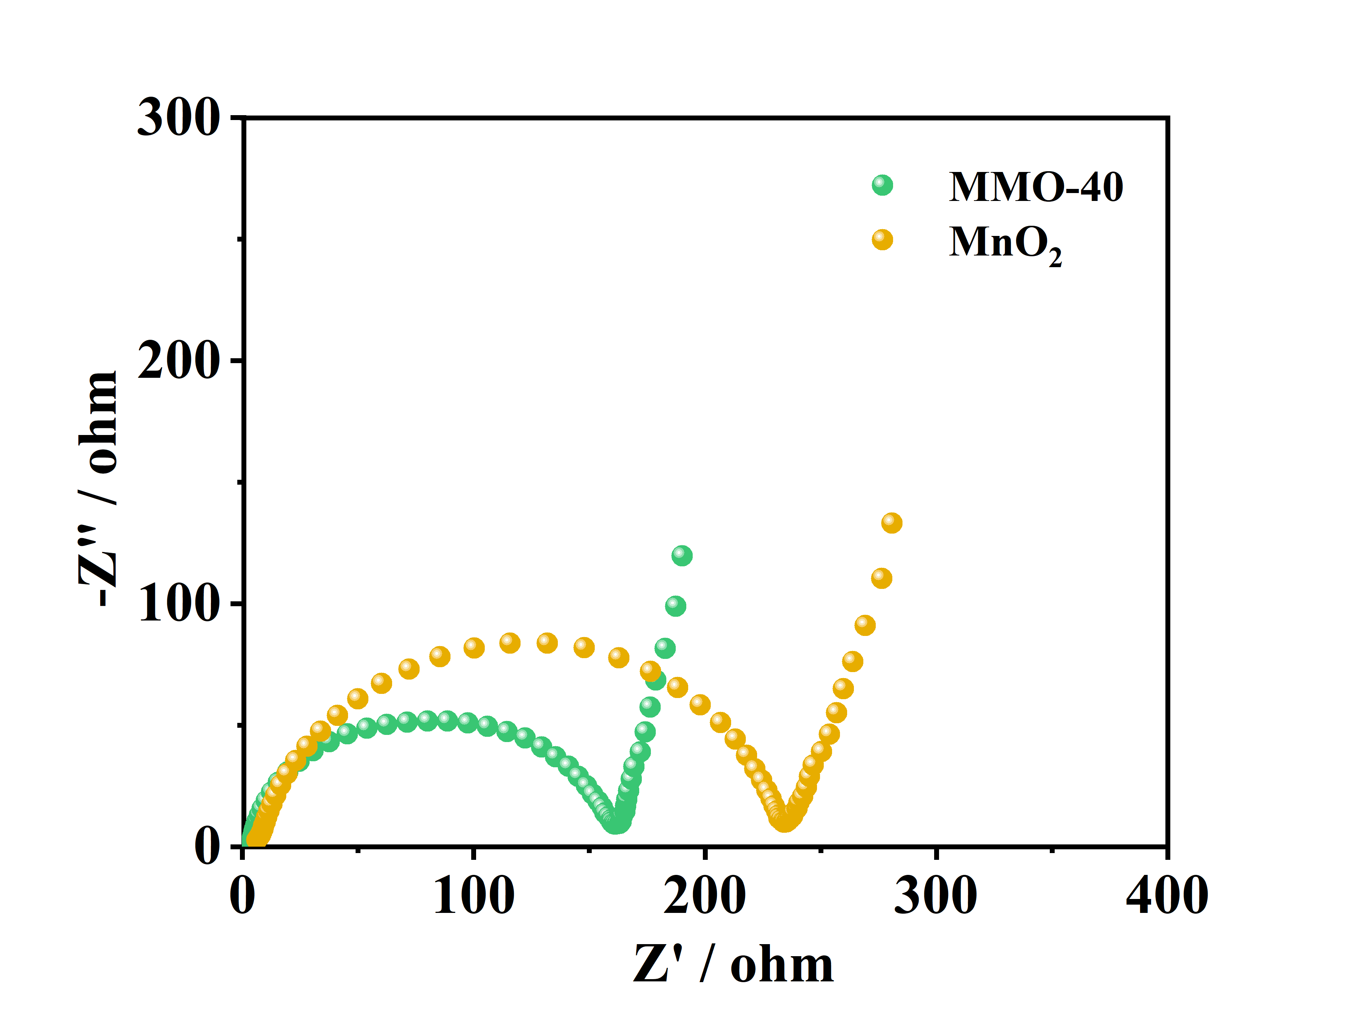

**Figure S19**. The EIS polts of the MMO-40 and MnO2.

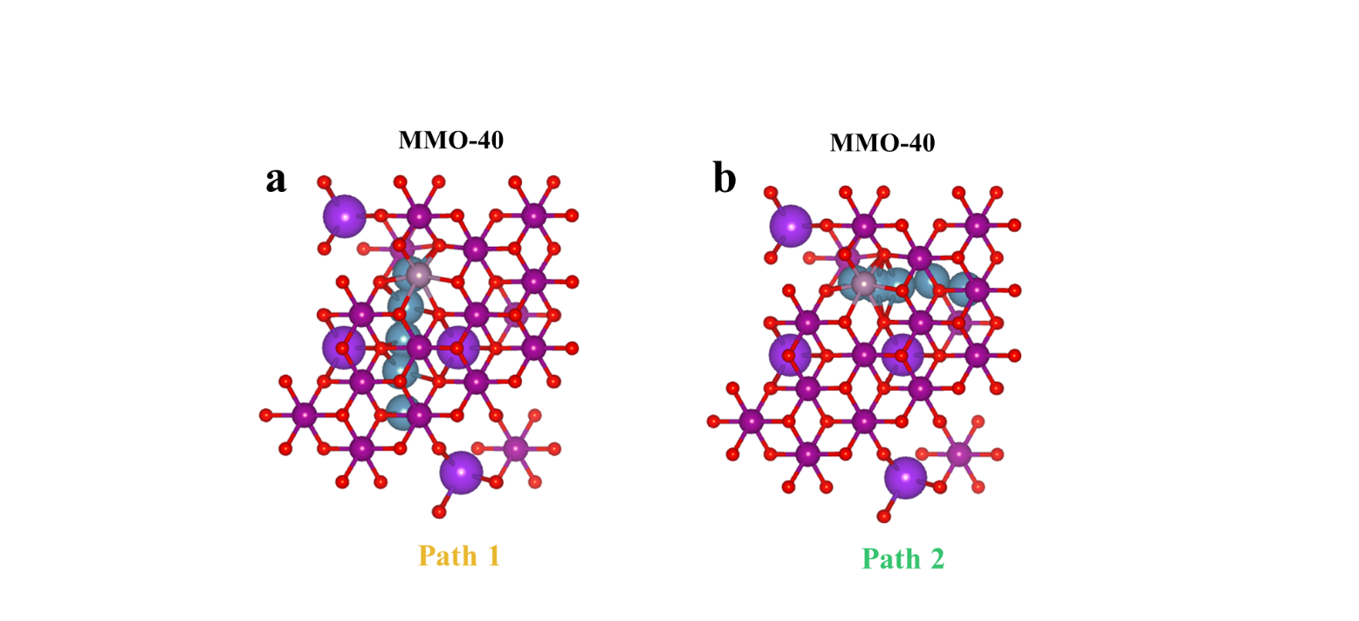

**Figure S20**. The diffusion path profiles of MMO-40 along (a) path 1 (b directions) (b) path 2 (a directions).

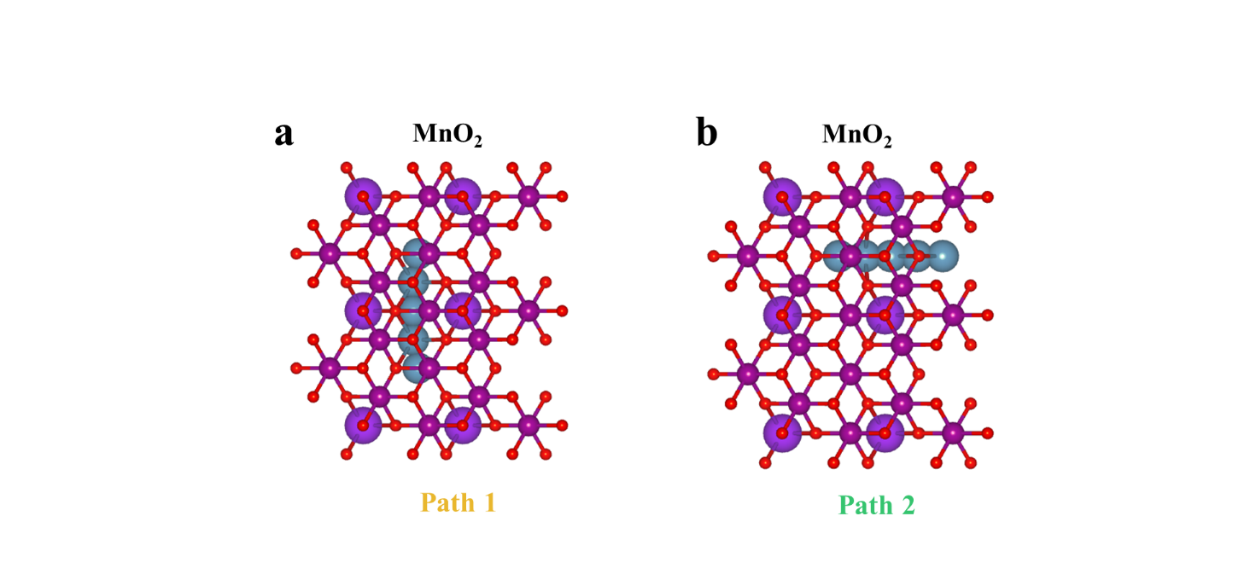

**Figure S21**. The diffusion path profiles of MnO2 along (a) path 1 (b directions) (b) path 2 (a directions).

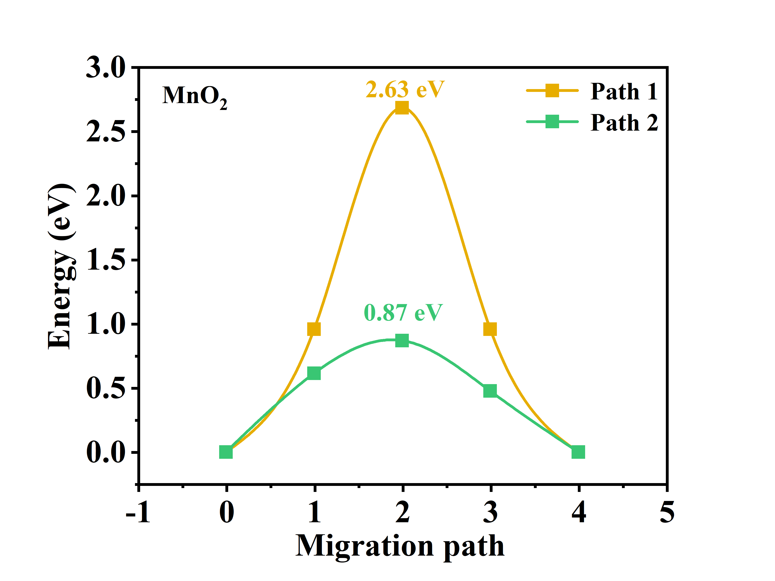

**Figure S23**. Ca ions migration behaviors along the a, b-axis in MnO2.

**Table S4.** The Jahn-Teller distortion of Mn-O octahedral in different MnO2. 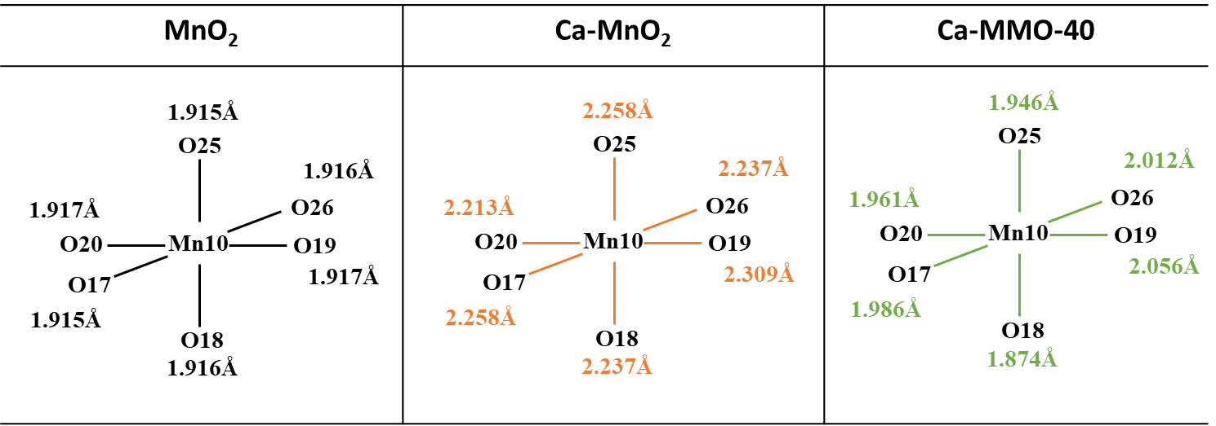

**Table S5.** The ICP results of MMO-40 electrodes at different states.

|  |  |  |  |
| --- | --- | --- | --- |
| **Materials** | **Ca** | **Mn** | **Ca/Mn** |
| **Pristine** | **0.01** | **0.44** | **0.02** |
| **1st discharge** | **0.04** | **0.45** | **0.10** |
| **1st charge** | **0.02** | **0.53** | **0.03** |
| **2nd discharge** | **0.04** | **0.41** | **0.11** |

[1] K. Chu, Y.-p. Liu, Y.-b. Li, Y.-l. Guo, Y. Tian, H. Zhang, *Applied Catalysis B: Environmental* 2020, 264.

[2] Y. Yi, Y. Xing, H. Wang, Z. Zeng, Z. Sun, R. Li, H. Lin, Y. Ma, X. Pu, M. M. Li, K. Y. Park, Z. L. Xu, Angew Chem Int Ed Engl 2024, 63, e202317177; Q. Wei, L. Zhang, X. Sun, T. L. Liu, Chem Sci 2022, 13, 5797; H. Song, C. Wang, *Advanced Energy and Sustainability Research* 2022, 3.

[3] C. Zuo, F. Xiong, J. Wang, Y. An, L. Zhang, Q. An, *Adv. Funct. Mater.*2022, 32.

[4] G. Kresse, J. r. FurthmÃ¼ller, Physical review B 1996, 54, 11169; G. Kresse, Hafner, Physical Review B 1994, 49, 14251; G. Kresse, D. Joubert, Physical review b 1999, 59, 1758.

[5] J. P. Perdew, Y. Wang, *Physical review B* 1992, 45, 13244.

[6] S. Grimme, J. Antony, S. Ehrlich, H. Krieg, *The Journal of chemical physics* 2010, 132.

[7] S. Liu, H. Zhu, B. Zhang, G. Li, H. Zhu, Y. Ren, H. Geng, Y. Yang, Q. Liu, C. C. Li, *Adv. Mater.* 2020, 32, e2001113.

[8] X. Xu, M. Duan, Y. Yue, Q. Li, X. Zhang, L. Wu, P. Wu, B. Song, L. Mai, *ACS Energy Letters* 2019, 4, 1328.

[9] J. Wang, S. Tan, F. Xiong, R. Yu, P. Wu, L. Cui, Q. An, *Chem Commun (Camb)* 2020, 56, 3805.

[10] B. Jeon, J. W. Heo, J. Hyoung, H. H. Kwak, D. M. Lee, S.-T. Hong, *Chem. Mater.* 2020, 32, 8772.

[11] Z.-L. Xu, J. Park, J. Wang, H. Moon, G. Yoon, J. Lim, Y.-J. Ko, S.-P. Cho, S.-Y. Lee, K. Kang, *Nat. Commun.* 2021, 12, 3369.

[12] C. Chen, F. Shi, S. Zhang, Y. Su, Z. L. Xu, Small 2022, 18, e2107853.

[13] P. A. Chando, S. Chen, J. M. Shellhamer, E. Wall, X. Wang, R. Schuarca, M. Smeu, I. D. Hosein, *Chem. Mater.* 2023, 35, 8371.

[14] C. Zuo, F. Chao, M. Li, Y. Dai, J. Wang, F. Xiong, Y. Jiang, Q. An, *Adv. Energy Mater.* 2023, 13.

[15] J. Wang, J. Wang, Y. Jiang, F. Xiong, S. Tan, F. Qiao, J. Chen, Q. An, L. Mai, *Adv. Funct. Mater.* 2022, 32.

[16] M. Adil, A. Sarkar, S. Sau, D. Muthuraj, S. Mitra, *J. Power Sources* 2022, 541.

[17] J. Hyoung, J. W. Heo, S.-T. Hong, *J. Power Sources* 2018, 390, 127.

[18] J. Hyoung, J. W. Heo, B. Jeon, S.-T. Hong, *J. Mater. Chem. A* 2021, 9, 20776.

[19] C. Zuo, F. Xiong, J. Wang, Y. An, L. Zhang, Q. An, *Adv. Funct. Mater.* **2022**, 32, 2202975

[20] B. J. Kwon, L. Yin, C. J. Bartel, K. Kumar, P. Parajuli, J. Gim, S. Kim, Y. A. Wu, R. F. Klie, S. H. Lapidus, B. Key, G. Ceder, J. Cabana, *Chem. Mater.* **2022**, 34, 836.

[21] J. Wang, J. Wang, Y. Jiang, F. Xiong, S. Tan, F. Qiao, J. Chen, Q. An, L. Mai, *Adv. Funct. Mater.* **2022**, 32.

[22] X. Xu, M. Duan, Y. Yue, Q. Li, X. Zhang, L. Wu, P. Wu, B. Song, L. Mai, *Acs Energy Lett.* **2019**, 4, 1328.

[23] M. E. Purbarani, J. Hyoung, S.-T. Hong, *Acs Appl. Energ. Mater.* **2021**, 4, 7487.

[24] T. N. Vo, H. Kim, J. Hur, W. Choi, I. T. Kim, *J. Mater Chem A* **2018**, 6, 22645.

[25] J. Wang, S. Tan, F. Xiong, R. Yu, P. Wu, L. Cui, Q. An, *Chem. Commun. (Camb)* **2020**, 56, 3805

[26] M. Adil, A. Sarkar, S. Sau, D. Muthuraj, S. Mitra, *J. Power Sources* **2022**, 541.

[27] B. Jeon, H. H. Kwak, S.T. Hong, *Chem. Mater.* **2022**, 34, 1491.

[28] J. Hyoung, J. W. Heo, B. Jeon, S.-T. Hong, *J. Mater. Chem. A* **2021**, 9, 20776.

[29] Z. L. Xu, J. Park, J. Wang, H. Moon, G. Yoon, J. Lim, Y. J. Ko, S. P. Cho, S. Y. Lee, K. Kang, *Nat. Commun.* **2021**, 12, 3369.

[30] M. Cabello, F. Nacimiento, J. R. Gonzalez, G. Ortiz, R. Alcantara, P. Lavela, C. Perez-Vicente, J. L. Tirado, *Electrochem. Commun.*  **2016**, 67, 59.

[31] S. Kim, L. Yin, M. H. Lee, P. Parajuli, L. Blanc, T. T. Fister, H. Park, B. J. Kwon, B. J. Ingram, P. Zapol, R. F. Klie, K. Kang, L. F. Nazar, S. H. Lapidus, J. T. Vaughey, *ACS Energy Lett.* **2020**, 5, 3203.

[32] B. Jeon, J. W. Heo, J. Hyoung, H. H. Kwak, D. M. Lee, S.-T. Hong, *Chem. Mater.***2020**, 32, 8772.

[33] A. L. Lipson, S. Kim, B. Pan, C. Liao, T. T. Fister, B. J. Ingram, *J. Power Sources* **2017**, 369, 133.

[34] T. N. Vo, H. Kim, J. Hur, W. Choi, I. T. Kim, *J. Mater. Chem. A* **2018**, 6, 22645.

[35] N. Kuperman, P. Padigi, G. Goncher, D. Evans, J. Thiebes, R. Solanki, *J. Power Sources* **2017**, 342, 414.

[36] A. L. Lipson, B. Pan, S. H. Lapidus, C. Liao, J. T. Vaughey, B. J. Ingram, *Chem. Mater.* **2015**, 27, 8442.

[37] S. J. R. Prabakar, W.-B. Park, J. Y. Seo, S. P. Singh, D. Ahn, K.-S. Sohn, M. Pyo, *Energy Storage Mater.* **2021**, 43, 85.

[38] L. Xiang, W. Yang, Y. Wang, X. Sun, J. Xu, D. Cao, Q. Li, H. Li and X. Wang, *Chem. Commun.* 2024, 60, 5459–5462

[39] S. Zhang, Y. Zhu, D. Wang, C. Li, Y. Han, Z. Shi, S. Feng, *Adv. Sci.* **2022**, 9, e2200397.

[40] S. Kim, L. Yin, S. M. Bak, T. T. Fister, H. Park, P. Parajuli, J. Gim, Z. Yang, R. F. Klie, P. Zapol, Y. Du, S. H. Lapidus, J. T. Vaughey, *Nano Lett.* **2022**, 22, 2228.

[41] S. Zhang, Y. Zhu, D. Wang, C. Li, Y. Han, Z. Shi, S. Feng, *Adv. Sci.* **2022**, 9, e2200397.