Supporting Information

Molecule Crowding Strategy in Polymer Electrolytes Inducing Stable Interfaces for All-Solid-State Lithium Batteries

Hong Zhang, Jiahui Deng, Hantao Xu, Haoran Xu, Zixin Xiao, Fan Fei, Wei Peng, Lin Xu*, Yu Cheng, Qin Liu, Guo-Hua Hu*, Liqiang Mai*

- Zhang, J.H. Deng, H.T. Xu, H.R. Xu, Z.X. Xiao, F. Fei, W. Peng, Prof. L. Xu, Y. Cheng, Q. Liu, Prof. L.Q. Mai

State Key Laboratory of Advanced Technology for Materials Synthesis and Processing, School of Materials Science and Engineering, Wuhan University of Technology, Wuhan 430070, China.
E-mail: linxu@whut.edu.cn (Lin Xu); mlq518@whut.edu.cn (Liqiang Mai)

Prof. L. Xu, Prof. L.Q. Mai
Hubei Longzhong Laboratory, Wuhan University of Technology (Xiangyang Demonstration Zone), Xiangyang 441000, Hubei, China.

Hainan Institute, Wuhan University of Technology Sanya 572000, China.

Prof. G.-H. Hu

Université de Lorraine, CNRS, LRGP, F-54001 Nancy, France.
E-mail: guo-hua.hu@univ-lorraine.fr (Guo-Hua Hu)

Keywords: 15-crown-5, molecule crowding strategy, interfacial chemistry, interface stability, all-solid-state lithium batteries

1.Experimental Section
1.1 Materials
15-crown-5 and anhydrous acetonitrile were obtained from Aladdin Company. Bis(trifluoromethane) sulfonamide lithium (LiTFSI) was purchased from DodoChem. Polyethylene oxide (Mn=600,000 g mol⁻¹) was supplied by Sigma-Aldrich Regent Co. Ltd., Shanghai, China. All reagents were used as-received without further purification.

1.2 Preparation of all-solid-state electrolytes
The PEO and PEOC₁₅ all-solid-state polymer electrolytes (SPEs) were simply prepared by solution casting method. First, the polyethylene oxide and LiTFSI powder with the molar ratio of [EO]:[Li]=8:1 were dissolved in anhydrous acetonitrile and vigorously stirred under 60 ºC to form a homogeneous solution. Subsequently, the15-crown-5 was added with 5 wt.% mass fraction, respectively, and stirred for 12 h under 60 ºC. The resultant solution was uniformly casted into a 5 μm PE porous supporting membrane on a smooth ziplock bag and then removed solvent at 60 ºC under vacuum to obtain flexible PEOC₁₅ electrolyte membrane. And the polyethylene oxide/LiTFSI solution was also casted into the ultrathin porous membrane to form all-solid-state electrolytes named PEO.

1.3 Preparation of cathodes and assemble of batteries
The coin cells were assembled with cathodes, all-solid-state electrolyte membranes and lithium metal inside CR-2016 type case in an argon-filled glovebox. And the pouch cells were assembled by similar process. To fabricate the cathodes, the commercial LiFePO₄, Super P, PVDF, polyethylene oxide and LiTFSI were mixed together with a mass ratio of 7:1:1:0.5:0.5 in N-methyl-2-pyrrolidone (NMP) to form a cathode slurry. After sonication for 1 h, the resulting slurry was then cast onto an aluminum foil and dried at 70 ºC for 24 h. The mass loading of LiFePO₄ active material for coin cells was about 1 mg cm⁻², and 2 mg cm⁻² for pouch cells. Similarly, the same weight ratio was applied to fabricated composite NCM811 cathode with a mass loading of about 1 mg cm⁻²

2.Materials characterization
The surface morphology characterization were examined via a JEOL JSM-7100F scanning electron microscope (SEM) equipped with an energy dispersive spectrometry (EDS) attachment at an accelerating voltage of 20 kV. Especially, the surface of lithium foils obtained by dissembling the symmetric cells equipped with PEO and PEOC₁₅ after cycling at 0.1 mA cm⁻² (200 h for PEO and 4360 h for PEOC₁₅), the morphology of NCM 811 particles with PEO and PEOC₁₅ electrolytes was detected after 300 cycles of NCM811||Li batteries at 0.5 C, and the lithium deposition morphology were investigated after 50 cycles of the Li-Cu cells at 0.2 mA cm⁻². STEM images and elemental mapping of SEI and CEI were acquired from an FEI Talos F200s field emission transmission electron microscope (FE-TEM) coupled with an EDS attachment operating at an acceleration voltage of 200 KV, in which the SEI on the lithium foil surface was investigated after 100 h cycling of symmetric cells at 0.1 mA cm⁻² and the CEI morphology was conducted after 10 cycles of NCM811||Li batteries with PEO and PEOC₁₅ electrolytes at 0.2 C. The AIST-NT SmartSPM 1000 scanning probe microscopy was employed to investigated the surface morphology of PEOC₁₅ and cycled lithium foil. The cycle condition of lithium foil is the same to that for SEM. The solid-state nuclear magnetic resonance spectra of SPEs were recorded on a Bruker Advanced II AV400 MHz NMR spectrometer. Fourier transform infrared spectrometer (FT-IR) (Thermo Nicolet Corporation; 7800-350/cm 0.01/cm/6700) was used to analyze the SPEs and their components. The X-ray photoelectron spectroscopy (XPS) analysis was conducted using a Kratos AXIS SUPRA spectrometer equipped with an Al Kα radiation source. The analysis software is CasaXPS. The lithium metal anode for XPS test was cycled after 100 h at 0.1 mA cm⁻², while the NCM 811 cathode of for that was cycled after 10 cycles at 0.2 C. TOF-SIMS measurements were conducted with a PHI nano TOF III. A Bi₃⁺⁺ beam (30 keV, 2 nA, 100×100 um²) was used as the primary beam to detect the samples, sputtering with an Ar⁺ beam (2 keV, 100 nA, 400×400 um²) was applied for depth profiling analysis. The sputtering rate is 9.16 nm min⁻¹ on SiO₂. The pre-treatment process of the lithium metal anode and NCM 811 cathode are similar to that of XPS. The Raman spectroscopy measurement was performed using a Raman spectrometer (Horiba Lab RAM HR Evolution) with a 532 nm excitation wavelength. The surface morphology was measured by AIST-NT SmartSPM 1000 scanning probe microscopy. The X-ray diffraction (XRD) patterns were recorded using a D8 discover X-ray diffractometer with Cu Kα radiation. Differential scanning calorimeter (DSC) was measured with a Netzsch STA 449C. The thermostability of SPEs was executed by thermogravimetric analysis (TGA) using a NETZSCH STA 449F5 instrument over the temperature range between 40 and 600 °C under Ar condition at a heating rate of 10 °C min⁻¹. A tensile testing machine (Instron 5967) was employed to obtain the stress-strain curves with the tensile speed of 0.2 cm min⁻¹. Atomic force microscope (AFM, Asylum Research, MFP-3D) was used to measure the Young's modulus of the SEI (the surface of lithium metal anode cycled with PEO and PEOC₁₅ electrolyte for 20 h at 0.1 mA cm⁻²), while the instrument was protected in a glove box full of Ar inert gas.

3.Electrochemical performance measurements
3.1. Ionic conductivity and activation energy
Electrochemical impedance spectroscopy (EIS) was tested by assembling blocking stainless steel||SPEs||stainless steel (SS) cells from 0.1 Hz to 10⁶ Hz with an amplitude of 10 mV via Autolab PGSTAT302N. The intrinsic ionic conductivity of SPEs (without PE porous membrane ) were calculated using the following Equation:
$$σ=\frac{L}{R_{b}S} \left(1\right)$$
Where S represents the effective contacting area among SPEs and SS, R represents the resistance value of the bulk electrolyte, and L is the thickness of the SPE. Activation energy (Ea) was obtained by calculating resistance at a temperature range of 20-80 ºC according to the Arrhenius law:
$$σ=Aexp(-E_{a}/RT) (2)$$
Where A is conductivity pre-exponential factor, E_{a} is the activation energy, T is the absolute temperature and R is the ideal gas constant.
3.2. Electrochemical stability window
The electrochemical stability window was tested by linear sweep voltammetry (LSV) on a Li||SPEs||SS cell from 0 to 6.5 V via Autolab PGSTAT302N at a scan rate of 10 mV s⁻¹.
3.3. Lithium-ion transference number
When it comes to the t_{Li}⁺(lithium-ion transference number), the Li||Li symmetrical cells assembled with GTSSE were measured by chronoamperometry method, a polarization of 10 mV (ΔV) was applied to the cells for 5,000 seconds. The polarization currents of cell including initial (I₀) and steady-state (I_{ss}) were recorded. The interfacial resistances before (R₀) and after (R_{ss}) polarization were tested by alternating current impedance. Afterwards, t_{Li}⁺ was calculated from Bruce-Vincent-Evans Equation:
$$t_{Li+}=\frac{I_{s}(ΔV-I_{0}R_{0})}{I_{0}(ΔV-I_{s}R_{s})} (3)$$
3.4. Lithium-ion diffusion coefficient
Lithium-ion diffusion coefficient D was evaluated by cyclic voltammetry of symmetrical Li||Li cells after 10 cycles at 0.1 mA cm⁻² via Autolab PGSTAT302N and calculated according to the Randles–Sevick equation:
$$Ip=0.446nFAC({\frac{nFvD}{RT})}^{\frac{1}{2}} (4)$$
where Ip is the peak current, n represents the number of electrons in the reaction (for Li–Li cell, n=1), A indicates the electrode area (1.54 cm²), C is the lithium-ion concentration in the SPE (2.52 mol L⁻¹ for PEOC₁₅ electrolyte and 3.06 mol L⁻¹ for PEO electrolyte), 𝜐 refers to the scanning rate, F is Faraday constant, T is the temperature, and R means gas constant.
3.5. Exchange current density
The exchange current density was evaluated by fitting CV curves of symmetrical Li||Li cells after 10 cycles at 0.1 mA cm⁻² via Autolab PGSTAT302N at a scan rate of 1 mV s⁻¹. according to the Tafel equation:
$$η=-\left(\frac{2.303RT}{αF}\right)logi_{o}+\left(\frac{2.303RT}{αF}\right)logi (5)$$
where i is the current density, 𝜂 is the overpotential, and 𝛼 is the transfer coefficient. The Tafel curve represents the logarithm of the current density versus the overpotential. Using the extrapolation method, on the linear Tafel region, the intercept with the Y-axis at the overpotential of 0 represents the exchange current density.
3.6. Lithium-ion diffusion energy barrier
Lithium-ion diffusion energy barrier (E_{a}) through the SEI was obtained by calculating to the resistance of the Li||PEO||Li and Li||PEOC₁₅||Li symmetric cells after 10 cycles at 0.1 mA cm⁻² performed at different temperatures (from 283 to 333 K) via Autolab PGSTAT302N according to the Arrhenius law:
$$R_{SEI}^{-1}=Aexp(-E_{a}/RT) (6)$$
Where R_{SEI} corresponds to the interface impedance between the electrode and electrolyte, E_{a} represents the lithium-ion diffusion energy barrier through the SEI, A is conductivity pre-exponential factor, T is the absolute temperature and R is the ideal gas constant.
3.7. Electrolyte reduction behavior
The reduction behavior of PEO and PEOC₁₅ was investigated by the cyclic voltammetry curves of Li||SPEs||Cu Cells obtained by using a Biology VMP3E from open-circuit voltage to 0.01 V to identify the decomposition potential, and the scan rate was 0.1 mV S⁻¹.

3.8. Batteries testing
The cycling stability of Li||SPEs||Li, Li||SPEs||Cu, and ASSLBs were conducted using the multichannel battery testing systems (LAND CT2001A and NEWARE CT-4008-5V10mA-164). The cycle performance of LiFePO₄||Li batteries were tested between 2.5 and 4.0 V, while NCM811||Li batteries were tested at charge-discharge ranges of 2.8~4.2V and 3~4.3 V. The C rates in all of the electrochemical measurements are defined based on 1 C=180 mA g⁻¹ (NCM811) and 1 C=170 mA g⁻¹ (LiFePO₄). All the electrochemical properties of SSLBs and lithium compatibility at 60 ºC. A reverse bend tester was employed to investigate the flexibility of pouch cell, and the open-circuit voltage of pouch cell was real-time monitoring by LAND CT2001A.

4.DFT calculation for binding energies
Geometry optimizations of the binding structures and the components were performed with the help of Gaussian 16 package via the M062X/6-311+G(d) level method. The binding energies E_{b} between Li⁺ and polyethylene oxide, 15-crown-5 and TFSI⁻ were calculated according to the following equation:
Where E_{total} is the total energy of each composite, E_{Li+} and Eadsorbent are the energies of isolated Li⁺ and adsorbent molecules by Li⁺.

5.Molecular dynamic (MD) simulations for radial distribution function (RDF) and coordination number
The radial distribution function (RDF) and coordinate number for Li⁺ in two solution systems, i.e. PEO and PEOC₁₅ were calculated by Forcite module with COMPASS Ⅱ force field in MS 2017. Van der Waals and Coulomb interactions were respectively considered by atom based and Ewald methods with a cut-off value of 12.5 Å. Equations of motion were integrated with a time step of 1 fs. After energy minimization, each system was fully relaxed under periodic boundary conditions for 400 ps in the NPT (P = 1 atmosphere, T = 333.15 K) ensemble using the Nose thermostat and Berendsen barostat, which was long enough for system temperature, potential and total energy to get stable. After reaching equilibrium state, another 400 ps simulation under NVT ensemble was performed to extract trajectory and data. The dynamic trajectory for each system was outputted at 4 ps interval and used for RDF and coordinate number calculation. The coordination number Ni of molecules i in the first solvation shell surrounding Li⁺ was calculated as:
Ni = 4πρ$\int_{0}^{R_{M}}{g}\left(r\right)r^{2}dr$
in which RM is the distance of the first minimum following the first peak in the RDF g(r) and ρ is the number density of molecules i.

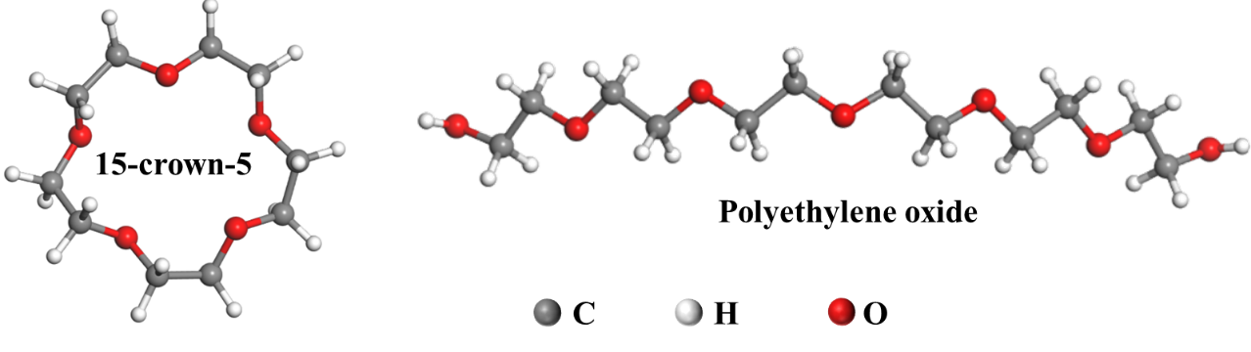
Figure S1. Structure of 15-crown-5 and polyethylene oxide.

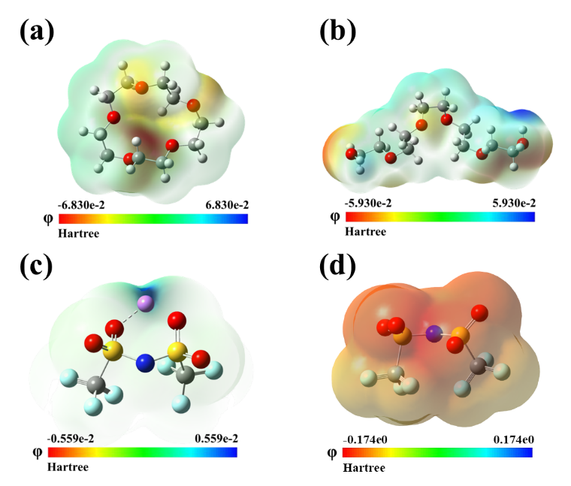
Figure S2. ESP simulation of (a)15-crown-5, (b) polyethylene oxide, (c) LiTFSI and
(d) TFSI⁻.

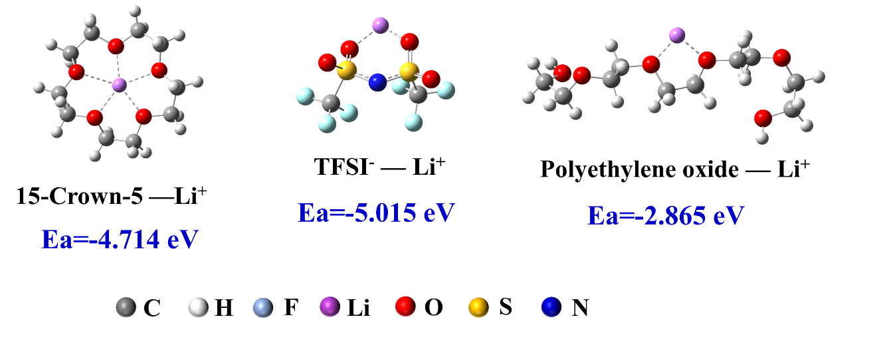
Figure S3. DFT calculation models for binding energy of Li⁺ in different systems.
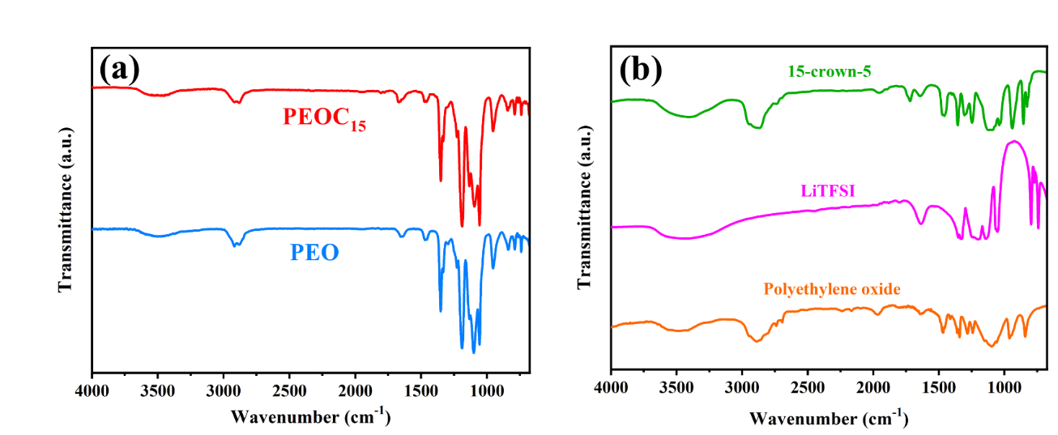
Figure S4. (a) FT-IR spectra of PEO and PEOC₁₅ electrolytes. (b) FT-IR spectra of 15-crown-5, LiTFSI and polyethylene oxide.

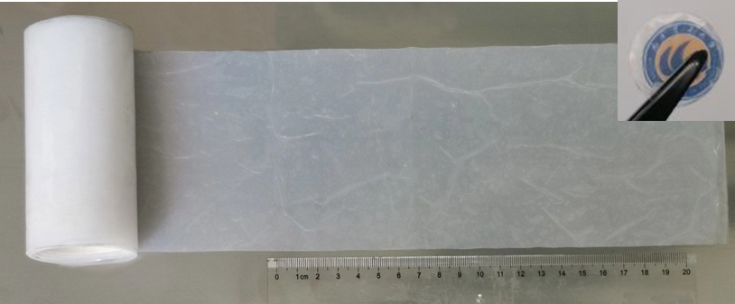
Figure S5. Digital image of PEOC₁₅ electrolytes membrane with large-scale production.

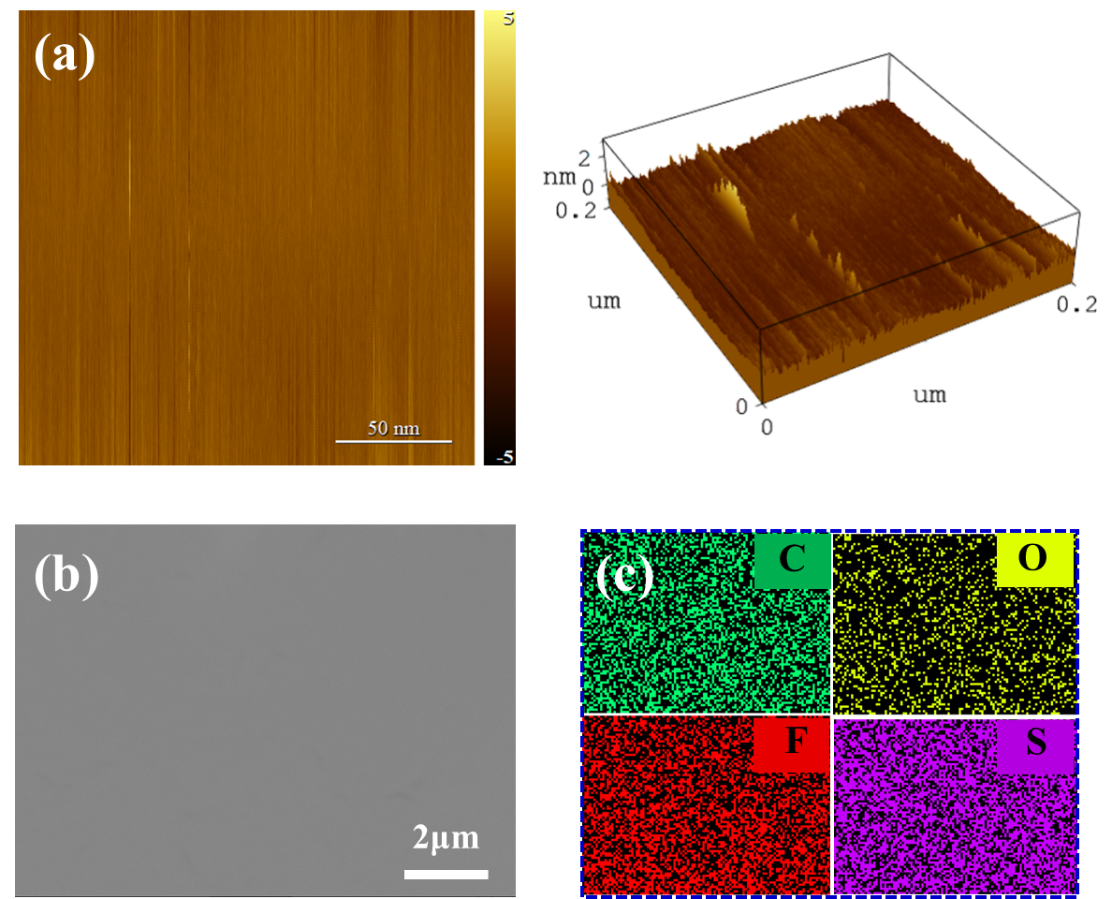
Figure S6. (a) AFM images, (b) top view SEM image, (c) EDS mappings of PEOC₁₅ electrolytes membrane.

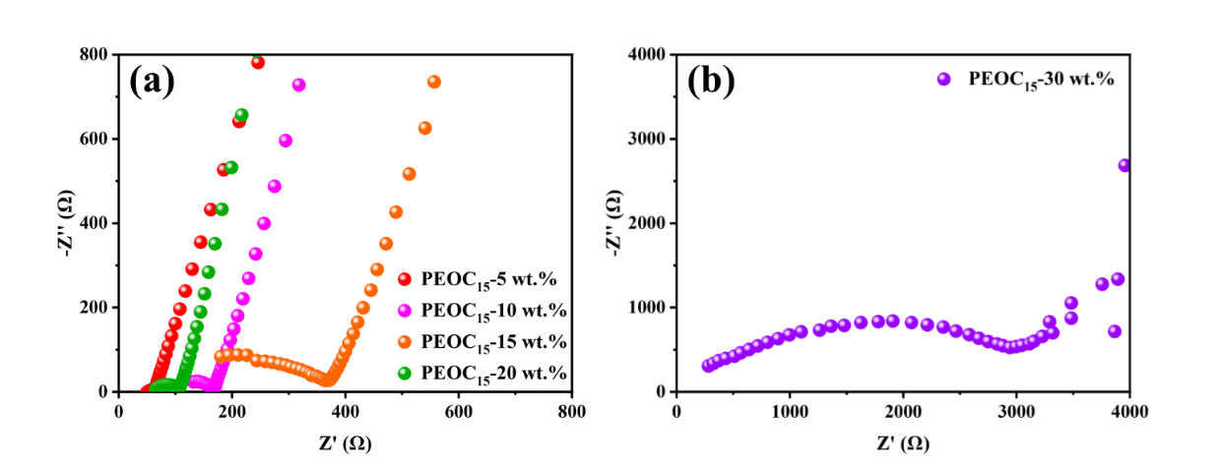
Figure S7. EIS curve of PEOC₁₅ electrolytes with different mass ratio: (a) 5%, 10%, 15% and 20%, and (b) 30%.

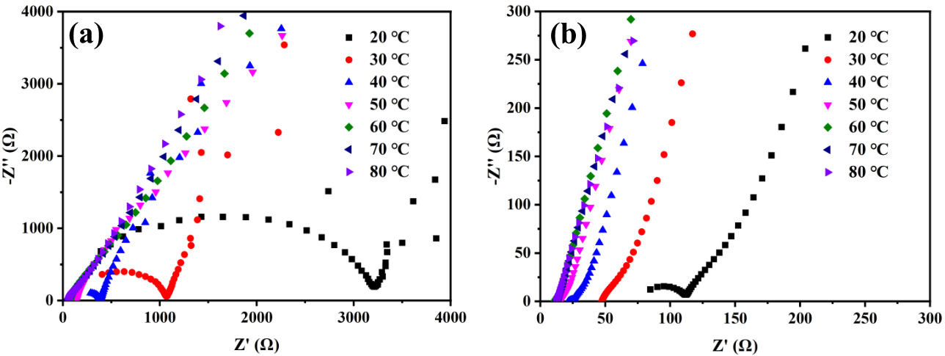
Figure S8. EIS curve of (a)PEO and (b) PEOC₁₅ electrolytes at different temperature.

Figure S9. Current-time curve following DC polarization of Li||PEO||Li symmetrical cell at 10 mV s⁻¹ (inset: EIS variation before and after polarization at 60 ºC.

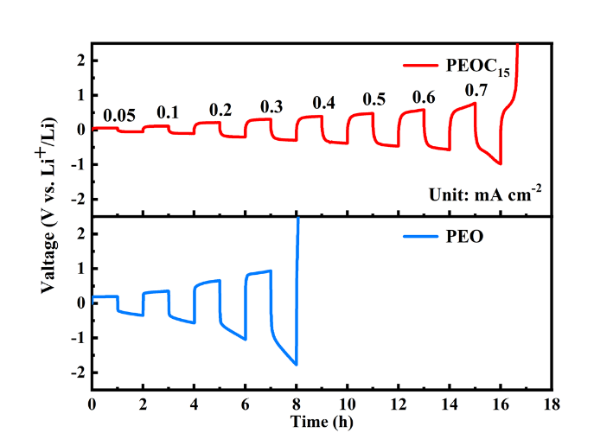
Figure S10. Current density ramping test of PEO and PEOC₁₅ electrolytes.

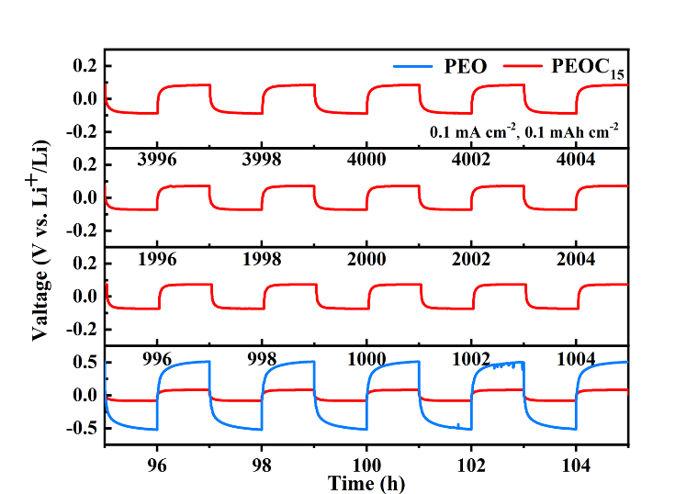
Figure S11. Voltage profiles at different cycles of the Li||PEO||Li and Li||PEOC₁₅||Li cells.

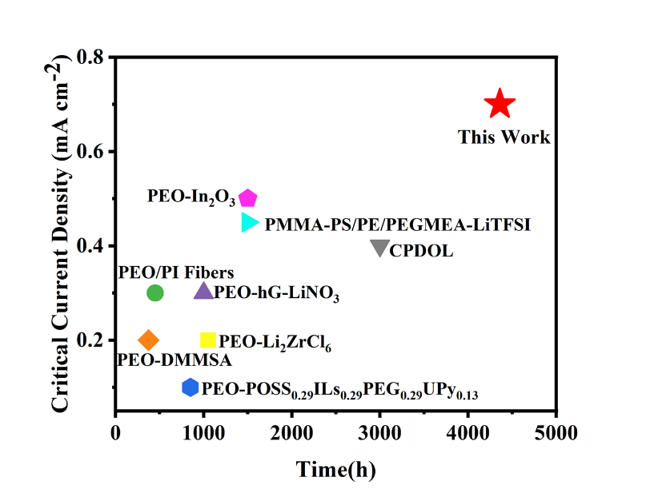
Figure S12. Comparison of the cycle life and CCD of symmetric cells with PEOC₁₅ and those of previously reported excellent SPEs.
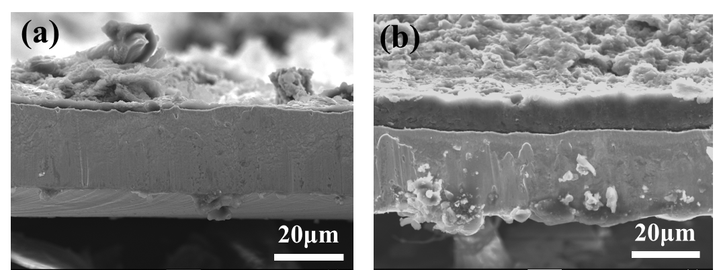
Figure S13. Side view SEM images of plated lithium using (a) PEO and (b) PEOC₁₅ electrolytes.

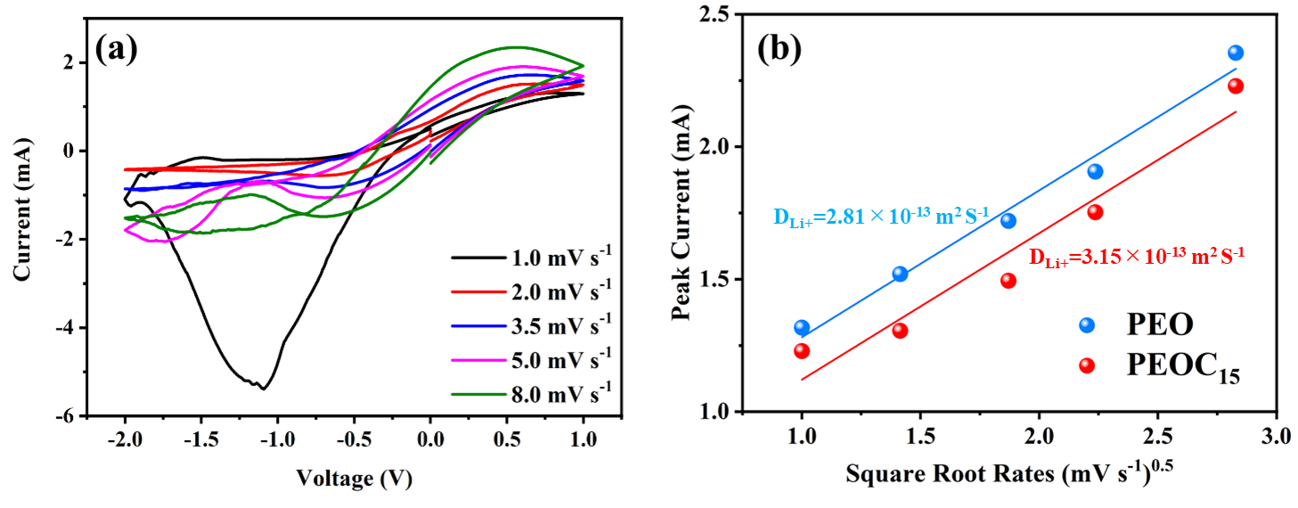
Figure S14. (a) CV curves of Li||PEO||Li cell at different voltage scan rates from 1.0 to 8.0 mV s⁻¹; (b) Linearly fitted graph of the relationship between peak current of CV curves and square root scan rates.

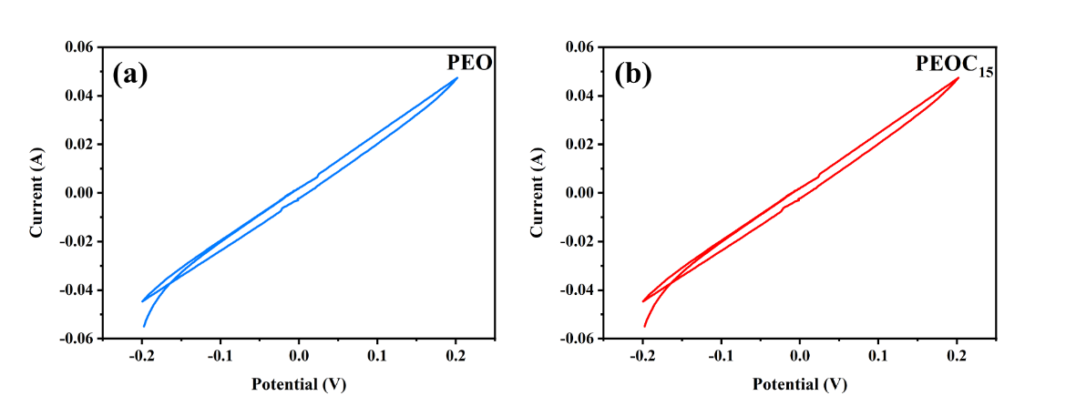
Figure S15. CV curve of (a) PEO and (b) PEOC₁₅ electrolytes.

Figure S16. EIS curve of (a) Li||PEO||Li and (b) Li||PEOC₁₅||Li cells symmetrical from 20 to 80 ºC.

Figure S17. XPS high-resolution S 2p spectra of interface of Li foils after cycling with the PEO and PEOC₁₅.

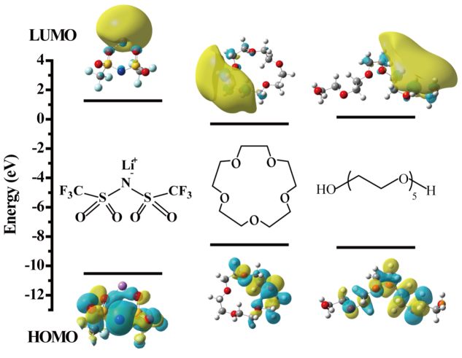
Figure S18. The HOMO and LUMO level of polyethylene oxide, 15-crown-5, and LiTFSI molecules.
Figure S19. TOF-SIMS negative ion spectrum of cycled Li foil in Li||PEOC₁₅||Li cell.

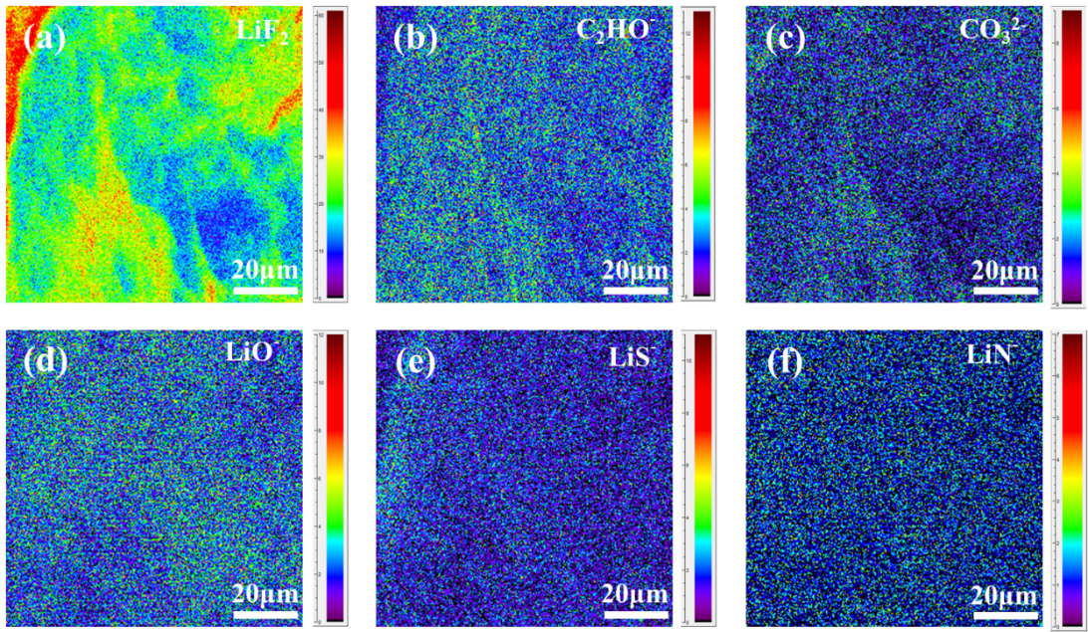
Figure S20. TOF-SIMS mapping images of LiF₂⁻, C₂HO⁻, CO₃²⁻, LiO⁻ LiS⁻ and LiN⁻.

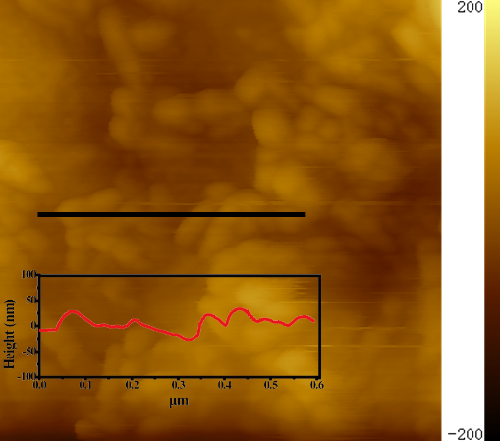
Figure S21. AFM height image of Li anode surface in Li||PEOC₁₅||Li after cycling.

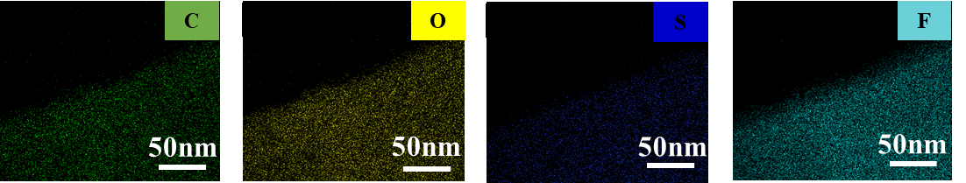
Figure S22. TEM elemental maps of the SEI between PEOC₁₅ electrolyte and lithium anode.
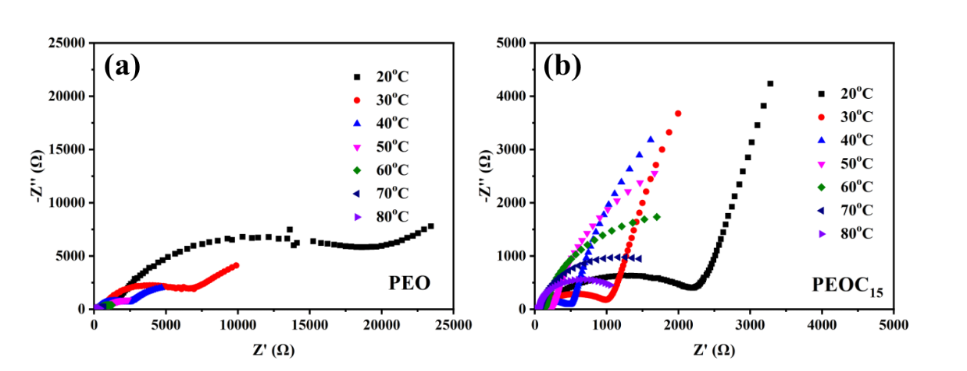
Figure S23. EIS curve of (a) NCM811||PEO||Li and (b) NCM811||PEOC₁₅||Li batteries from 20 to 80 ºC.
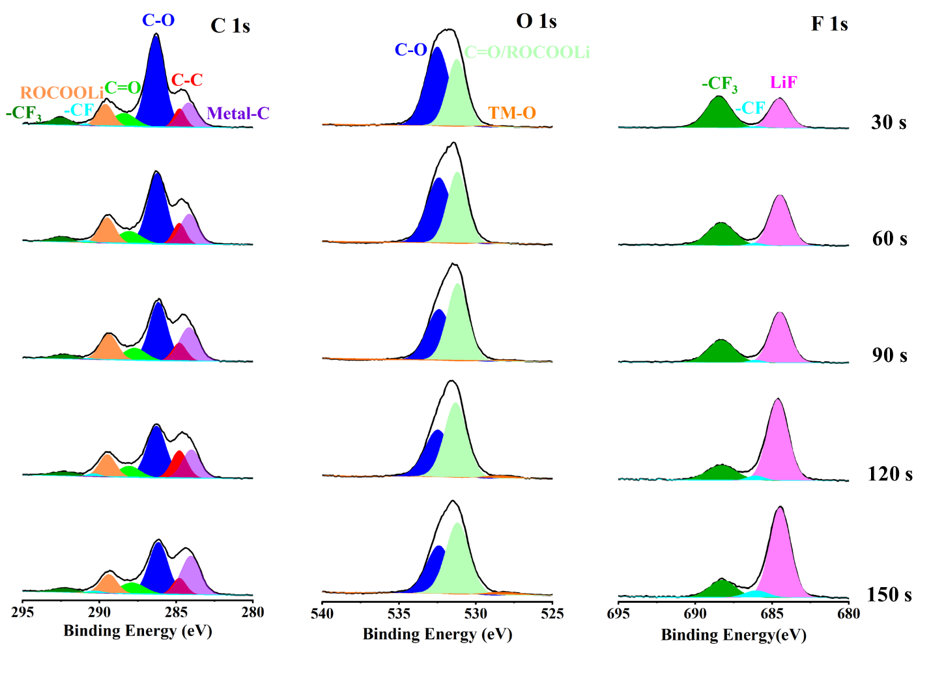
Figure S24. High-resolution XPS spectra of C 1s, O 1s, and F 1s of cycled NCM811 particles with PEO electrolyte at various sputtering times.

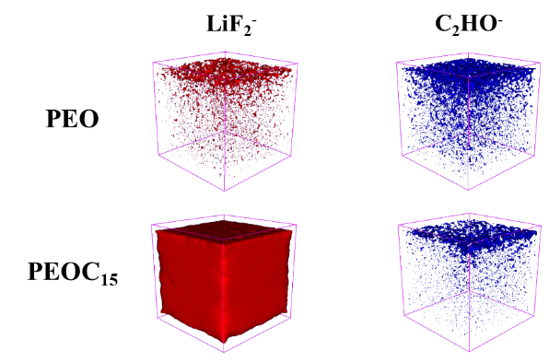
Figure S25.TOF-SIMS 3D reconstruction of the cycled NCM811 cathode surface with PEO and PEOC₁₅ electrolytes.

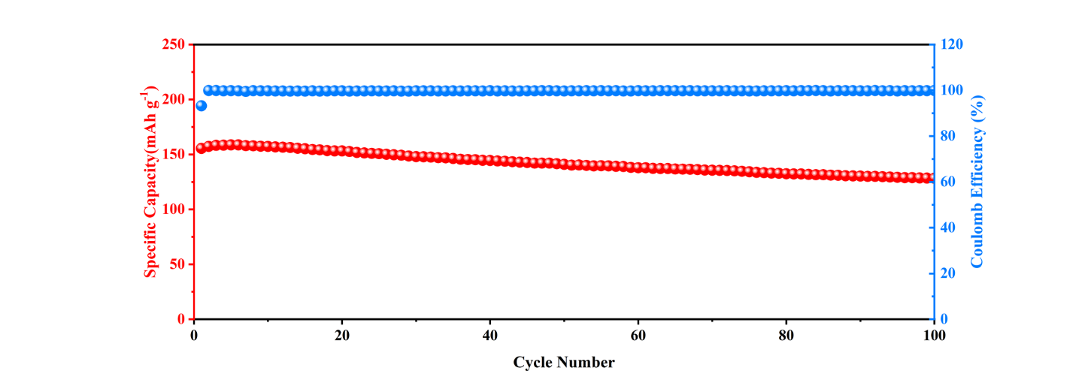
Figure S26.Cycling performance of NCM811||PEOC₁₅||Li batteries at 4.3V and 0.5 C.

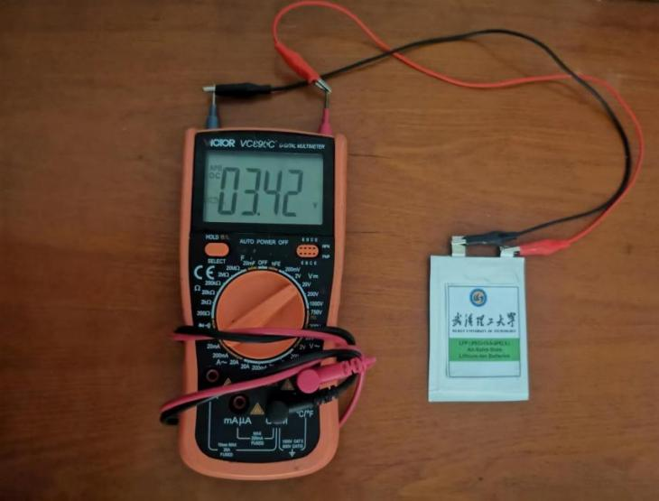
Figure S27. Photograph of the open-circuit voltage of pouch cell with the construction of LiFePO₄||PEOC₁₅||Li.
Table S1. Comparison of ionic conductivity (unit: S cm⁻¹) of electrolytes with different mass fraction of 15-crown-5 added at room temperature.

 | 5 wt.% | 10 wt.% | 15 wt.% | 20 wt.% | 30 wt.%
PEOC₁₅ | 1.22×10⁻⁴ | 6.20×10⁻⁵ | 2.39×10⁻⁵ | 7.60×10⁻⁵ | 3.53×10⁻⁶

Table S2. Ionic conductivity (unit: mS cm⁻¹) of PEO and PEOC₁₅ electrolytes at different temperature.

 | 20 ºC | 30 ºC | 40 ºC | 50 ºC | 60 ºC | 70 ºC | 80 ºC
PEO | 0.0696 | 0.165 | 0.359 | 0.52 | 0.617 | 0.655 | 0.701
PEOC₁₅ | 0.00233 | 0.00701 | 0.0195 | 0.0531 | 0.108 | 0.136 | 0.154

Table S3. Typical performances and stable time of Li||SPEs||Li symmetric cells in recent years

Type | CCD  (mA cm⁻²) |  | Overpotential  at stable state  (mV vs. Li/Li⁺) | Stable  time (h) | Year | Reference
CPDOL | 0.4 | 62 |  | 3000 | 2023 | ^{[1]}
PEO-In₂O₃ | 0.5 | 27 |  | 1500 | 2022 | ^{[2]}
PEO-hG-LiNO₃ | 0.3 | ~80 |  | 1000 | 2022 | ^{[3]}
PEO/PI Fibers | 0.3 | 45 |  | 450 | 2022 | ^{[4]}
PEO-Li₂ZrC_{l6} | 0.2 | 30 |  | 1050 | 2023 | ^{[5]}
PEO-DMMSA | 0.2 | ~50 |  | 375 | 2022 | ^{[6]}
PMMA-PS/PE/PEGMEA-LiTFSI | 0.45 | ~55 |  | 1500 | 2021 | ^{[7]}
PEO-POSS_{0.29}ILs_{0.29}  PEG_{0.29}UPy_{0.13} | 0.1 | ~250 |  | 850 | 2021 | ^{[8]}
PEOC₁₅ | 0.7 | ~70 |  | 4360 | — | This work

References
[1] H. Xu, J. Zhang, H. Zhang, J. Long, L. Xu, L. Mai, Adv. Energy Mater., 2023, 13, 2204411.
[2] X. Zhang, H. Zhang, Y. Geng, Z. Shi, S. Zhu, Q. Xu, Y. Min, Chem. Eng. J., 2022, 444, 136328.
[3] J. Xu, Y. Meng, Q. Ding, R. Wang, T. Gan, J. Zhang, Z. Lin, J. Xu, J. Mater. Chem. A, 2022, 10, 4402.
[4] Y. Li, Z. Fu, S. Lu, X. Sun, X. Zhang, L. Weng, Chem. Eng. J., 2022, 440, 135816.
[5] Q. Zhang, Q. Sun, S. Wang, C. Li, C. Xu, Y. Ma, H. Zhang, D. Song, X. Shi, C. Li, L. Zhang, ACS Appl. Mater. Inter., 2023, 15, 18252.
[6] P. Dong, X. Zhang, K. S. Han, Y. Cha, M.-K. Song, J.Energy Chem., 2022, 70, 363.
[7] Z. Wang, L. Shen, S. Deng, P. Cui, X. Yao, Adv. Mater., 2021, 33, 2100353.
[8] G. Yang, Y. Song, L. Deng, J. Mater. Chem. A, 2021, 9, 6881.

