**Supporting information (SI)**

**A micro battery supercapacitor hybrid device with ultrahigh cycle lifespan and power density enabled by bi-functional coating design**

Fazhi Ye, Wei Yang, * Xiaobin Liao, Chenhui Dong, Lin Xu, * Liqiang Mai*

F. Z. Ye, W. Yang, X. B. Liao, C. H. Dong, Prof. L. Xu, Prof. L. Q. Mai

State Key Laboratory of Advanced Technology for Materials Synthesis and Processing, School of Materials Science and Engineering, Wuhan University of Technology, Wuhan 430070, China

E-mail: weige830@163.com; linxu@whut.edu.cn; mlq518@whut.edu.cn

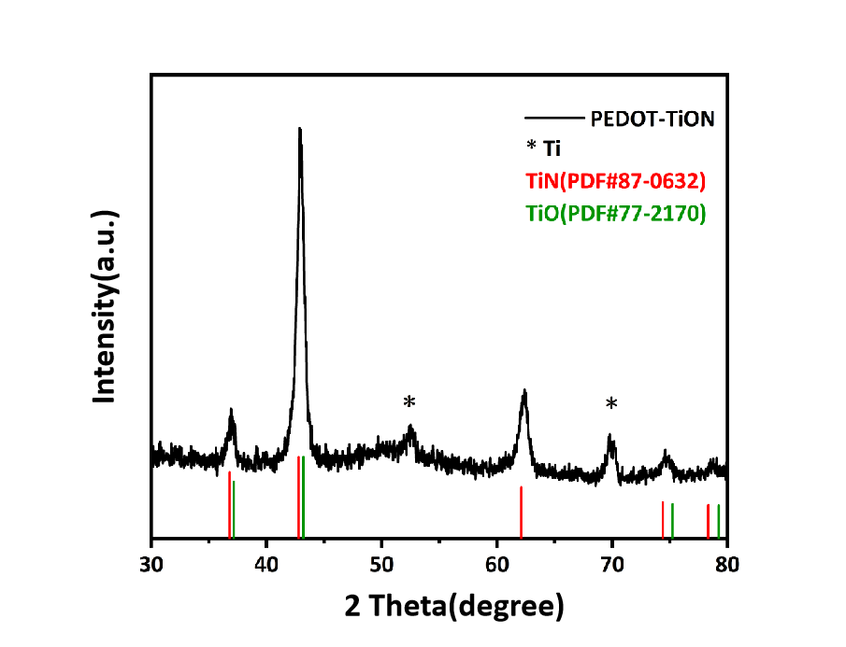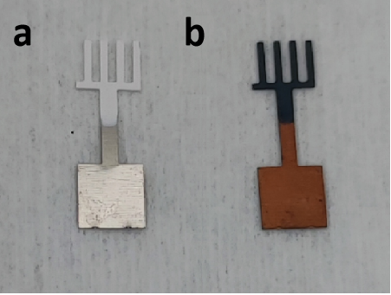**Figure S1.** The optical images of H2Ti3O7 and TiON microelectrodes.

**Figure S2.** The XRD of PEDOT-TiON nanowires microelectrodes.

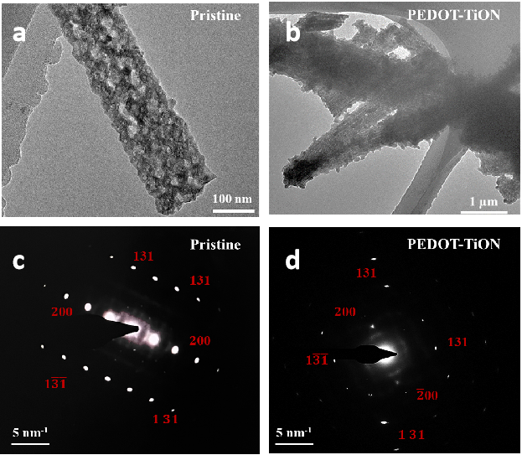

**Figure S3.** The HRTEM and SAED pattern of pure TiON nanowire (a,c) and PEDOT-TiON nanowire (b,d), respectively.

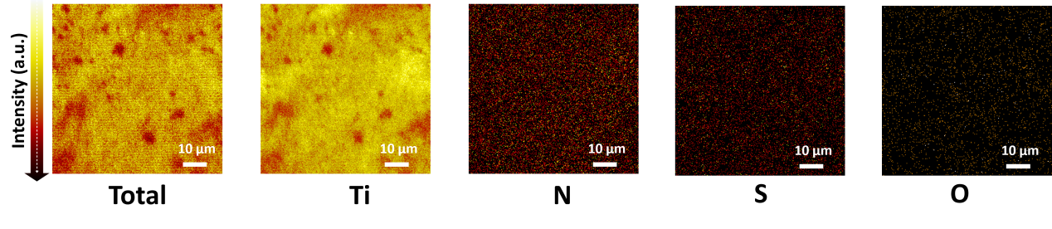

**Figure S4.** The TOF-SIMS pictures of PEDOT-TiON microelectrode.

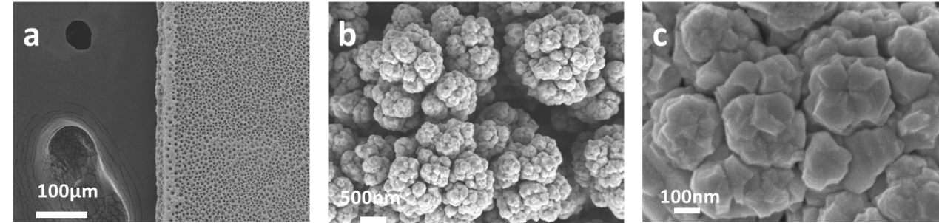

**Figure S5.** The SEM images of Ni(OH)2 microelectrodes with macroporous nano-structure.

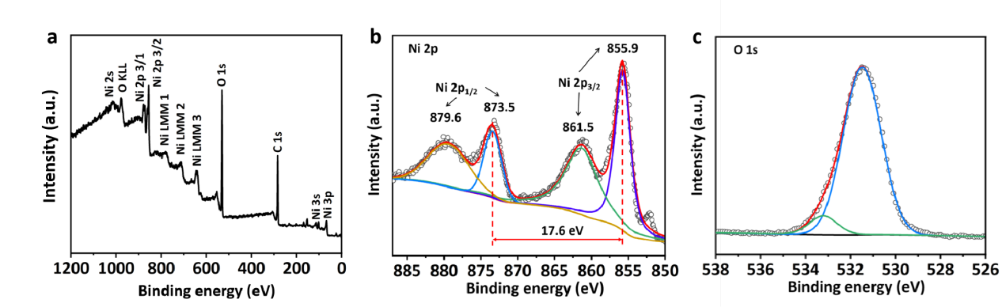

**Figure S6.** The XPS spectrum of porous Ni(OH)2 microelectrode (a) All peaks. (b) Ni 2p. (c) O1s.

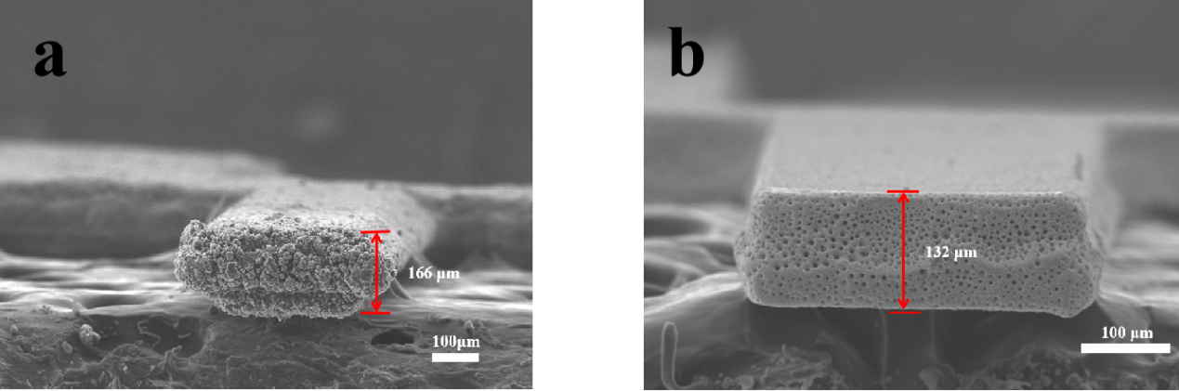**Figure S7.** Cross-section SEM images of (a) PEDOT-TiON microelectrode and (b) Ni(OH)2 microelectrode.

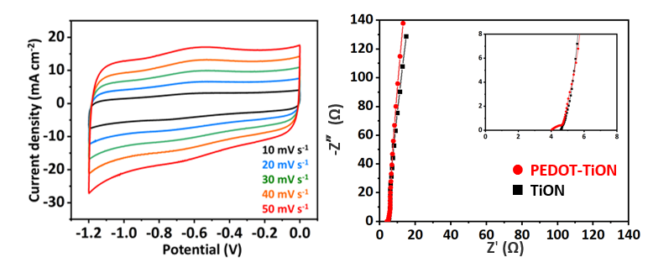

**Figure S8.** (a)CV curves of TiON NW microelectrode. (b) EIS results of TiON and PEDOT-TiON nanowires microelectrodes.

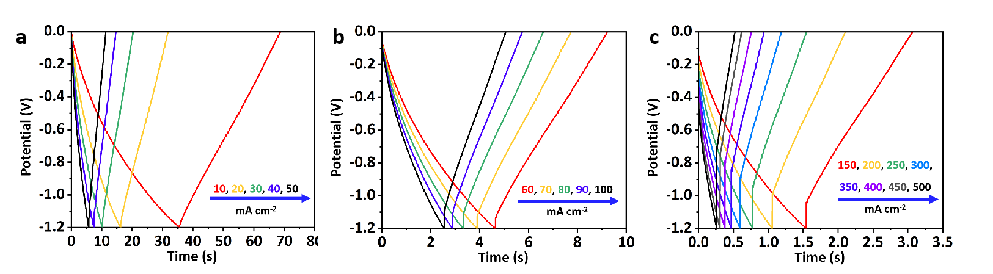

**Figure S9.** GCD curves of PEDOT-TiON nanowires microelectrodes varies from 10 to 500 mA cm–2.

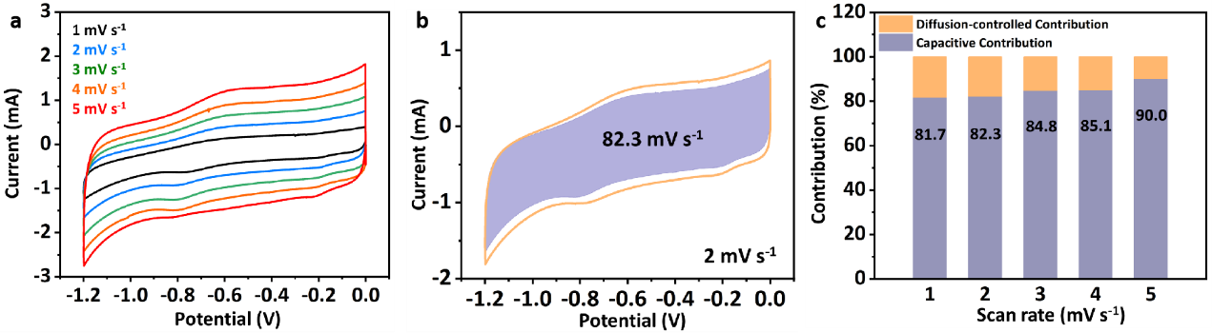

**Figure S10**. **(a)** CV curves of PEDOT-TiON at different scan rates(from 1–5 mV s–1). **(b)** CV curves of PEDOT-TiON NW microelectrode with a shadowed area exhibit the capacitive contribution. **(c)** Separations of capacitive and diffusion-controlled contribution at different scan rates for PEDOT-TiON nanowire microelectrode.

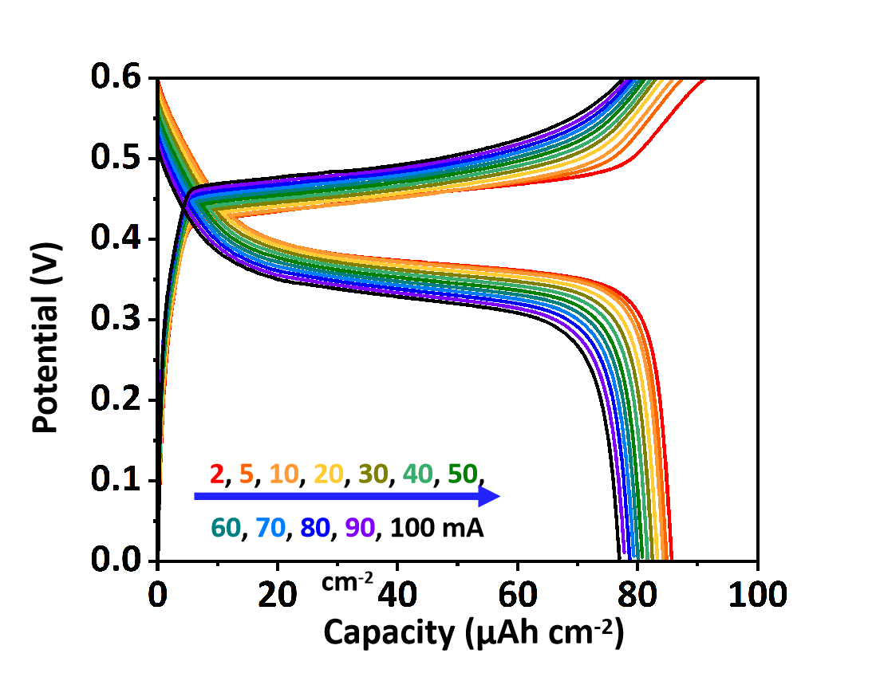

**Figure S11.** GCD curves of Ni(OH)2 microelectrodes varies from 2 to 100 mA cm–2.

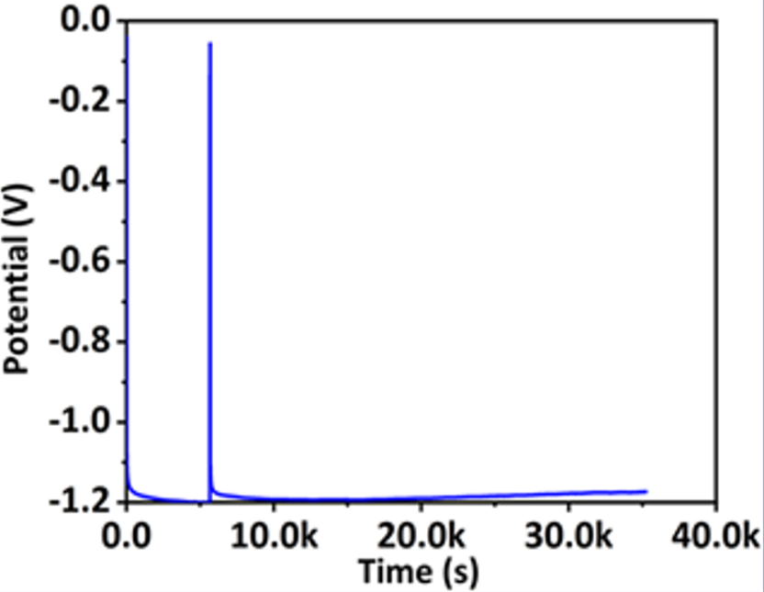

**Figure S12.** GCD curves of TiON microelectrodes after 2000 cycles.

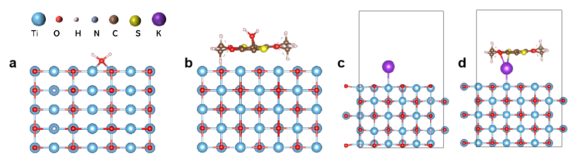

**Figure S13.** Optimize structure of (a)H2O molecule and TiON, (b)H2O molecule and PEDOT-TiON, (c) K+ ion and TiON and (d) K+ ion and PEDOT-TiON.

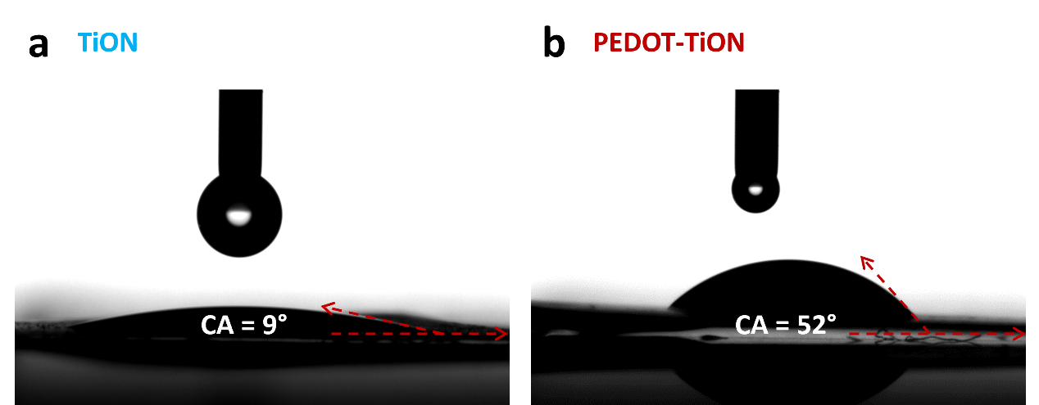

**Figure S14.** The water Angle test a) TiON microelectrode; b) PEDOT-TiON microelectrode.

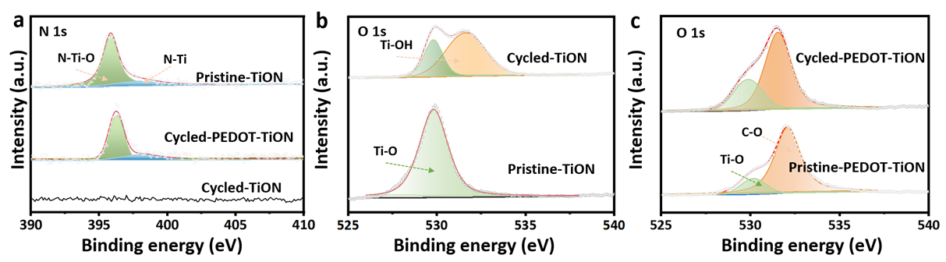

**Figure S15.** a) N 1s XPS peaks of Pristine-TiON, Cycled-PEDOT-TiON and Cycled-TiON microelectrodes; b-c) O 1s XPS peaks of Pristine-TiON, Cycled-TiON, Pristine-PEDOT-TiON and Cycled-PEDOT-TiON microelectrodes.

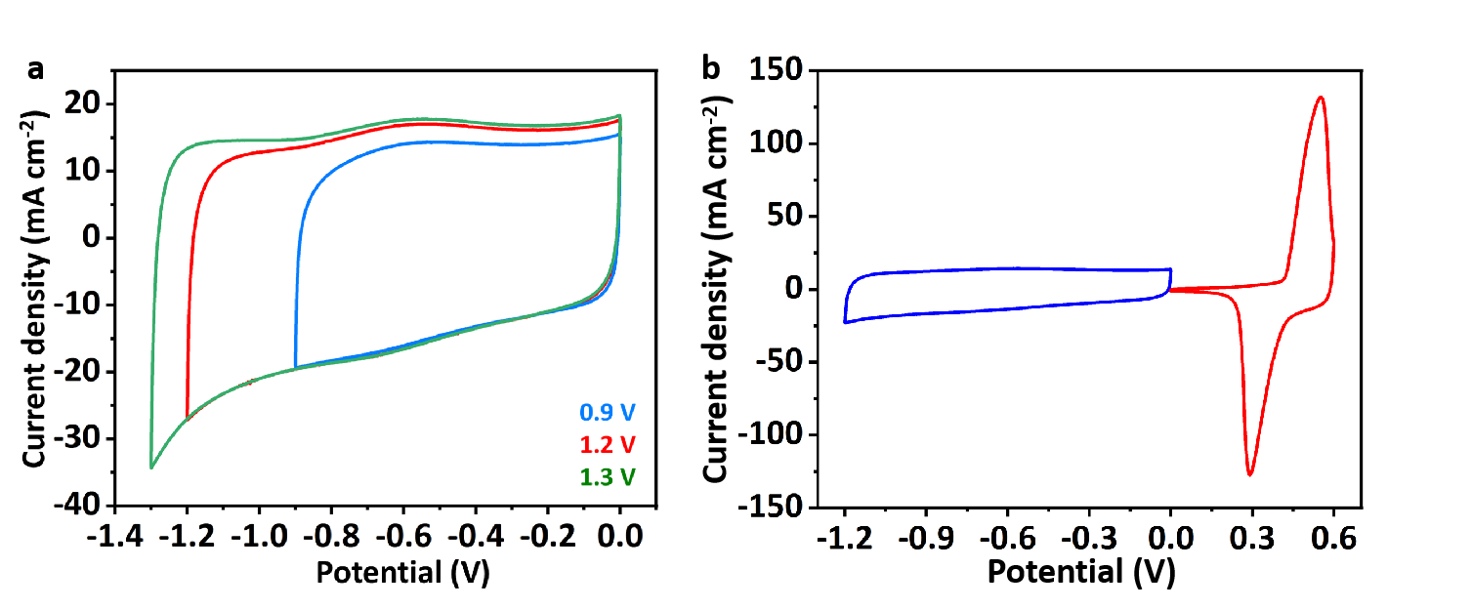

**Figure S16. (a)** CV curves of PEDOT-TiON NW microelectrode at different voltage window from –0.9 to –1.3V. (b) CV curves of Ni(OH)2 cathode and PEDOT-TiON anode for MBSH in different Potential ranges.

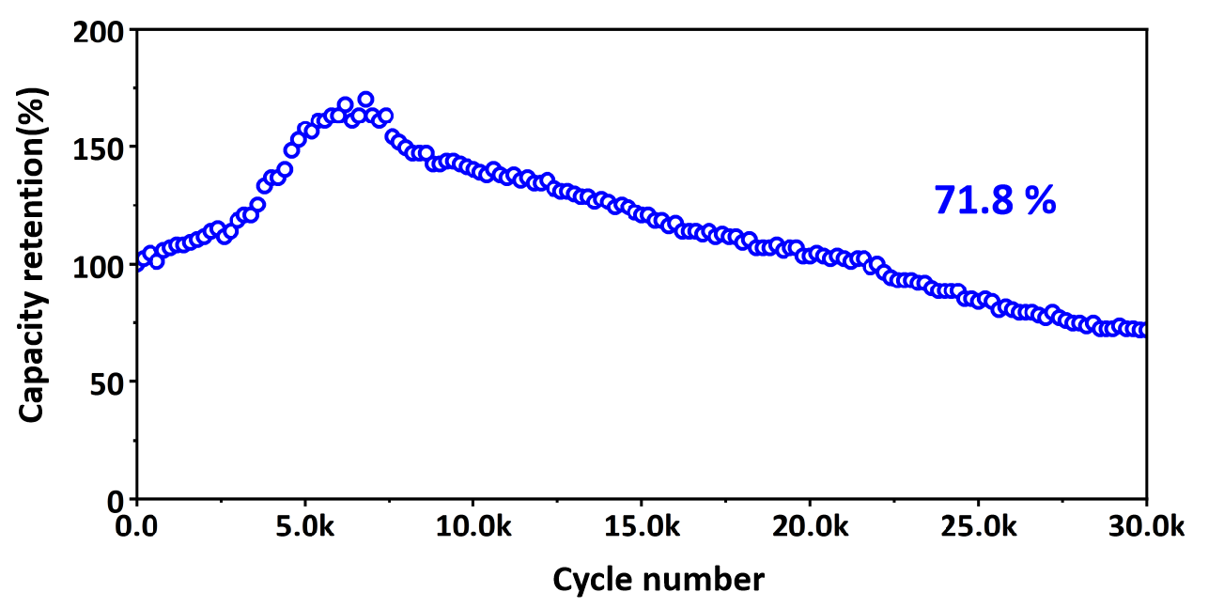

**Figure S17.** The ultra-long cycle performance of PEDOT-TiON//Ni(OH)2 device.

**Table S1.** Comparison ofCycle number between series reported high-performance MSCs, MBs and Our work.

|  |  |  |  |
| --- | --- | --- | --- |
| **Type** | **Cycle number** | **Capacity retention** | **Ref.** |
| 3D printed MSC | 10000 | 80% | [28] a) |
| Mxene MSC | 15000 | 78% | [28] b) |
| SNHUNs MB | 9500 | 80% | [28] c) |
| Zn//PNVO MB | 3500 | 80% | [28] d) |
| PTCDA/Ti3C2Tx MB | 10000 | 74% | [28] e) |
| PZIMBs | 3000 | 68% | [29] a) |
| Zinc-ammonium MB | 1000 | 92% | [29] b) |
| Printed ZIMB | 300 | 80% | [29] c) |
| Zn-I MB | 2600 | 89.2% | [29] d) |
| **PEDOT-TiON//(NiOH)2 MBSH** | **30000** | **71.8%** | **This work** |