Supplementary materials

**Identifying ultrathin dielectric nanosheets induced interface polarization for high-performance solid-state lithium metal batteries**

**Experimental Section**

**Synthesis of CNO Nanosheets**

CNO monolayer nanosheets were prepared according to the previously reported method of exfoliating layered perovskites[1]. The detailed preparation process is as following: KCa2Nb3O10 is prepared by solid-phase reaction among K2CO3, CaCO3 and Nb2O5, and then converted the product into HCa2Nb3O10·1.5H2O in nitric acid solution. Finally, monolayer nanosheets can be obtained by exfoliation in tetrabutylammonium hydroxide (TBAOH) aqueous solution.

**Preparation of CSPE and SPE film**

The SPE and SPE with CNO fillers are obtained by the solvent-casting method. For the CSPE with CNO monolayer nanosheets, the different contents of as-prepared CNO were dispersed in anhydrous acetonitrile, while LiTFSI (99.5%, Aladdin) and PEO (Mw=600000, Sigma Aldrich) were also dispersed in another anhydrous acetonitrile, then mix two solutions into a homogeneous solution under fully stirring for 12 h at 60 °C in the glove box (keep the molar ratio of EO to Li+ at 8:1). Finally, the homogeneous solution was poured into a polytetrafluoroethylene mold, then dried at 60 °C for 12 h under vacuum to obtain the CSPE with different content of CNO. The CNO-free SPE film was prepared by a similar method as described above without fillers. The PLCN electrolyte for room temperature test was prepared using ultrathin porous membrane (5 µm polyethylene separator, CHONGQING YUTIANHUA CO., Ltd.) as interlayer to enhanced mechanical properties.

**Materials characterization**

Field emission scanning electron microscopy (FSEM, JEOL JSM-7100F), transmission electron microscopy and HRTEM (TEM, Talos F200S) were used to observe the morphology of the CNO samples and electrolytes. Elemental mapping was conducted on an energy-dispersive X-ray spectroscopy (EDS) for analyzing the element of samples. Atomic force microscopy (AFM, DI Nanoscope) was carried out to analyze the morphology and thickness of the CNO. The crystal structure of CNO, CSPE and SPE were revealed by X-Ray diffraction (XRD, D8 Discover) analysis with angular range 10° ≤ 2θ ≤ 80° using Cu Kα radiation (λ = 1.5418 Å). The X-Ray photoelectron spectroscopy (XPS) (AXIS SUPRA) was performed to analyze the elemental composition of CNO, electrolytes and electrodes. Attenuated total reflection Fourier transform infrared (ATR-FTIR) spectra were obtained on Nicolet 6700 (Thermo Fisher Scientific Co., USA) with a range of 4000-400cm-1. Thermo-gravimetric (TG) was conducted on a NETZSCH STA 449F5 instrument (heating rate: 10 °C min-1 from 25 °C to 800 °C under Ar atmosphere). And Differential scanning calorimetry (DSC) was carried on Pyris 1 DSC analyzer in Ar from -80 °C to 200 °C with a heating rate of 10 °C min-1. The Raman spectra were obtained via a Raman spectrometer (LabRAM HR Evolution &SmartSPM) with 532 nm lasers at room temperature. The stress-strain curves of the as-prepared CSPE and SPE were tested by an Instron 5967 testing system. The solid state 7Li and 19Fmagic angle spinning (MAS) NMR spectra were acquired on a Bruker Advance III 400MHz Solid NMR Spectrometer at 25 °C using a commercial 3.2 mm DVT probe. The dielectric relaxation spectroscopy (DRS) of each film was carried out on Agilent Technologies 4294A precision LCR meter in the frequency range from 100 Hz to 1 MHz.

**Electrochemical Characterization of Solid Composite Electrolyte**

The CR2016 stainless steel (SS)||SS cell was assembled with different solid composite electrolytes for EIS test. Then IC of PLCNx (x=1, 3, 5, 7% wt.) and PL were evaluated at different temperatures by EIS from 106 Hz to 10 Hz with 10 mV amplitude on an Autolab PGSTAT302N. The equation for calculating IC is shown below:

$δ=\frac{l}{SR_{b}}$ (1)

Where l, Rb and S are the thickness of the electrolyte, bulk impedance of the electrolyte and the area of the blocking stainless steel electrode. Before EIS test, the cells were kept at the corresponding test temperature for 30 min to reach thermal equilibrium. The electrochemical stability window was obtained by carrying out the linear sweep voltammetry (LSV) test on a lithium/CSPE/SS cell from open circuit voltage to 6.0 V versus Li/Li+ with a scan rate of 0.5 mV s–1.

The activation energies of different electrolyte systems are calculated by the classical Arrhenius formula as shown below:

$\text{σ}\text{(T)=}\text{Aexp}\text{(-}\frac{E_{a}}{RT}\text{)}$ (2)

where A, T and Ea are the pre-exponential factor, absolute temperature and activation energy of the activated ion transition conduction process.

The lithium-ion transference number (tLi+) was obtained by assembling the Li/Li symmetric batteries for testing, and the specific value is calculated using the following equation:

$t_{{Li}^{+}}=\frac{I_{SS}(ΔV-I_{0}R_{0})}{I_{0}(ΔV-I_{SS}R_{SS})}$ (3)

where I0 and ISS are the initial and steady-state currents, ΔV is the potential applied on the cell, and R0 and Rss are the initial and steady-state resistance.

The symmetric Li||Li cells with different electrolytes were assembled for constant current charging and discharging performance on the LAND CT2001A battery test system at a current density of 0.1 mA cm−2.

**Batteries Assembly and Electrochemical Characterization**

The solid-state lithium metal batteries were prepared by using different electrolytes, using LiFePO4 (LFP) and NCM811 as cathode material and lithium metal with thickness of 60 μm as anode respectively. A small amount of liquid electrolyte (5 μL, LiPF6 in EC/DMC/EMC + 2%VC) was dripped to the PLCN/NCM811 interface for better contact at room temperature. The LFP cathode consist of 70% wt. LFP, 20% wt. acetylene black，5% wt. PL (EO: Li = 8) and 5% wt. PVDF. The mass loading of LFP is about 1.0-1.5 mg cm−2. The NCM811 cathode consist of 80% wt. NCM, 10% wt. acetylene black，5% wt. PL (EO: Li = 8) and 5% wt. PVDF. The mass loading of NCM is about 2.0 -2.7 mg cm−2. The solid-state lithium batteries were assembled in glove box with Ar atmosphere.

The cycling performances of solid-state lithium batteries (LFP||Li) at 60 °C were acquired at 0.2 C and 0.5 C within voltage range of 2.7-4.0 V and 1 C corresponds to 170 mAh g-1. Batteries for cycling test were first cycled twice at 0.1 C and then tested at the corresponding rate. The rate performances were obtained from 0.1 C to 2 C at 60 °C. The cycle of NCM811||(PLCN)||Li batteries were tested at 0.5 C between 2.7 and 4.2 V within 1 C corresponds to 180 mAh g-1 at room temperature. The rate performance of NCM811||(PLCN)||Li batteries were tested from 0.1 C to 2 C with voltage range from 2.7 to 4.2 V at room temperature. All electrochemical tests of cells mentioned above were realized by the LAND CT2001A battery testing system.

**Computational details**

All DFT calculation were constructed and implemented in the Vienma ab initio simulation package (VASP)[2, 3]. The electron exchange and correlation energy was treated within the generalized gradient approximation in the Perdew-Burke-Ernzerhof functional (GGA-PBE)[4]. The long-range dispersion interactions between adsorbates and surface was treated applying DFT-D3 method[5]. The electrostatic potentials (ESPs) of TFSI-, PEO and Ca2Nb3O10 were respectively calculated by DMol3 module in MS. Two kinds of electrolyte systems, i.e. PL and PLCN, consisting of same numbers of compositions were respectively built into rectangular simulation boxes. The solutions are composed of 15 LiTFSI and 120 PEO molecules. The PEO single chain used in MD simulation is constructed by repeating 10 times of PEO unit. All MD simulations were carried out by Forcite module with universal force field parameters[6] in MS 2017[7]. Vander Waals and Coulomb interactions were respectively considered by atom based and Ewald methods with a cut-off value of 12.5 Å. Equations of motion were integrated with a time step of 1 fs. After energy minimization, each system was fully relaxed under periodic boundary conditions for 400 ps in the NVT (T = 298.0 K) ensemble using the Nose thermostat, which was long enough for system temperature, potential and total energy to get stable. The dynamic trajectory for each system was outputted at 4 ps interval and used for density distribution analysis along the vertical direction.

**Supplementary figures**



**Figure S1.** (A) TEM image and (B) HRTEM images of CNO with inverse fast fourier transform (IFFT). (C) SEM image. (D) XRD pattern. (E) AFM image of CNO.



**Figure S2.** XPS spectra of the pure CNO nanosheets: (A) XPS survey spectrum. (B) Ca 2p, Nb 3d and O 1s spectra.

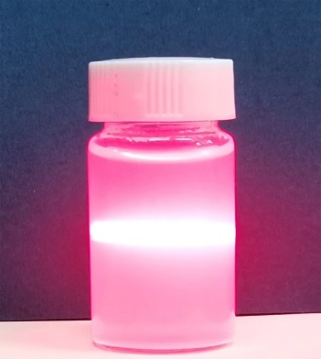

**Figure S3.** Dispersion of CNO in anhydrous acetonitrile.



**Figure S4.** (A) Surface and (B) cross-sectional SEM images of PL.



**Figure S5.** (A) Cross-sectional SEM image and EDS mappings of (B) Ca and (C) Nb for PLCN electrolyte.

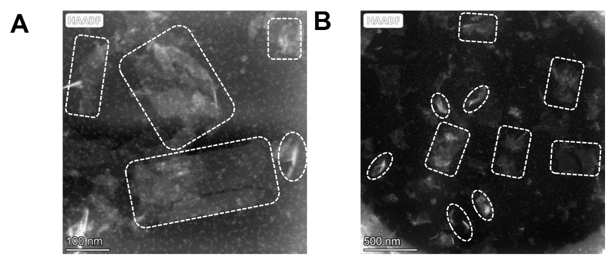

**Figure S6.** Ultrathin section TEM images of PLCN electrolyte (Ultrathin slices of PLCN electrolyte were obtained by slicing in a direction perpendicular to the electrolyte membrane plane). The CNO nanosheets plane inside the rectangular dashed box refer to the CNO nanosheets arranged perpendicular to the direction of the PLCN electrolyte membrane plane. And CNO nanosheets cross-section inside the elliptical dashed box refer to the CNO nanosheets arranged parallel to the direction of the PLCN electrolyte membrane plane or the CNO nanosheets with a direction of the PLCN electrolyte membrane plane at a certain angle (between 0° and 90°).



**Figure S7.** The optimized models of (A) PL and (B) PLCN.



**Figure S8.** The electrostatic potential (ESP) of (A) CNO-Li, (B) PEO and (C) PEO-Li. (The white, green, brown, red, indigo, cyan balls represent H, Li, C, O, Ca, and Nb atoms, respectively)



**Figure S9.** The crystallographic structure of (A) LiTFSI, (B) Li+ adsorbed on the surface of the CNO. (The white, green, brown, blue, red, grey, yellow, indigo, cyan balls represent H, Li, C, N, O, F, S, Ca, and Nb atoms, respectively)



**Figure S10.** Schematic diagrams of LiTFSI dissociation in (A) PL and (B) PLCN electrolyte.



**Figure S11.** Raman spectra of (A) PLCN1, (B) PLCN3 and (C) PLCN7 and (D) the statistical results of Raman spectra.



**Figure S12.** Li 1s XPS spectra of PLCN and PL.



**Figure S13.** (A) XRD patterns of PLCN1, PLCN3 and PLCN7. (B) tanδ of pure PEO (without LiTFSI), PL and PLCN. (C) TG curves of PL and PLCN.



**Figure S14.** Stress-strain curves of PL and PLCN.



**Figure S15.** The EIS spectra of SS||(PLCNx)||SS cell (x=0, 1, 3, 5, 7% wt.) at (A) room temperature and (B) 60 °C. (C) The ionic conductivity of PLCNx (x=0, 1, 3, 5, 7% wt.) at 60 °C.



**Figure S16.** EIS spectra of (A) SS||(PLCN)||SS cell and (B) SS||(PL)||SS cell from 20 to 80 °C. (C) Arrhenius plots of PLCN1, PLCN3 and PLCN7 electrolytes.



**Figure S17.** (a) The EIS spectra and ionic conductivity of PLBTO at room temperature. (b)The action energy of PLBTO. (c) The EIS spectra of PLBTO at different temperatures.



**Figure S18.** The Li+ migration mechanism in the PLCN electrolyte.



**Figure S19.** (A-D) Chronoamperometry curves of PLCN in Li symmetric cell with different CNO contents at room temperature, and insert figure is the corresponding EIS curves before and after polarization. (E) Li+ transference number with different CNO contents at room temperature.



**Figure S20.** (A-D) Chronoamperometry curves of PLCN Li symmetric cell at different temperatures (30, 40, 50 and 60 °C), and insert figure is the corresponding EIS curves before and after polarization. (E) Li+ transference number at different temperatures (25, 30, 40, 50 and 60 °C).



**Figure S21.** LSV curves of PL and PLCN.



**Figure S22.** Voltage-time profiles of the continued lithium plating/stripping cycling of Li||(PLCN1)||Li, Li||(PLCN3)||Li and Li||(PLCN7)||Li cells with a current density of 0.1mA cm−2 at 60 °C.



**Figure S23.** EIS spectra of Li||Li symmetric cells with (A) PLCN and (B) PL before cycle and after cycling 100 h.



**Figure S24.** (A) The surface SEM image and (B) corresponding F-element mapping image of Li electrode obtained from Li||(PLCN)||Li symmetric cells after cycling 120 h. (C) The surface SEM image of Li electrode obtained from Li||(PL)||Li symmetric cells after cycling 120 h. (D) The relative abundance of the components in the Li electrode obtained from Li||Li symmetric cells after cycling 120 h.



**Figure S25.** The S2-N and S2-C2 bond length in (A) free and (B) adsorbed TFSI on CNO nanosheet.



**Figure S26.** EIS spectra of (A) Li||(PLCN)||Li and (B) Li||(PL)||Li symmetric cells with time evolution at 60 °C.



**Figure S27.** The charging/discharging curves of LFP|| Li full battery with (A) PLCN and (B) PL at 0.5 C and 60 oC.



**Figure S28.** Cycle performance of LFP||Li full batteries at (A) 0.2 C. (B) Charge-discharge curves of the 20th, 40th and 60th cycle for LFP||(PLCN)||Li and LFP||(PL)||Li full batteries at 0.2 C.



**Figure S29.** The surface morphologies of Li electrode obtained from (A) LFP||(PLCN)||Li and (B) LFP||(PL)||Li batteries after cycling 10 cycles at 0.2 C.



**Figure S30.** (A) C 1s, F 1s and N 1s XPS spectra for lithium anode obtained from LFP||(PLCN)||Li and LFP||(PL)||Li batteries after cycling 10 cycles at 0.2 C. (B) The relative abundance of the components in the Li electrode from XPS spectra of Supplementary Figure 27 (A).

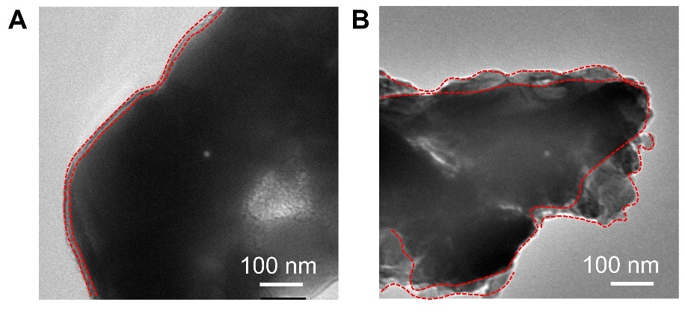

**Figure S31.** The TEM images of LFP electrode obtained from (A) LFP||(PLCN)||Li and (B) LFP||(PL)||Li batteries after cycling 10 cycles at 0.2 C.



**Figure S32.** C 1s, F 1s and N 1s XPS spectra for LFP obtained from LFP||(PLCN)||Li and LFP||(PL)||Li batteries after cycling 10 cycles at 0.2 C.



**Figure S33.** Radar diagram of electrochemical performance comparison, where different fillers such as fluoromethyl modified polyamine[8], Ca-doped CeO2[9], TiO2@PDA[10], g-C3N4[11], and ZIF-67 MOFs[12] are introduced into PEO respectively.

**References for the Supplementary materials**

[1] Y. Ebina, T. Sasaki, M. Watanabe, Study on exfoliation of layered perovskite-type niobates, Solid State Ion. 151 (2002) 177-182.

[2] G. Kresse av, J. Furthmiiller, Efficiency of ab-initio total energy calculations for metals and semiconductors using a plane-wave basis set, Comp. Mater. Sci. 6 (1996) 15-50.

[3] G. Kresse av, J. Furthmiiller, Efficient iterative schemes for ab initio total-energy calculations using a plane-wave basis set, Phys. Rev. B 54 (1996) 11169-11186.

[4] M. Ernzerhof., J.P. Perdew, Generalized gradient approximation to the angle- and system-averaged exchange hole, J. Chem. Phys. 109 (1998) 3313-3319.

[5] S. Grimme, J. Antony, S. Ehrlich, H. Krieg, A consistent and accurate ab initio parametrization of density functional dispersion correction (DFT-D) for the 94 elements H-Pu, J. Chem. Phys. 132 (2010) 154104.

[6] A.K. Rappé, C.J. Casewit, K.S. Colwell, W.A. Goddard, W.M. Skiff, UFF, a full periodic table force field for molecular mechanics and molecular dynamics simulations, J. Am. Chem. Soc. 114 (1992) 10024-10035.

[7] Dassault Systemes BIOVIA, Materials Studio, 8.0, Dassault Systemes, San Diego,2017.

[8] C. Li, S. Zhou, L. Dai, X. Zhou, B. Zhang, L. Chen, T. Zeng, Y. Liu, Y. Tang, J. Jiang, J. Huang, Porous polyamine/PEO composite solid electrolyte for high performance solid-state lithium metal batteries, J. Mater. Chem. A 9 (2021) 24661-24669.

[9] H. Chen, D. Adekoya, L. Hencz, J. Ma, S. Chen, C. Yan, H. Zhao, G. Cui, S. Zhang, Stable seamless interfaces and rapid ionic conductivity of Ca–CeO2/LiTFSI/PEO composite electrolyte for high‐rate and high-voltage all‐solid‐state battery, Adv. Energy Mater. 10 (2020) 2000049.

[10] E. Zhao, Y. Guo, A. Zhang, H. Wang, G. Xu, Polydopamine coated TiO2 nanofiber fillers for polyethylene oxide hybrid electrolytes for efficient and durable all solid state lithium ion batteries, Nanoscale 14 (2022) 890-897.

[11] Z. Sun, Y. Li, S. Zhang, L. Shi, H. Wu, H. Bu, S. Ding, g-C3N4 nanosheets enhanced solid polymer electrolytes with excellent electrochemical performance, mechanical properties, and thermal stability, J. Mater. Chem. A 7 (2019) 11069-11076.

[12] E. Zhao, Y. Guo, Y. Liu, S. Liu, G. Xu, Nanostructured zeolitic imidazolate framework-67 reinforced poly(ethylene oxide) composite electrolytes for all solid state Lithium ion batteries, Appl. Surf. Sci. 573 (2022) 151489.