Supporting Information

High Mass Loading Potassium Ion Stabilized Manganese Dioxide Nanowires Forests for Rechargeable Zn Batteries

Qiang Chen,a,b,# Jiantao Li,c,#,* Cong Liao,a Wenlong Liang,b Xuan Lou,b Ziang Liu,a Jianli Zhang,b Yiping Tang,b Liqiang Mai,a Liang Zhou,a,* and Khalil Aminec,*

*aState Key Laboratory of Advanced Technology for Materials Synthesis and Processing, Wuhan University of Technology, Wuhan, 430070, China*

*bCollege of Material Science and Engineering, Zhejiang University of Technology, Hangzhou 310014, China*

*cChemical Sciences and Engineering Division, Argonne National Laboratory, 9700 South Cass Avenue, Lemont, IL 60439, USA*

*#These authors contribute equally to this work*

E-mail: [jiantao.li@anl.gov](mailto:jiantao.li@anl.gov) (J. L); [liangzhou@whut.edu.cn](mailto:liangzhou@whut.edu.cn) (L. Z.); [amine@anl.gov](mailto:amine@anl.gov) (K. A.)

Methods

*Synthesis of KMO nanowires.*Firstly, KMO nanowires grown on carbon cloth were obtained via a seed-assisted hydrothermal method. The CC (2.0 cm × 3.0 cm) were immersed into a distilled (DI) water solution (85 ml), containing the 1.26 g KMnO4 and 2 ml H2SO4, for 3 min and further heated on a hotplate at 350 oC for another 3 min. The above operation was repeated again to forming seeds on carbon cloth. 1.26 g KMnO4 was dissolved distilled water (85 ml), and then added 2.0 ml H2SO4 into the solution. After stirring for 15 min, the seeded carbon cloth and the resultant precursor solution moved to a Teflon-lined stainless-steel autoclave (100 ml). The sealed autoclave was heated to 140 oC for 3.5 h. The samples washed with DI water several times, and dried. The mass loading of the KMO nanowires cathode measured to be 20.2 mg cm-2.

*Synthesis of Zn nanosheets.*Zn nanosheets (Zn NSs) was obtained by one-step electrodeposition method on carbon cloth. In brief, a typical two-electrode system consists of a piece of cleaned CC was used as work electrode (1.0 cm × 2.0 cm) and a graphite rod as counter electrode. The electrolyte with 6.25 g ZnSO4·7H2O, 1 g H3BO3, and 6.25 g Na2SO4 was dissolved in 100 mL DI water, and a constant current density of -40 mA cm-2 for 240 s. The mass loading of the Zn NSs is measured to be 5.1 mg cm-2.

*Fabrication of QSS Zn//KMO Battery.*The QSS Zn//KMO battery was assembled by using KMO (0.5 cm × 1.0 cm) as the cathode electrodes and Zn NSs (0.5 cm × 1.0 cm) anode electrodes with a NKK (Nippon Kodoshi Corporation) separator. PVA/ZnCl2-MnSO4-LiCl gel was served as electrolyte. In brief, the gel electrolyte was prepared by mixing PVA (2.0 g), LiCl (2.0 g), ZnCl2 (5.45 g), and MnSO4 (1.2 g), in DI water (20 ml), followed by heating at 85 °C for 3 h under vigorous stirring. The thickness and area of the devices are about 0.08 cm and 0.5 cm2.

*Characterization.* The sample compositions were analyzed by XRD (Bruker D8 Advance) and Raman spectrum (Renishaw INVIA). The valence states of elements in the materials were tested by XPS (VG Multi LAB 2,000). The morphology of the samples was studied by field-emission SEM (JEOL-7100F) and TEM (JEM-2100F). The molar ratio of K and Mn elements of the KMO were detected by ICP (Optima 4300DV).

*Electrochemical measurement.* The electrochemical measurements were collected on an electrochemical workstation (CHI 760D). The electrochemical performances of the aqueous Zn//KMO batteries were studied in a two-electrode system in a solution of 2.0 M ZnSO4, and 0.4 M MnSO4.

**Calculations:**

The areal capacitances of electrodes were measured by galvanostatic discharge method using the following equation:

$C_{cell-a}= \frac{\int_{0}^{∆t}{I}×dt}{△V ∙S}$ (1)

where *I* (mA) is the constant discharging current, Δt is the discharging time, and *S* (cm2) is the area of battey.

Specific capacity of the cell (*Ccell-s*) were calculated from the discharge curve using the following equations:

$C_{cell-s}= \frac{\int_{0}^{∆t}{I}×dt}{△V ∙ m}$ (2)

where *C*cell-s (mA h g-1) is the specific capacity of the Zn//KMO battery, *I* (mA) is the applied discharging current, *Δt* (h) is the discharging time and *m* (g) is the total mass of the KMO cathode.

Volumtric energy density E and power density P of the cell were obtained from the following equations:

$E= \frac{C_{cell-a}}{d} ×∆V$ (3)

$P= \frac{C_{cell-a}×∆V}{1000×Δt×d}$ (4)

where *E* (Wh cm-3*)* is the energy density, *Ccell-a* is the areal capacity obtained from Equation (1) and *ΔV* (V) is the voltage window. *P* (W cm-3) is the specific power density, *d* (cm) is the thickness of the device and *Δt* (h) is the discharging time.

Quality energy density $E_{m}$ and power density $E_{m}$ of the cell were obtained from the following equations:

$E_{m}= \frac{I\int{Ud}t}{m}$ (5)

$P_{m}= \frac{E_{m}}{t}$ (6)

where *I* is the discharging current, *U* is the voltage, and *t* is the discharging time.

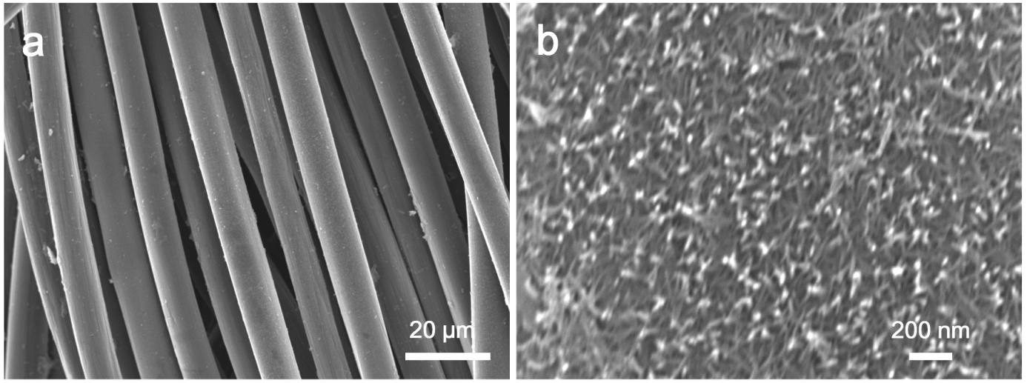

**Figure S1.** SEM images of KMO seed crystal at different magnification.

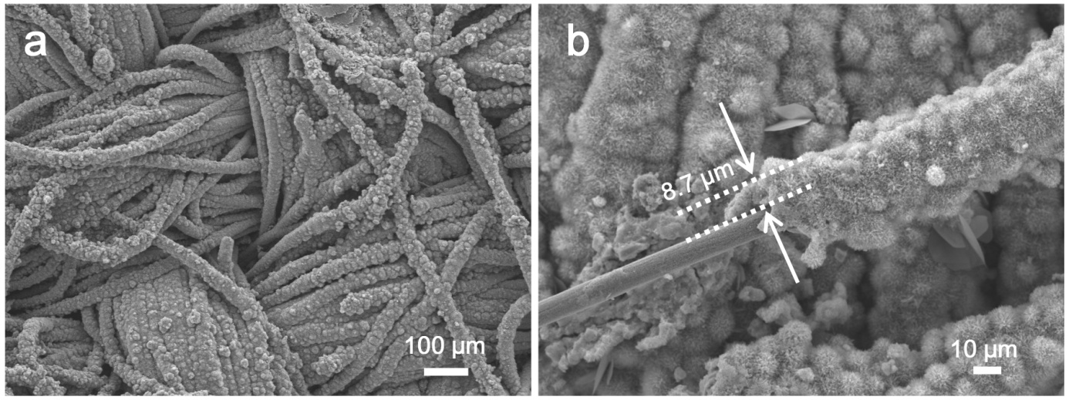

**Figure S2.** SEM images of KMO nanowires at different magnification.

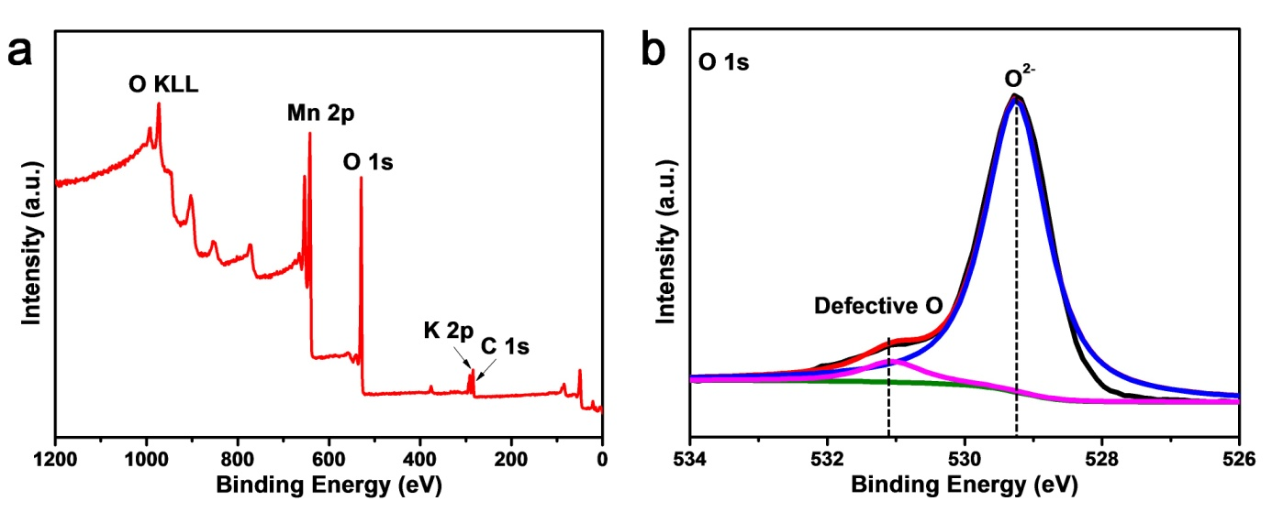

**Figure S3.** XPS spectra of KMO nanowires: (a) survey spectra, (b) O1s.

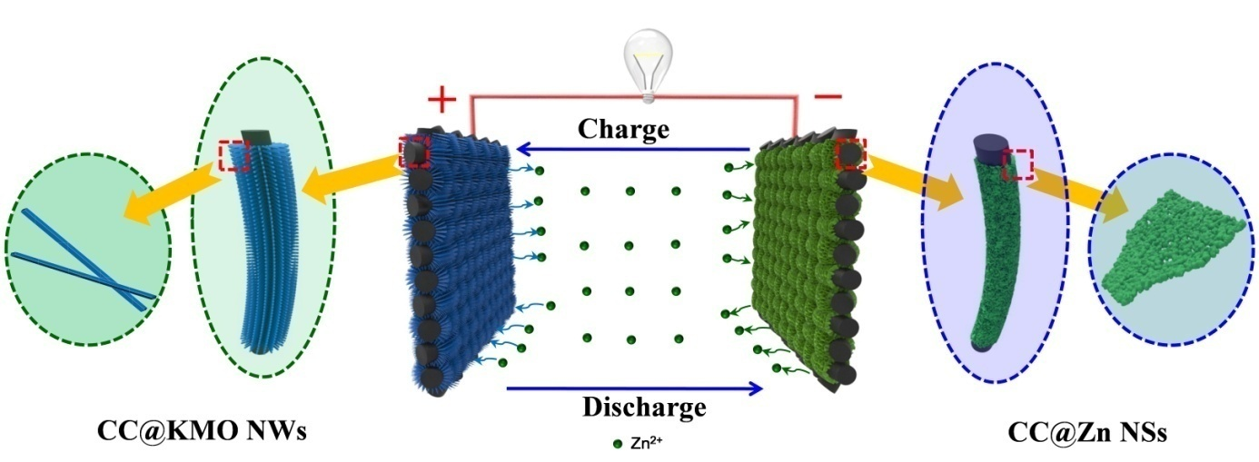

Figure S4. Schematic illustration of the Zn//KMO full battery using the 3D CC@KMO cathode and CC@Zn NSs anode.

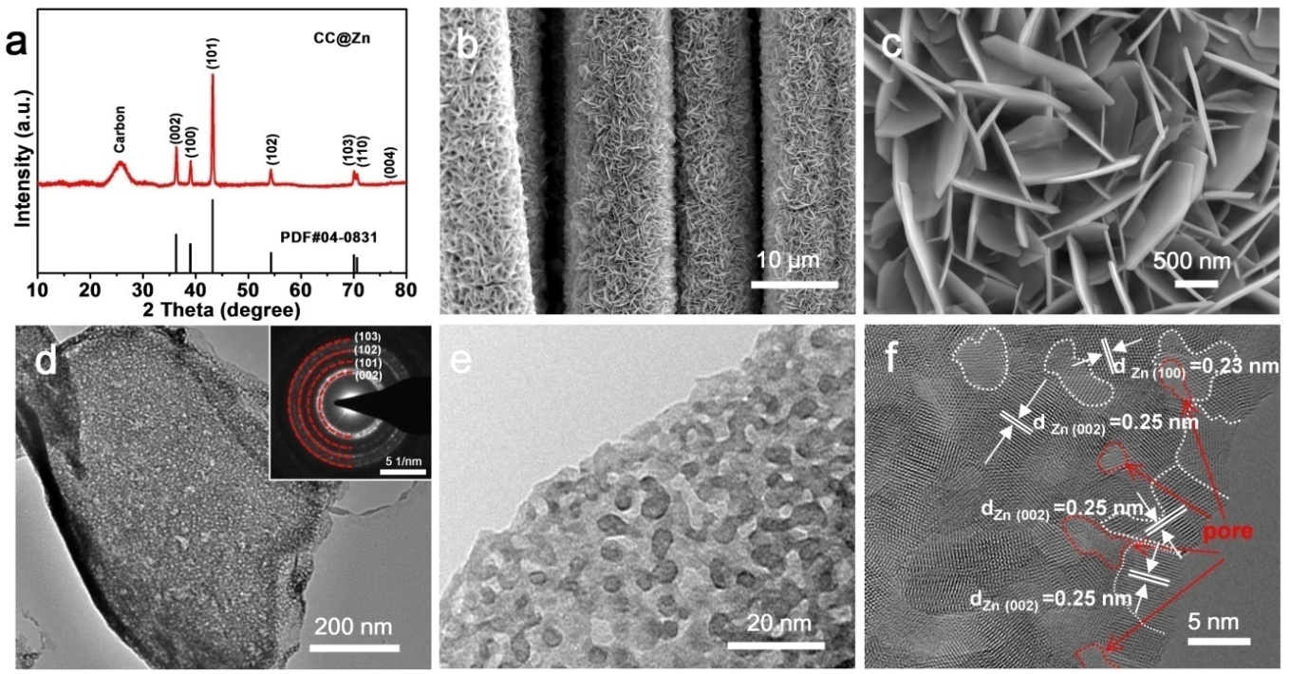

**Figure S5.** (a) XRD patterns of the CC@Zn nanosheets. (b, c) SEM images of the CC@Zn nanosheets array at different magnification. (d, e) TEM, (f) HRTEM of the Zn nanosheet. The insets in panel (d) are the SAED pattern.

Figure S5a shows the XRD patterns of the as-prepared Zn NSs. Except for the diffraction peaks from CC, all other diffraction peaks can be well indexed to the hexagonal Zn (JCPDS No. 04-0831). Figure S5b, c shows the SEM images of the freestanding Zn NSs (40~60 nm in thickness) grown on CC without any binder. TEM image demonstrates the mesoporous feature of the Zn nanosheet (Figure S5d). The polycrystalline nature of the Zn nanosheet is confirmed from the SAED pattern, as it shows Bragg spots corresponding well with (002), (101), (102) and (103) planes of hexagonal Zn. As show in Figure S5e, TEM image of the Zn nanosheet demonstrates that nanosheet consists of numerous uniformly distributed quantum dots ([size](javascript:;) of about 5 nm). The HRTEM image of the Zn nanosheet is shown in Figure S5f, it can be obvious that there are amorphous pore structures between regular lattice stripes. Furthermore, lattice fringes with interplanar spacing of 0.25 and 0.23 nm, corresponding to the (002) and (100) plane of Zn, respectively. The size range of the quantum dots is approximately 5 nm, which is consistent with the results of Figure S5e.

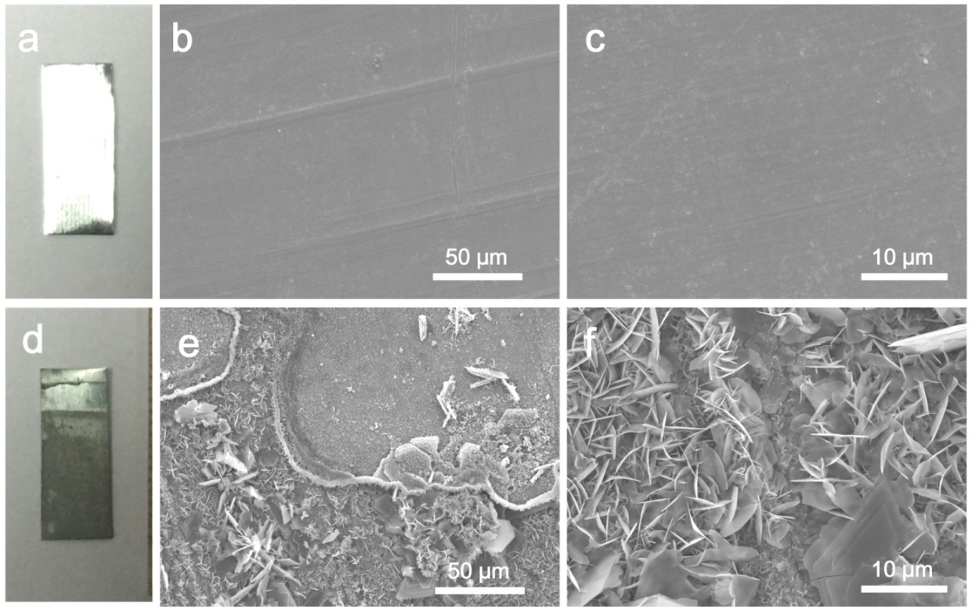

**Figure S6.** (a) Digital photos of the pristine Zn foil. (b, c) SEM images of Zn foil at different magnification. (d) Digital photos of the Zn foil after cycle testing. (e, f) SEM images of Zn foil after cycle testing at different magnification.

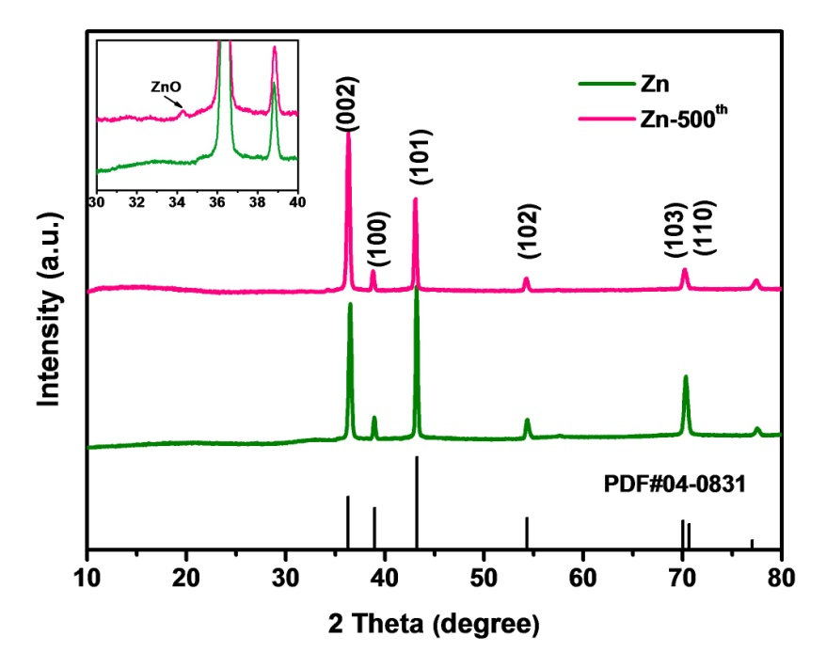

**Figure S7.** XRD patterns of the pristine Zn foil and after cycle testing Zn foil.

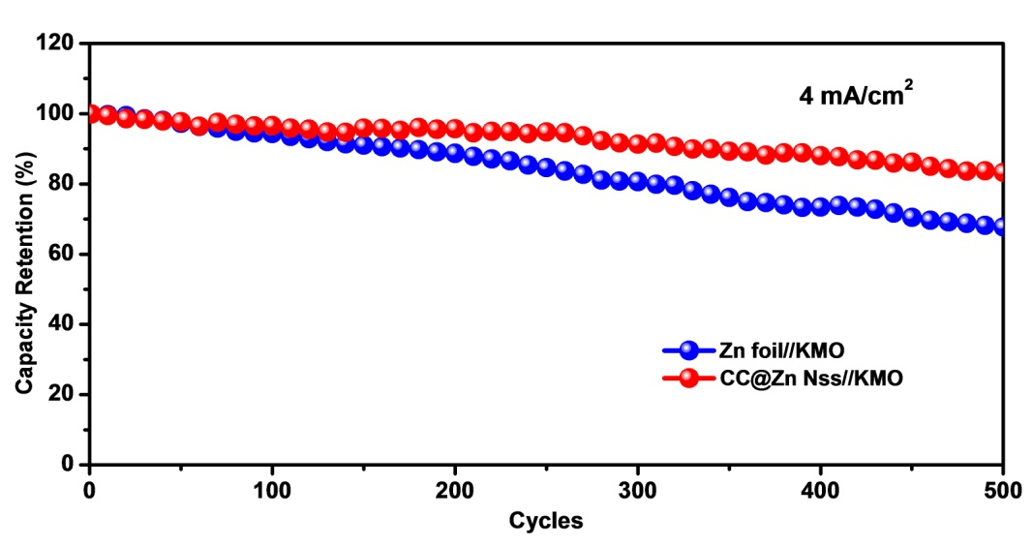

**Figure S8** Cycling performance at 4 mA cm-2 of the aqueous Zn foil//KMO and CC@Zn NSs//KMO batteries.**.**

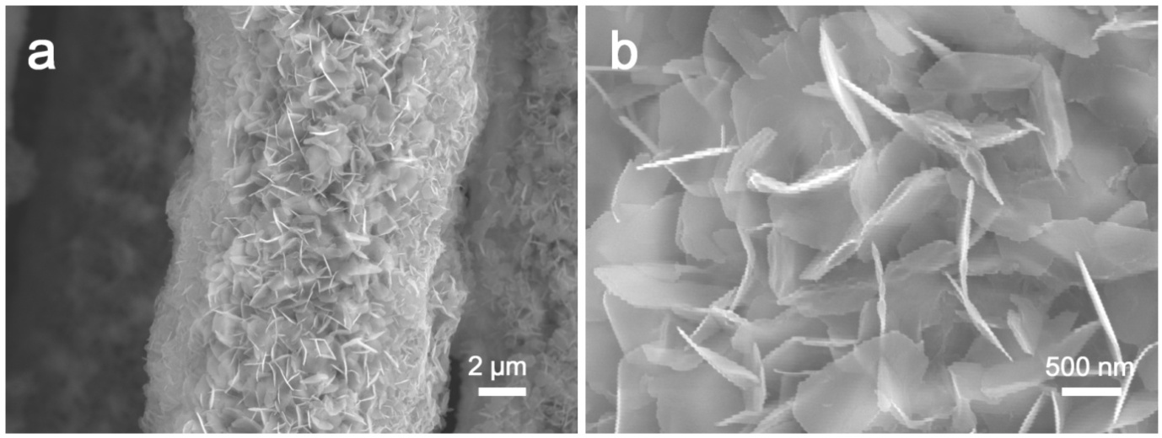

**Figure S9.** SEM images of CC@Zn NSs after cycle testing at different magnification.

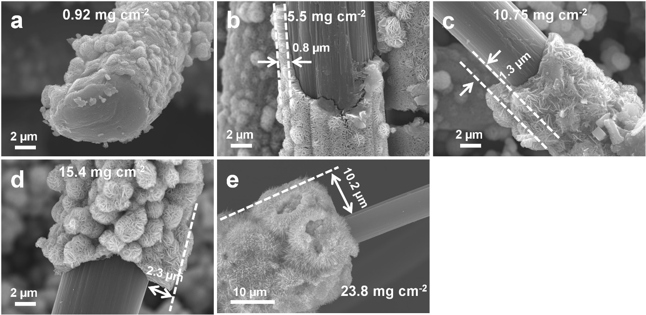

**Figure S10.** SEM images of KMO electrode at (a) 0.92, (b) 5.5, (c) 10.75, (d) 15.4, and (e) 23.8 mg cm-2 mass loading.

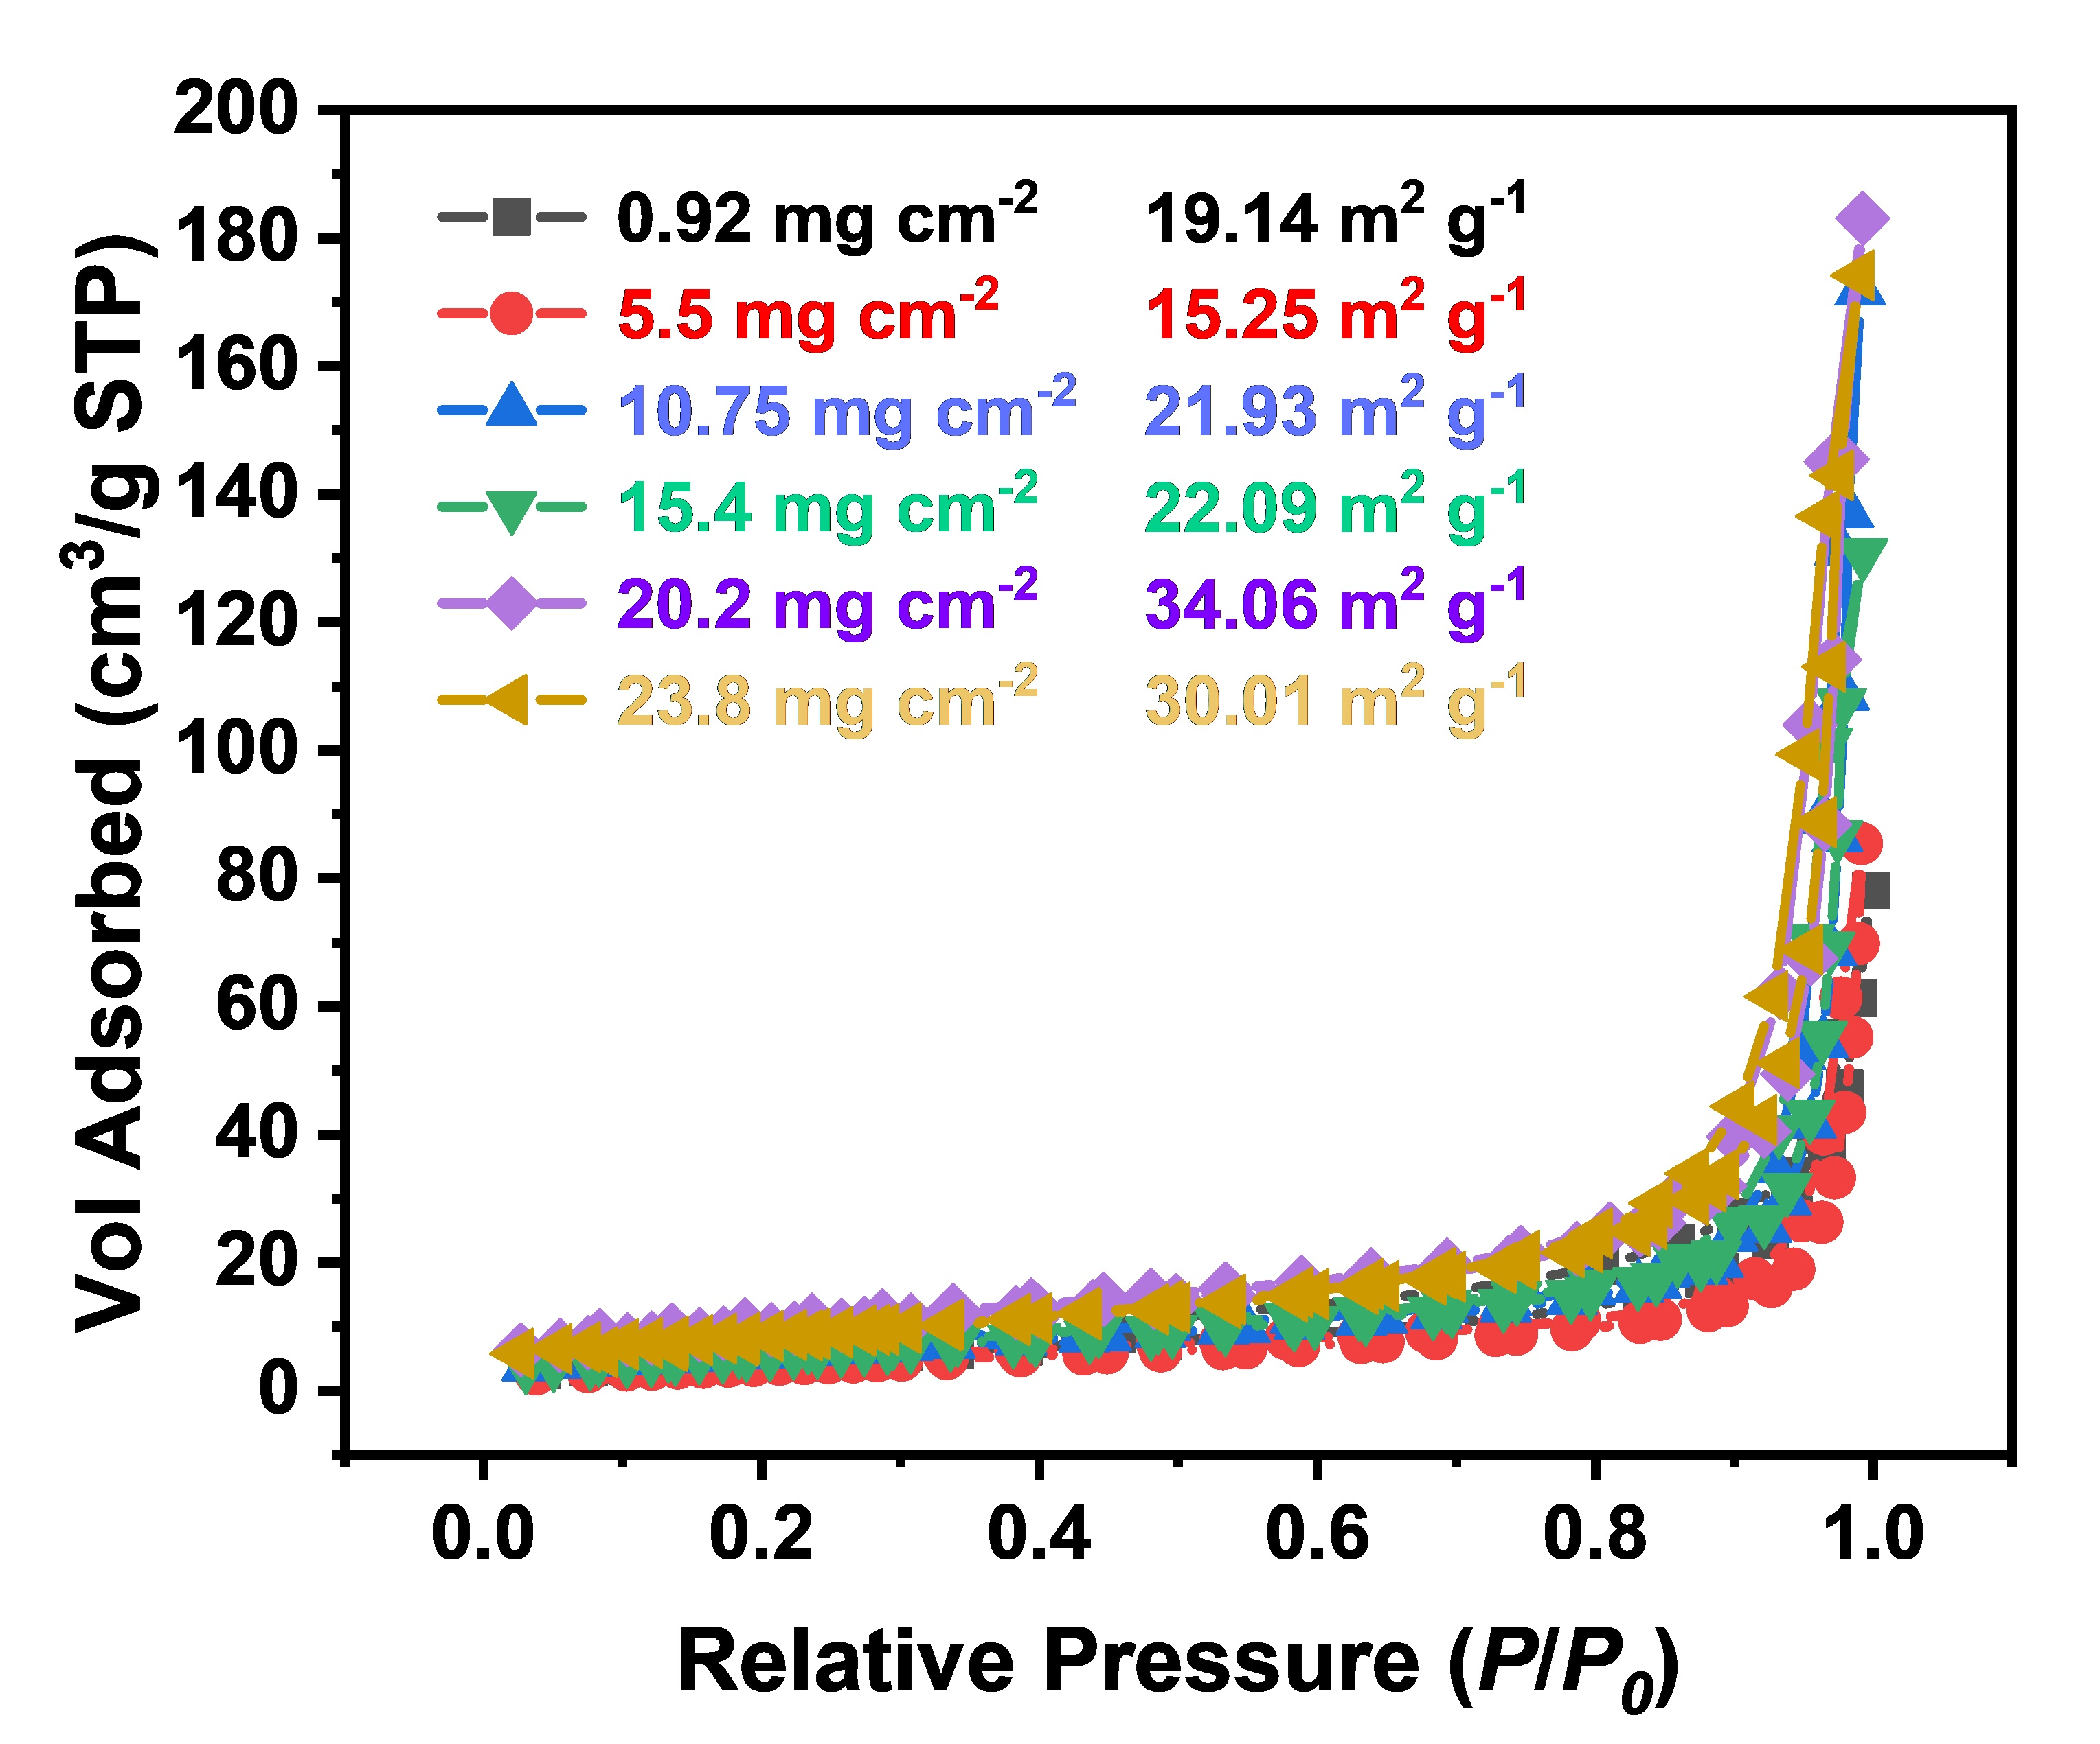

**Figure S11.** Nitrogen adsorption isotherms (at 77 K) of the KMO cathodes with different mass loading.

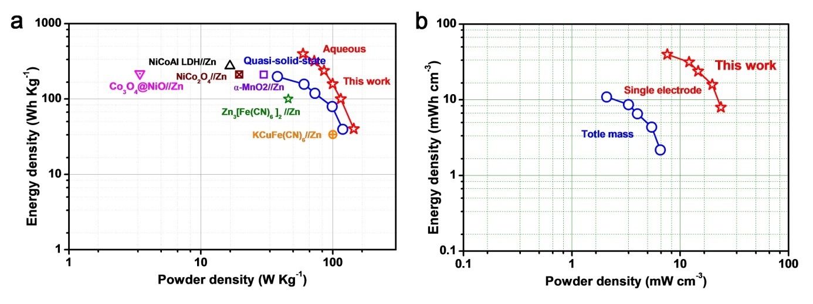

**Figure S12.** (a) Ragone plots for our QSS device and other recently reported aqueous batteries. (b) Ragone plots for our QSS device at different algorithms.

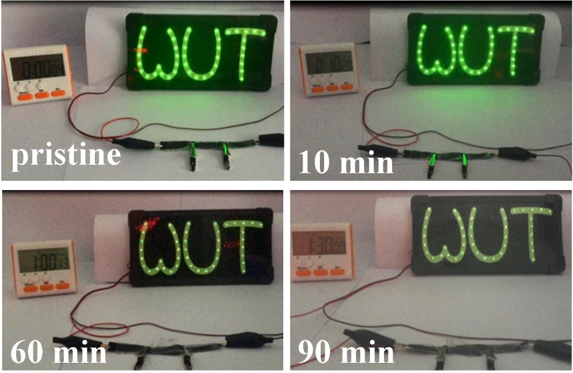

**Figure S13.** Photographs of 42 light-emitting diodes (LEDs) powered by three QSS Zn//KMO battery in series.

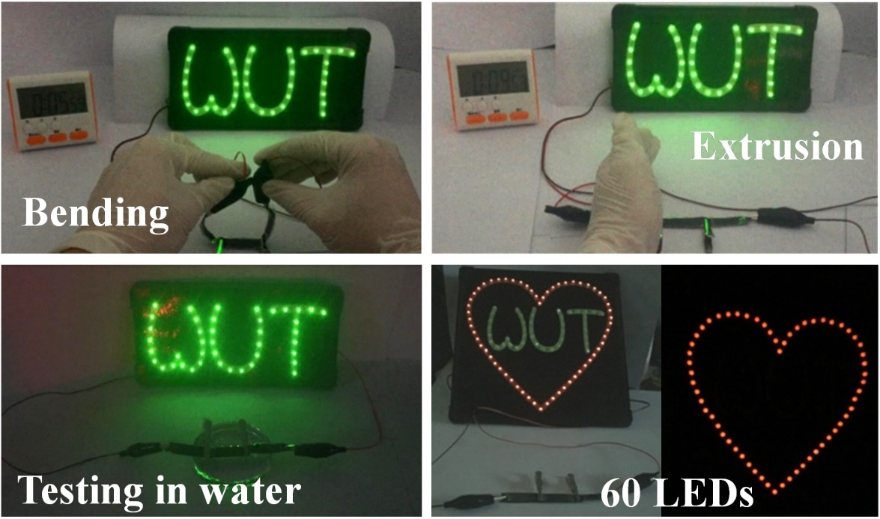

**Figure S14.** Photograph of LEDs powered by QSS Zn//KMO batteries under different environments.