Supporting Information

**Anchoring Ultralow Platinum by Harnessing Atomic Defects Derived from Self-reconstruction for Alkaline Hydrogen Evolution Reaction**

*Hancheng Ma****1, #****, Wei Peng****1, #****, Hoilun Wong****3, #****, Xuyun Guo****4****, Lin Xu****2****, Mohsen Tamtaji3, Yao Ding****1, \****

**1**School of Materials Science and Engineering, Wuhan University of Technology, Wuhan 430070, PR China.

**2**State Key Laboratory of Advanced Technology for Materials Synthesis and Processing, Wuhan University of Technology, Wuhan 430070, PR China.

**3**Department of Chemical and Biological Engineering and William Mong Institute of Nano Science and Technology, Hong Kong University of Science and Technology, Clear Water Bay, Kowloon, Hong Kong.

**4**School of Chemistry, Centre for Research on Adaptive Nanostructures and Nanodevices and Advanced Materials Bio-Engineering Research Centre, Trinity College Dublin, Dublin, D02PN40 Ireland.

\***Corresponding authors**

E-mail addresses: ydingaf@whut.edu.cn (Y. Ding)

**#**These authors contributed equally to this work.

**Keywords:** Ultralow Platinum, Self-reconstruction, NiMoO4, Atomic utilization, Hydrogen evolution reaction

***1. Experimental Methods***

*1.1 Synthesis of NiMoO4@NF:*

It has been reported plenty of methods for synthesis of the NiMoO4.[1] To begin with, small pieces of nickel foam (NF) (2.5×5.0 cm2) cut from the purchased sheets were ultrasonicated for 10 min in each of, in order, an aqueous solution (3.0 M HCl), isopropyl alcohol, and ultrapure water. Separately, a mixture of Ni(NO3)2-6H2O (0.3 mmol) and Na2MoO4-2H2O (0.3 mmol) was dissolved in ultrapure water (50 mL), and was transferred into a 100 mL Teflon-lined stainless-steel autoclave, in which the as-prepared NF was vertically immersed into the solution. The vessel was then heated for 6 h at a temperature of 180 ℃. After the autoclave was left to cool down, the NiMoO4@NF on which the product had adhered and grown was collected.

*1.2 Reconstruction of NiMoO4@NF:*

NiMoO4@NF was placed under a three-electrode system as a working electrode, a mercury oxide electrode was used as a reference electrode and a graphite rod was used as a counter electrode. Chronopotentiometry technology was obtained to keep the NiMoO4@NF at a current density of 40 mA cm-2 continuous OER for 0 h, 8 h and 24 h, respectively.

*1.3 Synthesis of Pt SAs-Ni4Mo/Ni@NF and Ni4Mo/Ni@NF:*

Soak NiMoO4@NF with varying degrees of reconstruction in 40 mL acetone solution, different amounts of Pt acetylacetonate (0.5, 1, 2, 4 mg, respectively) are added to control the concentration of Pt in the solution. After soaking and stirring for one day, remove and wash the organic matter on the surface of NiMoO4@NF with ultrapure water, and put it into a tube furnace with the atmosphere of N2: H2=5:1 for annealing (temperature racing speed of 25 ℃/min, and annealing at 425 ℃ for 1 h). Wait until the samples has cooled and remove to get Pt SAs-Ni4Mo/Ni@NF. To control for a single variable, a NiMoO4@NF that is not soaked in Pt solution is annealed under the same conditions to obtain Ni4Mo/Ni@NF.

*1.4 Obtainment of Pt SAs-Ni4Mo/Ni, Ni4Mo/Ni, R-NiMoO4 and NiMoO4:*

All the products obtained by the above methods are sonicated from Ni foam and dried in the vacuum oven.

*1.5 Obtainment of Pt/C@NF*

The Pt/C used in electrochemical tests is obtained by weighing equal amounts of NF and Pt SAs-Ni4Mo/Ni@NF, and calculating the difference weight between the two. Weighing equal weight of Pt/C and preparing it as ink for spraying on the NF yields Pt/C@NF.

***2. Characterizations***

The properties of the samples were characterized by a Bruker D8 Discover X-ray diffractometer (XRD) equipped with a Cu Kα radiation source and Raman spectra were carried out by using a HORIBA HR EVO Raman system with a 532 nm laser. Transmission electron microscopy (TEM), high-angle annular dark-field scanning transmission electron microscopy (HAADF-STEM) images, high-resolution TEM (HRTEM) images, the selected area electron diffraction (SAED) patterns, and EDS mapping were conducted with Talos F200S and Themis Z (3.2) operating at 200 KV. SEM images were carried out by a JEOL-7100F scanning electron microscope. X-ray photoelectron spectroscopy (XPS) was performed using ESCALAB 250Xi. X-ray absorption fine structure spectra (XAFS) was taken in Shanghai Synchrotron Radiation Facility (SSRF) and the energy was calibrated by the absorption edge of Pt foil. The XAFS of Pt foil, PtO2 and Pt-Ni4Mo/Ni samples were output under transmission mode and the data fitting were conducted by using Athena and Artemis codes. The individual element content of the samples was measured by a PerkinElmer ICP 2100 (ICP-MS).

*XRD measurement*: The PDF cards are all relevant to the **Figure 2a**.

|  |  |
| --- | --- |
| Chemical formula | Reference code |
| MoNi4 | 03-065-5480 |
| Ni | 00-004-0850 |
| NiMoO4 | 00-031-0902 |
| Ni(OH)2 | 00-003-0177 |

***3. Electrochemical measurements***

The electrochemical measurements were performed on the CHI760E electrochemical workstation with a standard three-electrode system at room temperature (25 ℃). A platinum electrode holder, a carbon rod and a Hg-HgO electrode were used as the working, counter and reference electrodes, respectively. The electrolyte was made of 1 M KOH solution saturated by Argon.Subsequently, the nickel foam cut size was 1×1 cm2 and clamped directly with the working electrode clamp so that the area immersed in the electrolyte was maintained at 1×0.5 cm2.

The LSV curves were collected at a sweep rate as 5.0 mV s-1 with 70% of ohmic drop compensation. The electrolyte of the calomel electrode was filled with saturated potassium chloride solution and replaced weekly. EIS measurements were conducted at an overpotential as 10 mV in the frequency range from 0.01 to 105 Hz with an amplitude of 5 mV. The chronograph potentiometer parameter test was set to be tested at a current density (*j*) of 10 mA cm-2 for over 100 h. Samples after stability testing were collected by sonication. The polarization curves were corrected by iR compensation. The correction was performed according to **Equation S1**:

Ecorrected = Emeasured - iRs **Equation S1**

The Ecorrected, Emeasured, i and Rs are the iR-corrected potential, the measured potential versus RHE, the current, and the internal resistance acquired by the EIS, respectively.

*Tafel slope analysis*:The overpotential values were defined by **Equation S2**, where η was the applied overpotential, *j* was the current density, the Tafel slope (b) can be obtained.

η = a + blog |*j*| **Equation S2**

*ECSA calculations*: The electrochemical double layer capacitance (Cdl) was determined with typical cyclic voltammetry (CV) measurements at various scan rates (40, 60, 80, 100 and 120 mV s-1) in nonreactive region, the voltage range of cycle-voltage measurements to determine double layer capacitance (Cdl) for HER was -0.02 ~ -0.12 V (vs. RHE). The electrochemical surface area (ECSA) of each sample can be evaluated from the double-layer capacitance (Cdl) according to **Equation S3**:

ECSA = $\frac{ \text{C}\text{dl} }{\text{Cs}}$**Equation S3**

Where Cs is the specific capacitance of the sample or the capacitance of an atomically smooth planar surface of the material per unit are under the same condition. In our estimates of ECSA, we take the general value of 80 μF cm-2 for Cs.

***4. EXAFS measurement***

The R factor, goodness of fit. Ѕ02 was set to be 1.6, accordingto the experimental EXAFS fit of Pt foil and PtO2 reference by fixing CN as the known crystallographic value. Data range 4.0 ≤ k ≤ 16.0 Å-1, 1.3 ≤ R ≤ 4.0 Å.

***5. Pt mass activity calculation***

To compare the Pt mass activities of Pt SAs-Ni4Mo/Ni and Pt/C, their activity values have been normalized to their Pt loadings, and the contributions of the Ni4Mo and NF have been deducted. The details are as follows: As shown in Figure 3a, the HER activities for NF, Ni4Mo/Ni, Pt SAs-Ni4Mo/Ni and Pt/C are 0.85, 4.6, 13.7 and 5.7 mA/cm-2, respectively, at the overpotential of 30 mV. The mass of the catalyst loaded on the NF before and after weighing is obtained by weighing the NF and the NF loaded with the catalyst. The Pt loading of Pt SAs-Ni4Mo/Ni was determined by ICP-OES to be 0.3 wt.% thus 1.02 μg cm-2. The Pt loading of 20 wt.% commercial Pt/C was 64 μg cm-2. Because all the samples were supported by NF in the measurements, the Pt mass activities of Pt/C and Pt SAs- Ni4Mo/Ni can be calculated using the **Equation S4** and **S5** to be 0.075 and 8.67 A mg-1, respectively.

*j* = = = 0.076 A mg-1 **Equation S4**

*j* = = = 8.92 A mg-1  **Equation S5**

***6. Details for DFT calculations***

The DFT calculations were conducted using Vienna ab initio simulation package (VASP) code[2], with the vdW-DF2 functional. General gradient approximation (GGA) exchange correlation functional of Perdew-Burke-Ernzerhof (PBE) was used to describe the exchange correlation, while projector augment wave (PAW) pseudopotential was used to describe the ion-electron interactions.[3] The cut-off energy of plane waves was 500 eV throughout the whole calculation with Gaussian smearing of 0.05 eV. The convergence criteria for electron self-consistent loop was 10-6 and Hellman–Feynman forces were required to be less than 0.02 eV Å-1. The K-points were 5x5x1 for both structure relaxation and free energy calculations. The (211) surface of four layer Ni4Mo slab with two bottom layer fixed was chosen as the study interface for the energy calculations with the cell dimension of 8.76 x 6.68 x 20 Å. For Pt-NixMo, one Mo defect was substituted by a Pt atom with the same cell dimension as Ni­­­4Mo.

*Free energy calculation*: The hydrogen adsorption Gibbs free energy calculation involves a single step pf hydrogen adsorption on the surfaces of Ni4Mo and Pt-NixMo, while the elementary steps for HER in alkaline condition involve (i) water adsorption (H2O*), (ii) water dissociation (OH* + H*) and (iii) hydroxide desorption (OH + H*). The adsorption energy was calculated by $∆G=∆E+∆ZPE-T∆S$, where $∆E$, $∆ZPE$, $T$ and $∆S$ represent binding energy, zero point energy change and temperature and entropy change, respectively.[4]

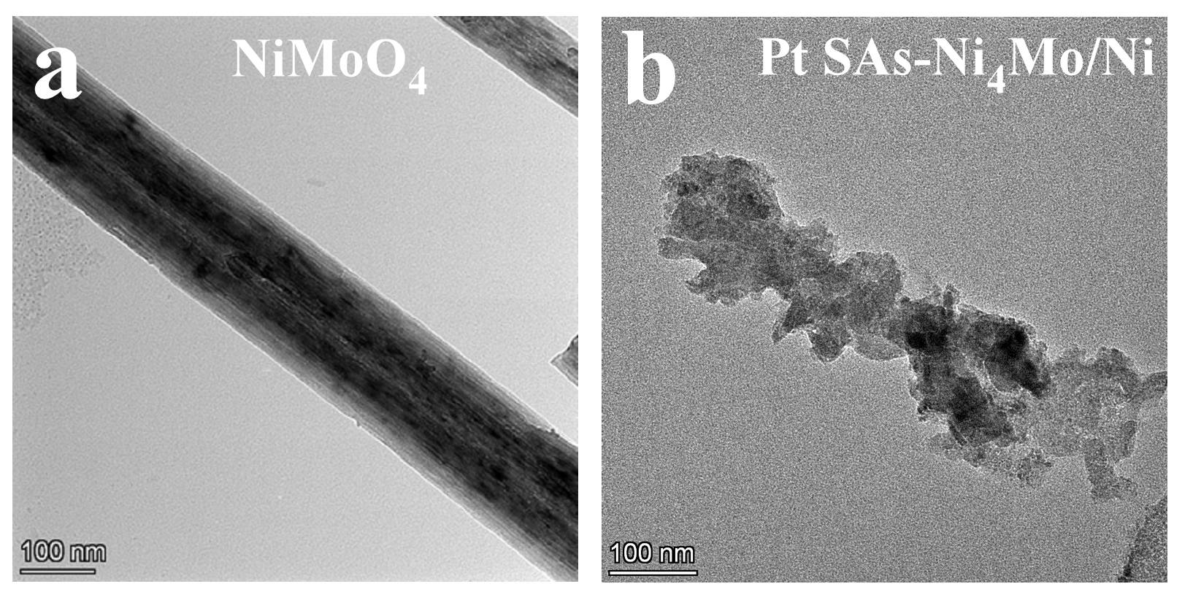

**Figure S1.** TEM image of (a) NiMoO4 and (b) Pt SAs-Ni4Mo/Ni.

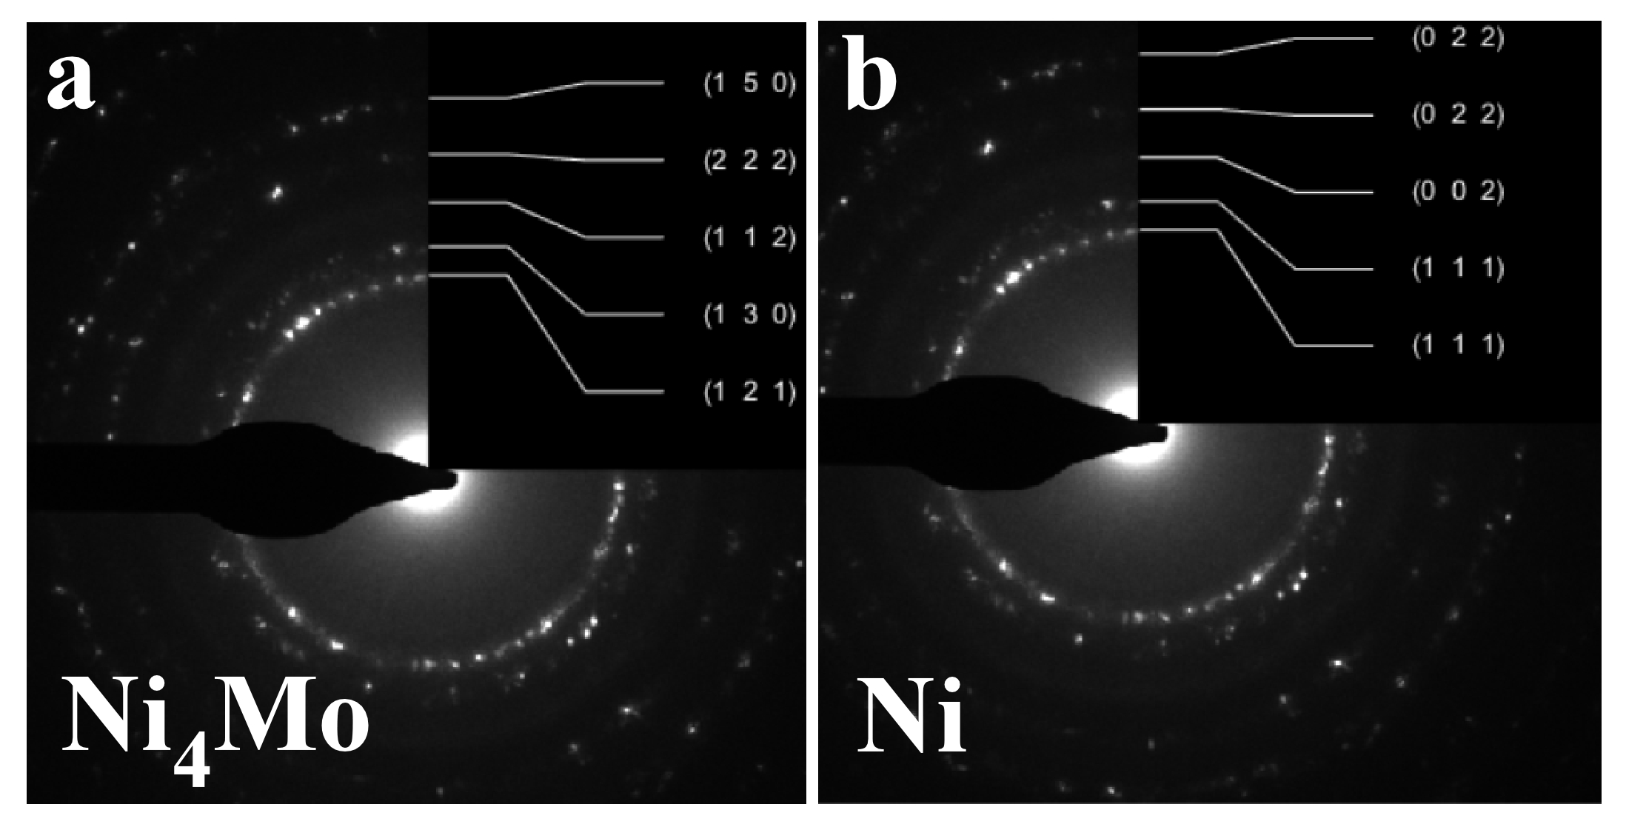

**Figure S2.** The intensity of different polycrystalline rings in simulated of Pt SAs-Ni4Mo/Ni.

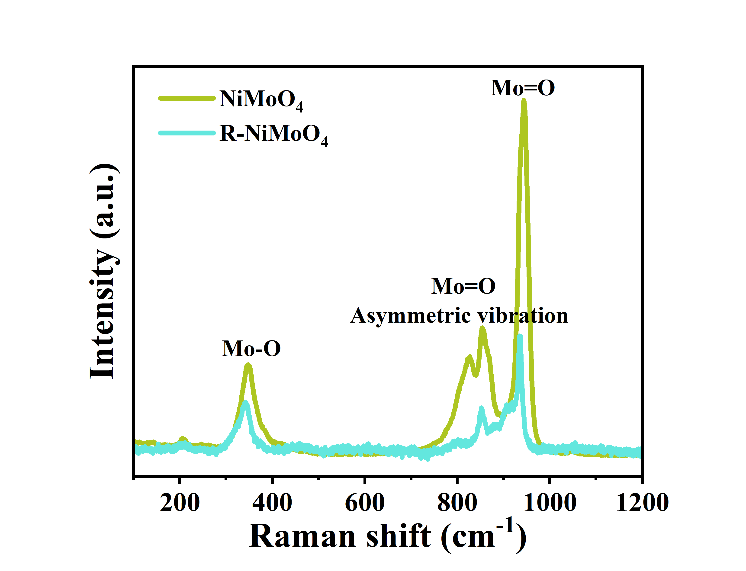

**Figure S3.** Raman test of NiMoO4 and R-NiMoO4 showing the self-reconstruction.[5]

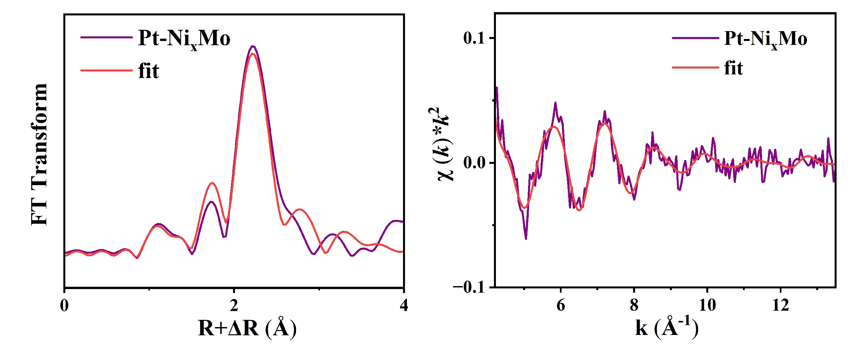

**Figure S4.** XAFS Fitting results of R-space and *k*-space of Pt SAs-Ni4Mo/Ni.

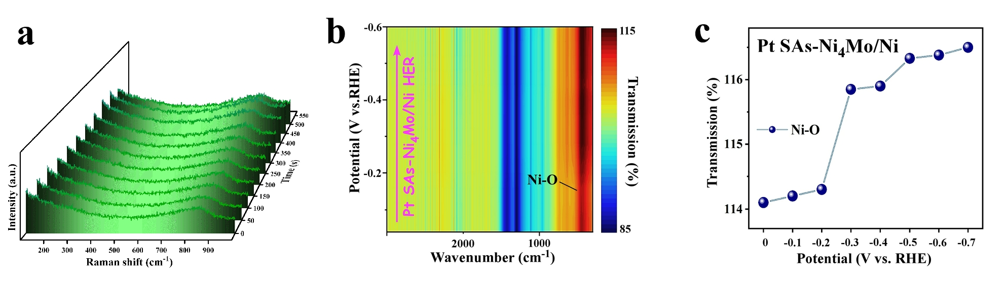

**Figure S5.** (a) *In-situ* Raman spectroscopy of Pt SAs-Ni4Mo/Ni during the HER process showing no obvious changes of Raman peaks. (b-c) *In-situ* FT-IR spectroscopy of Pt SAs-Ni4Mo/Ni during the HER process.

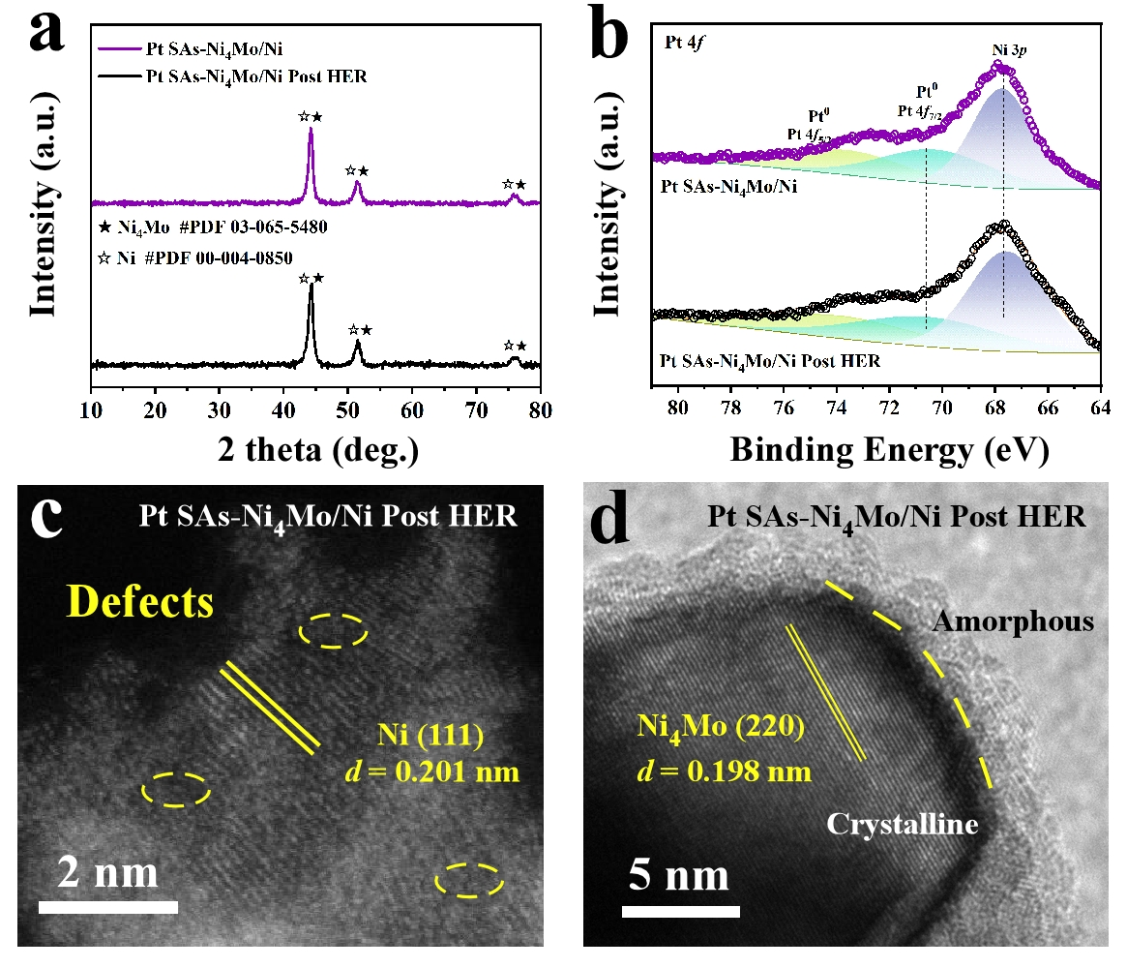

**Figure S6.** (a) XRD and (b) XPS of Pt SAs-Ni4Mo/Ni and Pt SAs-Ni4Mo/Ni Post HER. (c) HAADF-STEM and (d) high-resolution STEM image of Pt SAs-Ni4Mo/Ni and Pt SAs-Ni4Mo/Ni Post HER.

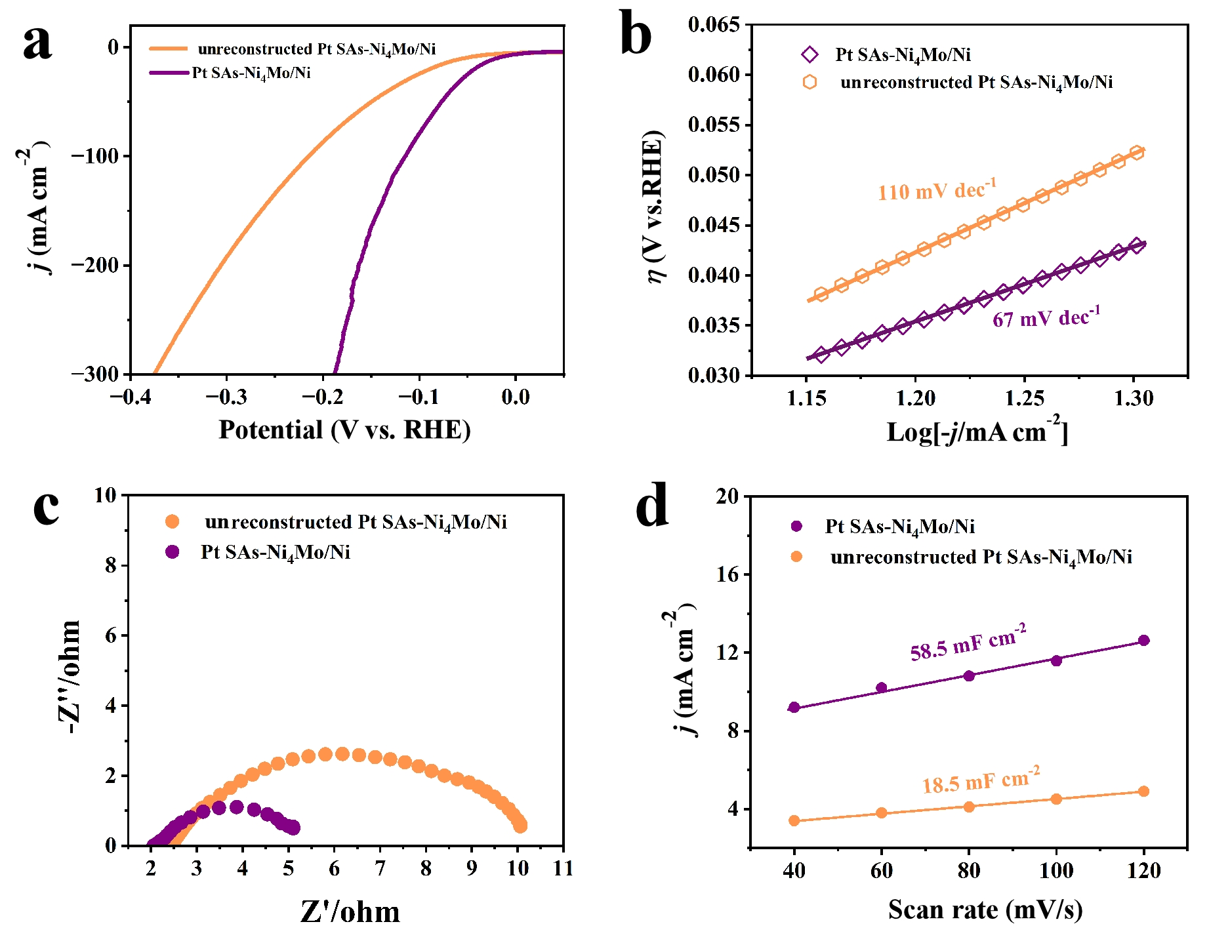

**Figure S7**. **(a)** HER polarization curves and **(b)** corresponding Tafel plots of Pt SAs-Ni4Mo/Ni@NF and unreconstructed Pt SAs-Ni4Mo/Ni@NF in 1 M KOH at a scan rate of 5 mV/s. **(c)** Nyquist plots of Pt SAs-Ni4Mo/Ni@NF and unreconstructed Pt SAs-Ni4Mo/Ni@NF at the same testing potential. **(d)** Extraction of the Cdl for different catalysts.

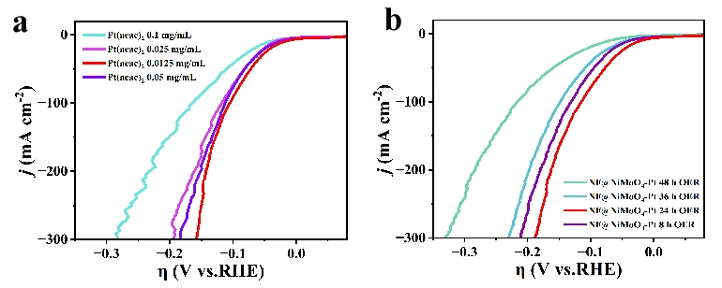

**Figure S8.** (a) Comparison of R-NiMoO4@NF at different immersion times in Pt solution. (b) Comparison of R-NiMoO4@NF at different Self-reconstruction times in Pt solution.

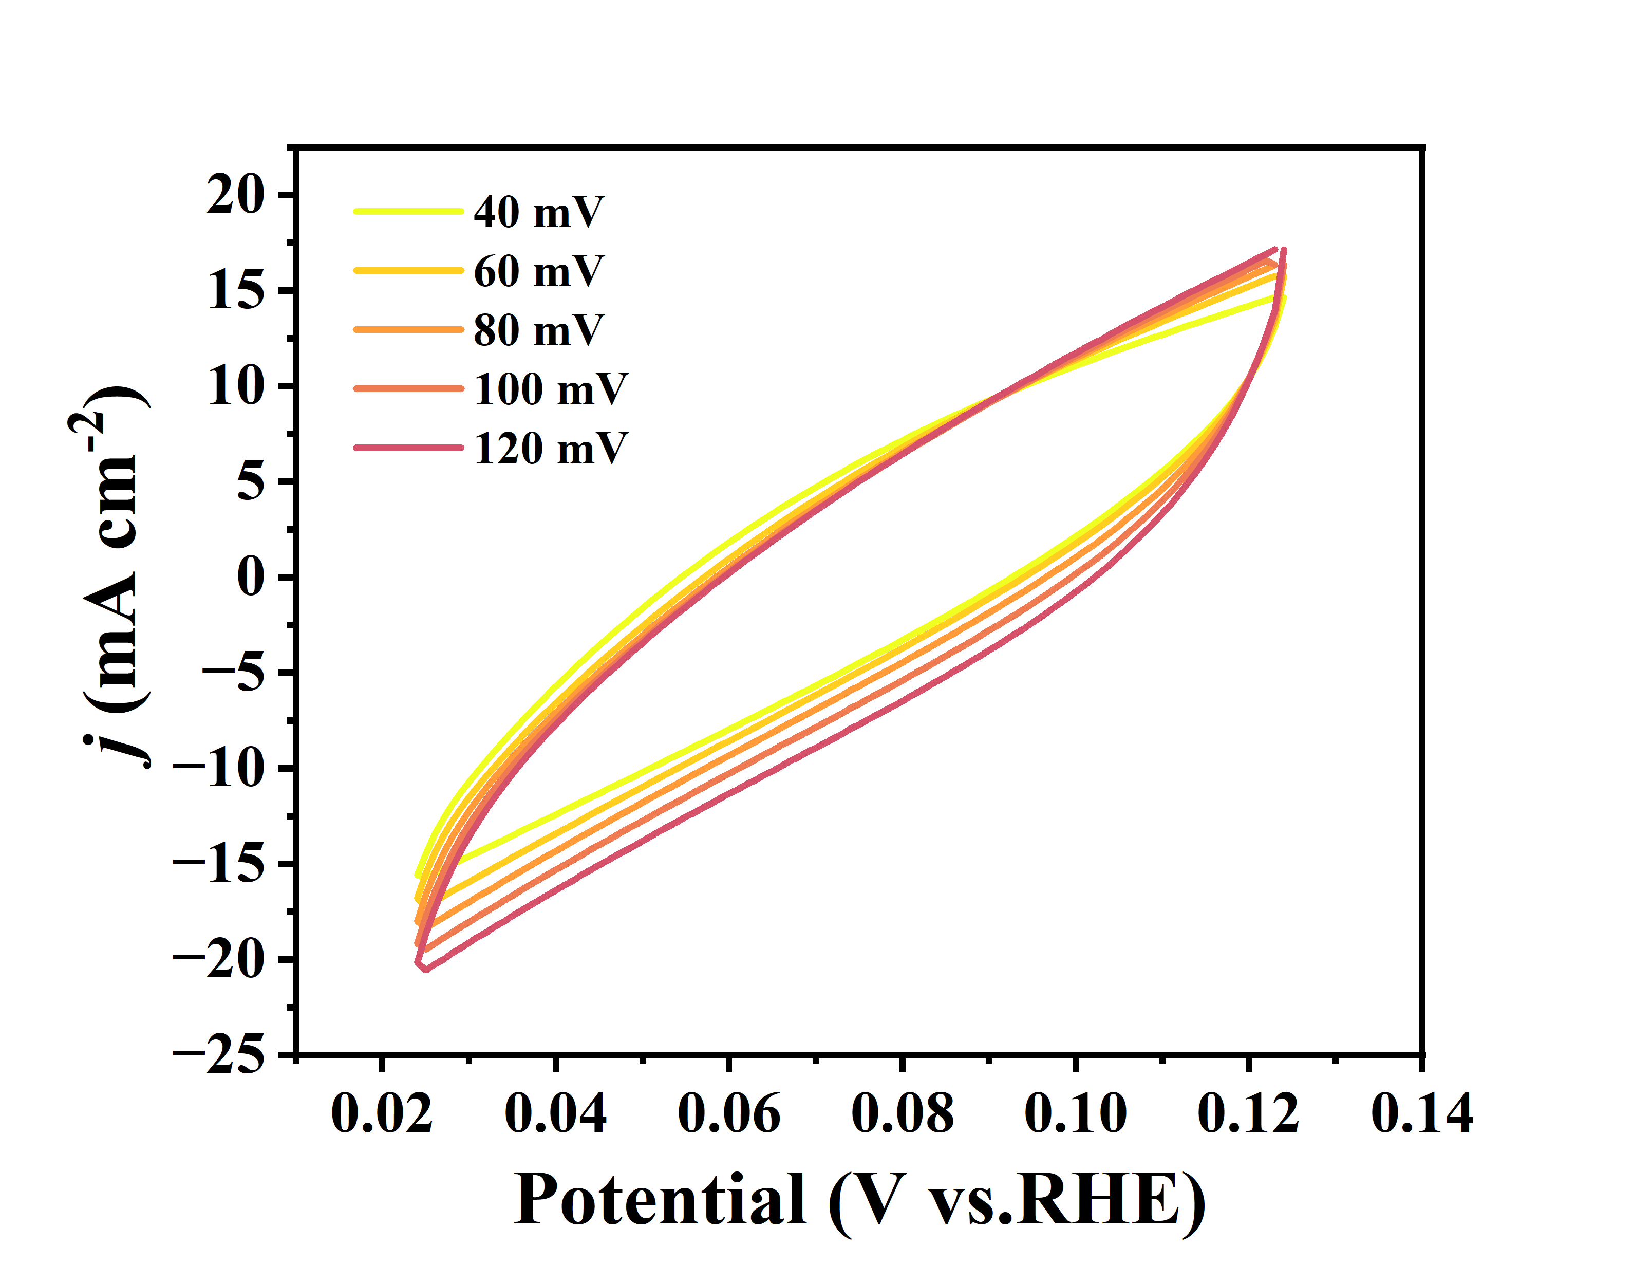

**Figure S9.** **ECSA Performance characterization.** Cyclic voltammetry curves at various scan rates for estimation of Pt of Pt SAs-Ni4Mo/Ni@NF.

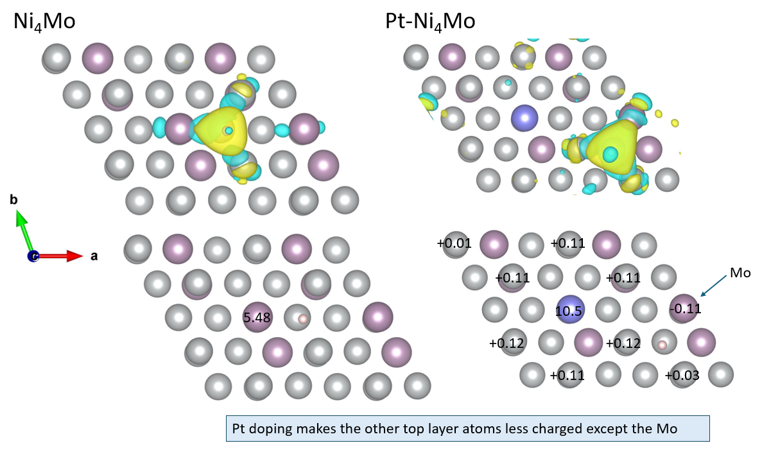

**Figure S10**. The charge difference details between Ni4Mo and Pt SAs-Ni4Mo with H adsorption.

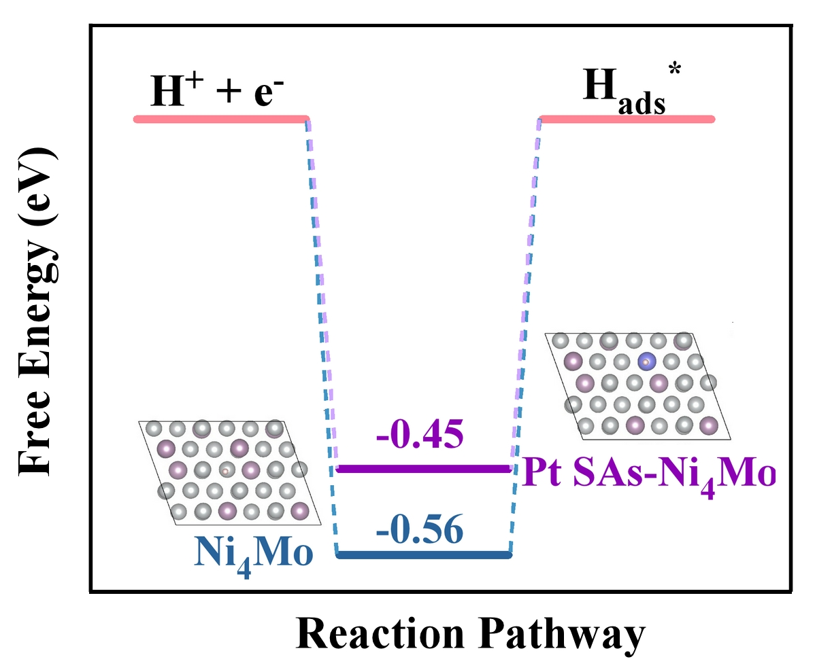

**Figure S11**. Adsorption free energy of hydrogen ad-atom on Ni4Mo and Pt SAs-Ni4Mo.

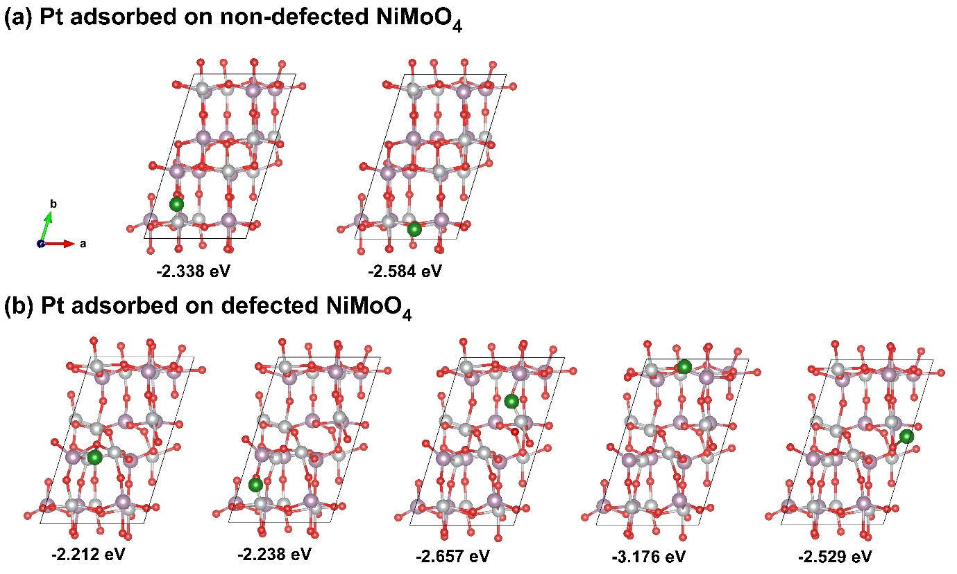

**Figure S12.** Top-view of adsorption configuration of Pt on the surfaces of (a) defected and (b) non-defected NiMoO4.

**Figure S13.** Top and side-view of optimized structure of the (a) non-defected and (b) defected NiMoO4.

**Table S1. ICP-OES results showing the molar ratio in the Pt SAs-Ni4Mo/Ni for different reconstruction time.**

|  |  |  |  |
| --- | --- | --- | --- |
| Sample | W (%) | | |
| Mo | Ni | Pt |
| 0 h | 27% | 28.5% | 0.01% |
| 8 h | 21% | 49% | 0.044% |
| 24 h | 8.92% | 43.96% | 0.3% |
| 24 h (post HER) | 8.52% | 41.75% | 0.25% |

**Table S2. Comparison of HER performance of reported Pt based catalysts in 1 M KOH**

|  |  |  |  |  |  |
| --- | --- | --- | --- | --- | --- |
| Catalyst | Pt Loading (wt. %) | *j* (A/mgPt)@30 mV | η (mV)@10 mA cm-2 | Tafel slope (mV dec-1) | Ref. |
| Pt SAs-Ni4Mo/Ni | 0.3 % | 8.92 | 17 | 67 | This work |
| Ni4Mo/Ni | - | - | 68 | 112 | This work |
| NiMoO4 | - | - | 214 | 167 | This work |
| Pt/C | 20 % | 0.076 | 48 | 122 | This work |
| Pt-V2CTx | 0.88 % | 7.88 | 68.1 | 98.6 | *Applied Catalysis B: Environmental* **2022**[6] |
| Ni3Fe-CO32-- LDH-Pt | 9.7 % | 0.625 | 45 | 37.8 | *Energy & Environmental Science* **2021**[7] |
| Ptsa-Mn3O4 | 1.58 % | 0.374 | 24 | 54 | *Energy & Environmental Science* **2022**[8] |
| WOx-PtNi@Pt DNWs/C | 58 % | 3.3 | 24 | 60 | *Advanced Energy Materials* **2020**[9] |
| Pt@TiO2 | 7 % | 0.032 | 70 | 73 | *Materials Today Chemistry* **2023**[10] |
| Ptsa-Co(OH)2@Ag NW | 2.8 % | 1.6 | 29 | 35.7 | *Energy & Environmental Science* **2020**[11] |
| PtNi-NC-900 | 6.68 % | 35 | 37 | 43 | *Journal of Materials Chemistry A* ***2020*** [12] |
| BC3N@Pt | 6 % | 2.5 | 23 | 41 | *Journal of Materials Chemistry A* ***2021***[13] |
| Au-Pd-Pt | 33 % | 0.3 | 30 | 55 | *Advanced Energy Materials* **2020**[14] |
| Pt-Ni NTAs | 0.6 % | 4.27 | 23 | 38 | *Energy & Environmental Science* **2021**[15] |

|  |  |  |  |
| --- | --- | --- | --- |
| **Species** | **ZPE (eV)** | $$T×S \left(eV\right)(298.15 K)$$ | **Δ (ZPE – TS) (eV)** |
| **H\*** | 0.17 | 0.00 | 0.24 |
| **H2O\*** | 0.64 | 0.16 | 0.50 |
| **H* + OH\*** | 0.53 | 0.09 | 0.45 |
| **H2** | 0.27 | 0.41 | - |
| **H2O** | 0.57 | 0.58 | - |

**Table S3. Details for different steps during HER.**

**References**

[1] X. Deng, J. Chen, C. Zhang, Y. Yan, B. Wu, J. Zhang, G. Wang, R. Wang, J. Chen, *J. Colloid Interface Sci.* **2023**, 640, 928.

[2] a) J. F. G. Kresse, *Phys. Rev. B* **1996**, 54, 11169; b) J. F. G. Kresse, *Comput. Mater. Sci.* **1996**, 6, 15; c) P. H. a. W. Kohn, *Phys. Rev.* **1964**, 136, 864.

[3] a) D. J. G. Kresse, *Phys. Rev. B* **1999**, 59, 1758; b) P.E.Blöchl, *Phys. Rev. B* **1994**, 50, 17953.

[4] Y. Zhao, X. Wang, G. Cheng, W. Luo, *ACS Catal.* **2020**, 10, 11751.

[5] R. N. Durr, P. Maltoni, H. Tian, B. Jousselme, L. Hammarstrom, T. Edvinsson, *ACS Nano* **2021**, 15, 13504.

[6] S. Park, Y.-L. Lee, Y. Yoon, S. Y. Park, S. Yim, W. Song, S. Myung, K.-S. Lee, H. Chang, S. S. Lee, K.-S. An, *Appl. Catal., B* **2022**, 304, 120989.

[7] W. Chen, B. Wu, Y. Wang, W. Zhou, Y. Li, T. Liu, C. Xie, L. Xu, S. Du, M. Song, D. Wang, Y. liu, Y. Li, J. Liu, Y. Zou, R. Chen, C. Chen, J. Zheng, Y. Li, J. Chen, S. Wang, *Energy Environ. Sci.* **2021**, 14, 6428.

[8] J. Wei, K. Xiao, Y. Chen, X.-P. Guo, B. Huang, Z.-Q. Liu, *Energy Environ. Sci.* **2022**, 15, 4592.

[9] W. Zhang, B. Huang, K. Wang, W. Yang, F. Lv, N. Li, Y. Chao, P. Zhou, Y. Yang, Y. Li, J. Zhou, W. Zhang, Y. Du, D. Su, S. Guo, *Adv. Energy Mater.* **2020**, 11, 2003192.

[10] S. Cho, G. Yim, J. Koh, H. Jang, J. T. Park, *Mater. Today Chem.* **2023**, 32, 101644.

[11] K. L. Zhou, C. Wang, Z. Wang, C. B. Han, Q. Zhang, X. Ke, J. Liu, H. Wang, *Energy Environ. Sci.* **2020**, 13, 3082.

[12] J. Guo, J. Liu, X. Zhang, X. Guan, M. Zeng, J. Shen, J. Zou, Q. Chen, T. Wang, D. Qian, *J. Mater. Chem. A* **2022**, 10, 13727.

[13] X. Zhao, M. Zheng, Z. Zhang, Y. Wang, Y. Zhou, X. Zhou, H. Zhang, *J. Mater. Chem. A* **2021**, 9, 16427.

[14] R. Du, W. Jin, R. Hübner, L. Zhou, Y. Hu, A. Eychmüller, *Adv. Energy Mater.* **2020**, 10, 1901945.

[15] A. Nairan, C. Liang, S.-W. Chiang, Y. Wu, P. Zou, U. Khan, W. Liu, F. Kang, S. Guo, J. Wu, C. Yang, *Energy Environ. Sci.* **2021**, 14, 1594.