Supporting Information

Improving Ca-ion storage dynamic and stability by interlayer engineering and Mn-dissolution limitation based on robust MnO₂@PANI hybrid cathode
Chunli Zuoª, Feiyang Chao^{b}, Ming Liª, Yuhang Daiª, Junjun Wangª, Fangyu Xiong ^{a,}*, Yalong Jiang ^{a,}*, Qinyou An^{a,c,}*
ª State Key Laboratory of Advanced Technology for Materials Synthesis and Processing, Wuhan University of Technology, Wuhan, 430070 P. R. China
^{b} Hubei Provincial Key Laboratory of Green Materials for Light Industry School of Materials and Chemical Engineering, Hubei University of Technology, Wuhan, 430068, P.R. China
^{c} Wuhan University of Technology (Xiangyang Demonstration Zone), Xiangyang, 441000, P. R. China *Corresponding Author
E-mail address: xiongfy0624@163.com, jyl504@whut.edu.cn, anqinyou86@whut.edu.cn

Experimental Section
Material Synthesis
Synthesis of the MnO₂: MnO2 was synthesized by a facile hydrothermal method^{[1]}. First, 1.67 mmol KMnO₄ was dissolved in 47 mL deionized water with stirring for 5 min at room temperature. Then, 1 mol KOH was slowly add to the above solution to form a brown solution (marked as A). Next, 3.34 mmol MnCl2∙4H2O was dissolved in 3 mL deionized water to form solution B. After the solution A was cooled to room temperature, solution B was poured into solution A and stirred for 1 h. The mixture solution was transferred into a 100 mL Teflon-lined autoclave and maintained for 48 h in an oven with the temperature of 180 °C. After that, the product was washed with deionized water for 3 times. Finally, the MnO2 was acquired through the freeze-drying.
Synthesis of the PANI: 0.4 mL aniline monomer was dissolved in dichloromethane (40 mL) with stirring for 30 min to form C solution. 0.5 g ammonium persulfate was added into 40 mL of 0.5 M HCl and stirred for 30 min to form solution D. After that, the C and D solution were mixed to obtain an aqueous/organic stratification system with a clear interface. The reaction system was kept at 5 °C for 24 h. Afterward, the product was filtered, washed with deionized water and ethanol, and finally dried at 60 °C for 8 h under vacuum.
Synthesis of the MnO₂-PANI: First, 0.05 g PANI was dispersed in 50 mL N-Methylpyrrolidone (NMP) solution and 0.1 g MnO2 was dispersed in another 50 mL NMP solution. Then, two dispersions were mixed at 40 °C and continuously stirred for 24 h. The obtained product was collected and centrifuged with NMP, ethanol, and 0.1 M HCl for three times, respectively, and finally dried at 60 °C for 8 h under vacuum.
Synthesis of the MoO₃: In a typical synthesis^{[2]}, (NH₄)₆Mo₇O₂₄·4H₂O (1 g) was dissolved in deionized water (30 mL) under vigorous stirring. Then, 5 mL HNO₃ (70%) was slowly added to the above solution and stirred continuously for 1 h to get homogeneous solution. The mixture solution was transferred into a 50 mL Teflon-lined autoclave and maintained for 24 h in an oven with the temperature of 180 °C. The product was washed thrice with anhydrous ethanol and dried at 60 °C under vacuum for 12 h.
Materials Characterizations
The crystal structures of samples were characterized by X-ray diffraction (XRD) (D8 Advance, Bruker AXS GmbH, Karlsruhe, Germany). The morphology was characterized by scanning electron microscope (SEM, JEOL-7100F) and transmission electron microscope (TEM, JEM-2100F). The fourier transform infrared (FTIR) spectra were collected using a Nicolet iS50 FTIR spectrometer. Thermogravimetric analysis (TGA) were performed on a NETZSCH-STA449c/3/G thermoanalyzer within a temperature range of 30-800 °C. X-ray photoelectron spectroscopy (XPS) spectra were carried out on a VG Multi Lab 2000 instrument. Inductively coupled plasma atomic emission spectroscopy (ICP-AES) spectrometer (JY/T015-1996) was used to determine the concentration of K and Mn elements.
Electrochemical Measurement
CR2016 coin cells were assembled in an Ar-filled glove box (<0.1 ppm of H₂O and <0.5 ppm of O₂) with activated carbon (AC) as the anode, glass fiber membrane (GF/A What-man) as the separator and 0.5 M Ca(TFSI)₂/acetonitrile(AN) as the electrolyte. The cathodes were prepared by mixing 60 wt% as-prepared active materials, 30 wt% Ketjen Black and 10 wt% binder (polytetrafluoroethylene, PTFE). The mass loading of cathode is about ~1.5 mg cm⁻². For full batteries, the 0.5 M Ca(TFSI)₂/AN was used as the electrolyte, and MoO₃ anode was pre-cycled for 3 cycles before assembling. The MoO₃ anode with mass load of about 3~4 mg cm⁻² was prepared by mixing 60 wt% as-prepared active materials, 30 wt% Ketjen Black and 10 wt% binder (PTFE). Galvanostatic charge–discharge measurements and galvanostatic intermittent titration technique (GITT) measurements were performed using multi-channel battery test system (CT2001A, LAND, Wuhan, China). According to our previous work, the potential of AC electrodes can be calculated to be approximately 3.023 V vs. Ca/Ca^{2+[3]}. The GITT curves were obtained at the constant current pulse of 50 mA g⁻¹ with pulse and relaxation periods of 15 and 20 min respectively. The water contents of the electrolyte solutions were 64.19 ppm for 0.5 M Ca(TFSI)₂ in acetonitrile (monitored by Karl Fischer). Cyclic voltammetry (CV) and electrochemical impedance spectroscopy (EIS) plots were collected using a VMP3 multichannel electrochemical workstation (Bio-Logic France).
Computational details
All the first-principles calculations are performed under the framework of the density functional theory (DFT), where the codes are implemented in the Vienna ab initio simulation package with the projector augmented plane-wave method^{[4]}. The generalized gradient approximation proposed by Perdew, Burke, and Ernzerhof (PBE) is selected to treat the exchange-correlation potential^{[5]}. The long-range van der Waals interaction is described by the DFT-D3 approach ^{[6]}. The cut-off energy for plane wave is set to 520 eV. The energy criterion is set to 10⁻⁵ eV in iterative solution of the Kohn-Sham equation. A vacuum layer of 12 Å is added perpendicular to avoid the interactions between periodic images. The Brillouin zone was sampled with allowed spacing between k points in 0.2 Å⁻¹, with Γ-centered Monkhorst−Pack k-point grid. All the structures are relaxed until the residual forces on the atoms have declined to less than 0.01 eV/Å. The 3D charge density plot is employed by VESTA software ^{[7]}. The formation energy of Mn vacancy is defined by
,
where is energy of the structure with one Mn vacancy, is the energy of the structure and is the energy of bulk Mn structure. Bader charge analysis is employed to calculate the charge transfer among Ca²⁺ and host structure^{[8]}. The Ca²⁺ migration pathway and energy barrier in MnO₂ (111) are determined by the nudged elastic band (NEB) method ^{[9]}.
kinetic calculation
According to previous reports^{[10]}, the peak current (i) and the sweep rate (v) meet the empirical formula i =av^{b}, where a and b are adjustable parameters. Furthermore, the contributions of diffusion controlled and capacitive process can be determined by the following equation,
i(V) = k₁v + k₂v^{1/2} (1)
where i is the current (A g⁻¹), v is the scan rate (mV s⁻¹).

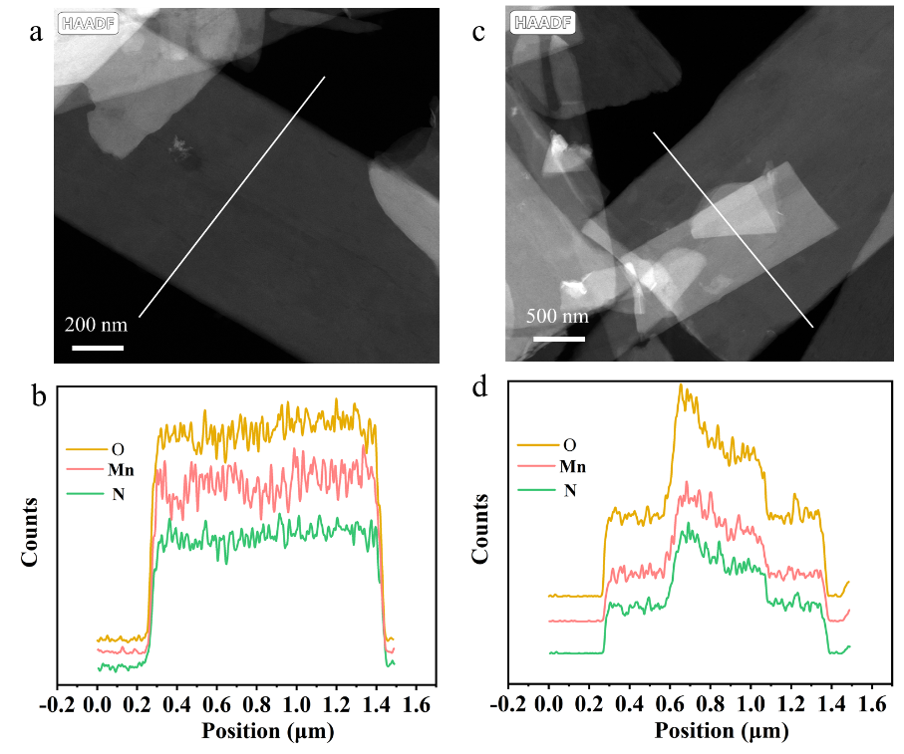
Figure S1. The line-scan TEM-EDS elemental distribution curves of Mn, O, and N.
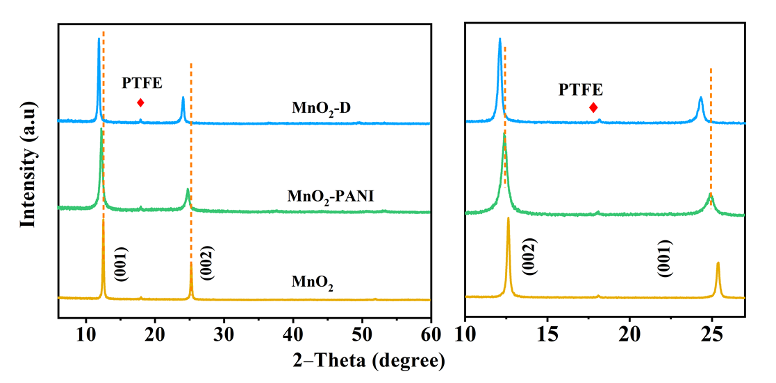
Figure S2. XRD patterns of pristine MnO₂, MnO₂-P and D-MnO₂.

Table S1. The ICP result of the pristine MnO₂, MnO₂-P and MnO₂-T.
Samples | K | Mn | K/Mn
MnO₂ | 11.86 | 49.29 | 0.34
MnO₂-P | 3.20 | 39.38 | 0.10
MnO₂-T | 1.76 | 16.45 | 0.15

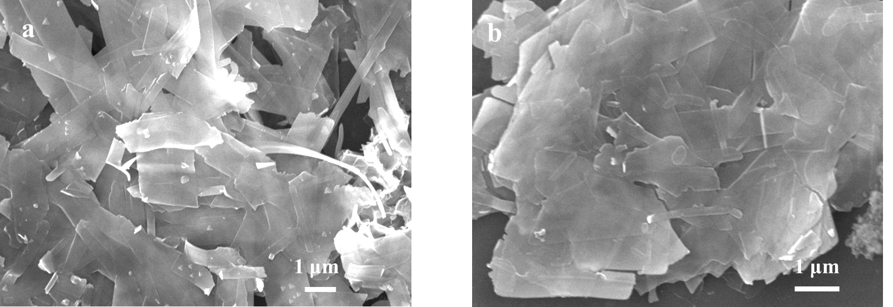
Figure S3. SEM images of (a) MnO₂-P and (b) pristine MnO₂.

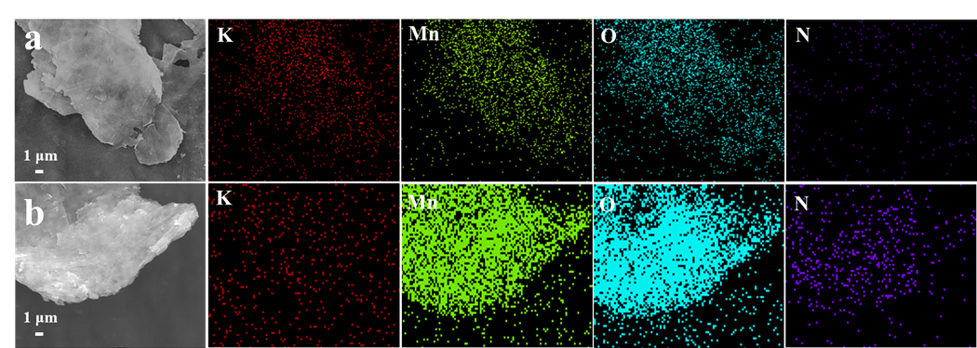
Figure S4. The SEM images and corresponding EDS mapping images of (a) pristine MnO₂; (b) MnO₂-P.

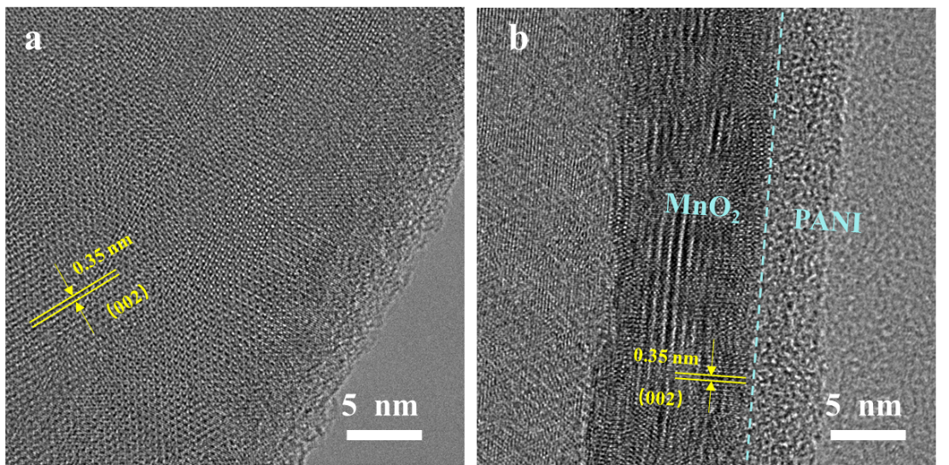
Figure S5. (a) HRTEM image of bare MnO₂ nanosheets, (b) HRTEM image of MnO₂-P nanosheets.
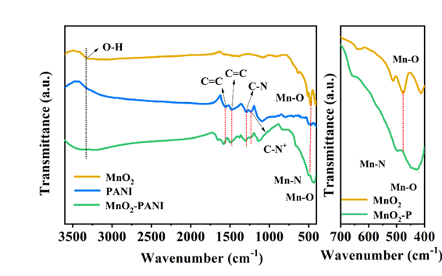
Figure S6. The FTIR spectra of PANI, MnO₂ and MnO₂-P

Table S2. The N element analysis by CHNS tests

Sample | Sample test quality (mg) | N (%) | C (%) | H (%) | S (%)
MnO₂ | 5.612 | 0.00 | 0.06 | 1.003 | 0.167
MnO₂-P | 5.609 | 2.53 | 13.88 | 1.855 | 0.634

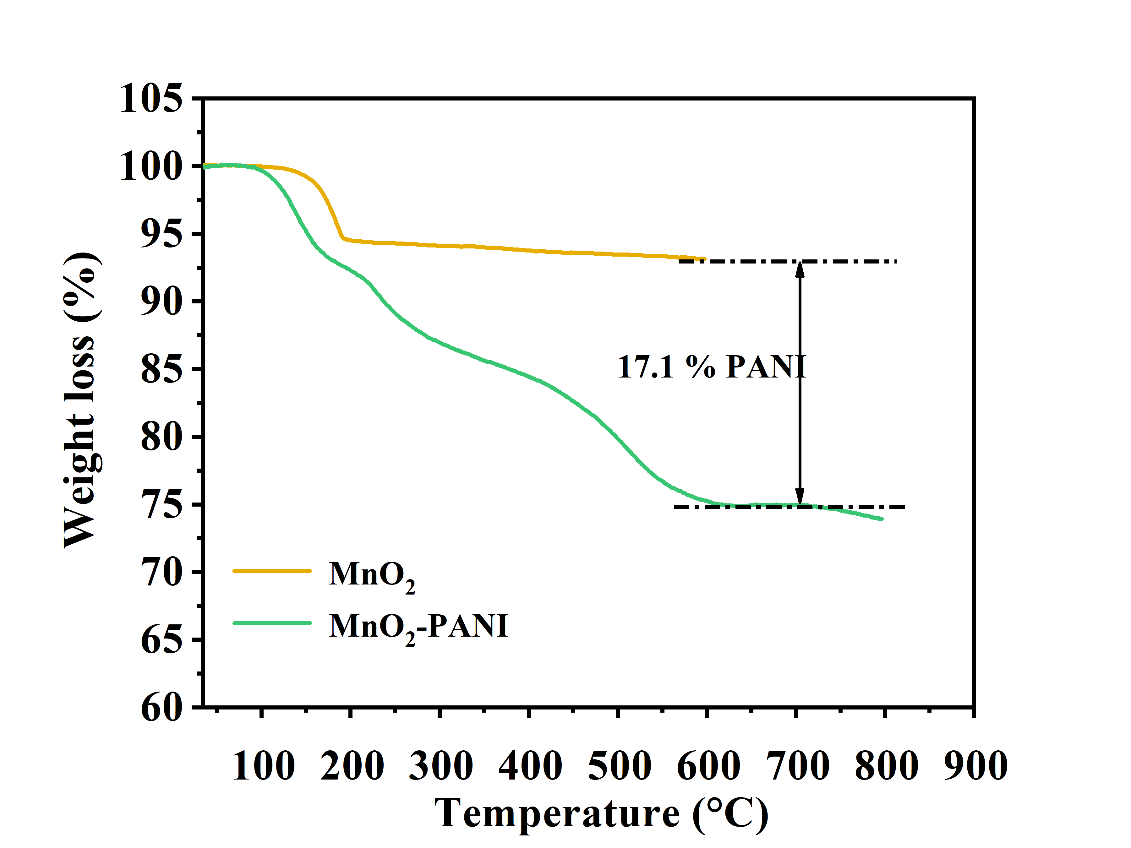
Figure S7. TG curve of MnO₂-P and pristine MnO₂.

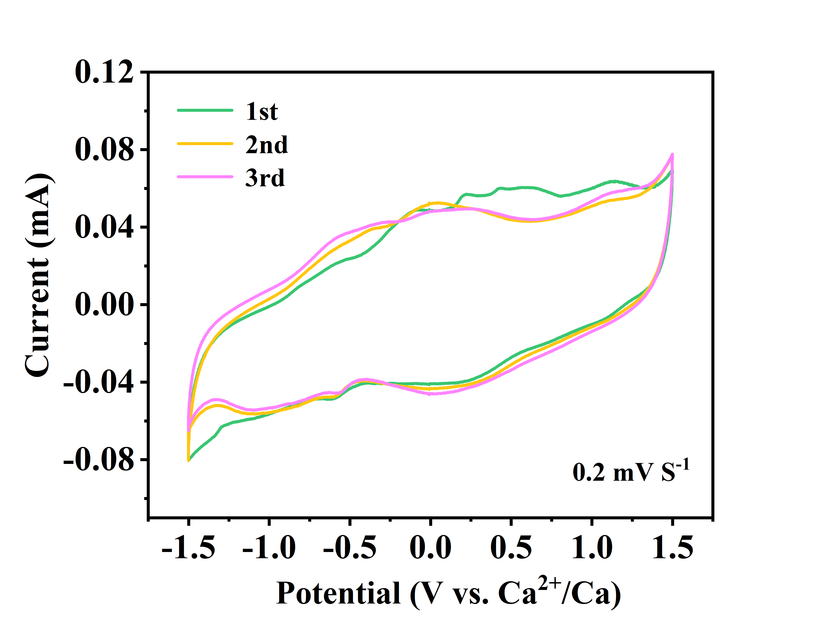
Figure S8. CV curves of MnO₂-P electrode at a scan rate of 0.2 mV s⁻¹.
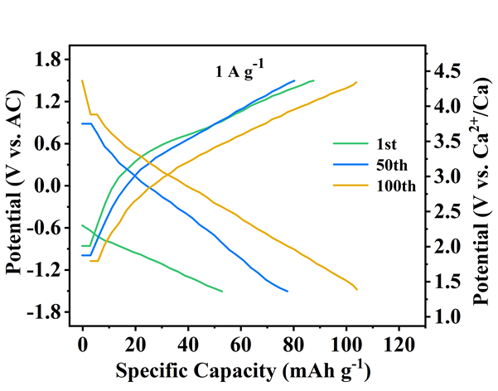
Figure S9. The GCD curves of MnO₂-P at different cycles.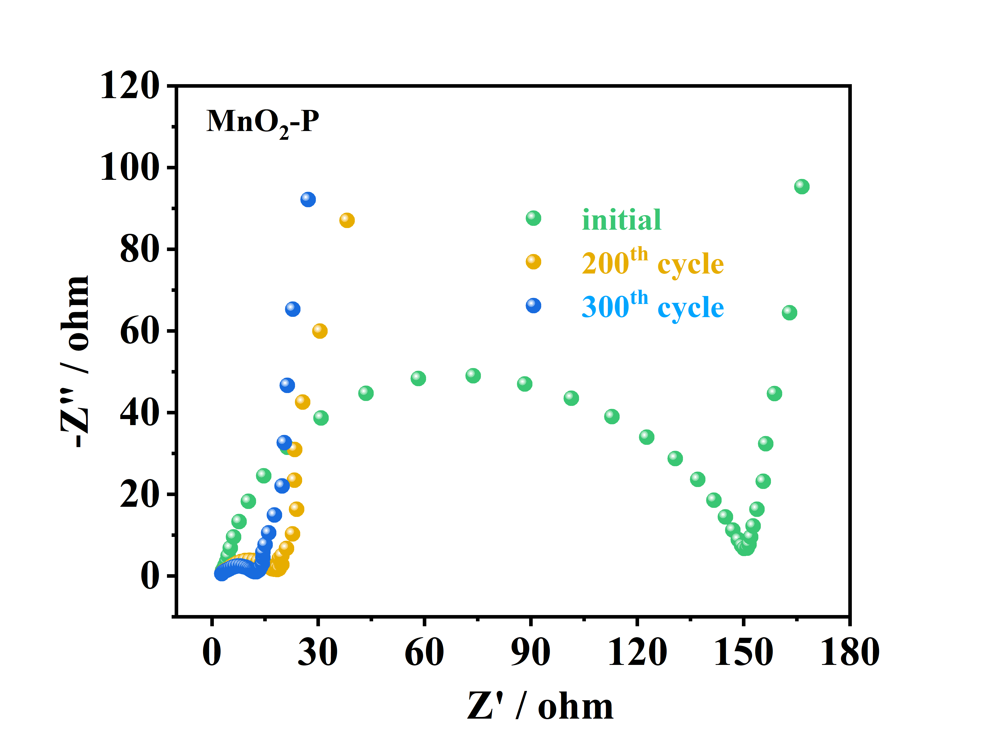
Figure S10. The EIS plots of MnO₂-P after different cycles.

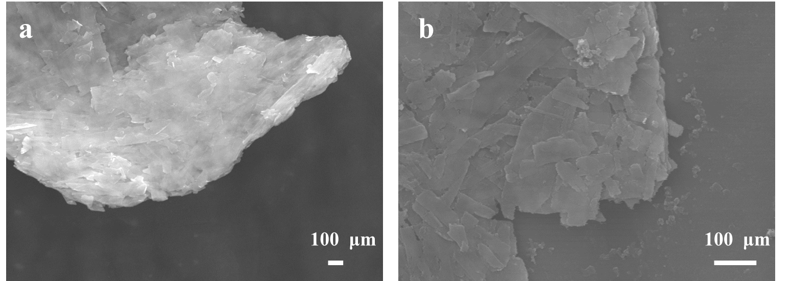
Figure S11. The SEM images of MnO₂-P electrodes (a) at pristine state and (b) after 300 cycles.
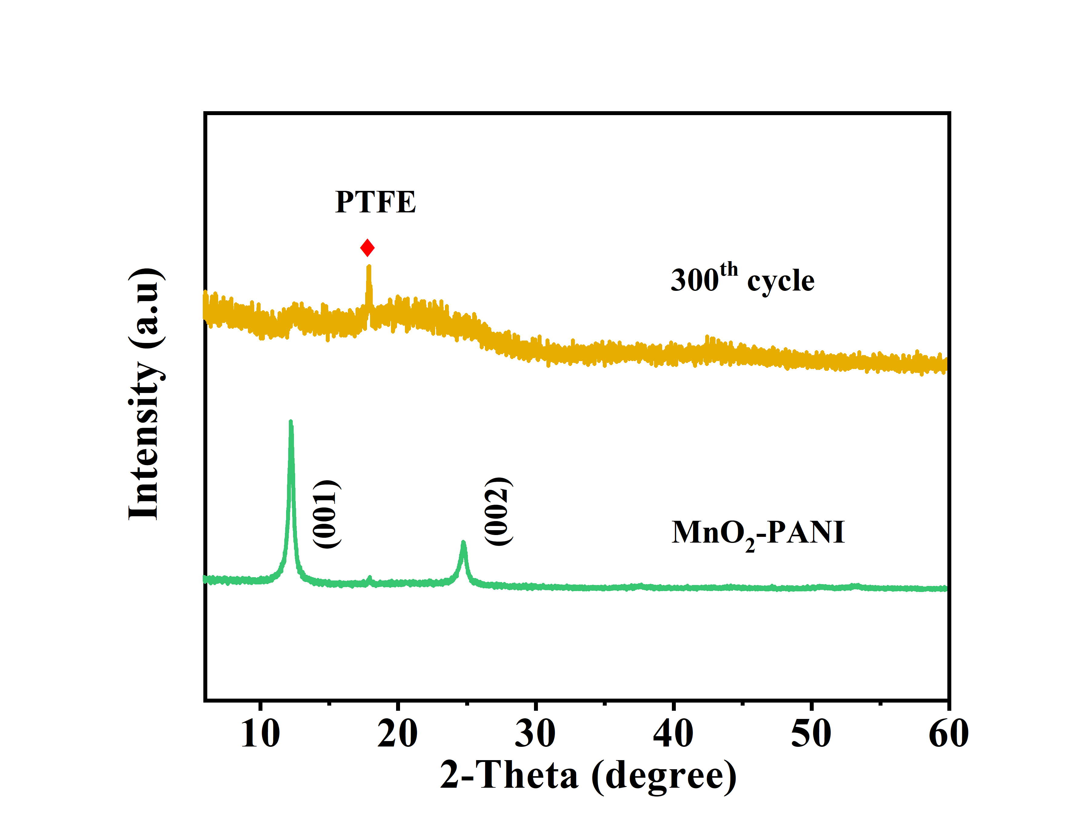
Figure S12. XRD patterns of MnO₂-P before and after 300 cycles

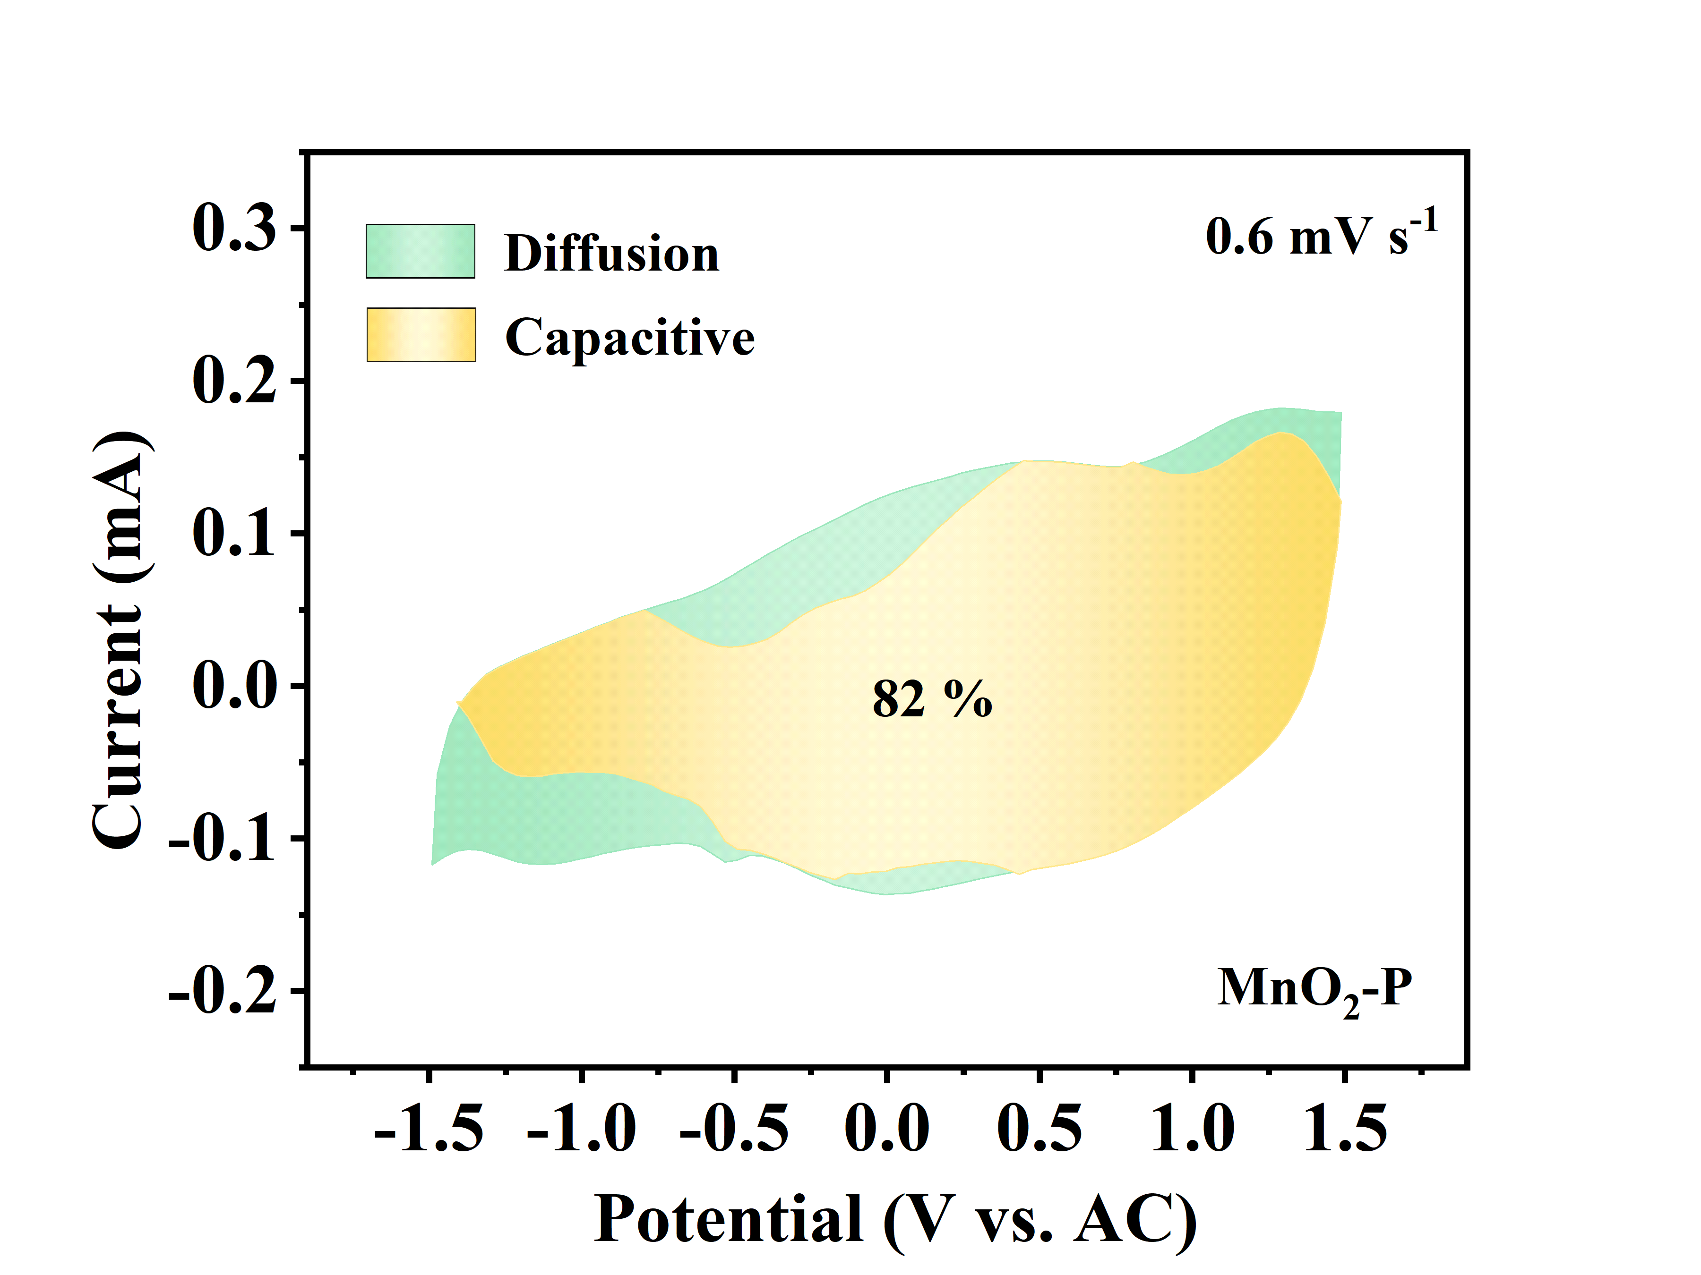
Figure S13. The calculated capacitive contribution to the charge storage of MnO₂-P at 0.6 mV s⁻¹.
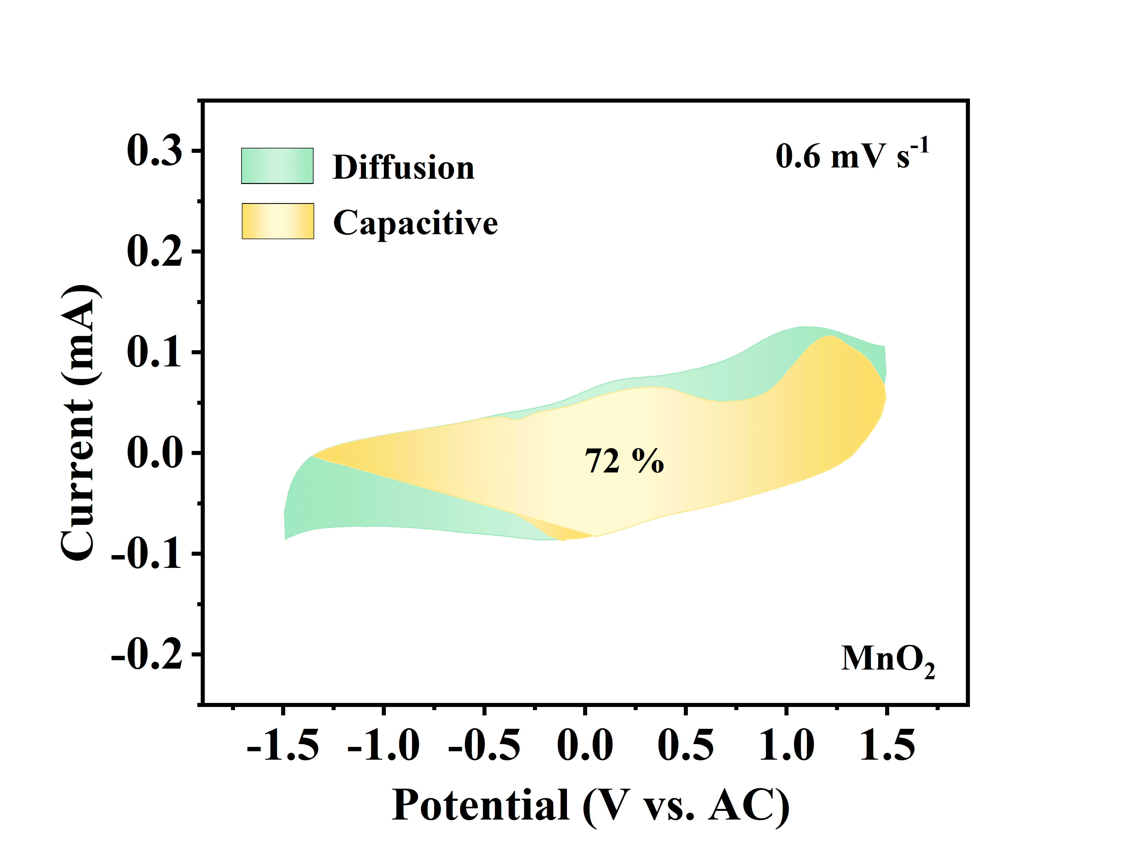
Figure S14. The calculated capacitive contribution to the charge storage of MnO₂ at 0.6 mV s⁻¹.

GITT test.
The dynamics of Mg ion solid-state diffusion in MVO cathode was evaluated by employing galvanostatic intermittent titration technique (GITT). The Mg²⁺ ion diffusion diffusivity (D^{GITT}) was obtained via the following equation:
$D^{GITT}=\frac{4}{}{\left(\frac{m_{B}V_{M}}{M_{B}S}\right)}^{2}{\left(\frac{Es}{Eτ}\right)}^{2}$ (2)
Where τ , m_{B}, V_{M}, and M_{B} are the constant current pulse duration, the mass loading, the molar volume, and the molar mass of the intercalated electrode material, respectively. S is the interface area between electrode and electrolyte. After a current pulse is conducted in a single step GITT experiment, ΔE_{S} and ΔE_{τ} represent the changes in steady-state voltage and total cell voltage regardless of the IR-drop, respectively. ΔE_{s} and ΔE_{τ} can be obtained from the GITT curves (Fig S15).
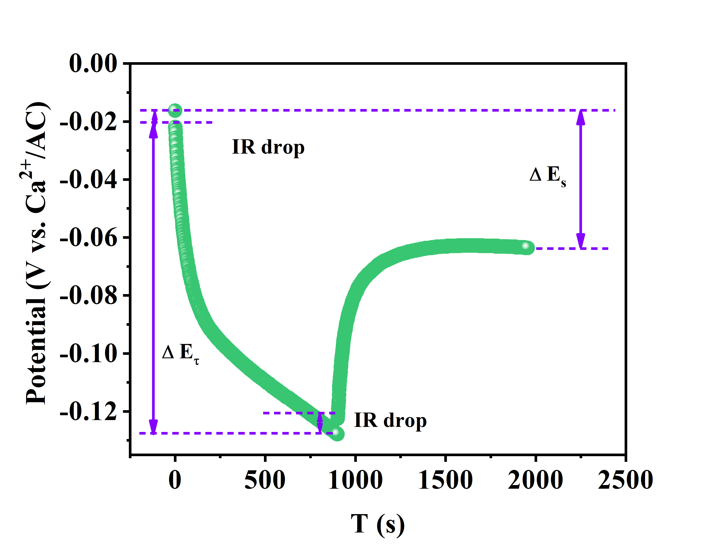
Fig. S15. GITT potential feedback curve with time.
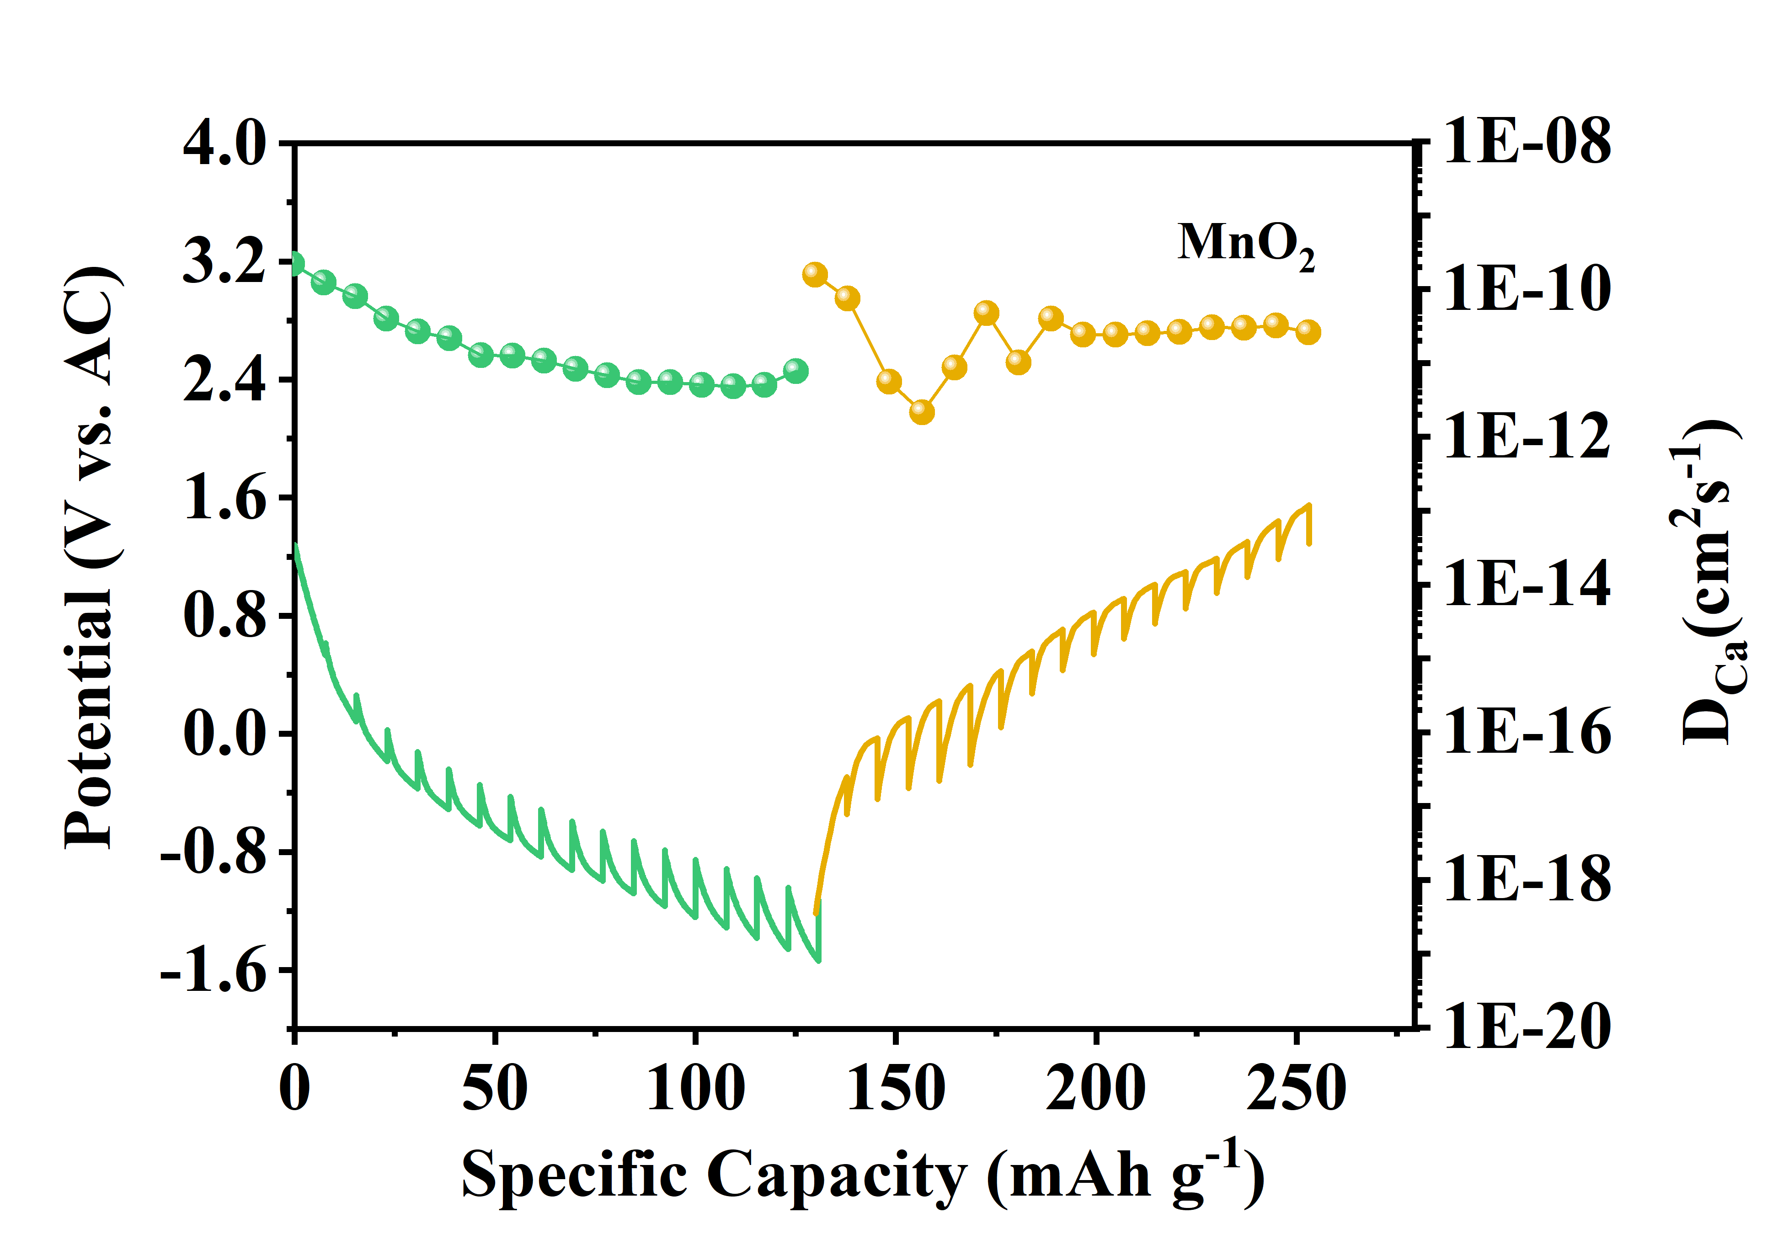
Figure S16. Discharge−charge GITT profiles and the corresponding Ca²⁺ diffusion coefficient of MnO₂ cathode.

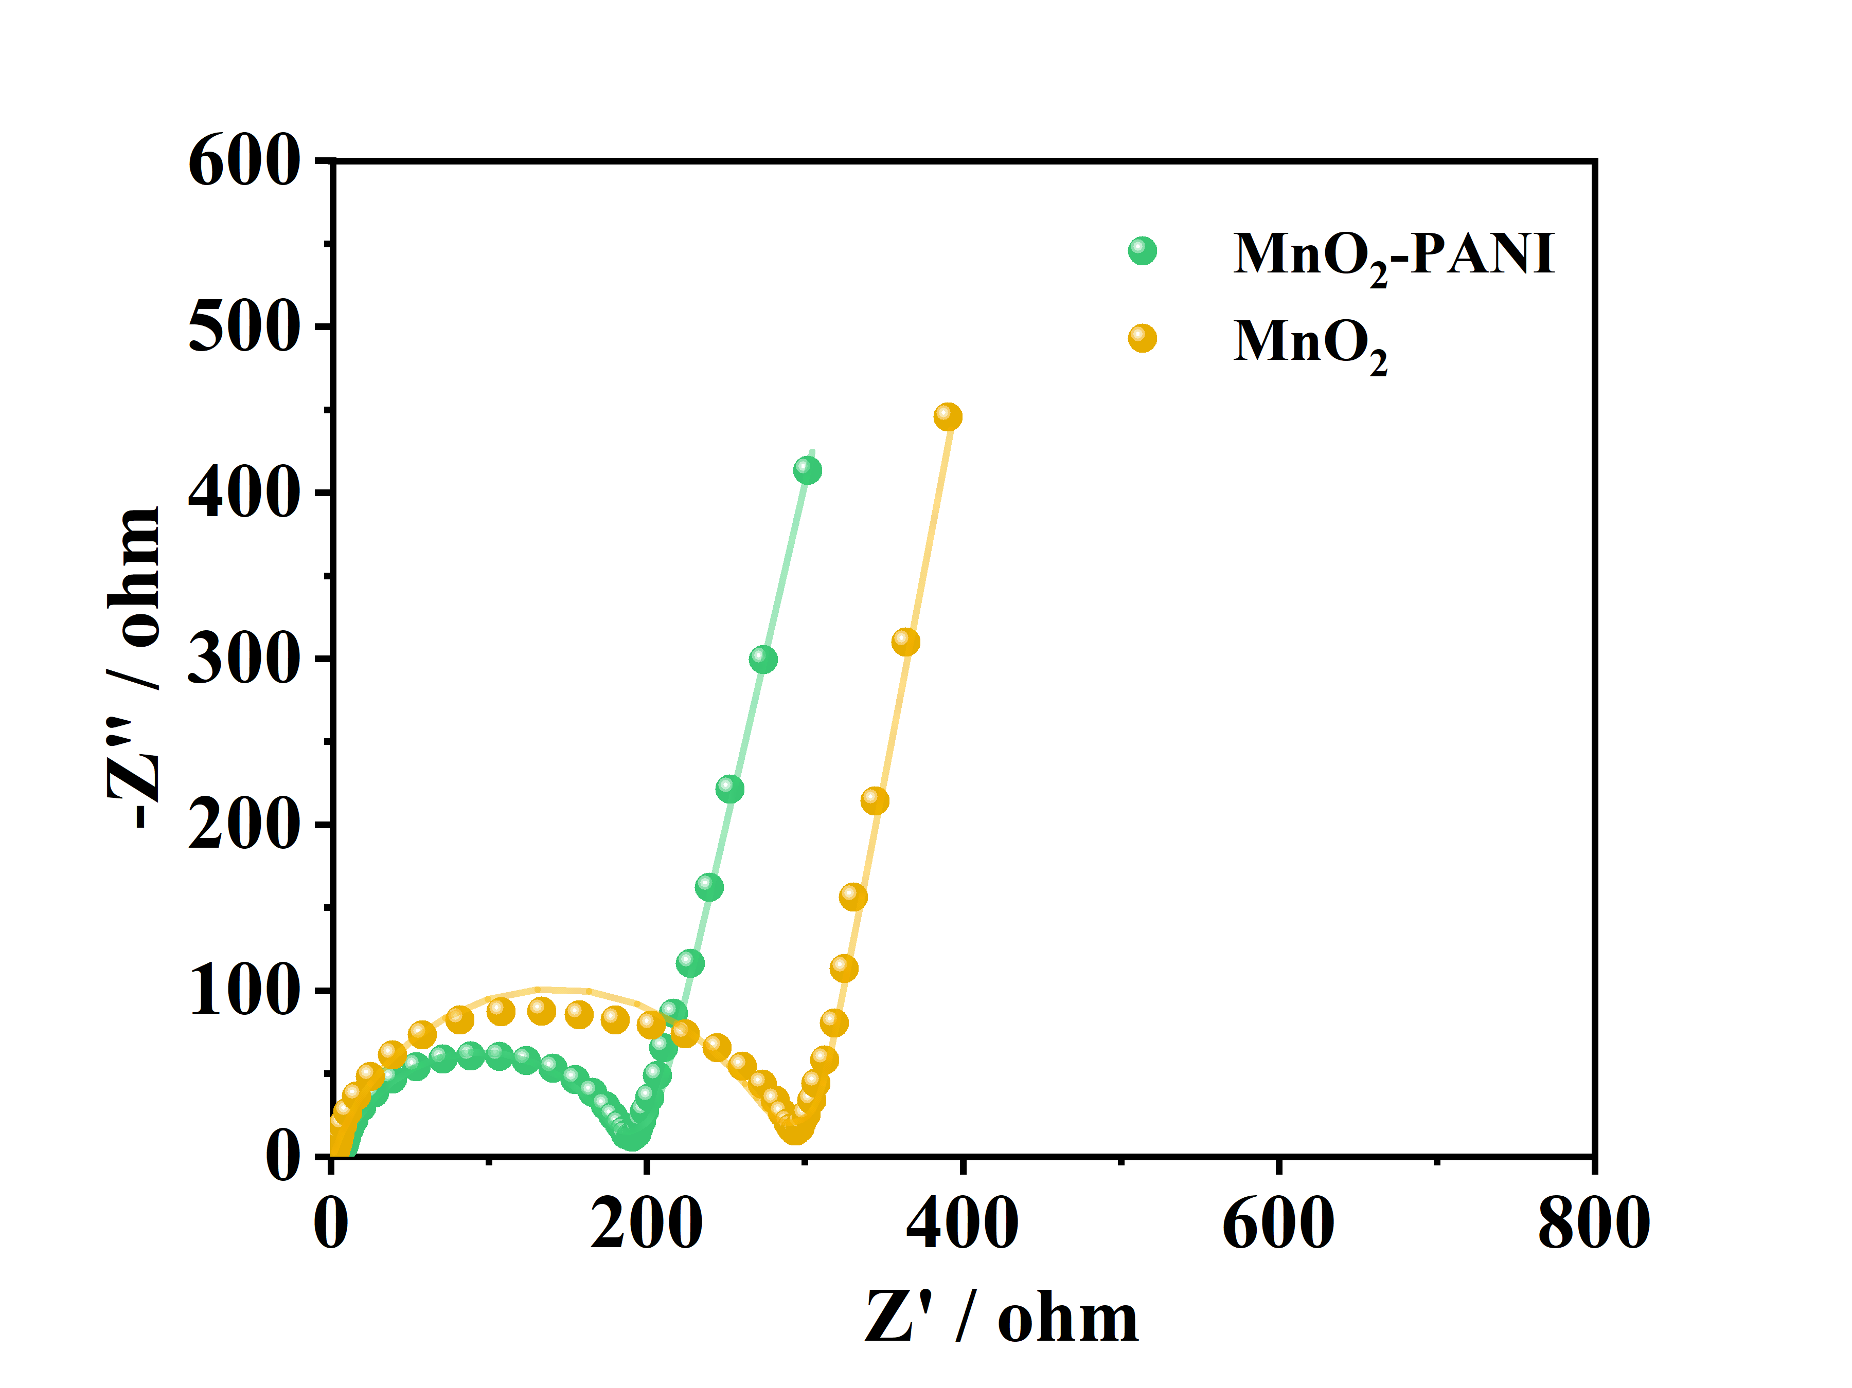
Figure S17. The EIS polts of the MnO₂-P and MnO₂.

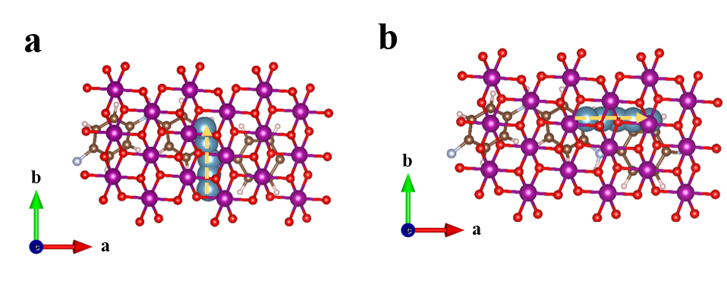
Figure S18. The diffusion path profiles of MnO₂-P along (a) path 1 (b directions) (b) path 2 (a directions).
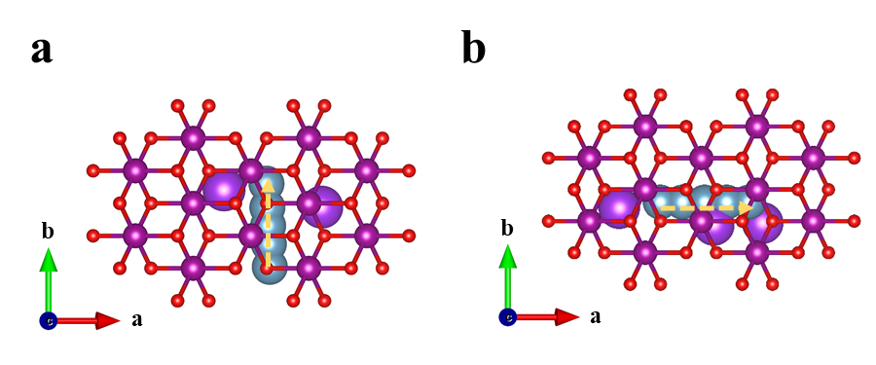
Figure S19. The diffusion path profiles of MnO₂ along (a) path 1 (b directions) (b) path 2 (a directions).
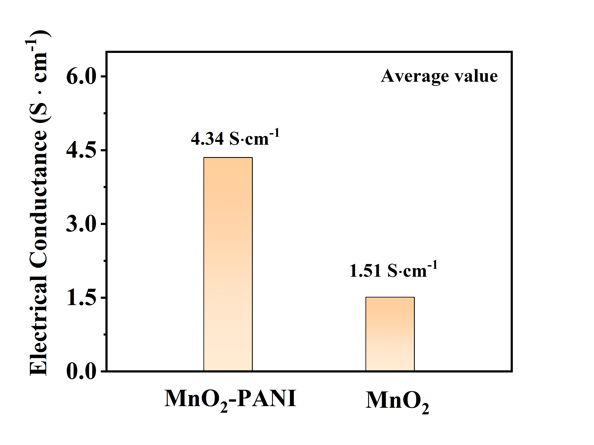
Figure S20. Four points resistance teste.

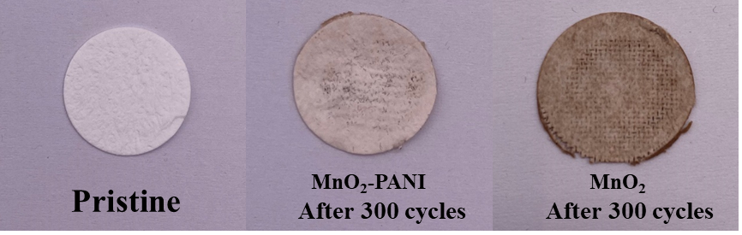
Figure S21. Digital images of glass fiber separators: pristine state (left), after 300 cycles in AC//MnO₂-P coin cell (middle) and after 300 cycles in AC//MnO₂ coin cell (right)

The corresponding percentage of cathode active material was calculated as follows: (1) The initial mass of the MnO₂ electrode is 1.76 mg, the mass of the electrode is 1.44 mg after 300 cycles, and the loss percentage of the MnO₂ active material of the is $\frac{(1.76-1.44)}{1.76×0.6}×100\%=30.3$%. (2) The initial mass of the MnO₂-P electrode is 1.30 mg, the mass of the electrode is 1.11 mg after 300 cycles, and the loss percentage of the MnO₂-P active material is $\frac{(1.30-1.11)}{1.30×0.6}×100\%=24.35$%. The results show that the introduction of polyaniline effectively inhibited the dissolution of manganese.
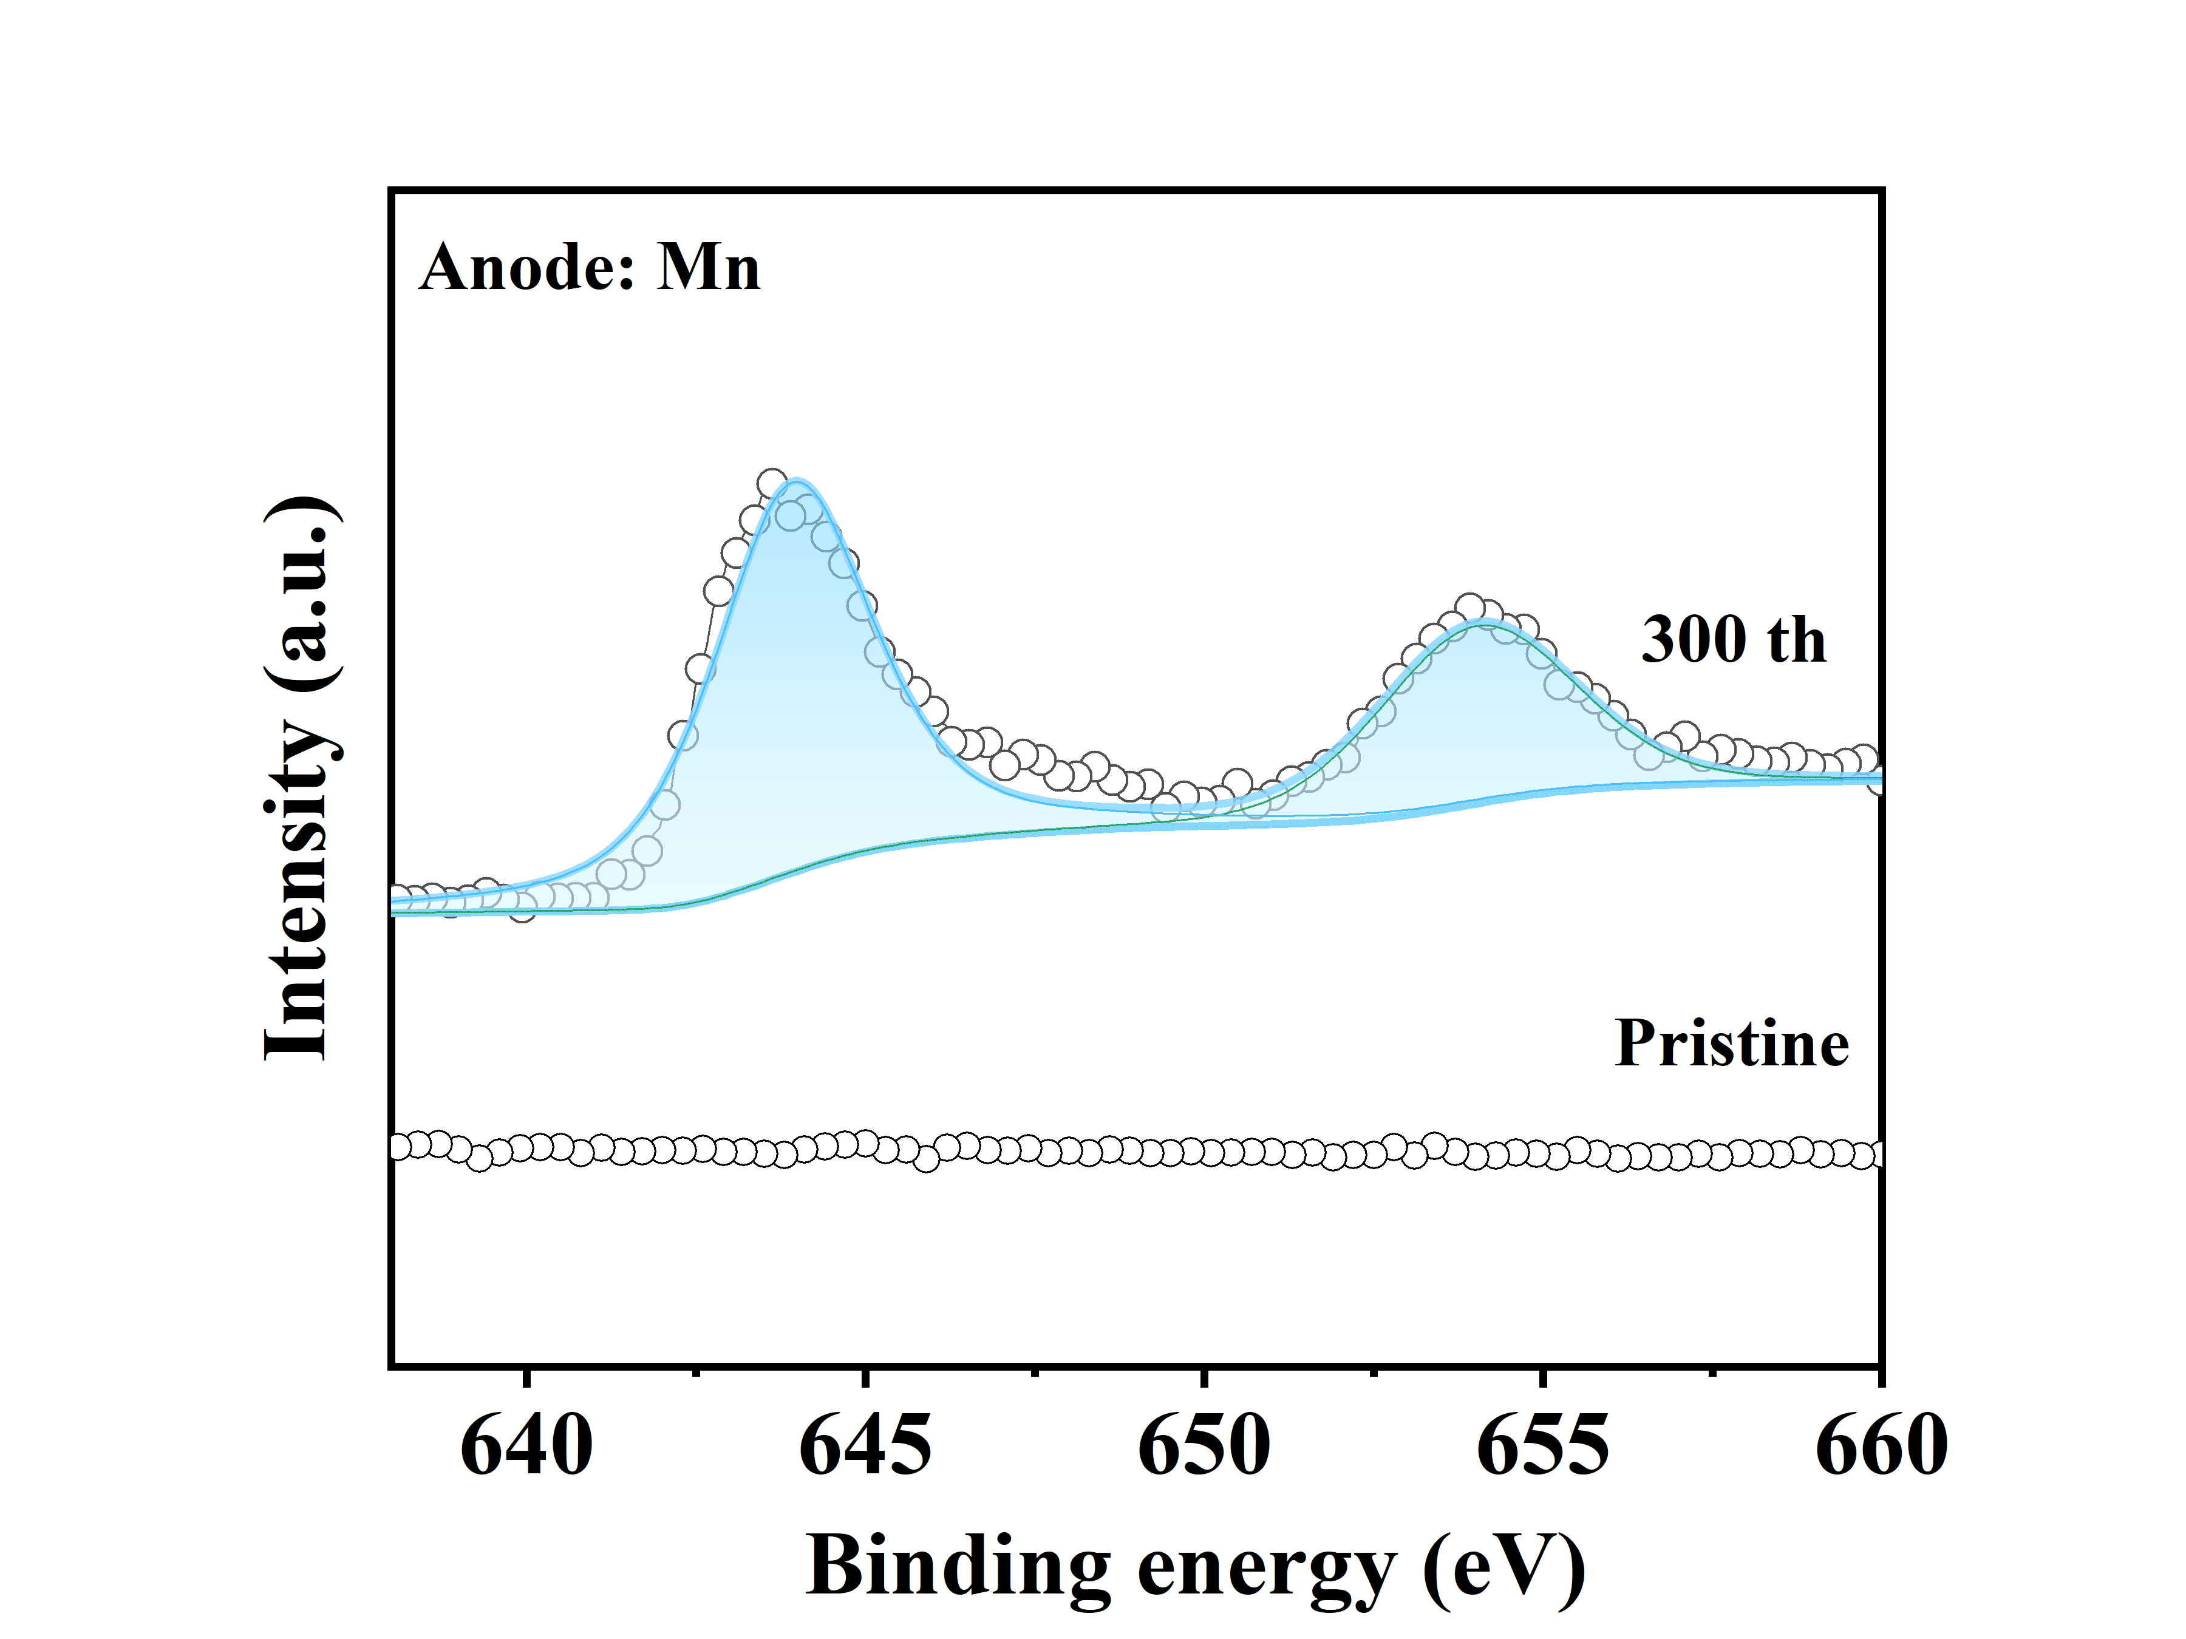
Figure S22. The XPS spectra of AC anodes at pristine and 300th cycled states.

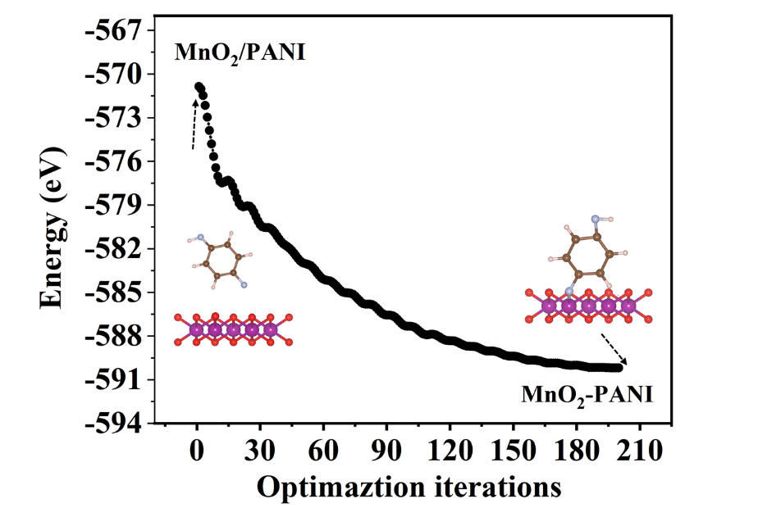
Figure S23. The energy change during the optimization iterations of model for the formation of Mn-N bond.

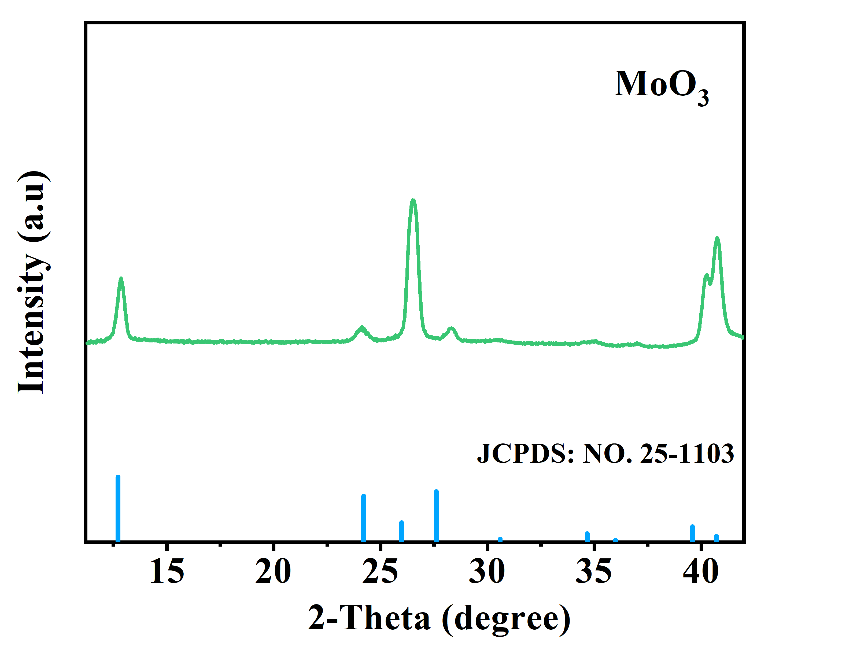
Figure S24. The XRD pattern of MoO₃.

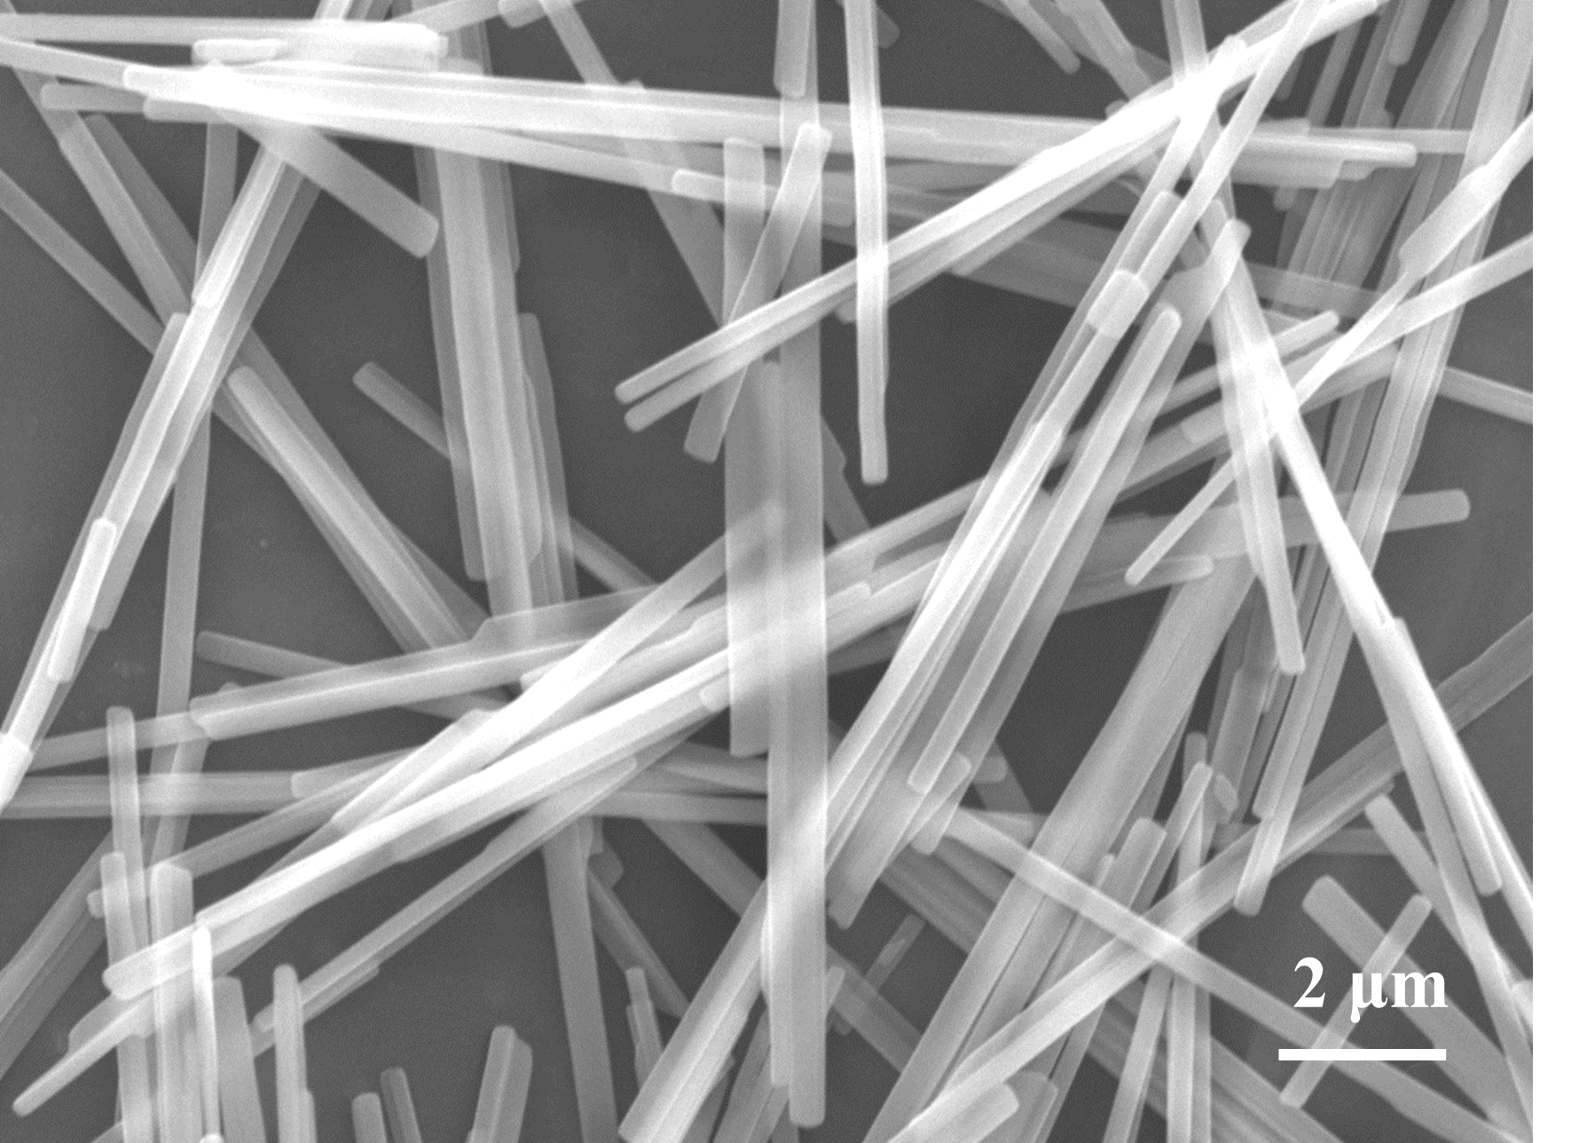
Figure S25. The SEM image of MoO₃.

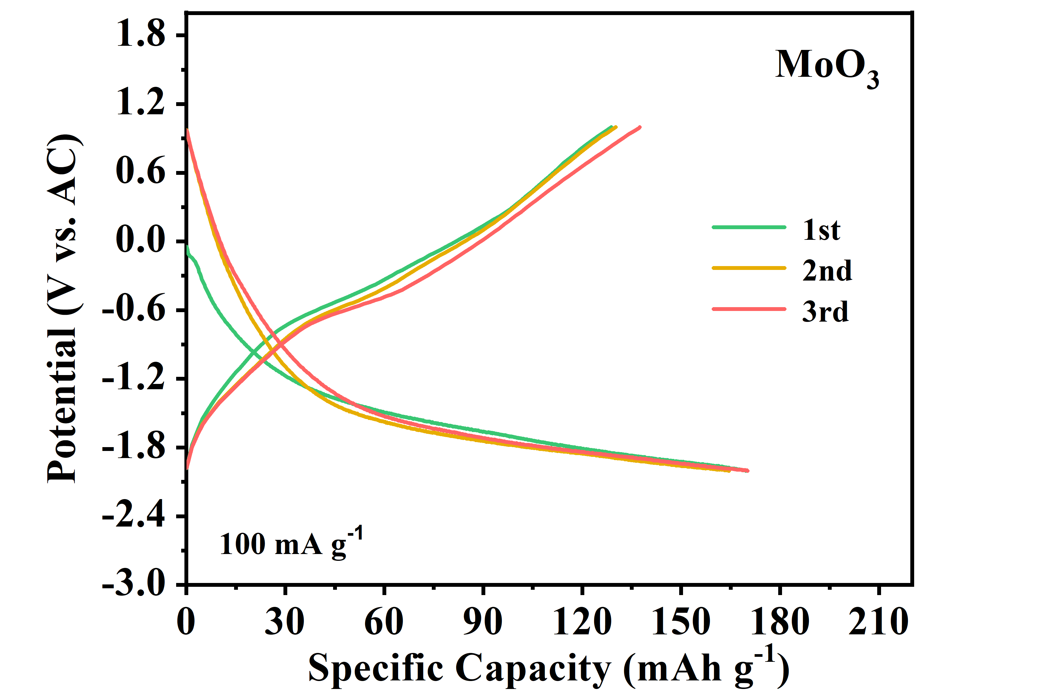
Figure S26. The charge discharge curves of MoO₃

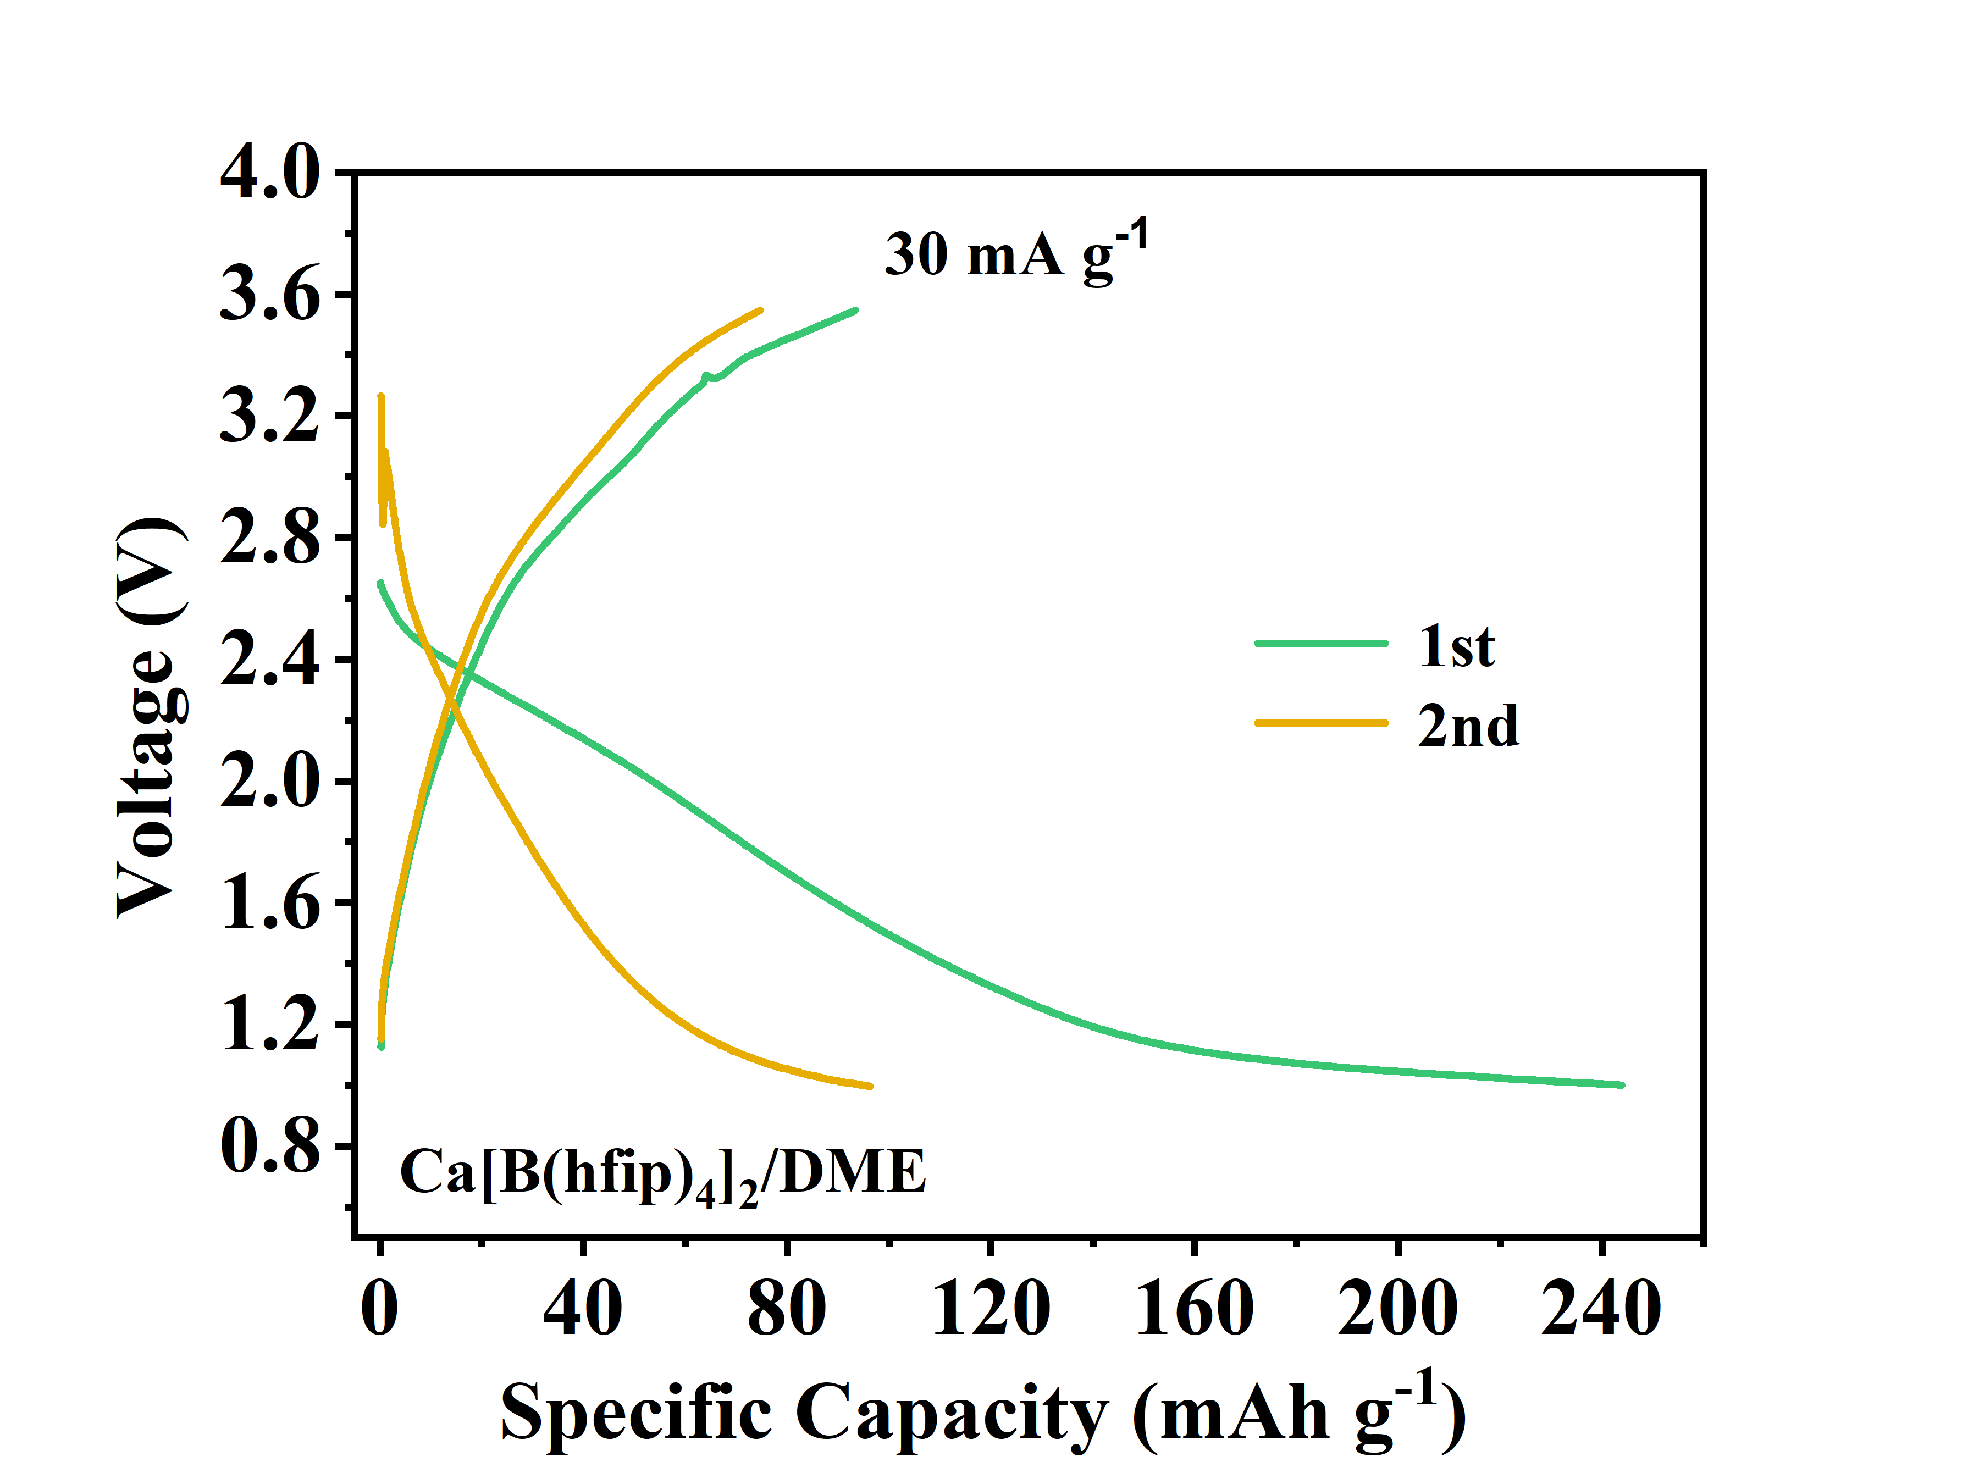
Figure S27. The charge/discharge curves of MnO₂-P with Ca[B(hfip)₄]₂/DME electrolyte at 30 mA g⁻¹.

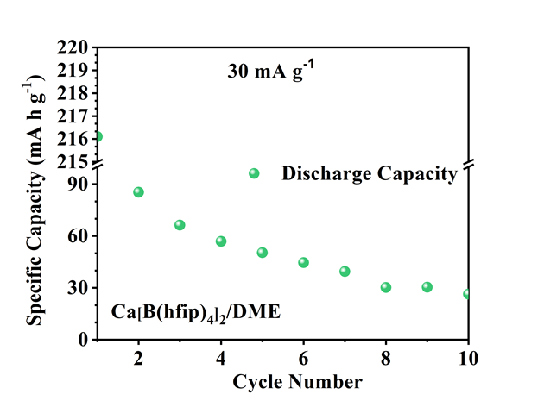
Figure S28. The cycling performance of MnO₂-P with Ca[B(hfip)₄]₂/DME electrolyte at 30 mA g⁻¹.

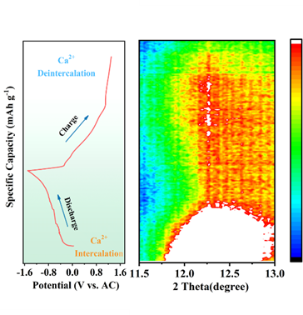
Figure S29. In situ XRD patterns and the GCD profiles of MnO₂-P.

Figure S30. Ex situ XRD patterns and the GCD profiles of MnO₂-P, the XRD intensity of MnO₂-P at initial state in the middle figure is reduced by twice.

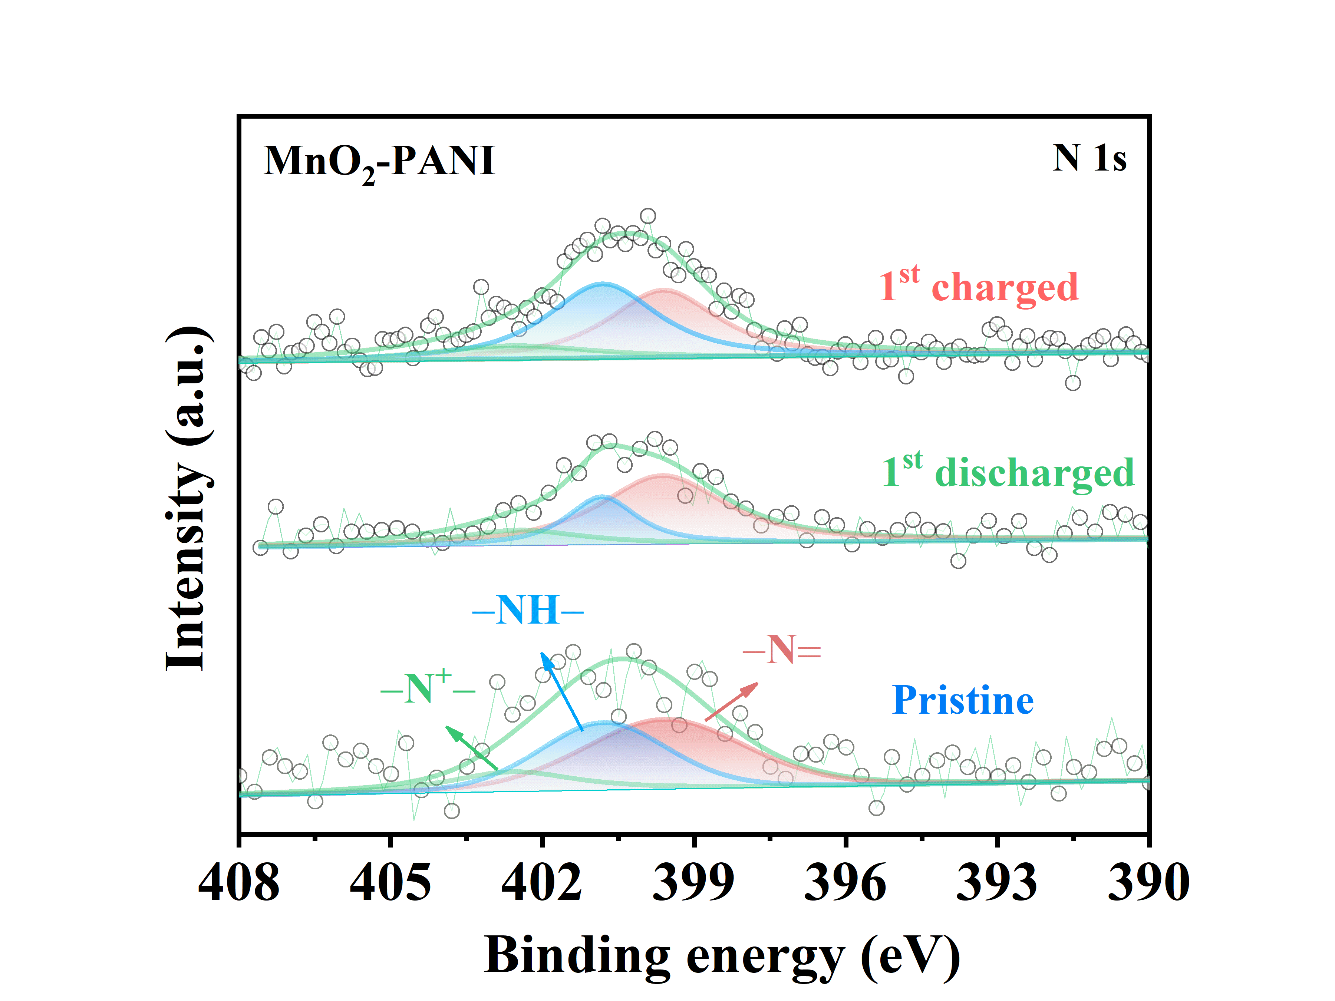
Figure S31. The N 1s XPS spectra of MnO₂-P at the pristine, discharged and charged states.

Table S3. The ICP result of the Ca/Mn atomic ratios of MnO₂-P electrode at different states.

Materials | Ca | Mn | Ca/Mn
Pristine | 0.00 | 0.43 | 0
1st discharge | 0.20 | 0.45 | 0.44
1st charge | 0.02 | 0.54 | 0.03

Table S4. The percentages of Mn²⁺, Mn³⁺, and Mn⁴⁺ at different states
States | Mn²⁺ (%) | Mn³⁺ (%) | Mn⁴⁺ (%)
Pristine | 6.81 | 20.41 | 72.76
1st discharged | 11.32 | 47.45 | 41.21
1st charged | 5.79 | 25.03 | 69.18

Table S5. Electrochemical performances of reported cathodes for CIBs and the MnO₂-P cathode in non-aqueous electrolyte (AC as counter electrode)
Materials | Electrolyte | Counter electrode | Operation range (V)  versus Ca/Ca²⁺ | specific capacity/current density (mA h g⁻¹) | Cycling performance after n cycle at z (mA h g⁻¹/mA g⁻¹) | References
MnO₂-P | Ca(TFSI)₂/AN | AC | 1.4 – 4.4 V | 145/100 140/200 134/500  129/1000 | ~ 62 after 5000 cycles (z=1000) | This Work
δ-MnO₂ | Ca(TFSI)₂/AN | AC | 1.4 – 4.4 V | 130/100 120/200 105/500  88/1000 | ~ 80 after 50 cycles (z=500) | ^{[3]}
CaV₆O₁₆·2.8H₂O | Ca(TFSI)₂/DME | AC | 1.4 – 2.2 V | 170/50 134/100 104/500  47/800 | ~ 45 after 1000 cycles  (z=500) | ^{[11]}
Ca_{x}Na_{0.5}VPO_{4.8}F_{0.7} | Ca(PF₆)₂ | AC | 1.9 – 4.3 V | 88/10 82/20 72/50  62/100 53/200 42/500 | ~ 70 after 500 cycles | ^{[12]}
Mg_{0.25}V₂O₅·H₂O | Ca(TFSI)₂ EC/PC/EMC/DMC | AC | 1.4 – 4.1 V | 120/20 90/50 72/100 | ~ 62.5 after 500 cycles | ^{[13]}
Na_{x}MnFe(CN)₆ | Ca(PF₆)₂ EC/PC | Ca_{x}Sn | 1.8 – 5.8 V | 10/100 | ~ 45 after 35 cycles | ^{[14]}
Ca_{x}MoO₃  K_{0.5}V₂O₅ | Ca(TFSI)2/DME  Ca(ClO4)₂/PC | AC  AC | 0.9 – 2.9 V  2 – 4.3 V | 80/2  100/13 87/40 70/66 50/133 | ~ 80 after 12 cycles  ~60 after 100 cycles | ^{[15]}  ^{[16]}
CaCo₂O₄  NaV₂(PO₄)₃  NaV₂(PO₄)₃  Na₂FePO₄F | Ca(ClO₄)₂/AN  Ca(TFSI)₂/AN  Ca(BF₄)₂ EC/PC  Ca(PF₆)₂ EC/PC | Ag/Ag⁺  AC  AC  AC | 2.65 – 3.65 V  2.5 – 3.3 V  2.8 – 3.5 V  1.4 – 5 V | 50/0.03 70/0.04 80/0.1  80/7.5  72/5.8 70/11.7 65/23.4 58.8/58 53/117  70/10 | ~ 80 after 30 cycles  ~ 80 after 40 cycles  ~ 70 after 30 cycles  ~ 80 after 50 cycles | ^{[17]}  ^{[18]}  ^{[19]}  ^{[20]}
NH₄V₄O₁₀ | Ca(ClO4)₂ AN | AC | 2.6 – 3.9 V | 150/100 90/300 65/500 61/1000 | ~ 150 after 100 cycles (z=100) | ^{[21]}
NiFe(CN)₆ | Ca(PF₆)₂ EC/PC | AC | 2.10083 – 3.97 V | 100/18 90/36 65/72 | ~ 120 after 80 cycles | ^{[22]}
CuS | Ca(TFSI)₂ EC/PC/EMC/DMC | AC | 1.5 – 3.2 V | 200/100 | ~ 95 after 30 cycles | ^{[23]}
VOPO₄·2H₂O | Ca(TFSI)₂ EC/PC/EMC/DMC | AC | 0.9 – 4.2 V | 120/10 100/20 70/50 55/100 40/200 | ~ 50 after 200 cycles | ^{[24]}
Ca_{0.13}MoO₃·(H₂O)_{0.41} | Ca(ClO₄)₂/AN | AC | 1.67 – 3.87 V | 192/85 138/171 108/342 | ~ 85 after 50 cycles | ^{[25]}
β-Ag_{0.33}V₂O₅ | Ca(PF₆)₂ EC/PC | AC | 1.87 – 3.87 V | 179/12.3 | ~ 90 after 50 cycles | ^{[26]}
Ti₂O(PO₄)₂(H₂O) | Ca(PF₆)₂ EC/PC | AC | 1.87 – 3.87 V | 86/20 60/50 38.5/100  17.2/200 | ~ 60.8 after 1500 cycles | ^{[27]}
PAQS@CNT | Ca(TFSI)₂ EC/PC/EMC/DMC | Ag/Ag⁺ | 1.27 – 3.72 V | 118/50 115/100 90/200  85/500 78/1000 70/2000  60/4000 | ~ 72 after 500 cycles | ^{[28]}
Cr-NH₄V₄O₁₀ | Ca(TFSI)₂/PC | AC | 2.37 – 3.52 V | 80/50 70/100 65/150  62/200 60/300 50/500 | ~ 55 after 500 cycles | ^{[29]}
α-MoO₃ | Ca(TFSI)₂/AN | AC | 2.07 – 3.37 V | 150/20 125/40 98/80  80/120 60/200 | ~ 100 after 500 cycles | ^{[30]}
Ca_{0.28}V₂O₅·H₂O | Ca(ClO₄)₂/PC | AC | 1.67 – 4.07 V | 138/10 122/20 110/30  90/50 | ~ 82 after 50 cycles | ^{[31]}
MnOx | Ca(TFSI)₂/AN | AC | 1.47 – 3.87 V | 133/11.2 | ~ 70 after 100 cycles | ^{[32]}

[1] M. Li, Y. Zhang, J. Hu, X. Wang, J. Zhu, C. Niu, C. Han, L. Mai, Nano Energy 2022, 100, 107539
[2] Z. Su, W. Ren, H. Guo, X. Peng, X. Chen, C. Zhao, Adv Funct Mater 2020, 30.
[3] C. Zuo, F. Xiong, J. Wang, Y. An, L. Zhang, Q. An, Adv Funct Mater 2022, 32, 2202975
[4] G. Kresse, D. Joubert, Physical Review.B.Condensed Matter 1999, 59.
[5] J. P. Perdew, K. Burke, M. Ernzerhof, Phys Rev Lett 1996, 77.
[6] T. Yanai, Y. Kurashige, E. Neuscamman, K. L. Chan, J Chem Phys 2010, 132, 24105.
[7] Izumi, Momma.
[8] H. Pinto, R. Jones, J. P. Goss, P. R. Briddon, J Phys Condens Matter 2009, 21, 402001.
[9] K. Bhat, F. Tietz, M. Guin, O. Guillon, 2015.
[10] S. Liu, H. Zhu, B. Zhang, G. Li, H. Zhu, Y. Ren, H. Geng, Y. Yang, Q. Liu, C. C. Li, Adv Mater 2020, 32, e2001113.
[11] J. Wang, J. Wang, Y. Jiang, F. Xiong, S. Tan, F. Qiao, J. Chen, Q. An, L. Mai, Adv Funct Mater 2022, 32.
[12] Z. L. Xu, J. Park, J. Wang, H. Moon, G. Yoon, J. Lim, Y. J. Ko, S. P. Cho, S. Y. Lee, K. Kang, Nat Commun 2021, 12, 3369.
[13] X. Xu, M. Duan, Y. Yue, Q. Li, X. Zhang, L. Wu, P. Wu, B. Song, L. Mai, Acs Energy Lett 2019, 4, 1328.
[14] A. L. Lipson, B. Pan, S. H. Lapidus, C. Liao, J. T. Vaughey, B. J. Ingram, Chem Mater 2015, 27, 8442.
[15] M. Cabello, F. Nacimiento, R. Alcántara, P. Lavela, C. Pérez Vicente, J. L. Tirado, Chem Mater 2018, 30, 5853.
[16] M. E. Purbarani, J. Hyoung, S.-T. Hong, Acs Appl Energ Mater 2021, 4, 7487.
[17] M. Cabello, F. Nacimiento, J. R. Gonzalez, G. Ortiz, R. Alcantara, P. Lavela, C. Perez-Vicente, J. L. Tirado, Electrochem Commun 2016, 67, 59.
[18] S. Kim, L. Yin, M. H. Lee, P. Parajuli, L. Blanc, T. T. Fister, H. Park, B. J. Kwon, B. J. Ingram, P. Zapol, R. F. Klie, K. Kang, L. F. Nazar, S. H. Lapidus, J. T. Vaughey, ACS Energy Lett 2020, 5, 3203.
[19] B. Jeon, J. W. Heo, J. Hyoung, H. H. Kwak, D. M. Lee, S.-T. Hong, Chem Mater 2020, 32, 8772.
[20] A. L. Lipson, S. Kim, B. Pan, C. Liao, T. T. Fister, B. J. Ingram, J Power Sources 2017, 369, 133.
[21] T. N. Vo, H. Kim, J. Hur, W. Choi, I. T. Kim, J Mater Chem A 2018, 6, 22645.
[22] N. Kuperman, P. Padigi, G. Goncher, D. Evans, J. Thiebes, R. Solanki, J Power Sources 2017, 342, 414.
[23] W. Ren, F. Xiong, Y. Fan, Y. Xiong, Z. Jian, Acs Appl Mater Inter 2020, 12, 10471.
[24] J. Wang, S. Tan, F. Xiong, R. Yu, P. Wu, L. Cui, Q. An, Chem Commun (Camb) 2020, 56, 3805.
[25] M. S. Chae, H. H. Kwak, S.-T. Hong, Acs Appl Energ Mater 2020, 3, 5107.
[26] J. Hyoung, J. W. Heo, B. Jeon, S.-T. Hong, J Mater Chem A 2021, 9, 20776.
[27] S. J. R. Prabakar, W.-B. Park, J. Y. Seo, S. P. Singh, D. Ahn, K.-S. Sohn, M. Pyo, Energy Storage Mater 2021, 43, 85.
[28] S. Zhang, Y. Zhu, D. Wang, C. Li, Y. Han, Z. Shi, S. Feng, Adv Sci 2022, 9, e2200397.
[29] M. Adil, A. Sarkar, S. Sau, D. Muthuraj, S. Mitra, J Power Sources 2022, 541.
[30] S. Kim, L. Yin, S. M. Bak, T. T. Fister, H. Park, P. Parajuli, J. Gim, Z. Yang, R. F. Klie, P. Zapol, Y. Du, S. H. Lapidus, J. T. Vaughey, Nano Lett 2022, 22, 2228.
[31] B. Jeon, H. H. Kwak, S.-T. Hong, Chem Mater 2022, 34, 1491.
[32] B. J. Kwon, L. Yin, C. J. Bartel, K. Kumar, P. Parajuli, J. Gim, S. Kim, Y. A. Wu, R. F. Klie, S. H. Lapidus, B. Key, G. Ceder, J. Cabana, Chem Mater 2022, 34, 836.

