Supporting Information

Molecular Carbon Skeleton with Self−Regulating Ion−Transport Channels for Long−Life Potassium Ion Batteries
Wencong Feng, Chuanqi Pan, Hong Wang, Biluan Zhang, Wen Luo, Chunli Shen, Junjun Wang, Chaojie Cheng, Xianmin Xv, Ruohan Yu, Yanbing Guo and Liqiang Mai

Experimental section

Materials and chemicals: All other chemicals were analytical grade and used as received without further purification.
Preparation of GDY: The GDY was synthesized on the surface of copper foils via a cross-coupling reaction using hexaethynylbenzene (HEB) precursors as previously described. ^{[1]} In a typical experiment, the HEB monomer (40 mg) was obtained after deprotecting hexakis-[(tri-methylsilyl)ethynyl]benzene (HEB-TMS) (120 mg) in tetrahydrofuran (THF) (50 mL) by tetrabutylammonium fluoride (TBAF, 1 M in THF, 1.5 mL) in an ice bath for 10 min away from light. The reaction mixture was diluted with ethyl acetate, washed three times with saturated sodium chloride, dried with anhydrous sodium sulfate and filtered. The solvent was evaporated under vacuum while maintaining the temperature below 30 °C. After ultrasonic cleaning with 4 M hydrochloric acid, distilled water, anhydrous ethanol and acetone in turn, and dried under nitrogen, copper foils were added to pyridine at 80 °C under an argon atmosphere in a three-necked flask. HEB was dissolved with pyridine and added slowly in 8 h. Then the mixture was kept under an argon atmosphere at 80 °C for 72 h. After reaction, the copper foils covered by GDY were first washed with acetone followed by hot N, N-dimethyl formamide under sonication to obtain black powder by centrifugation. The black powder was refluxed at 80 °C for 2 h in 4 M hydrochloric acid and 4 M sodium hydroxide, respectively, to remove the impurities and copper residue. The product was collected by vacuum filtering, washing with dilute hydrochloric acid, distilled water, anhydrous ethanol in turn, and then dried under vacuum to obtain pure GDY powder.
Liquid-phase exfoliation of GDY. In a typical experiment, 100 mg of Li₂SiF₆ was dissolved in 10 mL water, and then 20 mg bulk GDY was mixed into the solution. Liquid-phase exfoliation (LPE) was carried out by continuously stirring the as-prepared dispersion for 60 hours under ambient condition (25 °C). The obtained dispersion was centrifuged at 500 rpm for 5 minutes to remove large precipitates. After that, the product was collected and filtered through a nylon membrane with 100-nm pore size and consecutively washed several times with deionized water and isopropanol by vacuum filtration.
Material characterization. XRD analysis of the crystal structure was measured on a smart lab diffractometer (Rigaku, Japan) working at 30 kV and 10 mA with a Co Kα radiation source (λ = 1.79 Å). Raman spectroscopy experiments were performed on the HORIBA LabRAM HR Evolution micro-Raman spectroscopy system with the 523 nm laser. Scanning electron microscopy (SEM) images were collected using a scanning electron JEOL JSM−7100F microscope (JEOL, Japan). TEM images were collected by a JEM−2100F/Titan G2 60−300 microscope (JEOL, Japan). High−resolution TEM (HRTEM) images were recorded with a Titan G2 60−300 with EDS image corrector. X−ray photoelectron spectroscopy (XPS) measurements were collected using a VG MultiLab 2000 instrument. Raman spectra were recorded on a Renishaw InVia Reflex Raman microscope with an excitation laser of 633 nm. For the in situ Raman measurement, GDY cathode in situ batteries were discharged to 0.01 V and then charged to 2.5 V (vs K⁺ /K) at 0.2 A g⁻¹.
Electrochemical characterization. The electrochemical tests were measured by using CR2025 coin cells, which used potassium metal foil as counter electrode, a Grade GF/D Whatman glass microfiber filter as separator and a 5 M KFSI in 1,2−dimethoxyethane (DME) as electrolyte. The anodes were prepared by spreading the mixed slurry composed of 70 wt% GDY material after exfoliation, 20 wt% acetylene black, and 10 wt% polyvinylidene fluoride (PVDF) to Cu foils and dried at 70 °C with a mass loading of 0.6-1 mg cm⁻². Galvanostatic charge/discharge and cycling measurements were performed with a multichannel battery testing system (LAND CT2001A) in the potential range from 0.01−3 V (vs. K/K⁺) at different current densities. The cycle cyclic voltammetry (CV) curves and electrochemical impedance spectroscopy (EIS) tests (0.1 Hz–100 kHz, 5 mV) were conducted on an electrochemical workstation (Autolab PGSTAT302N). GITT curve was also measured using a LAND CT2001A multichannel testing system, which conducted at a pulse current of 10 mA g⁻¹ for 30 min, followed with a relaxation for 120 min.
CV measurement. Calculation of ion diffusion coefficient from CV curves at different scan rates. According to the Randles−Sevcik equation^{[2]}:
$$Ip=2.69×{10}^{5}×n^{1.5}A×{Dk}^{0.5}×v^{0.5}×C$$
Where 𝐼p is the peak current (A), n is the electron number, A is the electrode area, C is the K⁺ concentration in the electrolyte, v is the scanning rate, D_{k} is the K⁺ diffusion coefficient, respectively.
GITT measurement. Galvanostatic intermittent titration technique (GITT) is employed to measure the apparent diffusion coefficient of K⁺ in electrodes with a pulse current at 0.1 A g⁻¹ for 30 min between rest intervals for 2.0 h. The value of D_{K+} can be calculated according to the simplified Fick’s second law with the following equation^{[3]}:
$$D=\frac{4}{πτ}{\left(\frac{m_{B}V_{M}}{M_{B}A}\right)}^{2}{\left(\frac{ΔE_{s}}{ΔE_{τ}}\right)}^{2}$$
where τ is the current pulse duration, m_{B}, M_{B}, and V_{M} denote the mass, molar mass, and molar volume of electrode material, A is the interfacial area of electrode−electrolyte, ΔE_{τ} and ΔE_{s} are the change of voltage during the constant current pulse and steady state by a single−step GITT profile regardless of the IR drop.
EIS measurement. Electrochemical impedance spectroscopy (EIS) was further employed to study the interfacial charge transfer kinetics and diffusion behaviors. Where R_{s} represents the electrolyte resistance; R_{ct} and C_{ct} correspond to charge−transfer resistance and double−layer capacitance; R_{SEI} and C_{SEI} are the resistance and capacitance of the surface film fabricated on the electrodes, respectively; W stands for the Warburg impedance. The diffusion coefficient (D) of K⁺ can be investigated by using the below three equations^{[4]}:
$$ω=2πf$$
$$Zre=R+σω^{-1/2}$$
$$D=0.5R^{2}T^{2}/A^{2}n^{4}F^{4}C^{2}σ^{2}$$
The ƒ is test frequent, R (gas constant) is 8.314 J mol⁻¹ K⁻¹, T (Kelvin temperature) is 293.15 K, A (area of electrodes) is 0.5 cm², F (Faraday constant) is 96,485 C mol⁻¹, σ is Warburg coefficient, n is electronic transfer number per molecule, C is molar concentration of K⁺.
DFT Calculations: All calculations performed in this work were carried out by using density functional theory (DFT) as performed by Vienna ab initio simulation package (VASP)^{[5]}. The projector augmented wave (PAW) method was used to treat the effective interaction of the core electrons^{[6]} and nucleus with the valence electrons and the generalized gradient approximation (GGA) in the form of Perdew-Burke-Ernzerhof (PBE)^{[7]}.was adopted for the exchange-correlation functional. The Kohn-Sham electron wave functions were expanded using the plane-wave functions with an energy cutoff of 400 eV. The optimization was considered convergence when the spring force between adjacent images was less than 0.05 eV Å⁻¹, the total energy change upon two steps for the electronic self-consistent field iteration was less than 1E⁻⁴ eV.
Single-layer graphdiyne (GDY) was simulated by a repeated slab model with a 1×1 supercell. Meanwhile, ABC-stacked bulk graphdiyne was adopted in this work, which possessed lower energy than that of AA-stacked and AB-stacked graphdiyne. The replicas of GDY layers were separated by a vacuum layer of 15 Å along the z-direction, which led to negligible interactions between the research system and their mirror images.
As for the adsorption case of atoms and bulk, the binding energy (E_{b}) was defined as
E_{b} = E_{k@graphdiyne} – (E_{graphdiyne} + E_{K})
where E_{graphdiyne}, E_{k} and E_{k@graphdiyne} are the total energy of the bulk graphdiyne, the energy of free K atoms in its bulk form, and the total energy of K atoms inserted in graphdiyne, respectively. All three types of energies were derived from the scf calculations using the same calculated setting parameters. With this definition, a negative value indicates an exothermic adsorption and the more negative this value is, the more stable configuration has been proved.
Charge transfers were calculated using the Bader charge analysis method. In addition, the Brillouin zone integration was performed with 3×3×1 k-point sampling according to the Monk Horst-Pack scheme^{[8]} for geometric optimization and searching the transition state (TS), which is further verified by means of frequency calculations. Climbing images nudged elastic band (CL-NEB)^{[9]} calculations were performed to locate TS. The number of inserting image was chosen by the formula “dist/0.8” derived from the difference-comparing scripts called dist.pl embedded in the transition state tools (VTST) software package compiled in VASP. The specific capacity of the anode was calculated using the equation: C_{p} = n_{k}F/W, where F is the Faraday constant (96500 C·mol⁻¹) and W is the molecular weight of C in the whole supercell^{[10]}.

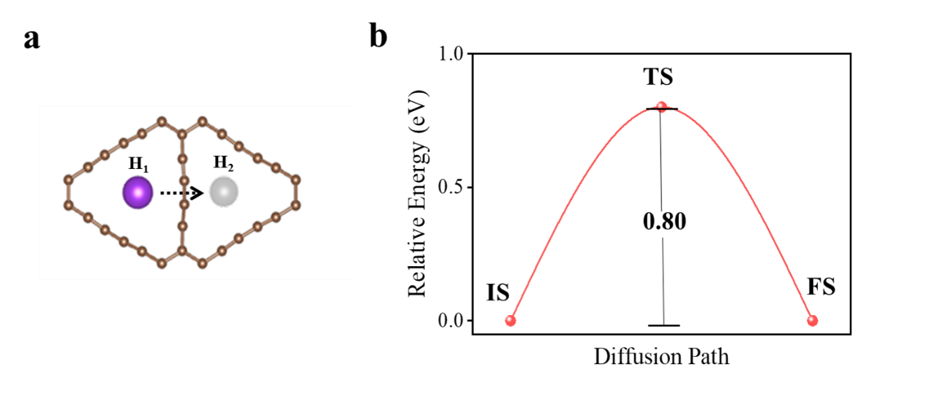
Figure S1. Diffusion path of K ion within in−plane graphdiyne cavity and corresponding energy profile.

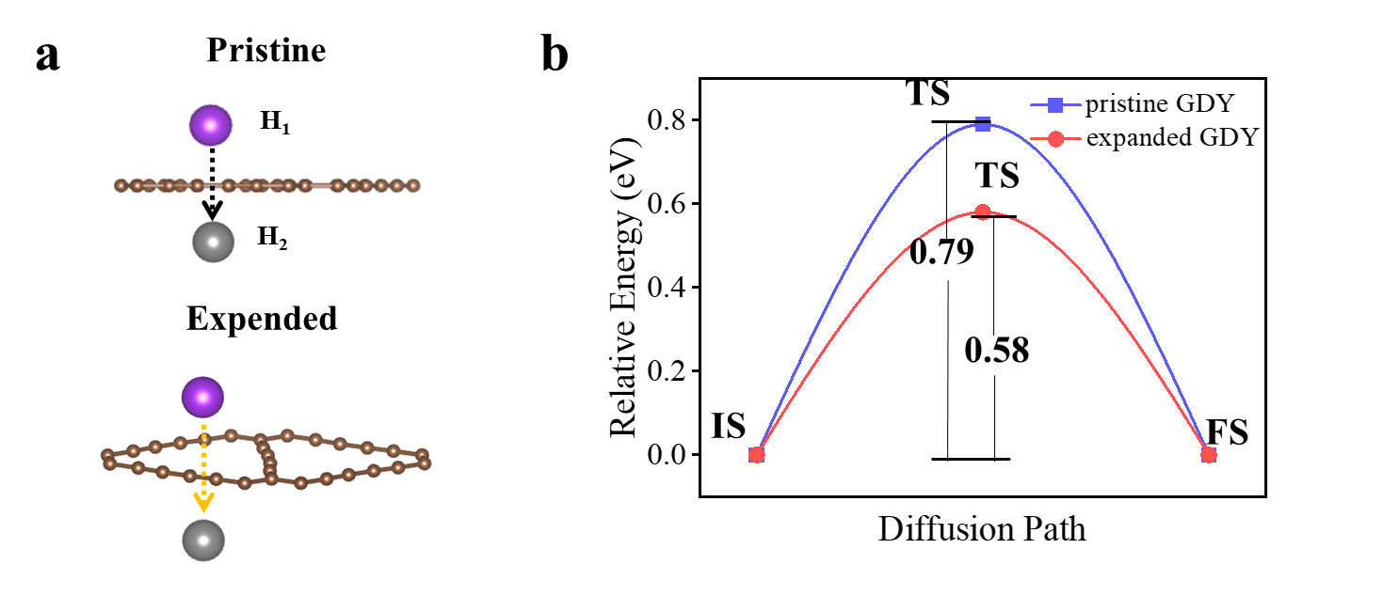
Figure S2. Diffusion path of K ion within out−plane graphdiyne cavity and corresponding energy profile.
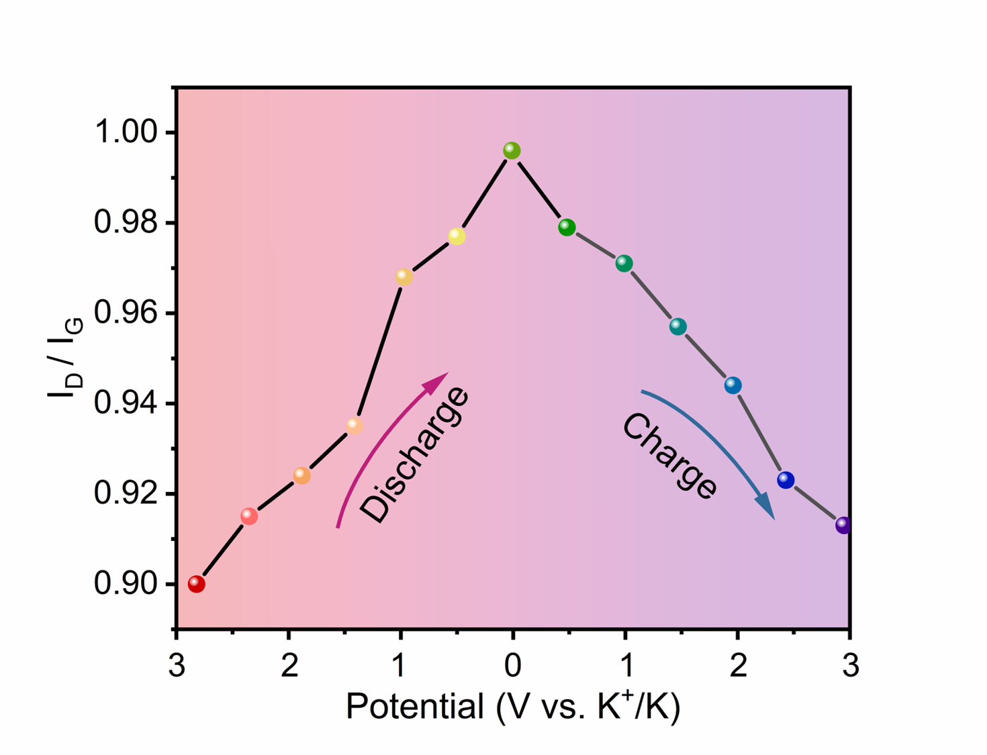
Figure S3. In situ Raman patterns corresponding evolution of I_{D}/I_{G} ratio.
Supplementary Note 1: The appearance of alkene feature reduces the corresponding electron-withdrawing ability and the electron deviation of benzene ring, and provides more p-electrons with sp² characteristics, which means that the conjugation degree of sp² is increased, leading to the redshift of G band.

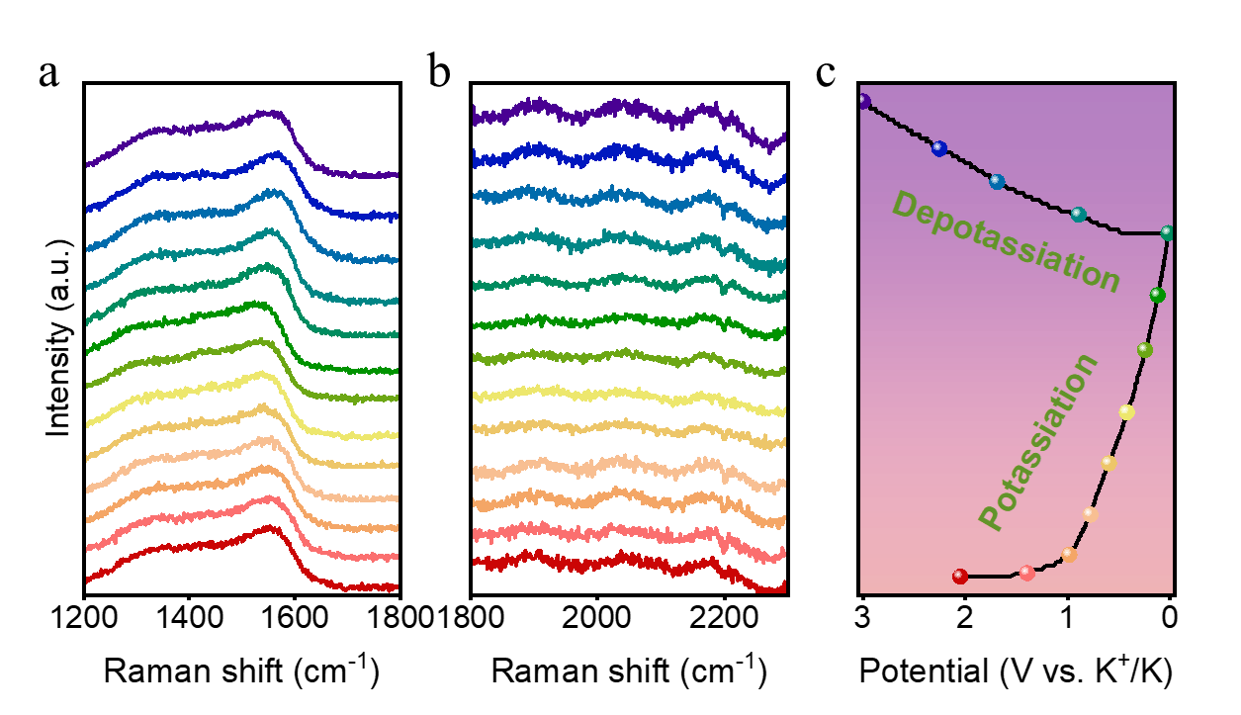
Figure S4. (a−c) In situ Raman patterns at second discharge–charge states.
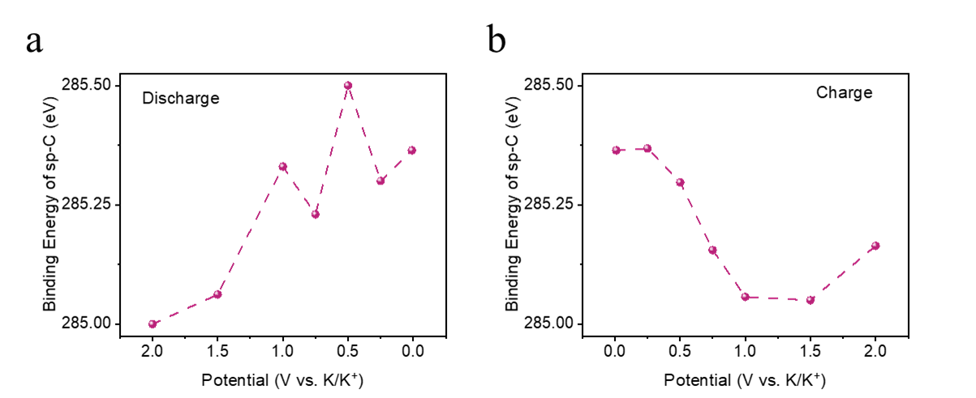
Figure S5. The change of binding energy of sp-C peak with discharge potential voltage (a) and charge potential voltage (b).
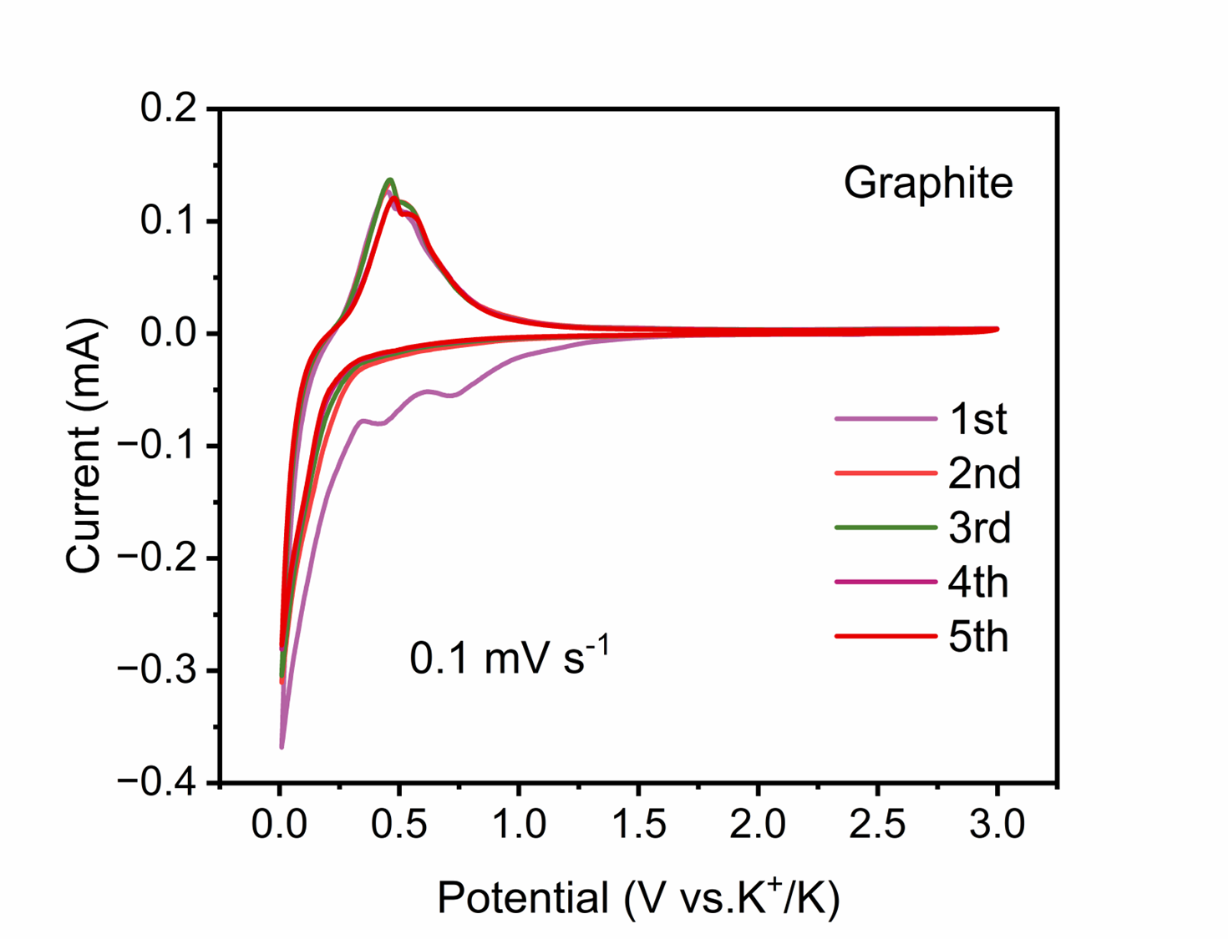
Figure S6. CV curves of Graphite at a scan rate of 0.1 mV s⁻¹.
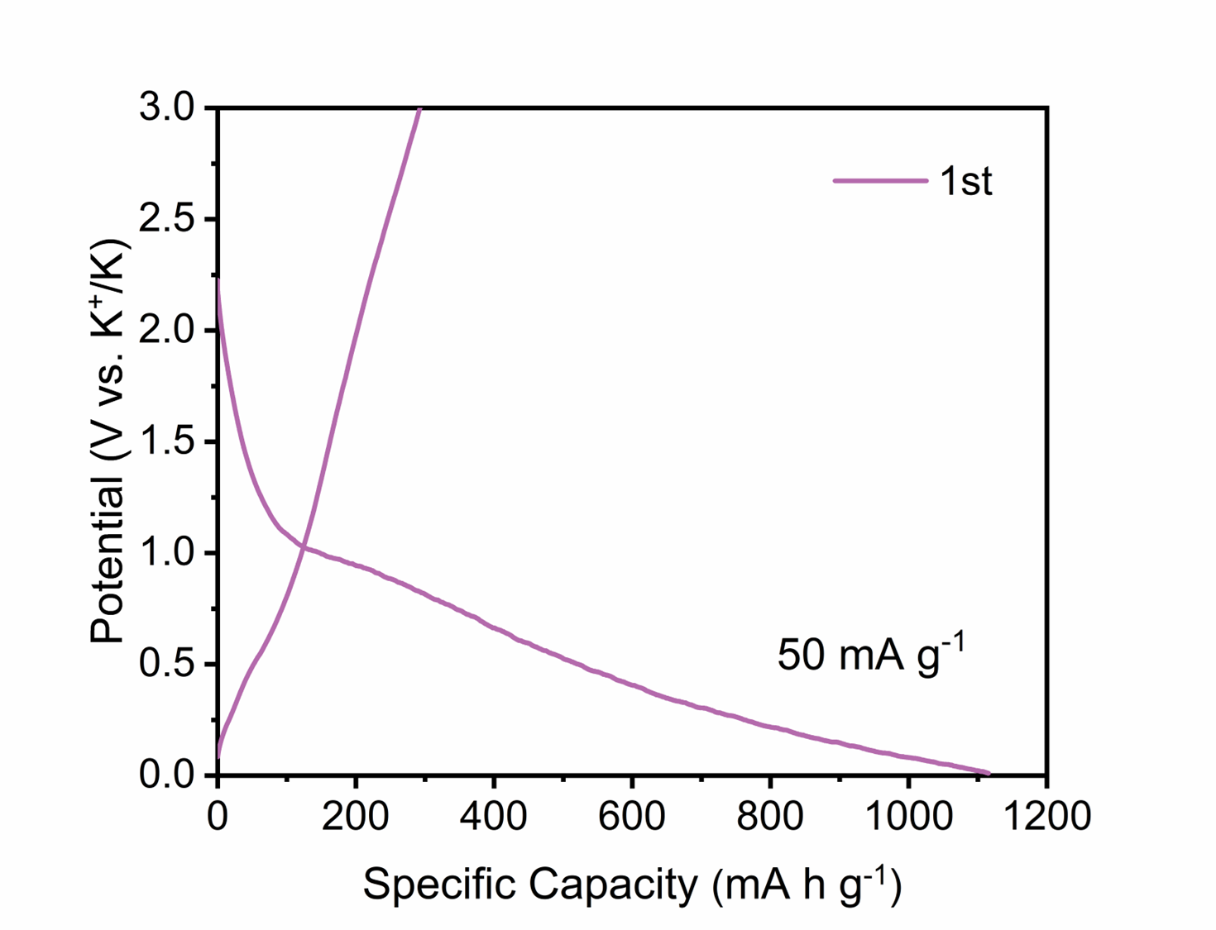
Figure S7. Charge and discharge curves of GDY at 50 mA g⁻¹.
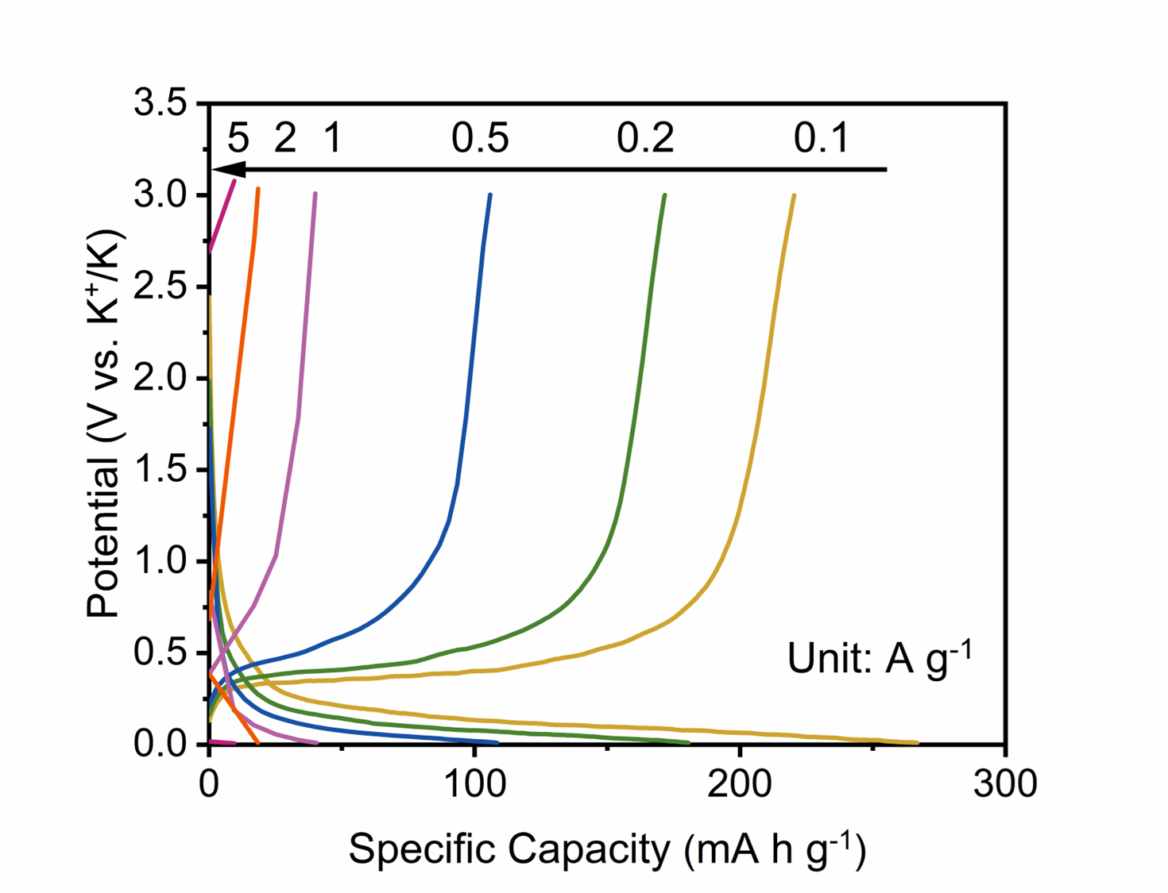
Figure S8. Charge and discharge curves of graphite at various current densities.
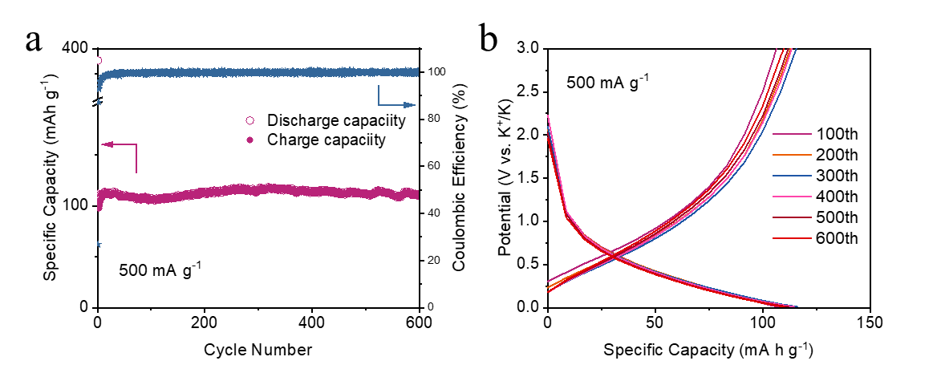
Figure S9. (a) Cycling performance of graphite at 500 mA g⁻¹, (b) charge and discharge curves of graphite at 500 mA g⁻¹.
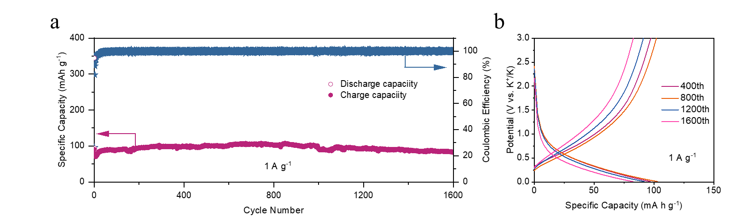
Figure S10. (a) Cycling performance of graphite at 1 A g⁻¹, (b) charge and discharge curves of graphite at 1 A g⁻¹.
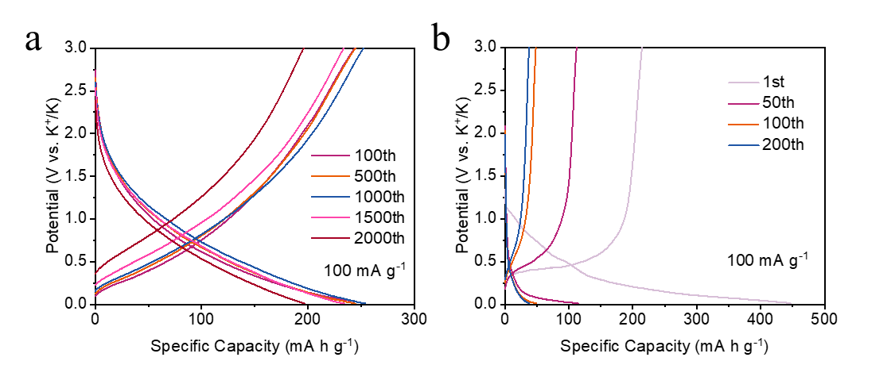
Figure S11. Charge and discharge curves of (a) GDY and (b)graphite at 100 mA g⁻¹.

Supplementary Note 2: To describe the capacitive behavior of the GDY, the CV curves in Figure 3a were analyzed. The peak current (i) follows a power law relationship with the scan rate (v), according to equation: $i=av^{b}$. The parameter b value is used to describe a surface-dominated capacitive characteristic which can be extracted from the slope of log (i) against log (v). Particularly, when the value of b is close to 0.5 or 1, the electrochemical reaction is dominated by the diffusion-controlled process or surface capacitive-controlled process, respectively. The calculated b values for GDY anode (Figure S10) are 0.64 and 0.68, suggesting that K⁺ storage behavior is a more favorable diffusion-controlled process. These results further proved that the large ion diffusion kinetics of GDY is due to its self-regulating mechanism of in-plane pores, rather than surface capacitive adsorption. In contrast, Figure S11 show that the capacity contribution of graphite is almost completely by the slow K⁺ insertion/extraction reaction.
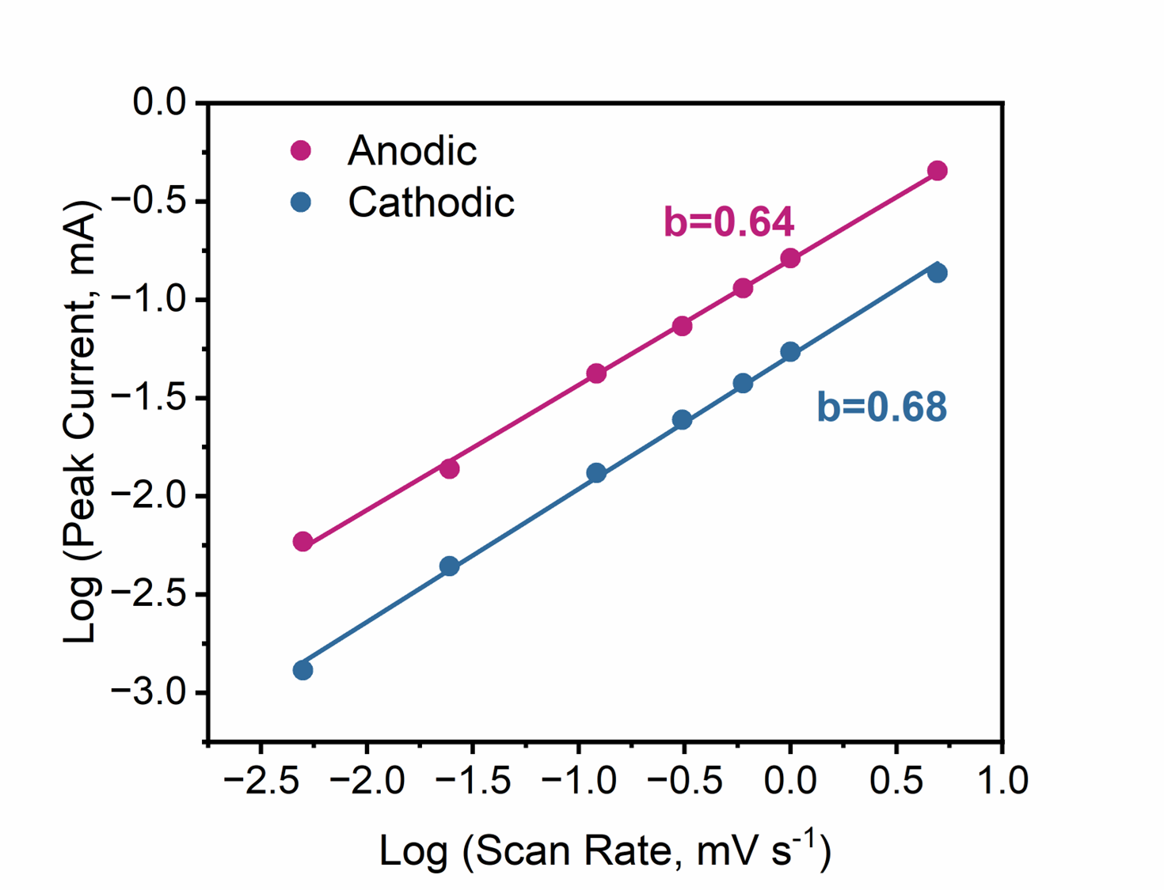
Figure S12. Corresponding b-values plotted of GDY for anodic peaks and cathodic peaks.
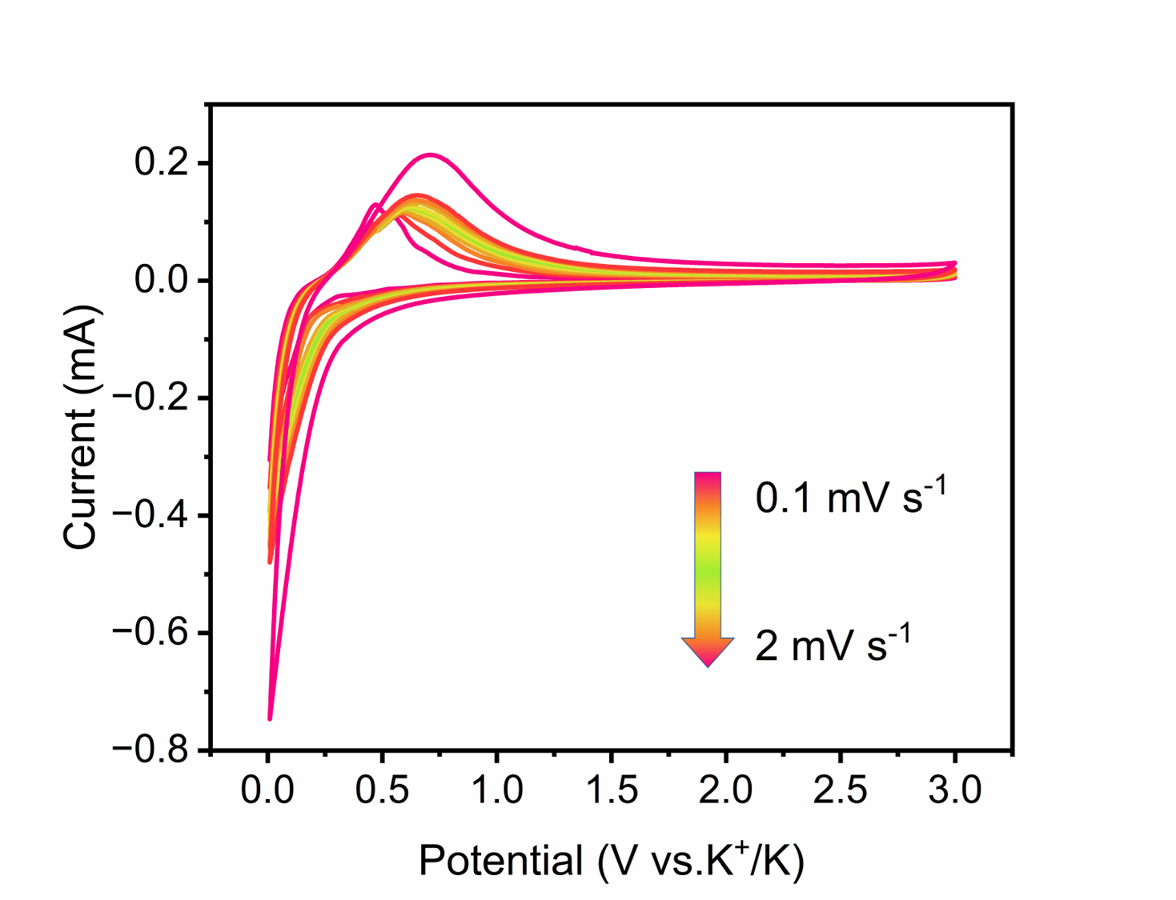
Figure S13. CV curves of the graphite electrodes at sweep rates from 0.1 to 2.0 mV s⁻¹.
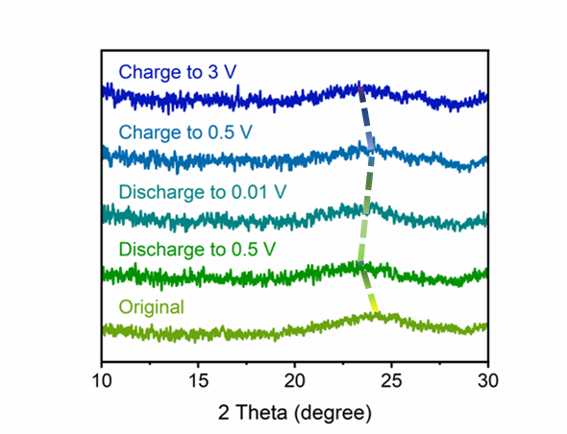
Figure S14. In situ XRD patterns of the GDY electrode at different states.
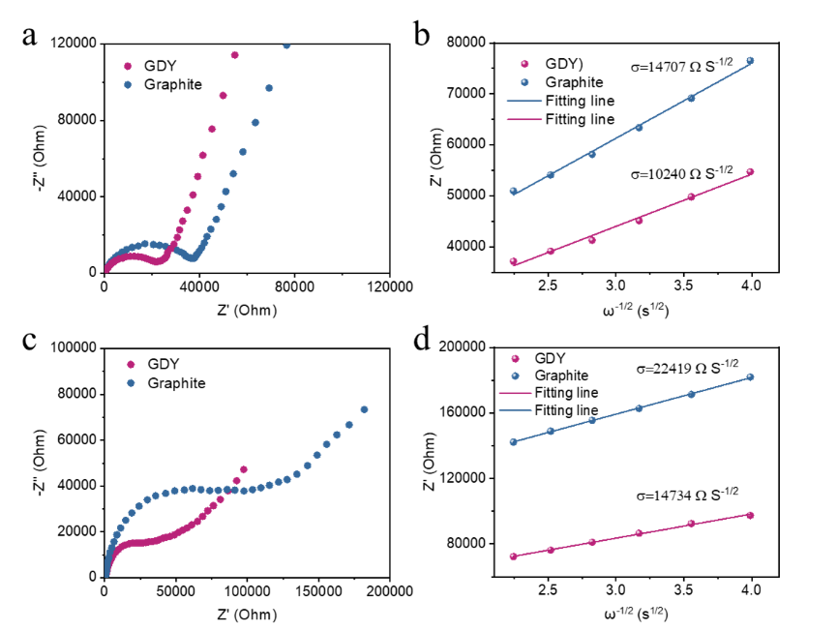
Figure S15. (a) Electrochemical impedance spectra of the GDY and graphite electrodes and (b) linear fits of the Z' versus ω^{−1/2} (ω=2πf) in the low−frequency region. (c) Electrochemical impedance spectra of the GDY and graphite electrodes after 100 cycles and (d) linear fits of the Z' versus ω^{−1/2} (ω = 2πf) in the low−frequency region.

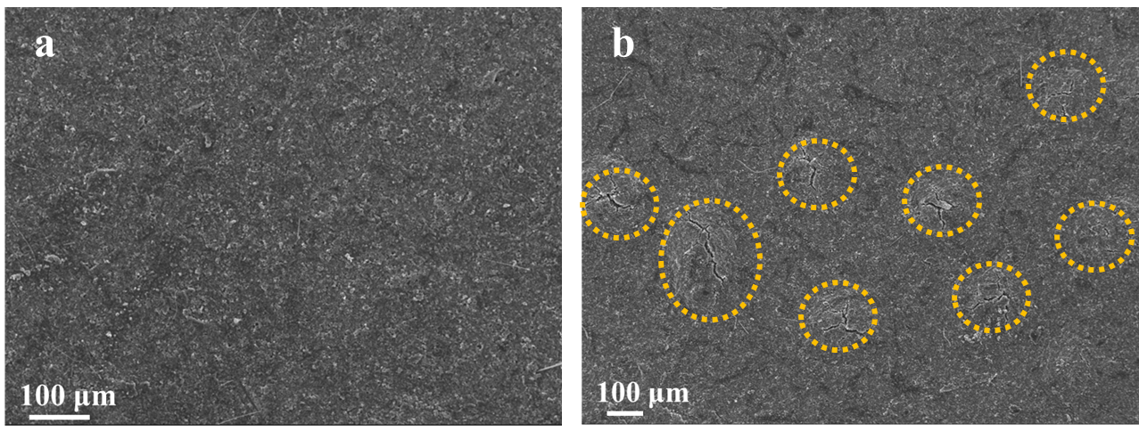
Figure S16. SEM images of the cycled anode of (a) GDY, (b) graphite at current density of 1 A g⁻¹ after 1000 cycles for KIBs.
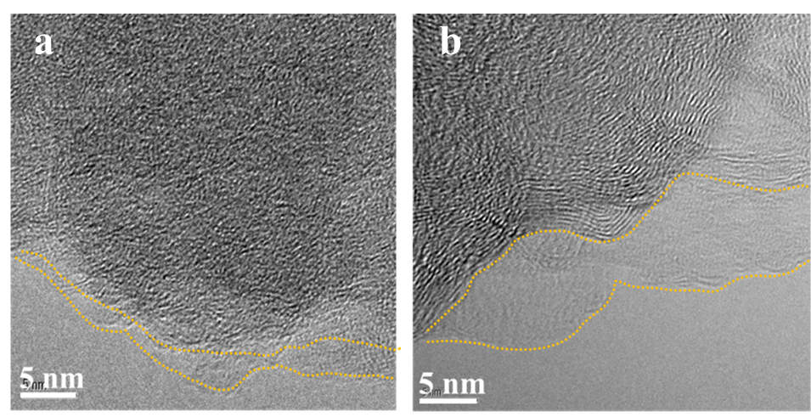
Figure S17. TEM images of the cycled anode of (a) GDY, (b) graphite at current density of 1 A g⁻¹ after 1000 cycles for KIBs.

Supplementary Note 3: The C 1s spectra can be deconvoluted into five peaks include C-C/C-H (~284.8 eV), C-O (~286.2 eV), C=O (~287.8 eV), CO₃²⁻ (~29.7 eV) and C-F bonds (~290.9 eV). The O 1s spectra can be deconvoluted into four peaks include C-O (~532.0 eV), C=O (~533.2 eV), O-F (~534.8 eV) and CO₃²⁻ (~530.0 eV). which are originated from PEO, PEDC, KxPFyOz and K₂CO₃. PEO exhibits superior mechanical flexibility and is able to build a fast K⁺ diffusion network, which favorable for improved electrochemical stability of SEI. In contrast, PEDC is an ionic insulator and easily decomposed to RCH2OK or K2CO3 upon long cycling. In F 1s spectra, the main peak around 688.5 eV is attributed to P- F bond, and the peaks at 684.5 eV, 686.2 eV are ascribed to K-F and C-F.

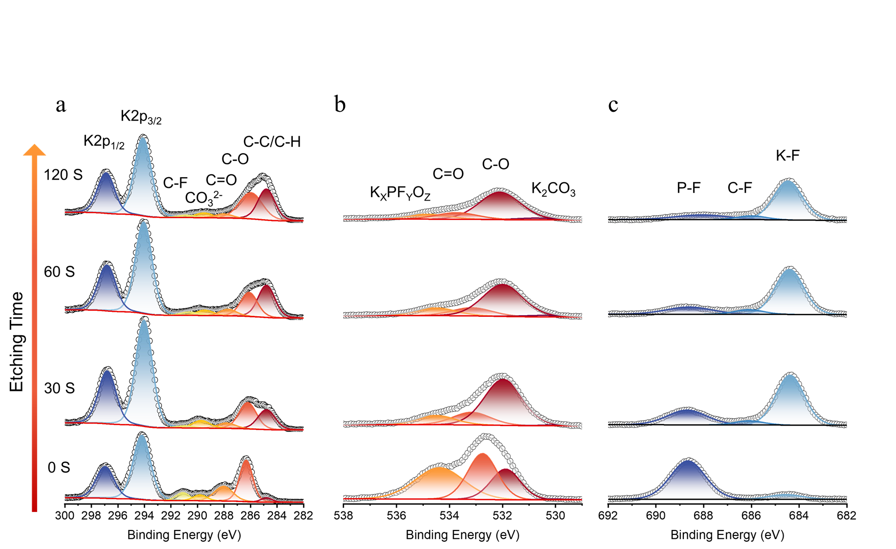
Figure S18. Depth profiling XPS analysis (normalized according to the relative peak intensity of the XPS spectrum) of the SEI chemistry after 10 cycles with sputtering time 0, 30, 60 and 120 s. Graphite electrode retrieved from Graphite/K half-cell charged to 3.0 V: (a) C 1s & K 2p, (b) O 1s and (c) F 1s.
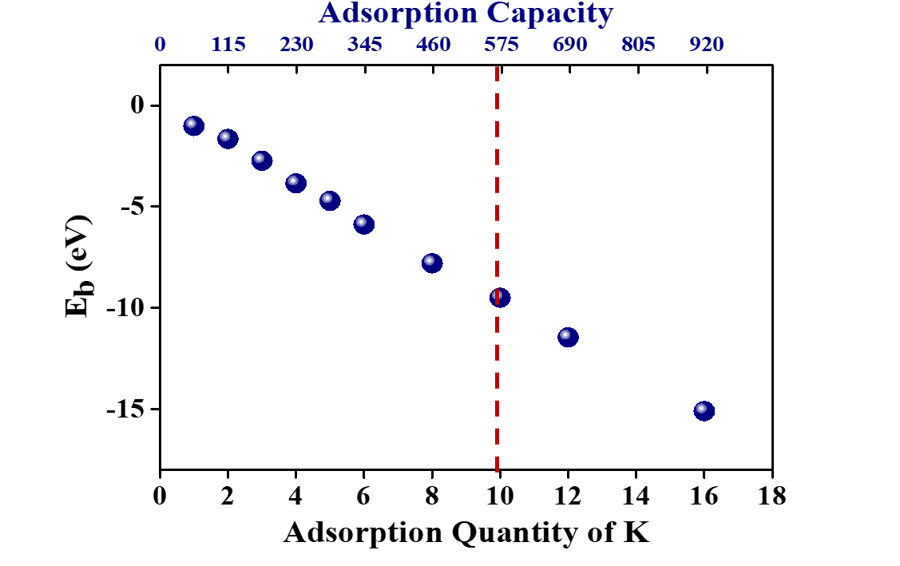
Figure S19. Calculated binding energy of K-ion adsorption, adsorption quantity, and the corresponding specific capacity.
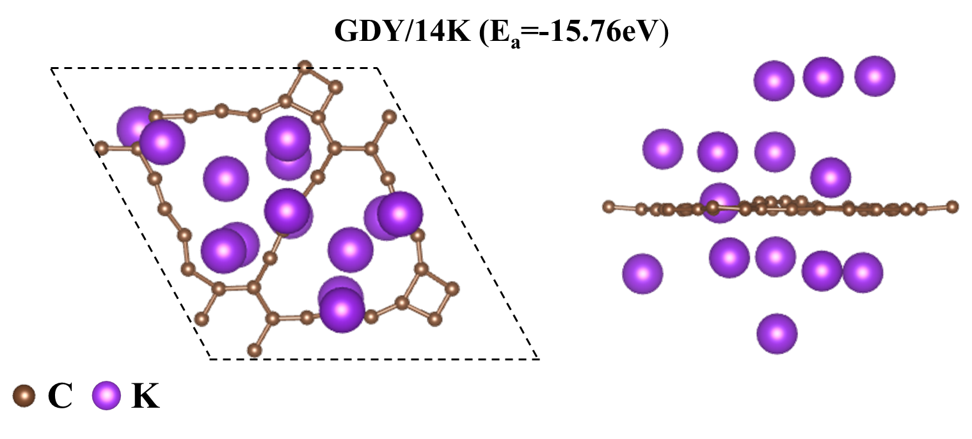
Figure S20. Optimized structure and binding energy of 14 potassium loading.

Supplementary in situ Movie 1: In situ TEM observation of potassiation of GDY electrode at a bias of −3 V. (The display was sped up by 5 times the real time of potassiation).

Table S1. The adsorption configuration and adsorption energy of single K atom in monolayer GDY.
Configurations | Structures |  | E_{ad}, eV | Distance
 | Top views | Side views
Site 1 | 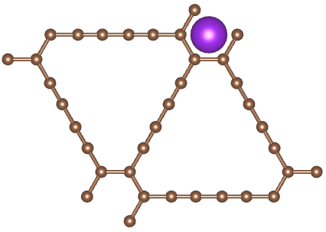 | 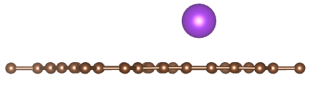 | -1.94 | 2.56Å
Site 2 | 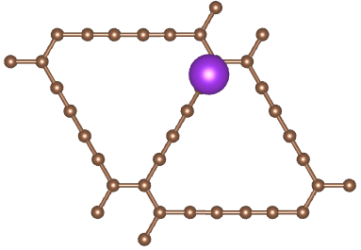 |  | -1.77 | 2.57Å
Site 3 | 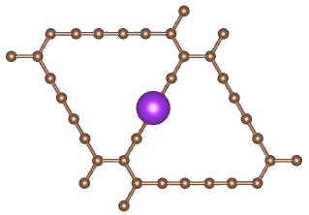 |  | -1.79 | 2.57Å
Site 4 | 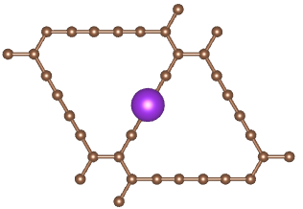 |  | -1.79 | 2.57Å
Site 5 | 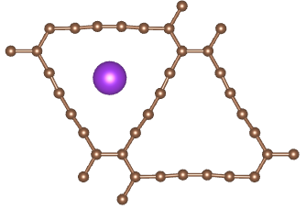 |  | -2.65 | 2.84Å
Site 6 |  |  | -2.65 | 2.84Å
Site 7 |  |  | -2.66 | 2.84Å

Table S2. Comparison of cyclic stability between the current GDY composite anode and other representative carbon composite electrodes in KIBs.
Materials | Current density/  A g⁻¹ | Capacity/  mAh g⁻¹ | Cycle number | Running Time/ months | Ref
GDY | 0.1 | 100 | 180 | 1 | ^{[11]}
GDY | 0.1 | 216 | 200 | 2 | ^{[12]}
Si-DY | 0.05 | 496 | 100 | 3 | ^{[13]}
CNFs | 0.2 | 168 | 100 | 1 | ^{[14]}
OGCS | 0.5 | 270 | 500 | 1 | ^{[15]}
NSG | 0.5 | 220 | 100 | 2 | ^{[16]}
SiC-CDC-900 | 0.1 | 284.8 | 200 | 2 | ^{[17]}
ENDC500 | 0.2 | 305 | 600 | 2 | ^{[18]}
SNHC | 0.1 | 213 | 500 | 3.5 | ^{[19]}
N-YS-CSS | 0.1 | 212 | 200 | 2 | ^{[20]}
ENPCS-500 | 0.1 | 246 | 150 | 1.5 | ^{[21]}
NCNF-650 | 0.2 | 191 | 200 | 1 | ^{[22]}
Graphite | 0.15 | 100 | 50 | 1 | ^{[23]}
SC-1200 | 0.28 | 220 | 1000 | 3 | ^{[24]}
QLGO | 0.1 | 200 | 100 | 1 | ^{[25]}
300-PGCNT | 0.2 | 148 | 950 | 2.5 | ^{[26]}
CFM-S₃₀NG | 0.1 | 251 | 200 | 2 | ^{[27]}
PP-1500 | 0.1 | 212 | 100 | 3 | ^{[28]}
ECM-800 | 0.5 | 291 | 100 | 0.5 | ^{[29]}
CNS-1000 | 0.1 | 321 | 400 | 4 | ^{[30]}
N-HPC | 0.1 | 292 | 400 | 4 | ^{[31]}
NHC2-NH₃/Ar | 0.2 | 225 | 1000 | 4 | ^{[32]}
GDY | 0.05 | 220 | 600 | 7 | This work
GDY | 0.1 | 202 | 2100 | 13 | This work

Table S3. The detail information about EIS analysis.
Sample | σ (Ω S^{-1/2}) | D_{k} (cm² s⁻¹）
graphite | 14707 | 6.34×10⁻¹⁶
GDY | 10240 | 1.31×10⁻¹⁵
graphite (100th cycles) | 22419 | 2.73×10⁻¹⁶
GDY (100th cycles) | 14734 | 6.31×10⁻¹⁶

[1] Li, G.; Li, Y.; Liu, H.; Guo, Y.; Li, Y.; Zhu, D., Architecture of graphdiyne nanoscale films. Chem. Commun., 2010, 46, 3256-8.
[2] Liang, X.; Li, X.; Xiang, Q.; Zhang, S.; Cao, Y.; Han, M.; Zhang, Y.; Zhou, C.; Xu, Y.; Mao, C.; Li, W.; Sun, J., Surficial Oxidation of Phosphorus for Strengthening Interface Interaction and Enhancing Lithium-Storage Performance. Nano Lett. 2022, 22, 9335-9342.
[3] Chen, J.; Cheng, Y.; Zhang, Q.; Luo, C.; Li, H. Y.; Wu, Y.; Zhang, H.; Wang, X.; Liu, H.; He, X.; Han, J.; Peng, D. L.; Liu, M.; Wang, M. S., Designing and Understanding the Superior Potassium Storage Performance of Nitrogen/Phosphorus Co‐Doped Hollow Porous Bowl‐Like Carbon Anodes. Adv. Funct. Mater. 2020, 31, 2007158.
[4] Liang, X.; Wang, X.; Li, G.; Xiang, Q.; Zhou, C.; Chen, A.; Li, X.; Zhang, S.; Cao, Y.; Han, M.; Han, C.; Gong, H.; Wang, H.; Zhang, Y.; Sun, J., Unlocking the side reaction mechanism of phosphorus anode with binder and the development of a multifunctional binder for enhancing the performance. J. Power Sources. 2022, 541.
[5] Kresse, G.; Furthmüller, J., Efficient iterative schemes for ab initio total-energy calculations using a plane-wave basis set. Phys. Rev. B. 1996, 54, 11169-11186.
[6] Perdew, J. P.; Burke, K.; Ernzerhof, M., Generalized Gradient Approximation Made Simple. Phys. Rev. Lett. 1996, 77, 3865-3868.
[7] Blöchl, P. E., Projector augmented-wave method. Phys. Rev. B. 1994, 50, 17953-17979..
[8] Henkelman, G.; Uberuaga, B. P.; Jónsson, H., A climbing image nudged elastic band method for finding saddle points and minimum energy paths. J. Chem. Phys. 2000, 113, 9901-9904.
[9] Heyden, A.; Bell, A. T.; Keil, F. J., Efficient methods for finding transition states in chemical reactions: Comparison of improved dimer method and partitioned rational function optimization method. J. Chem. Phys. 2005, 123, 224101.
[10] Zheng, J. P.; Liang, R. Y.; Hendrickson, M.; Plichta, E. J., Theoretical Energy Density of Li–Air Batteries. J. Electrochem. Soc. 2008, 155 (6), A432.
[11] Yi, Y.; Li, J.; Zhao, W.; Zeng, Z.; Lu, C.; Ren, H.; Sun, J.; Zhang, J.; Liu, Z., Temperature‐Mediated Engineering of Graphdiyne Framework Enabling High‐Performance Potassium Storage. Adv. Funct. Mater. 2020, 30, 2003039.
[12] Li, J.; Yi, Y.; Zuo, X.; Hu, B.; Xiao, Z.; Lian, R.; Kong, Y.; Tong, L.; Shao, R.; Sun, J.; Zhang, J., Graphdiyne/Graphene/Graphdiyne Sandwiched Carbonaceous Anode for Potassium-Ion Batteries. ACS Nano. 2022, 16, 3163-3172.
[13] Yang, Z.; Song, Y.; Zhang, C.; He, J.; Li, X.; Wang, X.; Wang, N.; Li, Y.; Huang, C., Porous 3D Silicon‐Diamondyne Blooms Excellent Storage and Diffusion Properties for Li, Na, and K Ions. Adv. Energy Mater. 2021, 11, 2101197.
[14] Li, H.; Cheng, Z.; Zhang, Q.; Natan, A.; Yang, Y.; Cao, D.; Zhu, H., Bacterial-Derived, Compressible, and Hierarchical Porous Carbon for High-Performance Potassium-Ion Batteries. Nano Lett. 2018, 18, 7407-7413.
[15] Qian, Y.; Jiang, S.; Li, Y.; Yi, Z.; Zhou, J.; Tian, J.; Lin, N.; Qian, Y., Water-Induced Growth of a Highly Oriented Mesoporous Graphitic Carbon Nanospring for Fast Potassium-Ion Adsorption/Intercalation Storage. Angew. Chem., Int. Ed. 2019, 58, 18108-18115.
[16] Lu, C.; Sun, Z.; Yu, L.; Lian, X.; Yi, Y.; Li, J.; Liu, Z.; Dou, S.; Sun, J., Enhanced Kinetics Harvested in Heteroatom Dual‐Doped Graphitic Hollow Architectures toward High Rate Printable Potassium‐Ion Batteries. Adv. Energy Mater. 2020, 10, 2001161.
[17] Wu, J.; Zhang, X.; Li, Z.; Yang, C.; Zhong, W.; Li, W.; Zhang, C.; Yang, N.; Zhang, Q.; Li, X., Toward High‐Performance Capacitive Potassium‐Ion Storage: A Superior Anode Material from Silicon Carbide‐Derived Carbon with a Well‐Developed Pore Structure. Adv. Funct. Mater. 2020, 30, 2004348.
[18] Zhang, W.; Cao, Z.; Wang, W.; Alhajji, E.; Emwas, A. H.; Costa, P.; Cavallo, L.; Alshareef, H. N., A Site-Selective Doping Strategy of Carbon Anodes with Remarkable K-Ion Storage Capacity. Angew. Chem., Int. Ed. 2020, 59, 4448-4455.
[19] Liu, Y.; Dai, H.; Wu, L.; Zhou, W.; He, L.; Wang, W.; Yan, W.; Huang, Q.; Fu, L.; Wu, Y., A Large Scalable and Low‐Cost Sulfur/Nitrogen Dual‐Doped Hard Carbon as the Negative Electrode Material for High‐Performance Potassium‐Ion Batteries. Adv. Energy Mater. 2019, 9, 1901379.
[20] Chong, S.; Yuan, L.; Li, T.; Shu, C.; Qiao, S.; Dong, S.; Liu, Z.; Yang, J.; Liu, H. K.; Dou, S. X.; Huang, W., Nitrogen and Oxygen Co-Doped Porous Hard Carbon Nanospheres with Core-Shell Architecture as Anode Materials for Superior Potassium-Ion Storage. Small.. 2022, 18 (8), e2104296.
[21] Xu, F.; Zhai, Y.; Zhang, E.; Liu, Q.; Jiang, G.; Xu, X.; Qiu, Y.; Liu, X.; Wang, H.; Kaskel, S., Ultrastable Surface-Dominated Pseudocapacitive Potassium Storage Enabled by Edge-Enriched N-Doped Porous Carbon Nanosheets. Angew. Chem., Int. Ed. 2020, 59, 19460-19467.
[22] Xu, Y.; Zhang, C.; Zhou, M.; Fu, Q.; Zhao, C.; Wu, M.; Lei, Y., Highly nitrogen doped carbon nanofibers with superior rate capability and cyclability for potassium ion batteries. Nat. Commun. 2018, 9, 1720.
[23] Jian, Z.; Luo, W.; Ji, X., Carbon Electrodes for K-Ion Batteries. J. Am. Chem. Soc. 2015, 137, 11566-9.
[24] Liu, Y.; Lu, Y. X.; Xu, Y. S.; Meng, Q. S.; Gao, J. C.; Sun, Y. G.; Hu, Y. S.; Chang, B. B.; Liu, C. T.; Cao, A. M., Pitch-Derived Soft Carbon as Stable Anode Material for Potassium Ion Batteries. Adv Mater. 2020, 32, e2000505.
[25] Zhong, L.; Zhang, W.; Sun, S.; Zhao, L.; Jian, W.; He, X.; Xing, Z.; Shi, Z.; Chen, Y.; Alshareef, H. N.; Qiu, X., Engineering of the Crystalline Lattice of Hard Carbon Anodes Toward Practical Potassium‐Ion Batteries. Adv. Funct. Mater. 2022, 33, 2211872.
[26] Chen, J.; Chen, G.; Zhao, S.; Feng, J.; Wang, R.; Parkin, I. P.; He, G., Robust Biomass-Derived Carbon Frameworks as High-Performance Anodes in Potassium-Ion Batteries. Small. 2023, 19, e2206588.
[27] Yang, W.; Zhou, J.; Wang, S.; Wang, Z.; Lv, F.; Zhang, W.; Zhang, W.; Sun, Q.; Guo, S., A Three-Dimensional Carbon Framework Constructed by N/S Co-doped Graphene Nanosheets with Expanded Interlayer Spacing Facilitates Potassium Ion Storage. ACS Energy Lett. 2020, 5, 1653-1661.
[28] Wu, S.; Song, Y.; Lu, C.; Yang, T.; Yuan, S.; Tian, X.; Liu, Z., High-rate soft carbon anode in potassium ion batteries: The role of chemical structures of pitches. Carbon. 2023, 203, 211-220.
[29] Yuan, F.; Shi, C.; Li, Q.; Wang, J.; Zhang, D.; Wang, Q.; Wang, H.; Li, Z.; Wang, W.; Wang, B., Unraveling the Effect of Intrinsic Carbon Defects on Potassium Storage Performance. Adv. Funct. Mater. 2022, 32, 2208966.
[30] Chen, Y.; Xi, B.; Huang, M.; Shi, L.; Huang, S.; Guo, N.; Li, D.; Ju, Z.; Xiong, S., Defect-Selectivity and "Order-in-Disorder" Engineering in Carbon for Durable and Fast Potassium Storage. Adv Mater. 2022, 34, e2108621.
[31] Zhou, X.; Chen, L.; Zhang, W.; Wang, J.; Liu, Z.; Zeng, S.; Xu, R.; Wu, Y.; Ye, S.; Feng, Y.; Cheng, X.; Peng, Z.; Li, X.; Yu, Y., Three-Dimensional Ordered Macroporous Metal-Organic Framework Single Crystal-Derived Nitrogen-Doped Hierarchical Porous Carbon for High-Performance Potassium-Ion Batteries. Nano Lett. 2019, 19, 4965-4973.
[32] Yang, W.; Zhou, J.; Wang, S.; Zhang, W.; Wang, Z.; Lv, F.; Wang, K.; Sun, Q.; Guo, S., Freestanding film made by necklace-like N-doped hollow carbon with hierarchical pores for high-performance potassium-ion storage. Energy Environ. Sci. 2019, 12, 1605-1612.

