Supporting Information

Single-Atom Lithiophilic Sites Confined within Ordered Porous Carbons for Ultra-Stable Lithium Metal Anodes

Wenzhong Huang, Shanlin Liu, Ruohan Yu, Liang Zhou, Zhenhui Liu*and Liqiang Mai*

1. Experimental Section

  - Chemicals
All the chemical reagents used were purchased from Sinopharm Chemical Reagent Co., Ltd. (Shanghai, China).

  - Synthesis of NOMC-Ni
NOMC-Ni was synthesized by dissolving 0.7 g Hexamethylenetetramine, 1.1g 3-Aminophenol, 2 ml Ammonium hydroxide and 2.2 g Pluronic F-127 in 52 ml deionized water. After stirring for 24 h at 80 ºC water bath, the solid powder obtained by the reaction is filtered and dried naturally. Then, the powder and NiCl₂ were dissolved in 5 ml deionized water at a mass ratio of 100:1. After stirring aifor 1 h, the mixed solution was suction filtered and dried naturally. Finally, the obtained powder product is carbonized in 800 °C flowing nitrogen for 2 h with 1 °C min⁻¹ heating rate.

  - Synthesis of NOMC
The synthesis of NOMC is the same as that of NOMC-Ni, except that NiCl₂ is not added.

  - Synthesis of OMC
The synthesis of OMC is the same as that of NOMC, except that 3-Aminophenol is replaced by resorcinol.

  - Characterization
XRD patterns were recorded on a Bruker D8 Discover X-ray diffractometer with Cu Kα radiation (λ = 1.5418 Å). Field emission scanning electron microscopy (FESEM, JEOL JSM-7100F) and transmission electron microscopy (TEM, Titan G2 60-300) were employed to characterize morphologies of the samples. The elemental mapping was collected by the TEM equipped with an energy-dispersive X-ray spectroscope (EDX). X-ray photoelectron spectroscopy (XPS) measurements were performed on a Thermo-Fisher Scientific, ESCALAB 250Xi system. The Inductively Coupled Plasma-Optical Emission Spector was employed to analysis the content of Fe/Co element (ICP, Prodigy 7). Fourier transform infrared (FT-IR) was applied on Nexus. Raman spectra were recorded using a confocal Raman microscope (DXR, Thermo-Fisher Scientific). Brunauer-Emmett-Teller (BET) surface areas were measured using a Tristar II 3020 instrument. The X-ray absorption spectroscopy (XAS) data were acquired at bending magnet beamline 12-BM-B at the Advanced Photon Source (APS), Argonne National Laboratory. The synchrotron radiation was filtered by a double-crystal Si (111) monochromator with a double-mirror system for focusing and harmonic rejection.

  - Electrochemical measurements
The NOMC-Ni (70 wt%), acetylene black (20 wt%), and Poly(vinylidene fluoride) (10 wt%) were dispersed in water to form a slurry. The slurry was spread onto a Cu foil by a doctor blade method, followed by drying in vacuum at 70 °C for 12 h. The mass loading of the active material was 1 mg cm⁻². 1.0 M LiTFSI in DOL/DME (50/50, v/v) was used as the electrolyte. The electrochemical performances were characterized by assembling CR2016 coin cells with lithium foil as the counter and reference electrode. Galvanostatic discharge/charge measurements were performed in a potential range of 0 – 1.0 V vs. Li⁺ /Li using a multichannel battery testing system (LAND CT2001A). NOMC-Ni/LiPFeO₄ full cells were also assembled. The weight ratio of cathode to anode was around 4:1, and the weight ratio of LiPFeO₄: acetylene black: PVDF was 70:20:10 in the cathode. The NOMC-Ni was firstly pre-lithiated in half cells and then taken out for full cell assembly. The Li-NOMC-Ni//LiFePO₄ full cells were charged/ discharged galvanostatically at 0.2, 0.5, 1.0 and 2.0 C (1 C = 170 mA h g⁻¹) in the electrochemical window of 2.5–4.2 V.

2. Supplemental figures and tables

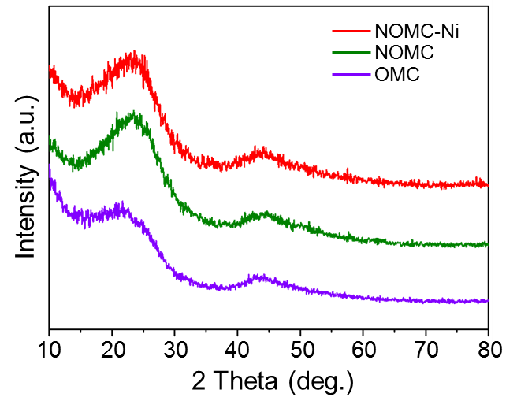
Figure S1. XRD patterns of NOMC, NOMC-Ni and OMC.

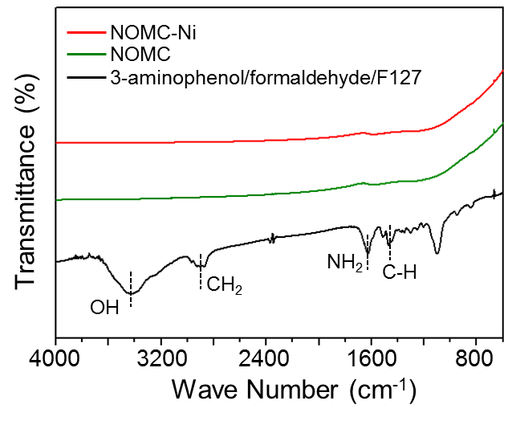
Figure S2. FT-IR spectra of 3-aminophenol/formaldehyde/F127, NOMC, and NOMC-Ni.

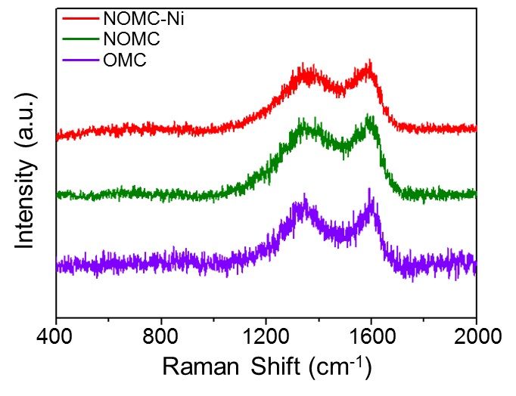
Figure S3. Raman spectra of NOMC, NOMC-Ni and OMC.

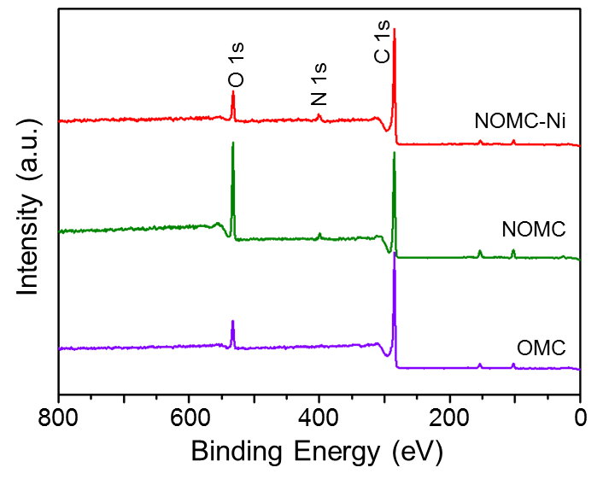
Figure S4. XPS survey spectra of NOMC, NOMC-Ni and OMC.

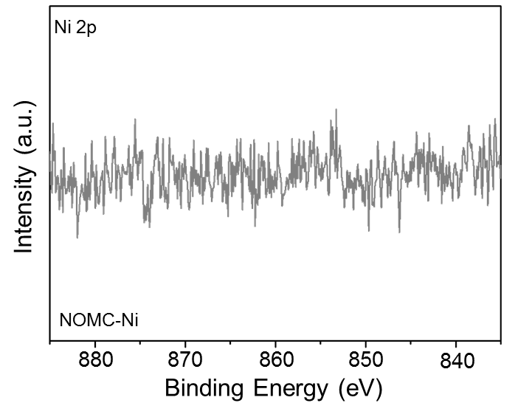
Figure S5. XPS spectra. Ni 2p spectra of NOMC-Ni.

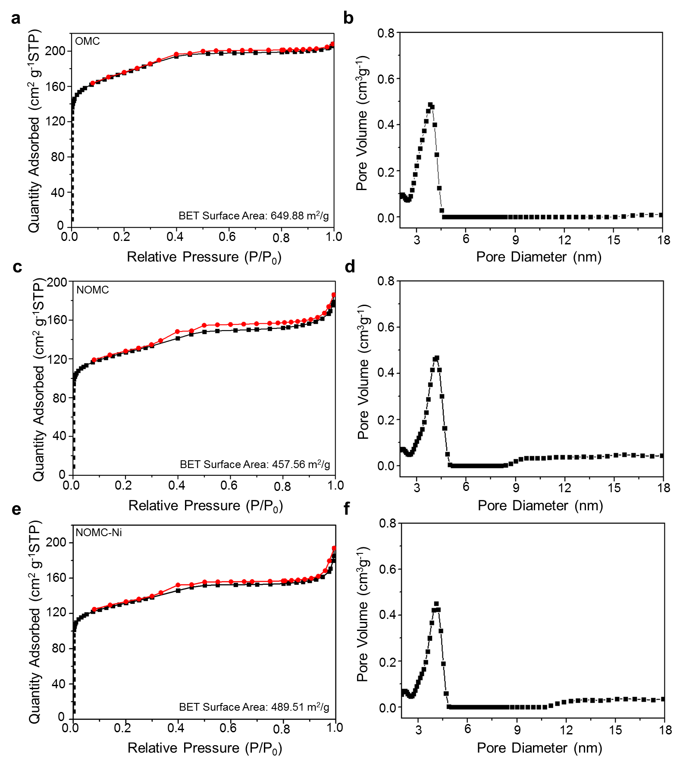
Figure S6. Nitrogen adsorption-desorption isotherms and pore diameter distribution of (a, b) OMC, (c, d) NOMC and (e, f) NOMC-Ni.

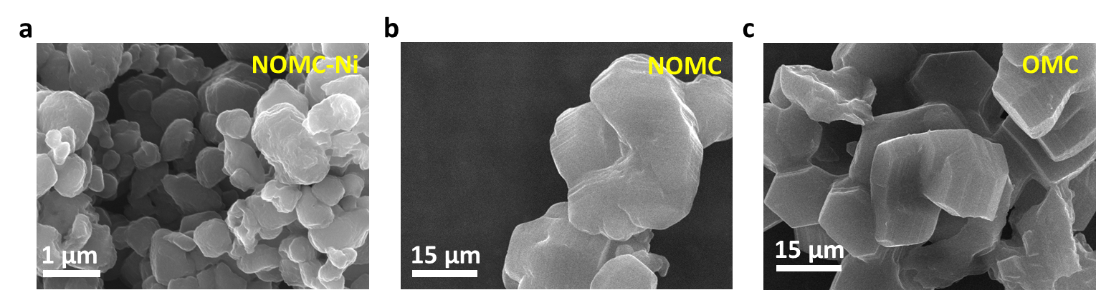
Figure S7. SEM patterns of (a) NOMC-Ni, (b) NOMC and (c) OMC.

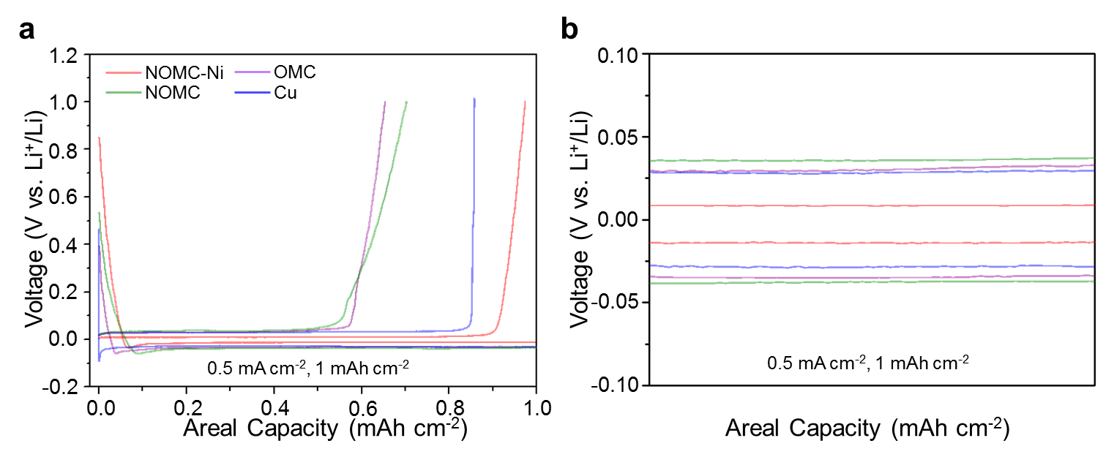
Figure S8. (a) Electrochemical performance of Cu, OMC, NOMC and NOMC-Ni: 80th Li plating/stripping profiles at current densities of 0.5 mA cm⁻² and (b) corresponding enlargement.

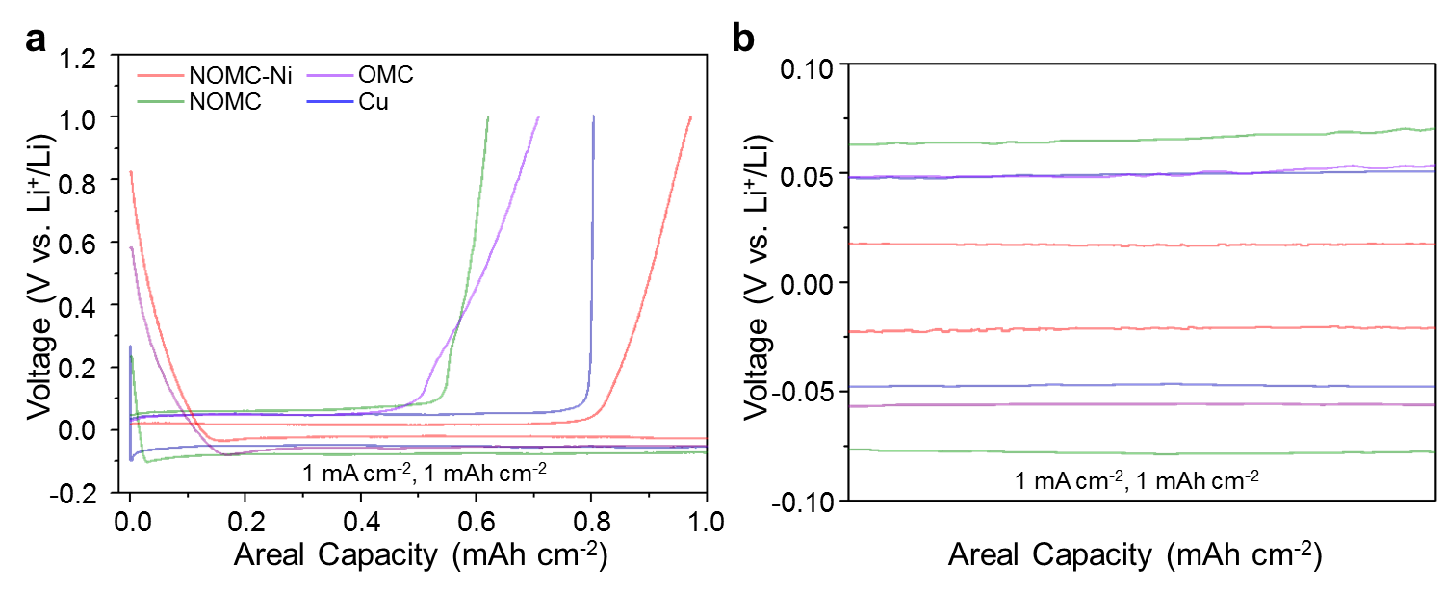
Figure S9. (a) Electrochemical performance of Cu, OMC, NOMC and NOMC-Ni: 80th Li plating/stripping profiles at current densities of 1 mA cm⁻² and (b) corresponding enlargement.

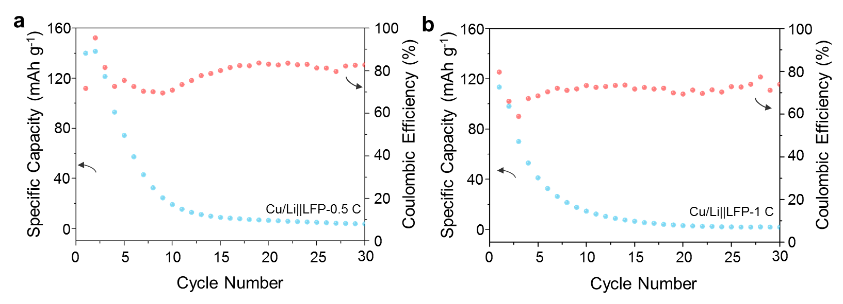
Figure S10. Cycling stability and CEs of Cu/Li||LFP full cells at (a) 0.5 C and (b) 1 C.

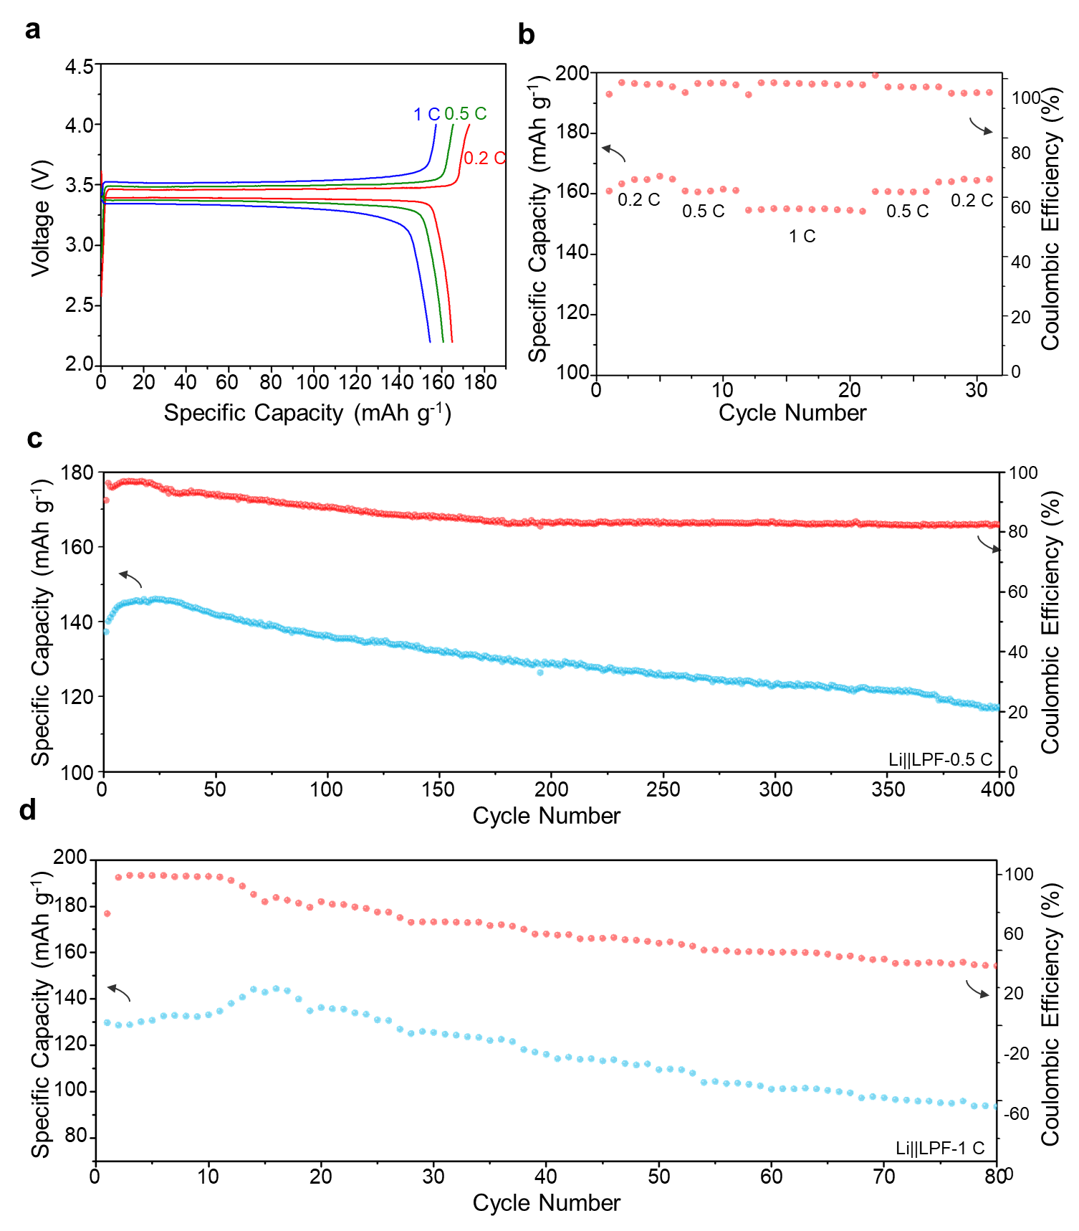
Figure S11. (a) Charge/discharge curves and (b) rate capability of LFP electrodes in half cells with Li at different rates from 0.2 to 1 C. Cycling stability and CEs of Li||LFP at (c) 0.5 C and (d) 1 C.

