Supporting Information
Crystal structure regulation boosts the conductivity and redox chemistry of T-Nb₂O₅ anode material
Jinghui Chen^{1,2}, Jiashen Meng³, Kang Han¹, Fang Liu⁴, Weixiao Wang¹, Qinyou An^{1,2*} and Liqiang Mai^{1,2*}
¹ State Key Laboratory of Advanced Technology for Materials Synthesis and Processing,Wuhan University of Technology, Wuhan 430070, P. R. China
² Hainan Institute, Wuhan University of Technology, Sanya 572000, China
³ Beijing Key Laboratory of Theory and Technology for Advanced Batteries Materials, School of Materials Science and Engineering, Peking University, Beijing, 100871, China
⁴ NRC (Nanostructure Research Centre) ,Wuhan University of Technology, Wuhan 430070, P. R. China
* Corresponding authors.
E-mail addresses: anqinyou86@whut.edu.cn (Prof. Q. Y. An), mlq518@whut.edu.cn (Prof. L. Q. Mai)

Experimental section
Synthesis of Co-Nb₂O₅ and Nb₂O₅
Materials Synthesis: The Co-Nb₂O₅ particles were synthesized by a simple calcination process after obtaining a precursor by simple heat treatment. First, 2 g of terephthalic acid (H₂BDC) was dissolved in 80 ml of N, N-dimethylformamide after magnetic stirring 1 h at room temperature. Second, 4 mmol of niobium pentachloride (NbCl₅) and 2% of cobaltous chloride (CoCl₂, 99.7%) were dissolved in previous solution with vigorous stirring at room temperature for another 1 h. Then, the solution was transferred into a 100 mL Teflon-autoclave and allowed to stand for 12 h in an oven with the temperature of 200 °C. After the autoclave was naturally cooled down to room temperature, the interior mixture was centrifuged to obtain the precipitate, which was subsequently washed with ethanol for 3 times and then dried in an oven at 70 °C for 12 h. The dried light blue powder by the previous steps (named as Co-Nb-BDC) was sintered under air at 800 °C for 2 h. The heating rate of the muffle furnace is 5 °C min⁻¹. As a comparison, the Nb₂O₅ and Co-Nb₂O₅-2 were synthesized using the same processes, without CoCl₂ and with 4% cobaltous chloride, respectively. Additionally, the precursor of Nb₂O₅, white powder, is named as Nb-BDC.
Material characterization
The XRD patterns to investigate the crystallographic structure were performed by powder X-ray diffraction using a D8 Discover X-ray diffractometer, with Cu Kα radiation (λ = 1.5418 Å). TOPAS 4.2 software was used to perform XRD Rietveld refinement. Scanning electron microscopy (SEM) images and energy dispersive X-ray spectra (EDS) were obtained using a JEOL JSM-7100F SEM/EDS microscope at an acceleration voltage of 20 Kv. Transmission electron microscopy (TEM), high resolution TEM (HRTEM) and selected area electron diffraction (SAED) images were collected by a JEM-2100F/Titan G2 60-300 microscope. ICP measurement was recorded with a PerkinElmer Optima 4300DV spectrometer. X-ray photoelectron spectroscopy (XPS) analysis was performed using a VG Multilab 2000 instrument. Raman spectra were obtained using a Renishaw INVIA micro-Raman spectroscopy system. The I-V curve tests were carried out by using probe station (Lake Shore, TTPX). UV-Vis diffuse reflectance spectra were acquired by Lambda 750 S.

Electrochemical properties
The electrochemical properties were characterized by assembling 2016 coin cells in a glove box (O₂ ≤ 0.01 ppm and H₂O ≤ 0.01 ppm), and a Li metal (99.5%, Sigma-Aldrich) of 200 µm in thickness was used as the reference electrode. 1 M LiPF₆ in 1:1 ratio v/v ethylene carbonate/dimethyl carbonate (EC/DMC; Sigma-Aldrich, battery grade) (140 µl) was used as the electrolyte, and the separator was Celgard 2400 microporous membrane. To obtain the anodes, 70% as-synthesized active materials, 20% acetylene black and 10% polyvinylidene fluoride (PVDF) were mixed in N-methyl-2-pyrrolidone (NMP). The copper foil coated with active materials was dried at 70 °C in a vacuum oven overnight. The loading of the active material was 1.2-2.0 mg cm⁻². The cathode was obtained by casting slurry containing LiFePO₄ (70 wt%), acetylene black (20 wt%), and PVDF (10 wt%) in NMP onto aluminum foil with a mass loading of the active material about 2.5 mg cm⁻². The laminates were then dried at 70 °C under vacuum for at least 12 h prior to use. For the assembly of half cells, the as-prepared laminates were used as the working electrodes, Li metal (99.5%, Sigma-Aldrich) as the counter/reference electrode. A full cell was constructed with a LiFePO₄ cathode and a Co-Nb₂O₅ anode with a capacity ratio of 1.1-1.2. Galvanostatic charge/discharge tests were performed over the potential range from 1 to 3.0 V vs. Li/Li⁺ using a multichannel battery testing system (LAND CT2001A). GITT curves were also measured using a LAND CT2001A multichannel testing system, which conducted at a pulse current of 20 mA g⁻¹ for 5 min, followed with a relaxation for 30 min. Cyclic voltammetry (CV) and Electrochemical Impedance Spectroscopy (EIS) were conducted at room temperature using an electrochemical workstation (CHI600E and Autolab PGSTAT 302N).
Lithium storage measurements
In situ XRD experiments during electrochemical testing of batteries were performed on a D8 Discover X-ray diffractometer equipped with a non-monochromated Cu Kα X-ray source scanned at the 2θ range of 20-40°. For in situ XRD measurements, the electrode was placed immediately behind an X-ray transparent beryllium window that also served as the current collector. The cathode was cut into 2 mm × 2 mm × 0.1 mm sheet.
The DFT calculations are carried out by using the projector-augmented wave representations within the spin-polarized DFT as implemented in the Vienna Ab initio Simulation Package.^{[1]} The exchange–correlation interactions of the generalized gradient approximation in the scheme proposed by Perdew-Burke-Ernzerhof functional. The wave functions are expanded by using the plane waves up to a kinetic energy cutoff of 520 eV. Brillouin-zone integrations are approximated by using special k-point sampling of MonkhorstPack scheme with a k-point mesh resolution of 2π × 0.05 Å⁻¹.^{[2]} The Projector Augmented Wave (PAW) method was used to calculate the effect of core electrons on the valence electron density. The convergence tolerance of energy and force on each atom during structure relaxation were less than 1E⁻⁰⁵ eV and 0.01 eV Å⁻¹. Activation barrier calculation is performed with the climbing nudged elastic band (NEB) method in unit cell of 16 f.u. (formula unit).^{[3]} During the NEB calculations, the lattice parameters are fixed at the relaxed values of the fully delithiated structures, with all the internal degrees of freedom relaxed. The Bader analysis was performed using the Bader Charge Analysis Code.^{[4]}

Fig. S1. XPS survey spectra for Co-Nb-BDC complex and 1,4-dicarboxybenzene.

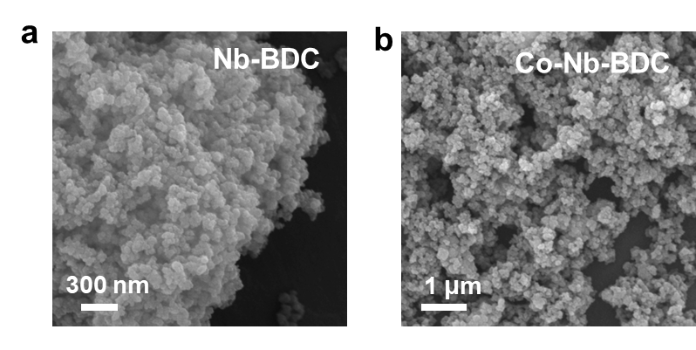
Fig. S2. SEM images of Nb-BDC (a) and Co-Nb-BDC (b).
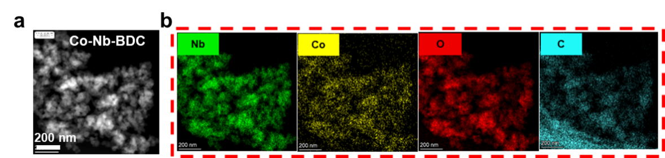
Fig. S3. a) HAADF-STEM image and b) EDX mapping image of Co-Nb-BDC, including Nb, Co, O and C elements.
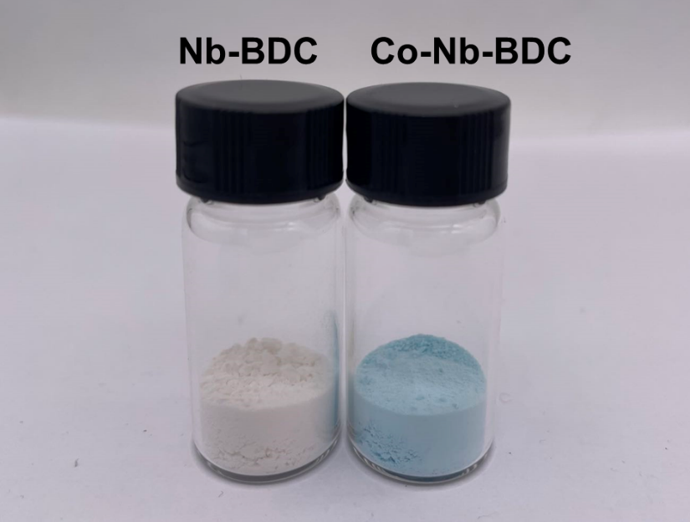
Fig. S4. Powder color comparison of Nb-BDC and Co-Nb-BDC complex precursors.

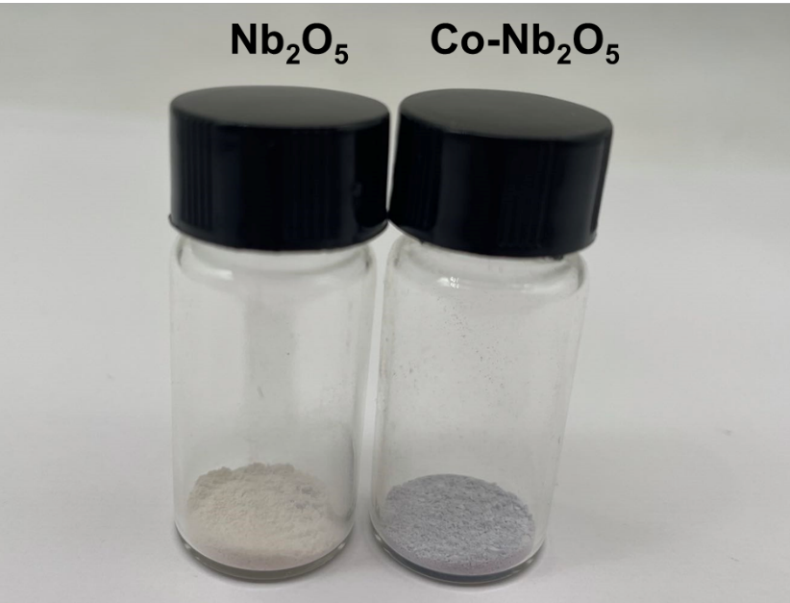
Fig. S5. Powder color comparison of Nb₂O₅ and Co-Nb₂O₅.
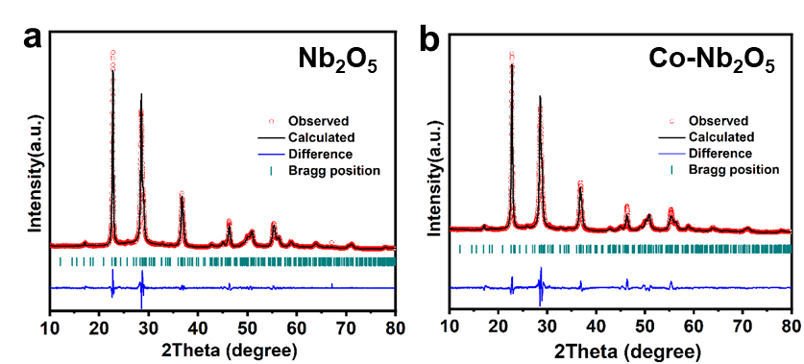
Fig. S6. XRD Rietveld refined diffractograms of Nb₂O₅ (a) and Co-Nb₂O₅ (b).
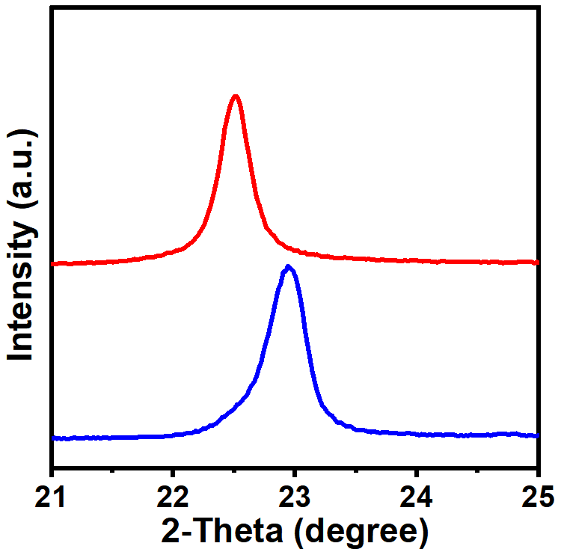
Fig. S7. The enlarged view of the XRD pattern of Co-Nb₂O₅ and Nb₂O₅ in (001) interlayer peak.

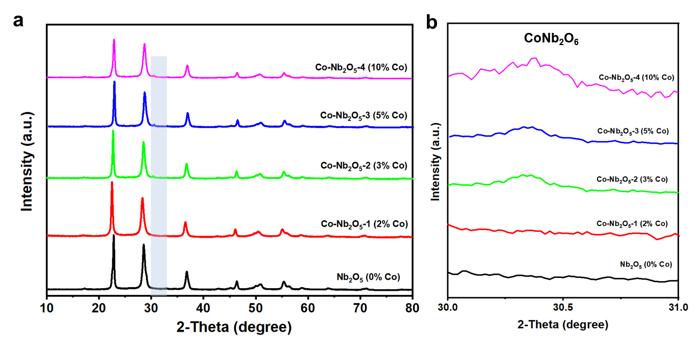
Fig. S8. a) The XRD patterns of Nb₂O₅, Co-Nb₂O₅-1 (Nb₂O₅ doped with 2% Co), Co-Nb₂O₅-2 (Nb₂O₅ doped with 3% Co), Co-Nb₂O₅-3 (Nb₂O₅ doped with 5% Co), and Co-Nb₂O₅-4 (Nb₂O₅ doped with 10% Co), and the enlarged view in the 2θ range of 30-31° (b), respectively.
Fig. S9. XPS survey spectra for pure Nb₂O₅ and Co-Nb₂O₅.
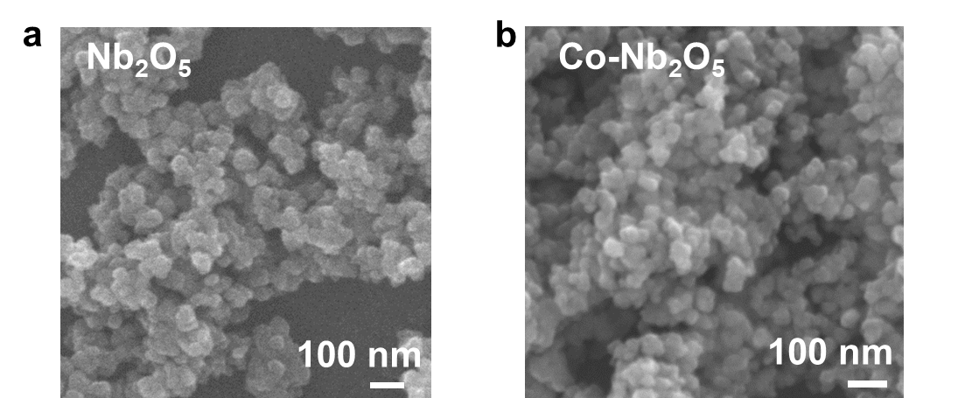
Fig. S10. SEM images of Nb₂O₅ and Co-Nb₂O₅ nanoparticles.
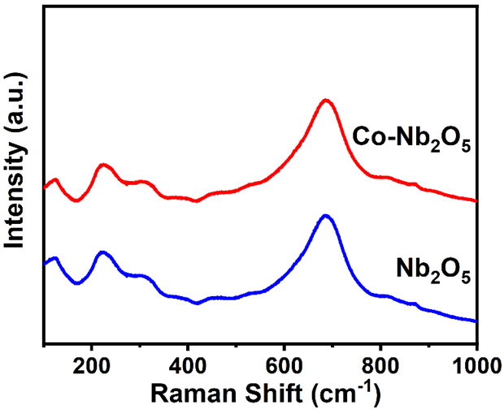
Fig. S11. Raman spectra of Nb₂O₅ and Co-Nb₂O₅ samples.
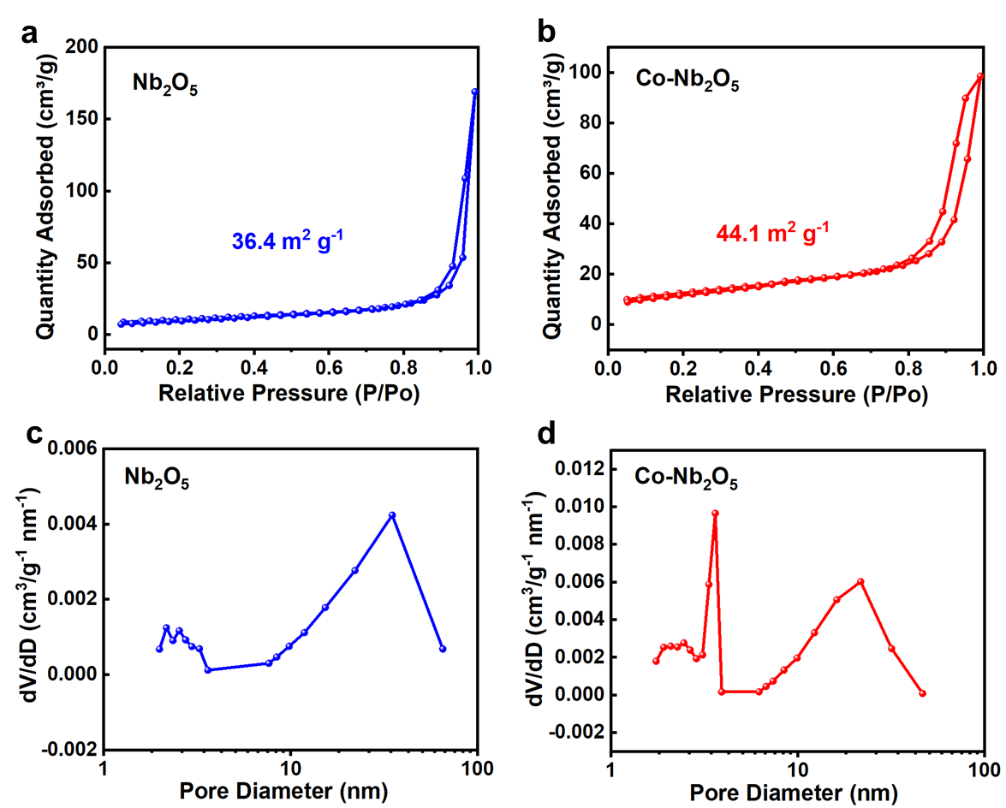
Fig. S12. a, c) BET and BJH curves of Nb₂O₅. b, d) BET and BJH curves of Co-Nb₂O₅ samples.

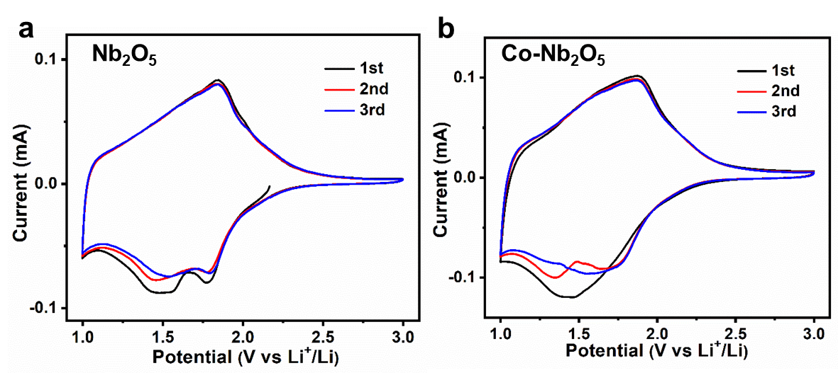
Fig. S13. CV analysis of the first three cycles at 0.1 mV s⁻¹ of Nb₂O₅ (a) and Co-Nb₂O₅ (b) electrodes.

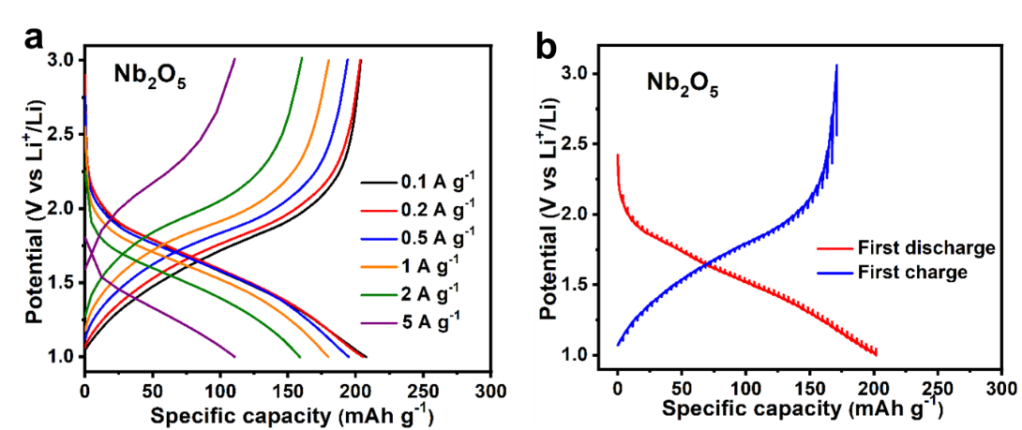
Fig. S14. a) The discharge/charge curves of Nb₂O₅ at various current densities ranging from 0.1, 0.2, 0.5, 1, 2, and 5, back to 0.1 A g⁻¹. b) The GITT curves of charge/discharge process for Nb₂O₅.
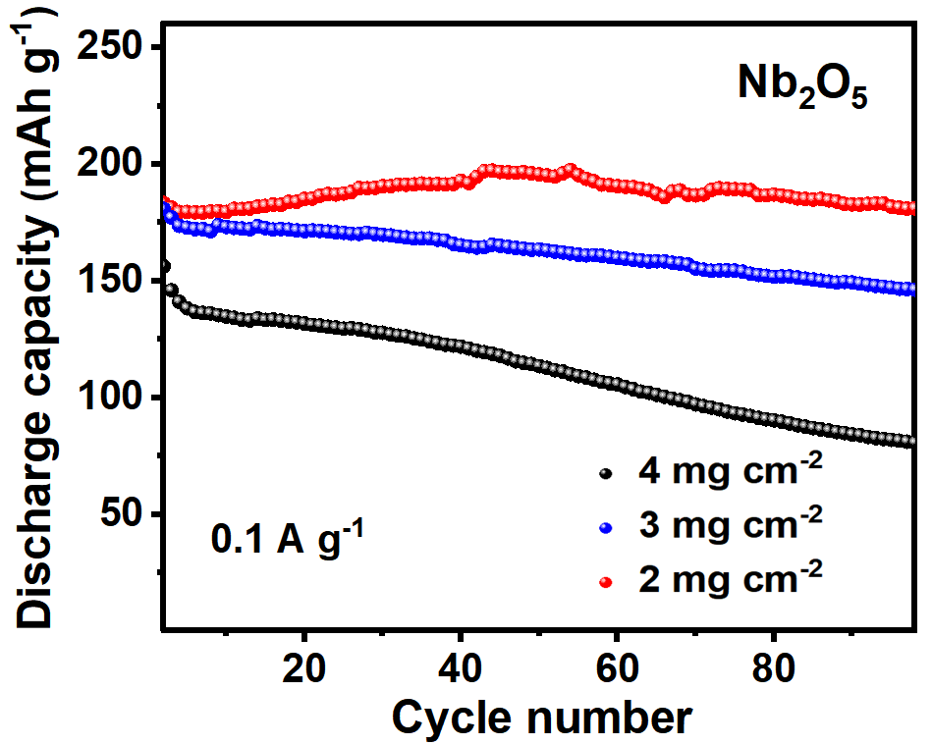
Fig. S15. Cycling performance of Nb₂O₅ with high areal loadings of 2, 3 and 4 mg cm⁻² at 0.1 A g⁻¹.

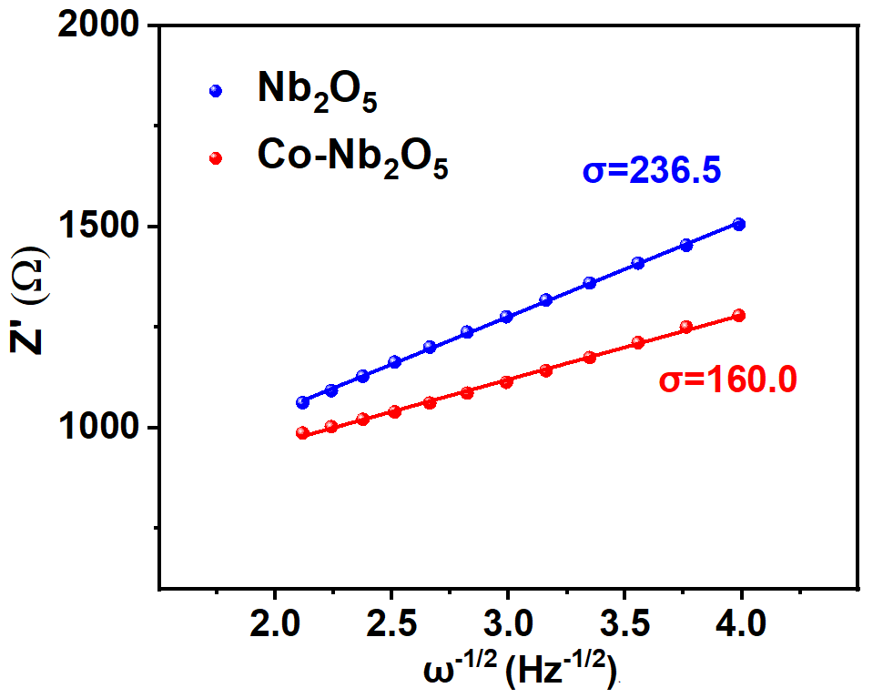
Fig. S16. The relationship between Z′ and ω^{−1/2} (ω = 2πf) of Nb₂O₅ and Co-Nb₂O₅ samples.
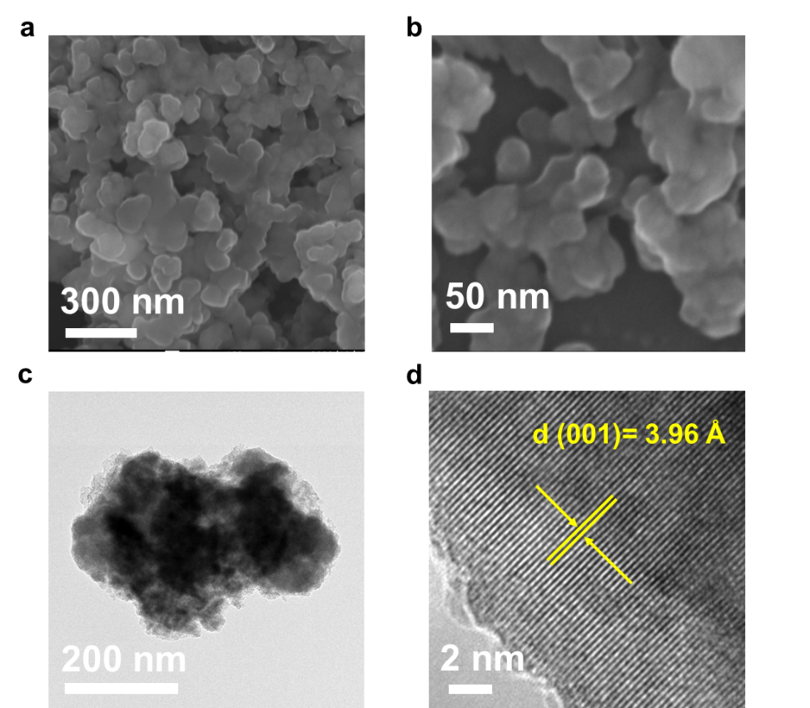
Fig. S17. SEM images (a, b), TEM image (c) and HRTEM image (d) of Co-Nb₂O₅ after 100 cycles.
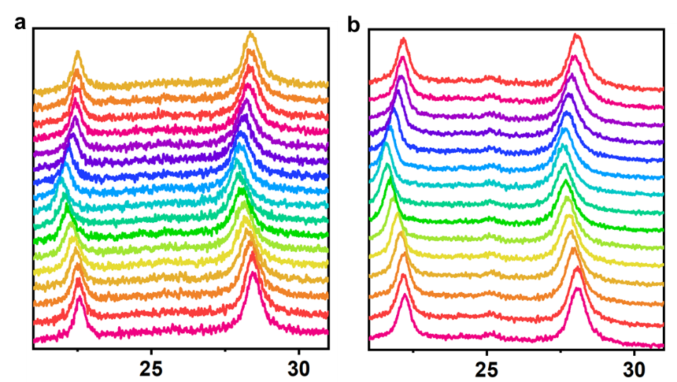
Fig. S18. In situ XRD patterns of a) Nb₂O₅ and b) Co-Nb₂O₅ samples during first charge/discharge process at 0.1 A g⁻¹.
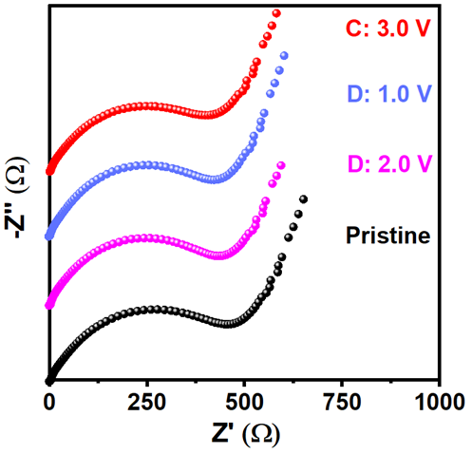
Fig. S19. Ex situ EIS during the initial cycle of Co-Nb₂O₅ electrodes.

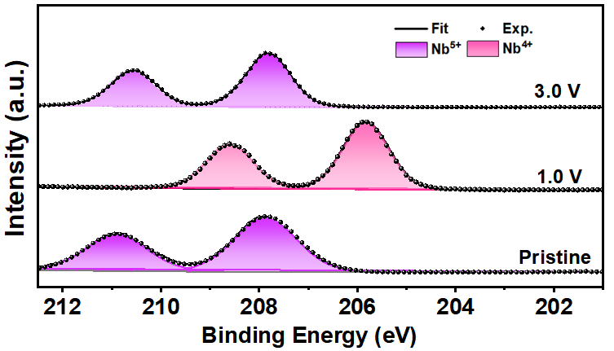
Fig. S20. High-resolution XPS spectra of the T-Nb₂O₅ electrodes upon lithiation/delithiation processes.
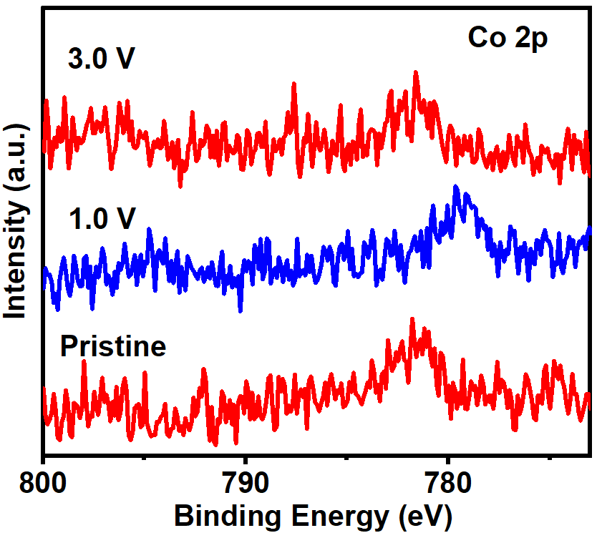
Fig. S21. High-resolution XPS spectra of Co 2p for the Co-Nb₂O₅ electrodes upon lithiation/delithiation processes.
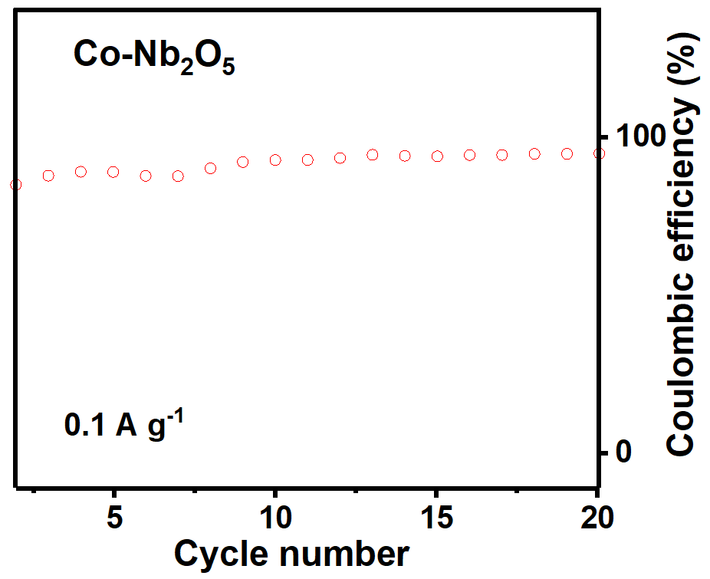
Fig. S21. The enlarged Coulombic efficiencies tested at 0.1 A g⁻¹ during first 20 cycles.
Table S1. ICP measurement results of Nb₂O₅, Co-Nb₂O₅, Co-Nb₂O₅-2, Co-Nb₂O₅-3 and Co-Nb₂O₅-4 samples.
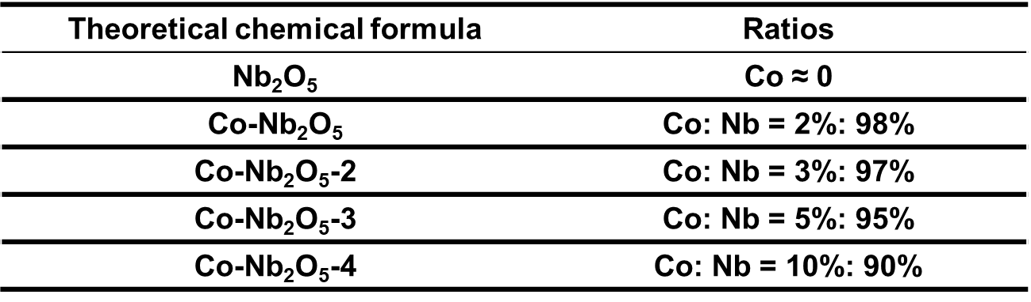
Table S2. Comparison of the capacity retain of the Co-Nb₂O₅ and previous T-Nb₂O₅ with increasing current density.
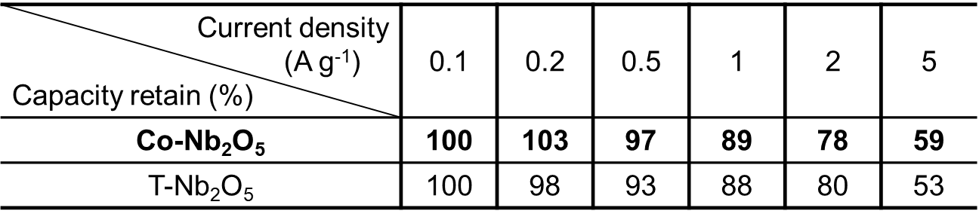
Table S3. Comparison of capacity and cycling life of the Co-Nb₂O₅ presented herein and selected similar Nb-based oxides reported earlier in literature^{[5-13]}.
anode | Voltage range (V) | Capability (mA g⁻¹) | Cycling life | Capaciy retention | Reference
Co-Nb₂O₅ | 1.0-3.0 | 256 (0.5C)  189 (5C) | 110  500 | 97%  90% | Our work
(N-C@MSC-Nb₂O₅) | 1.0-3.0 | 185 (10C) | 1000 | 83% | Adv. Mater. 2020, 32, 2001001.
H-Nb₂O₅ | 1.0-3.0 | 230 (0.5C)  151 (10C) | /  2000 | /  90% | Energy Environ. Sci. 2022, 15, 254-264.
T-Nb₂O₅@C | 1.0-3.0 | 197 (1C) | 200 | 93% | Adv. Energy Mater. 2019, 1802695.
Nb₂O₅@Nb₄C₃T_{x} | 1.0-3.0 | 208 (0.25C) | 400 | 94% | Adv. Funct. Mater. 2016, 26, 4143.
Nb₂O₅ | 1.2-3.0 | 182 (0.5C) | 150 | 97% | ACS Nano 2016, 10, 507.
T-Nb₂O₅ | 1.2-3.0 | 175 (0.1C) | 100 | 91% | J. Am. Chem. Soc. 2016, 138, 8888.
H-Nb₂O₅/rGO | 1.0-3.0 | 176 (1C) | 450 | 97% | J. Mater. Chem. A 2019, 7, 693.
T‑Nb₂O₅ NTs200 | 1.0-3.0 | 199 (0.5C)  155 (5C) | 200  500 | 84%  89% | ACS Appl. Mater. Interfaces 2021, 13, 16445.
Nb₂O₅@N-C | 1.0-3.0 | 188 (10C) | 2900 | 41% | J. Alloys Compd. 2021, 876, 160145.
References
- G. A. B. S. L. Dudarev, S. Y. Savrasov, C. J. Humphreys, A. P. Sutton, Phys. Rev. B: Condens. Mat ter 57 (1998) 1505.
- H. J. Monkhorst, J. D. Pack, Special points for Brillouin-zone integrations, Physical review B 13 (1976) 5188.
- D. Su, H. Ahn, G. Wang, Ab initio calculations on Li-ion migration in Li₂FeSiO₄ cathode material with a P21 symmetry structure, Applied Physics Letters 99 (2011) 141909.
- G. Henkelman, A. Arnaldsson, H. Jónsson, Comput, A fast and robust algorithm for Bader decomposition of charge density, Mater. Sci. 36 (2006) 354-360.
- Z. Song, H. Li, W. Liu, H. Zhang, J. Yan, Y. Tang, J. Huang, H. Zhang, X. Li, Ultrafast and stable Li‐(de) intercalation in a large single crystal H‐Nb₂O₅ anode via optimizing the homogeneity of electron and ion transport, Adv. Mater. 32 (2020) 2001001.
- T. Li, G. Nam, K. Liu, J.-H. Wang, B. Zhao, Y. Ding, L. Soule, M. Avdeev, Z. Luo, W. Zhang, T. Yuan, P. Jing, M. G. Kim, Y. Song, M. Liu, A niobium oxide with a shear structure and planar defects for high-power lithium ion batteries, Energy Environ. Sci. 15 (2022) 254-264.
- J. Meng, Q. He, L. Xu, X. Zhang, F. Liu, X. Wang, Q. Li, X. Xu, G. Zhang, C. Niu, Z. Xiao, Z. Liu, Z. Zhu, Y. Zhao, L. Mai, Identification of phase control of carbon‐confined Nb₂O₅ nanoparticles toward high‐performance lithium storage, Adv. Energy Mater. 9 (2019) 1802695.
- C. J. Zhang, S. J. Kim, M. Ghidiu, M.-Q. Zhao, M. W. Barsoum, V. Nicolosi, Y. Gogotsi, Layered orthorhombic Nb2O5@Nb₄C₃T_{x} and TiO₂@Ti₃C₂T_{x} hierarchical composites for high performance Li‐ion batteries, Adv. Funct. Mater. 26 (2016) 4143-4151.
- H. Zhang, Y. Wang, P. Liu, S. L. Chou, J. Z. Wang, H. Liu, G. Wang, H. Zhao, Highly ordered single crystalline nanowire array assembled three-dimensional Nb₃O₇(OH) and Nb₂O₅ superstructures for energy storage and conversion applications, ACS Nano 10 (2016) 507-514.
- K. J. Griffith, A. C. Forse, J. M. Griffin, C. P. Grey, High-rate intercalation without nanostructuring in metastable Nb₂O₅ bronze phases, J. Am. Chem. Soc. 138 (2016) 8888-8899.
- S. Li, T. Wang, W. Zhu, J. Lian, Y. Huang, Y.-Y. Yu, J. Qiu, Y. Zhao, Y.-C. Yong, H. Li, Controllable synthesis of uniform mesoporous H-Nb₂O₅/rGO nanocomposites for advanced lithium ion hybrid supercapacitors, J. Mater. Chem. A 7 (2019) 693-703.
- N. Li, X. Lan, L. Wang, Y. Jiang, S. Guo, Y. Li, X. Hu, Precisely tunable T-Nb₂O₅ nanotubes via atomic layer deposition for fast-charging lithium-ion batteries, ACS Appl. Mater. Interfaces 13 (2021) 16445-16453.
- T. Yang, Z. Yang, X. Cheng, Y. Ding, Y. Fan, G. Liu, K. Zhang, S. Jin, X. Liu, Z, Qiao, Three-dimensional hierarchical urchin-like Nb₂O₅ microspheres wrapped with N-doped carbon: An advanced anode for lithium-ion batteries, J. Alloys Compd. 876 (2021) 160145.

