Supporting Information

Synergistic adsorption and electrocatalytic effect of Mott-Schottky heterostructures functionalized separators for lithium-sulfur batteries

Jiapei Gu¹, Chenxu Dong¹, Cheng Zhou¹, Chunli Shen¹, Yuqiang Pi^{2*}, Xu Xu^{1*}

¹ State Key Laboratory of Advanced Technology for Materials Synthesis and Processing, International School of Materials Science and Engineering, Wuhan University of Technology, Wuhan 430070, P. R. China
² School of Chemistry and Materials Science, Hubei Engineering University, Xiaogan 432000, P. R. China

*E-mail addresses: xq0502@163.com (Dr. Y. Pi), xuxu@whut.edu.cn (Dr. X. Xu).

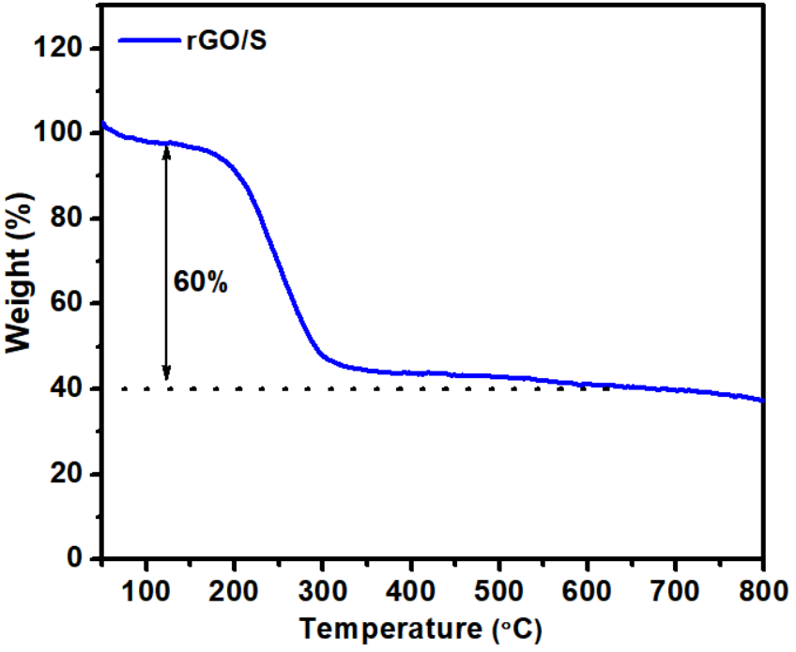
Figure S1 TGA curve for sulfur cathode.

Figure S2 (a) SEM image, (b) TEM image, (c-e) TEM elemental mapping images of Bi, Mo and O of Bi₂MoO₆ nanosheets. (f) HRTEM image.

Figure S3 TGA curves for Bi₂MoO₆ and Bi₂MoO₆-PPy.

Figure S4 (a) Full XPS profiles, and XPS spectra of (b) Bi 4f, (c) Mo 3d, (d) O 1s and (e) N 1s of Bi₂MoO₆ and Bi₂MoO₆-PPy.

Figure S5 N₂ adsorption-desorption isotherm for Bi₂MoO₆ and Bi₂MoO₆-PPy.

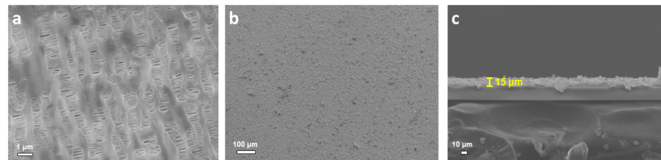
Figure S6 (a) SEM image of PP separator. (b) SEM image of the surface and (c) the cross-sectional SEM image of Bi₂MoO₆@PP separator.

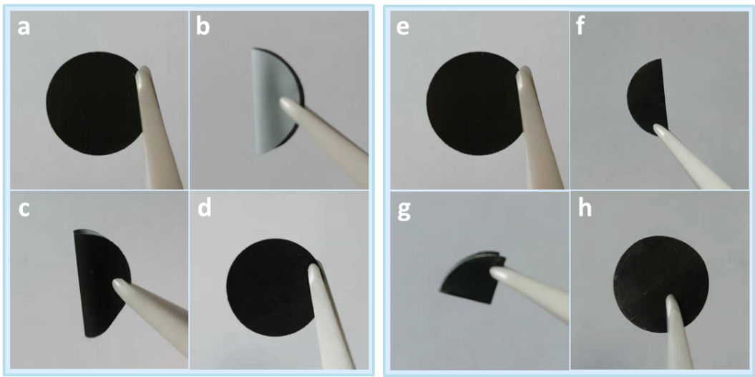
Figure S7 Digital photographs of the Bi₂MoO₆-PPy@PP separator before and after repeated folding (a-d) or curving (e-h).

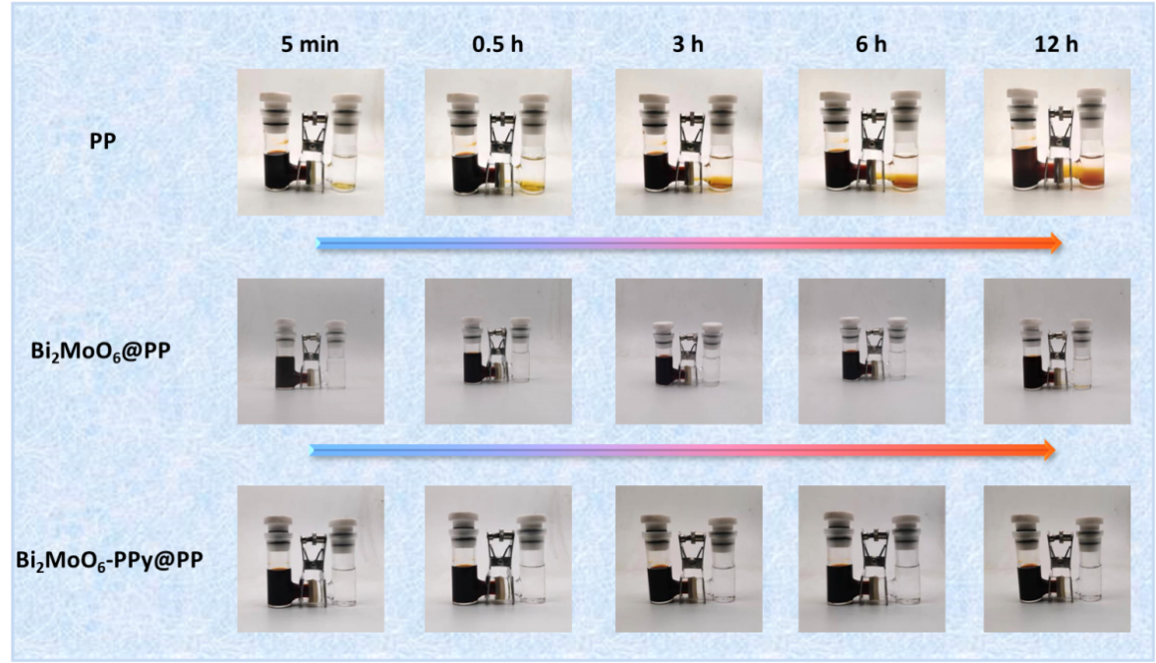
Figure S8 Permeation experiments with a double-L device for PP, Bi₂MoO₆@PP and Bi₂MoO₆-PPy@PP separators.

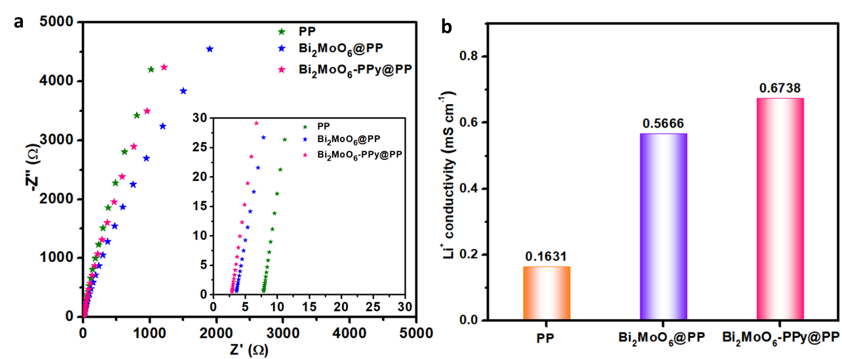
Figure S9 (a) The Impedance plots and (b) the lithium-ion conductivity of the Li-S cell with pristine PP, Bi₂MoO₆@PP, and Bi₂MoO₆-PPy@PP separators.

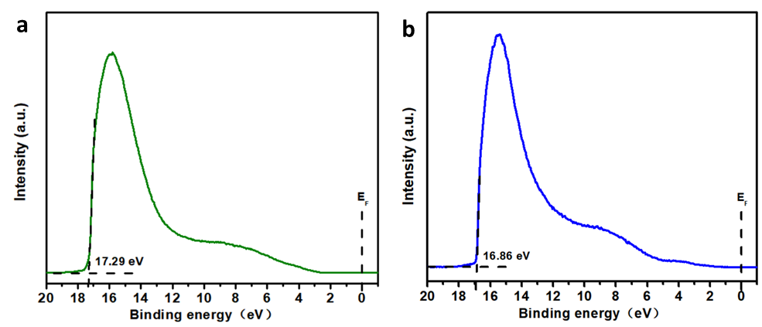
Figure S10 UPS spectra of a) Bi₂MoO₆ and b) PPy. The work function (Φ) of Bi₂MoO₆ and PPy samples were determined by the equation of Φ = 21.22 eV - (E_{cutoff} - E_{F}) as 3.93 and 4.36eV, respectively.

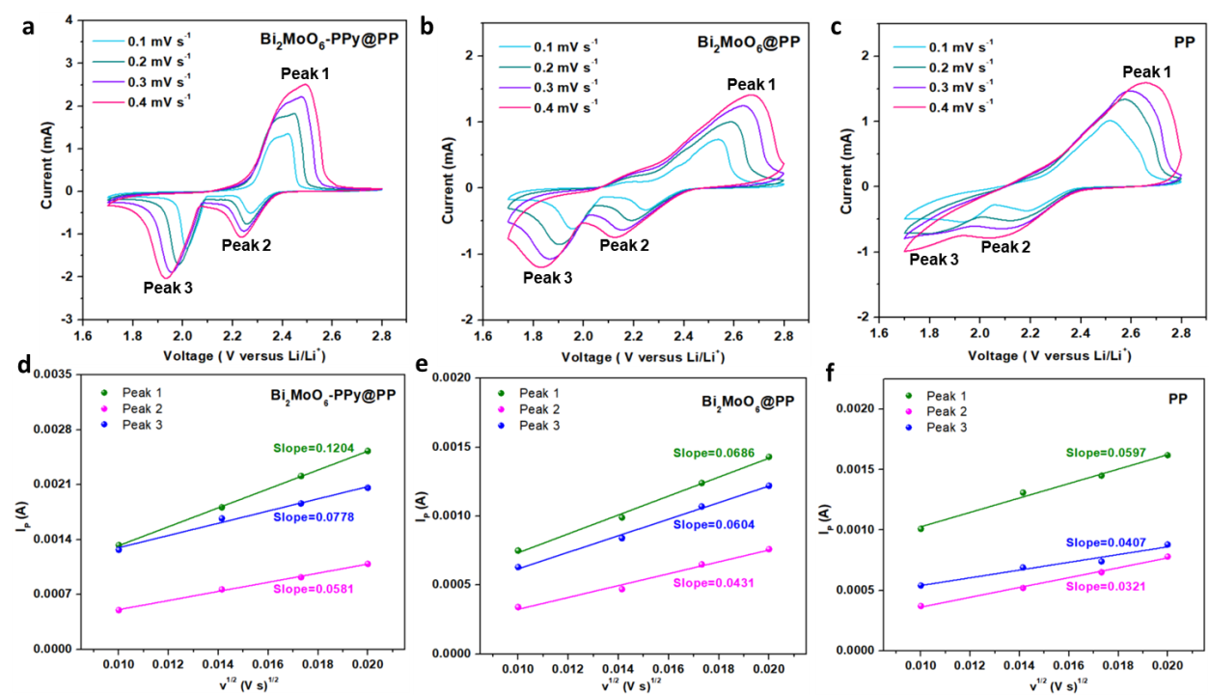
Figure S11 The CV curves of the Li-S cell with different separators at 0.1-0.4 mV/s scan rate and the corresponding linear relation of peak current (I_{p}) versus the square root of scan rate: (a, d) Bi₂MoO₆-PPy@PP; (b, e) Bi₂MoO₆@PP; (c, f) PP.

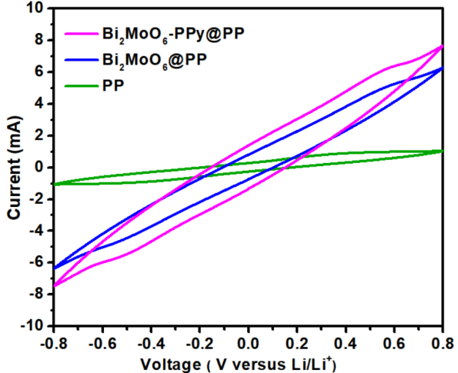
Figure S12 CV curves of symmetric cells at 50 mV s⁻¹.

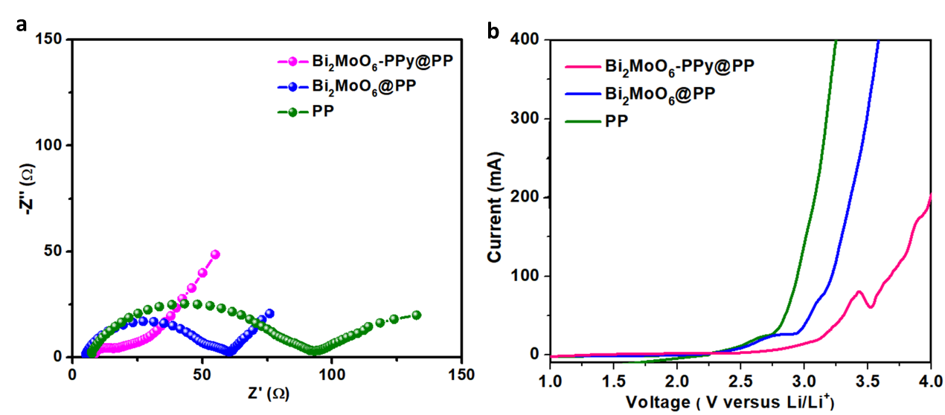
Figure S13 (a) The EIS spectrum and (b) LSV curves of polysulfide (Li₂S₆) symmetric batteries.

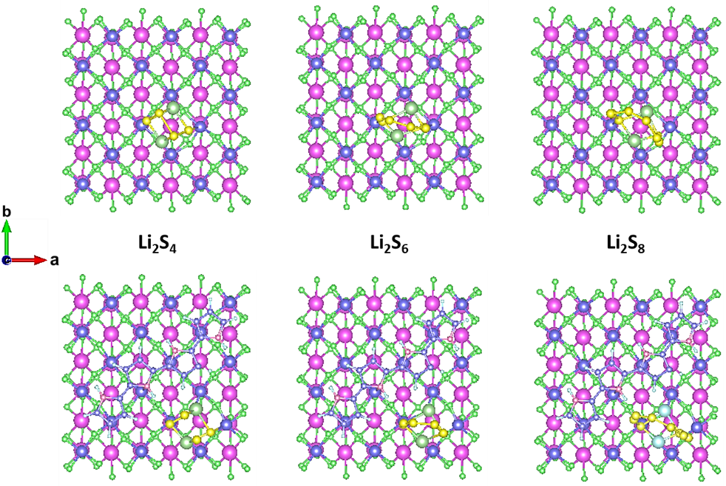
Figure S14 Top view of the optimized configurations for the binding of long-chain Li₂S_{n} to Bi₂MoO₆ and Bi₂MoO₆-PPy.

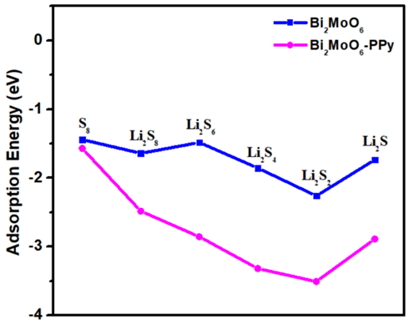
Figure S15 The binding energy of LiPSs to Bi₂MoO₆ and Bi₂MoO₆-PPy.

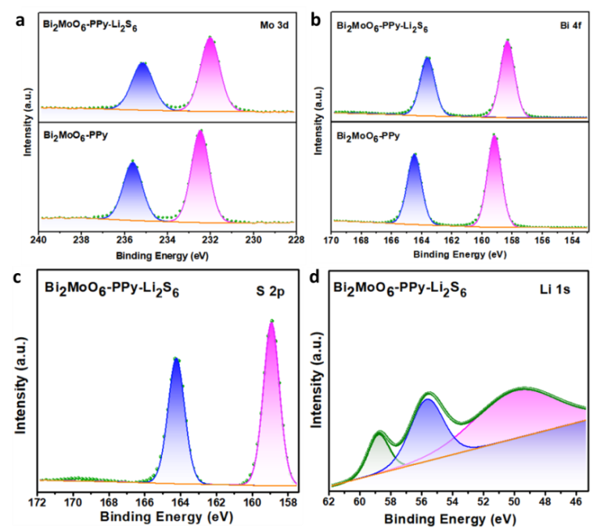
Figure S16 XPS spectra of a) Bi 4f, b) Mo 3d, c) S 2p and d) Li 1s of Bi₂MoO₆-PPy before and after Li₂S₆ adsorption.

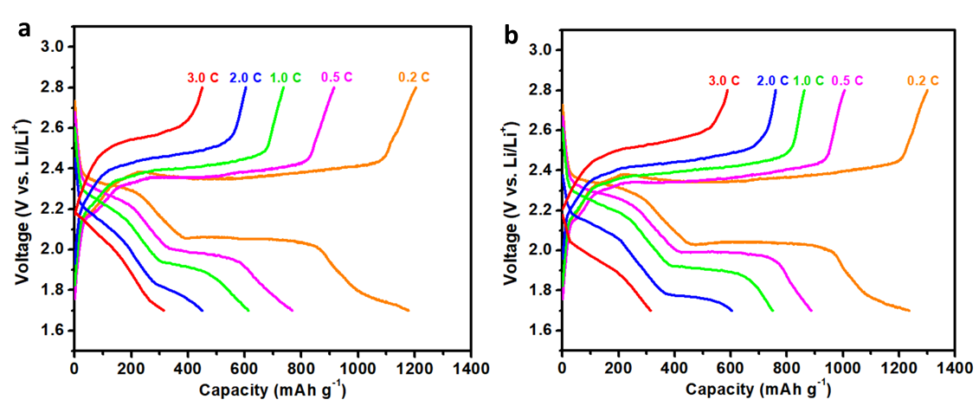
Figure S17 The constant current charge/discharge voltage curves of different rate for (a) PP separator and (b) Bi₂MoO₆@PP separator.

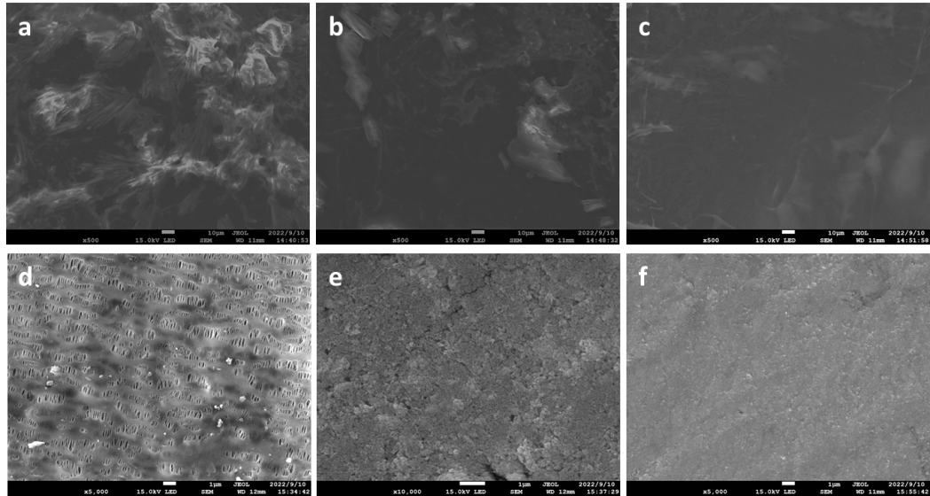
Figure S18 SEM images of the Li anodes (top) and the separators (bottom) for Li-S batteries after cycling at 2 C with the (a, d) PP, (b, e) Bi₂MoO₆@PP and (c, f) Bi₂MoO₆-PPy@PP separators.

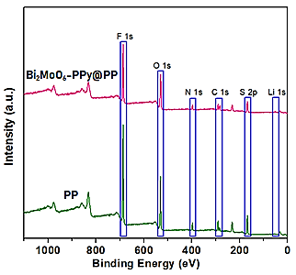
Figure S19 Full XPS profiles of Li anodes for Li-S batteries with PP and Bi₂MoO₆-PPy@PP separator after cycling at 2 C.

Table S1 BET surface area and pore volume of the resulting samples.
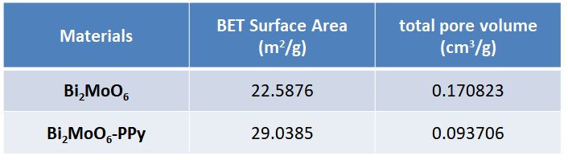

Table S2 Electrochemical performances of this work compared with previous works involving different separators in recently reported literature.
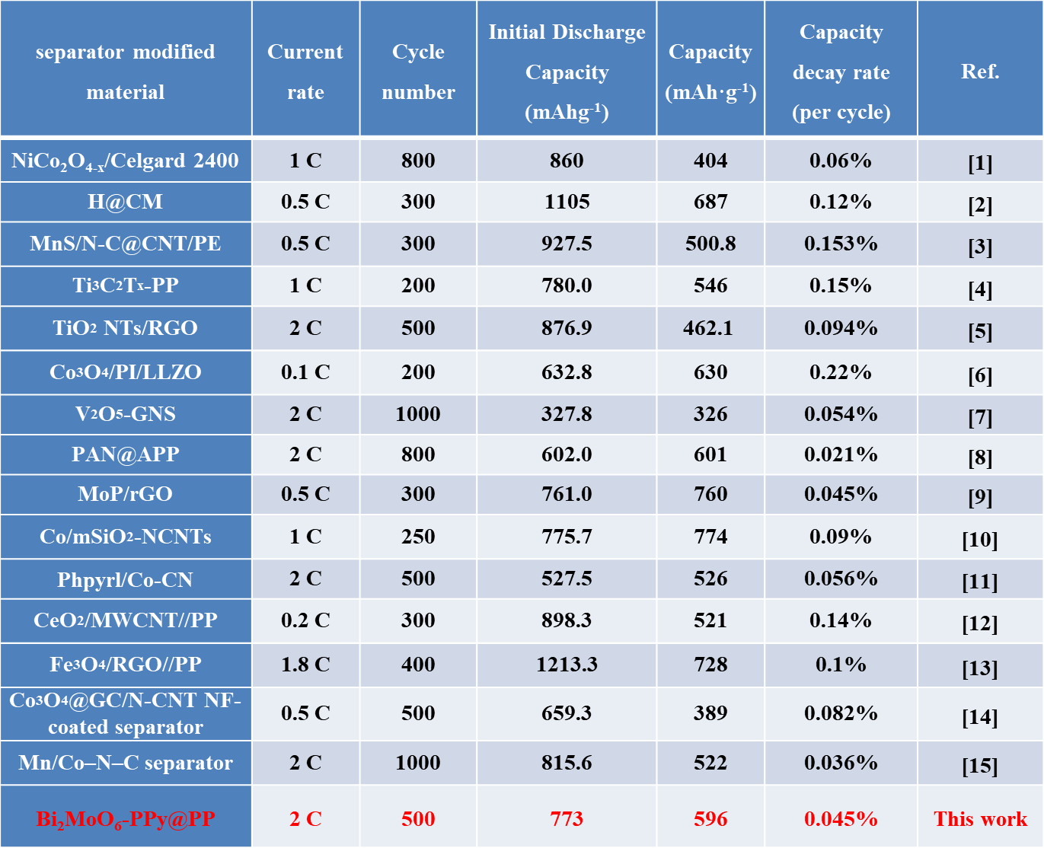

Table S3 Surface species concentration by XPS for Li-S batteries with PP and Bi₂MoO₆-PPy@PP separator after cycling at 2 C.
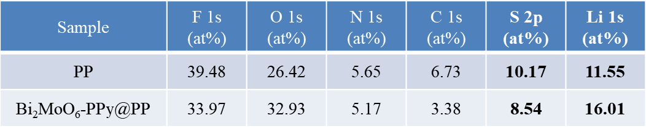

References
[1] Zhu Y, Zuo Y, Ye F, et al. Dual-regulation strategy to enhance electrochemical catalysis ability of NiCo₂O_{4-x} for polysulfides conversion in Li-S batteries. Chem Eng J, 2022, 428: 131109.
[2] Rao Z, Meng J, Wu J, et al. Huang, Y. A multifunctional inorganic composite separator for stable high safety lithium-sulfur batteries. ACS Appl Energy Mater, 2020, 3: 10139-10146.
[3] Li F, Qian X, Jin L. MOF-derived MnS/N-C@CNT composites as separator coating materials for long-cycling Li-S batteries. ACS Sustainable Chem Eng, 2021, 9: 15469-15477.
[4] Li N, Xie Y, Peng S, et al. Ultra-lightweight Ti3C2Tx MXene modifified separator for Li-S batteries: Thickness regulation enabled polysulfifide inhibition and lithium ion transportation. J Energy Chem, 2020, 42: 116-125.
[5] Gui Y, Chen P, Liu D, et al. TiO₂ nanotube/RGO modified separator as an effective polysulfide-barrier for high electrochemical performance Li-S batteries. J Alloy Comp, 2022, 895: 162495.
[6] Zhou Z. F, Li Y, Fang T. T, et al. MOF-derived Co₃O₄ polyhedrons as efficient polysulfides barrier on polyimide separators for high temperature lithium-sulfur batteries. Nanomaterials-Basel, 2019, 9: 1574.
[7] Guo Y, Zhang Y, Zhang Y, et al. Interwoven V₂O₅ nanowire/graphene nanoscroll hybrid assembled as efficient polysulfide-trapping-conversion interlayer for long-life lithium-sulfur batteries. J Mater Chem A, 2018, 6: 19358-19370.
[8] Lei T. Y, Chen W, Hu Y, et al. A nonflammable and thermotolerant separator suppresses polysulfide dissolution for safe and long-cycle lithium-sulfur batteries. Adv Energy Mater, 2018, 8: 1802441.
[9] Li M, Wang C, Miao, L. X, et al. A separator-based lithium polysulfide recirculator for high-loading and high-performance Li-S batteries. J Mater Chem A, 2018, 6: 5862-5869.
[10] Fang D. L, Wang Y. L, Liu X. Z, et al. Spider-web-inspired nanocomposite-modified separator: structural and chemical cooperativity inhibiting the shuttle effect in Li-S batteries. ACS Nano, 2019, 13: 1563-1573.
[11] Lin J, Zhou Y, Wen J, et al. Pyrrole derivatives as interlayer modifier of Li-S batteries: modulation of electrochemical performance by molecular perturbation. J Energy Chem, 2022, 75: 164-172.
[12] Zhu W, Zhang Z, Wei J, et al. A synergistic modification of polypropylene separator toward stable lithium-sulfur battery. J Memb Sci, 2020, 597: 117646.
[13] Cheng P, Guo P, Liu D, et al. Fe₃O₄/RGO modified separators to suppress the shuttle effect for advanced lithium-sulfur batteries. J Alloys Compd, 2019, 784: 149-156.
[14]Saroha R, Oh J. H, Lee J. S, et al. Hierarchically porous nanofibers comprising multiple core-shell Co₃O₄@graphitic carbon nanoparticles grafted within N-doped CNTs as functional interlayers for excellent Li-S batteries. Chem Eng J, 2021, 426: 130805.
[15] Qiao S, Wang Q, Lei D, et al. Oxygen vacancy enabled fabrication of dual-atom Mn/Co catalysts for high-performance lithium-sulfur batteries. J Mater Chem A, 2022, 10: 11702-11711.

