Supporting Information

Self-Assembled Tent-Like Nanocavities for Space-Confined Stable Lithium Metal Anode

Nannan Zhang,¹ Lulu Du,¹ Jianyong Zhang, Hantao Xu, Xuan Zhou, Liqiang Mai, and Lin Xu*

N. N. Zhang, L. L. Du, J. Y. Zhang, H. T. Xu, X. Zhou, Prof. L. Q. Mai, Prof. L. Xu
State Key Laboratory of Advanced Technology for Materials Synthesis and Processing, School of Materials Science and Engineering, Wuhan University of Technology,
Luoshi Road 122, Wuhan, 430070, P. R. China.
E-mail: linxu@whut.edu.cn

Prof. L. Xu, Prof. L. Q. Mai
Hubei Longzhong Laboratory, Wuhan University of Technology (Xiangyang Demonstration Zone), Xiangyang 441000, Hubei, China.
E-mail: linxu@whut.edu.cn

Prof. L. Xu, Prof. L. Q. Mai
Hainan Institute, Wuhan University of Technology, Sanya 572000, China.
E-mail: linxu@whut.edu.cn

Keywords: tent-like nanocavities, space-confined strategy, dendrite-free deposition, Li metal anodes

Experimental Details
Preparation of Zn/CC samples: Zn was plating on the carbon cloth (CC) with CHI 605 electrochemical workstation. Prior to electrodeposition, the CC (WS 1009, fabric mass: 11.46 mg cm⁻², thickness: 300 μm) was pre-treated with hydrochloric acid, acetone, and ethanol for 15 min, respectively. Then the electrolyte was prepared by mixed 25 g zinc sulfate heptahydrate (ZnSO₄·7H₂O), 25 g sodium sulfate (Na₂SO₄), and boric acid (H₃BO₃) in 200 mL DI water. Typically, the Pt sheet was employed as the counter electrode, and the AgCl electrode was used as the reference electrode.^{[1]} The electrodeposition parameters were set to the constant density of 0.16 mA for 10 min and obtained samples were dried in a 50℃ vacuum drying oven.
Preparation of TLI-GO/Zn/CC samples: The GO suspension was synthesized with the Hummer method with a PH of 6.^{[2]} The prepared Zn/CC samples were immersed into GO suspension for 1 min, then the samples were dried in a vacuum oven for 5min and repeated 5 times of the same process, the TLI-GO/Zn/CC sample was prepared.^{[3]}
Structure Characterizations: The microstructure and morphology of the samples were analyzed by scanning electron microscope (SEM, JEOL JSM-7100F) with an accelerating voltage of 20 kV. Powder X-ray diffraction (XRD) patterns were acquired through the D8 Discover X-ray diffractometer (Cu Kα radiation, λ=1.054056 Å). Raman spectra were recorded using DXR, Thermo-Fisher Scientific, with 532 nm excitation from an argon-ion laser. X-ray photoelectron spectroscopy (XPS) spectra were tested on the Thermo-Fisher Scientific- ESCALAB 250Xi. Fourier transform infrared spectrometer (FT-IR) was tested by Thermo Nicolet Corporation. Transmission electron microscope (TEM) and High-resolution transmission electron microscope (HRTEM) patterns were all performed by Talos F200 S. Mechanical properties of samples were measured using Atomic Force Microscope (AFM, Dimension Icon). Force-displacement curves were performed on the surface of samples using the force-distance spectroscopy mode, and Young’s modulus was calculated.
Electrochemical Measurements: CR2016-type coin cells were assembled to investigate the electrochemical performance in an Argon atmosphere glove box. Polypropylene (Celgard 2500) membrane was employed as the separator and the electrolyte was 1 M Li bis(trifluoromethanesulfonyl)imide (LiTFSI) in 1,3-dioxolane (DOL)/1,2 dimethoxyethane (DME) (v/v = 1:1) binary mixture with 1 wt % LiNO₃. The electrolyte dosage was fixed at an excess of 26 µL cm⁻². Bare CC, Zn/CC, and TLI-GO/Zn/CC disks (12 mm) were pre-deposited 3 mAh cm⁻² of Li, then the prepared electrodes were assembled into symmetric batteries. For the coulombic efficiency test, a fixed capacity of Li (1 mAh cm⁻²) was deposited by discharging at 1 mA cm⁻² and then charged to 1 V. The symmetric battery tests and coulombic efficiency tests were carried out on Neware electrochemical testing system. Electrochemical impedance spectroscopy (EIS) were tested using Nova with scanning frequency range from 10⁵ to 0.1 Hz. Full cells were assembled to characterize the feasible of the Li@TLI-GO/Zn/CC anode and the LiFePO₄ (LFP) was chosen as cathode. LFP, acetylene black, and polyvinylidene fluoride (PVDF) were added to N-methyl-2-pyrrolidone (NMP) in a ratio of 7:2:1, and the loading of the active material is about 2.54 mg cm⁻². The mixture solution was scraped evenly onto the carbon coated aluminum foil. Then the mixture was dried in a vacuum oven at 70 °C for 12 hours. The full cells were cycled at 2.6-4 V at different current densities on LAND electrochemical testing system.
Computational details: All spin-polarized density functional theory (DFT) calculations within the generalized gradient approximation (GGA) were employed in the Vienna Ab Initio Package (VASP) using the Perdew-Burke-Ernzerhof (PBE) formulation.^{[4]} The projected augmented wave (PAW) potentials were chosen to describe the ionic cores and take valence electrons into account using a plane wave basis set with a kinetic energy cutoff of 450 eV.^{[5]} Partial occupancies of the Kohn−Sham orbitals were allowed using the Methfessel-Paxton smearing method and a width of 0.2 eV. The electronic energy was considered self-consistent when the energy change was smaller than 10⁻⁵ eV. A geometry optimization was considered convergent when the energy change was smaller than 0.02 eV Å⁻¹. The vacuum spacing in a direction perpendicular to the plane of the structure is 15 Å. The adsorption energy of Li atoms was defined as E_{b} = E_{total} - E_{slab} - E_{Li}, where E_{slab} represents the energy of the studied system, E_{total} is the energy of the corresponding system with Li atom adsorbed, and E_{Li} is the energy of one isolated Li atom.^{[6]} The interface binding energy (E_{I}) between GO and Zn was calculated as E_{I} = E_{Zn} + E_{GO} - E_{tot}, where E_{tot} represents the energy of the studied system, E_{Zn} and E_{GO} are the energy of Zn and GO of the system.

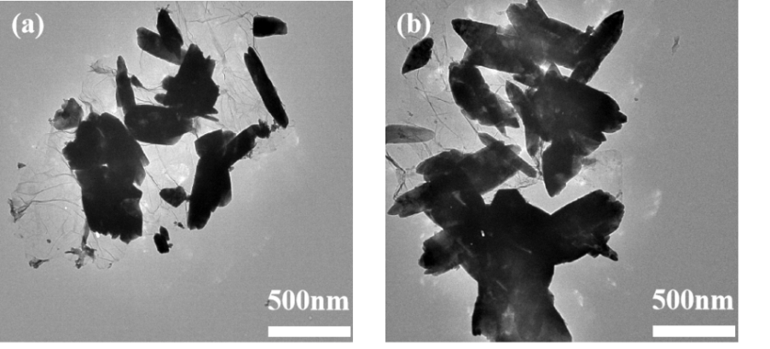
Figure S1. TEM images of TLI-GO/Zn/CC.

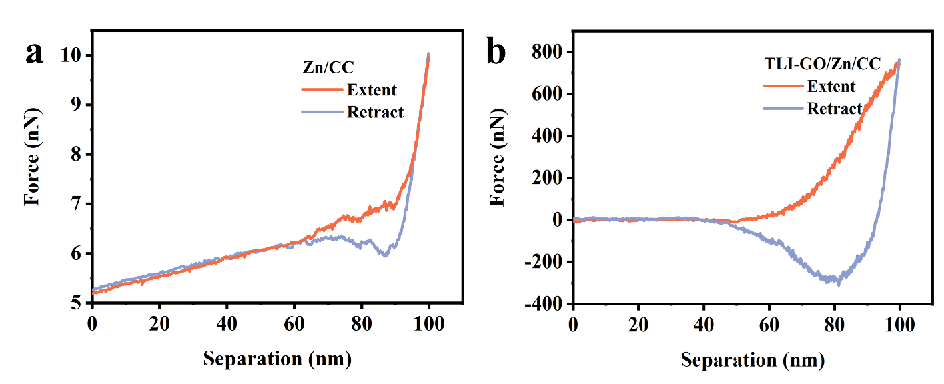
Figure S2. Representative force-displacement curves for both Zn/CC (a) and TLI-GO/Zn/CC (b).

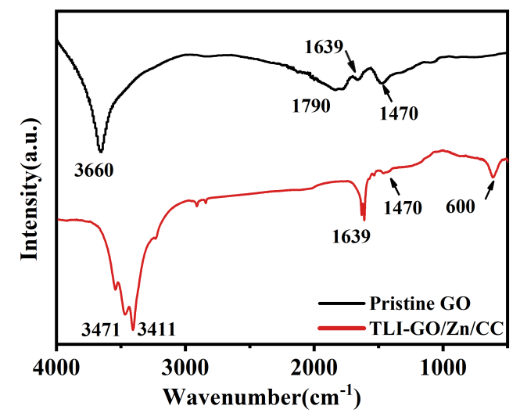
Figure S3. FTIR spectra of pristine GO and TLI-GO/Zn/CC.

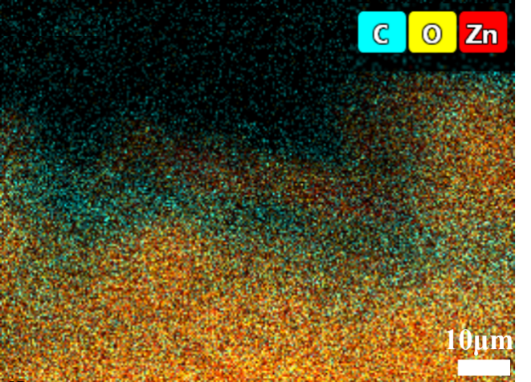
Figure S4. High magnification image with the SAED pattern of TLI-GO/Zn/CC.

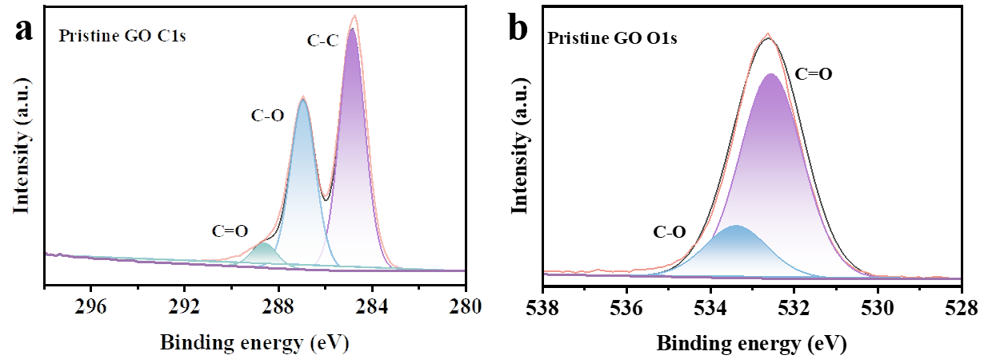
Figure S5. XPS spectra of C 1s (a) and O 1s (b) in pristine GO.

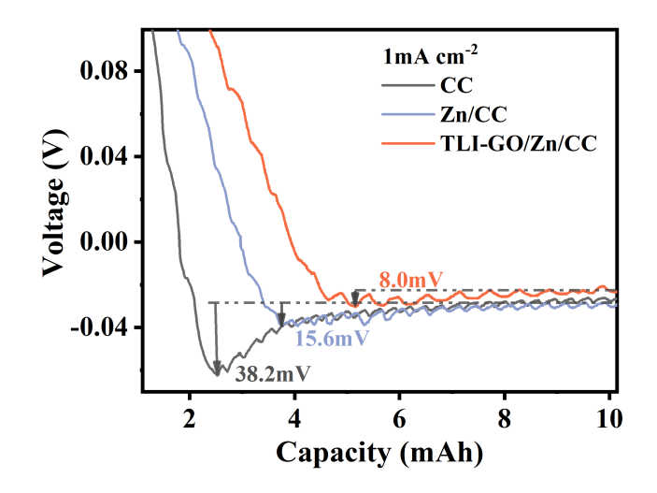
Figure S6. Voltage-capacity curves of Li plating/stripping at a current density of 1.0 mA cm⁻² on varied electrodes.

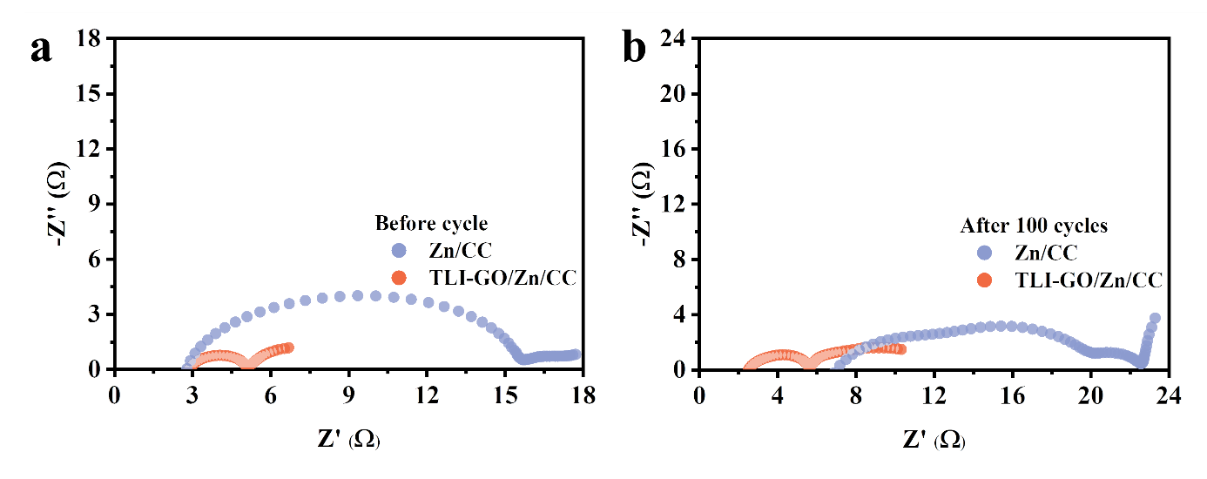
Figure S7. EIS spectra of Li-Zn/CC, and Li-TLI-GO/Zn/CC electrodes before (a) and after 100 cycles (b) at 1 mA cm⁻².

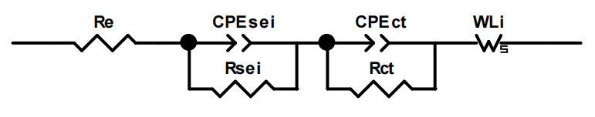
Figure S8. The equivalent circuit model for fitting the Nyquist diagrams.

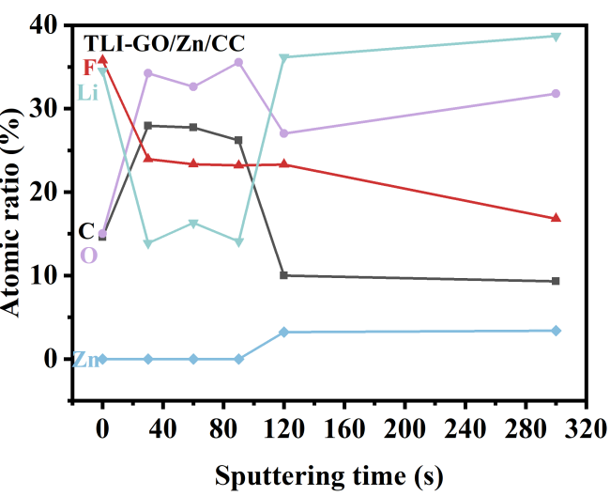
Figure S9. The corresponding depth profiles of the atomic concentration of Li, F, C, O and Zn elements of TLI-GO/Zn/CC.

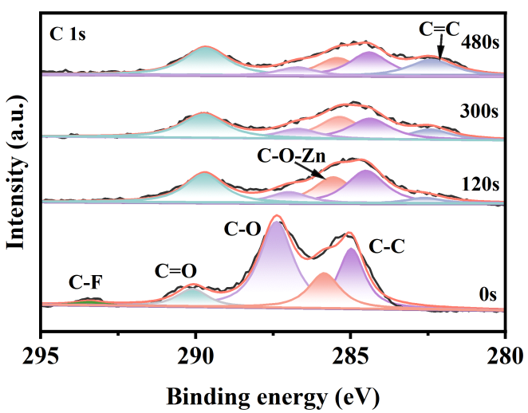
Figure S10. XPS depth profiling of C 1s at different sputtering times after 10th cycle.

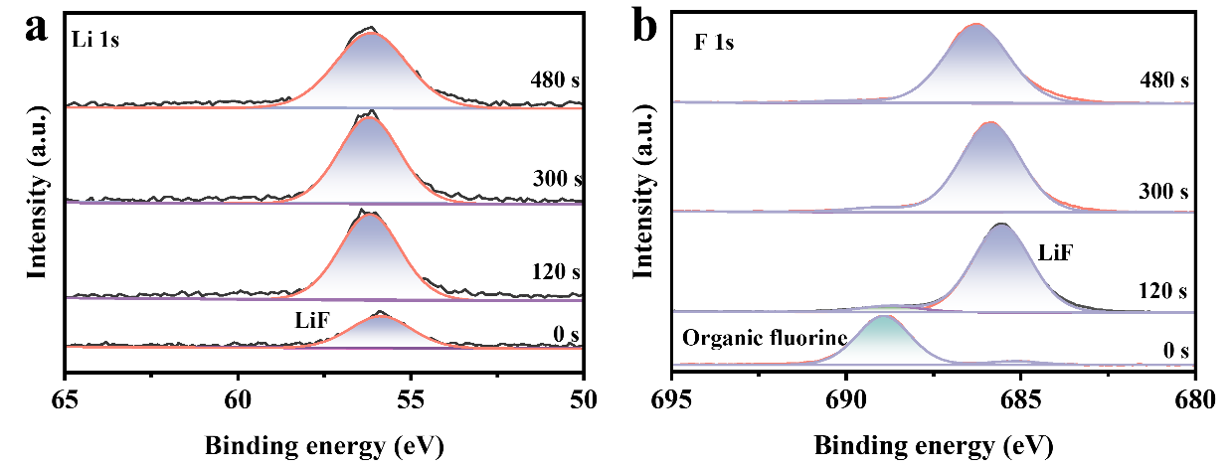
Figure S11. XPS depth profiling of Li 1s (a) and F 1s (b) at different sputtering times after the Zn/CC electrodes cycling 10 times.

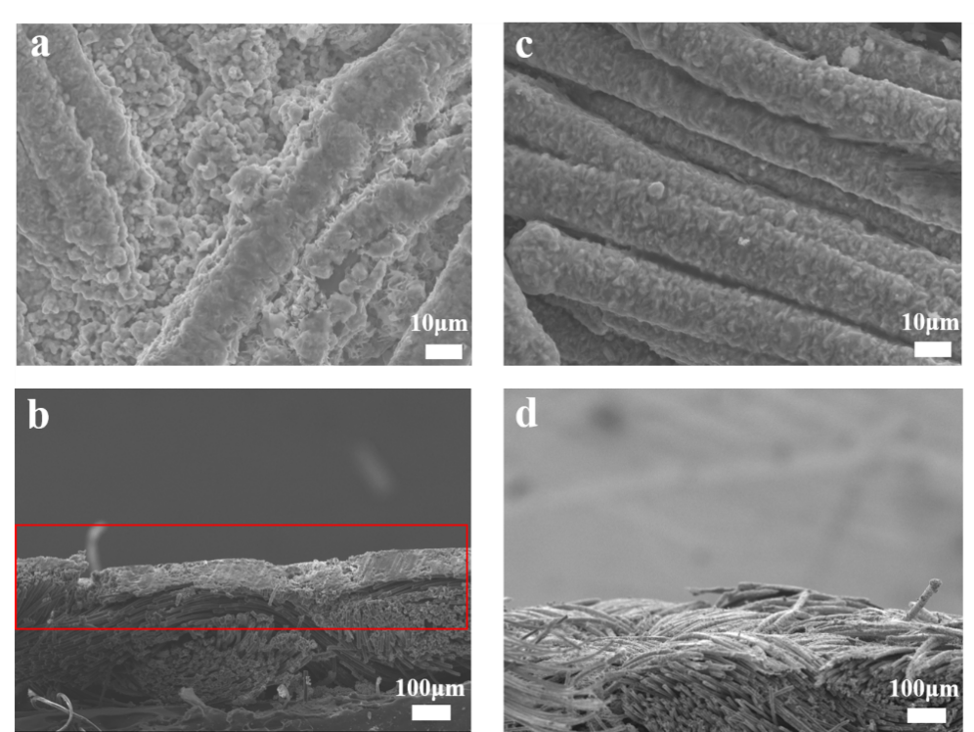
Figure S12. Morphology of plating with 1 mAh cm⁻² and corresponding cross section images of Zn/CC (a, b) and TLI-GO/Zn/CC (c, d).

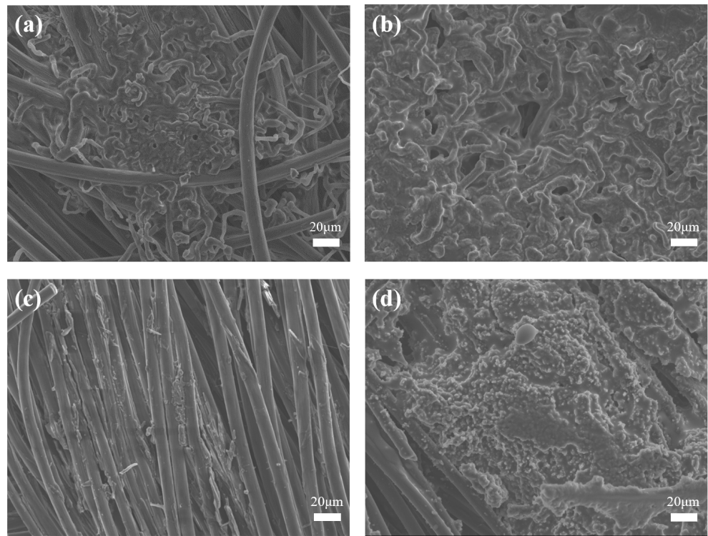
Figure S13. Morphology of CC at different states. SEM images of plating with 1 mAh cm⁻² (a), 5 mAh cm⁻² (b) and after 1st (c), 10th (d) cycle.

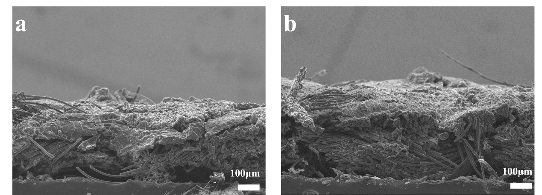
Figure S14. Morphology of cross section images after plating with 1 mAh cm⁻² (a) and 5 mAh cm⁻² (b) of CC.

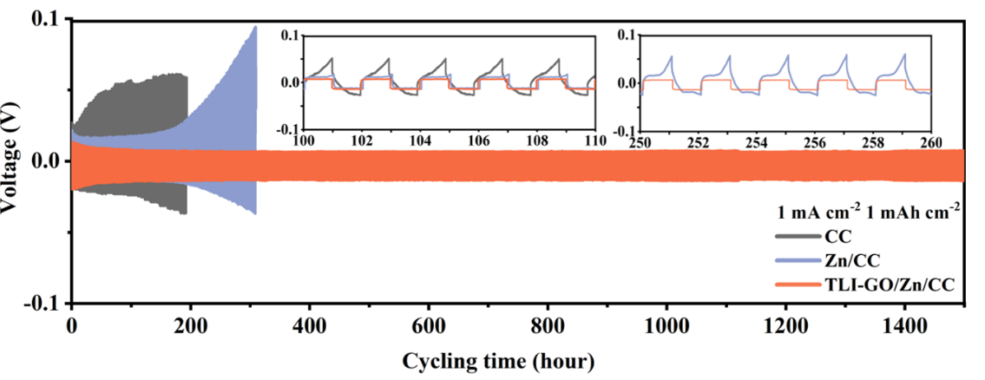
Figure S15. The Li/Li symmetrical battery performance and corresponding local magnified images at 1 mA cm⁻².

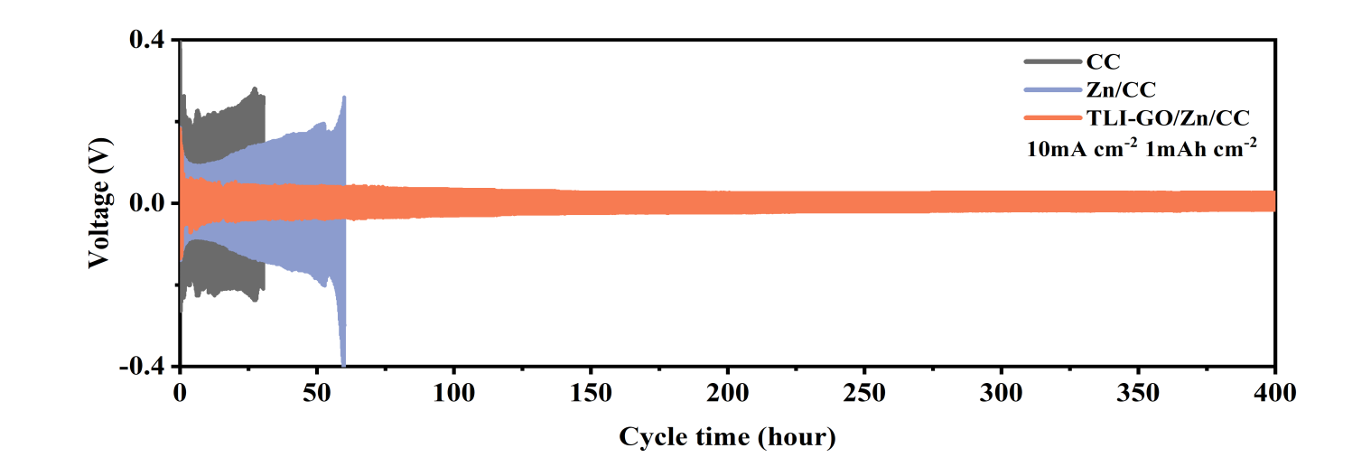
Figure S16. Cycling performance of Li/Li symmetric batteries with different electrodes at 10 mA cm⁻², 1 mAh cm⁻².

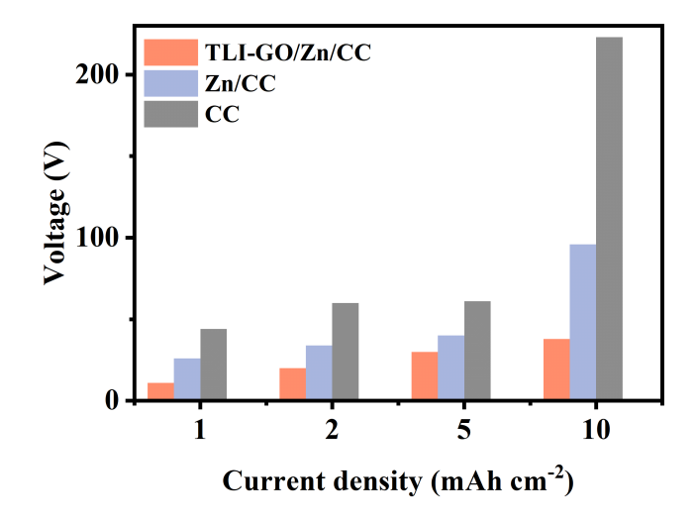
Figure S17. Voltage polarization histogram at different current conditions.

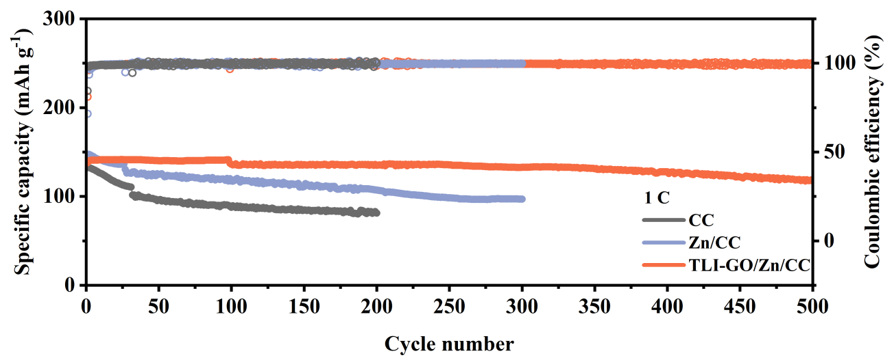
Figure S18. Voltage profiles for full cells with different anodes under 1 C.

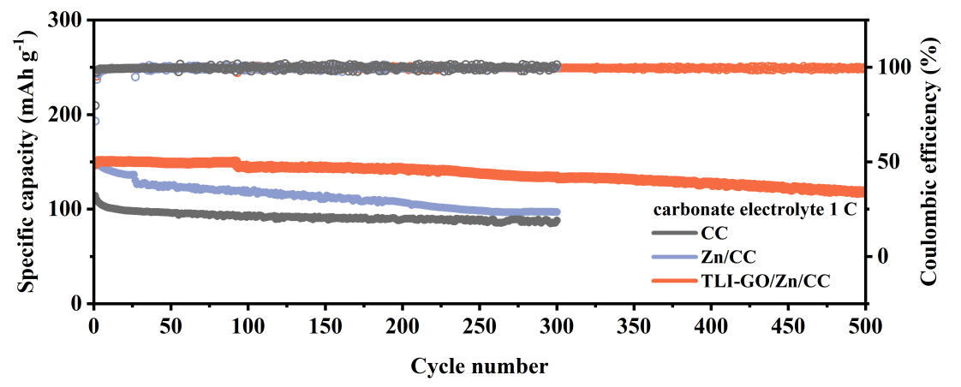
Figure S19. The cycling performances at 1 C in carbonate electrolytes.

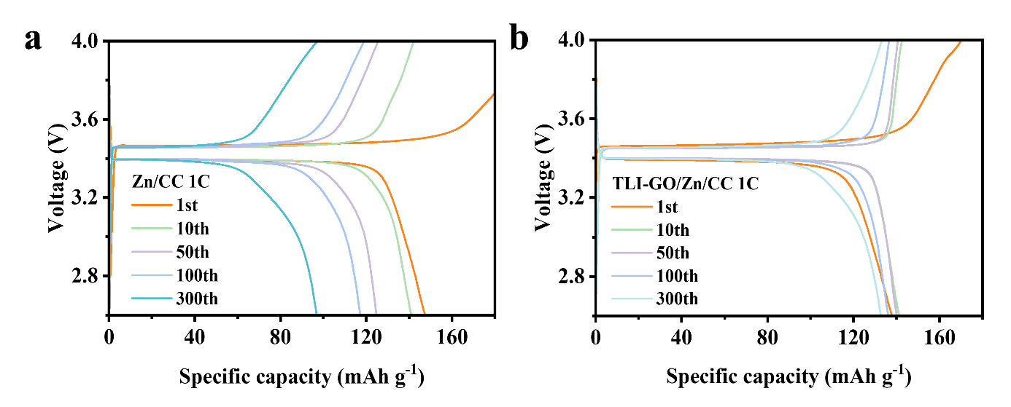
Figure S20. Charge/discharge profiles with different anodes at 1 C.

Table S1. The interface binding energy between GO and Zn layer of tent-like interface.
E_{tot}/eV | E_{Zn}/eV | E_{GO}/eV | E_{I}/eV
-407.57898 | -75.116355 | -305.26114 | 27.201485

Table S2. Absorption energy calculation of isolated Li atom to different substrates.
 | E_{total}/eV | E_{slab}/eV | E_{b}/eV | E_{Li}/eV
Li to Zn slab | -82.497 | -80.663 | -1.792 | -0.042
Li to Zn–O–C | -407.579 | -410.676 | -3.097

Table S3. The resistances of fitting results in Zn/CC@Li and TLI-GO/Zn/CC@Li symmetric cells.
Sample | Re (ohm) | R_{sei}(ohm) | R_{ct} (ohm)
Zn/CC | 2.6924 | 13.388 | 3.9805
Zn/CC after 100th | 6.9438 | 14.370 | 3.284
TLI-GO/Zn/CC | 2.8944 | 2.2795 | 3.8096
TLI-GO/Zn/CC after 100th | 2.569 | 3.1753 | 4.6094

Table S4. Comparison of cycling life of symmetrical batteries with Li@TLI-GO/Zn/CC composite anodes and various reportes interface-modified anodes under different current densities.
Refer | Current  (mA cm⁻²) | Capacity  (mAh cm⁻²) | Cycle time (hour) | Overpotential (mV) | Samples
^{[7]} | 2 | 1 | 800 | 20 | Co@C@CC
^{[8]} | 1 | 1 | 1000 | 25 | LiC₆@C
^{[9]} | 1 | 1 | 1000 | 30 | Li@CFeltCu
^{[10]} | 1 | 1 | 400 | 60 | Li@CF/Ag
^{[11]} | 1 | 1 | 600 | 40 | SRC-Zein@CS
^{[12]} | 1 | 1 | 600 | 15 | (CNT)/NiO
^{[13]} | 1 | 1 | 1200 | 25 | NCH-CFs
^{[14]} | 1 | 1 | 400 | 24 | Cu₃P/CoP@C/CNT
^{[15]} | 3 | 1 | 800 | 120.8 | Li@GaLi
^{[16]} | 1 | 1 | 1600 | 50 | Li@DPL
^{[17]} | 0.5 | 1 | 1000 | 10 | Li@MMT
^{[18]} | 1 | 1 | 1500 | 17 | Li@MCI
^{[19]} | 1 | 1 | 1200 | 40 | Li@PTCDI
^{[20]} | 1 | 1 | 1200 | 15.2 | Zn-MXENE
^{[21]} | 0.5 | 0.5 | 1050 | 12 | Ti₃C₂T_{x}/g-C₃N₄
^{[22]} | 1 | 1 | 1000 | 14 | LTO/PVDF
^{[23]} | 1 | 2 | 1100 | 36 | Li@N-organic/Li₃N
This work | 1 | 1 | 1600 | 11 | Li@TLI-GO/Zn/CC
Remarks: all the electrolytes are LiTFSI in DOL/DME (v/v = 1:1) with x mol% LiNO₃ in the table.

Supporting Information Reference
[1] Y. Zeng, X. Zhang, Y. Meng, M. Yu, J. Yi, Y. Wu, X. Lu, Y. Tong, Adv. Mater. 2017, 29.
[2] L. Dong, J. Yang, M. Chhowalla, K. P. Loh, Chem. Soc. Rev. 2017, 46, 7306.
[3] Y. h. Zhu, Y. b. Yin, X. Yang, T. Sun, S. Wang, Y. s. Jiang, J. m. Yan, X. b. Zhang, Angew. Chem. Int. Ed. 2017, 56, 7881.
[4] a) J. F. G. Kresse Comput. Mater. Sci. 1996, 6, 15; b) G. Kresse, PhRvB 1996, 54; c) K. B. John P. Perdew, Matthias Ernzerhof, Phys. Rev. Lett. 1996, 77, 3865.
[5] a) G. Kresse, PhRvB 1999, 59; b) P. E. Blochl, Phys Rev B Condens Matter 1994, 50, 17953.
[6] P. Zou, Y. Sui, H. Zhan, C. Wang, H. L. Xin, H.-M. Cheng, F. Kang, C. Yang, Chem. Rev. 2021, 121, 5986.
[7] T. Zhou, J. Shen, Z. Wang, J. Liu, R. Hu, L. Ouyang, Y. Feng, H. Liu, Y. Yu, M. Zhu, Adv. Funct. Mater. 2020, 30.
[8] P. Shi, T. Li, R. Zhang, X. Shen, X. B. Cheng, R. Xu, J. Q. Huang, X. R. Chen, H. Liu, Q. Zhang, Adv. Mater. 2019, 31, e1807131.
[9] X. Y. Yue, X. L. Li, W. W. Wang, D. Chen, Q. Q. Qiu, Q. C. Wang, X. J. Wu, Z. W. Fu, Z. Shadike, X. Q. Yang, Y. N. Zhou, Nano Energy 2019, 60, 257.
[10] R. Zhang, X. Chen, X. Shen, X. Q. Zhang, X. R. Chen, X. B. Cheng, C. Yan, C. Z. Zhao, Q. Zhang, Joule 2018, 2, 764.
[11] X. Fu, R. Odstrcil, M. Qiu, J. Liu, W. H. Zhong, Energy Stor. Mater. 2021, 42, 22.
[12] Y. Mei, J. Zhou, Y. Hao, X. Hu, J. Lin, Y. Huang, L. Li, C. Feng, F. Wu, R. Chen, Adv. Funct. Mater. 2021.
[13] C. Chen, J. Guan, N. W. Li, Y. Lu, D. Luan, C. H. Zhang, G. Cheng, L. Yu, X. W. D. Lou, Adv. Mater. 2021, 33, 2100608.
[14] X. Zhang, S. Jin, M. H. Seo, C. Shang, G. Zhou, X. Wang, G. Li, Nano Energy 2022, 93.
[15] Y. Zhou, J. Zhang, K. Zhao, Y. Ma, H. Zhang, D. Song, X. Shi, L. Zhang, Y. Ding, Energy Stor. Mater. 2021, 39, 403.
[16] K. Zhang, F. Wu, K. Zhang, S. Weng, X. Wang, M. Gao, Y. Sun, D. Cao, Y. Bai, H. Xu, X. Wang, C. Wu, Energy Stor. Mater. 2021, 41, 485.
[17] Y. Nan, S. Li, C. Han, H. Yan, Y. Ma, J. Liu, S. Yang, B. Li, Adv. Funct. Mater. 2021, 31.
[18] Z. Luo, S. Li, L. Yang, Y. Tian, L. Xu, G. Zou, H. Hou, W. Wei, L. Chen, X. Ji, Nano Energy 2021, 87.
[19] P. Zhao, Y. Feng, T. Li, B. Li, L. Hu, K. Sun, C. Bao, S. Xiong, A. Matic, J. Song, Energy Stor. Mater. 2020, 33, 158.
[20] J. Gu, Q. Zhu, Y. Shi, H. Chen, D. Zhang, Z. Du, S. Yang, ACS Nano 2020, 14, 891.
[21] F. Zhao, P. Zhai, Y. Wei, Z. Yang, Q. Chen, J. Zuo, X. Gu, Y. Gong, Adv Sci (Weinh) 2022, 9, e2103930.
[22] X. Xiong, W. Yan, Y. Zhu, L. Liu, L. Fu, Y. Chen, N. Yu, Y. Wu, B. Wang, R. Xiao, Adv. Energy Mater. 2022.
[23] S. Ye, L. Wang, F. Liu, P. Shi, H. Wang, X. Wu, Y. Yu, Adv. Energy Mater. 2020, 10.

